Testing Analysis (Automated Unit Testing)
Course: SWE 303
Author: Eridjon Krrashi
Tools: JUnit 5, Mockito
Testing Level: Unit Testing (Service Layer)1. Testing Approach
The testing analysis was carried out through automated unit tests written in JUnit 5, as required.
To support Equivalence Class Testing and Boundary Value Testing, Mockito was used to mock database-related dependencies. This allows isolation of the service-layer logic and enables deterministic testing of all logical paths without relying on a real database.Each test case described in the tables below corresponds to an executable JUnit test.

2. Testing Analysis – savedEmployee(EmployeeDTO, Response)

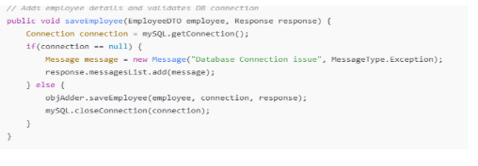Method Description:This method verifies database connectivity and delegates employee persistence to the data access layer.

Test Case Table
Test ID | Test Type | Input Condition | Equivalence / Boundary | Expected Result
TC-EMP-01 | Equivalence | Valid employee, DB available | Valid class | Employee saved successfully
TC-EMP-02 | Equivalence | Any employee, DB unavailable | Invalid class | Error message returned
TC-EMP-03 | Boundary | Connection just available | Boundary | Delegation executed

Coverage:Statement Coverage: 100%,Branch Coverage: 100%,Condition Coverage: 100%

3. Testing Analysis – addProduct(ProductDTO, Response)

Method Description:This method verifies database connectivity and delegates product persistence to the data access layer.

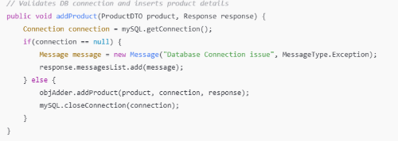Test Case Table
Test ID | Test Type | Input Condition | Equivalence / Boundary | Expected Result
TC-PROD-01 | Equivalence | Valid product, DB available | Valid class | Product saved successfully
TC-PROD-02 | Equivalence | Any product, DB unavailable | Invalid class | Error message returned
TC-PROD-03 | Boundary | Connection established | Boundary | Connection closed correctly

Coverage:Statement Coverage: 100%,Branch Coverage: 100%,Condition Coverage: 100%
4. Automated Test Implementation
Automated tests were implemented using JUnit 5 with Mockito to simulate database availability.
Mocking the database connection enables controlled testing of both valid and invalid equivalence classes, as well as boundary conditions such as null versus non-null connections.
All tests execute independently and verify correct delegation, error handling, and resource management.5. Summary
This testing analysis demonstrates Boundary Value Testing and Equivalence Class Testing through automated JUnit tests, in accordance with the course requirements.
By using mocks, the service layer was tested in isolation, achieving full logical coverage while ensuring reliability and repeatability of test execution.

