Problem 3.60:

1. X is stored in %rdi  
   N is stored in %esi  
   Result is stored in %rax  
   Mask is stored in %rdx
2. Initial value of result: 0  
   Initial value of mask: 1
3. The test condition is mask != 0;
4. Mask gets updated by the salq command on line 10; Mask gets left shifted by the value in %cl, which is N
5. Result gets updated by the orq command on line 9; Result gets OR’ed with the value in %r8, which is (X & mask)
6. 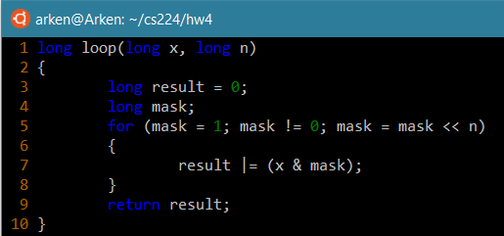

Problem 3.65:

1. Register %rdx holds a pointer to array element A[i][j]
2. Register %rax holds a pointer to array element A[j][i]
3. The value of M is 15

Problem 3.66:

NR: #define NR n\*3

NC: #define NC 1+(n\*4)

Problem 3.67:

1. Diagram
2. The elements of structure argument s are stored on the stack, so `process` can access them.
3. Process moves the intended value from a stack location to the register where structure r is storing its value.
4. Function arguments are simply stored on the stack.

Problem 3.68:

Value of A:

Value of B: