1. array[0] = 0x44434241  
   array[1] = 0x48474645  
   str0 = qrstuvwxyz  
   str1 = 0123456

Contents of Memory starting from 0x7ffd858e3ed0:

Array[0]:  
0x7ffd858e3ed0: 41  
0x7ffd858e3ed1: 42  
0x7ffd858e3ed2: 43  
0x7ffd858e3ed3: 44  
  
array[1]:  
0x7ffd858e3ed4: 45  
0x7ffd858e3ed5: 46  
0x7ffd858e3ed6: 47  
0x7ffd858e3ed7: 48  
0x7ffd858e3ed8: 0x69 i  
0x7ffd858e3ed9: 0x6a j  
0x7ffd858e3eda: 0x6b k  
0x7ffd858e3edb: 0x6c l  
0x7ffd858e3edc: 0x6d m  
0x7ffd858e3edd: 0x6e n  
0x7ffd858e3ede: 0x6f o  
0x7ffd858e3edf: 0x70 p

Str0  
0x7ffd858e3ee0: 0x71 q  
0x7ffd858e3ee1: 0x72 r  
0x7ffd858e3ee2: 0x73 s  
0x7ffd858e3ee3: 0x74 t  
0x7ffd858e3ee4: 0x75 u  
0x7ffd858e3ee5: 0x76 v  
0x7ffd858e3ee6: 0x77 w  
0x7ffd858e3ee7: 0x78 x  
0x7ffd858e3ee8: 0x79 y  
0x7ffd858e3ee9: 0x7a z  
0x7ffd858e3eea: 0x00 (null)

Empty Space:  
0x7ffd858e3eeb:   
0x7ffd858e3eec:   
0x7ffd858e3eed:   
0x7ffd858e3eee:   
0x7ffd858e3eef:

Str1:  
0x7ffd858e3ef0: 0x31  
0x7ffd858e3ef1: 0x32  
0x7ffd858e3ef2: 0x33  
0x7ffd858e3ef3: 0x34  
0x7ffd858e3ef4: 0x35  
0x7ffd858e3ef5: 0x36  
0x7ffd858e3ef6: 0x37  
0x7ffd858e3ef7: 0x00

1. (3^5) is 243, there is 8 left, so 2*(3^1) and 2*(3^0), therefore 100022.
2. 1101//1110//1010//1101//1011//1110//1110//1111//0000 goes 0xdeadbeef0
3. (2^5) is 32, (2^3) is 8, (2^2) is 4, (2^0) is 1, 32+8+4+1 = 45.  
   32+16+8+4 = 60  
   16+8+2+1 = 27  
   8+2+1 = 11  
   16+1 = 17  
   32+16+8+4+2+1 = 63
4. -32 + 8 + 4 + 1 = -19  
   -32 + 16 + 8 + 4 = -4  
   16 + 8 + 2 + 1 = 27  
   8 + 2 + 1 = 11  
   16 + 1 = 17  
   -32 + 16 + 8 + 4 + 2 + 1 = -1
5. 0x2d  
   0x3c  
   0x1b  
   0x0b  
   0x11  
   0x3f
6. 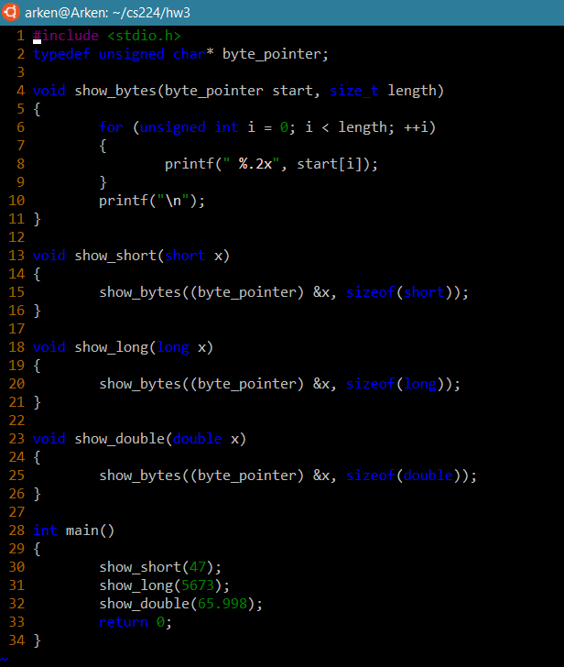
7. 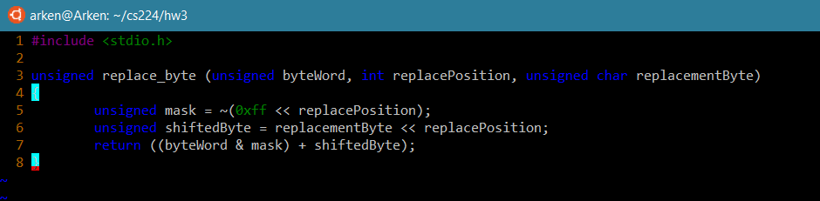
8. A) !!x  
   B) !!(~x)  
   C) !!(x & 0xff)  
   D) !!(~x & (0xff << 24))
9. 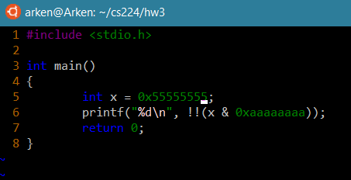
10. A) maxBytes gets implicitly cast to a size_t, so therefore if maxBytes is too small, it will become the hugely positive representation of the negative number resulting from the subtraction.  
    B) if ((signed)(maxBytes – sizeof(val)) > = 0)
11. A) (x << 4) + (x << 0)  
    B) (x << 0) – (x << 3)  
    C) (x << 6) – (x << 2)  
    D) (x << 4) – (x << 7)

|  |  |  |  |
| --- | --- | --- | --- |
| Format A Bits | Value | Format B Bits | Value |
| 1 01111 001 | -9/8 | 1 0111 0010 | -9/8 |
| 0 10110 011 | 176 | 0 1110 0110 | 176 |
| 1 00111 010 | -5/1024 | 1 |  |
| 0 00000 111 | 7/131072 | 0 |  |
| 1 11100 000 | -8192 | 1 |  |
| 0 10111 100 | 384 | 0 |  |

1. Taylor Whitlock, Evan Smith, Nathan Nelson, Neil Knight; Group 25