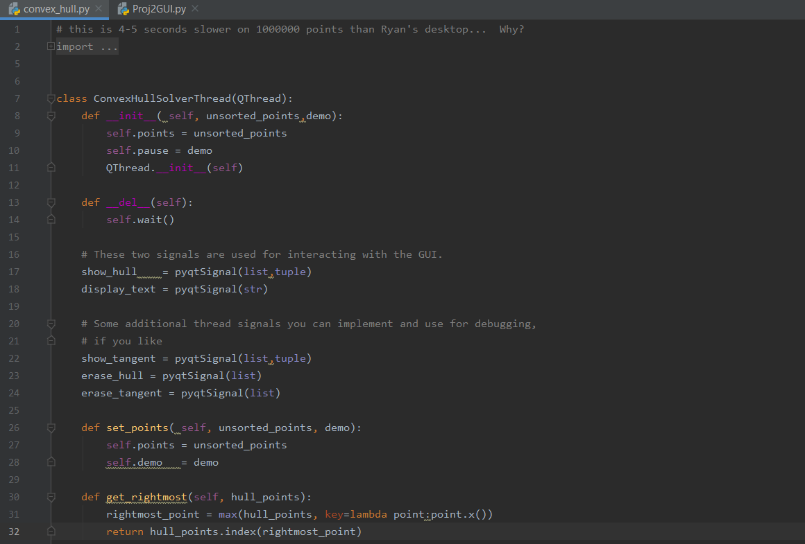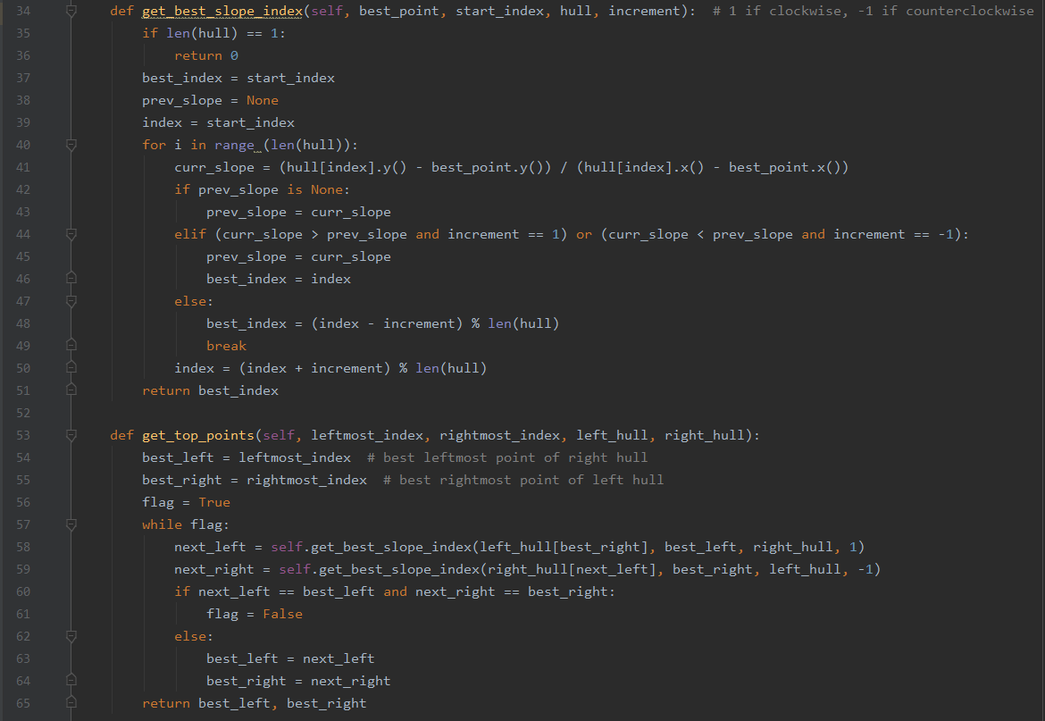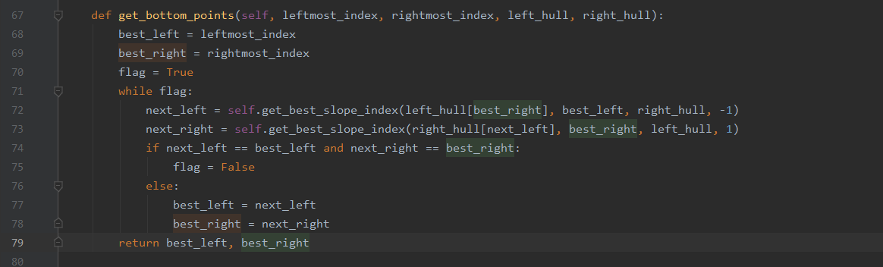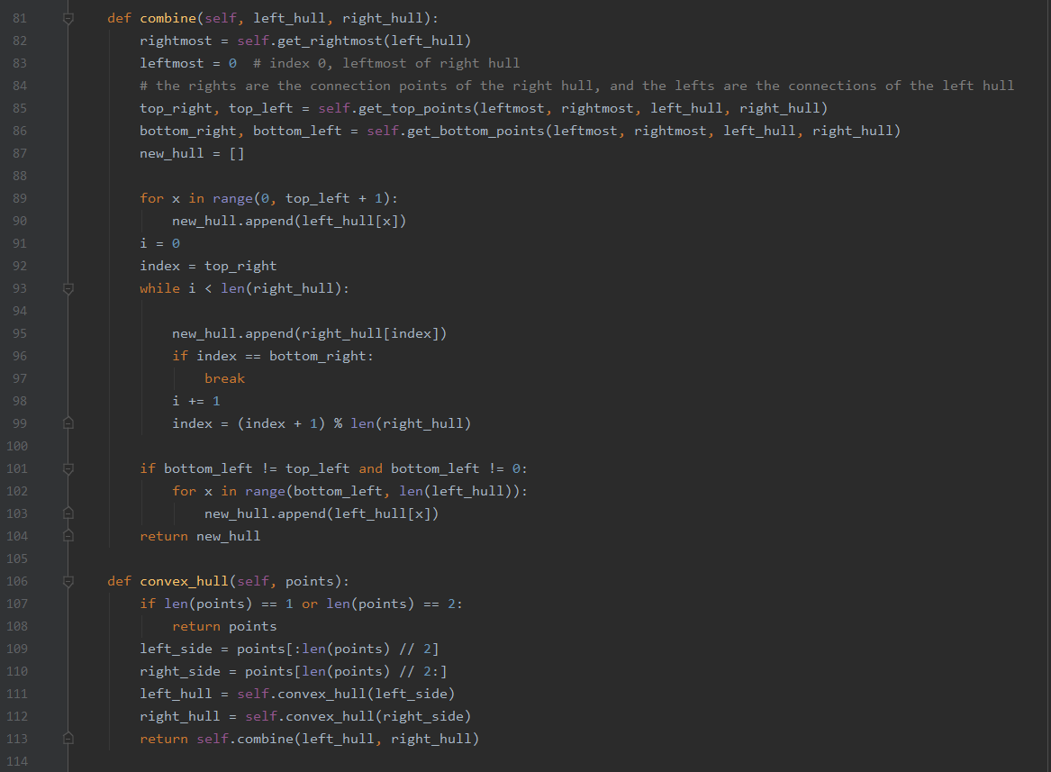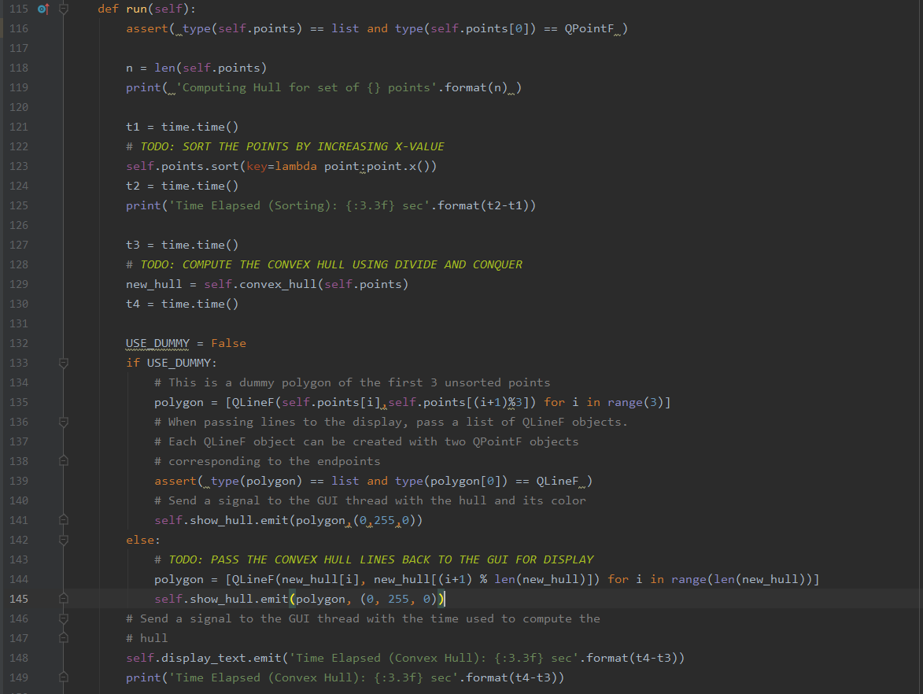

The get_rightmost function will be O(n), since it has to search through the list to find the max.

The get_best_slope_index will be at worst O(n), if it has to go through every point to find the best slope.

The get_top_points and get_bottom_points will both be O(n), since the biggest time sinks are the calls to get_best_slope_index

Combine will be O(n) since a new hull is created and all the points are added to it.

Overall, the time complexity is O(nlog(n)) according to the Master Theorem; A = 2, B = 2, and D = 1

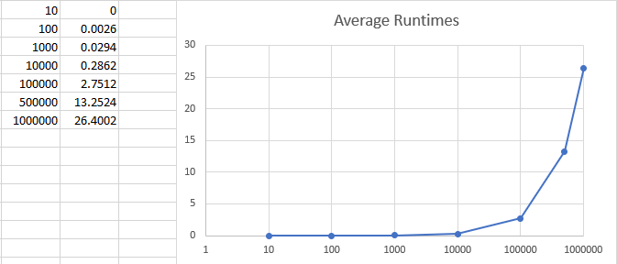

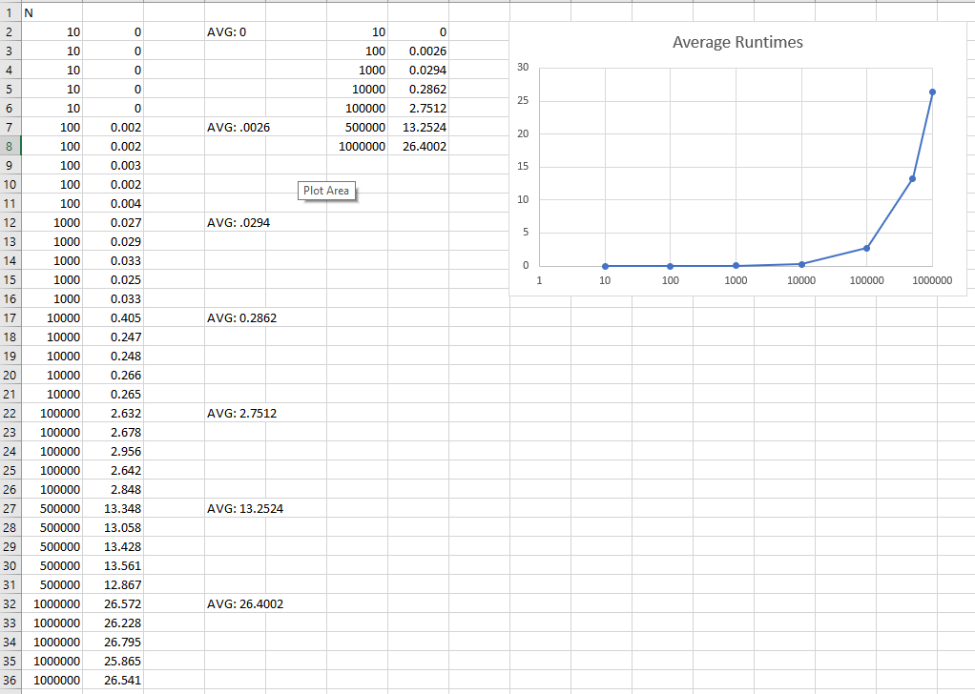

For the constant of proportionality, I got about 4.4*10^(-6), but my data fit my time complexity analysis otherwise.

For n = 1000000, k = 26.4002 / (1000000*log(1000000))

