Two Sum:

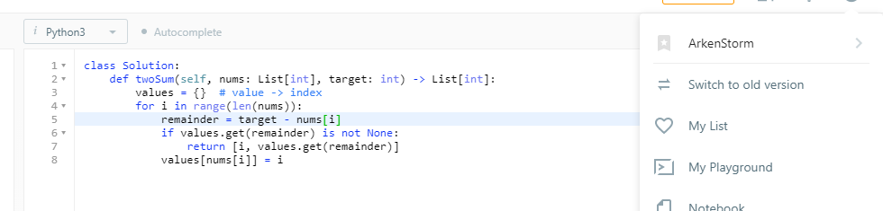

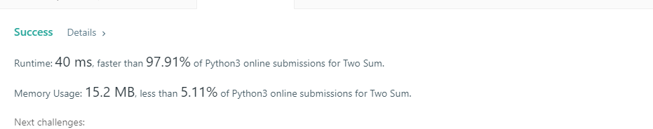

I discussed the problem with Michael Sederberg, Nicole Curtis, and Cara Johnson

Container with Most Water:

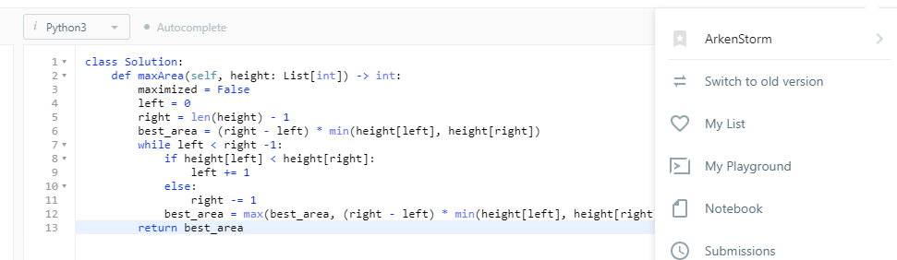

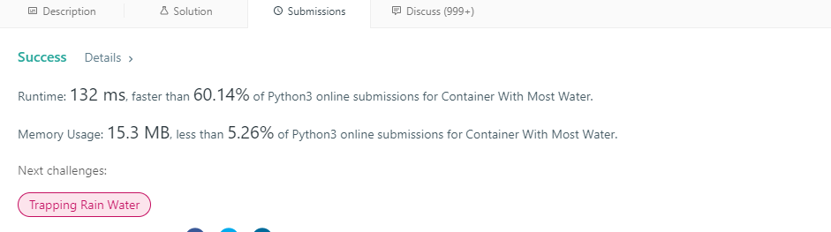

I discussed the problem with Michael Sederberg, Nicole Curtis, and Cara Johnson

Combination Sum:

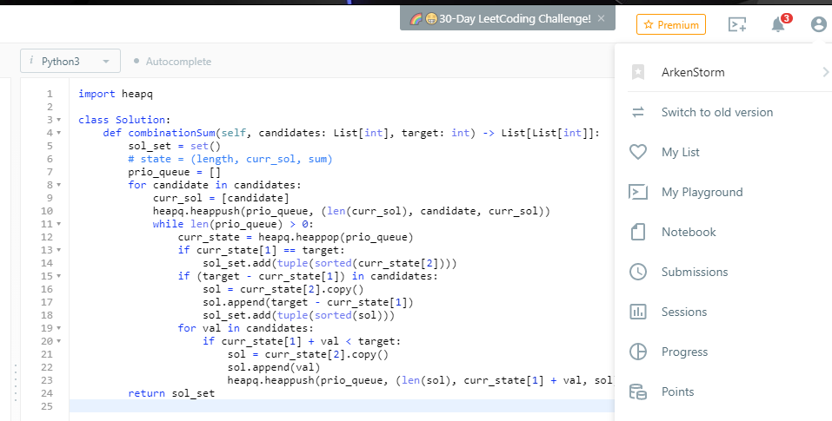

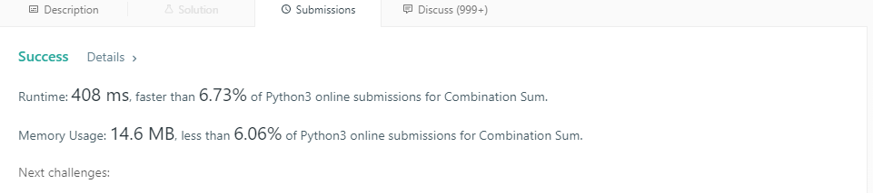

I discussed this one with Ryan Echols.

Triangle:

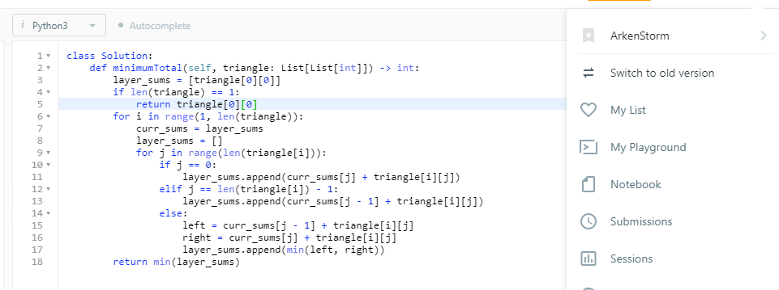

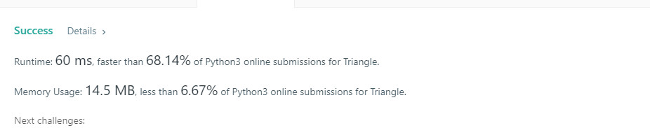

I discussed this one with Nicole Curtis

Friend Circles:

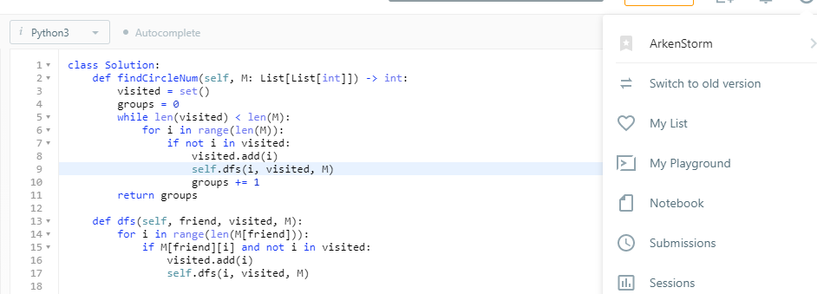

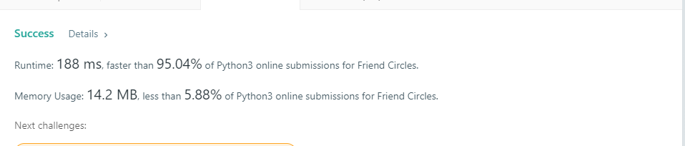

I discussed this one with Nicole Curtis and Ryan Echols

N-th Tribonacci:

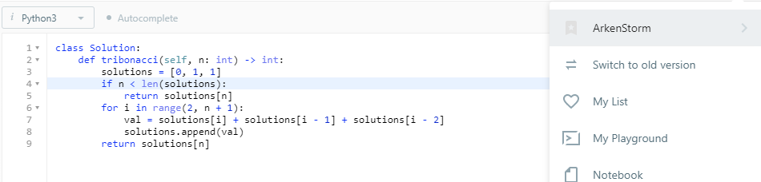

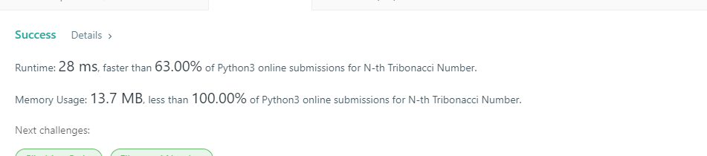

I discussed this one with Nicole Curtis and Ryan Echols

For most of them I found that they had done similar methods to my initial approaches, but I wanted to improve and challenge myself to do better algorithms. When I was discussing with Ryan, he had a bunch of linear algebra solutions that were really cool, but they hadn’t even crossed my mind. So it was really interesting to see the linear algebra theory behind the solutions that he came up with.