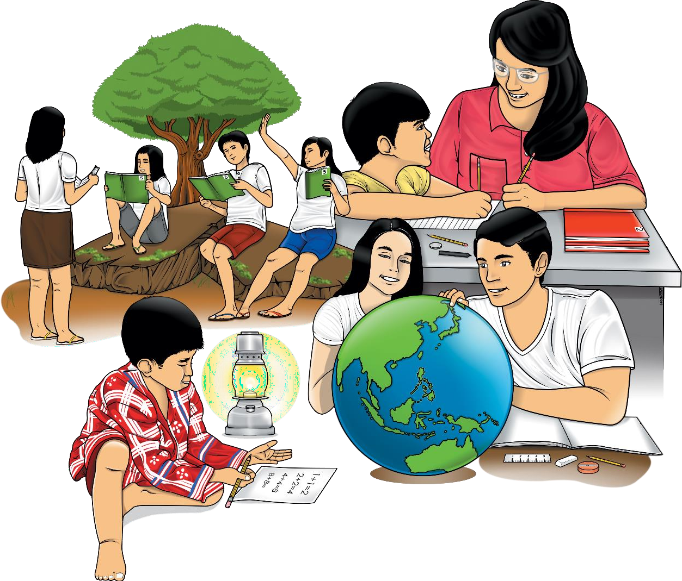
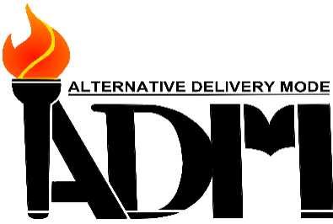


Arts
-10

Quarter 2 – Module 1: Elements and Distinct Characteristics of Technology- Based Production Arts

CO_Q2_Arts 10_ Module 1

Arts Grade 10
Alternative Delivery Mode
Quarter 2 Module 1: Elements and Distinct Characteristics of Technology-Based Production Arts
First Edition, 2020

Republic Act 8293, section 176 states that: No copyright shall subsist in any work of the Government of the Philippines. However, prior approval of the government agency or office wherein the work is created shall be necessary for the exploitation of such work for a profit. Such agency or office may, among other things, impose as a condition the payment of royalties.

Borrowed materials (i.e., songs, stories, poems, pictures, photos, brand names, trademarks, etc.) included in this module are owned by their respective copyright holders. Every effort has been exerted to locate and seek permission to use these materials from their respective copyright owners. The publisher and authors do not represent nor claim ownership over them.

Published by the Department of Education Secretary: Leonor Magtolis Briones Undersecretary: Diosdado M. San Antonio
Writers: Editors:

Reviewers:

Illustrator: Layout Artists:
Development Team of the Module
Winifredo P. Pe Benito, Reymond A. Sebastian
Flora B. Tinaza, Dharen-Jake R. Garcia, Frances Jocelle C. Singson
Francis A. Domingo, Marlon G. Taloza, Jowell T. Pilotin, Evangeline A. Cabacungan, Alma R. Tabilang, Sheryl R. Rialubin
Christian Rey R. Ricarze, Rogelio “Jon-Boy” Berbano
Florence A. Pilotin, Carina B. Buquing, Sharon Rose S. Boguen
Management Team: Tolentino G. Aquino, Arlene A. Niro, Maria Salome R. Abero,
Gina A. Amoyen, Editha T. Giron, Alma R. Tabilang

Printed in the Philippines by Department of Education – Region I
Office Address: Flores St., Catbangen, City of San Fernando, La Union Telefax: (072) 682-2324; (072) 607-8137
E-mail Address: region1@deped.gov.ph.

10

Arts

Quarter 2 – Module 1: Elements and Distinct Characteristics of Technology-Based Production Arts



Introductory Message
This Self-Learning Module (SLM) is prepared so that you, our dear learners, can continue your studies and learn while at home. Activities, questions, directions, exercises, and discussions are carefully stated for you to understand each lesson.
The SLM is composed of different parts. Each part shall guide you step-by- step as you discover and understand the lesson prepared for you.
Pretest is provided to measure your prior knowledge on lessons in each SLM. This will tell you if you need to proceed on completing this module or if you need to ask your facilitator or your teacher’s assistance for better understanding of the lesson. At the end of each module, you need to answer the posttest to self-check your learning. Answer Key is provided for each activity and test. We trust that you will be honest in using these.
In addition to the material in the main text, Notes to the Teacher are also provided to our facilitators and parents for strategies and reminders on how they can best help you on your home-based learning.
Please use this module with care. Do not put unnecessary marks on any part of this SLM. Use a separate sheet of paper in answering the exercises and tests. And read the instructions carefully before performing each task.
If you have any questions in using this SLM or any difficulty in answering the tasks in this module, do not hesitate to consult your teacher or facilitator.
Thank you

ii
CO_Q2_Arts 10_ Module 1

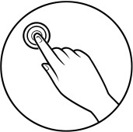
What I Need to Know

Hello! Learning is a long journey, right? In learning, doing all the prepared activities is quite challenging, yet it is fun and interesting. In the previous modules, you learned about modern art forms. In this module, you are to deal with modern technology in creating artworks.
As part of today’s generation, you are already familiar with the various use of technology. Unnoticeably, you might have been using technology-generated arts in your laptops, tablets, smartphones, and other gadgets. This module will help you understand the concepts used in creating technology-based art forms, such as computer-based art, and how they are related to our daily lives. Relatively, this will also introduce you to computer-based art.
Read the contents of the pages before doing the activities and answering the test questions. You are advised to use a wide variety of reading articles from different sources as references aside from the information in this module. Seek guidance from any member of your family or even your friends to help you achieve the goals set by this learning module.
In understanding and learning the module, you have to do the following:
- read each page carefully;
- follow directions strictly;
- answer all questions on each page correctly and completely;
- use a separate sheet of paper for your answers;
- do not write anything on this module; and
- ask for guidance from your teacher if necessary.

You can check your answers on the different activities and assessments through the answer key at the latter part of the module. However, you are encouraged to work independently and honestly.

It is now your time to shine!

Learning Competencies:
- Identifies art elements in the technology-based production arts.

(A10EL-IIb-1)
- Identifies distinct characteristics of arts in the 21st century in terms of:
  - production; and
  - functionality range of audience reach. (A10EL-IIa-2); and
- Identifies artworks produced by technology from other countries and their adaptation by Philippine artists. (A10EL-IIa-3)


What I Know

Pretest (Duration: 15 minutes)
- Directions: Choose the letter of the correct answer. Write your answers in your Art notebook.
  - What art is essentially made using computer generation and manipulation?
    - Collage Making
    - Stencil Drawing
    - Technology-based Art
    - Traditional Painting

  - What is the figure of a particular condition that outlines anything that you can see?
    - Color
    - Line
    - Texture
    - Shape

  - Which of the following illustrations shows texture?
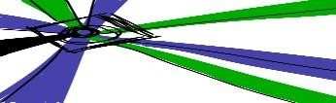
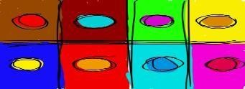
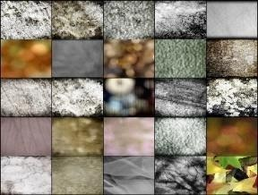
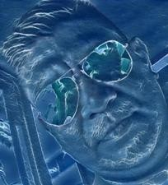

B. C. D.
Note: All artworks used are created by Christian Rey R. Ricarze

  - It refers to the distance or areas between or within components of a space.
    - Form
    - Line
    - Space
    - Value

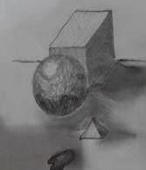
  - What generalization is derived from this illustration?
    - applies the principle of rhythm
    - emphasizes shapes
    - illustrates on texture
    - values on spacing

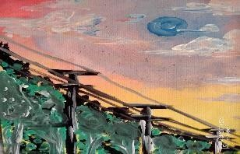
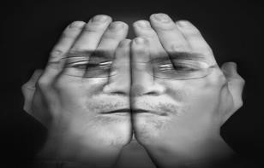
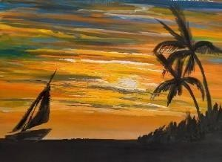
  - Which of the following picture is digitally made?
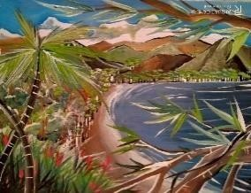

B. C. D.
Note: All artworks used are originally taken by Winifredo P. Pe Benito
  - Which of the following is a digital artwork of Antonio Gerardo?
    - Cityscape
    - Gravel
    - Polygon Drawings
    - Ordres
  - He is a foreign artist who created the brilliant Morrissey illustration for Rolling Stone magazine.
    - Evgeny Parvenov
    - Jean Pierie Hebert
    - Kaya Oldaker
    - Olga Kiseleva
  - It is defined as technology-based art which is generated by the use of gadgets like computers, smartphones, and graphic tablets.
    - Computer Art
    - Digital Art
    - Technology-based Art
    - Traditional Art
  - He is a multimedia artist in various companies in 2008 and by 2010, he focused on illustrations with his colorful and vibrant illustration style.
    - Antonio Gorordo
    - Kaya Oldaker
    - Ronnie del Carmen
    - Vincent Raphael Aseo
- Directions: Identify the following statements. Write T if the statement is true and write F if the statement is false.
  - Technology-based art allows communication between the artist and the audience.
  - Digital art has the same characteristics as traditional art.
  - Elements of art are indispensable factors that also affect technology-based art.
  - The use of lightness and darkness of color, shading, and highlighting in an artwork is value.
  - Vincent Raphael Aseo is the co-director of the animated film inside-out and an animator in Warner Bros.

Lesson  1 | Elements and Distinct Characteristics of Technology- Based Production Arts

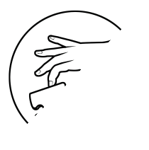
What’s In


In Quarter 1, you have learned how the modern art forms started. Impressionism art started the modern art movements in the early 19th century in Europe, particularly in Italy, Germany, and the Netherlands. Consequently, other modern art forms emerged such as expressionism, abstractionism, abstract expressionism, installation art, and performance art. These modern art forms became the foundation of the existing 21st-century art which will be discussed in this module.

What’s New

Directions: Below are painting and technology-based artworks. Identify the similarities and differences using the Venn diagram.
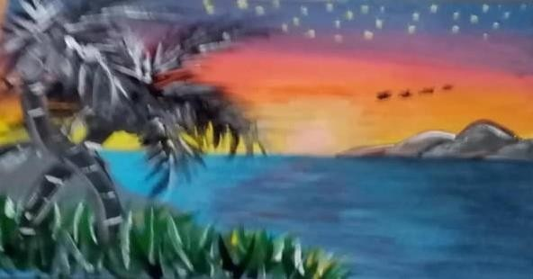
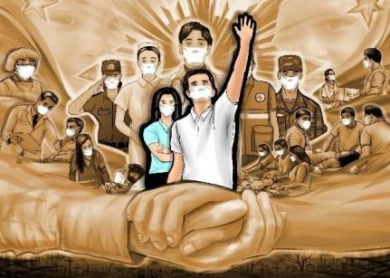
Painting Digital Art
painting
digital art


What is It

Elements of Art as Applied to Technology-Based Art

The elements of art help you identify and interpret an artwork easily. These are line, shape, color, value, form, texture, and space. These are incorporated in any artwork- traditional or technology-based/digital art.

ELEMENTS | DEFINITION | SAMPLE
Line | Distance between two points (or the path of a moving point), taking any form along the way. | 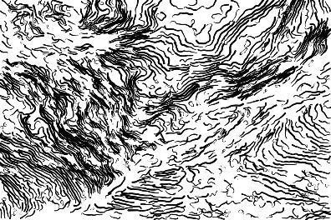  Source: Marcu Ioachim, Line art, Line art | Art | Marcu Ioachim | Flickr. Creative Commons Public Domain 1.0
Shape | A figure of a particular condition that outlines anything that you can see | 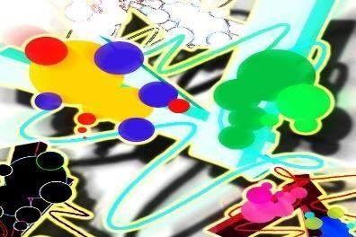  Source: Spencer Fitzsimmons, Playing with Shapes, Playing with Shapes | a slow day with the pen and shape tool… | Spencer Fitzsimmons  | Flickr. Creative Commons Attribution-Non- Commercial-ShareAlike 2.0 Generic.
Color | Different hues, shades applied in arts and design |   Photo was taken by Winifredo P. Pe Benito May 20, 2018 (Original Photo-Flowers)

Value | The use of lightness and darkness of color, shading, and highlighting in an artwork. | 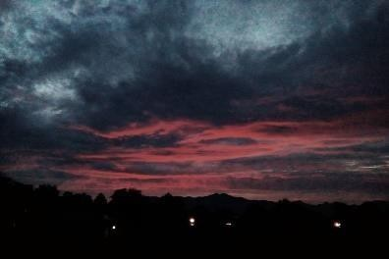  Photo was taken by Winifredo P. Pe Benito on January 12, 2017  (Original Photo-Altered Sunset)
Form | Can be created by the forming of two or more shapes or as a three- dimensional shape (cube, pyramid, sphere, etc.) | 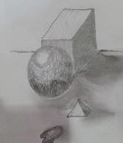  Photo and art were taken by Winifredo P. Pe Benito in December 2018 (Original Photo-Combinations)
Texture | Quality of a surface or the way any work of art is represented. | 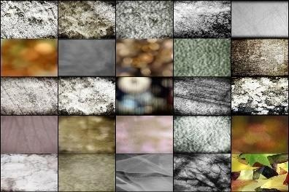  Source: Brenda Clarke,Free Textures 1 - 24 + 1,Free Textures 1 - 24 + 1 | 1. Free Texture #1, 2. Free Textu… | Flickr. Creative Commons Attribution-Non- Commercial-ShareAlike 2.0 Generic.
Space | Refers to the distances or areas around, between, or within components of a piece. | 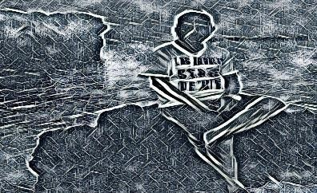  The photo was taken by Winifredo P. Pe Benito October 2018 (Original Photo-Crafted Spaces)

These elements of art are indispensable factors that also affect the technology- based arts. Same as the traditional artists, the digital artists are also guided by these elements which you will be dealing with as you go through this module.

Distinct Characteristics of Arts in the 21st Century

Technological advancement is inevitable. Day by day, it is influencing every aspect of our life. Its impact can be seen also in the arts since arts continuously evolve with technological growth.

Computer technology has been a part of every aspect of modern life. Anyone with a computer device like desktop PC, laptop, tablet, or android phone can now capture and edit images and videos; create, manipulate, and share works of art; and even compose music.
Traditional artists employ palettes and brushes with wide choices of inks, paints, and other pigments that are applied in a paper, canvass, walls, ceilings, fabric, and the like. Meanwhile, today’s artists use technology in creating their masterpieces. They employ the powers of image manipulation programs and applications, either physical or virtual art experience.

Consequently, digital art is a technology-based art form that is generated using gadgets like computers, smartphones, or graphic tablets. Eventually, the concept of computer-generated works as a means of serious artistic expression has gained ground among the younger generation of local artists.

The distinct characteristics of technology-based art are as follows:
- It is produced digitally.
- It is easy to reproduce since it is digitally made.
- It allows communication between the artist and the audience.
- It can be easily accessed and shared with the use of gadgets and the internet.
- It uses different qualities of art elements in creating a visual effect.

In producing technology-based arts, sharing and reaching computer/digital art internet connections are vital in downloading applications and programs to be used in the manipulations of photos, images, and videos.

Examples of Technology-based/Digital Artworks:

Digital Image Creation Produced through an Image Manipulation Program
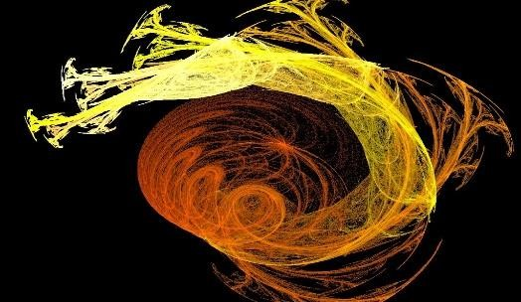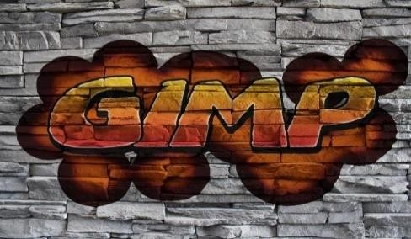

Source: garlandcannon, Horns of Glory,
Horns of Glory | Caelum videre iussit, et erectos ad sidera … | Flickr. Creative Commons Attribution-Non-Commercial-ShareAlike 2.0
Source: dOOnLoL Gimp graffiti,
Gimp graffiti | Elaborato con The GIMP Image source: Brick w… | Flickr. Creative Commons Attribution-Non-Commercial-ShareAlike 2.0
Generic.

Digital Painting Produced through a Pen Tablet
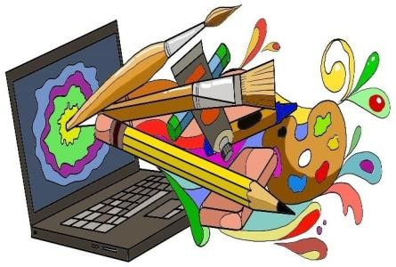
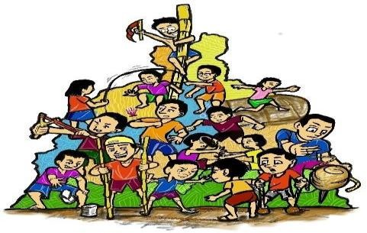
Digital Artworks by Christian Rey R. Ricarze (Original Artwork)

Mobile Phone Art
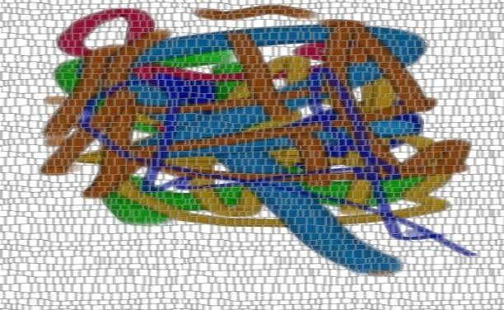
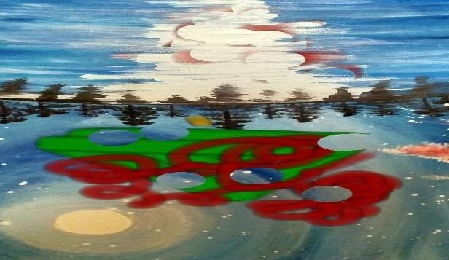
Unity in Diversity Landscape 101
Mobile Phone Artworks by Winifredo P. Pe Benito (Original Works)

Foreign Artworks and Adaptation of Filipino

Exhibits of computer art or technological-based artworks became highly popular and critically acclaimed, as digital artists or computer art masters or “superstars” came to the fore in Europe, Russia, and the United States.

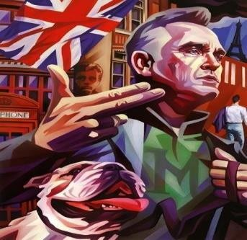
Evgeny Parvenov

He created this brilliant Morrissey illustration for Rolling Stone Magazine. He also created work for clients including Wired and GQ.

Source: Evgeny Parvenov, Morrisey, https://killer- inspiration.tumblr.com/post/48804734982/morrissey-by- evgeny-parfenov

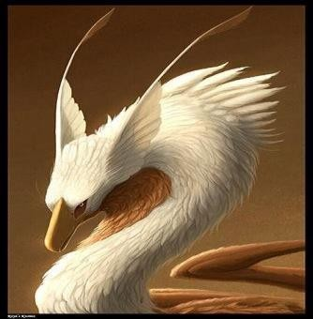
Kaya Oldaker

A versatile fantasy artist who created digital arts from Great Britain. Drawing dragons were her favorite thing to make.

Source: KAYA Oldaker, Mumbeltrousse the Madagascan Honey Dragon, ArtStation - Mumbeltrousse the Madagascan Honey Dragon., Kaya Oldaker

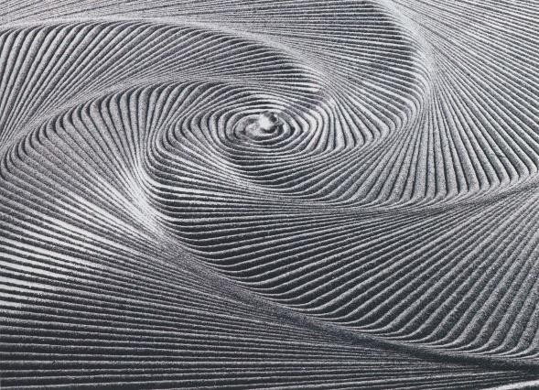
Jean Pierre Hebert
He was an independent visual artist
of algorithmic art, drawings, and mixed media.

Source: Jean-Pierre Hebert, Ulysse, Jean-Pierre Hébert: Ulysse – ACM SIGGRAPH ART SHOW ARCHIVES

In our country, Filipino artists were likewise influenced by the technological development in art. From time to time, it’s agreeable to know about the prominent artists in our preferred fields who were inspired by the work of foreign artists. With that, let’s get to know our Filipino artists who adapted artworks produced by technology and learn from them.

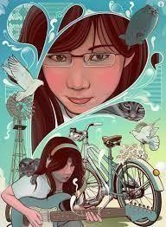
Vincent Rhafael Aseo
He is an independent visual artist of algorithmic art, drawings, and mixed media.

Source: Vincent Rhafael Aseo, The Song of Venus,https://www.cuded.com/vector-digital-art-by- vincent-rhafael-aseo/

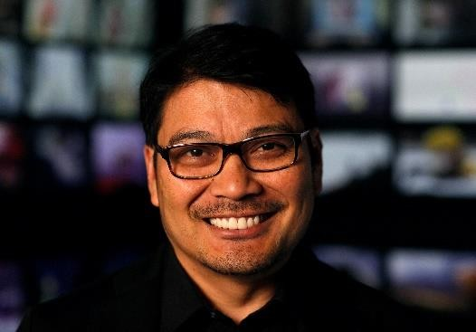
Ronnie del Carm
He is the co-director of the animated film Inside Out, an animator in Warner Bros, and became a storyboard artist for Batman: The Animated Series.

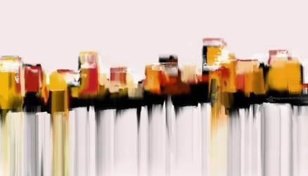
Source: Ronnie del Carmen, Writer/Director. I make animated features. You may have seen a few of them, Ronnie del Carmen (@ronniedelcarmen) / Twitter
Source: Deborah Coleman - Ronnie Del Carmen photographed File:20140806RonnieDelCarmen03.jpg - Wikimedia Commons. Creative Commons Attribution- Non-Commercial-ShareAlike 3.0 Unported.

Cityscape Antonio Gorordo, c 2010-2012 Digital Art

Source: antonio tonigordz gorordo, Cityscape
cityscape by angordz on DeviantArt

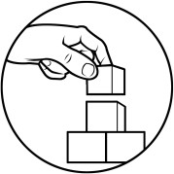
What’s More

Activity 1: List Me Down!
Directions: From the example of a technology-based artwork below, list the elements of art used. Write your answers in a separate sheet or you may use your notebook.
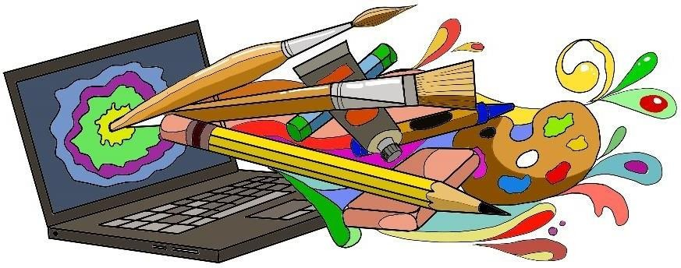

Elements of Art
Digital Artwork by Christian Rey R. Ricarze

Activity 2: Bubble Graph

Directions: Complete the bubble graph by writing words associated with the characteristics of the 21st Century Arts.

Characteristics of 21st Century Arts

Activity 3: Identify Me!
Directions: Identify the artists of the given artwork below.
1. 2.

3. 4.

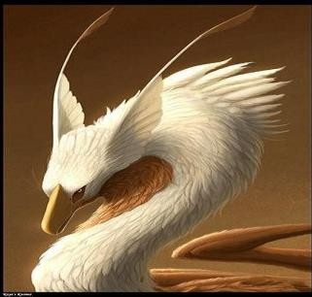
5.

Note: You can check your answers in the activities from the Answer Key on page 16 of this module.

Good job! You really mastered your lesson. Now, let us proceed to summarize the things you have learned on the next page. Are you ready? Let’s go!


What I Have Learned

Directions: Express your knowledge and reflections on the lesson by completing the exit cards.
Things I have learned….
Things I want to treasure….
Things I want to know more….

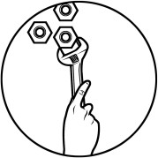
What I Can Do

Situation: You are planning to buy a t-shirt for your brother who is fond of watching cartoon movies. With your knowledge of the elements and distinct characteristics of technology-based art, how will you describe the clothes you want to buy for him? Write your description on a separate sheet.
Note to the Teacher: This can be done by students as performance task. A rubric for the activity can be provided by the teacher as guide for students to accomplish the task.


Assessment

Post Test (Duration: 10 minutes)

- Directions: Identify the following statements. Write T if the statement is true and write F if the statement is false. Write your answers in your Art notebook.

  - The use of lightness and darkness of color, shading, and highlighting in an artwork is value.
  - Vincent Raphael Aseo is the co-director of the animated film Inside-out and an animator in Warner Bros.
  - Technology-based art allows communication between the artist and the audience.
  - Elements of art are indispensable factors that also affect technology-based art.
  - Digital art is the same as traditional art.

- Directions: Read carefully each statement below and write the letter of the best answer that corresponds to the following questions in your notebook.

- What is the figure of a particular condition that outlines anything that you can see?
  - Color
  - Line
  - Texture
  - Shape

- Which of the following illustrations show texture?
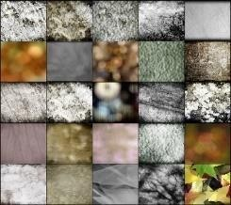

B. C. D.

- This refers to the distance of areas that occurred between or within components of a piece.
  - Form
  - Line
  - Space
  - Value

- What art is essentially made using computer generation and manipulation?
  - Collage making
  - Stencil Drawing
  - Technology-based art
  - Traditional painting

- He is a foreign artist who created the brilliant Morrissey illustration for Rolling Stone magazine.
  - Evgeny Parvenov
  - Jean Piere Hebert
  - Kaya Oldaker
  - Olga Kiseleva

- It is defined as a technology-based art that is generated using gadgets like computers, smartphones, and graphic tablets.
  - Computer art
  - Digital art
  - Technology-based art
  - Traditional Art

- Which of the following picture is digitally made?
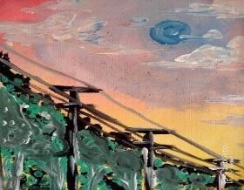
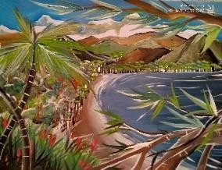

B. C. D.
- He is a multimedia artist in various companies in 2008 and by 2010. He focused on illustrations with his colorful and vibrant illustration style.
  - Antonio Gorordo
  - Kaya Oldaker
  - Ronnie del Carmen
  - Vincent Raphael Aseo

- Which of the following is a digital artwork of Antonio Gorordo?
  - Cityscape
  - Gravel
  - Polygon Drawings
  - Ordres

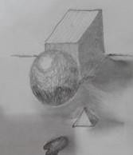
- What generalization is derived from this illustration?
  - Applies principles of rhythm
  - Emphasizes shapes
  - Illustrates on texture
  - Values on spacing

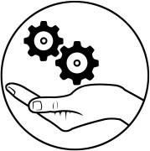

Additional Activities
Directions: Research at least 2 examples of technology-based art done by Filipino artists. Print the artwork and identify the following:
- Elements used
- Distinct Characteristics

Rubrics for the activity:

Criteria | 5  (Outstanding  ) | 4 (Very Good) | 3 (Good) | 2 (Fair)
Technology- based Arts | 5 printed technology- based art  samples were submitted | 5 printed technology- based art  samples were submitted | 5 printed technology- based art  samples were submitted | 5 printed technology- based art  samples were submitted
Elements of Art | Identified all the art elements in the different technology- based art printed  samples | Identified at least 5 art elements in the different technology- based art printed  samples | Identified at least 4 art elements in the different technology- based art printed  samples | Identified at least 3 art elements in the different technology- based art printed  samples
Distinct Characteristic s | Identified 5 distinct characteristic s of technology- based art from the  printed samples. | Identified 4 distinct characteristic s of technology- based art from the  printed samples. | Identified 3 distinct characteristic s of technology- based art from the  printed samples. | Identified 2 distinct characteristic s of technology- based art from the  printed samples.
Note to the Teacher: For the students without the capacity and access to the internet connection and printer, teacher can provide technology-based artworks samples for students.

References
Aseo, Vincent Rhafael. 2012. www.cuded.com. Accessed May 25, 2021. https://www.cuded.com/vector-digital-art-by-vincent-rhafael-aseo/.

Carmen, Ronnie del. 2009. www.twitter.com. March. Accessed May 25, 2020.
Ronnie del Carmen (@ronniedelcarmen) / Twitter.

Clarke, Brenda. 2009. www.flickr.com. April 24. Accessed May 24, 2020. Free
Textures 1 - 24 + 1 | 1. Free Texture #1, 2. Free Textu… | Flickr.

Coleman, Deborah. 2014. www.wikimedia.com. August 6. Accessed August 16, 2021. File:20140806RonnieDelCarmen03.jpg - Wikimedia Commons.

doonlol. 2011. www.flickr.com. March 22. Accessed May 24, 2020. Gimp graffiti |
Elaborato con The GIMP Image source: Brick w… | Flickr.

Fitzsimmons, Spencer. 2007. www.flickr.com. September 29. Accessed May 24, 2020. Playing with Shapes | a slow day with the pen and shape tool… | Spencer Fitzsimmons | Flickr.

garlandcannon. 2010. www.flickr.com. January 20. Accessed August 16, 2021.
Horns of Glory | Caelum videre iussit, et erectos ad sidera … | Flickr.

Gorordo, Antonio. 2010. www.deviantart.com. March 30. Accessed May 25, 2020. cityscape by angordz on DeviantArt.

Hebert, Jean-Pierre. 2005. www.acmsigraphartworksarchives.com. Accessed May 25, 2020. Jean-Pierre Hébert: Ulysse – ACM SIGGRAPH ART SHOW ARCHIVES.

loachim, Marcu. 2014. www.flickr.com. July 29. Accessed May 24, 2020. Line art | Art | Marcu Ioachim | Flickr.

Oldaker, Kaya. 2013. www.artstaion.com. Accessed August 16, 2021. ArtStation - Mumbeltrousse the Madagascan Honey Dragon., Kaya Oldaker.

Parfenov, Evgeny. 2013. www.tumblr.com. April 24. Accessed May 25, 2020. https://killer-inspiration.tumblr.com/post/48804734982/morrissey-by- evgeny-parfenov.

Raul M. Sunico, Evelyn F. Cabanban, Melissa Y. Moran. 2015. HORIZONS: Music and Arts Appreciation for Young Filipinos. Quezon City: Tawid Publications.

For inquiries or feedback, please write or call:
Department of Education - Bureau of Learning Resources (DepEd-BLR) Ground Floor, Bonifacio Bldg., DepEd Complex
Meralco Avenue, Pasig City, Philippines 1600 Telefax: (632) 8634-1072; 8634-1054; 8631-4985
Email Address: blr.lrqad@deped.gov.ph * blr.lrpd@deped.gov.ph

