DigiPort: DIGITAL PORTFOLIO FOR NAAWAN CENTRAL SCHOOL

A Capstone Project

Presented to the
Faculty of the Department of Information Technology
College of Marine and Allied Sciences
Mindanao State University at Naawan
9023, Naawan, Misamis Oriental

In Partial Fulfillment
Of the Requirements for the Degree of
Bachelor of Science in Information Technology
Major in Database Management

By:
Arkenz Q. Gabonada
Kent John L. Montebon
China V. Roa

December 2025
ABSTRACT

DigiPort, a Digital Portfolio Management System developed for Naawan Central School, tackles key challenges in traditional paper-based processes, including data loss during project compilation, tracking inefficiencies in portfolio creation, and accessibility issues in submission and review workflows. Built using the Agile Scrum model with technologies such as, PostgreSQL, Python, and Tailwind CSS, the web-based platform enables pupils to submit academic projects by subject, organize multimedia portfolios with integrated paint tools, track submission statuses, and view feedback, while teachers manage classes, monitor progress through dashboards, provide remarks, and handle revisions via notifications and history records.
The system's design incorporates UML diagrams like use cases, activity flows, functional decomposition, and data flow models to ensure intuitive navigation for both desktop and potential mobile users. Iterative Agile sprints supported development and black box testing, with usability validated through the System Usability Scale (SUS) among 30 teachers and pupils, achieving "good to excellent" scores (75–100) despite minor training needs for low-digital-literacy users. Ultimately, DigiPort streamlines organization, enhances teacher-pupil collaboration, promotes pupil ownership of learning, and modernizes academic documentation, with suggestions for future enhancements such as improved features and mobile optimization to further support the school's educational objectives.
TABLE OF CONTENTS
TITLE i
TABLE OF CONTENTS ii
LIST OF FIGURES iii
LIST OF TABLES iv
CHAPTER 1 INTRODUCTION 1
1.1 Background of the Project 1
1.2 Context of the Project 2
1.3 Narrative Listing 2
1.4 Issues and Problems 6
1.5. Objective of the Project 6
1.5.1. General Objective 6
1.5.2. Specific Objectives 6
1.6 Significance of the Project 6
1.7 Scope and Limitations 7
1.8. Software Development Model of the Project 7
1.9. Summary of the Chapter 8
CHAPTER 2 REVIEW OF RELATED LITERATURE AND SYSTEMS 9
2.1 Related Literature 9
2.2 Related Systems 12
2.3 Summary of the Chapter 18
CHAPTER 3 CONCEPT, THEORIES, AND TECHNICAL BACKGROUND 19
3.1 Design Tools of the System 20
3.2 Development Tools of the System 21
3.3 Testing Tools of the System 22
CHAPTER 4 METHODOLOGY 25
4.1 Design Methodology of the System 25
4.2. Development Methodology of the System 25
4.3. Testing Methodology of the System 25
4.3.1 Web-Based System 26
4.3.1.1 Teacher 26
4.3.1.2 Student 29
CHAPTER 5 RESULT AND DISCUSSION 31
5.1. Design Results of the System 31
5.2 Development Results of the System 57
5.3 Summary of the Chapter 71
REFERENCES 72

LIST OF FIGURES
Figure 1. NCS Digital Portfolio..……………………………………………….…………………..…2
Figure 2. Project Compilation……………………....…………………………..……..…..4
Figure 3. Portfolio Making……………………………….………………………....………5
Figure 4. Portfolio Submission…………………………………….………....……………6
Figure 5. Agile Scrum Model Digital Portfolio System…………………….…….…..…20
Figure 6. Black Box Test of Digital Portfolio System………………..……..…………..24
Figure 7. System Architecture of Digital Portfolio System……………..…..…………26
Figure 8.Use Case Diagram of Digital Portfolio System……………………………….29
Figure 9. Activity Diagram of Digital Portfolio System……………………..…………..30
Figure 10. Activity Diagram of Digital Portfolio System………………..………………31
Figure 11. Activity Diagram of Digital Portfolio System………………………………..32
Figure 12. Activity Diagram of Digital Portfolio System………………….…………….33
Figure 13. Activity Diagram of Digital Portfolio System………………………..………34
Figure 14. Activity Diagram of Digital Portfolio System………………………..………35
Figure 15. Activity Diagram of Digital Portfolio System………...………..……………36
Figure 16. Activity Diagram of Digital Portfolio System……………….………………37
Figure 17. Activity Diagram of Digital Portfolio System……………………………….38
Figure 18. Activity Diagram of Digital Portfolio System…………………….…………39
Figure 19. Activity Diagram of Digital Portfolio System………………….……………40
Figure 20. Activity Diagram of Digital Portfolio System…………………….…………41
Figure 21. Activity Diagram of Digital Portfolio System……………………..………..42
Figure 22. Activity Diagram of Digital Portfolio System…………………..…………..43
Figure 23. Activity Diagram of Digital Portfolio System………………………..……..44
Figure 24. Activity Diagram of Digital Portfolio System………………………..……..45
Figure 25. Activity Diagram of Digital Portfolio System……………………...……….46
Figure 26. Functional Decomposition Diagram of Digital Portfolio System……..….47
Figure 27. Context Diagram of Digital Portfolio System……………………………….48
Figure 28. Data Flow Diagram of Digital Portfolio System……………..……………..49
Figure 29. Teacher User Interface Dashboard…………………………………………52
Figure 30. Digital Portfolio System Teacher User Interface Login Form………....…53
Figure 31. Digital Portfolio System Teacher User Interface Create Classes…...….54.
Figure 32. Digital Portfolio System Teacher User Interface Pupil’s Portfolio……….55
Figure 33. Digital Portfolio System Teacher User Interface Pupil’s History Records………………………………………………………………………….…………56
Figure 34. Digital Portfolio System Teacher User Interface Teacher’s Notification…………………………………………………………………………………57
Figure 35. Digital Portfolio System Student User Interface Login Form…………….58
Figure 36. Digital Portfolio System Student User Interface View Newsfeed……..…59
Figure 37. Digital Portfolio System Student User Interface Edit Profile………..……60
Figure 38. Digital Portfolio System Student User Interface View Portfolio…………..61
Figure 39. Digital Portfolio System Student User Interface Manage Pending Project………………………………………………………………………………………62
Figure 40. Digital Portfolio System Student User Interface View Completed Work…………………………………………………………………………….…………..63
Figure 41. Digital Portfolio System Student User Interface View Notification………64
Figure 42. Digital Portfolio System Student User Interface View Paint…………..…65
Figure 43. Digital Portfolio System Student User Interface Upload Post……….…..66

LIST OF TABLES
Table 1. Hardware Design Component used in the development of Digital Portfolio System…………………………………………………………………………………………………27
Table 2. Software Design Component used in the development of Digital Portfolio System………………………………………………………………………………………………...28
Table 3. Data Dictionary of the Designed Database of Digital Portfolio System………………………………………………………………………………………………...51

vi

CHAPTER 1
INTRODUCTION
This chapter discusses the foundation which provides an overview of Showcase: Digital Portfolio System. It begins by outlining the current challenges faced by Naawan Central School in managing pupil documentation. Many schools struggle with traditional methods of tracking pupil progress, which can be cumbersome and inefficient. These challenges often lead to a lack of effective communication between teachers and pupils, hindering the collaborative effort needed to support learning. By integrating features that promote reflection and self-assessment, the system encourages pupils to take ownership of their learning journey.

1.1 Background of the Project
Naawan Central School, the primary client of this project, seeks to improve how pupils document and showcase their academic activities. This digital portfolio system aims to address the needs of teachers, and pupils by providing a structured platform to organize and highlight academic outputs and achievements. Maintaining a well-structured portfolio is essential for fostering growth, engagement, and skill development while helping identify areas for improvement. Without such a system, pupils' efforts often go unnoticed, it is because there might be some scenarios that the teachers might be unable to keep their outputs, limiting opportunities to showcase their talents and achievements. This lack of acknowledgment can hinder motivation, reflection, and personal growth. A digital portfolio ensures that pupils' progress, skills, and creativity are consistently documented and recognize, empowering them to take pride in their work while enhancing collaboration between teachers, and pupils.
By implementing a Digital Portfolio System, Naawan Central School aims to address these challenges and enhance the learning experience for its pupils. This project will provide pupils with a structured platform to showcase their work, which not only highlights their achievements but also boosts their confidence and motivation. The system also provides significant benefits for pupils by helping them track their growth over time, identify areas for improvement, and reflect on their learning journey. A well-organized platform makes it simple for pupils to show their progress to teacher, and peers, which increases encouragement and appreciation. Furthermore, the ability to showcase their work prepares pupils for future opportunities, such as applying for scholarships or participating in competitions, where highlighting achievements is essential.

1.2 Context of the Project
The primary stakeholder for this project is Naawan Central School, an elementary institution dedicated to nurturing the academic and personal development of its pupils. Serving grade levels from kindergarten to grade six, the school plays a crucial role in ensuring that pupil acquire foundational knowledge and skills essential for their future learning. Naawan Central School was selected for this project due to its pressing need for a modernized system capable of efficiently managing student academic records. Currently, the school archives the student outputs by grade level coordinator. This project aims to address Naawan Central School's need for a more efficient and streamlined system to manage student academic records. By implementing a modernized digital portfolio system, the school can enhance its ability to archive and track student outputs effectively. The following section details the specific features and functionalities of the proposed system to meet the school's unique requirements.

1.3 Narrative Listing
Figure 1 shows the three main phases of the digital portfolio workflow at Naawan Central School. Their process starts in the project compilation phase, where pupil submit their academic projects through the system, which are organized by teachers according to subjects, ensuring all submissions are complete and notifying pupils of any missing work. Next, during Portfolio Making, pupils compile their work into digital portfolios. Finally, in the Portfolio Submission and Review phase, pupils submit their portfolios for teacher evaluation, with opportunities for revisions before the final assessment is completed and the portfolio is archived for future reference.
Figure 1. NCS Digital Portfolio
Project Compilation
This process is shown in figure 2, pupils submit their academic projects through the digital portfolio system. Teachers receive the submitted projects and organize them by subjects. This helps in maintaining a structured record of all submissions. After organizing the projects, teachers cross-check these submissions against the class record archives to ensure that all required projects have been submitted. There have been cases where projects went missing, teachers had to notify the pupils, who then receive the information and proceed to submit the missing projects. Once all required projects are submitted, teachers complete the review and record-keeping process for each pupil’s projects.
Portfolio Making
Teachers inform pupils about the need to compile their projects into their digital portfolios. Pupils receive this information and prepare the project compilation, which includes organizing their work in the portfolio system. After compilation, pupils review their own work and make any necessary improvements or adjustments.

Portfolio Submission and Review
Pupils submit their portfolios at designated times at the end of the semester or school year. Teachers receive the portfolios and store them digitally, organizing them for evaluation and future reference. Pupils may be given the option to update or revise their portfolios before final evaluation. Teachers often have trouble in tracking when revisions are required. However when revisions are needed, teachers return the portfolio for updates. Once the portfolio is complete, teachers proceed with the evaluation of the student’s work. At the end of the school year, the evaluated portfolios are returned to the pupils as a record of their academic achievements. However, issues arise in this process such as portfolios being misplaced, lost, or unintentionally kept by teachers, preventing pupils from reclaiming their work. These situations not only disrupt the continuity of a pupil's academic record but also deprive them of their intellectual property rights due to instances where teachers will then use the pupils’ output as class materials for their classes without proper credit.
Figure 2. Project Compilation

Figure 3. Portfolio Making
Figure 4. Portfolio Submission

1.4 Issues and Problems
This section discusses the issues and problems that occurred in Naawan Central School, particularly concerning the management of student documentation.
Data Loss Issue
Data loss occurs in the compilation process where instances of missing or failure to recognize the owner of the project itself, incomplete records of their academic work happens. Lost outputs create further challenges, as they prevent teachers from evaluating a pupil’s learning outcomes and providing necessary feedback.
Data Tracking Issues
Data tracking issues arise in the portfolio making process, where teachers face difficulties in verifying and monitoring pupils' outputs within their portfolios. While reviewing pupil submissions, teachers encounter challenges such as identifying missing or incomplete work. This leads to inefficiencies in tracking progress. Double-checking outputs, although redundant in the portfolio submission process, becomes necessary due to lack of clear indicators for submission status.
Data Accessibility and Intellectual Property Issues
Data accessibility and intellectual property concerns arise due in the portfolio submission process where pupils’ can no longer reclaim their work, and are used in classes they did not consent it to be a material of.

1.5. Objective of the Project

1.5.1. General Objective
This project aims to develop Showcase: Digital Portfolio System using Agile Model, to enhance the efficiency of tracking student performance, encouraging creativity in portfolio creation, and engaging assessment activities Naawan at Central School.

1.5.2. Specific Objectives

- to design a digital portfolio system based on the business processes and policies of NCS;
- to develop the system based on the design; and
- to test the functionality and usability of the developed system using the System Usability Scale (SUS) and the Adjective Rating Scale (ARS) for the interpretation of the SUS score.

1.6 Significance of the Project
The Digital Portfolio System for Naawan Central School provides substantial benefits to various stakeholders involved in the educational process, offering improvements in how academic work is documented, monitored, and assessed.

For Pupils
The digital portfolio system has several positive effects on pupils, which is allowing them to systematically store and organize their work, and it makes tracking progress over time much easier. This structured platform not only helps pupils stay organized but also fosters a sense of responsibility for their learning and encouraging them to take ownership of their educational journey.
For Teachers
Educators benefit from streamlined access to student submissions, enabling more efficient assessment and timely feedback. This system allows teachers to identify areas where pupils may need additional support, facilitating tailored instruction that meets individual learning needs.

For Naawan Central School
This project supports the school’s mission to adopt modern tools and technologies, aligning its practices with contemporary educational trends. It also enhances the school's reputation as a forward-thinking institution that prioritizes efficient and transparent learning processes. The school benefits from a centralized, digital solution that consolidates student work, streamlines communication, and enhances collaboration among teacher, and pupils. By reducing the reliance on physical documentation and paper-based processes, the digital portfolio system contributes to the school’s sustainability efforts, promoting a greener and more eco-friendly educational environment.

1.7 Scope and Limitations
The proponents aim to create a digital portfolio system for the whole Naawan Central School wherein pupils will keep track of their portfolio and while this also contains the works that they can share.
However, the system has certain limitations. It will serve solely as a repository and sharing platform for pupil works and does not include features for grading outputs or providing prompts for missing projects. Despite these limitations, the system effectively enhances accessibility, organization, and engagement, ensuring that pupils’ achievements are properly documented and shared.

1.8. Software Development Model of the Project
The proponent of the Digital Portfolio System for Naawan Central School will break the project into smaller components, and the developers will use the Agile Model. Throughout the project, the proponents are able to collect ongoing input and make improvements thanks to this adaptable and iterative strategy. The developers make sure the system successfully satisfies the needs of stakeholders, such as teachers and pupils, by working closely with them. The project will be broken up into multiple "sprints," each of which will concentrate on a different function, including portfolio management, and project submission.
To collect specific requirements and evaluate technical demands, the proponents will begin with a planning step. Following this, the developers group will design a user-friendly system architecture. Specific modules will be developed, tested, and improved at each sprint, and feedback will be gathered for future versions. After it is finished, the proponents will install the system at the school and give administrators and teachers training sessions in addition to user manuals for pupils. To resolve any problems and implement changes based on user feedback, there will be continuous support and maintenance accessible. This Agile approach ensures that this project Digital Portfolio System adapts to the evolving needs of Naawan Central School while maintaining high-quality standards.

1.9. Summary of the Chapter
This chapter provided an overview of the foundational elements of the Digital Portfolio System for Naawan Central School. It started by outlining the background of the project and the need for a digital platform to improve the recording and monitoring of pupils' academic progress. The key stakeholders, including pupils, teachers, and school administrators, were identified, emphasizing how the system addresses the specific challenges they face. The chapter outlined the current issues, such as the lack of a centralized platform for organizing student work, which the project aims to solve.
Furthermore, it discussed the significance of the project for each stakeholder, highlighting how it improves organization, engagement, and communication. The Agile Software Development Model was introduced as the methodology guiding the development process, allowing for flexibility and continuous feedback. Lastly, a project plan was outlined, detailing how the system will be developed, tested, and deployed in phases to ensure it meets the evolving needs of the school. This chapter sets the foundation for the more detailed technical and methodological discussions that will follow in the subsequent chapters.

CHAPTER 2
REVIEW OF RELATED LITERATURE AND SYSTEMS
This chapter presents a review of prior research and related systems that lay the foundation for the development of a Digital Portfolio System for Naawan Central School. The first section discusses literature on digital portfolios in educational settings, examining the purpose, methodology, results, and significance of each study. The second section provides an analysis of similar systems, highlighting key functionalities and their relevance to the current project, which aims to improve student documentation, and support student self-assessment.

2.1 Related Literature
The Digital Portfolio as a Support for Reflective Practice in Elementary School Teachers: An Improvement-oriented Case Study
The use of digital portfolios in basic education teachers offers numerous benefits such as the effective organization and storage of students’ work, projects and evaluation, which facilitates the access and search for information from anywhere when it is considered necessary. It also allows evaluating and providing feedback in a more efficient way, since it allows the teacher to add comments directly to the students’ work and share them quickly and easily. As mentioned by Díaz Barriga et al. (2015), the digital portfolio has taken great importance for the educational field since it is considered as a tool that allows to carry out the teaching-learning process, it also promotes self-reflection, self-evaluation, and allows to review and analyze the progress of students, allowing to identify areas for improvement and develop strategies to strengthen their teaching practice.The use of digital portfolios in basic education teachers offers numerous benefits such as the effective organization and storage of students’ work, projects and evaluation, which facilitates the access and search for information from anywhere when it is considered necessary. It also allows evaluating and providing feedback in a more efficient way, since it allows the teacher to add comments directly to the students’ work and share them quickly and easily. As mentioned by Díaz Barriga et al. (2015), the digital portfolio has taken great importance for the educational field since it is considered as a tool that allows to carry out the teaching-learning process, it also promotes self-reflection, self-evaluation, and allows to review and analyze the progress of students, allowing to identify areas for improvement and develop strategies to strengthen their teaching practice. The use of digital portfolios in basic education teachers offers numerous benefits such as the effective organization and storage of students’ work, projects and evaluation, which facilitates the access and search for information from anywhere when it is considered necessary. It also allows evaluating and providing feedback in a more efficient way, since it allows the teacher to add comments directly to the students’ work and share them quickly and easily.As mentioned by Díaz Barriga et al. (2015), the digital portfolio has taken great importance for the educational field since it is considered as a tool that allows to carry out the teaching-learning process, it also promotes self-reflection, self-evaluation, and allows to review and analyze the progress of students, allowing to identify areas for improvement and develop strategies to strengthen their teaching practice. The use of digital portfolios in basic education teachers offers numerous benefits such as the effective organization and storage of students’ work, projects and evaluation, which facilitates the access and search for information from anywhere when it is considered necessary. It also allows evaluating and providing feedback in a more efficient way, since it allows the teacher to add comments directly to the students’ work and share them quickly and easily. As mentioned by Díaz Barriga et al. (2015), the digital portfolio has taken great importance for the educational field since it is considered as a tool that allows to carry out the teaching-learning process, it also promotes self-reflection, self-evaluation, and allows to review and analyze the progress of students, allowing to identify areas for improvement and develop strategies to strengthen their teaching practice. The use of digital portfolios in basic education teachers offers numerous benefits such as the effective organization and storage of students’ work, projects and evaluation, which facilitates the access and search for information from anywhere when it is considered necessary. It also allows evaluating and providing feedback in a more efficient way, since it allows the teacher to add comments directly to the students’ work and share them quickly and easily. As mentioned by Díaz Barriga et al. (2015), the digital portfolio has taken great importance for the educational field since it is considered as a tool that allows to carry out the teaching-learning process, it also promotes self-reflection, self-evaluation, and allows to review and analyze the progress of students, allowing to identify areas for improvement and develop strategies to strengthen their teaching practice
The use of digital portfolios in basic education teachers offers numerous benefits such as the effective organization and storage of students’ work, projects and evaluation, which facilitates the access and search for information from anywhere when it is considered necessary. It also allows evaluating and providing feedback in a more efficient way, since it allows the teacher to add comments directly to the students’ work and share them quickly and easily. As mentioned by Diaz Barriga et al. (2019), the digital portfolio has taken great importance for the educational field since it is considered as a tool that allows to carry out the teacher-learning process, it also promotes self-reflection, self-evaluation, and allows to review and analyze the progress of students, allowing to identify areas for improvement and develop strategies to strengthen their teaching practice.
This research work is based on the importance of these reflective practices supported by the use of a digital portfolio that allow teachers to develop their digital competencies in their educational practice within the elementary school “Libertadores de America” of the La Raza colony in the city of Pachuca de Soto, Hidalgo towards the transition of the new Mexican school. This renewed relevance of reflection in teaching is inter-twined with the accelerated advance of information and communication technologies (ICT), which have significantly reshaped educational dynamics, teaching methodologies and the tools available to educators. It is in this context that the digital portfolio emerges as a valuable tool to support, systematize and demonstrate the reflective process of the teacher. Likewise, the digital portfolio, more than a simple repository of evidence, is positioned as a dynamic platform that allows teachers to collect, organize, reflect and share their pedagogical practice, thus becoming a means that facilitates self-evaluation and metacognition, key elements in reflective practice.
Digital Portfolios in Elementary Education
This study aims to explore how digital portfolios impact elementary students' motivation, engagement, and ability to reflect on their learning. This study was conducted using a mixed-methods approach, incorporating surveys and classroom observations over an academic term. The study concluded that digital portfolios not only provided a structured method for pupils to review their achievements but also supported reflective learning practices. This is particularly significant for the school, as it indicates that implementing a digital portfolio system can increase student motivation and promote active engagement with their learning journey, meeting the school’s goal to foster a culture of student self-reflection and academic ownership (Anderson et al., 2022).
The portfolio for developing cognitive strategies and metacognition is defined as a collection of a student who is proof of his competence, showing relevant traces of his achievements. Beyond this relatively simple definition, research allowed the presentation of different portfolios used in the school context. The presentation portfolio aims to highlight the illustrious achievements of students.

Maintaining Privacy in Digital Portfolios: Essential Strategies
Privacy in digital portfolios is paramount as it safeguards personal and sensitive information shared by pupils and professionals in online learning environments. Digital portfolios often contain academic achievements, personal reflections, and project work that represent an individual’s evolving identity and competencies. Protecting this information from unauthorized access and potential exploitation is essential. The significance of maintaining privacy in digital portfolios extends beyond individual protection. When learners know their information is secure, they are more likely to engage fully in e-learning, thus enhancing their educational experience. Institutions must prioritize privacy to retain their credibility.
Maintaining privacy in digital portfolios requires implementing specific strategies to safeguard sensitive information. Utilizing strong, unique passwords and enabling two-factor authentication on all relevant accounts can significantly reduce the risk of unauthorized access. Regularly reviewing privacy settings on portfolio platforms ensures that personal information remains secure. Users should limit visibility to only trusted individuals or relevant professional contacts. This is particularly important within the context of e-learning, where portfolio content may include personal reflections and academic achievements (McKinney, 2024).
Digital Portfolios as a Reflection Tool in Education: Enhancing Student Learning Paths
Digital portfolios inherently promote self-assessment and motivation. By reflecting on their work, pupils can set personal goals and take charge of their learning trajectories, leading to a more motivated and self-directed educational experience. This reflection encourages pupils to understand the purpose behind each task and the learning outcomes they need to achieve. The real value of digital portfolios lies in the self-evaluative aspect as they are not just a collection of work but a tool for pupils to critically assess and understand their own progress. Digital portfolios have become an increasingly popular tool in the educational landscape, heralding a new approach to reflection and learning. These electronic collections of work are revolutionizing how students, educators, and institutions assess progress, showcase achievements, and foster a deeper sense of personal growth. They provide a structured platform to document, reflect upon, and share learning experiences, enabling a richer, more comprehensive understanding of a learner’s journey (Moen, 2020).

2.2 Related Systems
Seesaw Learning Journal
Seesaw is a digital platform that empowers pupils to demonstrate and share learning, unlock creative thinking across all subjects, and provide teachers with insights into the strengths and growth of their pupils. It is a free application that enables pupils to capture and present their work in a digital portfolio and eases the job of teachers in monitoring student progress.
The use of the digital portfolio is a powerful method of monitoring student development in any given area and provides teachers and parents with an invaluable record of achievement. The best way to introduce technology into schools is unclear. Educating children using computers as a vehicle to improve learning or to give technology to teachers first’ is the choice. There is no evidence to prescribe which of these is the correct answer (Harb, 2020).

Google Classroom Portfolio
Google Classroom’s portfolio feature was designed to streamline assignment tracking, feedback, and organization within educational environments. Data analysis revealed that pupils could access the learning activities easily, they could communicate with other pupils in their subject electronically, they could decide when they wanted to learn, and they could work at their own pace. Results also showed that the pupils could regularly access online resources and they had the autonomy to ask their tutor what they did not understand. Pupils experienced a sense of satisfaction and achievement and they felt at ease in working collaboratively with other students. The pupils were also happy to print lectures and exercise materials from resources uploaded by their teachers.
Google Classroom is closely related to digital portfolios as it provides a centralized platform for organizing, creating, and sharing student work, making it ideal for building a digital portfolio. The platform supports reflection and feedback, with teachers offering comments and suggestions that help pupils track their progress and growth over time. Google Classroom also promotes collaboration, enabling pupils to work together on projects and share their work with peers and teachers (Rahman, 2020).
ClassDojo Portfolio System
ClassDojo’s portfolio feature was developed to strengthen communication between parents and teachers, allowing parents real-time insight into student progress and achievements. This qualitative systematic review examined the existing research on using this system in the classroom. The purposes were to provide evidence of the system for teachers, and pupils to identify the study characteristics, such as the publication trends, participant profiles, or the methodological approaches from the published research about ClassDojo. The platform provides diverse functions, including home school communication, strategies for positive behavior interventions and classroom management for many users. It allows for communication between teachers and families in real time and across many languages. Teachers can send pictures of children and comment about student behavior, achievements or activities, also can share information about upcoming programs and more, all via a self-contained online platform that can be accessed through a mobile based application (Kelly, 2021).
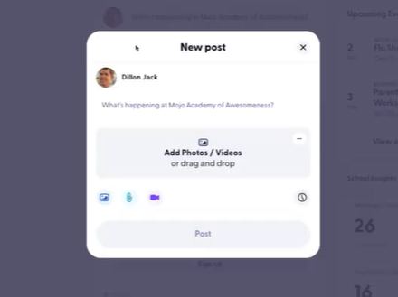
Microsoft OneNote for Education
Microsoft OneNote is designed to facilitate personalized documentation in education, allowing pupils to create multimedia portfolios. A pilot study in middle schools demonstrated that OneNote’s multimedia features enabling pupils to add text, images, and videos increased student creativity and engagement. The multimedia options allowed pupils to present their learning in unique, visually engaging ways that reflected their individual academic journeys. The paper also shares the findings of a study to explore the student perspective of Microsoft OneNote as a learning resource, against the context of the University’s Virtual Learning Environment. The research was undertaken by staff at the University’s Centre for Academic Practice on behalf of the School (Flint, 2019).
Microsoft OneNote for Education is closely related to digital portfolios because it offers a flexible, organized platform for pupils and educators to collect, document, and showcase learning experiences over time. It allows users to create sections, pages, and subsections where pupils can compile notes, assignments, projects, multimedia, and reflections. This makes it an effective tool for building a personalized digital portfolio that tracks progress, displays academic achievements, and facilitates ongoing self-reflection.

Brightspace Portfolio
Brightspace Portfolio offers a structured environment for continuous feedback, supporting timely teacher-student communication and improved learning outcomes. It empowers learners of all ages to independently capture evidence of learning. Learners can maintain their digital portfolio year after year, as they progress through their learning journey. The system also controls what items you want to include in your portfolio, how they are organized, and who you want to share them with. When you share items with your peers, mentors, or potential employers, you can give them permission to view items, edit items, see or add comments, and see or add assessments to receive feedback. This helps pupils develop metacognitive skills as they reflect on their learning journey, set goals, and track their development over time. Brightspace Portfolio also facilitates personalized learning experiences, enabling instructors to provide feedback and guidance while allowing pupils to share their portfolios with peers, parents, or potential employers. In this way, it not only supports assessment and learning documentation but also encourages pupils to take ownership of their learning and build a meaningful, evolving record of their academic and personal achievements (Yamani, 2019).

2.3 Summary of the Chapter
This chapter reviewed relevant literature and existing systems that provide valuable insights for the design and development of Naawan Central School’s Digital Portfolio System. Studies show that digital portfolios are effective tools for fostering student motivation and reflective learning, which align well with the goals of Naawan Central School. Additionally, existing systems such as Seesaw, Google Classroom, and Brightspace Portfolio demonstrate practical features that improve usability, real-time communication, and feedback mechanisms. These findings create a foundation for a comprehensive and user-friendly digital portfolio system that promotes collaboration, student growth, and active participation from all stakeholders.

CHAPTER 3
CONCEPTS, THEORIES AND TECHNICAL BACKGROUND

This chapter details the foundational concepts, theories, and technical tools critical to the development of Naawan Central School’s Digital Portfolio System. It provides an overview of the Software Development Life Cycle (SDLC) model used, as well as the design, development, and testing tools selected to create a comprehensive, user-friendly application. Each section discusses how these tools and theories contribute to the development process, aligning with the project’s educational and functional goals.

Agile Scrum Model
Figure 5. Agile Scrum Model Digital Portfolio System

Agile Scrum is a prominent methodology in software development, known for its emphasis on collaboration, iterative progress, and flexibility. Developed by Jeff Sutherland and Ken Schwaber in the early 1990s, Scrum was introduced as a framework to improve software development processes by focusing on continuous improvement, teamwork, and adaptive planning. Unlike the linear Waterfall model, Scrum divides work into “sprints,” or time-bound phases, allowing teams to address new requirements and make adjustments based on user feedback with each iteration. This cyclical process ensures that the project evolves in line with users’ needs, allowing developers to respond quickly to feedback and deliver high-quality increments of the system. The triple constraint of the software project like time, cost and scope is directly dependent on the requirement of the project. Agile methodology is the iterative way for developing the software project for frequent changes, fast delivery and reduced risk (Hayat et al., 2019).
The Agile Scrum methodology is well-suited for Naawan Central School’s Digital Portfolio System, as it supports iterative development and aligns with the need for consistent stakeholder feedback. In each phase, the project team can develop, test, and optimize a new set of features or enhancements, ensuring that the system remains responsive to the needs of pupils, and teachers. The collaborative nature of Scrum fosters open communication between the developers, school administration, and end-users, enabling the team to incorporate educational feedback directly into the system. Ultimately, Agile Scrum facilitates a structured yet adaptable approach that supports the project’s goal of delivering an accessible, feature-rich platform for academic engagement.

3.1 Design Tools of the System
Unified Modeling Language (UML)
Unified Modeling Language (UML) is an essential tool for visualizing, specifying, and documenting software systems. Created by Grady Booch, Ivar Jacobson, and James Rumbaugh in the 1990s, UML was developed as a standardized way to depict the architecture and behavior of complex systems. UML provides a comprehensive set of diagramming tools that illustrate different facets of the system, including its structure, interactions, and data flows. Use Case Diagrams, Sequence Diagrams, and Activity Diagrams help clarify system functionality and visualize user interactions, making it easier for stakeholders to understand and communicate requirements. The UML uses mostly graphical notations to express the design of software projects. Using the UML helps project teams communicate, explore potential designs, and validate the architectural design of the software.
In the Digital Portfolio System project, UML diagrams play a crucial role in bridging communication between developers and non-technical stakeholders. By using UML, the project team can create Use Case Diagrams to illustrate how pupils, and teachers will interact with the system, from uploading assignments to providing feedback. Additionally, Sequence Diagrams are useful for mapping out processes like data submission and retrieval, while Entity-Relationship Diagrams (ERDs), based on Peter Chen’s 1976 ER model, help organize data into a structured database schema. This approach supports effective database design, ensuring that information such as student records, assignments, and assessments are stored and retrieved efficiently. Together, UML and ERDs enable the development team to define clear system requirements, improve data organization, and create a robust database that supports educational functions.
Functional Decomposition Diagram
A functional decomposition diagram (FDD) is a visual depiction that deconstructs a complex system or process into its individual functions or sub-functions. It illustrates the organizational structure of functions and how they relate to one another. The links between functions are indicated by connecting arrows, and each function is represented by a box. FDD aids in comprehending a system's functional flow and dependencies providing a methodical approach to system analysis and design and the implementation. In addition it assists in resource allocation and serves as a foundation for system integration and testing provides identification of functional requirements. To analyze and create complicated systems, FDD is frequently used in software development and systems engineering projects.
The Functional Decomposition Diagram (FDD) was an essential tool in the development of the system. It allows the developers to break down the system's functionality into smaller, manageable components, providing a structured and organized approach to system design.

3.2 Development Tools of the System
PostgreSQL
PostgreSQL, often referred to as Postgres, is an advanced open-source relational database management system (RDBMS) known for its reliability, performance, and robust data handling. Developed by Michael Stonebraker and released in 1996, PostgreSQL has become a leading choice for handling complex data operations and maintaining data integrity. With support for advanced data types, indexing, and complex queries, PostgreSQL is highly suitable for managing the diverse data needs of educational platforms.
PostgreSQL’s performance and data integrity features make it ideal for Naawan Central School’s Digital Portfolio System, where data consistency and security are paramount. The system requires a database that can handle a wide range of data, including student records, assignments, and feedback. PostgreSQL’s advanced indexing and query capabilities enable fast data retrieval, ensuring that users can access information quickly and efficiently. Additionally, PostgreSQL’s support for ACID (Atomicity, Consistency, Isolation, Durability) compliance ensures that data operations are reliable, safeguarding student records and maintaining trust in the system’s data management.
Laravel
Laravel is a PHP-based web application framework designed to streamline back-end development. Created by Taylor Otwell in 2011, Laravel provides an elegant syntax that simplifies common web development tasks, such as authentication, routing, and database management. Laravel’s MVC (Model-View-Controller) architecture separates the application’s business logic from the user interface, making code more manageable and maintainable. Additionally, Laravel includes built-in support for data validation, security, and session management, which helps ensure that the Digital Portfolio System is secure and efficient.
For Naawan Central School’s Digital Portfolio System, Laravel’s robust functionality and ease of integration make it an ideal choice. Laravel’s Eloquent ORM (Object-Relational Mapping) allows seamless interaction with databases, making it easier to store, retrieve, and manage data related to student records, assignments, and assessments. Furthermore, Laravel’s scalability ensures that the system can adapt to increased data volume and user numbers as the school grows. Overall, Laravel’s features help create a stable, secure, and scalable back-end for the portfolio system, which supports reliable user interactions.
Python
Python is a versatile programming language known for its readability, simplicity, and wide range of applications, including web development, data science, and automation. Created by Guido van Rossum in 1991, Python has become one of the most popular programming languages due to its ease of use and robust community support. In the Digital Portfolio System, Python is used primarily for data processing tasks and integration with third-party services. With libraries such as Pandas, NumPy, and Matplotlib, Python allows developers to analyze data, create reports, and visualize trends that can support educational insights.
Python’s data processing capabilities are particularly relevant for the Digital Portfolio System’s reporting functions, enabling the project team to generate insights on student performance and academic trends. By integrating Python scripts, the system can produce customizable reports, which teachers can use to assess student progress and identify areas for improvement. Python’s versatility also makes it a valuable tool for future enhancements to the system, allowing for the addition of machine learning models and data analysis features that could support more personalized learning experiences.
Tailwind CSS
Tailwind CSS is a modern utility-first CSS framework created by Adam Wathan in 2017. Unlike traditional CSS frameworks that provide predefined components, Tailwind CSS offers low-level utility classes that allow developers to design highly customized user interfaces (Wathan, 2018). By focusing on customization and flexibility, Tailwind enables developers to create unique and visually appealing layouts without overriding default styles, as is common in component-based frameworks.
In the Digital Portfolio System, Tailwind CSS is used to create a clean, user-friendly interface that supports pupils, and teachers in navigating the platform. The utility-first approach allows developers to design responsive, mobile-friendly pages that adapt to various screen sizes, making the system accessible on both desktop and mobile devices. Tailwind’s flexibility also enables rapid prototyping, which is valuable during Agile Scrum’s iterative development process, as adjustments to the UI can be implemented quickly in response to user feedback.

3.3 Testing Tools of the System
Figure 6. Black Box Test of Digital Portfolio System
Black Box Testing
Black Box Testing is an approach that evaluates the system’s functionality without examining the internal code structure. This technique, introduced by William Elmendorf in 1967, focuses on testing the input-output behavior of the system, verifying that it responds correctly to user actions and data (Kelley, 2022). For the Digital Portfolio System, Black Box Testing allows developers to simulate real user interactions, ensuring that features like login, data upload, and feedback functions work correctly without requiring internal code inspection.
Functional Testing
Functional Testing assesses whether each feature of the system operates as intended, while Non-Functional Testing evaluates aspects such as performance, usability, and reliability. Functional Testing involves breaking down features into test cases that validate expected behavior, covering user roles like pupils, and teachers.
Unit testing
Unit Testing focuses on evaluating individual components or units of a system in isolation to ensure they function as intended. Testers use predefined test cases to verify that each unit produces the expected results. The primary deliverables include the test cases and their corresponding results, which help identify and resolve errors at the unit level. This process is carried out by software testers to ensure the reliability and correctness of each component before integrating it into the larger system.
Integration testing
Integration Testing ensures that different components or systems, especially in hybrid setups, work together seamlessly. It focuses on verifying the interaction between integrated parts to identify issues with data flow or functionality. Testers use predefined test cases and document the results to confirm that the integration meets the expected behavior. This phase, conducted by software testers, is crucial for detecting and resolving errors that arise when individual modules are combined.
System testing
System Testing focuses on validating the entire system to ensure that all components work together seamlessly as a whole. It involves executing task scenarios based on end-user actions to simulate real-world usage and verify the system's functionality. The primary deliverables include task scenarios and their corresponding results, which help identify issues across integrated components. This phase is conducted by software testers to confirm that the system meets its requirements and performs as expected before deployment.
User Acceptance Testing (UAT)
User Acceptance Testing (UAT) is a crucial final step in the testing process, allowing end-users to evaluate the system in a real-world setting to confirm that it meets their expectations and needs. This testing phase provides valuable insights into how users interact with the Digital Portfolio System, highlighting areas where improvements might enhance usability. Feedback from UAT sessions informs final adjustments, ensuring that the system aligns with the practical requirements of pupils, and teachers.
Non-functional testing
Non-Functional Testing focuses on evaluating aspects of the system that go beyond functionality, such as usability, performance, and user experience. System Usability Testing assesses how user-friendly and accessible the system is by involving at least 30 end-users. Participants test the system using task lists, the System Usability Scale (SUS), and an adjective rating scale to interpret results. This process ensures the system meets user expectations, providing a smooth and intuitive experience for end-users.
System Usability Scale (SUS)
The System Usability Scale (SUS), developed by John Brooke in 1986, is a reliable tool for assessing user satisfaction and system usability through a standardized ten-question survey. Each question captures different aspects of the user experience, such as ease of navigation, learnability, and efficiency. In the Digital Portfolio System, SUS provides quantifiable feedback on user experience, enabling developers to identify strengths and areas for improvement in the system’s design and functionality.
Adjective Rating Scale (ARS)
The Adjective Rating Scale (ARS) is used to assess users’ subjective perceptions of the system, such as its appeal, ease of use, and reliability. Originally developed to capture qualitative insights, ARS offers a structured approach to understanding user satisfaction, providing adjectives (e.g., “efficient,” “user-friendly”) for users to rate. This feedback allows the development team to refine the Digital Portfolio System’s interface and ensure it meets user expectations for a positive experience.
Summary of the Chapter
Chapter 3 has presented a comprehensive overview of the methodologies, tools, and techniques essential to developing the Digital Portfolio System. Figure 6 illustrates the conceptual framework, highlighting each stage of system development, from requirements gathering to usability testing. Each phase integrates agile principles to maintain flexibility and adaptability, ensuring the system’s functionality aligns closely with the needs of pupils, and teachers.
The chapter also explored the tools and technologies involved in the project, such as Laravel, PostgreSQL, Python, and Tailwind for efficient, scalable development. Rigorous testing protocols, including Black Box Testing, System Usability Scale (SUS), and Adjective Rating Scale (ARS), play a key role in refining the user experience and enhancing usability. This structured approach, as represented in the conceptual framework, ensures the Digital Portfolio System is reliable, user-friendly, and ready to support the academic environment at Naawan Central School.

CHAPTER 4
METHODOLOGY
In this study, the proponents discuss methodology, software design, software development, software testing, software usability, and summary of the project.

4.1 Design Methodology of the System
The proponents utilize various diagrams to ensure a comprehensive understanding and effective development of the DigiPort: Digital Portfolio System. The Use Case Diagram visually represents the interactions between users (actors) and the system, highlighting key functionalities and user requirements. This helps identify system features, ensuring clarity in planning, designing, and testing to meet user needs and deliver a seamless experience. The Activity Diagram illustrates the step-by-step flow of activities within the system, including decision points and user interactions, providing a clear visualization of processes to optimize workflows and ensure logical accuracy during implementation. The Functional Decomposition Diagram (FDD) breaks down the system’s overall functionality into smaller, manageable components, offering a hierarchical view of its features. This approach simplifies development, enhances clarity, and allows stakeholders to focus on specific functionalities to meet user requirements efficiently. The Data Flow Diagram (DFD) visually represents how data moves through the system, from its sources to processes, storage, and destinations. By showing inputs, outputs, and transformations, the DFD ensures efficient data handling, identifies potential bottlenecks, and optimizes system processes for smooth functionality. Additionally, the Entity Relationship Diagram (ERD) is used to model the system's data structure by defining the relationships between entities, attributes, and key data points. The ERD ensures that data is logically organized and connected, providing a strong foundation for database design, enabling efficient storage, retrieval, and management of information within the system. Together, these diagrams provide a clear, visual representation of the system’s structure, processes, and data flow, aiding developers, designers, and stakeholders in building a well-optimized and functional system.

4.2. Development Methodology of the System
The developers, in collaboration with stakeholders, proceeded to build the Digital Portfolio System for Naawan Central School using agile methodologies, completing each sprint with tasks from the sprint backlog derived from the product backlog. Every sprint iteration spanned two weeks, with regular meetings for planning and retrospectives. During these meetings, the team reviewed sprint goals, discussed any blockers, and strategize for the following sprint. Developers provided asynchronous daily updates to track progress and maintain momentum toward sprint objectives.
The development stack for the system included PostgreSQL for the database, with PHP and Laravel powering the backend and Tailwind CSS for front-end styling. Each sprint saw frontend and backend teams working closely to ensure smooth integration. The backend team focused on secure data handling and API functionality with Laravel, while the frontend team utilized Tailwind CSS for a responsive, user-friendly interface. Bi-monthly reviews with the SCRUM Master were conducted to gather feedback and confirm alignment with user needs, allowing for iterative improvements and timely adjustments to the system's functionality.
4.3. Functional Requirements
These are the expected project functionalities of the Digital Portfolio System, developed in alignment with Naawan Central School’s requirements for documentation, progress tracking, and communication.
4.3.1. Web-Based System

4.3.1.1 Teacher

Class Management
- Create Class: Set up new classes with grade level, section, and subject.
- View Class Lists: Browse and manage all active classes.
- View Class: Open detailed information about a specific class.
- View Archived Class List: Display all archived classes.
- Archive Class: Move active classes to archived status.
- Unarchive Class: Restore previously archived classes to active status.
- Remove Class: Permanently delete a class (only if no pupil submissions exist).

Pupil Management
- View Pupil List: See all pupils enrolled in a class.
- //Add Pupil: Enroll pupils from available grade/section pools.
- Search Pupil: Locate a specific pupil by name.

Learning Content Management
- View Classwork Lists: Display all classworks created in a class.
- View Activity Lists: Show all created activities.
- View Material Lists: Display all uploaded learning materials.
- View Material/Activity: Open details of a specific material or activity.
- Add Activity: Create new activity with title, description, due date, and type.
- Edit Activities/Materials: Modify existing activity or material details.
- Remove Activities/Materials: Delete activities or materials (only if no submissions exist).
- Publish Draft Activities: Make draft activities visible to pupils.

Assessment & Grading
- View Student Output List: List all submissions with status indicators (scored/unscored).
- View Student Submission: Open individual student submissions.
- Add Score: Assign grades, optional rubric, and remarks.
- Edit Grades: Modify previously assigned grades or comments.
- Track Progress: View assignment status summaries and pending tasks.

Portfolio Management
- View Student Portfolio: Open individual pupil portfolios.
- Start Compilation: Approve students to begin portfolio compilation.
- Review Portfolio Design: View student-selected layout templates and color themes.
- View Scored Activities: Filter and view submissions marked as scored.
- View Missing Activities: Identify unsubmitted outputs.
- Approve/Reject Portfolio/Outputs: Approve or reject student submissions in portfolio.
- Compile Missing (student only): Teachers do not compile, only monitor progress.
- Drop Portfolio Compilation: Close compilation session and reset status.

Remarks & Feedback
- View Student Remark List: Display all remarks associated with pupils.
- Add Remark: Add feedback for a pupil’s activity.
- Edit Remark: Modify existing remarks via three-dot menu.
- Delete Remark: Remove a remark after confirmation.
- Approve Remark: Approve pupil remarks.
- Save Remark for Output: Enter feedback directly tied to student outputs.

Class Interaction
- Add Announcements: Create class-wide updates.
- View Announcement List: Display all announcements.
- Edit Announcement: Update existing announcements.
- Add Comments on Announcements/Materials/Activities: Respond to pupil inputs.
- Remove Comments on Announcements: Delete irrelevant comments.

Notifications
- View Notifications: Access notifications from dashboard or bell icon.
- View Notification Details: Redirect to related content (submissions, portfolio updates).

Newsfeed / Student Submissions
- View Teacher Home Page: Review approved student posts in a newsfeed-style interface.
- Like/Comment: Engage with student submissions.
- View Student Sketch: Review sketches submitted by students (read-only).

Account & Settings
- View Manage Account: Open profile dropdown and access account settings.
- Settings: Customize notifications, privacy, and display preferences.

4.3.1.2 Student

Class Access
- View Enrolled Class List: Browse all classes the student is currently enrolled in.
- View Enrolled Class: Open a selected class to display its details.

Learning Content Management
- View Assigned Classwork: Display all classwork assigned by the teacher.
- View Assigned Activity List: Show all assigned activities.
- View Assigned Activity: Open detailed information for a specific activity.
- Submit Work: Upload files for assigned activities.
- View Uploaded Material List: Display learning materials uploaded by the teacher.
- View Uploaded Material: Open and view specific learning materials and documents.

Portfolio Management
- View Student Portfolio Compilation: Access the portfolio compilation section.
- Start Compilation: Begin portfolio compilation when allowed by the teacher.
- Design Portfolio: Select layout templates and color themes for portfolio design.
- Save and Continue: Save portfolio design progress.
- Submit Portfolio: Compile all completed work and submit the portfolio.
- View Portfolio: Review all compiled outputs in the portfolio.
- Activity Compilation: View all successfully compiled student outputs.
- Missing Outputs: See activities that were not submitted.
- Compile Missing Outputs: Complete and add previously unsubmitted activities to the portfolio.

Class Interaction
- View Teacher Announcements: Read teacher announcements and class updates.
- Add Comments on Announcements/Materials/Activities: Participate in discussions by adding comments.
- View Classmate List: See all pupils enrolled in the same class.
- Search Classmates: Locate specific classmates by name.

Sketch & Newsfeed
- View Sketch: Open saved sketches.
- Post to Newsfeed: Submit sketches or work for teacher approval.
- View Remarked: Access “My Remarks” (remarks received) and “Output Remarks” (feedback on submitted activities).

Account & Settings
- View Manage Account: Open profile dropdown and access account settings.
- Settings: Customize notifications, privacy, and display preferences.

4.3.1.3 Common Functions

Personal Management
- Log-in: Allows registered users to access the system using their valid credentials.
- Log-out: Enables users to securely exit their session from the system.
- View Profile: Displays the user’s personal information, including name, role, and account settings.

Notification Management
- View Notifications: Displays a list of all received notifications triggered by system activities (e.g., submissions, approvals, remarks).
- Mark as Read: Allows users to mark notifications as read to distinguish them from new ones.
- Clear Notifications: Enables users to remove all or selected notifications from the list.
- View Notification Details: Opens specific information about the event that triggered the notification, redirecting the user to the related content (e.g., submitted activity, portfolio update).
4.3.1.3. Web-Base Log Functions
- Log-in: Registered users must have a valid login id to perform their respective user functions.
- Log-out: Users can log-out from the site.

4.4. Web-Base Functional and Technical Requirements
4.4.1. Technical Requirements:
These are the expected project reliability of the web application of the technical issues considered by the team. It comprises four functions.
4.4.1.1. Performance Requirements:
The system should efficiently handle multiple concurrent users, ensuring smooth access for pupils, and teachers without delays. It must load pages and process requests within 3 seconds under normal conditions. The system should be able to manage large volumes of student data, including portfolios, files, and evaluations, without compromising speed or reliability.
4.4.1.2. Security Requirements:
The system must ensure data confidentiality, integrity, and availability. User authentication is required for pupils, and teachers, with role-based access control (RBAC) to limit actions based on user roles. Data encryption must be implemented for sensitive information during storage and transmission. The system should include regular backups to prevent data loss and comply with data privacy standards to protect student information.
4.4.1.3. Error handling:
- OFS shall handle expected and unexpected errors in ways that prevent loss in information and a long downtime period.
4.4.1.4. Log:
- The system should maintain detailed logs of user activities, such as logins, file uploads, modifications, and evaluations, to ensure accountability and traceability. These logs will include timestamps, user IDs, and actions performed.

4.5. Testing Methodology of the System
This phase required organizations to complete various tests to ensure the accuracy, the inclusion of expected functionality and interoperability of the developed system. Erroneous codes were rewritten and tested again until desired output was achieved. In this phase, the researchers hence the developer conducted system testing methods such as System Usability Scale (SUS) to ensure all the features of the developed system are functioning as expected as well as reliability of the system.
To evaluate usability and reliability, the team utilized the System Usability Scale (SUS). The SUS test involved real-world scenarios where participants completed typical tasks within the system, allowing researchers to observe ease of use, efficiency, and potential areas for improvement. Test results were analyzed to confirm that all functionalities, from assignment uploads to feedback management, worked as intended and that the system could handle concurrent user interactions without compromising performance.
4.4 Usability Evaluation
The test participants included administrators, teachers, and pupils, each representing the primary users of the Digital Portfolio System. Administrators and teachers evaluated features related to managing student portfolios, uploading assignments, and providing feedback. Pupils tested the portfolio submission and feedback review functionalities. All participants received brief training on app navigation and were expected to have basic familiarity with mobile devices to ensure relevant feedback and effective usability testing.
4.4.1 Test Participants
The goal was to administer the test to at least 30 individuals to ensure that the system is evaluated from multiple perspectives. All of the expected 30 test participants’ generation were planned to be noted during the testing process. The developers expected to gain insights into how different age groups interacted with the system and whether there were any specific areas that needed improvement based on the preferences of different generations that would improve DigiPort usability.
4.4.2 The Usability test setup
The Usability Test Setup involves evaluating how user-friendly and accessible a system is by having real users interact with it in a controlled environment. Participants, representing the system's target client, are asked to complete tasks that simulate real-world usage, such as submitting or reviewing a portfolio. Observers track user behavior, noting any difficulties or errors, while collecting usability metrics like task completion time and user satisfaction. Feedback is gathered through surveys or interviews to gain insights into user experience. This process helps identify areas for improvement, ensuring the system is intuitive, efficient, and aligned with user needs.
4.5 Summary of the Chapter
This chapter outlined the methodology for designing, developing, and testing the Digital Portfolio System for Naawan Central School. The study applied Agile methodologies to ensure continuous collaboration and iterative improvements based on user feedback. The development involved both front-end and back-end integration, utilizing PostgreSQL, PHP/Laravel, and Tailwind CSS. Functional, technical, and security requirements were detailed to ensure the system meets the needs of teachers, and pupils.
The testing phase, including System Usability Scale (SUS) evaluation, aimed to validate system functionality and usability. Through this structured methodology, the study provided a solid foundation for developing a responsive and efficient digital portfolio system, with potential for scalability and future enhancements.

CHAPTER 5
RESULTS AND DISCUSSION
This chapter discusses the flow of the developing system through the following diagrams, images and tools presented. It explains the behavioral aspect of the system that assists the proponents in visualizing the design components of the project.

5.1. Design Results of the System
5.1.1 System Architecture
This section presents the system architecture process of how the proposed system works.
Figure 7. System Architecture of Digital Portfolio System
The figure shows the system architecture of the Digital Portfolio System. This architecture is designed to enable efficient and secure communication among teachers, and pupils. Each user interacts with the system through their designated user interface: the Teacher User Interface, and the Student User Interface. All user interfaces are connected to the Internet, allowing users to access the system remotely. This setup ensures that users can interact with the system from any location, providing flexibility and convenience. The Internet serves as the medium through which each user interface communicates with the central server.
The server, acting as the core processing unit, manages incoming requests from all user interfaces. It connects directly to the PostgreSQL DBMS, which facilitates the retrieval, update, and storage of data in the central database. The PostgreSQL DBMS enables the system to handle various data operations, supporting activities such as viewing student progress and submitting assignments.
5.1.2. Hardware and Software Design Components
The following tables below show the Hardware and Software Components required for the development of the system. Proponents will be using a laptop that has the description on the following tables.

Table 1. Hardware Design Component used in the development of Digital Portfolio System.

Table 2. Software Design Component used in the development of Digital Portfolio System
5.1.3. Use Case Diagram
This section illustrates the interaction between the actors and external system that defines the basic flow of events in a use case.
Figure 8.Use Case Diagram of Digital Portfolio System

5.1.4. Activity Diagram
This section presents the workflow of the Digital Portfolio System that helps the proponents in depicting the sequencing events of the project.

5.1.4.1 Teacher

Figure 9. Activity Diagram of Login Use Case

Figure 9 shows the Activity Diagram for the Login use case illustrates the sequence of interactions between the teacher and the system from entering credentials up to accessing the appropriate dashboard. The diagram begins with the teacher accessing the login page and entering an email and password, after which the system validates the input format and then checks the credentials against stored records; if the input is invalid or the credentials do not match, the system returns an error message and the flow loops back to allow the teacher to re-enter the information. Once valid credentials are confirmed, the user selects a role (teacher or student), and the system evaluates this decision node to redirect the authenticated user to the corresponding dashboard, ensuring that each role is granted access only to its designated interface and functionalities.
Figure 10. Activity Diagram of View Classroom
Figure 10 illustrates the process of viewing a classroom. The process begins when the teacher selects a class. The system then displays the available grade levels and section options for the teacher to choose from. After selecting a specific grade and section, the system retrieves and presents the list of pupils enrolled in that class, allowing the teacher to view all students in the selected classroom.
Figure 10. Activity Diagram of Search Student List
Figure 10 illustrates the process of Search Student List shows the flow of searching for a student within the system. The process starts when the user enters a student’s name or email in the search field. The system then filters the student list based on the entered input. If a matching student exists, the system displays the filtered student list showing the relevant student. If no match exists, the student list remains empty.
Figure 10. Activity Diagram of View Activity Folder List
Figure 10. Activity Diagram of View Activity Folder List illustrates the flow of viewing activity folders in the system. The activity begins when the user clicks Student Activities. The system then retrieves the available activity folders. If activity folders exist, the system displays a folder list. If no activity folders are available, the system displays an empty folder list.

Figure 11. Activity Diagram of Add Activity Folder List
Figure 11 illustrates the process of Add Activity Folder List. The activity begins on the teacher dashboard when the “Create Class” option is selected. The system then presents a form for entering class details, including grade level, section, and subject. Once the teacher fills in the information and submits the form, the system validates all inputs for completeness and uniqueness. If the inputs are valid, the class is successfully created and stored in the system; otherwise, the system prompts the teacher to correct any errors before proceeding.
Figure 11. Activity Diagram of View Activity Folder
Figure 11. Activity Diagram of View Activity Folder illustrates the process of displaying the list of activity folders to the user. The activity begins when the user clicks the Student's Activities tab. The system then retrieves the list of created activity folders. If folders are available, the system displays them as cards showing the folder name and the number of activities within each folder. Each folder card includes a 3-dot menu icon that the user can click to reveal available folder actions. If no folders exist, the system simply displays an empty view with no folders shown. The activity ends after the folder list is displayed.
Figure 11. Activity Diagram of Add New Subject Folder
Figure 11. Activity Diagram of Add New Subject Folder illustrates the process of creating a new subject folder in the system. The activity begins when the user clicks the Create Class Activity button. The system then displays a form for creating a new folder. The user inputs the Folder Name and optionally provides a Description, then submits the form. The system validates the input; if it is valid, the new folder is saved and the updated folder list is displayed, now including the newly created folder. If the input is invalid, the system displays error messages prompting the user to correct the input. The activity ends after the folder is successfully added or errors are resolved.
Figure 11. Activity Diagram of Update Activity Folder
Figure 11. Activity Diagram of Update Activity Folder illustrates the process of updating an existing activity folder in the system. The activity begins when the user clicks the 3-dot menu icon on a specific folder and selects the Update option. The system then displays an Update Folder form where the user can edit the Folder Name and optionally the Description. After submitting the form, the system validates the input. If the input is valid, the system saves the changes and displays the updated folder information. If the input is invalid, the system shows error messages prompting the user to correct the input. The activity ends after the folder is successfully updated or errors are resolved.
Figure 11. Activity Diagram of Drop Activity Folder
Figure 11. Activity Diagram of Drop Activity Folder illustrates the process of deleting an existing activity folder from the system. The activity begins when the user clicks the 3-dot menu icon on a specific folder and selects the Drop option. The system then prompts the user to confirm the deletion. If the user confirms, the system deletes the selected folder and updates the folder list to remove it. If the user cancels, the deletion is aborted.
Figure 11. Activity Diagram of View Activity Details
Figure 11. Activity Diagram of View Activity Details illustrates the process of viewing the details of an activity within a created folder. The activity begins when the user clicks on a folder in the Student Activities section. The system retrieves the list of activities contained in that folder. If activities are available, the system displays them with basic information such as title and type. The user can then select a specific activity to view its full details, including type, title, instructions, due date, due time, and available actions. If no activities exist, the system displays an empty activity list. The activity ends after the activity details or empty list are displayed.

Figure 13. Activity Diagram of Add Activity
Figure 13 illustrates the process of adding an activity. The process begins when teachers select the “Add Activity” option from the class or folder interface. The system then displays a form where teachers enter activity details, including title, description, due date, and assignment type. Upon submission, the system validates that all required fields are filled and that the dates are valid. If validation succeeds, the activity is saved and associated with the selected class or folder; otherwise, the system prompts the teacher to correct any errors before proceeding.
Figure 14. Activity Diagram of Retract Activity
Figure 14 illustrates the process of retracting an activity. The process begins when a teacher selects the “Retract Activity” option. The system first checks whether the activity’s deadline is at least 3 hours away. If it is, the system prompts the teacher for confirmation. Upon confirmation, the system changes the activity status from published to unpublished, removing it from students’ dashboards while preserving any existing student submissions. This allows teachers to edit activity details without losing data. If the activity is within 3 hours of the deadline, the system prevents retraction and notifies the teacher that the action is not allowed.
Figure 15. Activity Diagram of Edit Activity
Figure 15 illustrates the process of editing an activity. The process begins when teachers navigate to the class activity list and select the activity they wish to modify, often after retracting it. By clicking the “Edit” option, the system loads a pre-filled form containing the current activity details, including title, description, due date, and instructions. Teachers can then update any of these details and submit the changes. The system validates the inputs, saves the updated activity, and reflects the changes in the class or folder where the activity resides.
Figure 16. Activity Diagram of Publish Activity
Figure 16 illustrates the process of publishing an activity. The process begins after teachers finalize the creation or editing of an activity. By selecting the “Publish” option, the system updates the activity status from draft or unpublished to published. The activity is then pushed to student dashboards, displaying instructions, due dates, and submission links. This ensures that all students in the class or folder can access and complete the activity as scheduled.
Figure 17. Activity Diagram of View Submitted Output List
Figure 17 illustrates the process of viewing the student output list. The process begins when teachers select a specific activity. The system then retrieves and displays a complete list of student submissions, categorized by status such as unscored and scored. Visual indicators are used to differentiate submission statuses, allowing teachers to quickly assess which submissions require grading and which have already been evaluated.
Figure 18. Activity Diagram of View Unscored Submission
Figure 18. Activity Diagram of View Unscored Submission illustrates the process of viewing an unscored student submission. The activity begins when the teacher selects a specific unscored entry from the student submission list. The system then loads the selected submission, displaying its full content along with relevant metadata such as submission time, student details, and current status. This allows the teacher to review the submission before scoring it. The activity ends after the unscored submission is fully displayed for review.
Figure 19. Activity Diagram of Add Score
Figure 19 illustrates the process of adding a score to a student submission. The process begins when teachers select an unscored submission from the student output list. The system then opens the scoring interface, which includes numeric input fields for the grade, optional grading rubrics, and remark sections for providing contextual feedback. After entering the score and any comments, the teacher submits the evaluation, and the system updates the submission status and records the score.
Figure 19. Activity Diagram of Scored Submission
Figure 19. Activity Diagram of Save Remark

Figure 20. Activity Diagram of View Track Progress
Figure 20 illustrates the process of tracking student progress. The process begins when teachers access the activity list, which displays all assignments along with status summaries such as pending, submitted, and scored. Quick statistics highlight unscored submissions, enabling teachers to quickly identify outputs that require grading and monitor overall student progress efficiently.
Figure 21. Activity Diagram of View Progress Tracking
Figure 21 illustrates the activity diagram of the View Progress Tracking process. The process begins when the teacher logs into the system and selects a specific class. Upon accessing the Track Progress feature, the system displays the list of students and their progress information. A search option is available to help locate a specific student. After selecting a student, the teacher may view the student’s outputs and detailed progress records. This process is intended solely for viewing and monitoring student performance and does not involve any modification of data.
Figure 21. Activity Diagram of Search Filter
Figure 21 illustrates the activity diagram of the Search Filter process. The process begins when the teacher accesses the student progress list and enters a keyword in the search field. The system then filters the student records and displays the matching results, allowing the teacher to easily locate a specific student from the list.

Figure 21. Activity Diagram of Search Student Name or ID
Figure 21 illustrates the process of searching for a student. The process begins when teachers enter either a student ID or name into the dedicated search field on the class dashboard. The system performs real-time matching against the pupil database using the exact input criteria. Matching results are then displayed, allowing the teacher to quickly locate the desired student’s information or profile.
Figure 21. Activity Diagram of Search Folder or Activity
Figure 21 illustrates the activity diagram of the Search Folder or Activity process. The process begins when the teacher accesses the list of folders or activities within the system. The teacher may enter a keyword in the search field to locate a specific folder or activity. The system then filters the records based on the input and displays the matching results, allowing the teacher to quickly identify and select the desired folder or activity for viewing.
Figure 22. Activity Diagram of View Details
Figure 22 illustrates the process of viewing detailed student information. The process begins when teachers access a specific student’s record. The system displays clear indicators showing whether each activity has been submitted, is pending, or is overdue. Additionally, any teacher-added remarks, such as feedback, notes, or instructions, are shown alongside each activity, allowing teachers to monitor progress and provide targeted guidance effectively.
Figure 22. Activity Diagram of View Remark History
Figure 22 illustrates the activity diagram of the View Remark History process. The process begins when the teacher accesses the detailed progress page of a student and selects the option to view remark history. The system then retrieves and displays a list of recent remarks related to the student’s performance.

Figure 23. Activity Diagram of View Output
Figure 23 illustrates the process of viewing student outputs. The process begins when teachers access the student submissions, which are displayed in a visual gallery format with thumbnails of all submitted images. Submissions are organized either by activity or chronologically to facilitate easy browsing and identification. Selecting or tapping any thumbnail expands the image to full view, displaying detailed submission information for review.
Figure 24. Activity Diagram of View Teacher Home Page
Figure 24 illustrates the process of viewing the Teacher Home Page as a newsfeed of activities. The feed displays only activities that have already been approved and published to the class.
Figure 25. Activity Diagram of Like
Figure 25 illustrates the process of liking a post. The process begins when users view approved posts in the Teacher Home Page newsfeed and tap the like button on a student’s post. The system records the like action in the database, increments the total like count for the post, and updates the newsfeed display in real-time for all class members. Users can also undo the action by tapping the like button again, which removes their like and updates the count accordingly.

Figure 26. Activity Diagram of Comment
Figure 26 illustrates the process of commenting on a post. The process begins when users view approved posts in the newsfeed-style Teacher Home Page and tap the comment button on a student submission. This opens a text input field for feedback or discussion. The system validates the comment for length and content, saves it to the database linked to the specific post, and displays it threaded below the post along with the author, timestamp, and reply options, enabling interactive classroom discussions.

Figure 27. Activity Diagram of Remark’s Management Page
Figure 27 illustrates the process of viewing the student remark list. The interface displays a list of students along with their associated remarks. A search bar allows filtering by student name or ID, enabling teachers to quickly locate specific pupils. From this interface, teachers can review the feedback history for each student or add new remarks, facilitating efficient management of student feedback.

Figure 28. Activity Diagram of Search Student List
Figure 28 illustrates the process of searching the student list within the remark section. The process begins when teachers access the remark interface and enter a student ID or name in the search field. The system performs real-time filtering through the student database, quickly locating and displaying the matching student(s) along with their associated remarks. This allows teachers to efficiently find and manage student feedback.

Figure 29. Activity Diagram of Add Remark
Figure 29 illustrates the process of adding a remark for a student. The process begins when teachers select a student from the remark list or search results. They then tap the “Add Remark” option, which opens an input field for entering feedback text. Optional fields allow teachers to reference a specific activity and assign a rating. After submitting, the system saves the remark to the database and links it to the selected student, making it viewable in their remark history.
Figure 30. Activity Diagram of Edit Remark
Figure 30 illustrates the process of editing a remark. The process begins when teachers access the student remark list and locate the remark entry associated with a submission. By clicking the three-dot menu next to the remark, teachers select the “Edit” option, which opens a pre-filled input field containing the existing text. Teachers can then modify the remark, and upon submission, the system validates and saves the updated feedback, ensuring the student’s remark history is accurately maintained.

Figure 31. Activity Diagram of Delete Remark
Figure 31 illustrates the process of deleting a remark. The process begins when teachers access the student remark list and locate the remark they want to remove. By clicking the three-dot menu next to the remark, they select the “Delete” option. The system then displays a confirmation dialog to prevent accidental deletion. If the teacher confirms, the system removes the remark from the database and updates the student’s feedback record accordingly.
Figure 32. Activity Diagram of View Notice
Figure 32 illustrates the process of viewing notices. The process begins when users open the notices section from the dashboard. The system then displays pending posts, showing thumbnails, submission timestamps, and relevant activity context. This allows users to quickly review notices and understand their associated activities or updates.
Figure 33. Activity Diagram of Review Student Output
Figure 33 illustrates the process of viewing full student work. The process begins when teachers select pending posts from the notices section or relevant lists. The system then loads the full work interface, displaying complete content such as images, documents, and multimedia. This allows teachers to thoroughly evaluate the submission before making a decision, such as approval or reject.
Figure 34. Activity Diagram of Reject
Figure 34 illustrates the process of rejecting a student submission. The process begins when teachers review the full work from notices or relevant lists and determine that it requires revision. By selecting the “Reject” option, the system opens a feedback field where teachers provide reasons for rejection and suggestions for improvement. Once submitted, the system records the rejection along with the feedback and updates the student’s submission status accordingly.
Figure 35. Activity Diagram of Approve Remark
Figure 35 illustrates the process of approving a student remark. The process begins when teachers review student remarks from the list or notice section and identify one that requires approval. After verifying the content for appropriateness and relevance, the teacher selects the “Approve” action. The system then records the approval, updates the remark’s status, and makes it visible in the relevant interface for other users.
Figure 36. Activity Diagram of View Archived
Figure 36 illustrates the process of viewing archived content. The process begins when users navigate to the archived section from the dashboard or newsfeed. The system retrieves and displays completed activities, approved posts, and historical submissions that are no longer active in the main feed. This allows users to access past content efficiently for reference or review.
Figure 37. Activity Diagram of Save Remark for Output
Figure 37 illustrates the process of saving a remark for a student’s output. The process begins when teachers review student submissions and enter feedback text directly into the remark field associated with a specific output. Optional fields allow teachers to provide ratings or detailed notes. Once submitted, the system saves the remark to the database, linking it to the corresponding output for future reference and evaluation.
Figure 38. Activity Diagram of View Portfolio
Figure 38 illustrates the process of viewing a student portfolio compilation. The process begins when the user taps the “View Portfolio Compilation” option from the student dashboard in DigiPort. The system then displays the portfolio interface, prominently showing the “Start Compilation” button, allowing the student to initiate the process of compiling and organizing their portfolio content.
Figure 39. Activity Diagram of Start Portfolio Compilation
Figure 39 illustrates the process of starting a student portfolio compilation. The process begins when the user selects the “Start Portfolio Compilation” option. The system triggers a confirmation dialog asking, “Confirm Start Compilation and Notify Student?” If the user clicks “Confirm,” the system notifies the student and updates the compilation status. If the user clicks “Cancel,” the system returns to the portfolio view..

Figure 40. Activity Diagram of View Portfolio Compilation
Figure 40 illustrates the process of viewing a student portfolio. The process begins when the user taps the “View Portfolio Compilation” option. The system first displays the “Portfolio Status.” If a student portfolio compilation exists, the system displays the student’s compilation details. If no compilation exists, the system shows the message no student has started yet indicating that the portfolio has not yet been initiated.

Figure 41. Activity Diagram of View Scored Activities
Figure 40 illustrates the process of viewing scored activities. The process begins when the user navigates to the student portfolio or class activity list and selects the “View Scored Activities” filter. The system queries the database for submissions marked as “Scored” and displays them, allowing the user to review completed and graded activities efficiently.
Figure 42. Activity Diagram of View Missing Activities
Figure 42 illustrates the process of viewing missing activities. The process begins when the teacher opens the student portfolio and selects a specific student. The teacher then applies a filter or selects the “Missing Activities” tab, which isolates and displays outputs that have not been submitted. This allows the teacher to quickly identify incomplete work and follow up with the student as needed.

Figure 43. Activity Diagram of Drop Portfolio Compilation
Figure 43 illustrates the process of dropping a portfolio compilation. The process begins when the teacher selects the “Drop Portfolio Compilation” option. The system presents a confirmation dialog: selecting “Confirm” closes the current compilation session for the class, resets the portfolio status to “Unstarted,” and returns to the “Start Portfolio Compilation” screen. Selecting “Cancel” aborts the action and returns the teacher to the current portfolio status view.
Figure 44. Activity Diagram of View Notification
Figure 43 illustrates the process of viewing notifications. The process begins when the teacher taps the bell icon (notification button) on the dashboard. The system displays a dropdown list of recent notifications. When the teacher clicks on an individual notification, the system redirects them to the related content, such as new submissions, portfolio updates, or other relevant classroom activities.
Delete Notification

5.1.4.2. Student

Figure 45. Activity Diagram of Login
Figure 45 shows the process of logging into the system, beginning with the user entering their email and password. The system validates the input and checks the provided credentials for accuracy. If the information is incorrect or incomplete, an error message is displayed, prompting the user to try again. Once the credentials are confirmed to be valid, the user selects their role to proceed. The process concludes with the system redirecting the user to the appropriate dashboard based on the selected role.

Figure 54. Activity Diagram of Student Classroom
Figure 54 illustrates the process of accessing a student classroom. The process begins when the user selects “My Classes” from the dashboard and chooses a specific class (e.g., Grade 1-A). The system then displays the “My Classroom” interface, which includes tabs for viewing the list of students, class activities, and portfolio compilation, allowing the user to manage and monitor classroom content efficiently.
Figure 55. Activity Diagram of Folder Activity
Figure 54 illustrates the process of accessing folder activities. The process begins when the user selects “My Classes” from the dashboard and chooses a specific class (e.g., Grade 1-A). The system loads the class classroom interface. The student then taps the “Student’s Activities” folder or tab, and the system displays categorized activity folders organized by subject, allowing easy navigation and access to specific class activities.
Figure 56. Activity Diagram of View Manage Pending Activity
Figure 54 illustrates the process of viewing and managing pending activities. The process begins when the user navigates from the dashboard to “My Classes” and selects a specific class (e.g., Grade 1-A). The system loads the classroom interface. The user then taps the “Activities” section, where the system displays an organized folder structure containing activities categorized by subject. By opening a specific folder via “View Folder,” the system filters and reveals all pending activities, displaying relevant details for each activity to allow efficient management and review.
Figure 57. Activity Diagram of Add or Create
Figure 54 illustrates the process of adding or creating work for a pending activity. The process begins when the user clicks the “Add or Create” button from the pending activity view. The system then opens an “Add or Create Work” dialog, providing options such as “From Device” to upload files or “My Sketch” to select a saved sketch, allowing the user to submit work through multiple input methods.
Figure 58. Activity Diagram of From Device
Figure 54 illustrates the process of adding work from a device. The process begins when the user clicks “Add or Create” and selects the “From Device” tab (default). The system opens a file browser with the “Browse Files” button enabled. The user selects a file from the device, and the system uploads it, displaying a preview in the “Your Work” section. This allows users to review their selected files before final submission.
Figure 59. Activity Diagram of My Sketch
Figure 54 illustrates the process of adding work from “My Sketch.” The process begins when the user clicks “Add or Create” in the pending activity interface, opening the “Add or Create Work” dialog. The user then selects the “My Sketch” tab. A decision point checks whether the user chooses a specific sketch: if yes, the system prompts “Use This Sketch?” Upon confirmation, the system uploads the sketch and displays it in the work area. If the user cancels, the system returns to the Activity Details view, allowing the user to make alternative selections.
Figure 60. Activity Diagram of Save as Draft
Figure 54 illustrates the process of automatically saving work as a draft. The process begins when the user opens the “Add or Create Work” dialog and starts working on a sketch or document. The system continuously or periodically auto-saves the current work to the “Your Work” section without requiring the user to click a save button. This ensures that progress is preserved in real time, allowing the user to return later to continue or finalize their submission.
Figure 61. Activity Diagram of Turn in
Figure 54 illustrates the process of turning in work for a pending activity. The process begins when the user accesses a pending item under “Your Work” and selects the “Turn In” option. The system prompts for confirmation of the submission. Upon confirmation, the system validates the completeness of the work, updates its status to “Submitted,” and notifies the teacher of the new submission.
RESUBMIT

Figure 46. Activity Diagram of View Sketch
Figure 45 illustrates the process of viewing and interacting with the sketch interface. The process begins when the user navigates from the main dashboard or portfolio section to the Sketch page. The system displays a canvas showing either the current sketch or a blank area for drawing. Students can use touch or mouse input to draw, with tools such as brushes, erasers, and undo functions available in the toolbar for editing and refining their work.
Figure 47. Activity Diagram of Save Sketch
Figure 45 illustrates the process of saving a sketch. The process begins when the user completes their drawing on the sketch canvas using the available tools. The user then taps the “Save” button. The system displays a confirmation message, “Sketch Saved Successfully,” and redirects the user to the “My Sketches” page, where the saved sketch can be accessed or further managed.
Figure 48. Activity Diagram of Post to Newsfeed
Figure 45 illustrates the process of posting a sketch to the newsfeed. The process begins when the user taps the “Post to Newsfeed” button on the sketch page. The system opens a dialog displaying saved sketches. The student selects a sketch, optionally adds a caption, and confirms the post. The system then sends the content for teacher approval and displays a confirmation message, “Submitted for Approval,” indicating that the sketch is pending review before appearing on the class newsfeed.
Figure 49. Activity Diagram of View Remarked
Figure 45 illustrates the process of viewing remarked content. The process begins when the user navigates from the dashboard or portfolio section to the “Remarked” section. The system then loads a list of remarks, clearly separating them into “My Remarks” (remarks made by the user) and “Output Remarks” (remarks received on submitted outputs), allowing easy review and tracking of feedback
Figure 50. Activity Diagram of My Remark
Figure 45 illustrates the process of viewing “My Remark.” The process begins when the student navigates to the “Remarked” section and selects the “My Remark” option. The system then displays a list of remarks made by the student. Upon selecting a specific remark from the list, the system shows the full details of that remark, allowing the student to review their submitted feedback.
Figure 51. Activity Diagram of Output Remarks
Figure 45 illustrates the process of viewing “Output Remarks.” The process begins when the user navigates to the “Remarked” section and selects the “Output Remarks” tab. The system then queries the database for all teacher comments linked to the student’s submitted activities and outputs, displaying them in a list format for review. This allows students to track feedback on their submitted work efficiently.
Figure 52. Activity Diagram of View Archived
Figure 45 illustrates the process of viewing archived remarked content. The process begins when the user selects the “View Archived” option from the homepage. The system displays a list of archived classes or portfolios. When the user chooses a specific archived item, the system shows its details—such as past activities, outputs, and remarks—in read-only form, preserving historical records for reference.
Figure 53. Activity Diagram of View Notification
Figure 54 illustrates the process of viewing notifications. The process begins when the teacher taps the bell icon (notification button) on the dashboard. The system displays a dropdown list of notifications. When the teacher clicks on an individual notification, the system redirects them to the related content, such as new submissions, portfolio updates, or other relevant classroom activities.

Figure 61. Activity Diagram of Turn in
Figure 54 illustrates the process of turning in work for a pending activity. The process begins when the user accesses a pending item under “Your Work” and selects the “Turn In” option. The system prompts for confirmation of the submission. Upon confirmation, the system validates the completeness of the work, updates its status to “Submitted,” and notifies the teacher of the new submission.
Figure 62. Activity Diagram of Submitted Collection
Figure 54 illustrates the process of viewing submitted work. The process begins when users access their personal “Submitted” or “Completed Work” section. The system displays all turn-ins along with metadata such as the exact submission timestamp, teacher-assigned score, activity title, and folder name. This allows users to track their submissions, review grades, and reference specific activities efficiently.

Figure 63. Activity Diagram of Portfolio Compilation
Figure 54 illustrates the process of viewing portfolio compilation status while waiting for teacher action. The process begins when the user navigates to the Portfolio Compilation section. The system loads the interface and displays a status message, “Waiting for Teacher,” indicating that the compilation process cannot proceed until the teacher initiates or approves the next step. This informs the user of the current state and prevents premature actions.
Figure 64. Activity Diagram of Start Creating My Compilation
Figure 54 illustrates the process of starting a portfolio compilation. The process begins when the user navigates to the Portfolio Compilation section. Since the teacher has already permitted the student to begin, the system immediately loads the interface and displays the “Start Compilation” option. This indicates that the student can now proceed with initiating and organizing their portfolio content.
Figure 65. Activity Diagram of Design Portfolio
Figure 54 illustrates the process of designing a student portfolio. The process begins when the student clicks the “Start Compilation” button. A dialog appears prompting the student to begin designing the portfolio. Once the student confirms, the system opens the design interface, allowing the student to choose layout templates, color themes, and other design elements to customize their portfolio.
Figure 66. Activity Diagram of Save and Continue
Figure 54 illustrates the process of saving and continuing after portfolio design. The process begins when the student completes the portfolio design and selects the “Save and Continue” option. The system stores the finalized design and then displays the completed portfolio envelope, allowing the student to review the finished design before proceeding to the next step in the compilation process.
Figure 67. Activity Diagram of Submit Portfolio
Figure 54 illustrates the process of submitting a portfolio. The process begins when the user reviews all completed outputs and compiles them into the portfolio. The user then selects the submit option. The system records the submission, updates the portfolio status to indicate it has been officially submitted, and ensures that the compiled work is now finalized for teacher evaluation.
Figure 68. Activity Diagram of Edit Design
Figure 54 illustrates the process of editing a portfolio design. The process begins when the system displays a dialog prompting the student to begin designing the portfolio. Once the student confirms, the design interface opens, allowing them to modify layout templates, color themes, and other design elements. This enables students to refine or update the portfolio appearance before saving or submitting.

Figure 69. Activity Diagram of View Portfolio
Figure 69 illustrates the process of viewing a compiled portfolio. The process begins when the student accesses the portfolio section. The system displays all compiled outputs included in the portfolio, allowing the student to review the complete set of submitted works and verify that everything has been included correctly.
Figure 70. Activity Diagram of Activity Compilation
Figure 54 illustrates the process of viewing compiled activities within the portfolio. The process begins when the user navigates to the “View Portfolio” section and selects the “Activity Compilation” tab. The system then displays all outputs that have been successfully compiled by the student, allowing the user to review the complete list of compiled activities.
Figure 71. Activity Diagram of Missing Activity Compilation
Figure 54 illustrates the process of viewing missing outputs within a portfolio. The process begins when the user navigates to the “View Portfolio” section and selects the “Missing” tab. The system then displays all activities that the student failed to submit, highlighting incomplete or missing requirements, which allows both students and teachers to quickly identify and address outstanding work.
Figure 72. Activity Diagram of Compile Missing
Figure 54 illustrates the process of compiling previously missing outputs into a portfolio. The process begins when the student accesses the “Missing” tab within the portfolio. The system then allows the student to complete and add the previously unsubmitted activities, updating the portfolio to include these newly compiled outputs and ensuring the portfolio reflects all required work.

Figure 72. Activity Diagram of View Manage Account
Figure 54 illustrates the process of viewing and managing account settings. The process begins when the user opens the profile dropdown. After selecting it, the system displays the Profile and Settings interface, allowing the user to access personal information, preferences, and account management options.
Figure 72. Activity Diagram of Settings
Figure 54 illustrates the process of accessing and customizing system settings. The process begins when the user opens the profile dropdown menu and selects the “Settings” option. The system then displays the view settings interface, offering various customization options such as notification preferences, privacy settings, and sorting preferences, allowing the user to personalize their experience.
Figure 72. Activity Diagram of Notification Preference
Figure 54 shows the process of Notification Preference when this activity diagram illustrates the user flow for managing notification preferences within the system. The process begins when the user accesses the Notification Preferences panel, where five configurable options are displayed: Email Notifications, Push Notifications, Submission Alerts, Remark Alerts, and Activity Reminders. The user can toggle each preference on or off using the switch located on the right side of every item.
Figure 72. Activity Diagram of Preferences
Figure 54 shows the process of Preferences when this section allows users to customize their system experience by selecting their preferred language, choosing the appropriate timezone for accurate scheduling, and setting their desired date format for displaying dates throughout the platform. Each option is presented with a dropdown menu, enabling users to easily adjust and save their personalized settings.

Figure 72. Activity Diagram of Save All Settings
Figure 54 shows the process of Save All Settings illustrates the activity flow involved when a user saves all settings within the Preferences page. The process begins when the user opens the Preferences interface and reviews configurable options such as language, timezone, date format, and notification preferences. After making the desired changes, the user initiates the “Save All Settings” action. The system then validates the inputs, checks for any missing or incorrect values, and proceeds to update the user’s profile settings. Once the changes are successfully stored, the system confirms the update and displays a success message, completing the process.

Figure 72. Activity Diagram of Profile
Figure 54 shows the process of Profile that presents the activity flow for managing a user’s profile information. The process begins when the user accesses the Profile page, where the system retrieves and displays the current personal details such as name, email, contact information, and profile picture.

Figure 72. Activity Diagram of Personal Information
Figure 54 shows the process of Personal Information illustrates the activity flow for managing a user’s personal information within the system. The process begins when the user navigates to the Personal Information section, prompting the system to retrieve and display existing details such as name, birthdate, gender, address, and contact information. The user reviews these fields and updates any necessary information. After making changes, the user selects the “Save” action. The system then validates the inputs, checks for errors or incomplete fields, and, if valid, updates the information in the database. Once successfully saved, the system confirms the update and presents a success message, concluding the process.
Figure 72. Activity Diagram of Change Password
Figure 54 shows the process of Change Password shows the activity flow for updating a user’s account password. The process begins when the user navigates to the Change Password section, and the system displays the required fields: current password, new password, and confirm password. The user enters the necessary information and submits the request. The system first validates the current password, then checks whether the new password meets security requirements and matches the confirmation field. If any validation fails, the system displays an error message and prompts the user to correct the information. If all inputs are valid, the system updates the password in the database and confirms the successful change by displaying a success message, completing the process.

5.1.5. Functional Decomposition Diagram
This section represents the functional decomposition diagram of the system from start to finish in a chronological method.

Figure 26. Functional Decomposition Diagram of Digital Portfolio System

5.1.6. Context Diagram
This section demonstrates the detailed function of the proposed system that outlines how the external entities interact with each other. Digital Portfolio System interacts with external entities, highlighting each user’s role and data flow within the system. Teachers, and pupils, are the primary external entities, each engaging with the system to fulfill distinct functions. Teachers can input grades, feedback, and manage student portfolios, while pupils submit assignments and view feedback.
Figure 27. Context Diagram of Digital Portfolio System

5.1.7. Data Flow Diagram
This section illustrates the visual representation of the system’s data flow that encompasses a more detailed view about the inputs and outputs of each process entity. Teachers, and pupils, serve as primary data sources, with teachers inputting grades and feedback, pupils submitting assignments. Data flows through the system to the PostgreSQL database, where it is stored and accessed as needed. The DFD captures how each user action generates specific outputs, like updated portfolios or feedback summaries, ensuring data integrity and efficient information retrieval within the system.
Figure 28. Data Flow Diagram of Digital Portfolio System

5.1.8. Database Design using Entity Relationship Model
This section Database Design using the Entity Relationship Model (ERM) outlines the structure of the Digital Portfolio System’s database, defining key entities and their relationships. Primary entities include Pupils, Teachers, Assignments, Feedback, and Portfolios. Each entity is linked based on their interactions: for instance, Pupils are associated with Assignments and Feedback, while Teachers provide Feedback and track Student progress. Relationships in the ERM illustrate these connections, using primary and foreign keys to ensure data consistency and efficient retrieval. This structured design supports secure, scalable data management across the system.

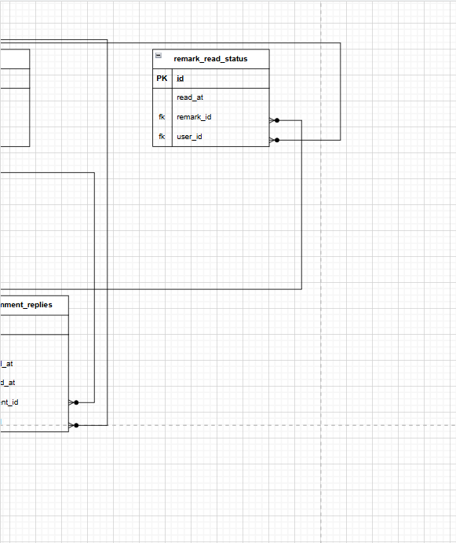

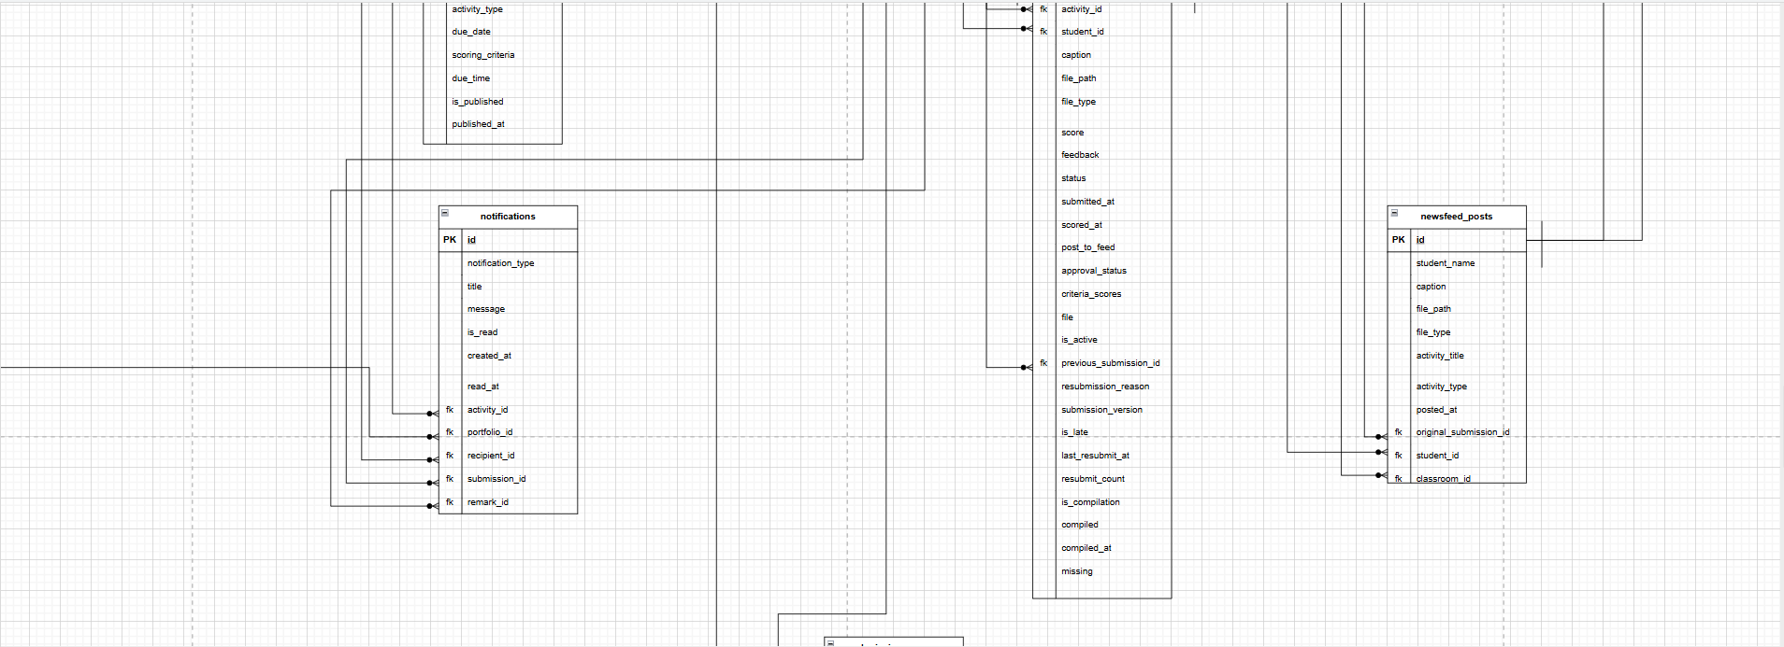



5.1.9. Data Dictionary of the Designed Database
This section shows the characteristics of the tables and attributes in the database that provides data elements of the proposed system.

Table 3. Data Dictionary of the Designed Database of Digital Portfolio System
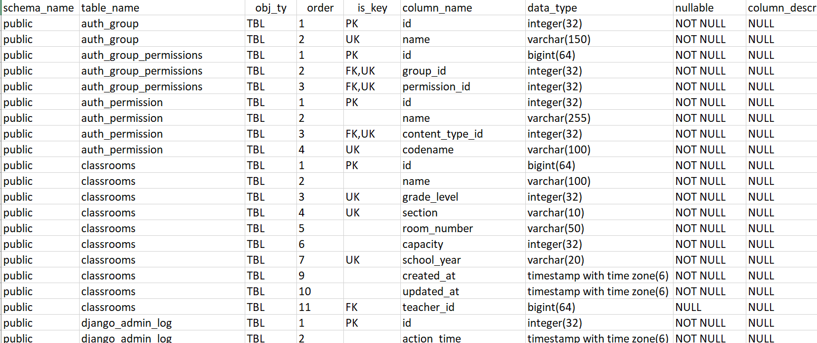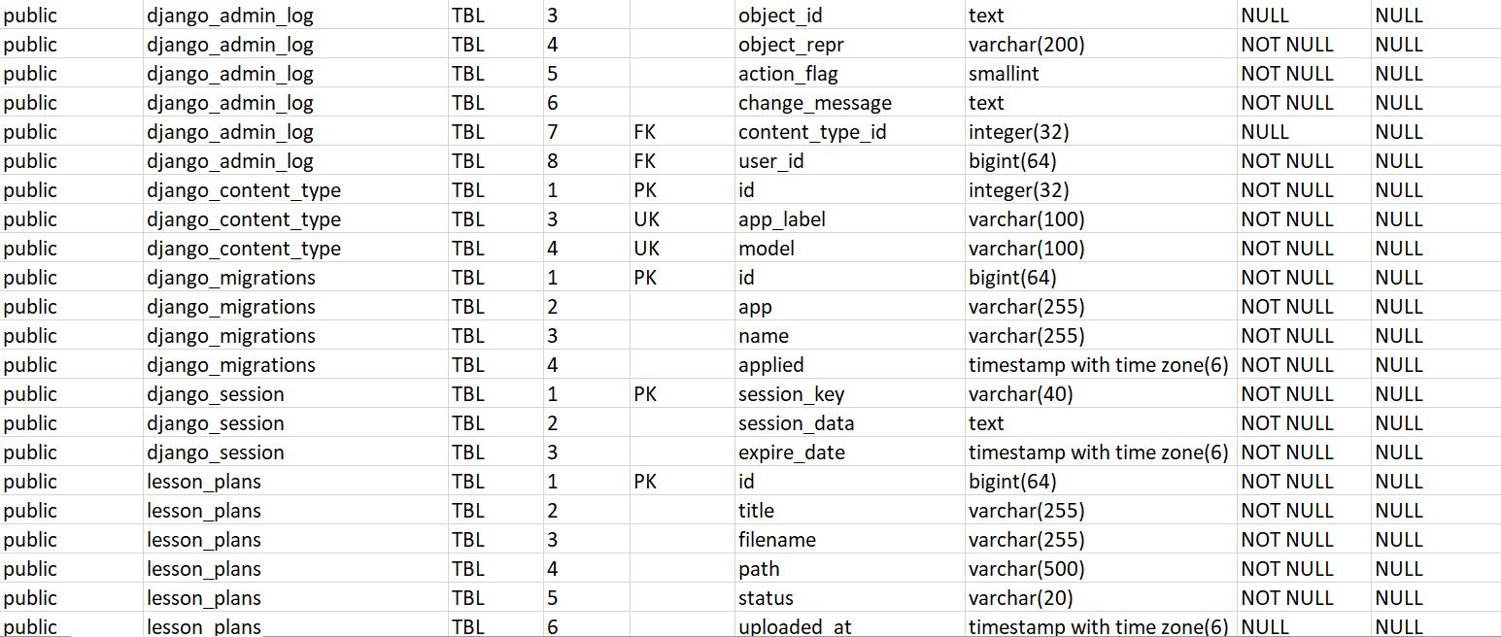
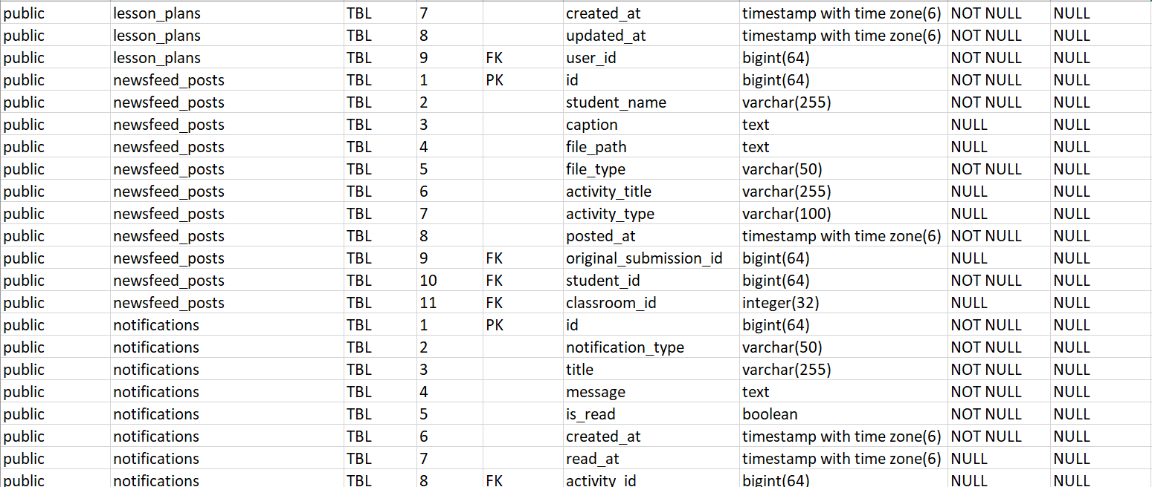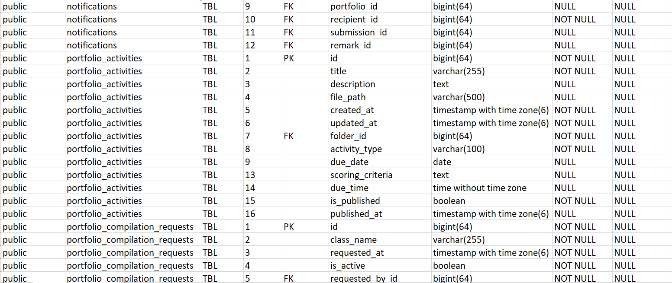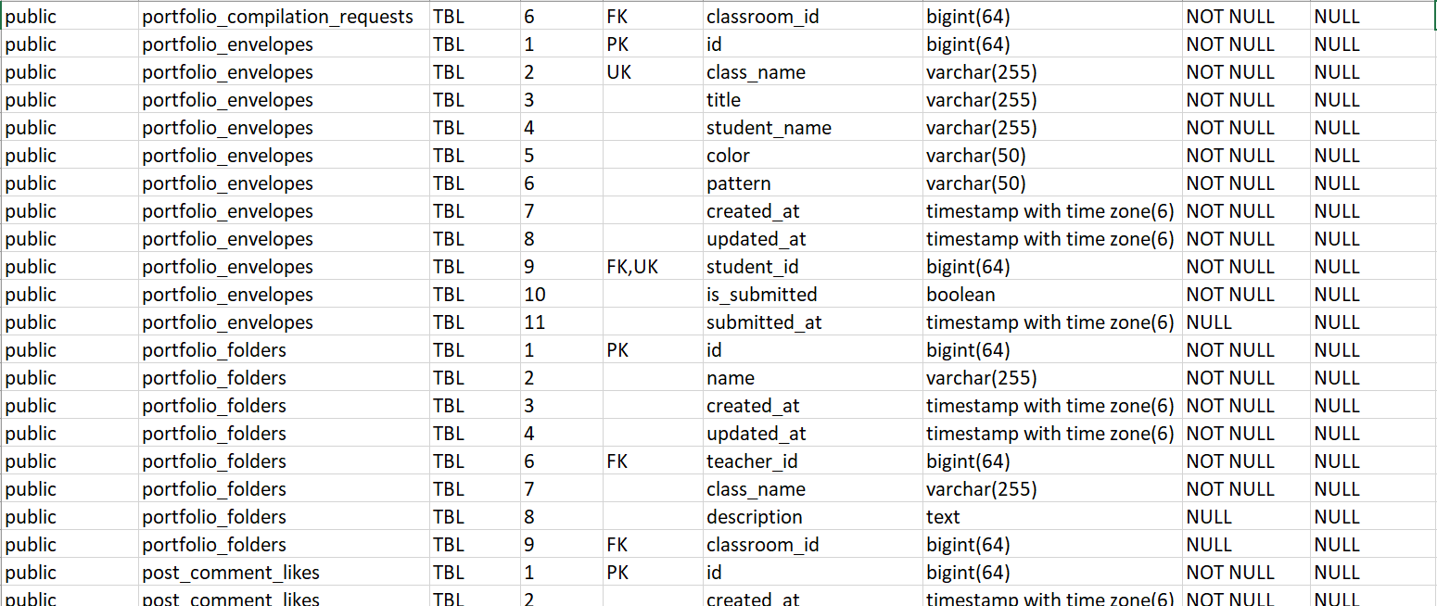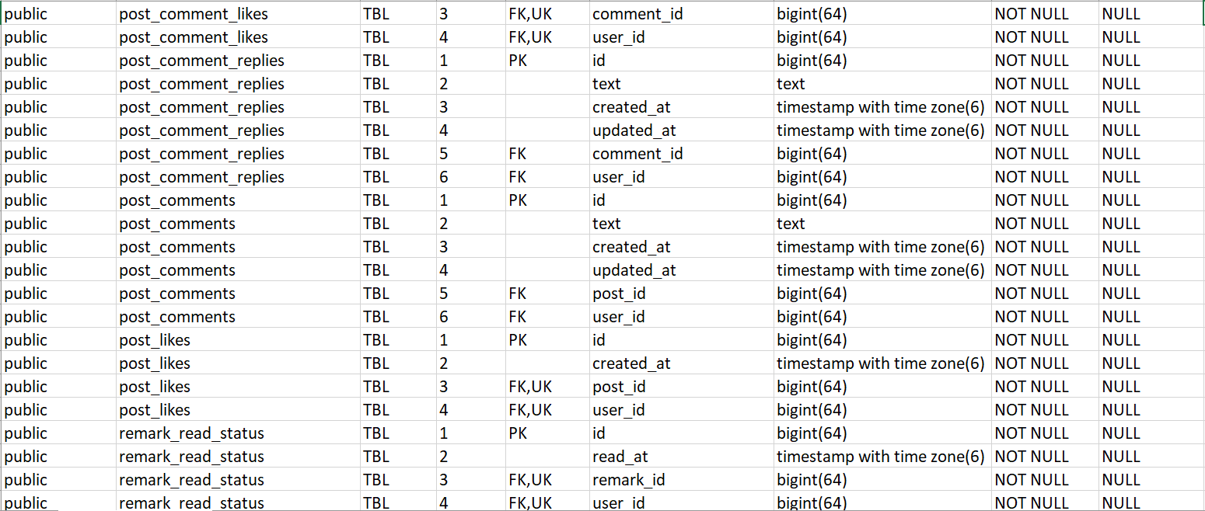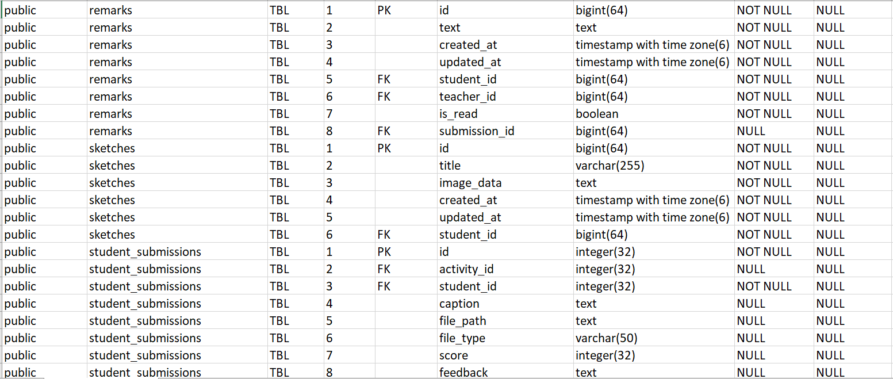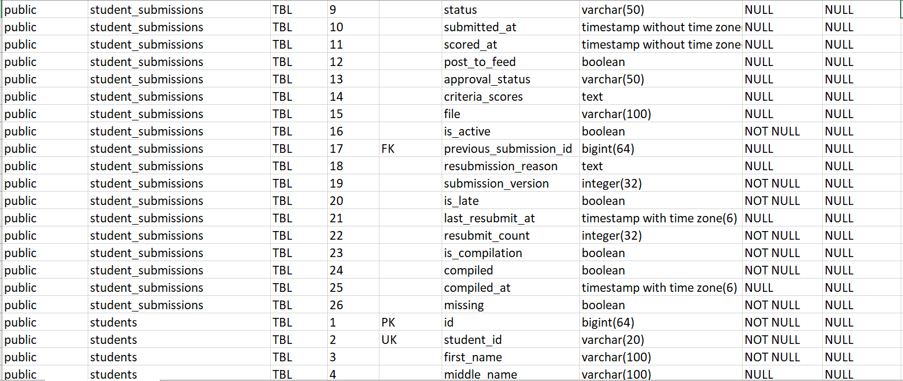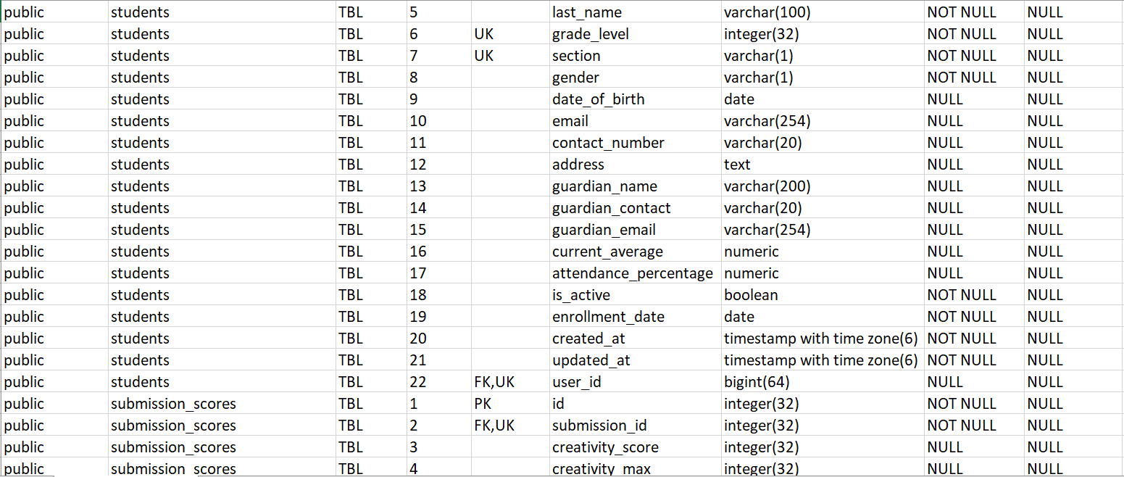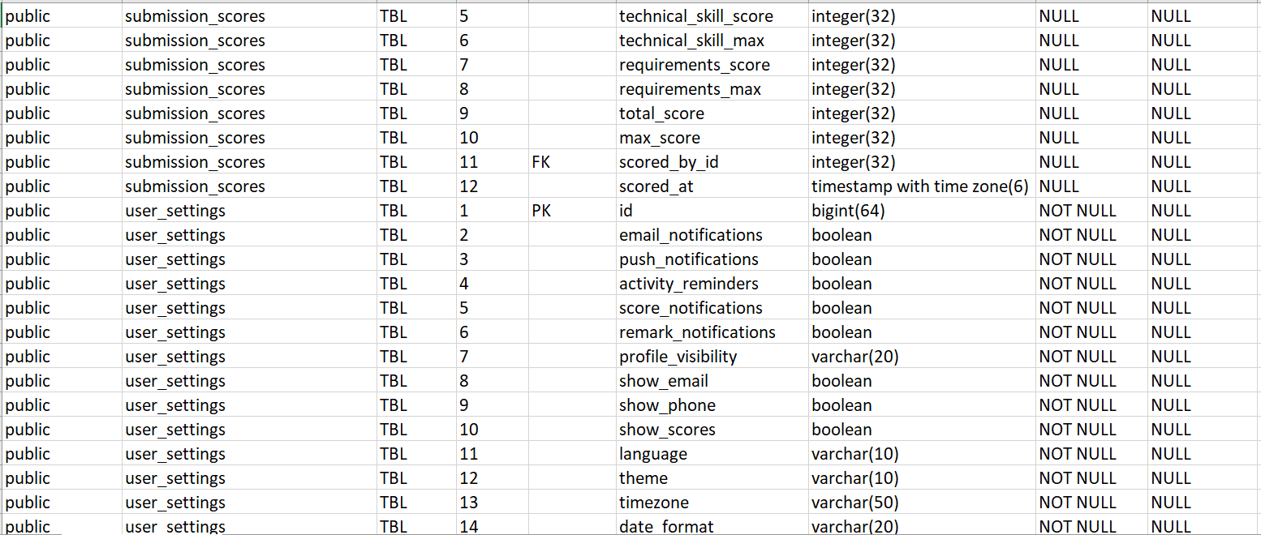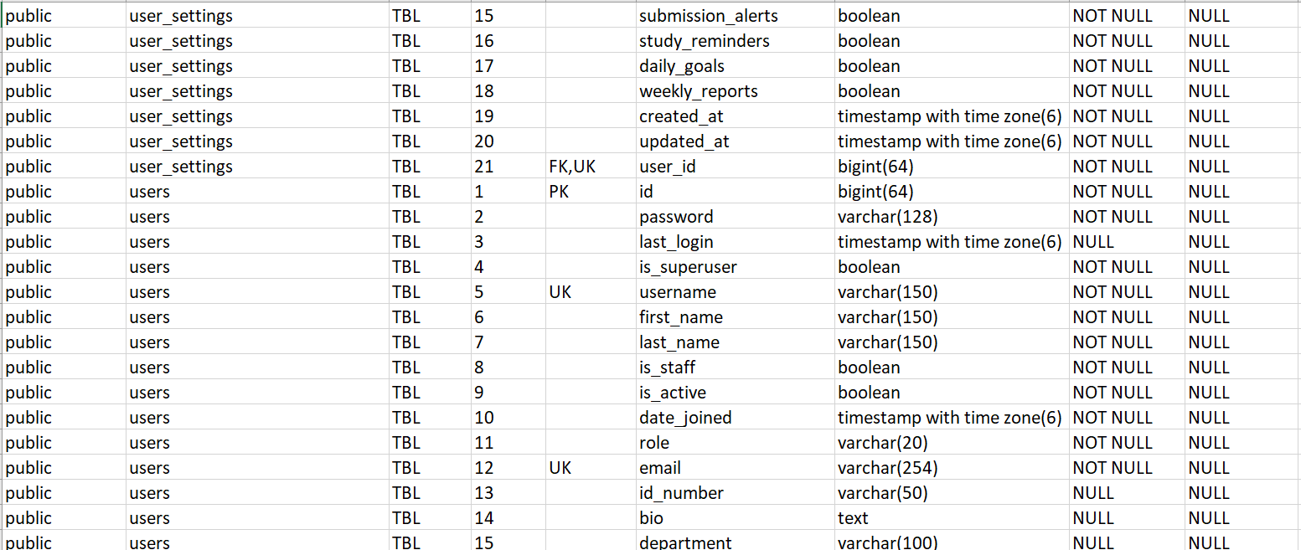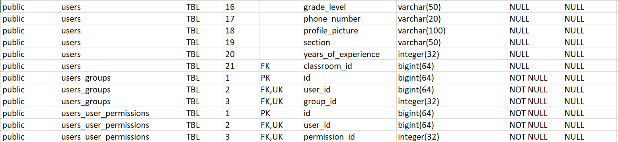

5.1.10. Summary of the Design and Development of the Digital Portfolio System
This section highlights the different diagrams, figures and tables. Digital Portfolio System sums up the planning, structure, and implementation processes that shaped the system. Altogether, this approach delivered a robust, user-centered platform that supports seamless tracking, feedback, and communication within an educational setting.

5.2 Development Results of the System
5.2.1. Graphical User Interface of Digital Portfolio System
The Digital Portfolio System’s Graphical User Interface (GUI) is crafted to deliver an efficient, visually appealing experience, allowing users to interact effortlessly with the system. By using intuitive icons, buttons, and visual elements, the GUI minimizes the need for text-based commands, enabling quick and easy access to essential features. This interface design is consistent across devices, including the mobile application, ensuring that users whether teachers or administrators can navigate smoothly, manage digital portfolios, and access data in real-time. This cohesive and user-friendly approach enhances productivity and supports efficient digital portfolio management across various user roles.
5.2.2. Graphical User Interface of Digital Portfolio System’s Desktop Application
5.2.2.1 Admin/Teacher User Interface

Figure 29 shows the graphical user interface of the Teacher landing page.
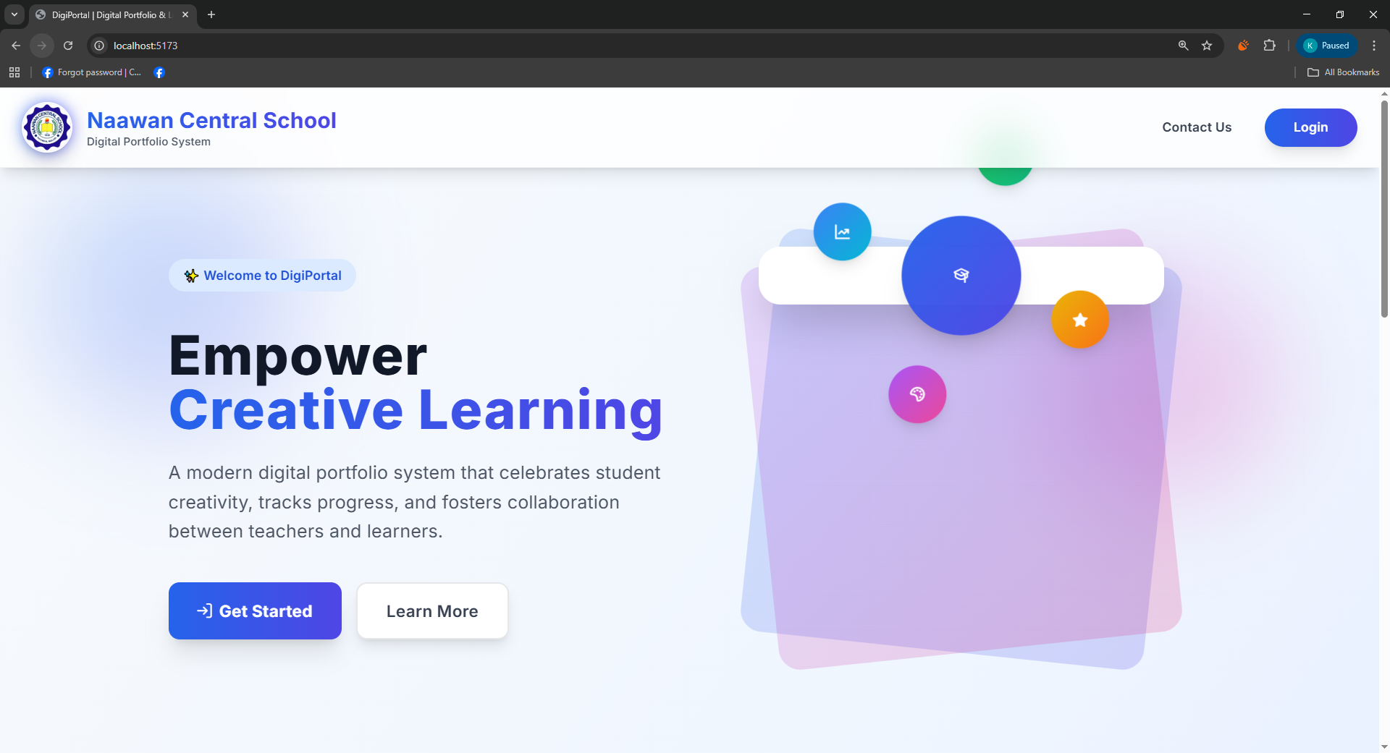
Figure 29. Digital Portfolio System Teacher User Interface Landing Page

Figure 30 shows the graphical user interface of the selected role Teacher Login Form.
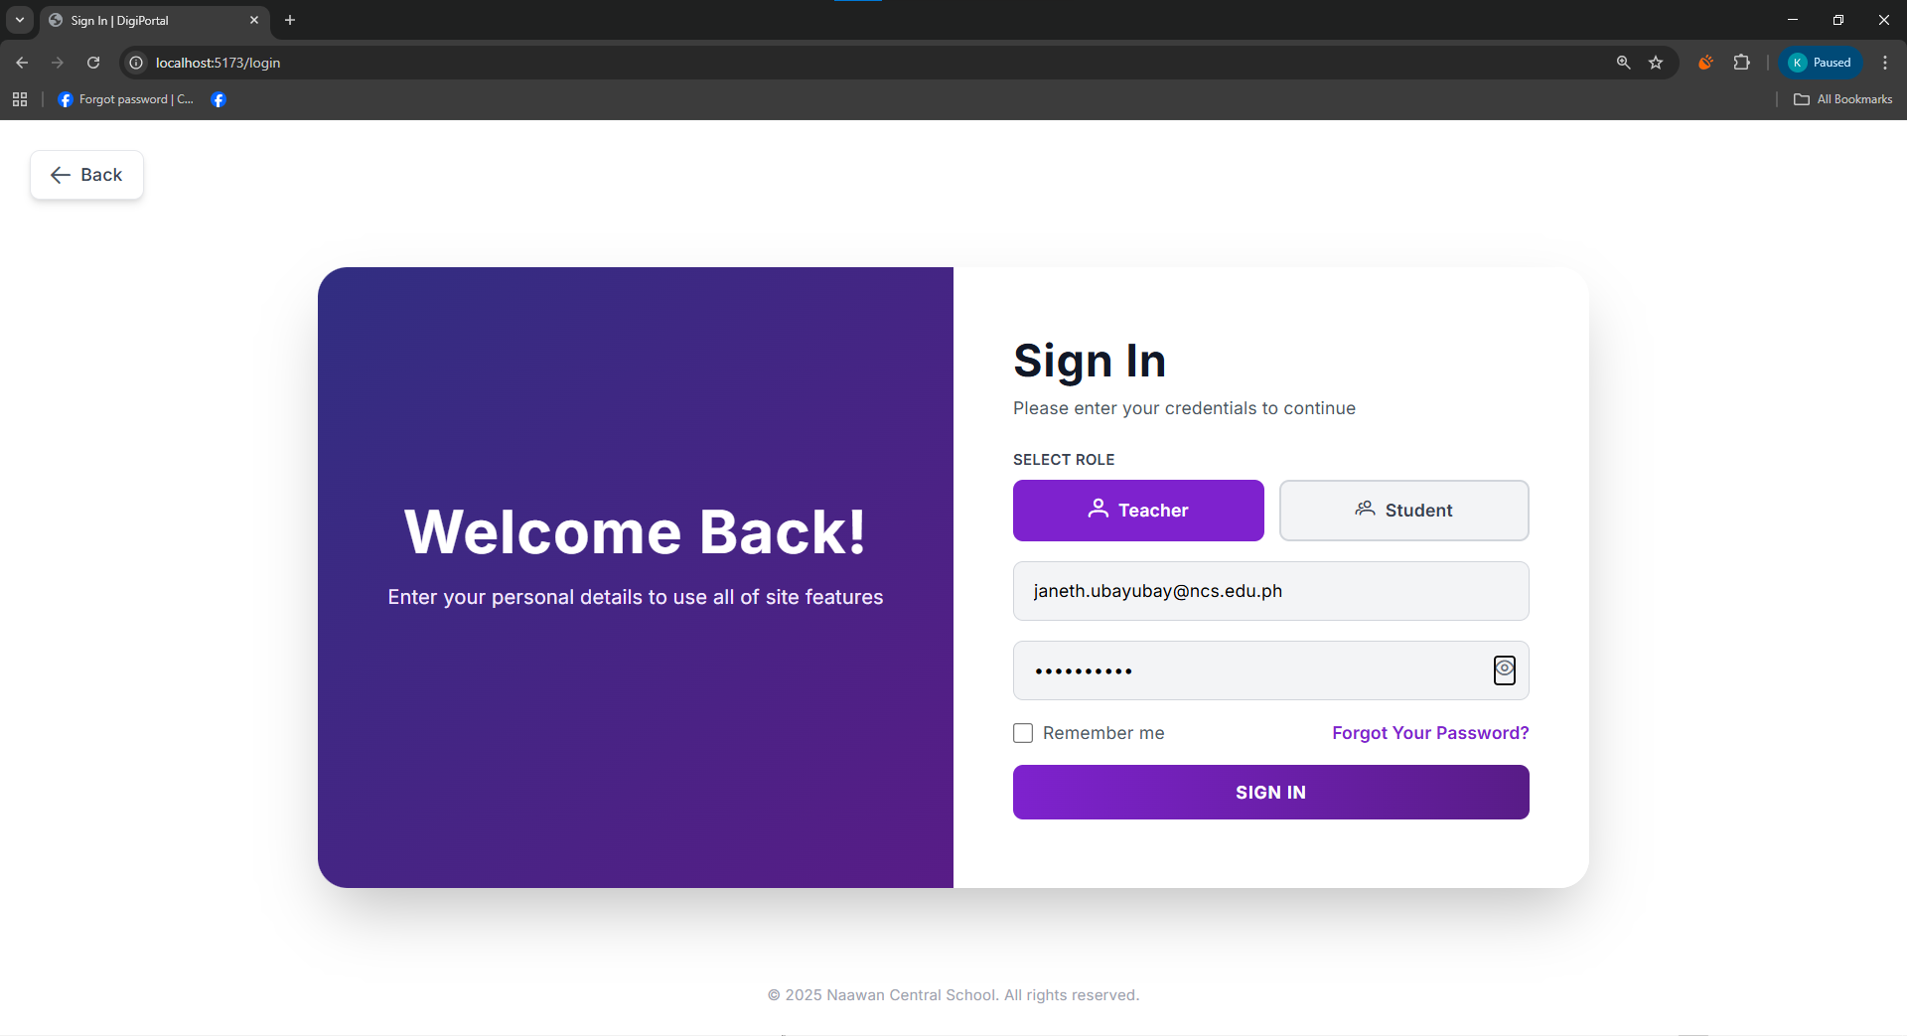
Figure 30. Digital Portfolio System Teacher User Interface Login Form

Figure 31 shows the graphical user interface of the teacher, offers a clean organized activity feed where the educators can monitor student submission activity post, images, with timestamps and class organization, all accessible through an intuitive sidebar navigation.
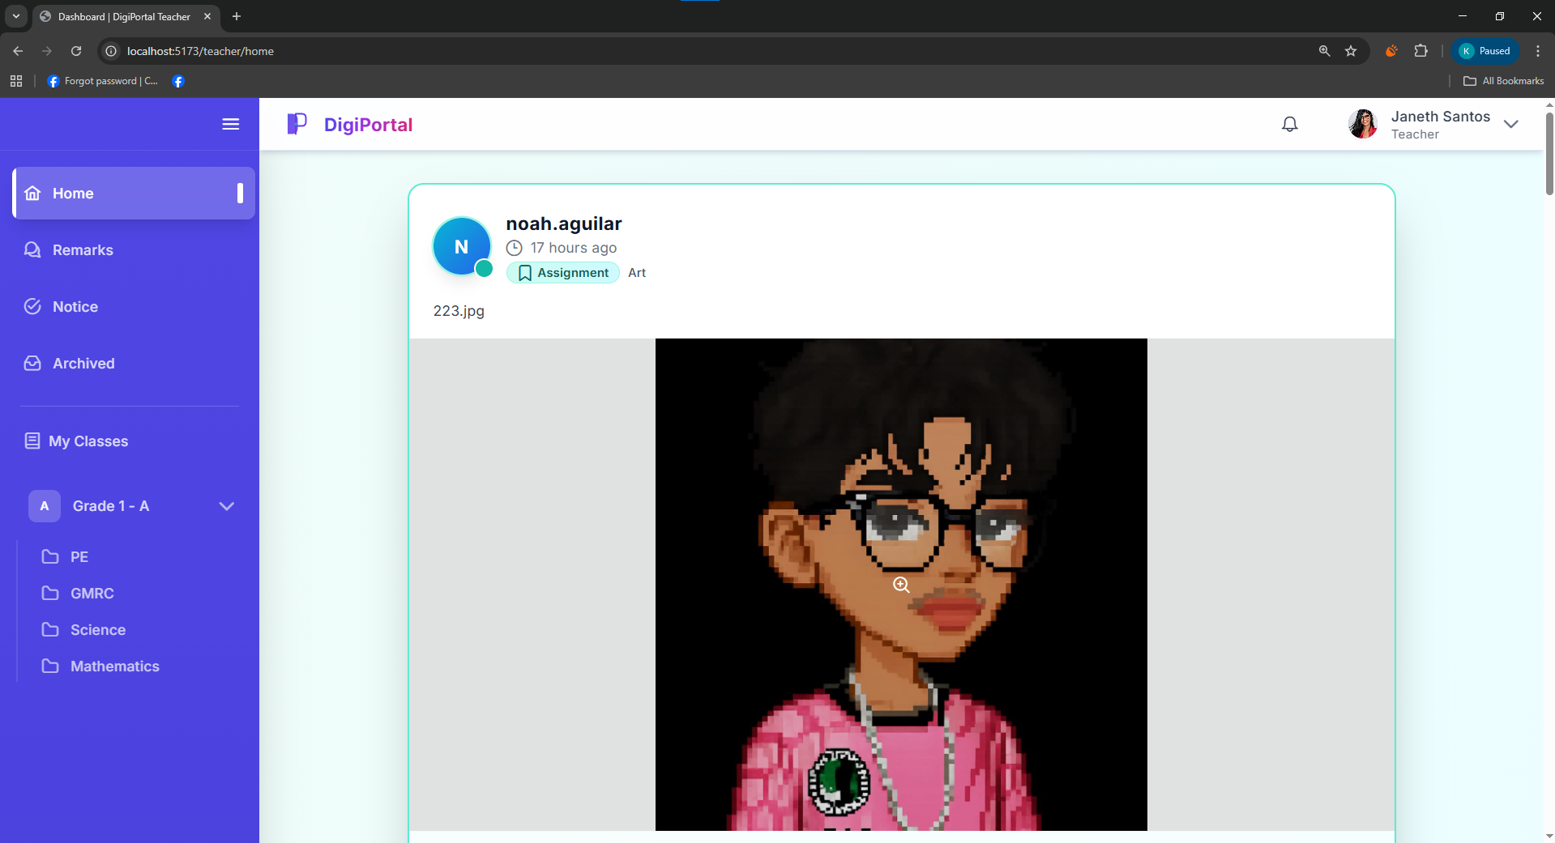
Figure 31. Digital Portfolio System Teacher User Interface Home/Newsfeed

Figure 32 shows the graphical user interface of the teacher notification panel displaying recent portfolio-related updates that are visible only to the logged-in teacher or pupil user. Each notification summarizes a specific action, such as a new post, approval, etc. Allowing the user to quickly review important activities without leaving the current page.
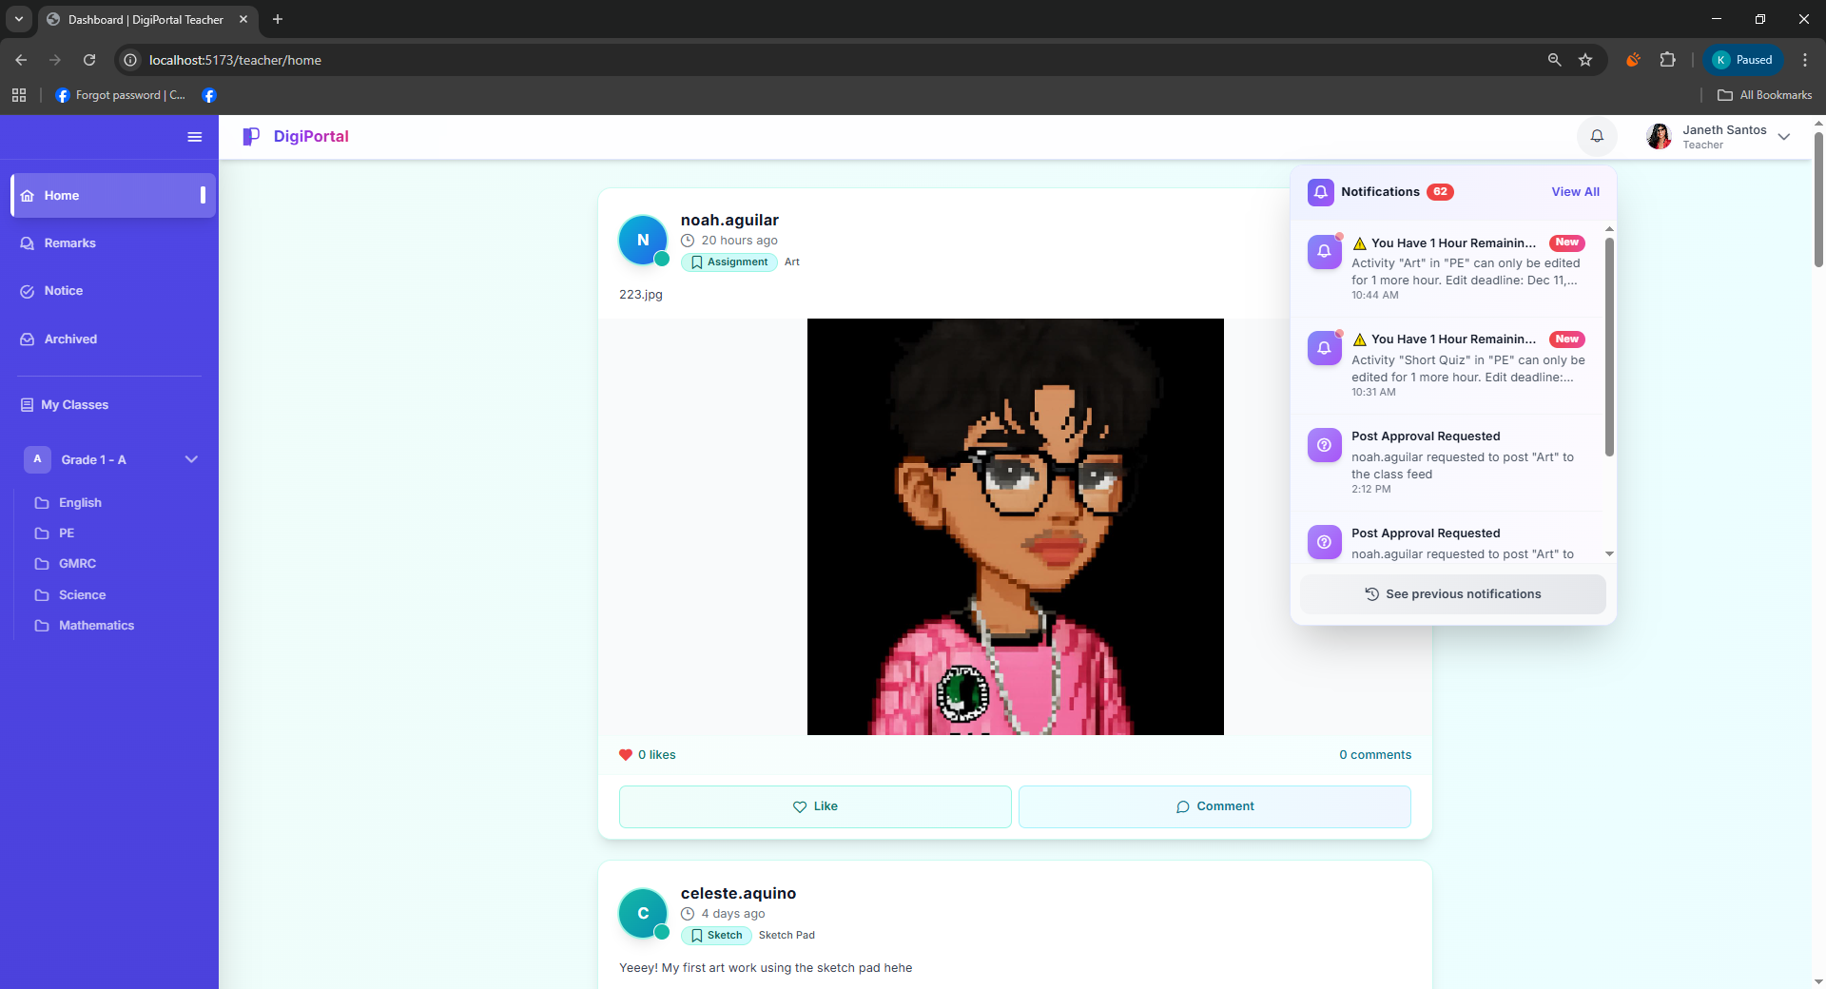
Figure 32. Digital Portfolio System Teacher User Interface Notification
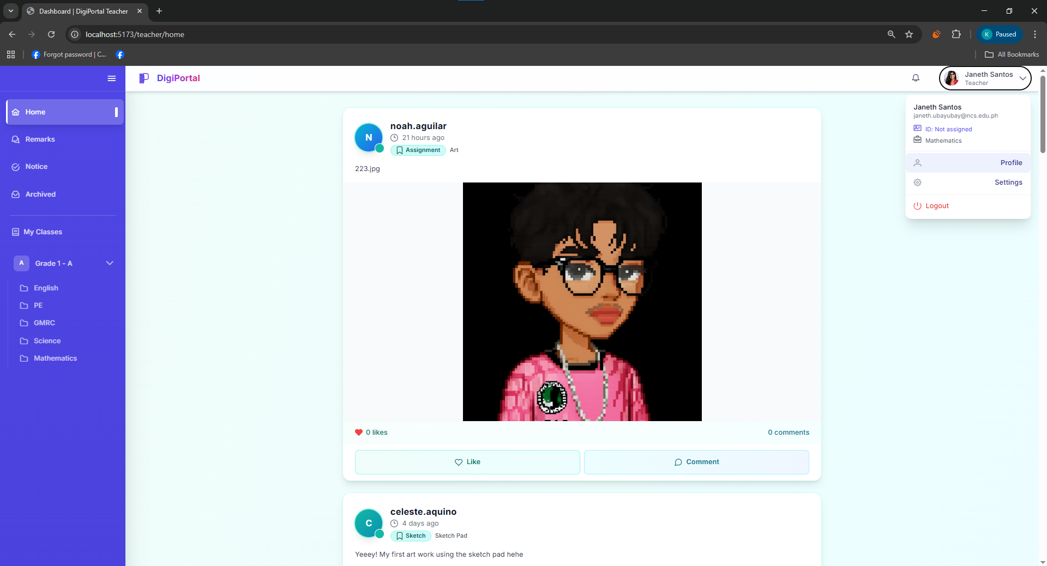
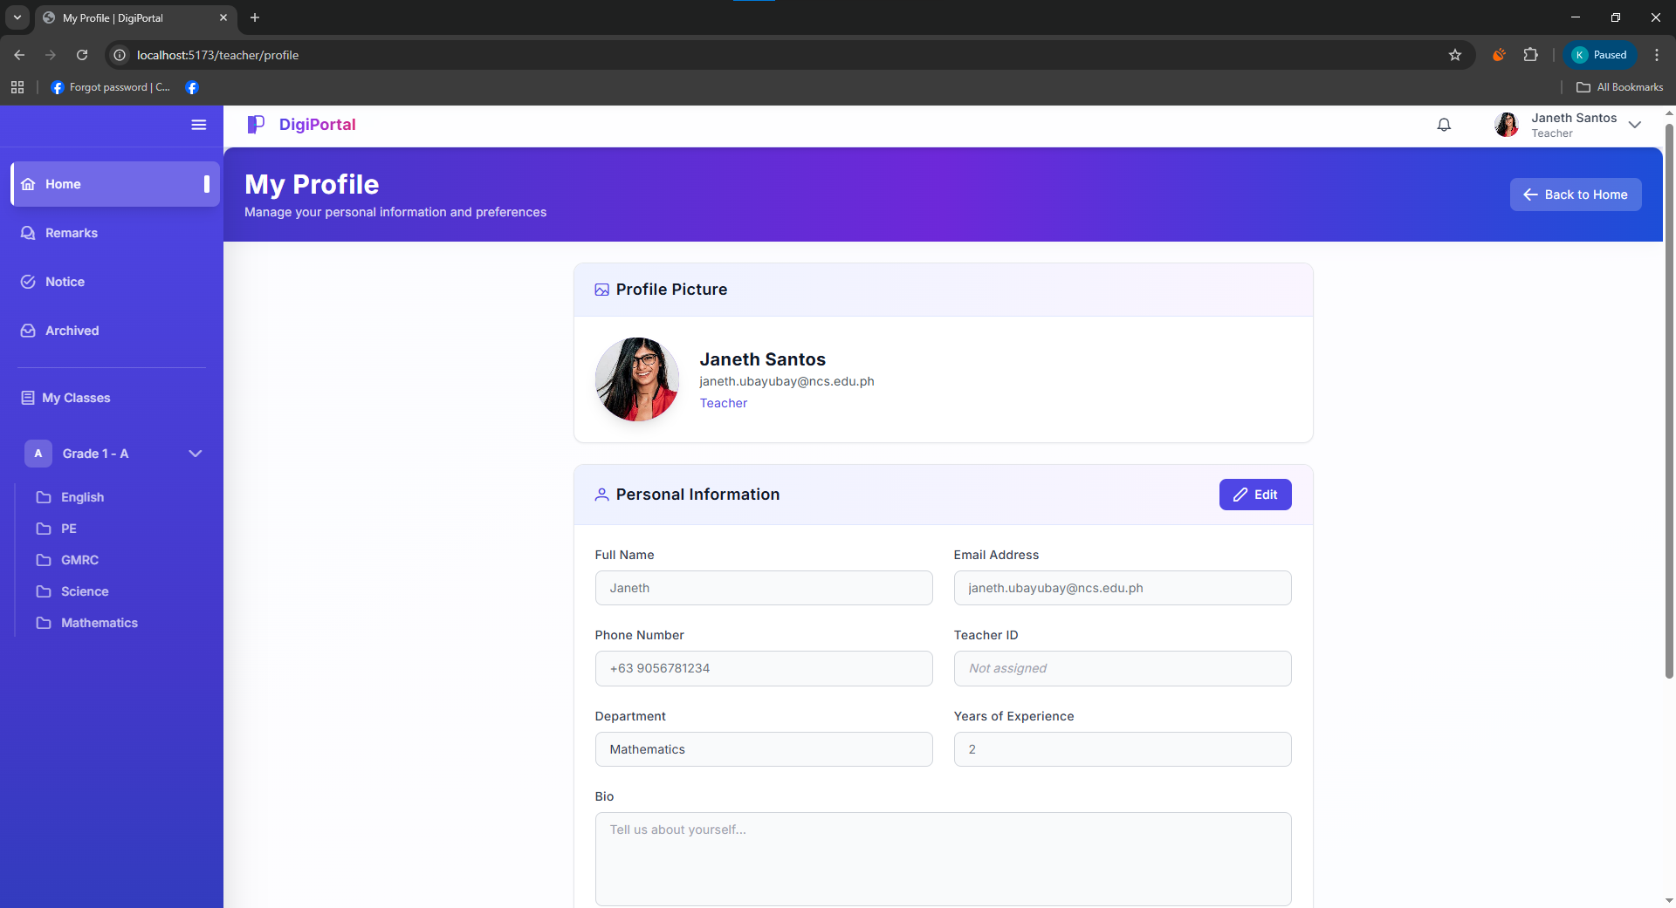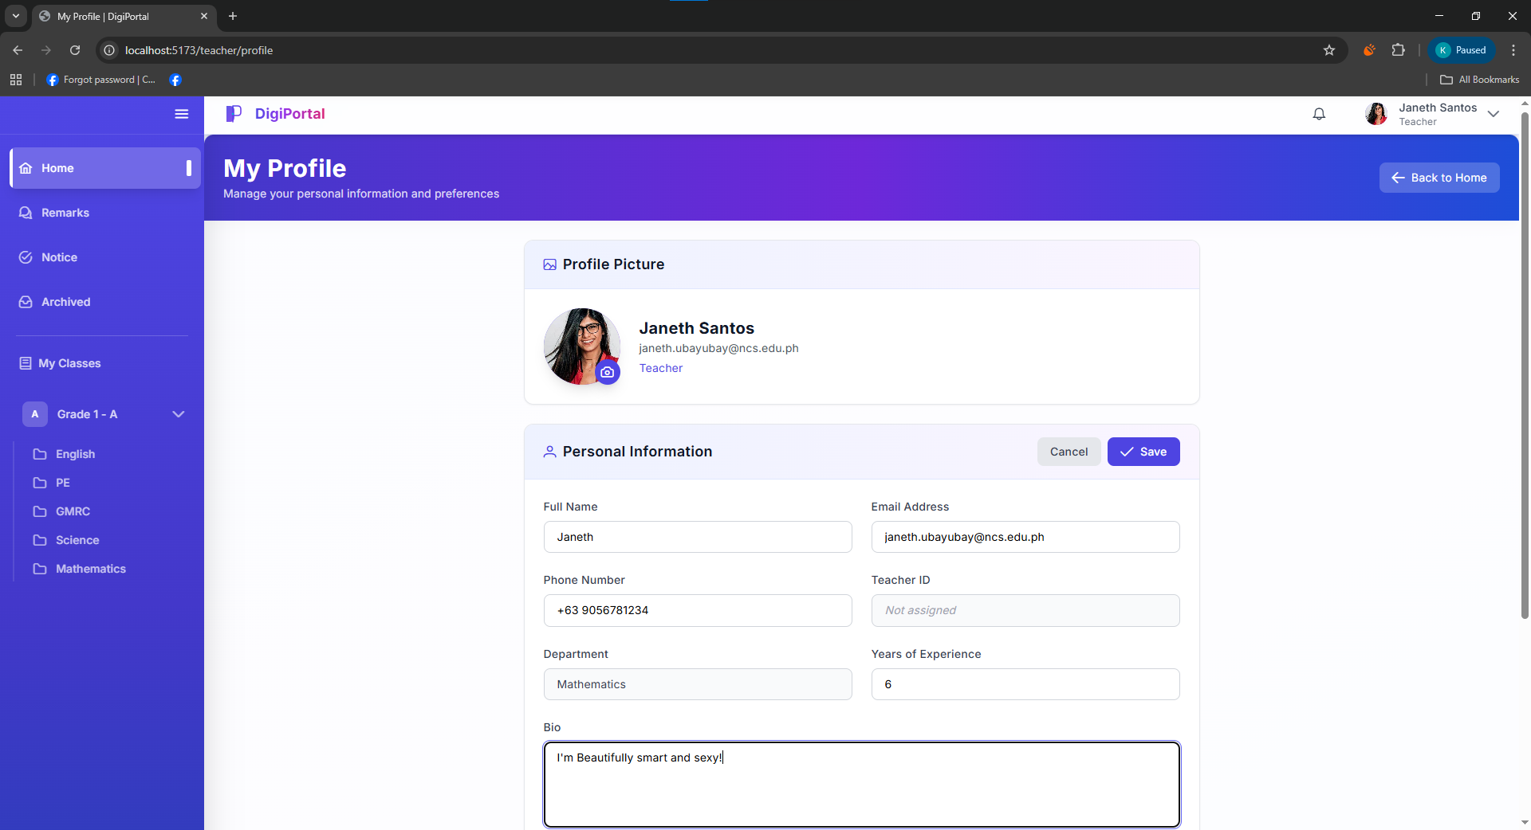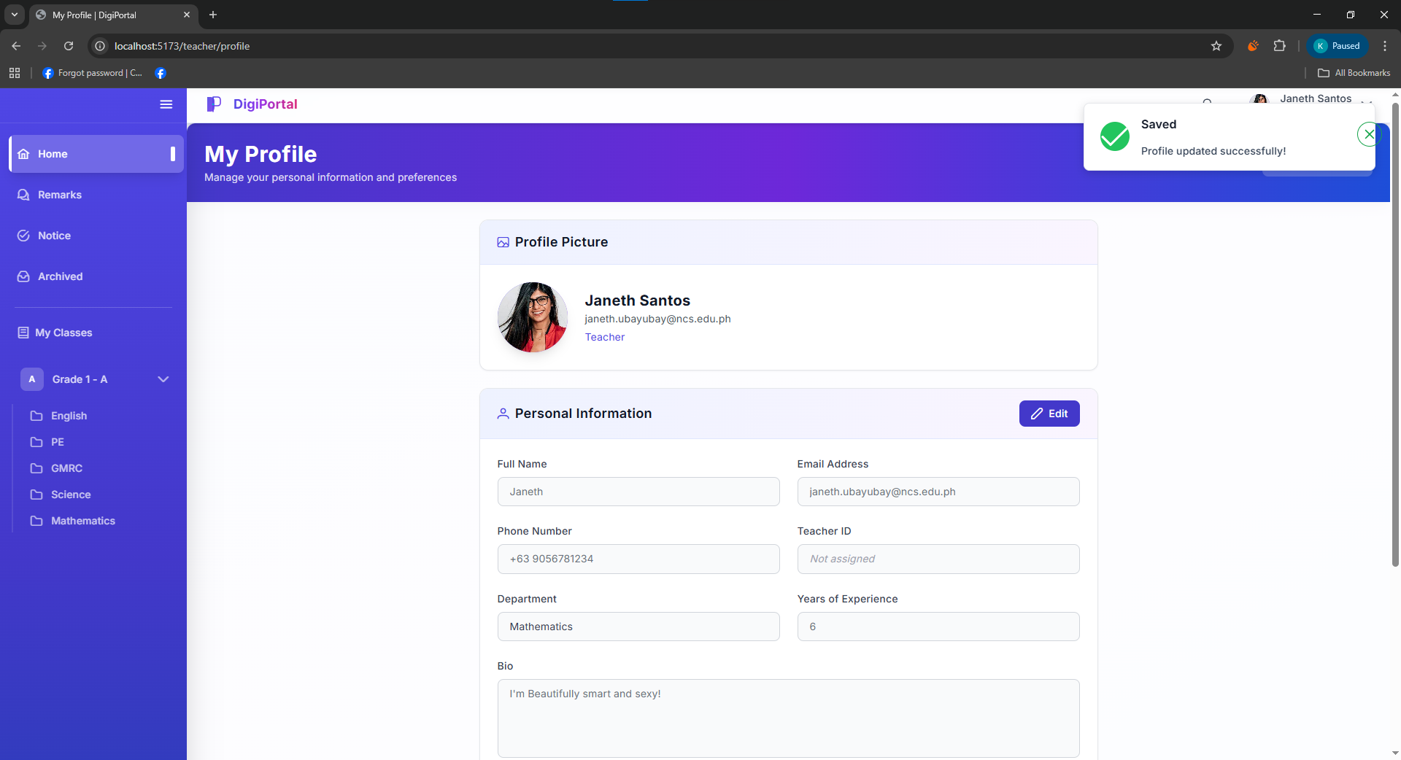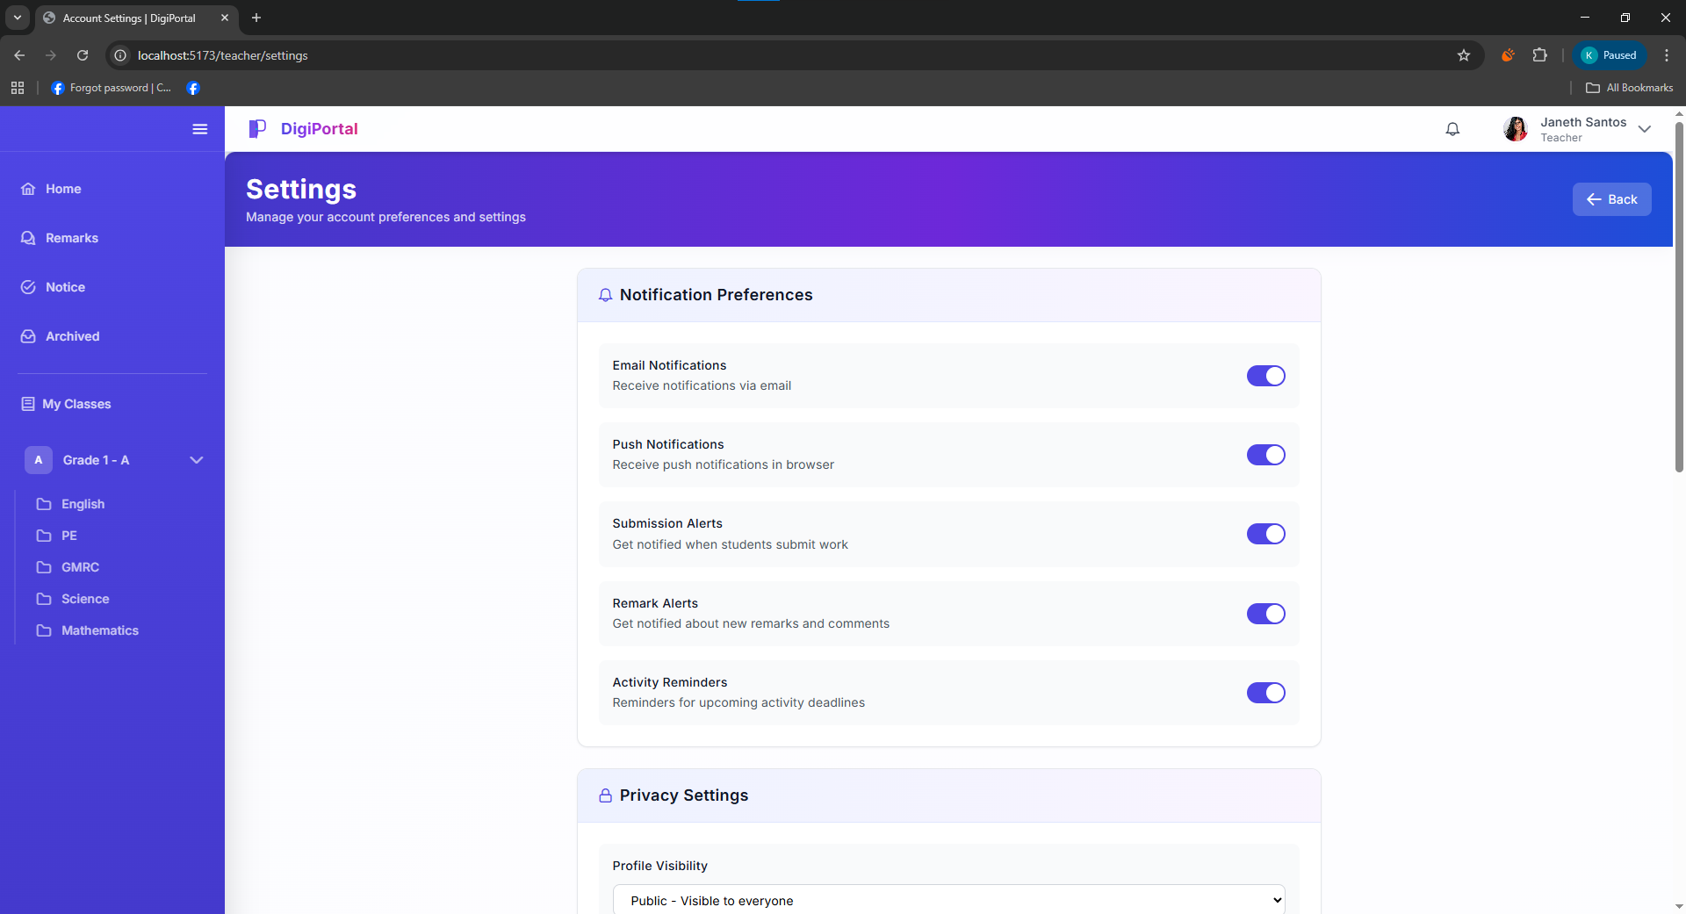
Figure 33. Digital Portfolio System Teacher User Interface Manage User Account

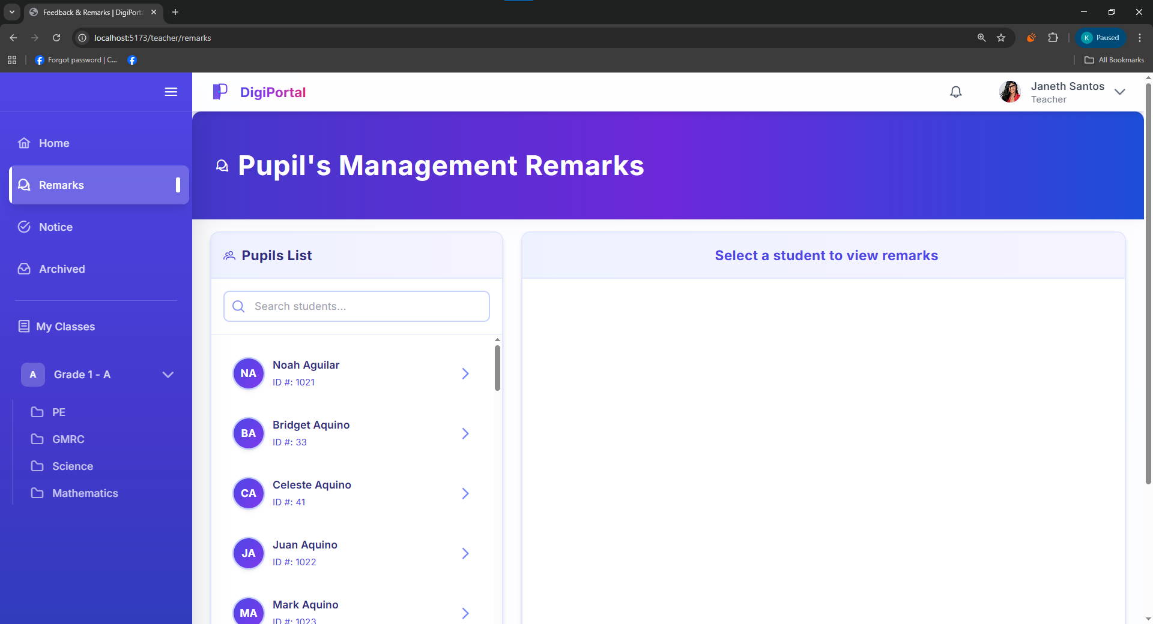
Figure 34. Digital Portfolio System Teacher User Interface Pupil’s Management Remarks List

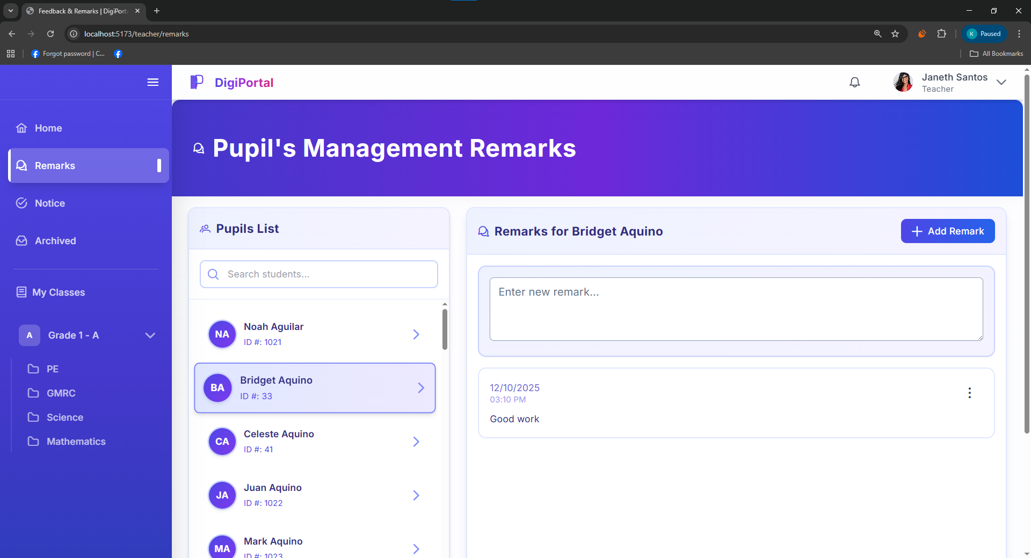
Figure 35. Digital Portfolio System Teacher User Interface Pupil’s Add Remark List

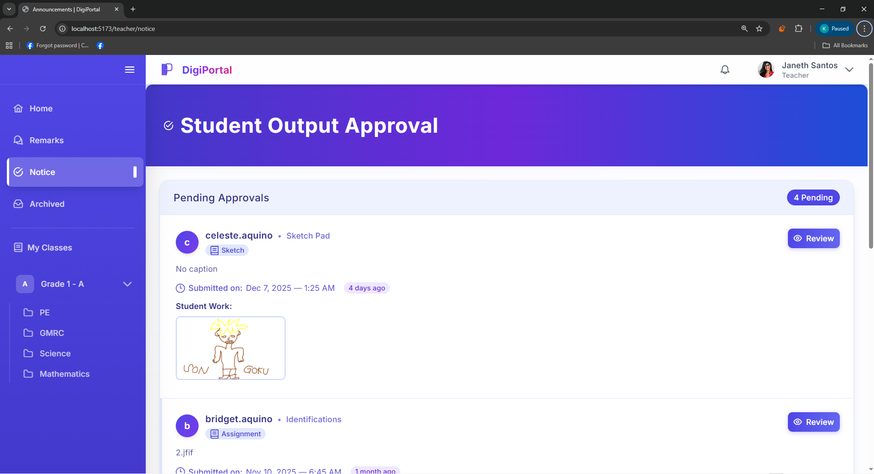
Figure 36. Digital Portfolio System Teacher User Interface Pupil’s Output Approval List

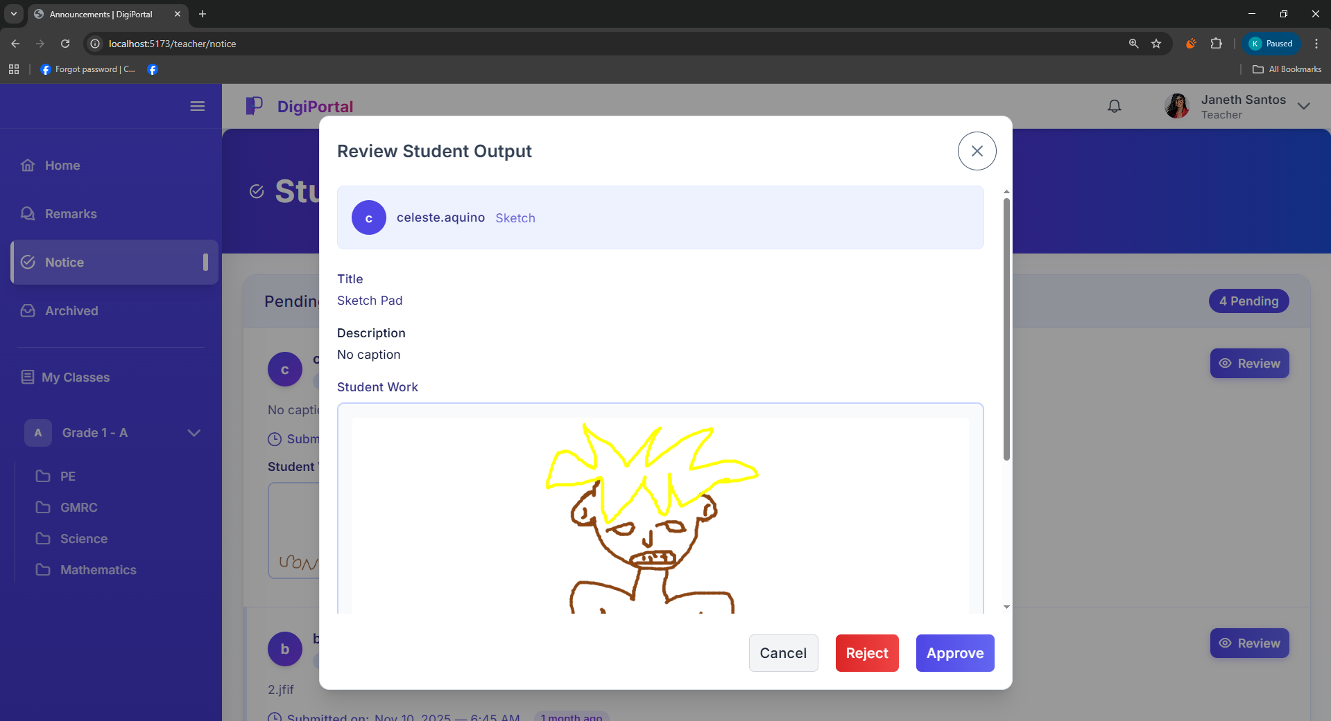
Figure 37. Digital Portfolio System Teacher User Interface Review Pupil’s Output

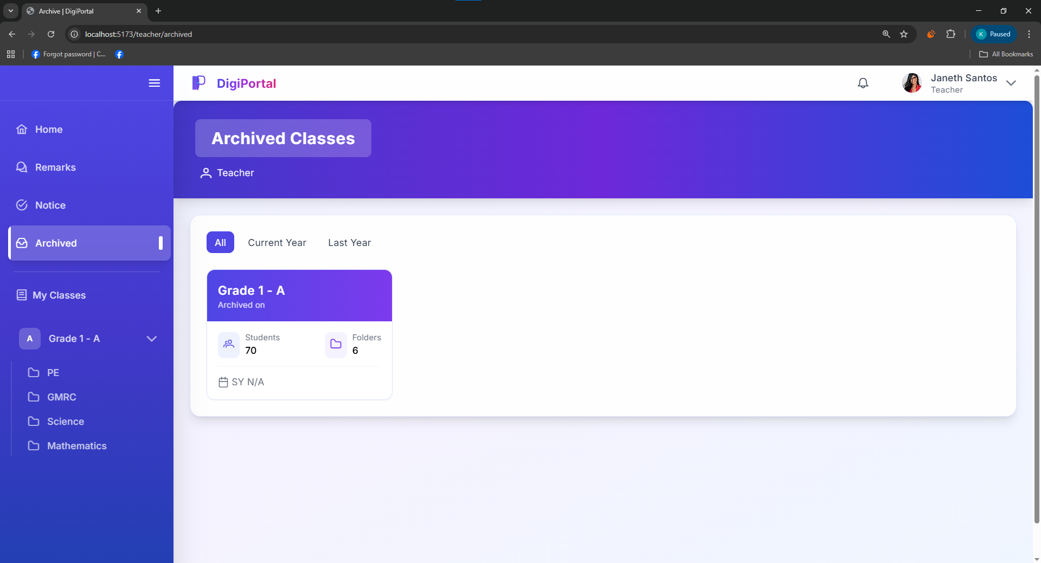
Figure 38. Digital Portfolio System Teacher User Interface Archived Classes

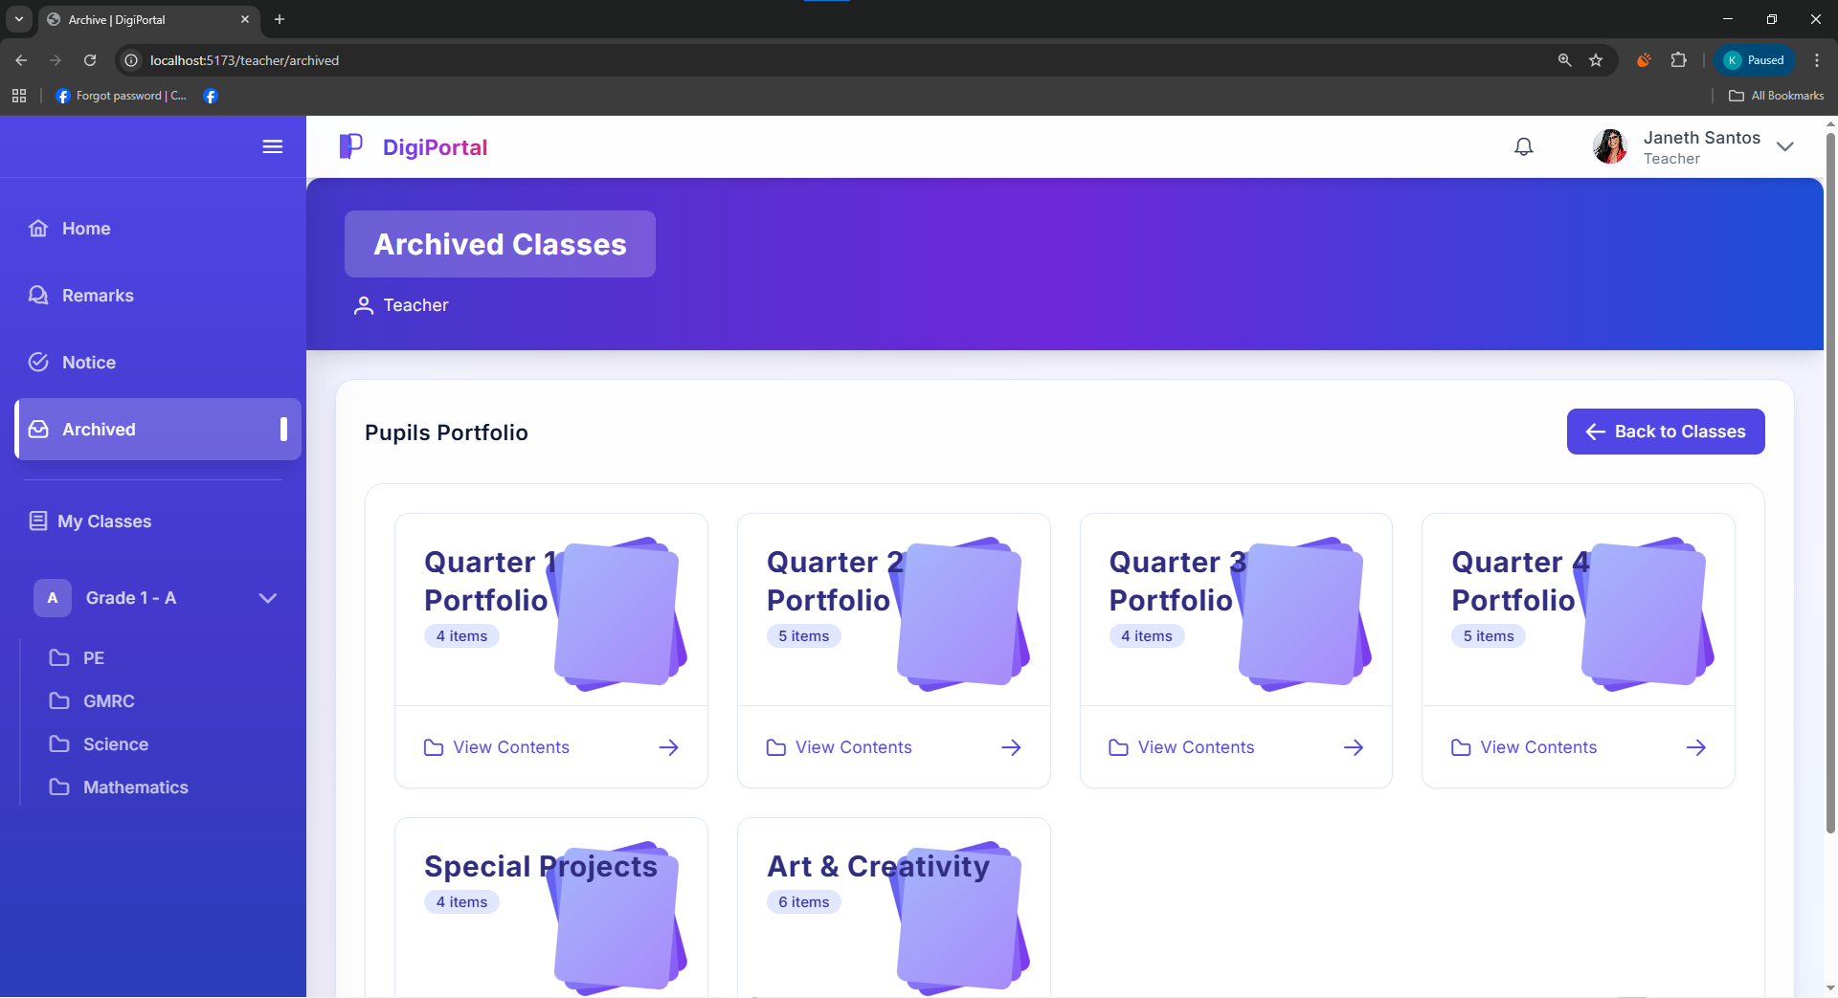
Figure 39. Digital Portfolio System Teacher User Interface Archived Classes in Pupil’s Portfolio List

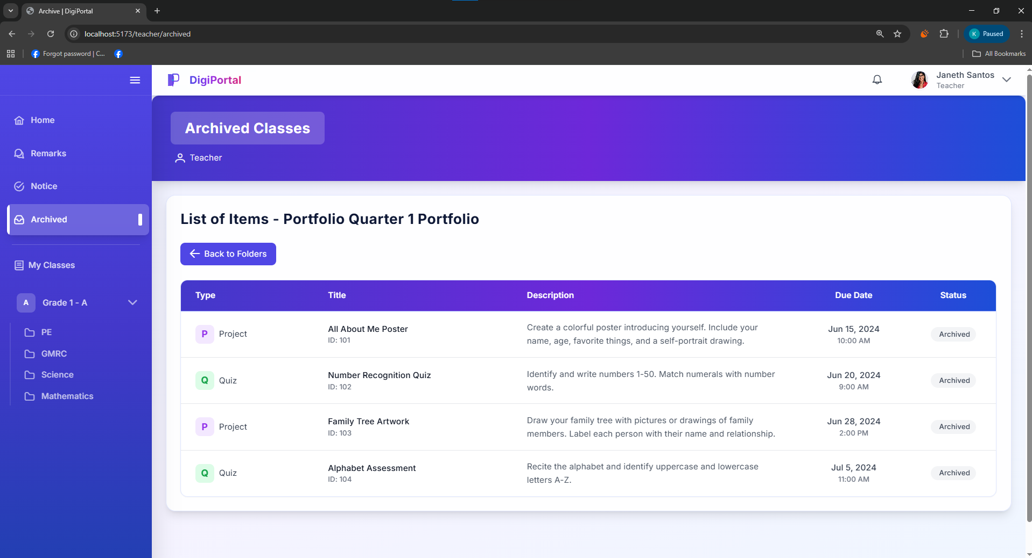
Figure 40. Digital Portfolio System Teacher User Interface Archived Classes in Pupil’s Portfolio List of Items

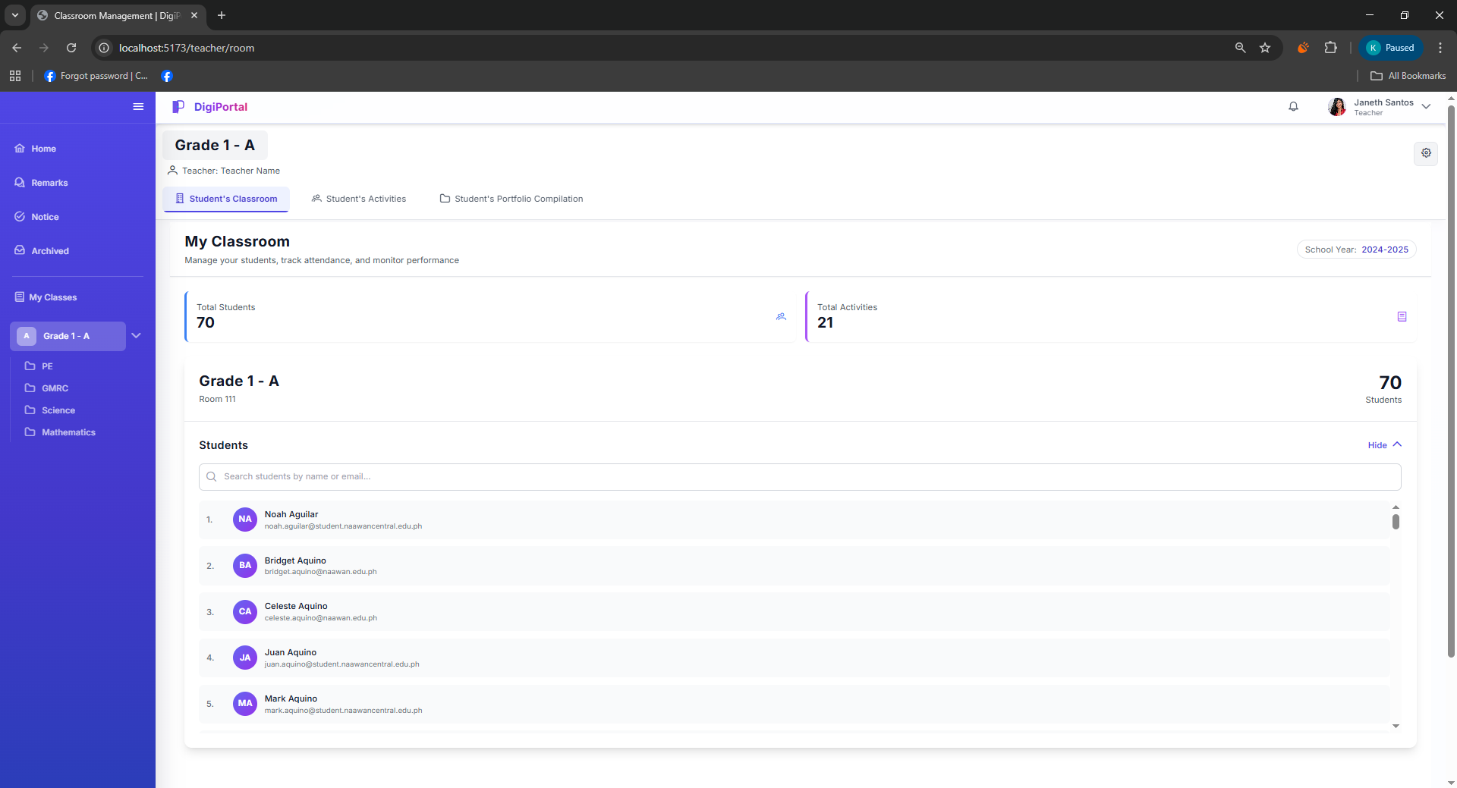
Figure 41. Digital Portfolio System Teacher User Interface Pupil’s Classroom

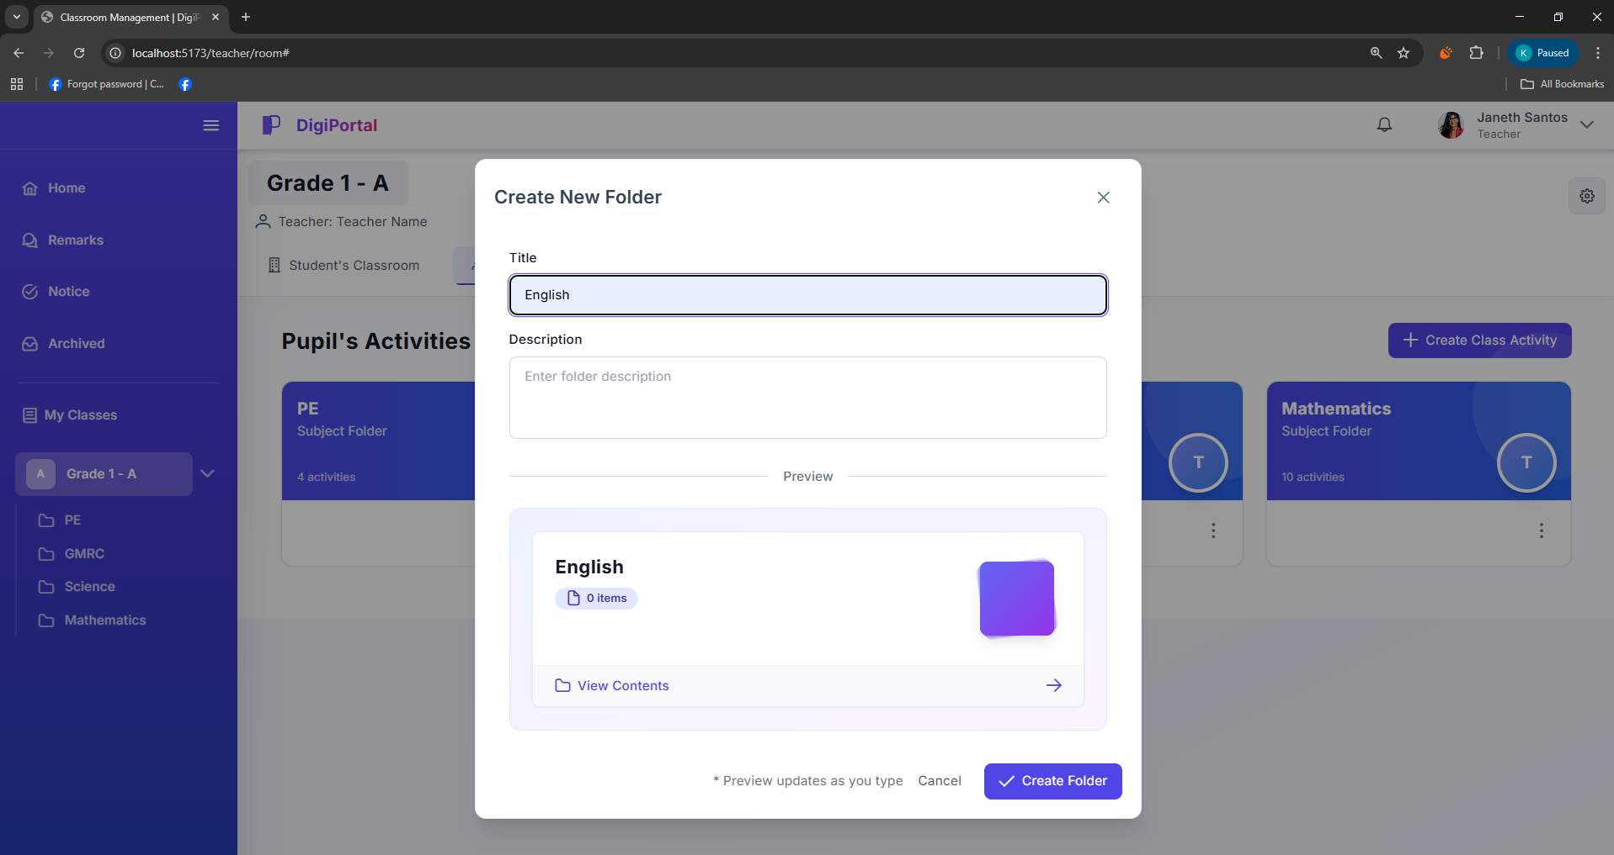
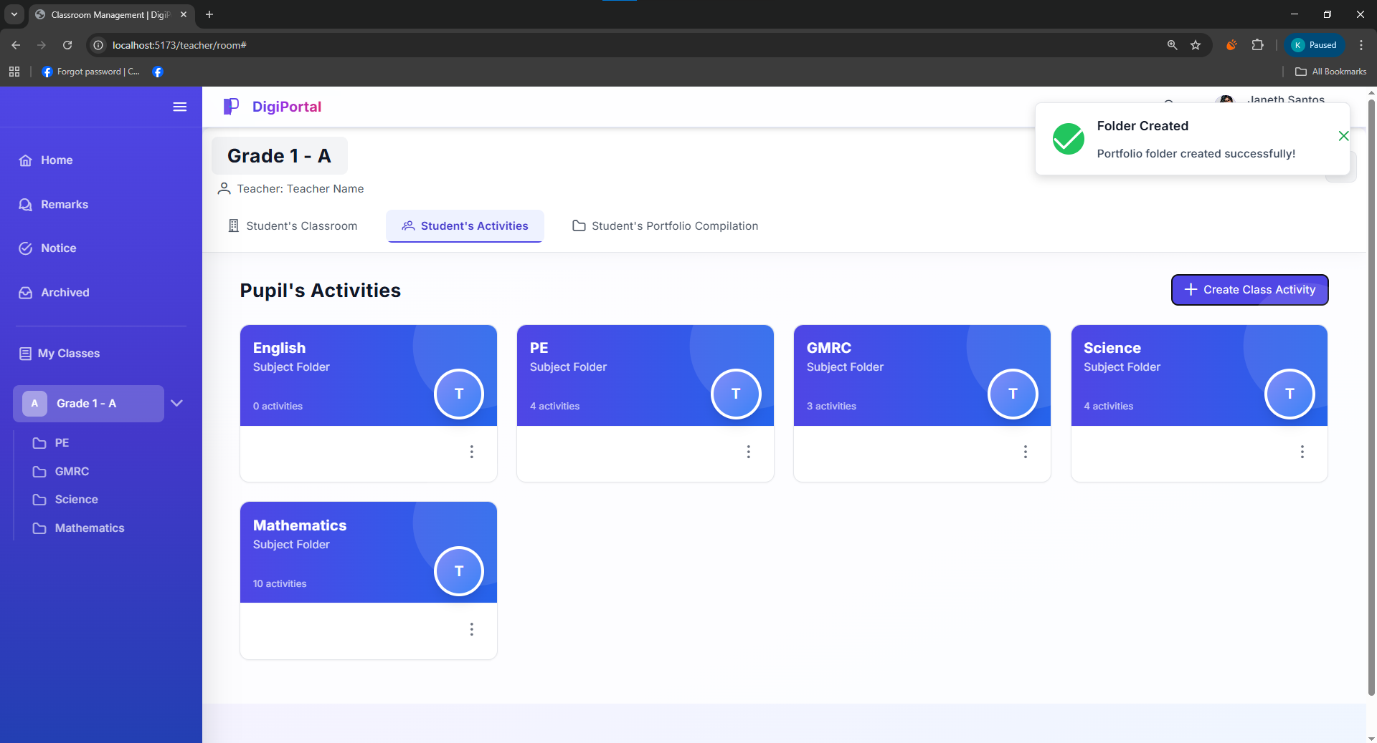
Figure 42. Digital Portfolio System Teacher User Interface Pupil’s Activities

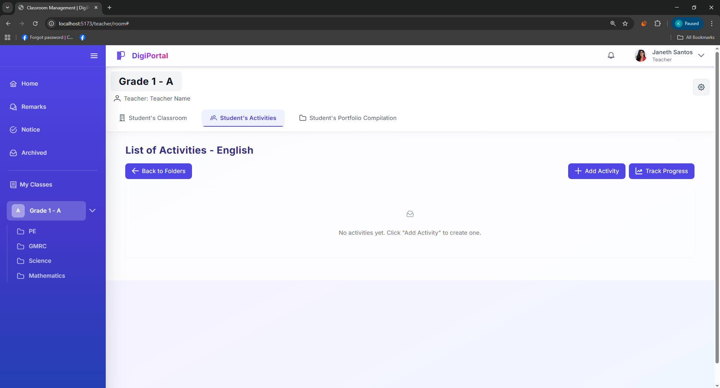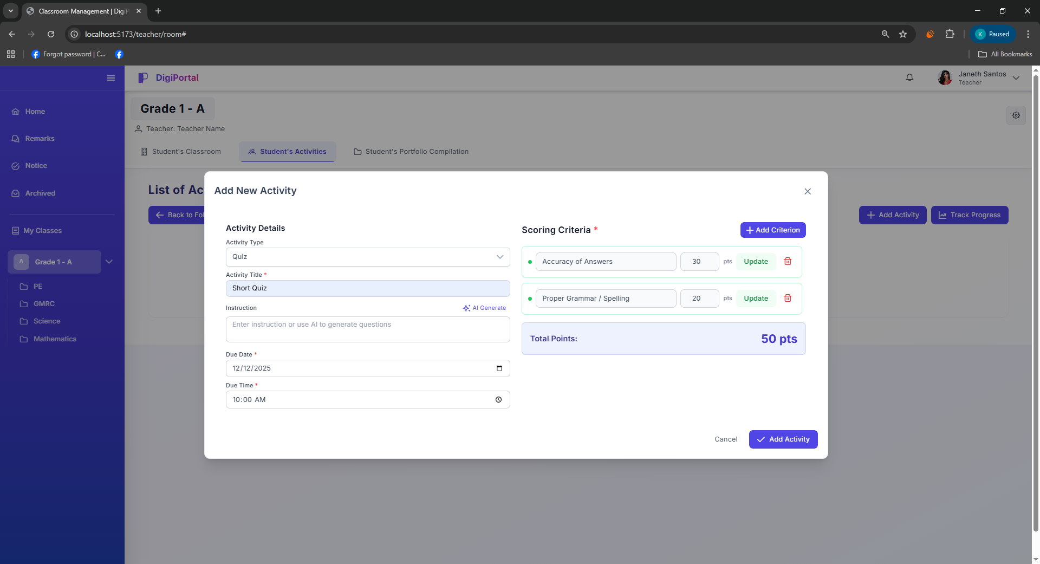
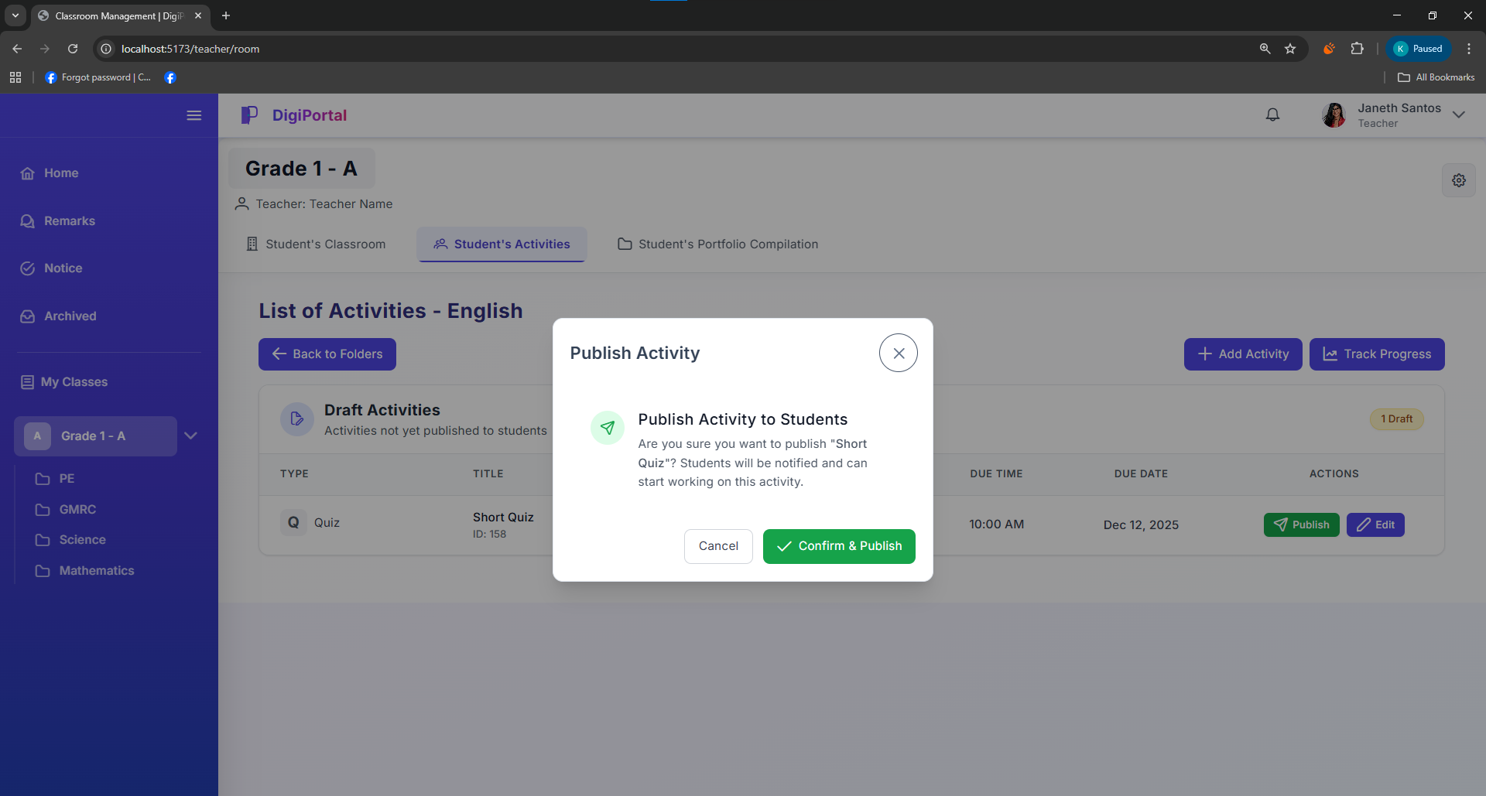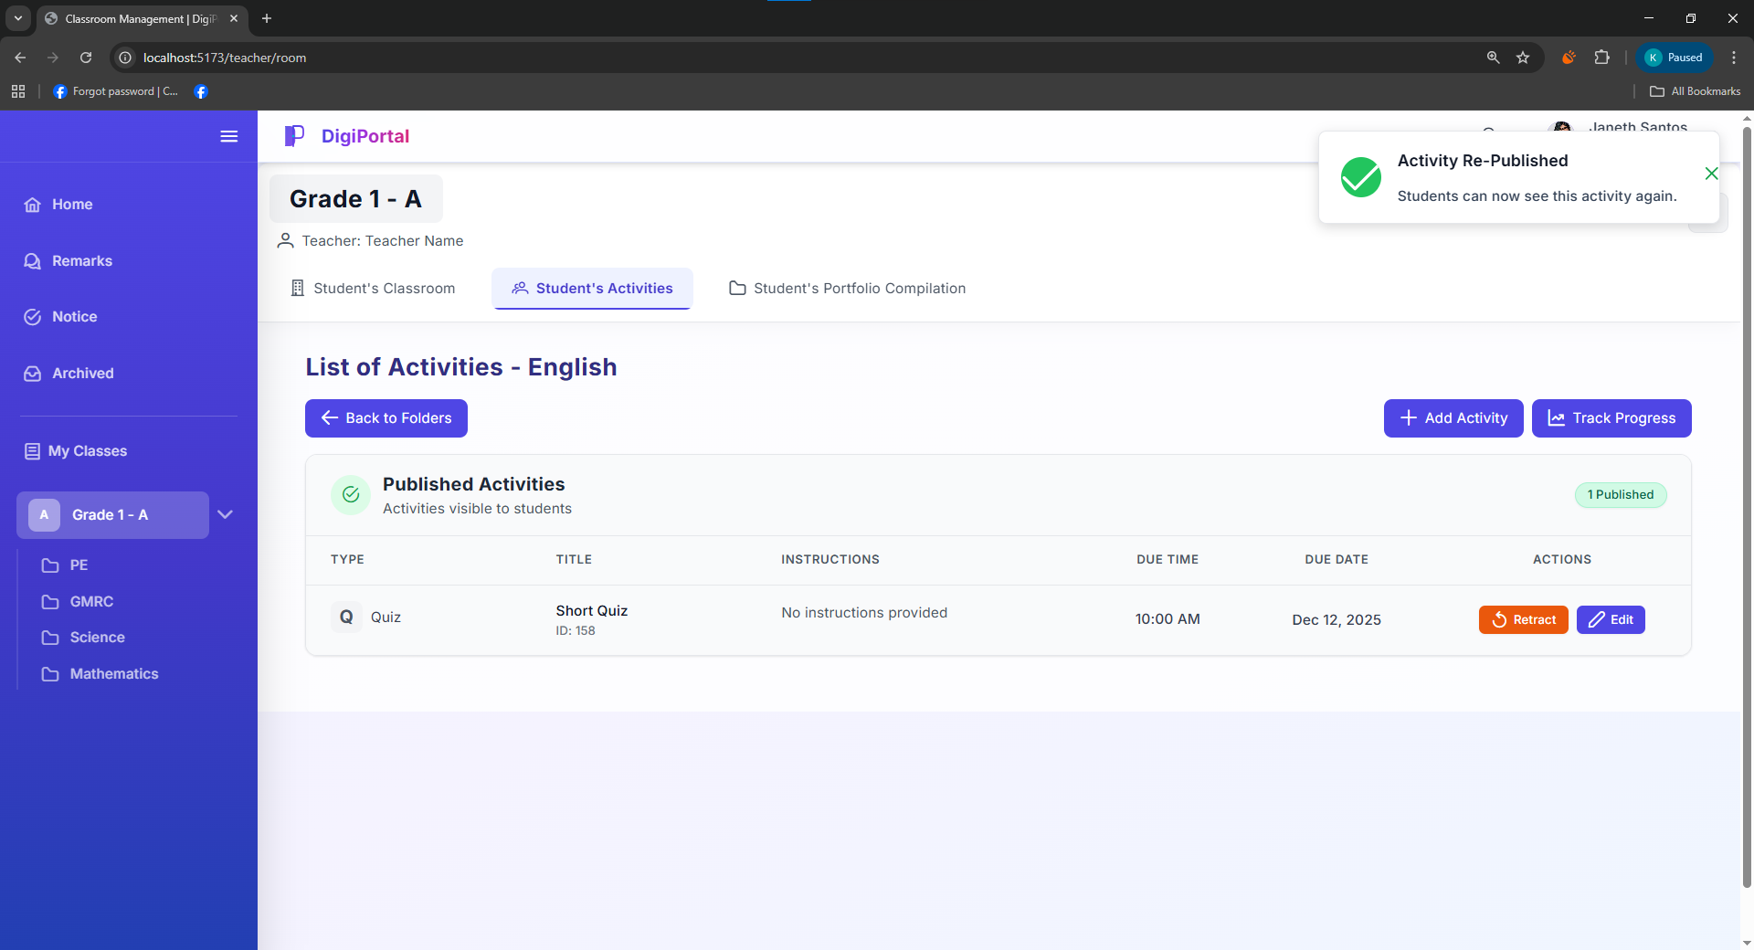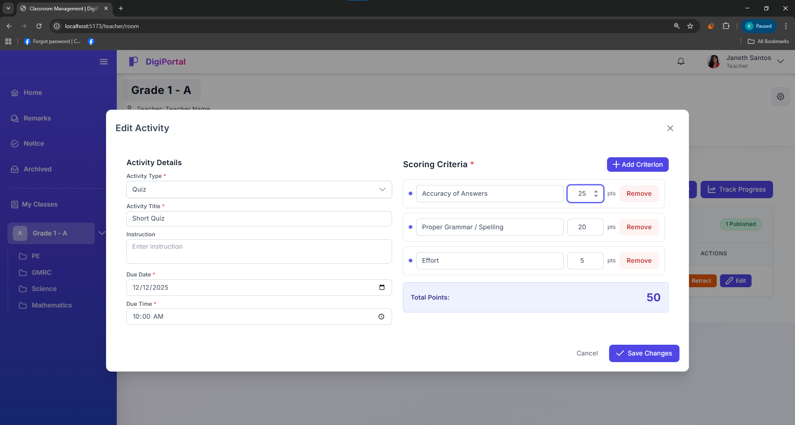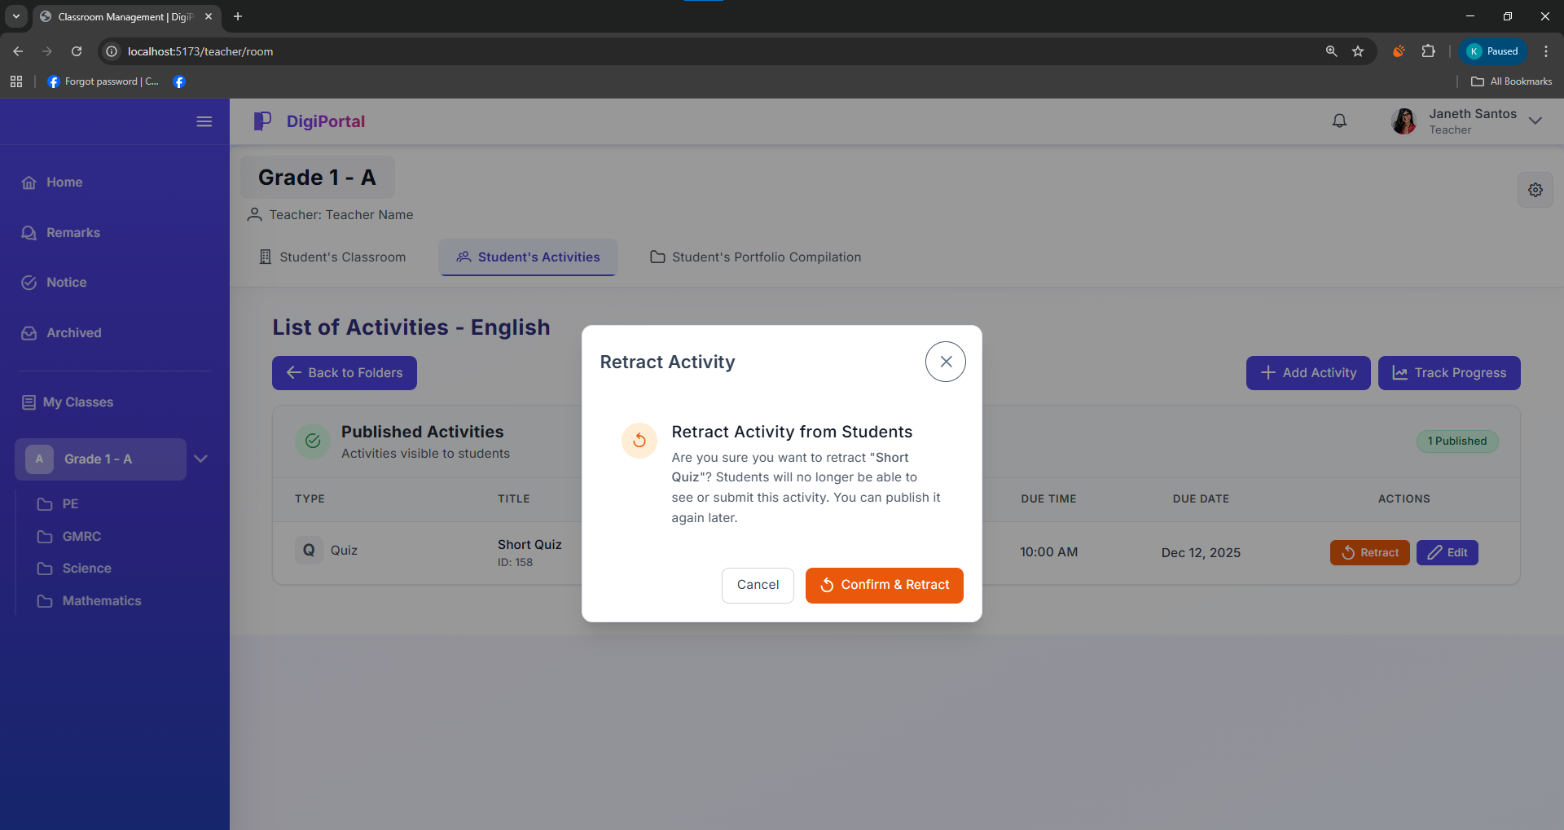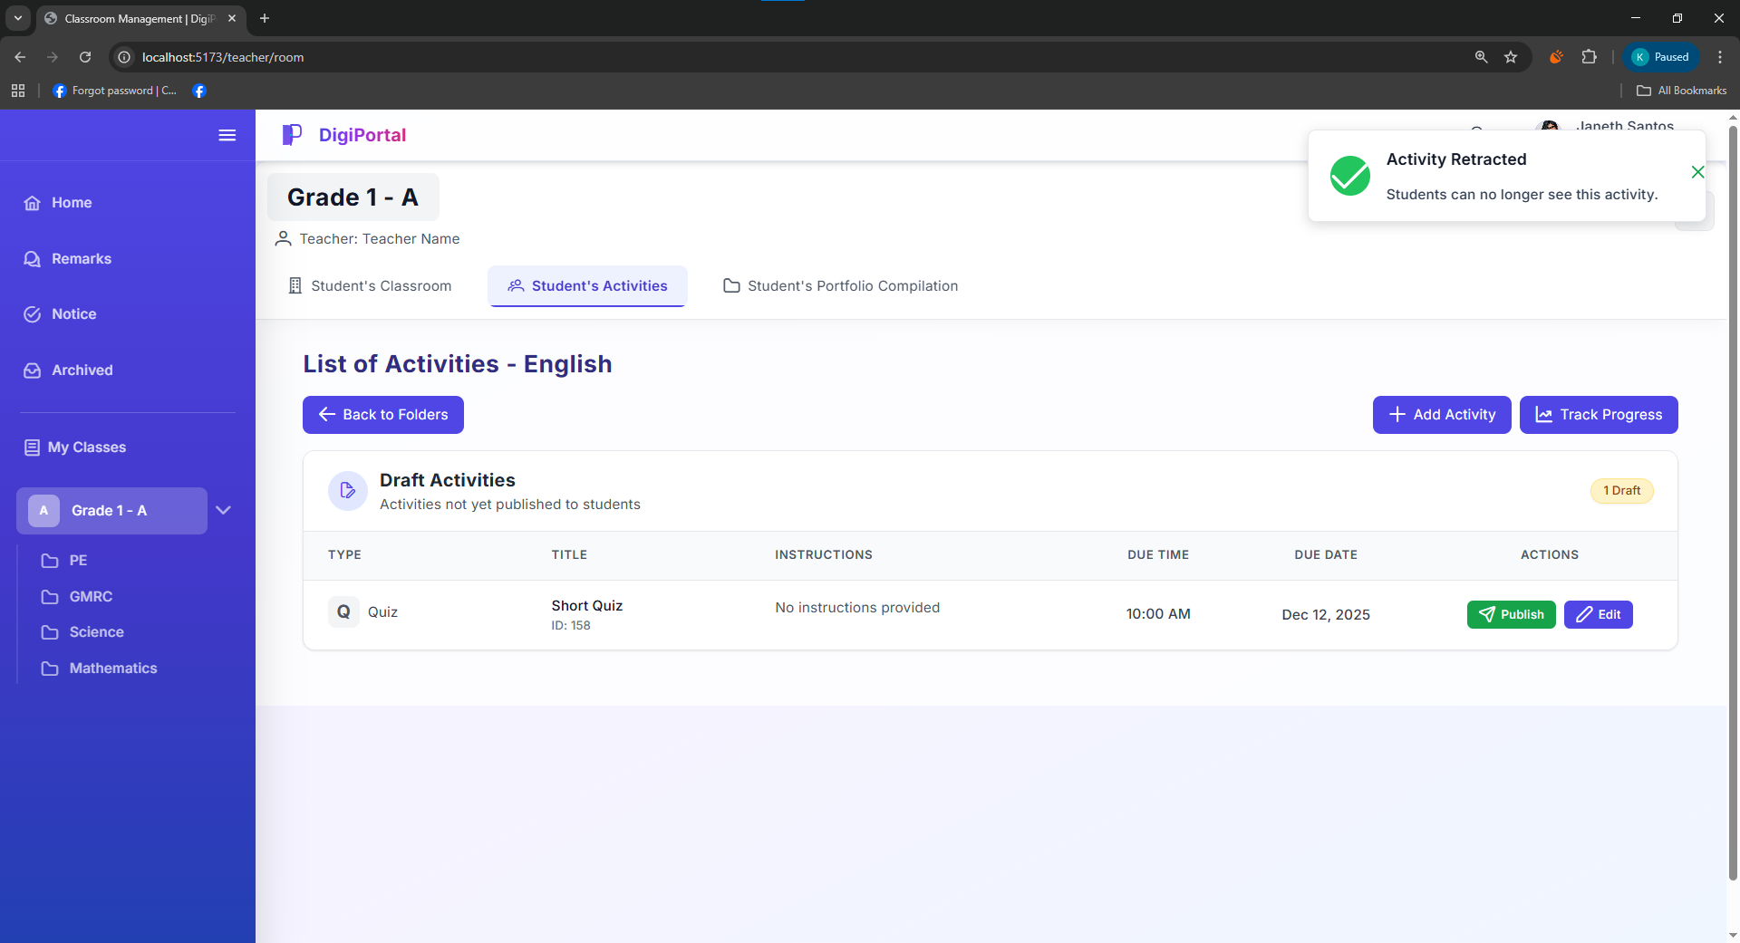
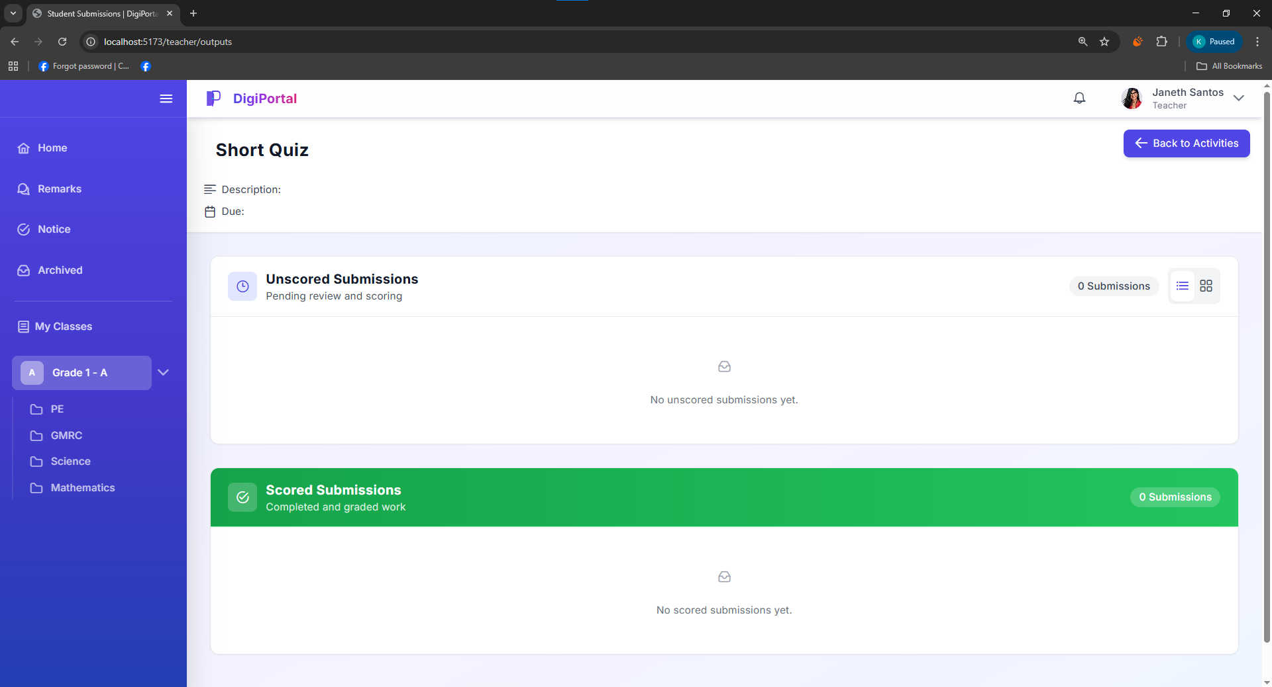
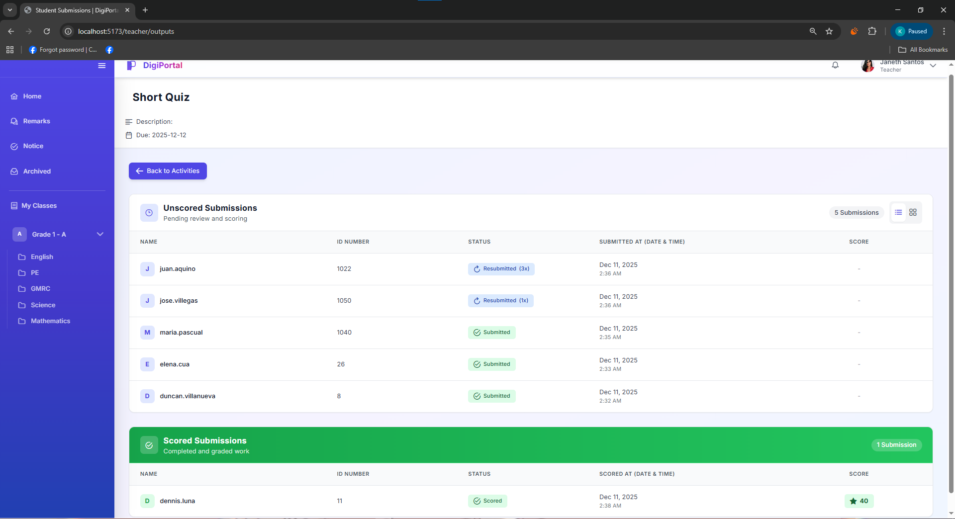
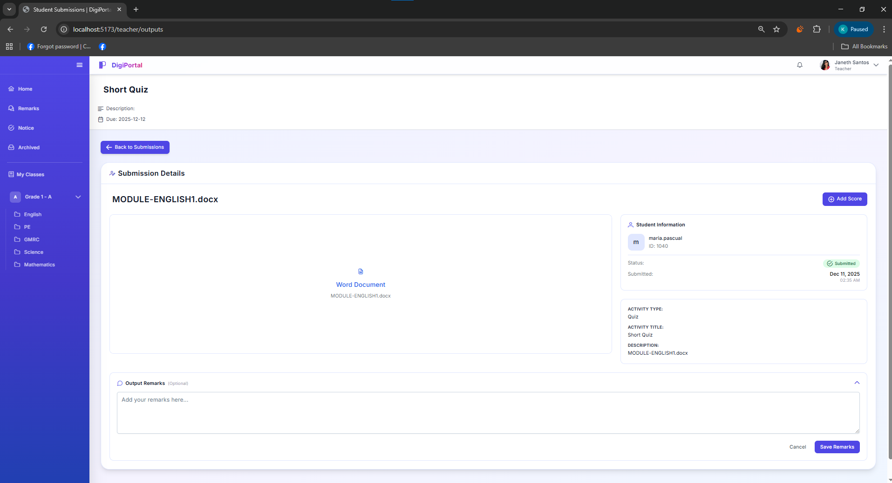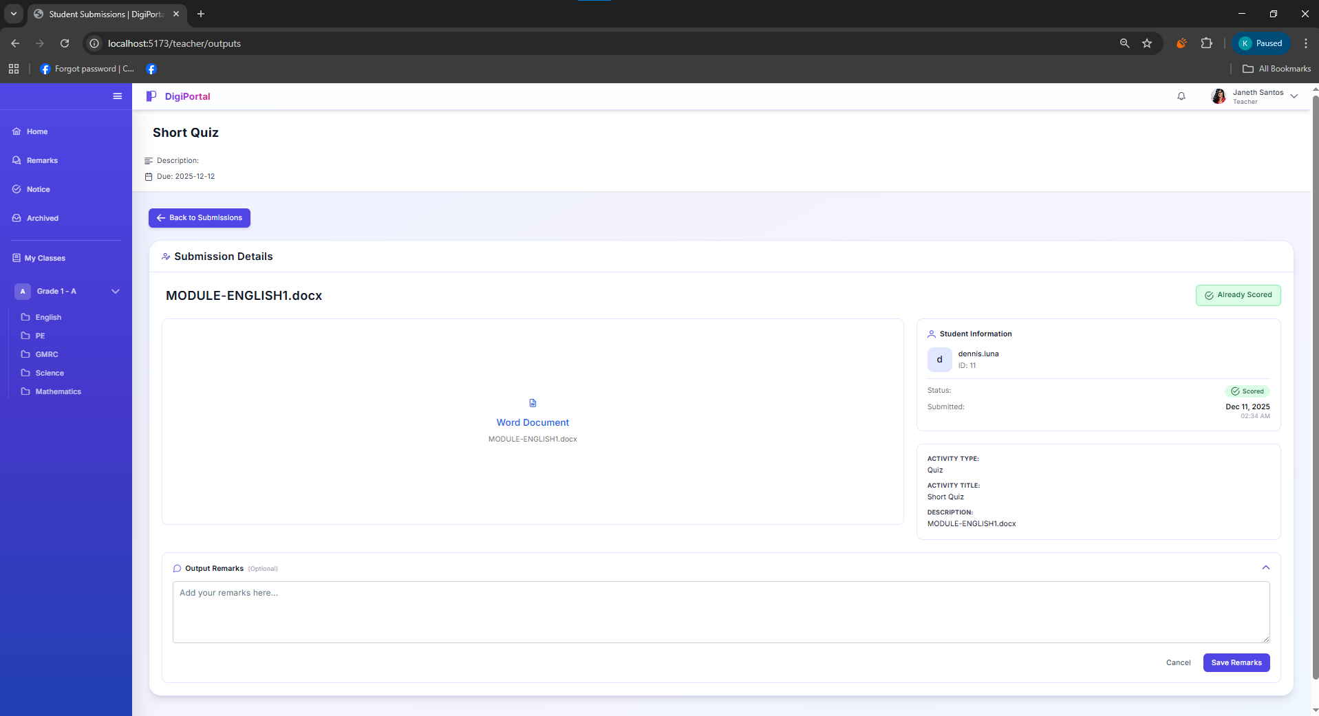
Figure 43. Digital Portfolio System Teacher User Interface Pupil’s Activities

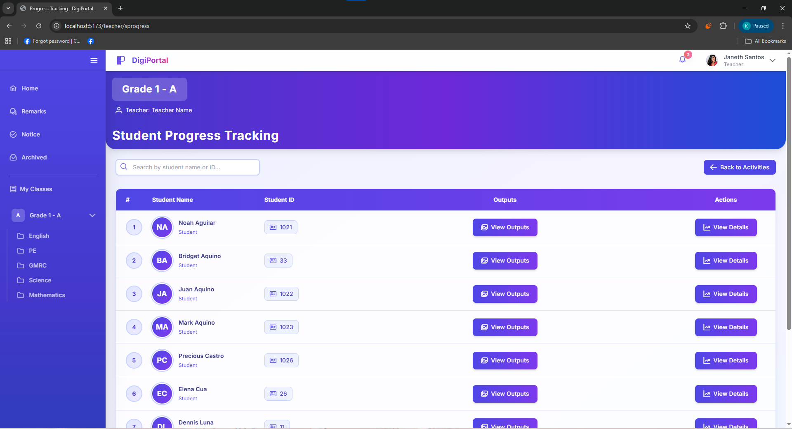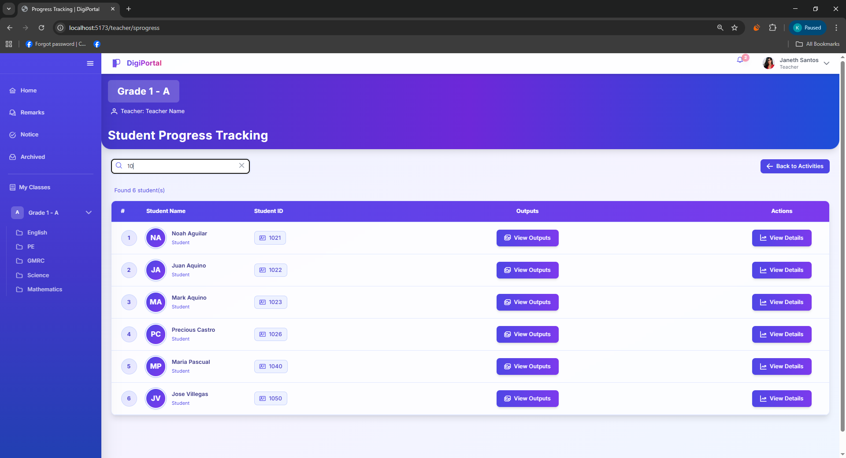
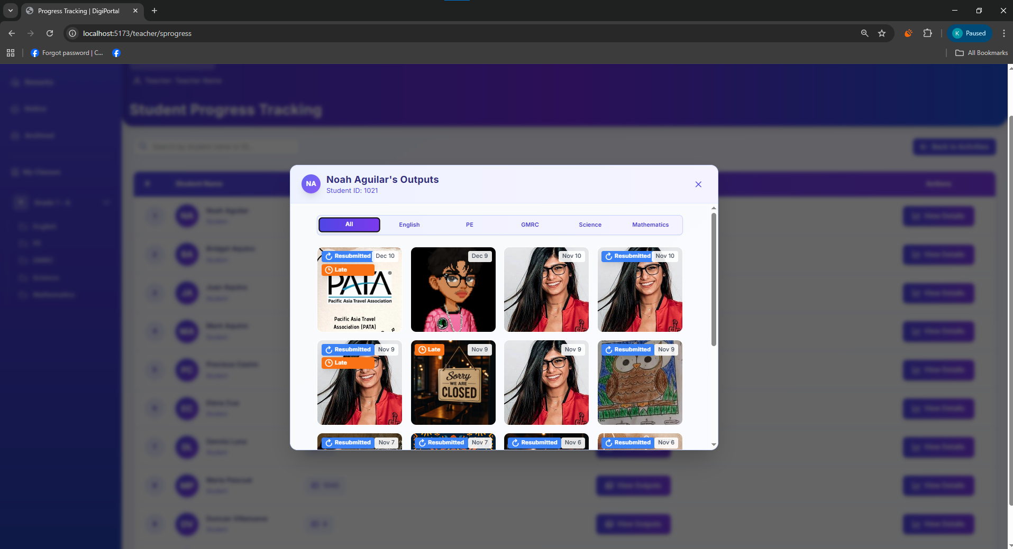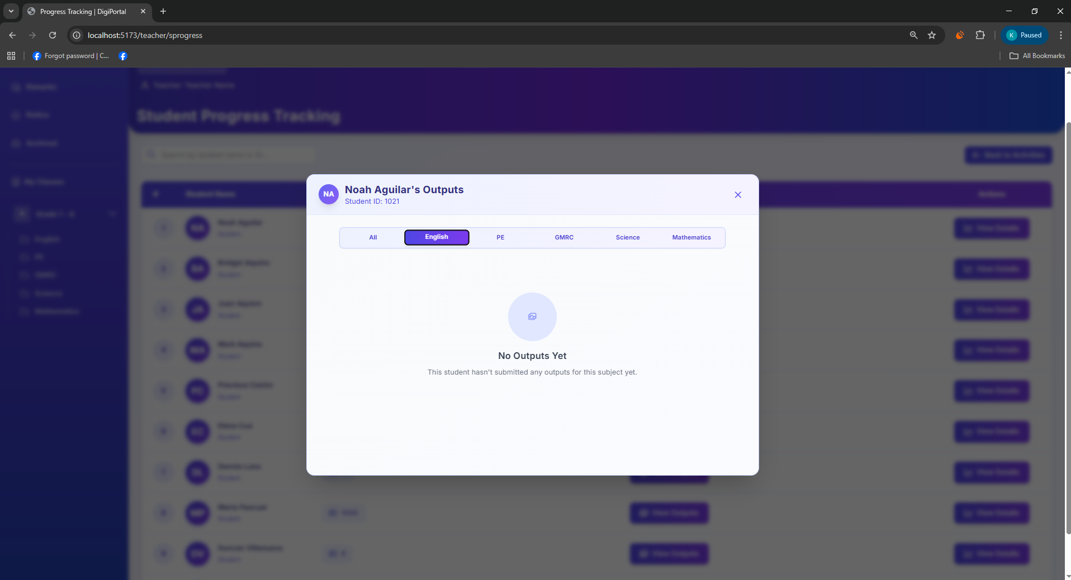
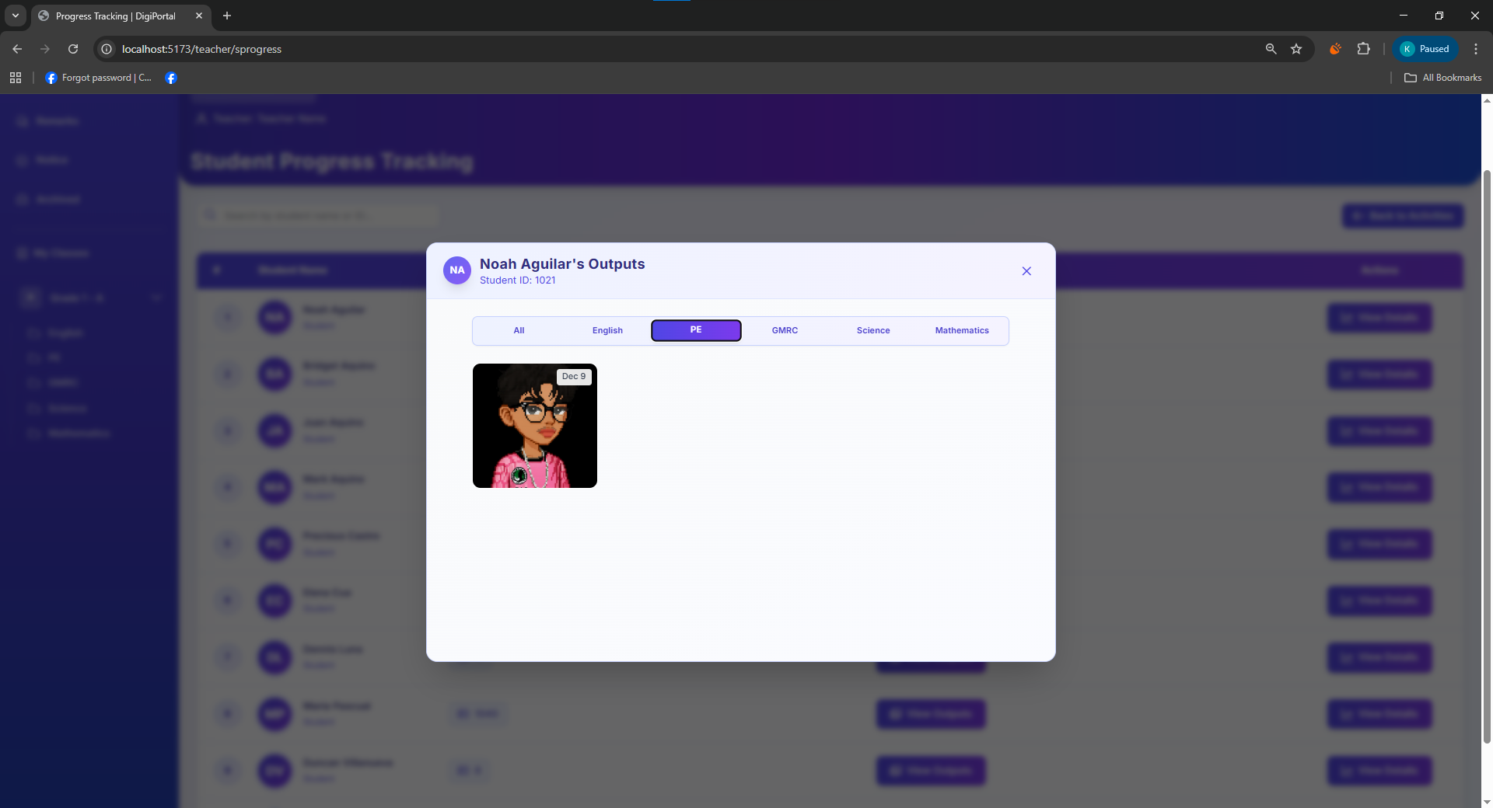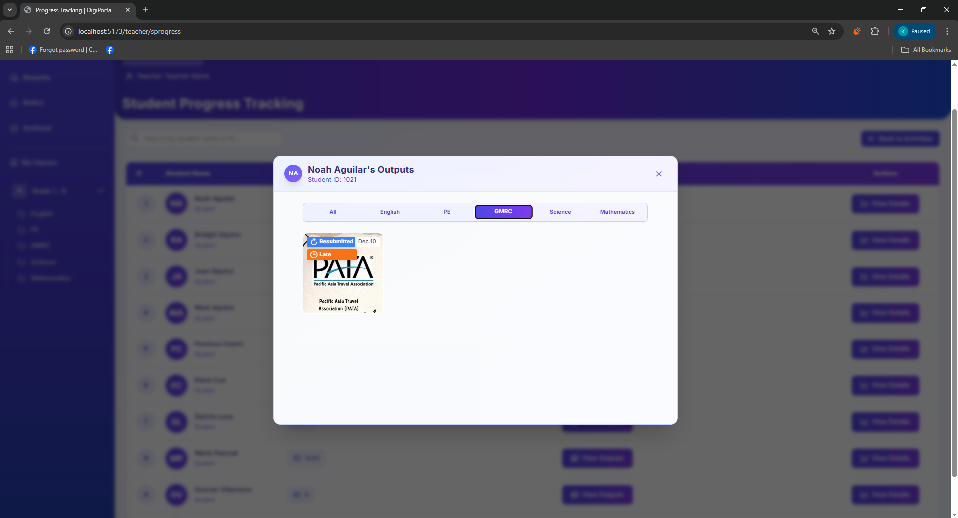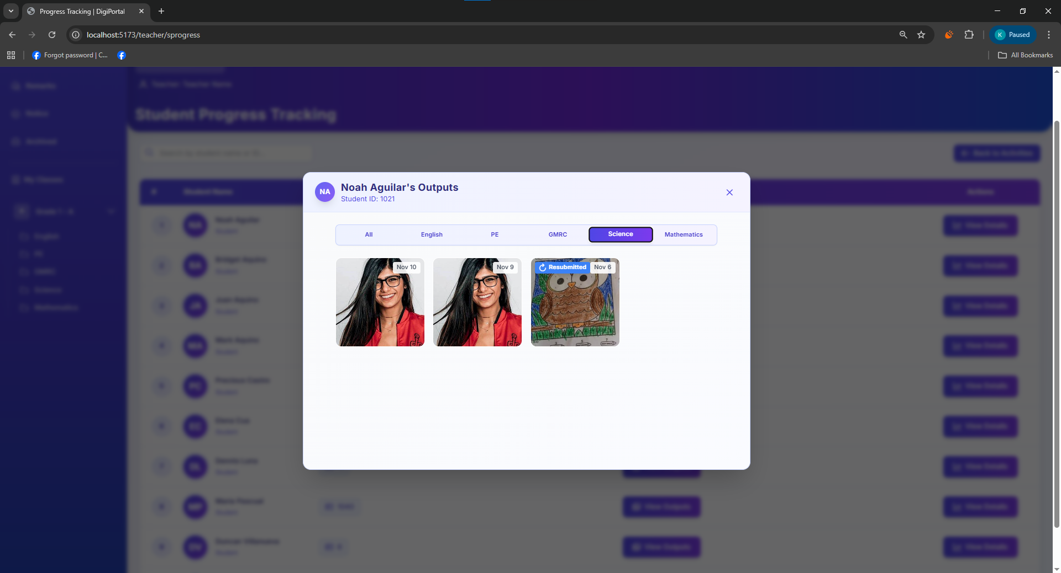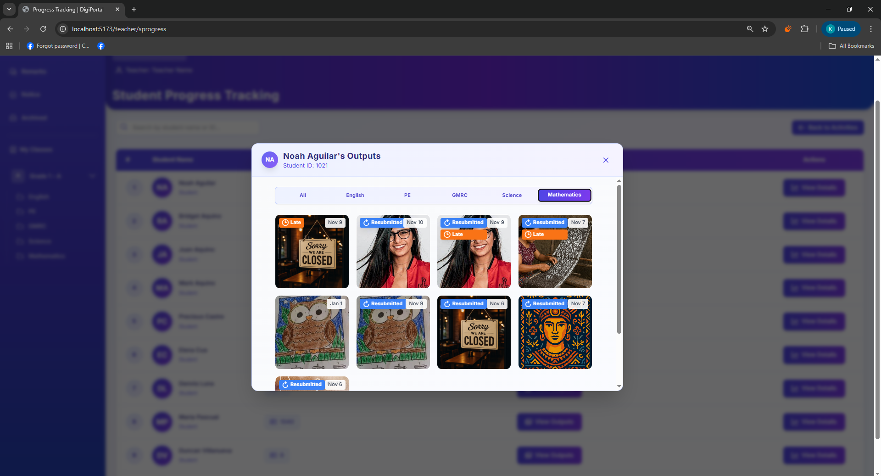
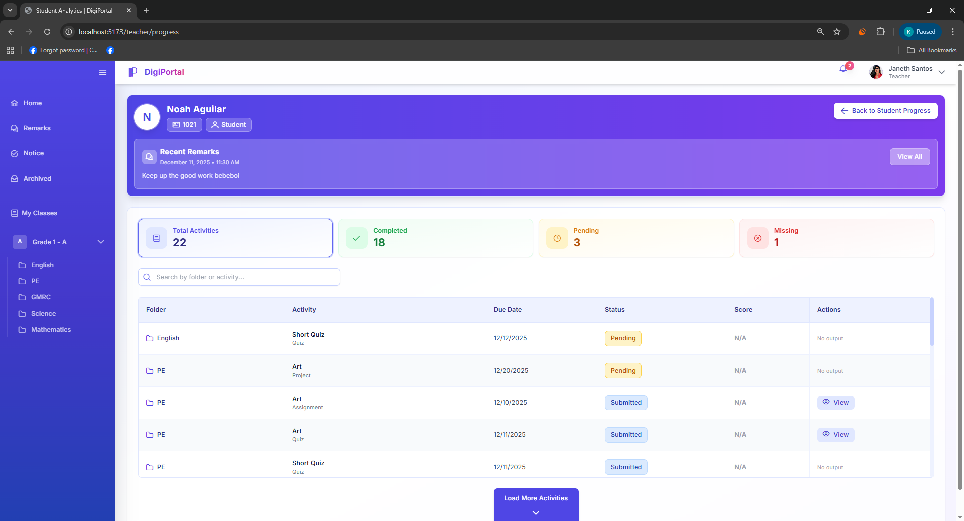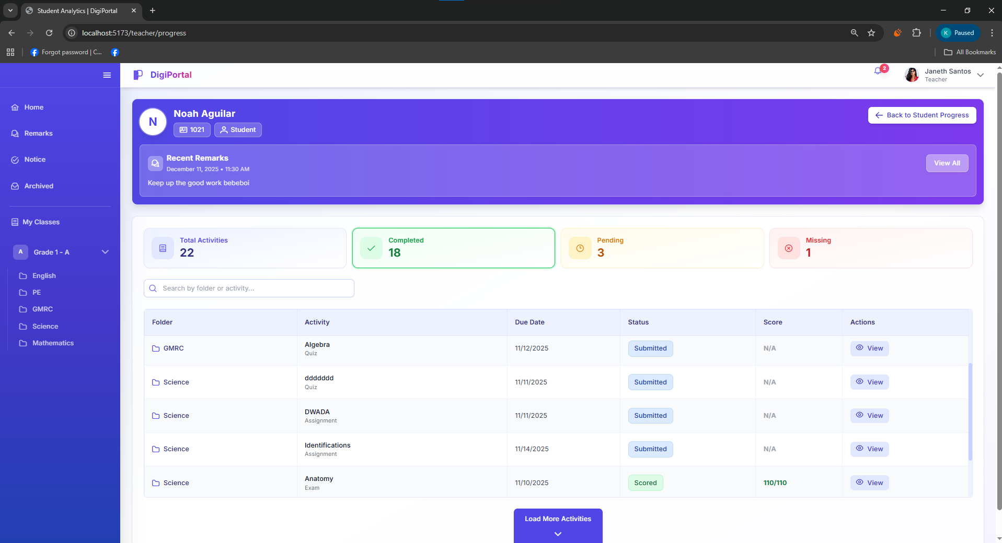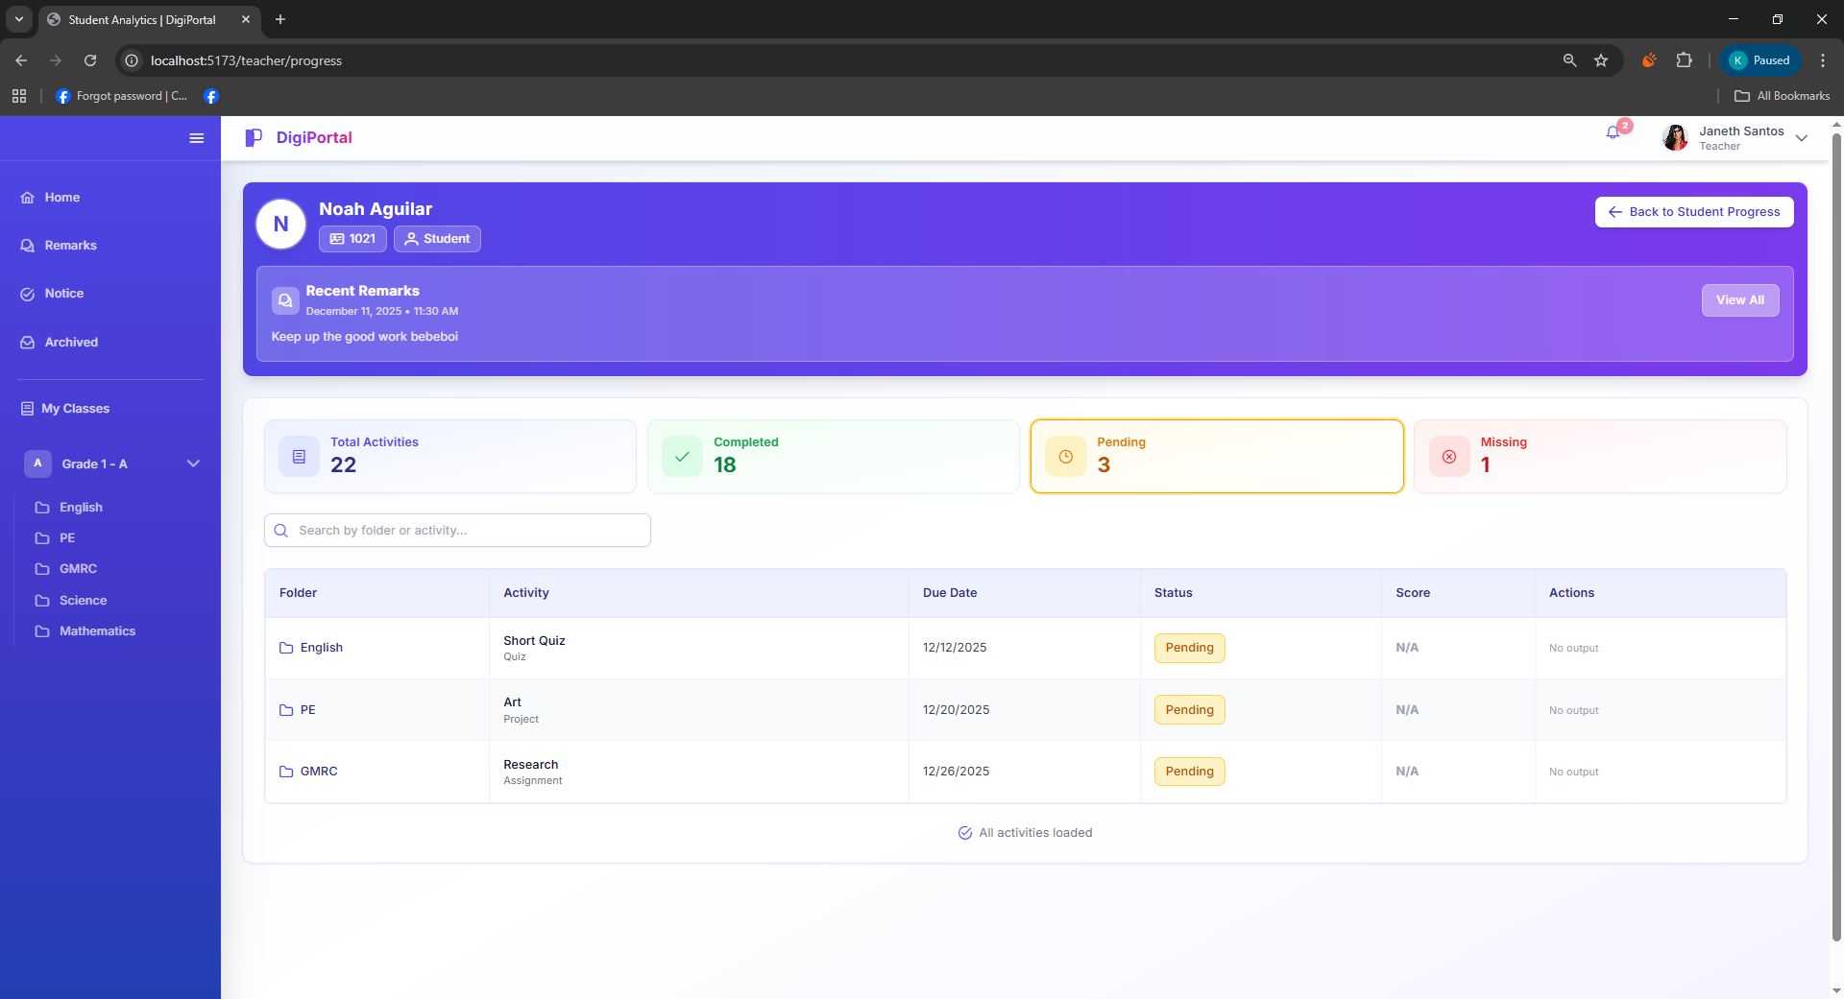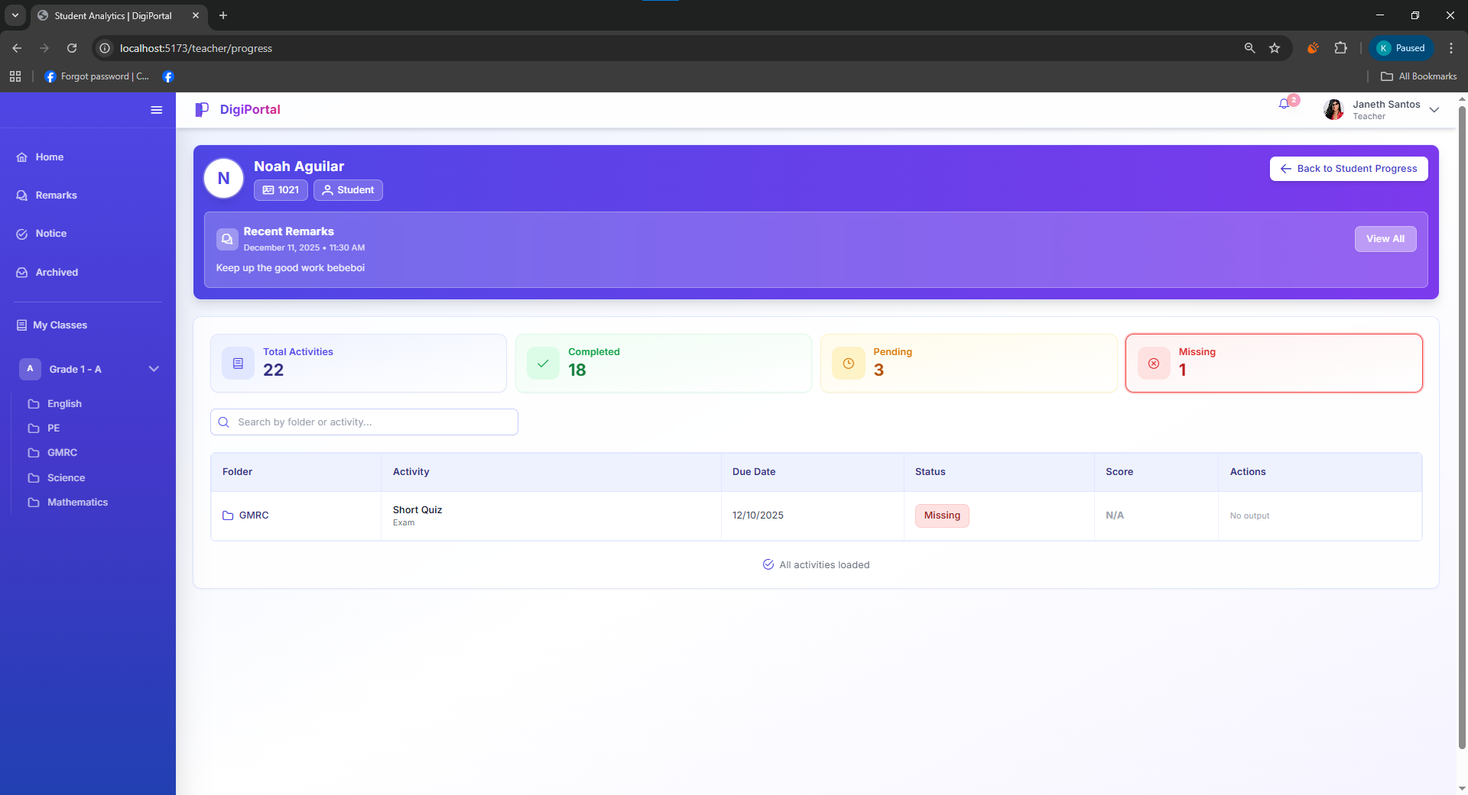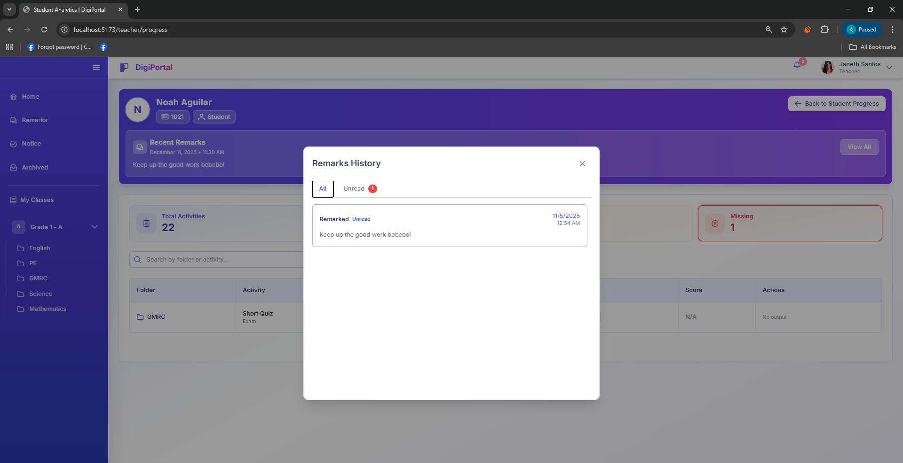
Figure 44. Digital Portfolio System Teacher User Interface Pupil’s Progress Tracking

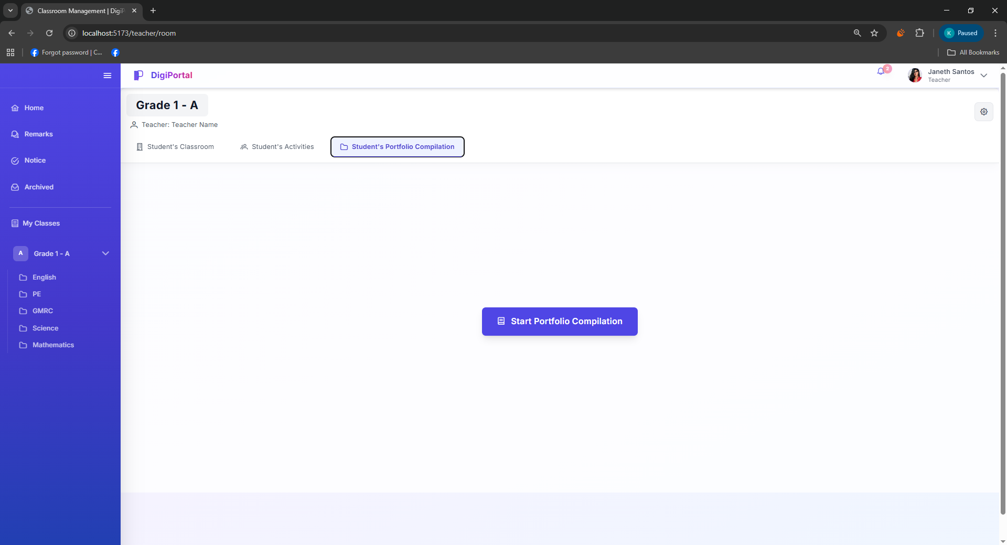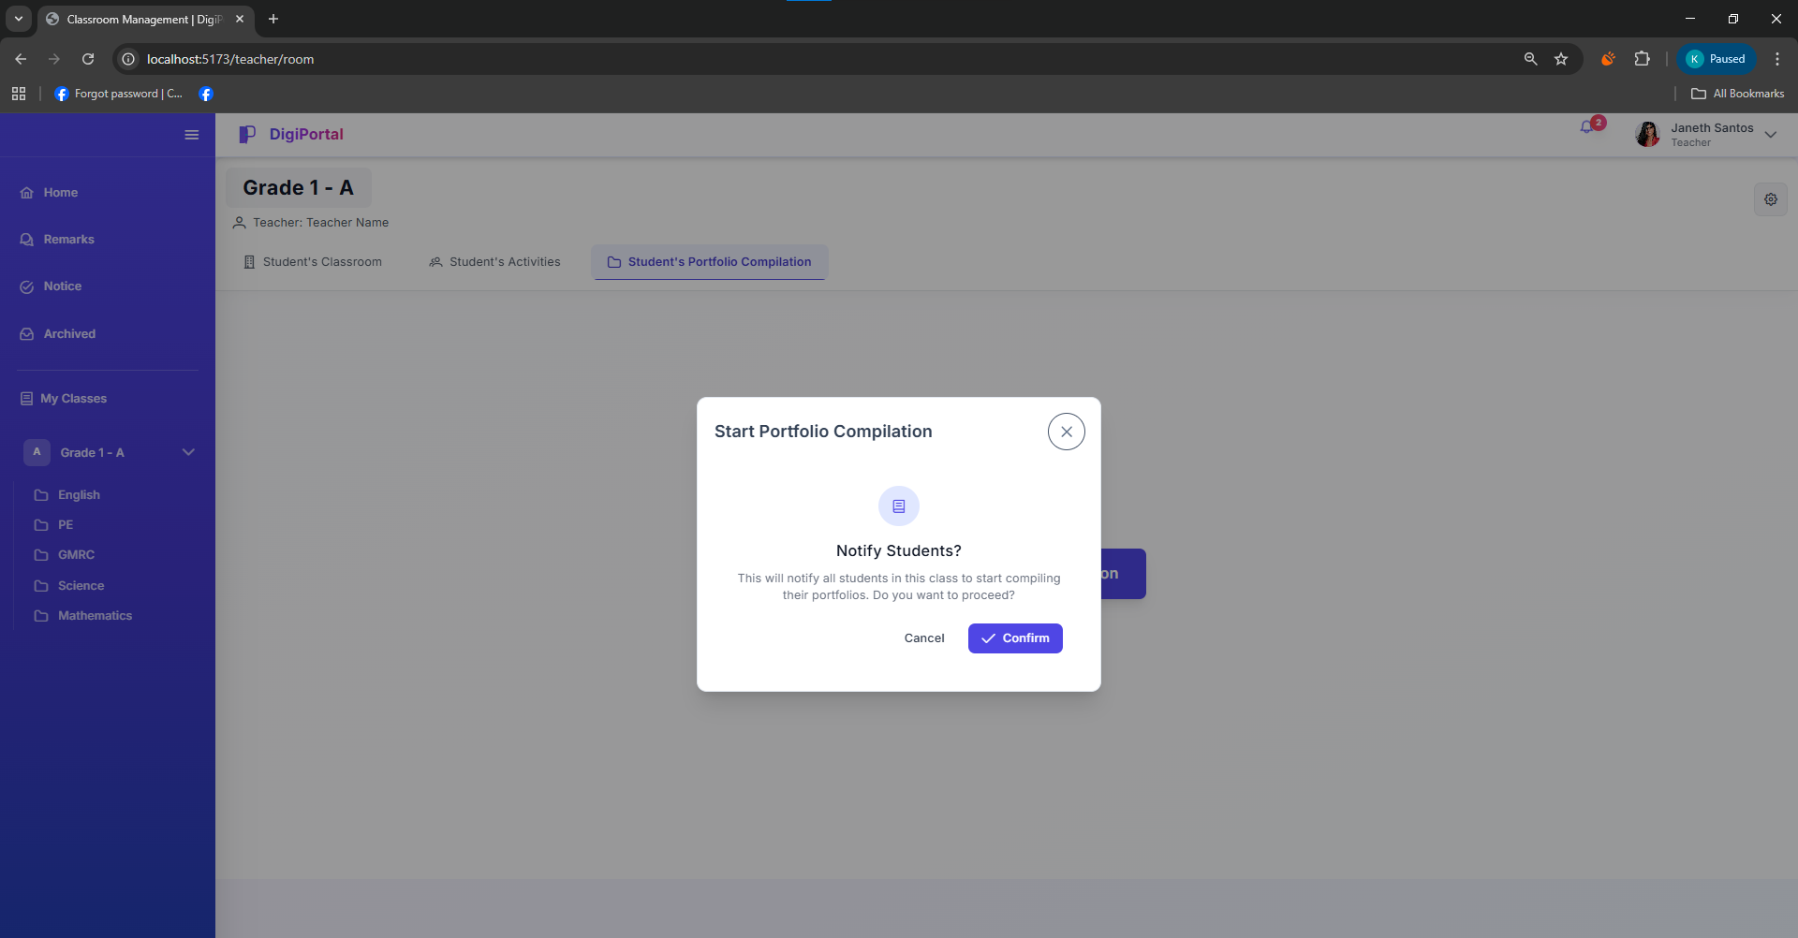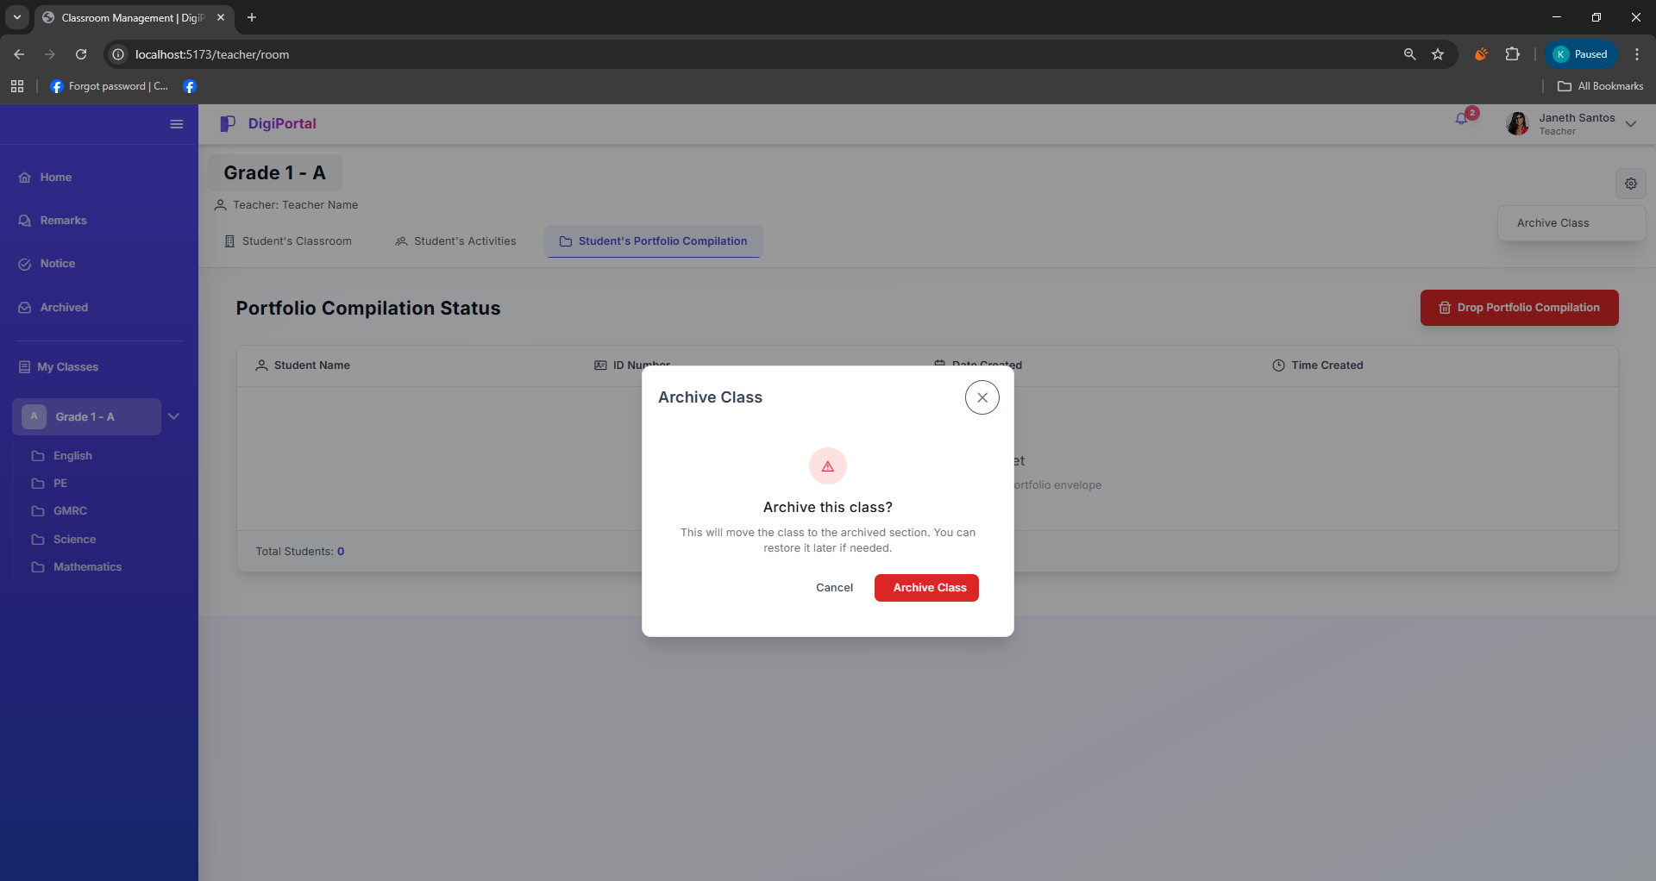
Figure 45. Digital Portfolio System Teacher User Interface Pupil’s Portfolio Compilation

Student User Interface
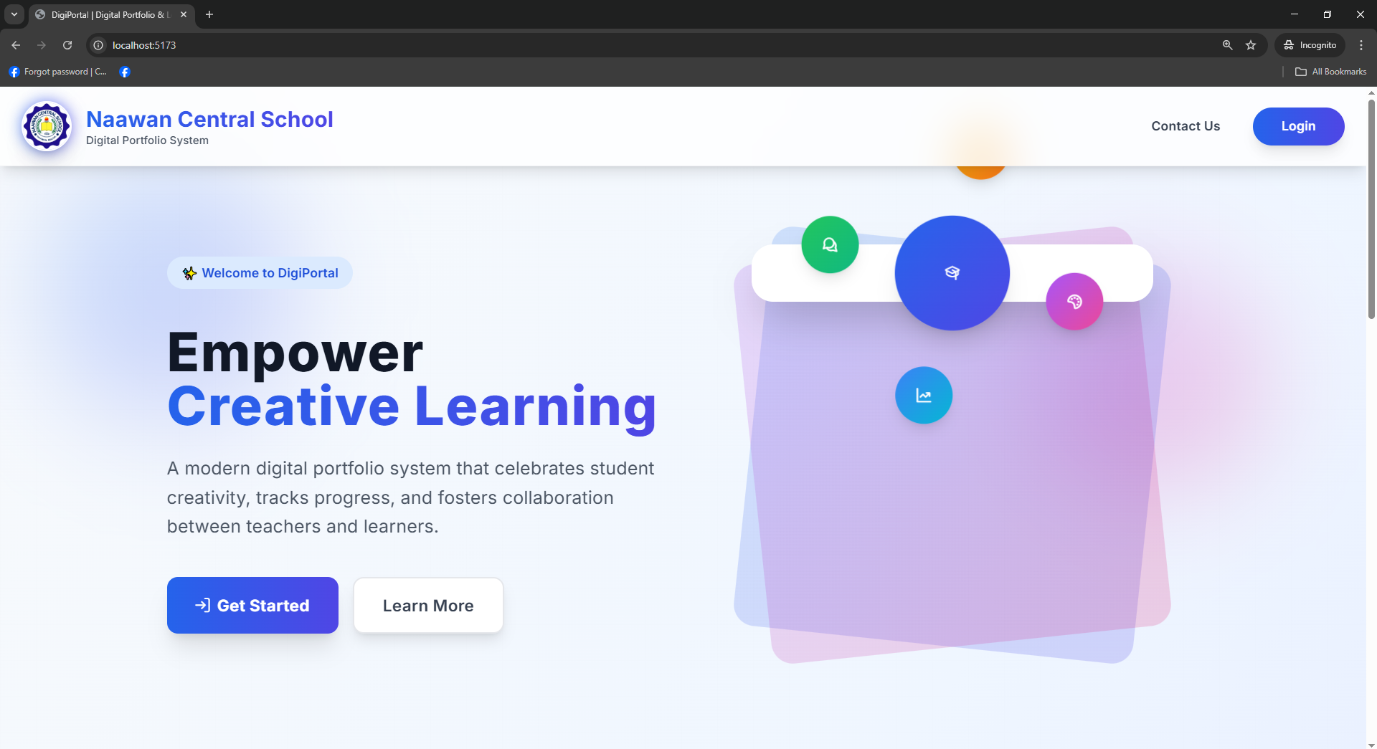

Figure 46 Digital Portfolio System Student User Interface Landing Page
The figure shows the graphical user interface of the student landing page.

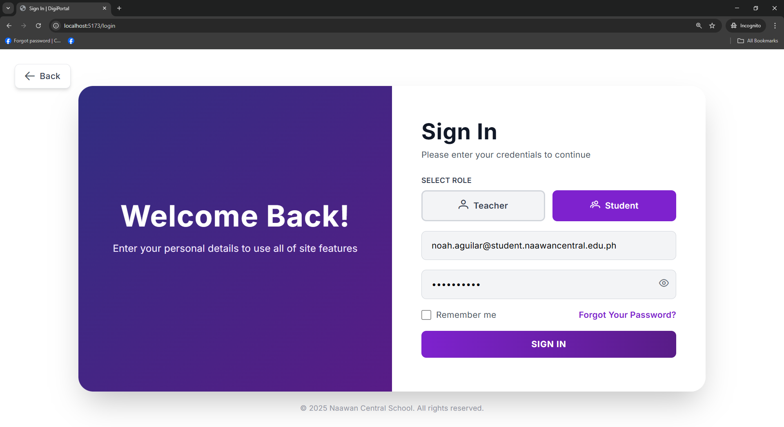
Figure 47 Digital Portfolio System Student User Interface Login Page
Figure 47 shows the graphical user interface of the selected role Student Login Form

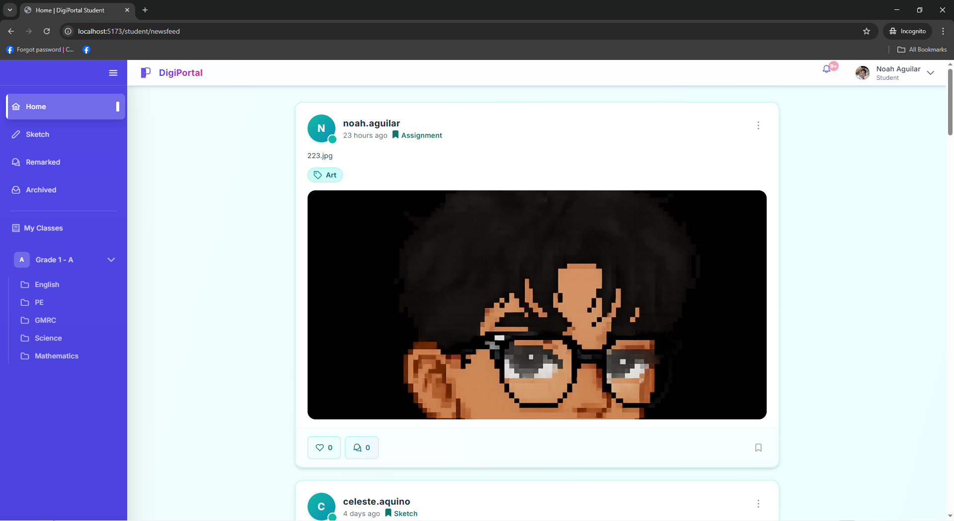
Figure 48 Digital Portfolio System Student User Interface Home/Newsfeed Page
Figure 49 Digital Portfolio System Student User Interface Notification Page

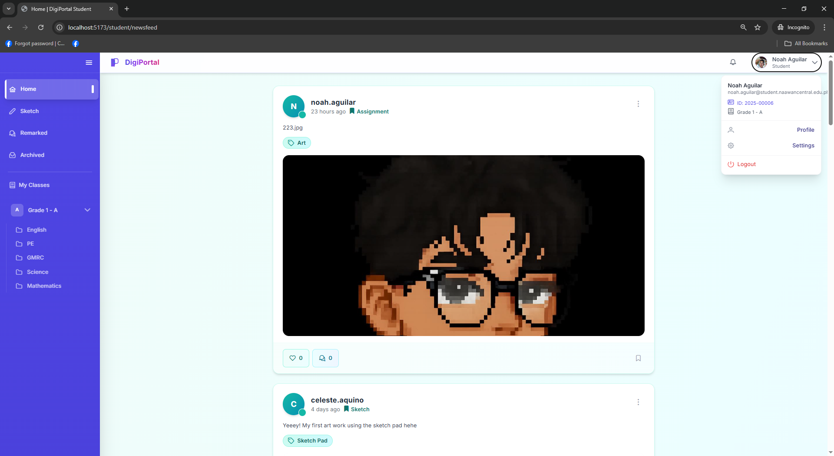
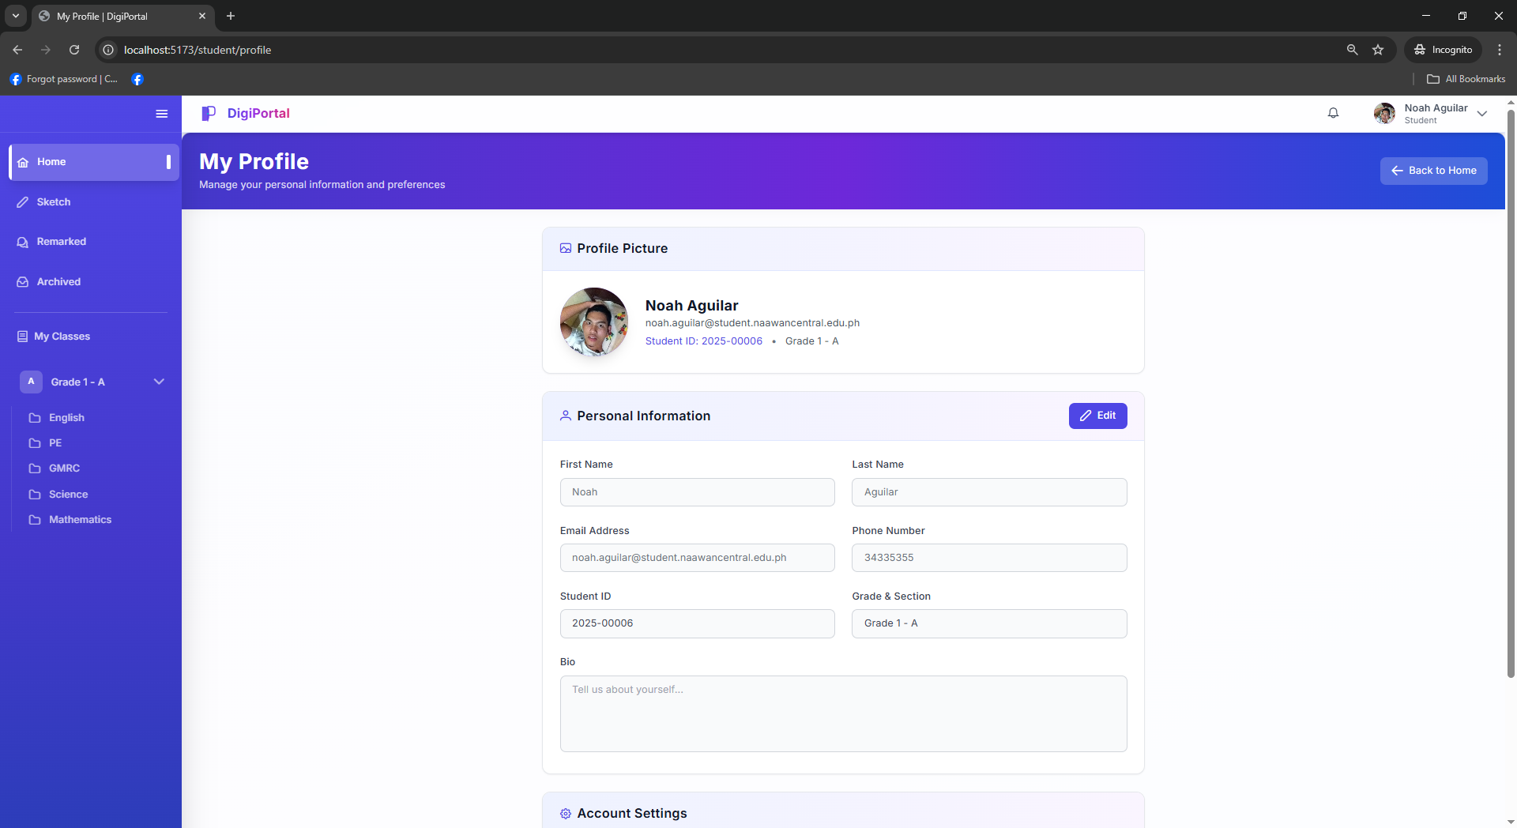
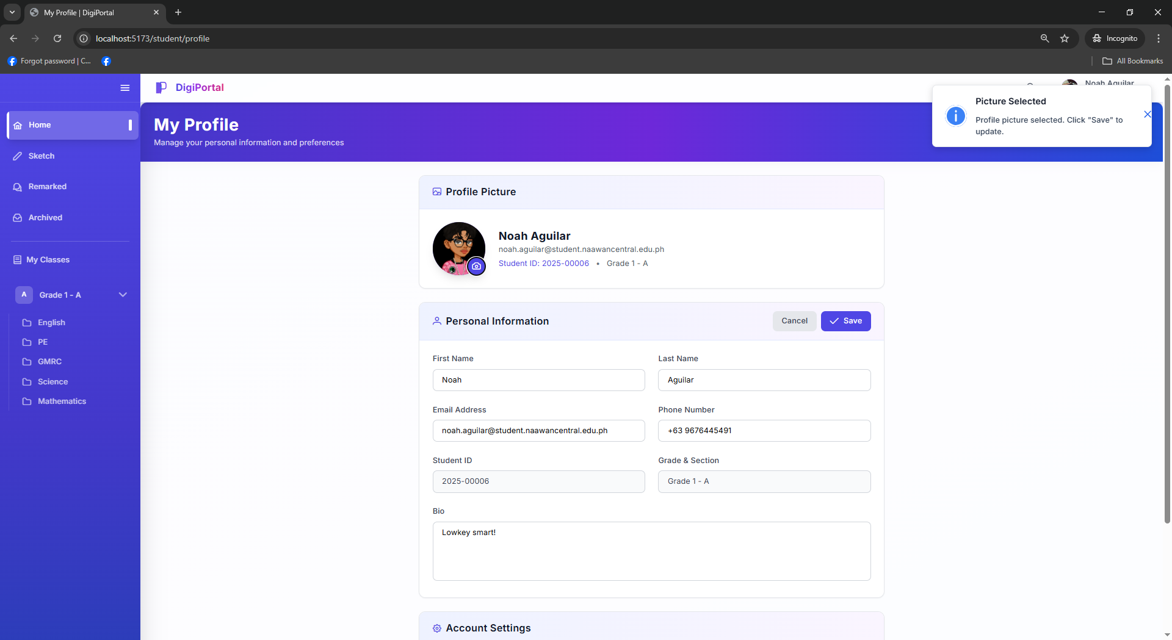
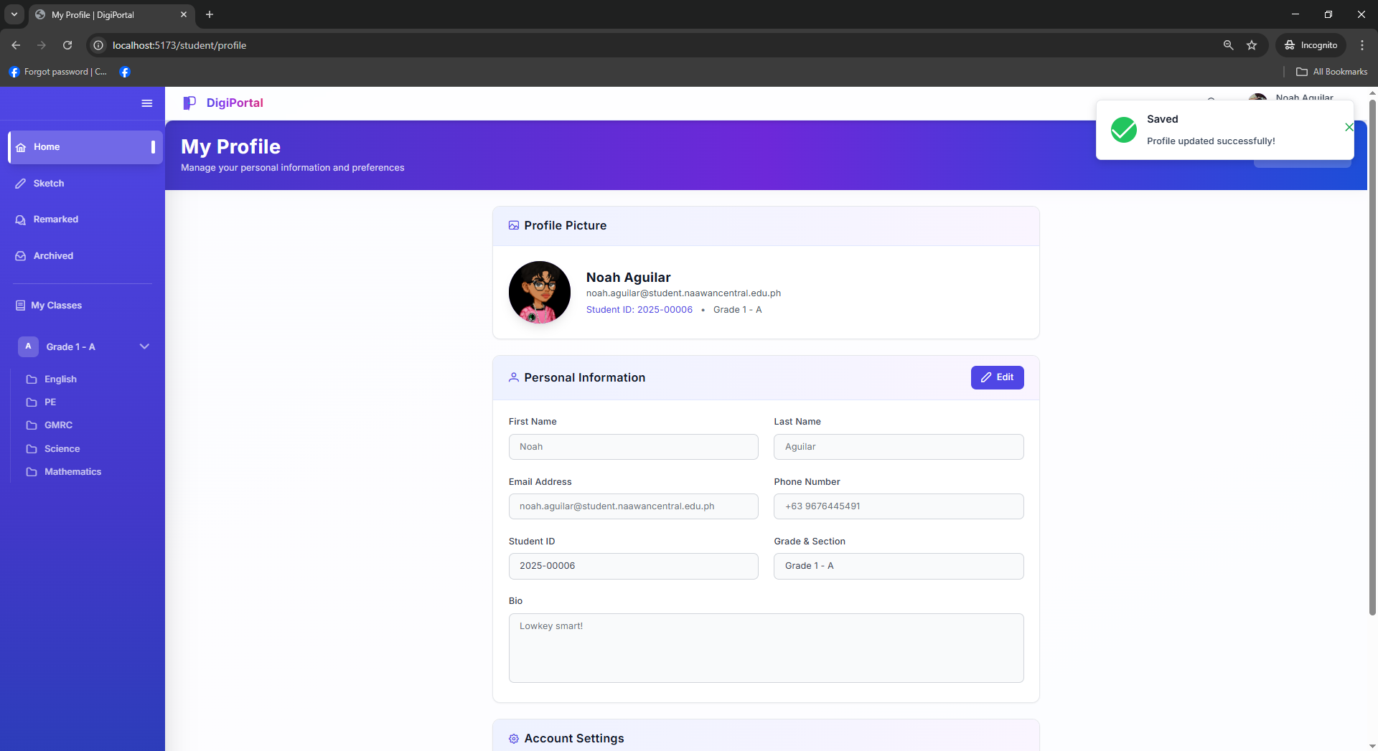
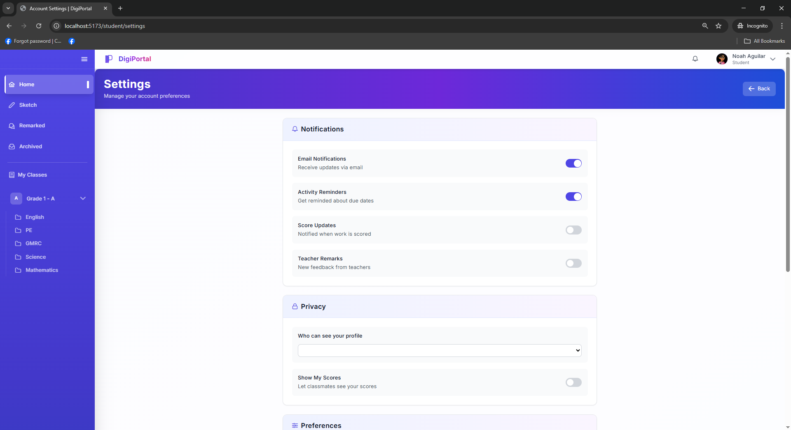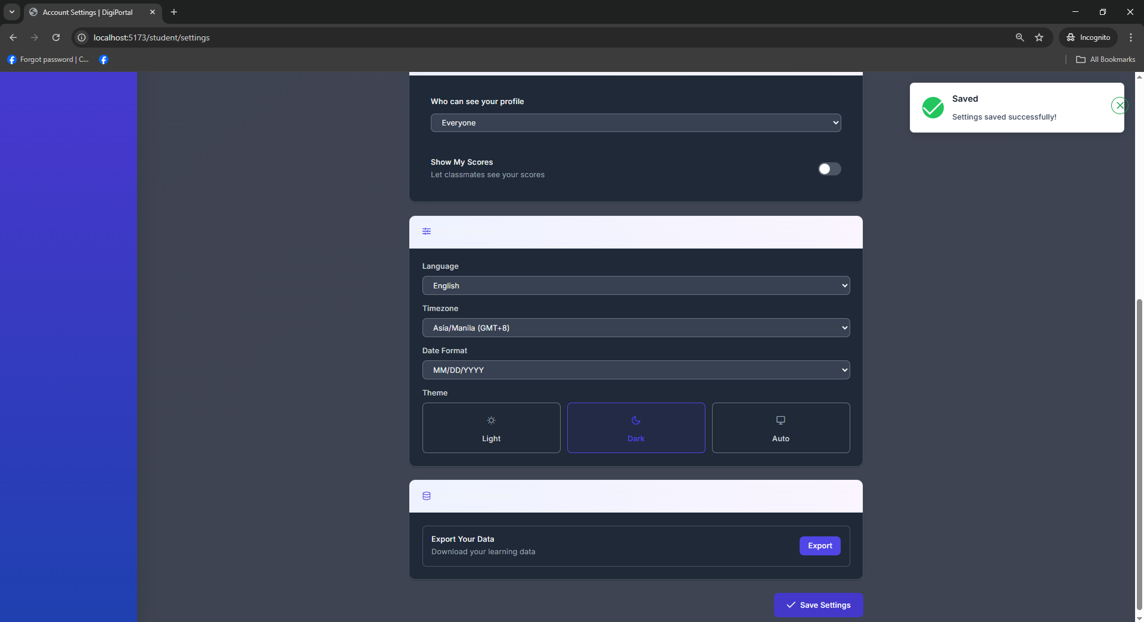
Figure 50 Digital Portfolio System Student User Interface Manage User Profile
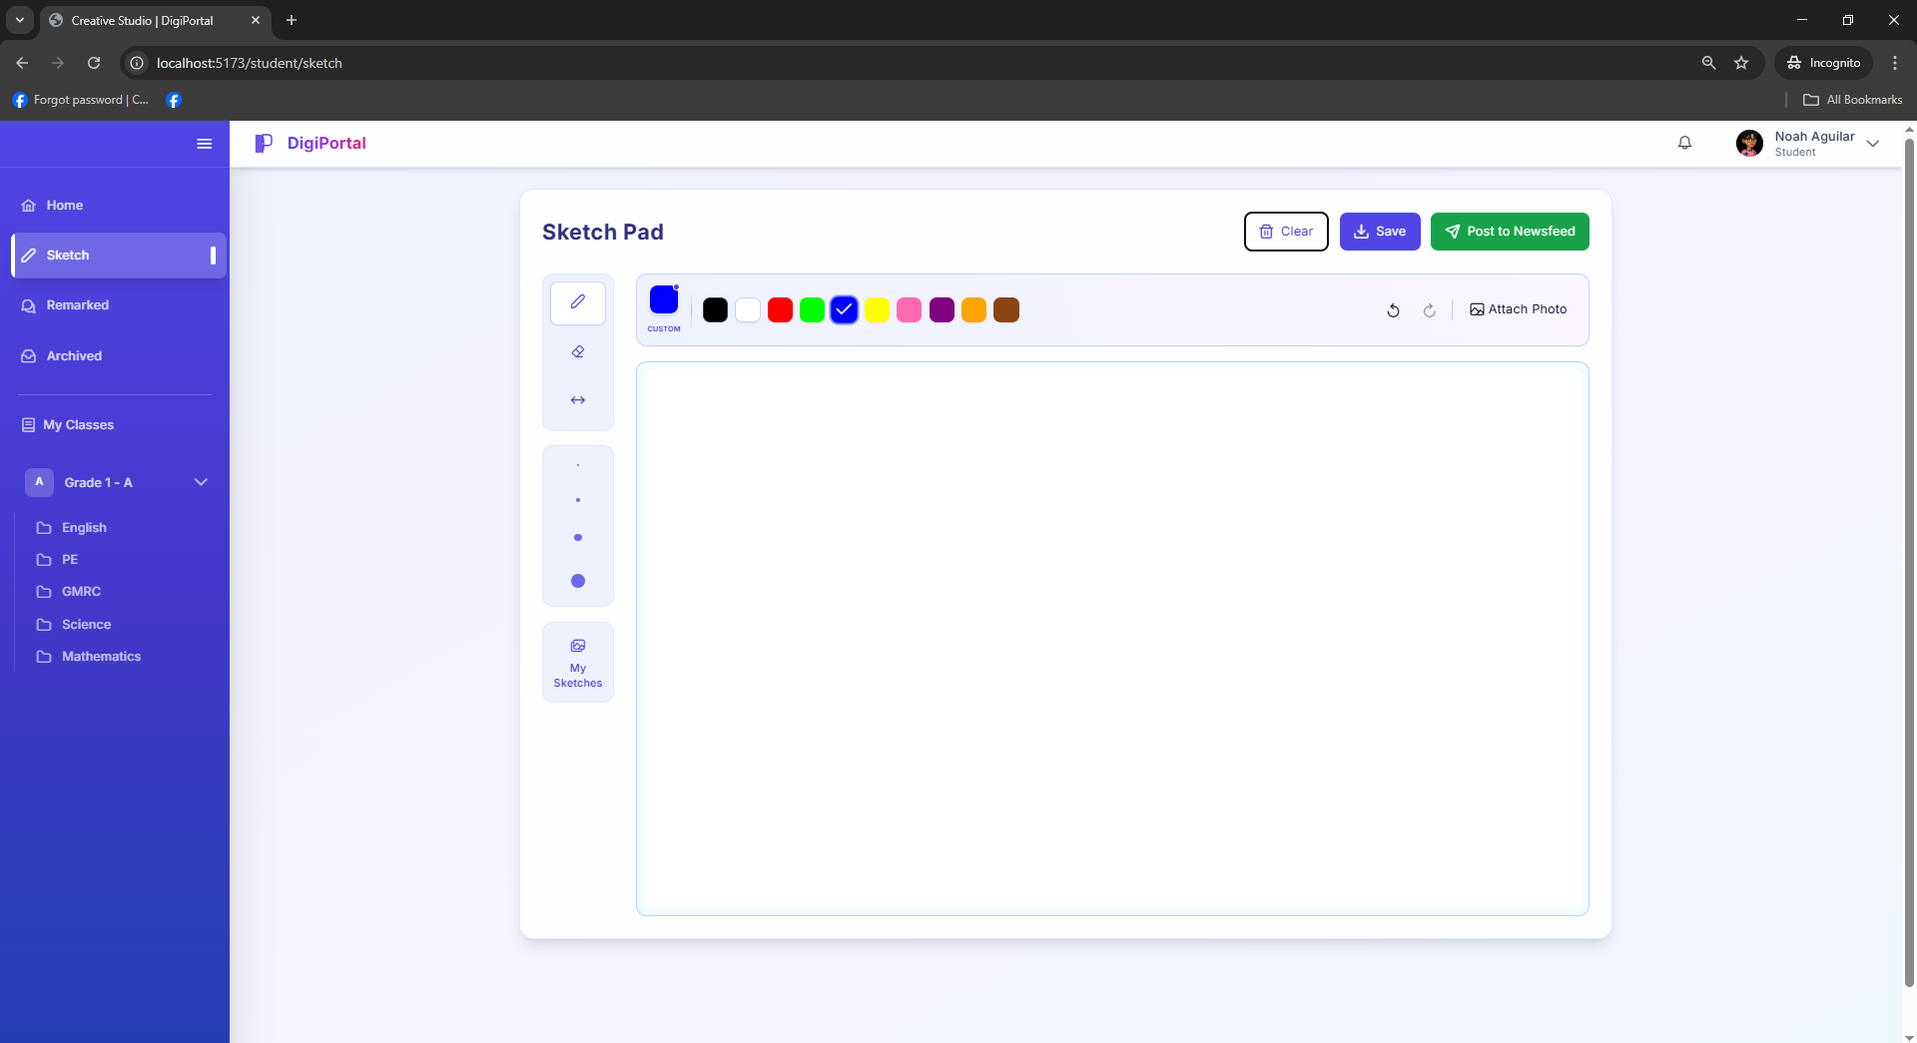
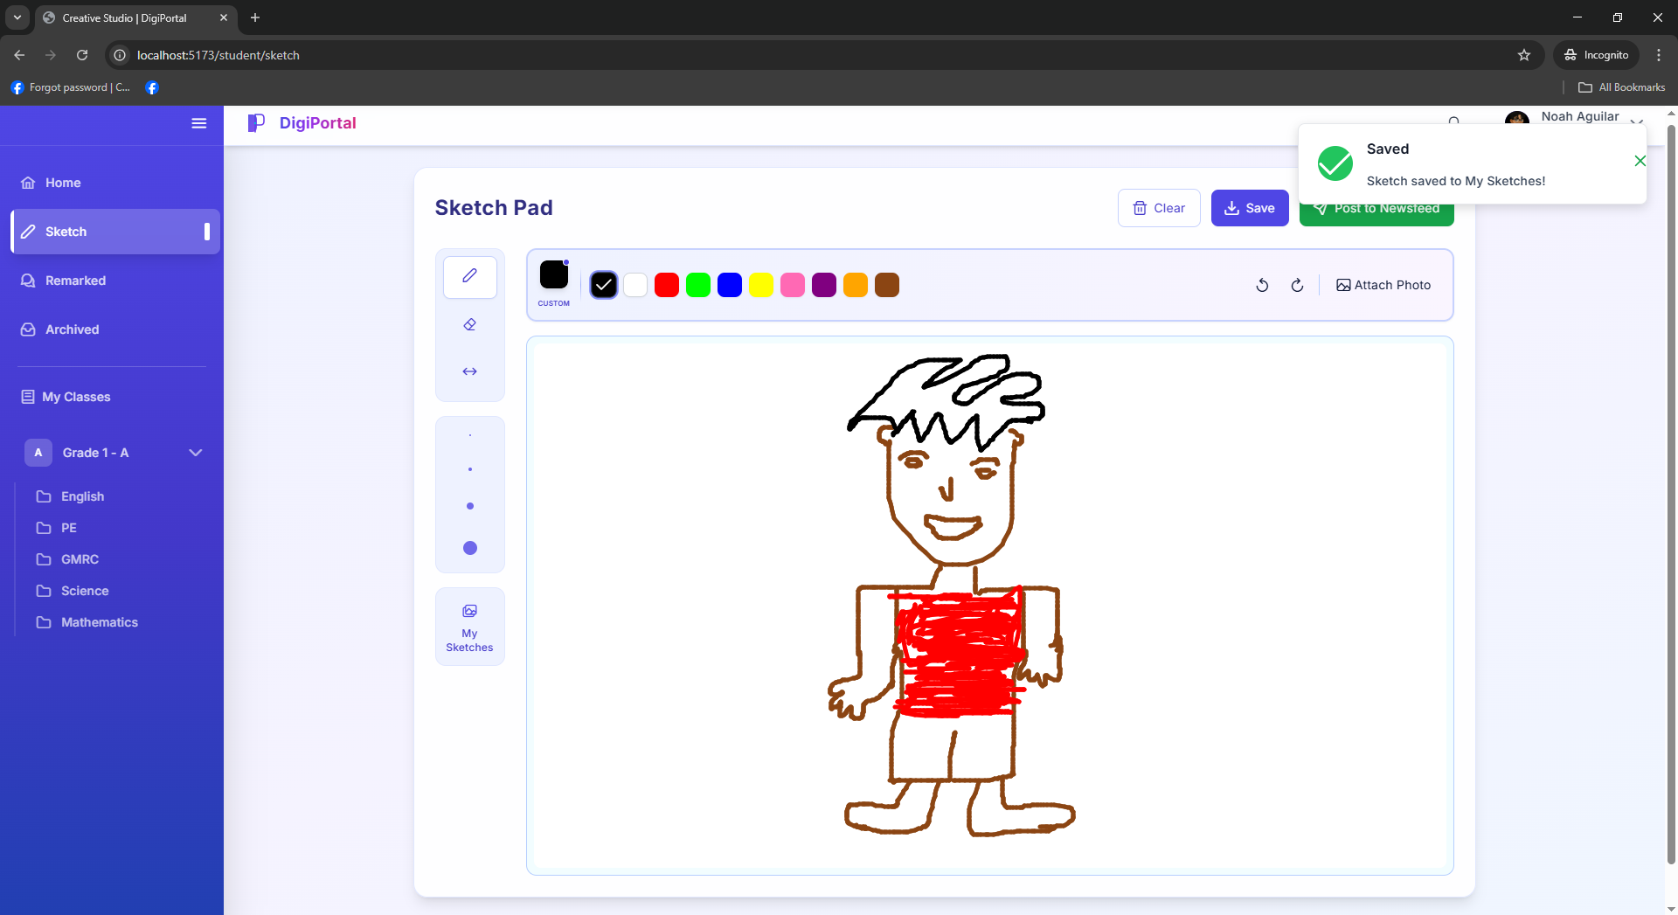
Figure 51 Digital Portfolio System Student User Interface Sketch Pad Page
Figure 52 Digital Portfolio System Student User Interface My Remarks Page
Figure 53 Digital Portfolio System Student User Interface My Archived Classes Page
Figure 54. Digital Portfolio System Student User Interface My Archived Classes in Portfolio List
Figure 55. Digital Portfolio System Student User Interface My Archived Classes in Portfolio List of Activities
Figure 56. Digital Portfolio System Student User Interface My Classroom List
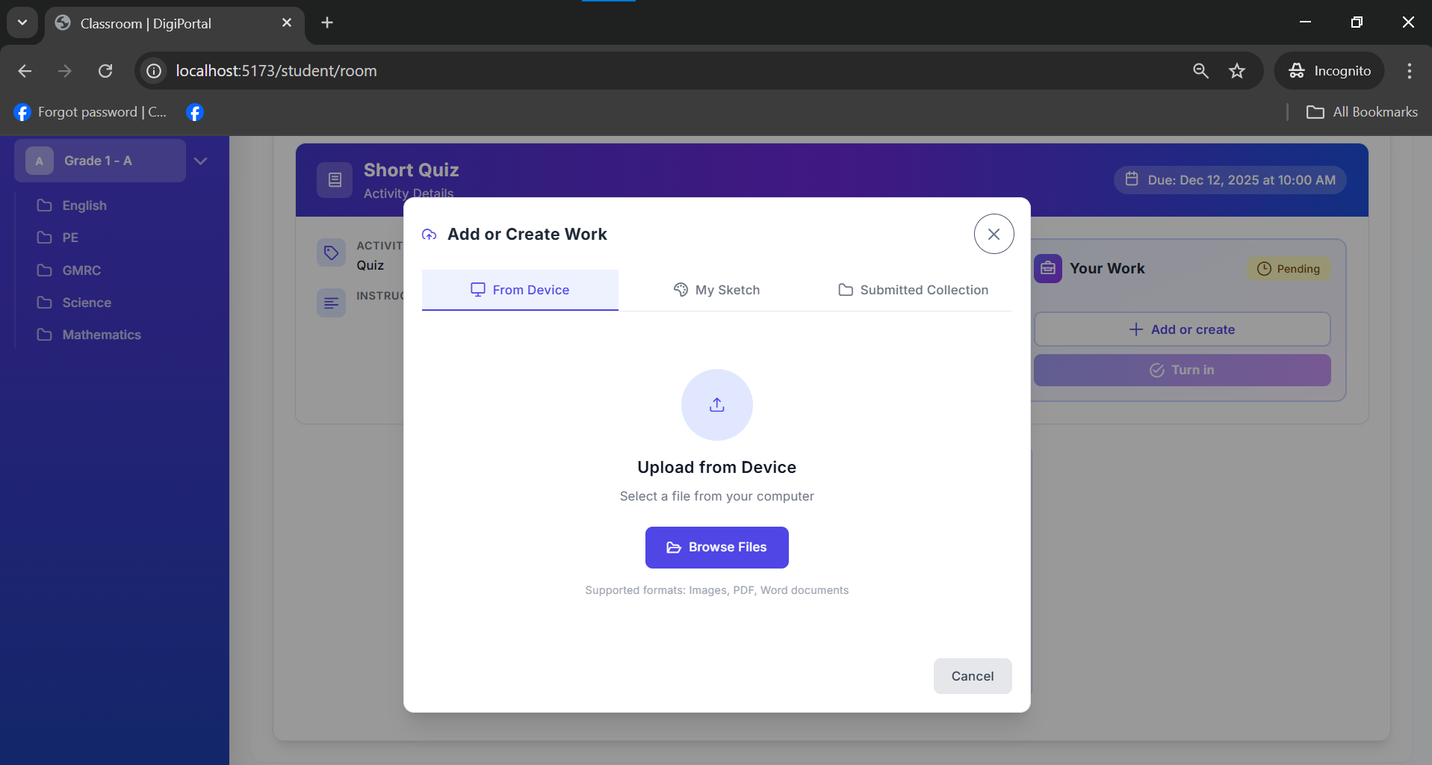
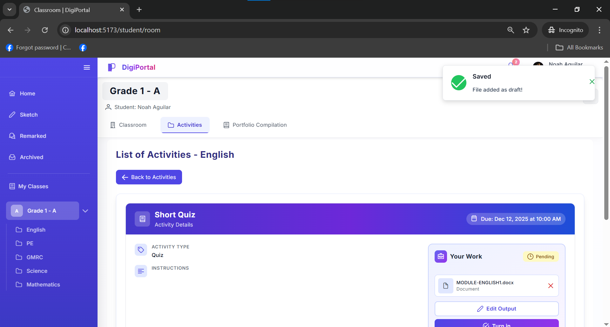
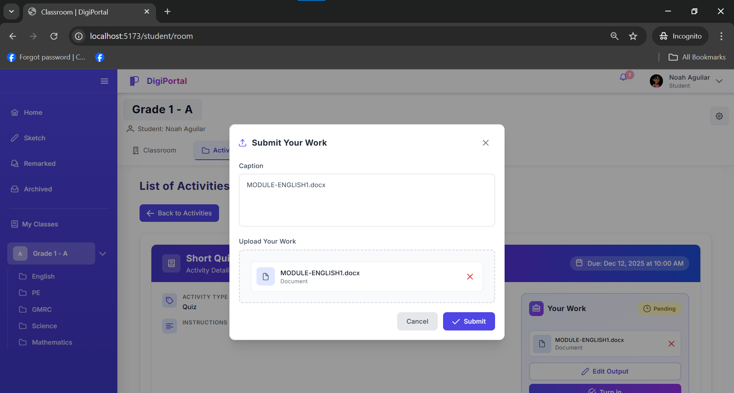
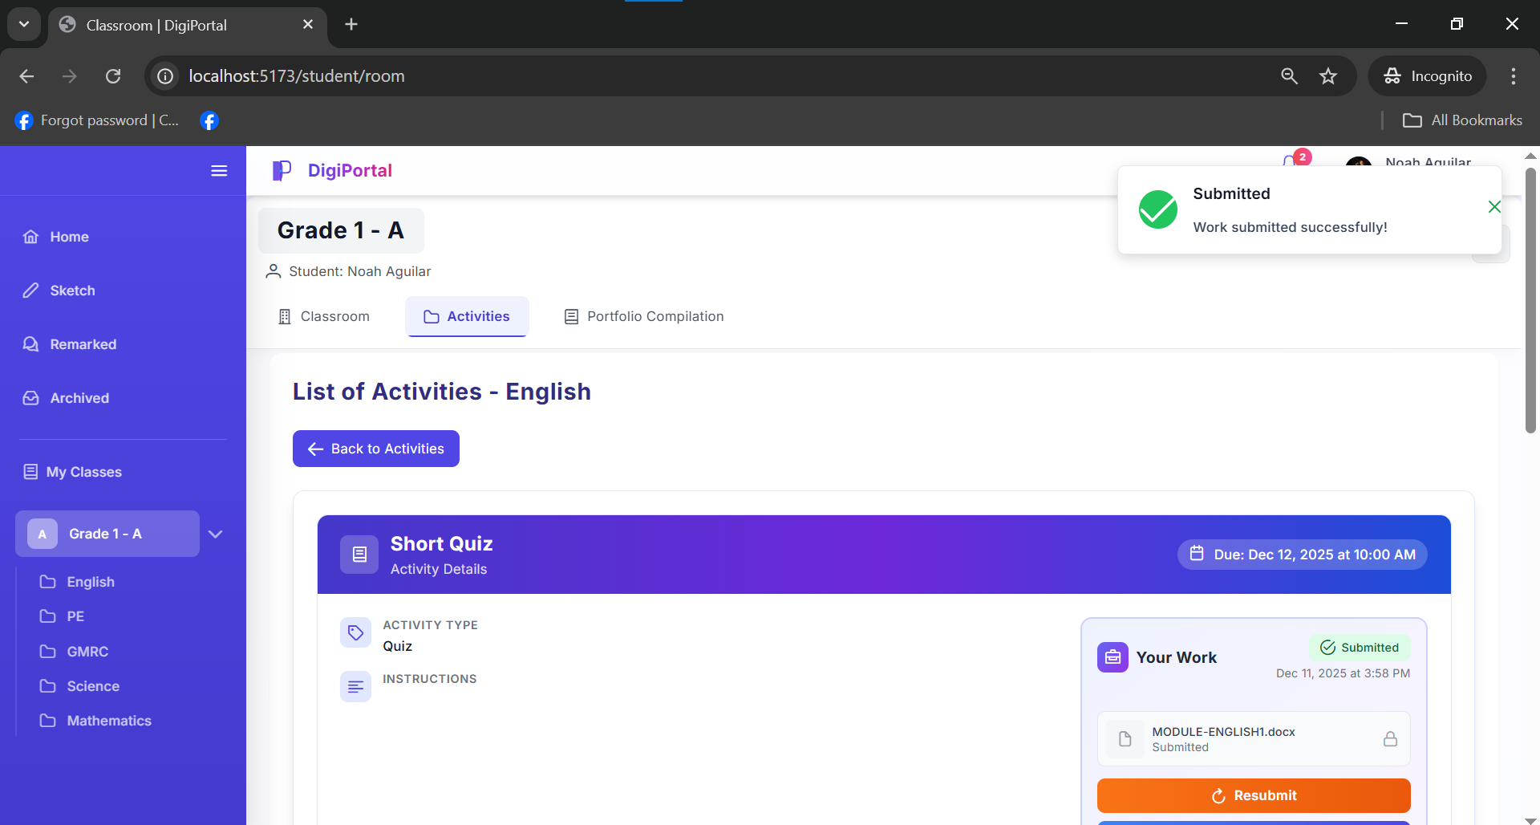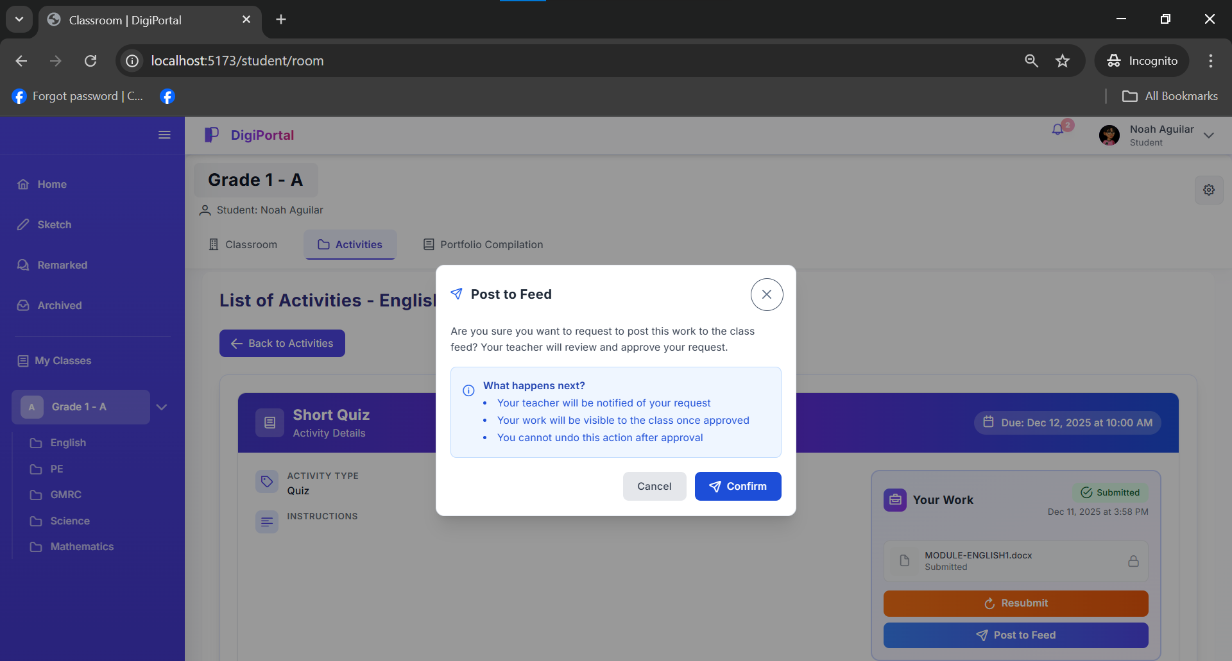
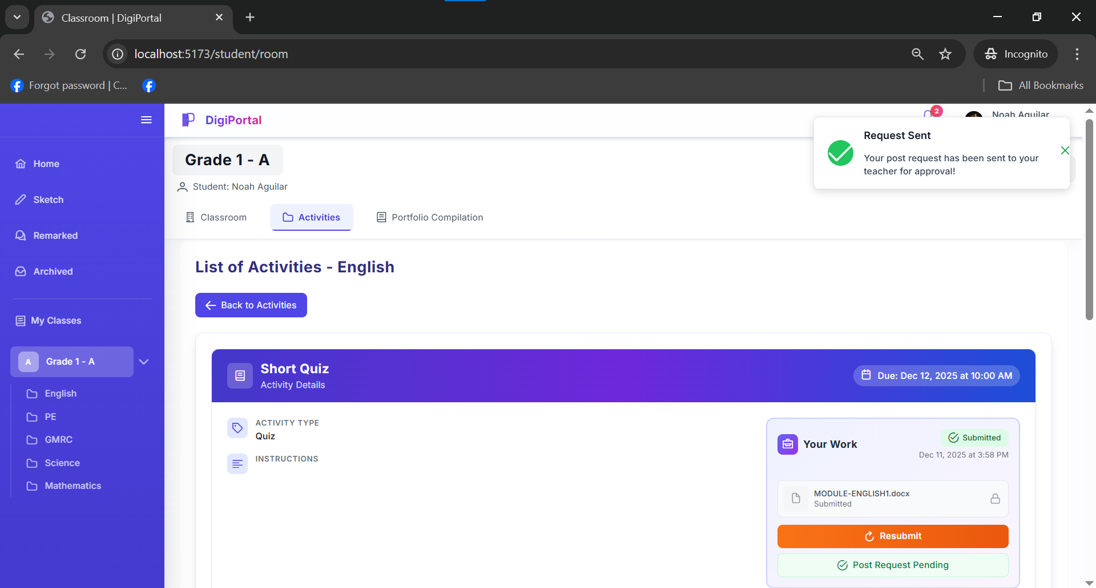
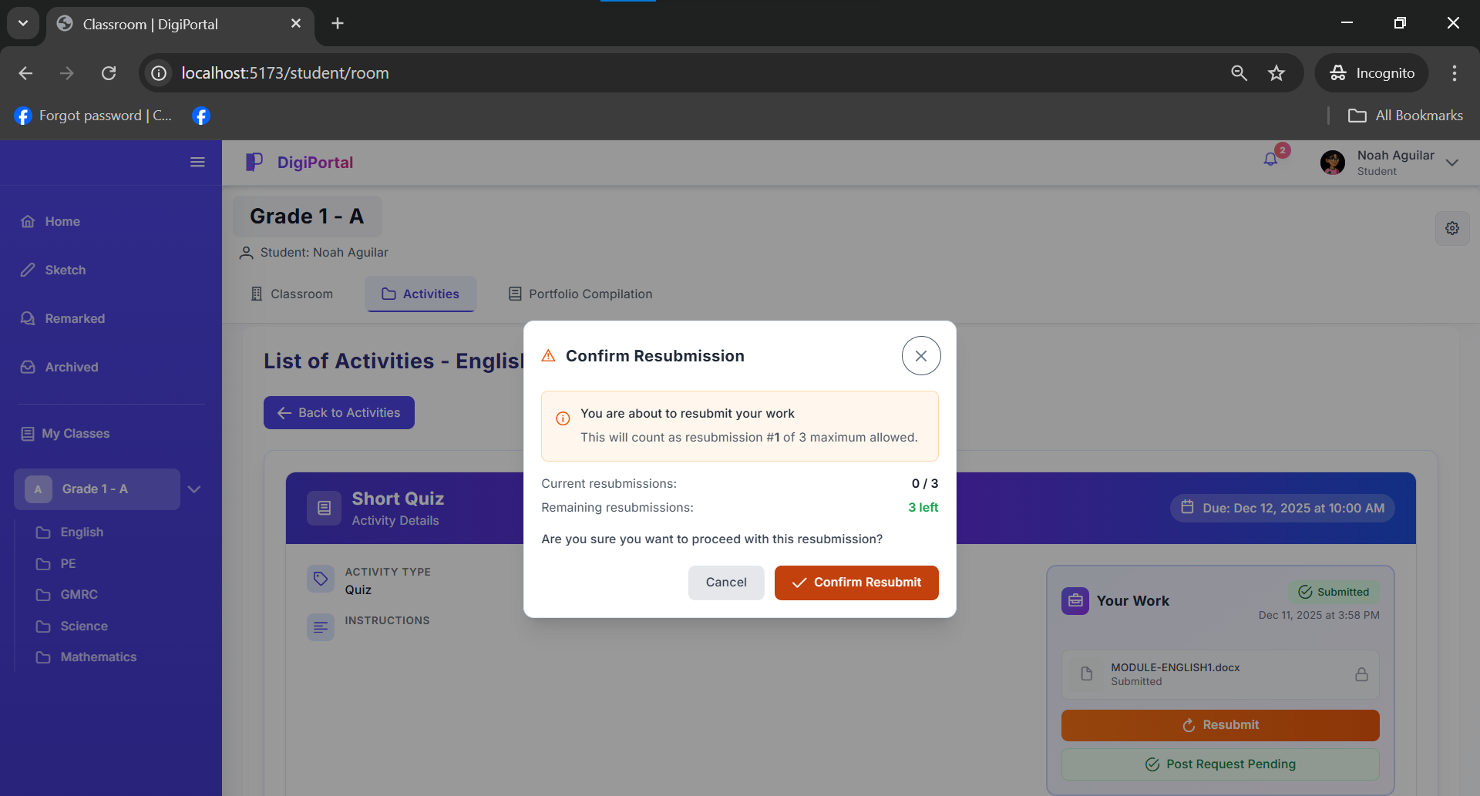
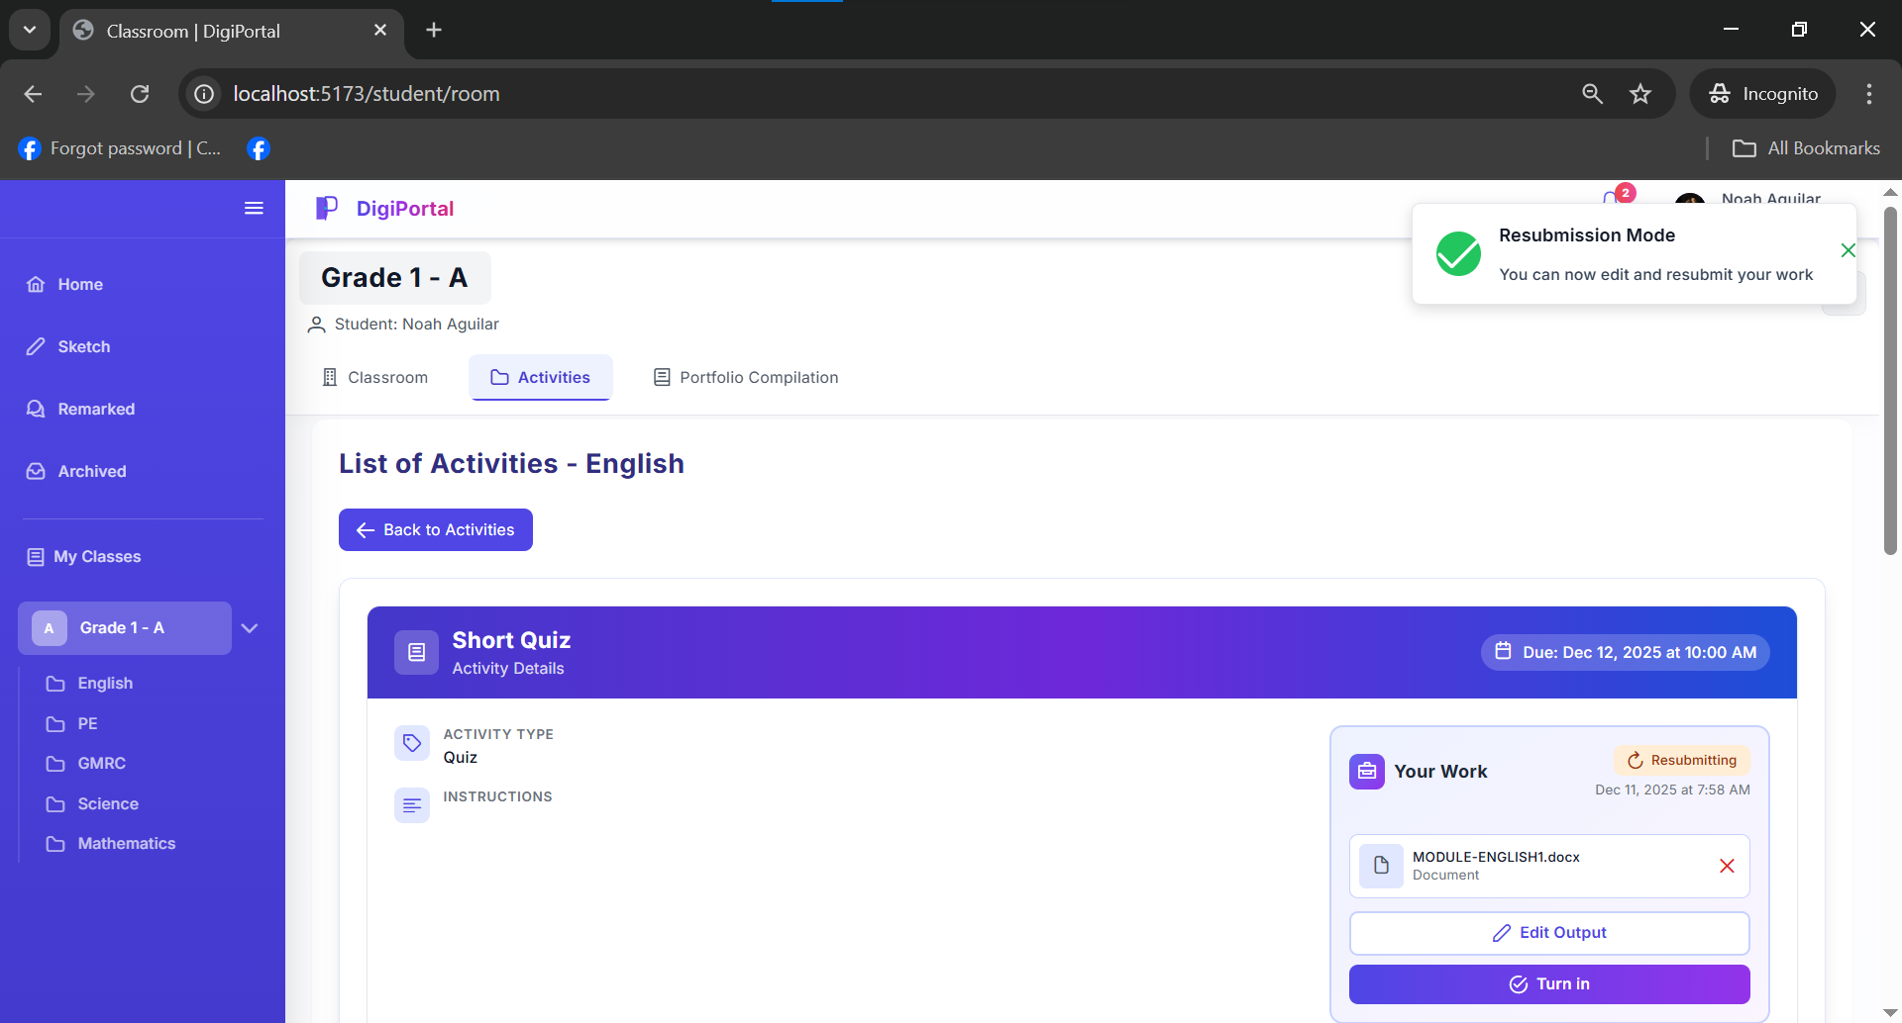
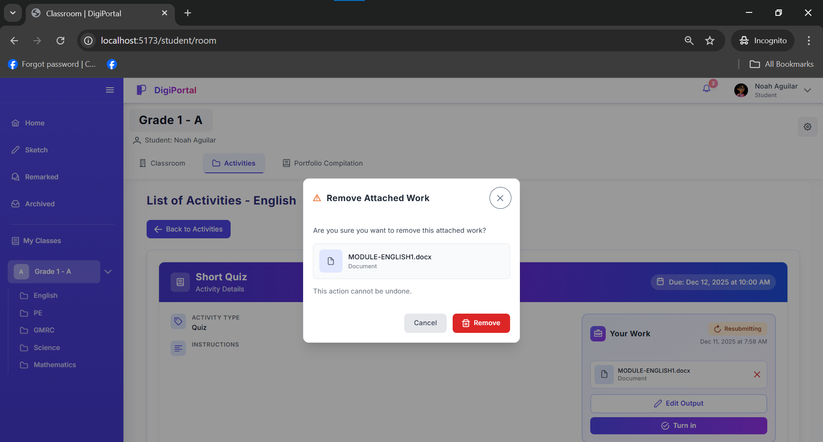
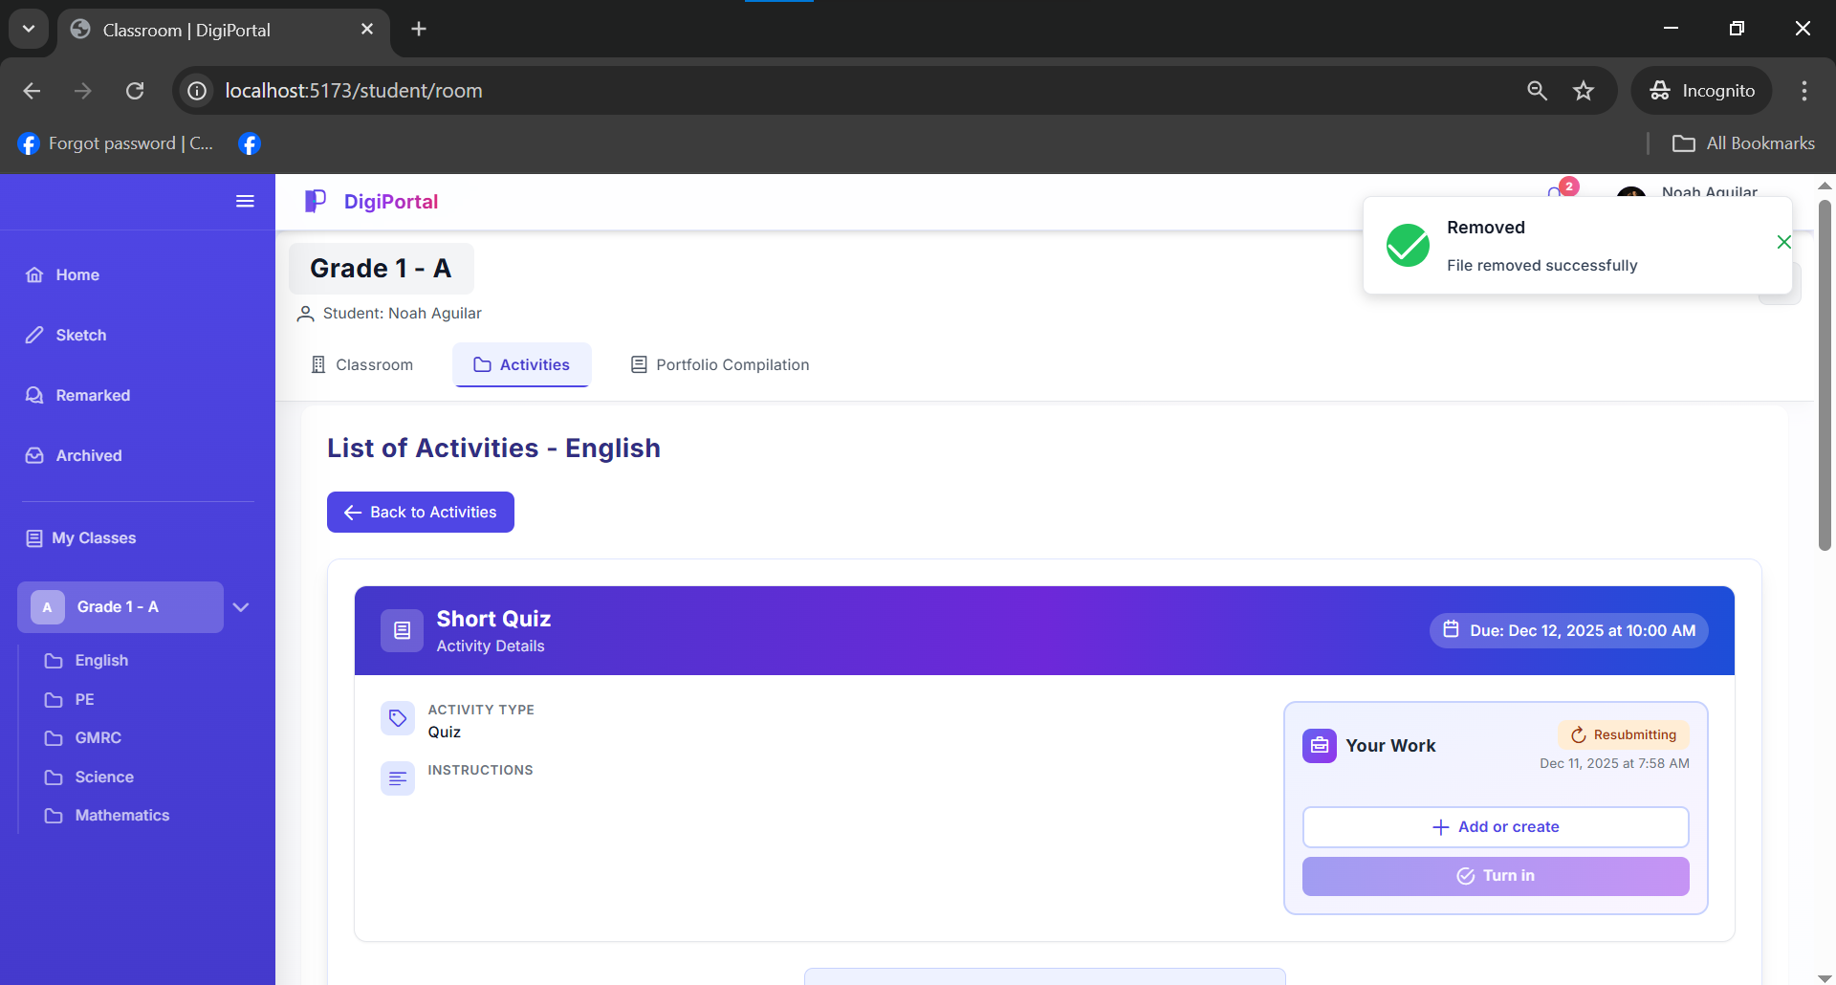
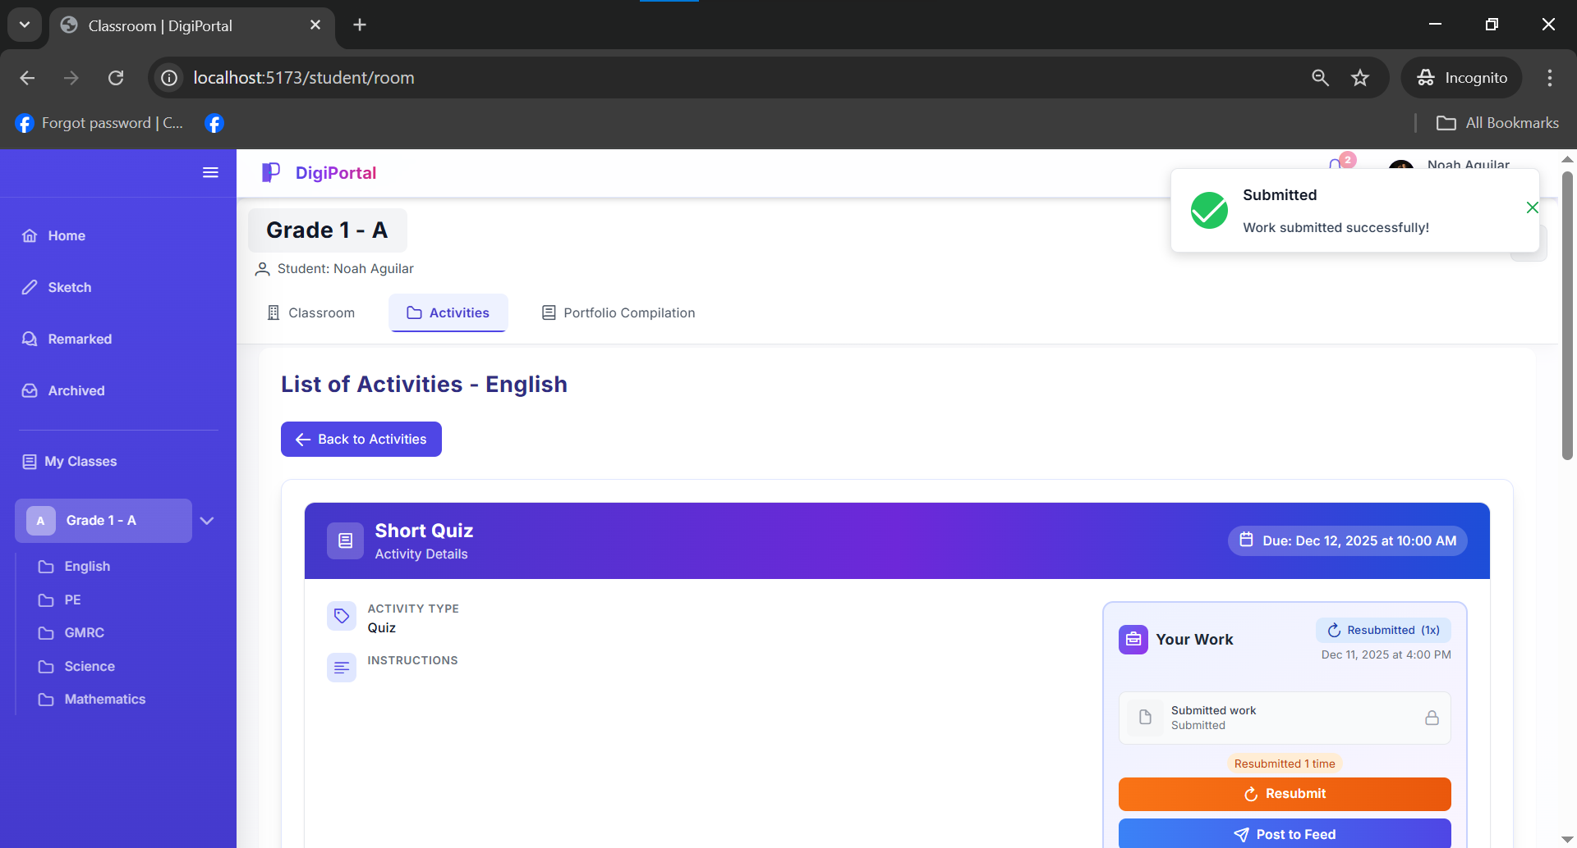
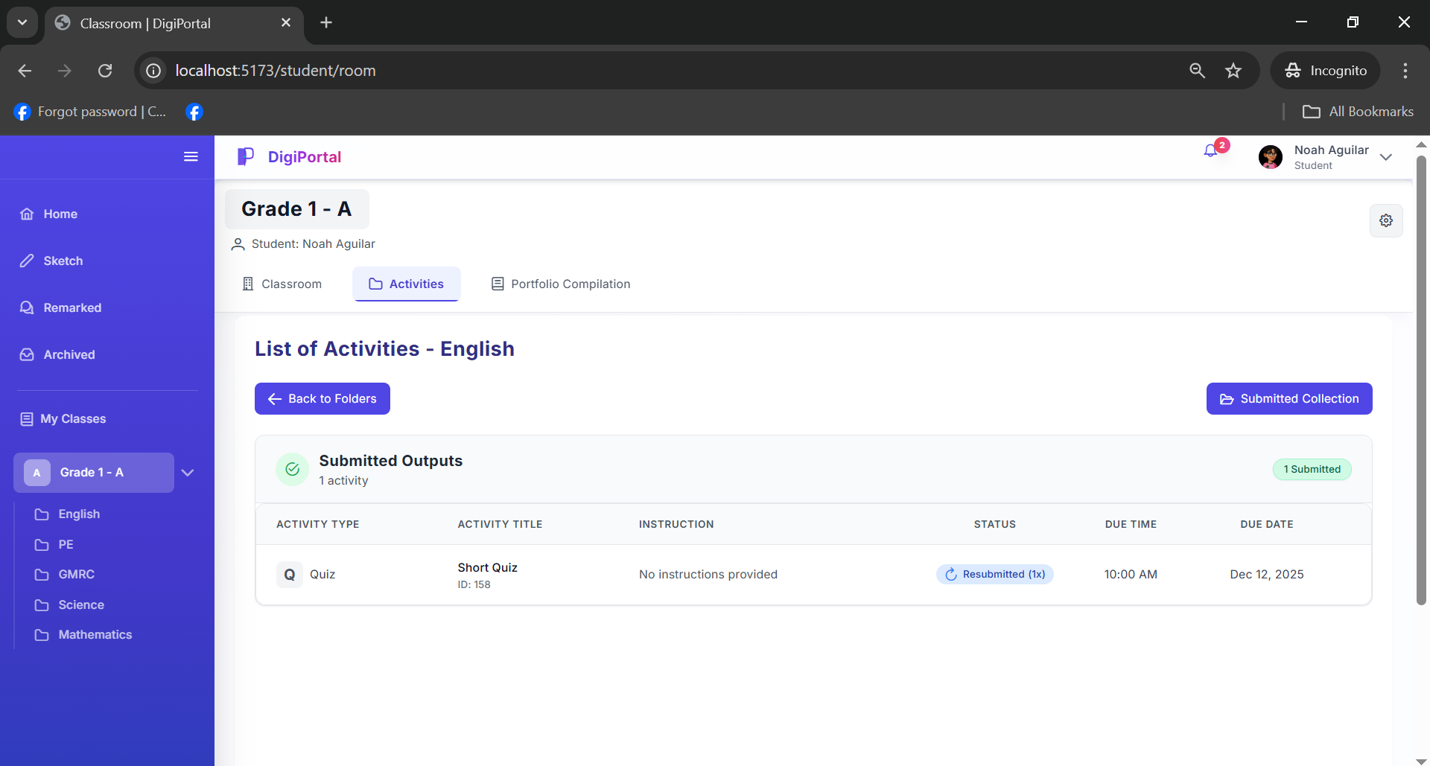
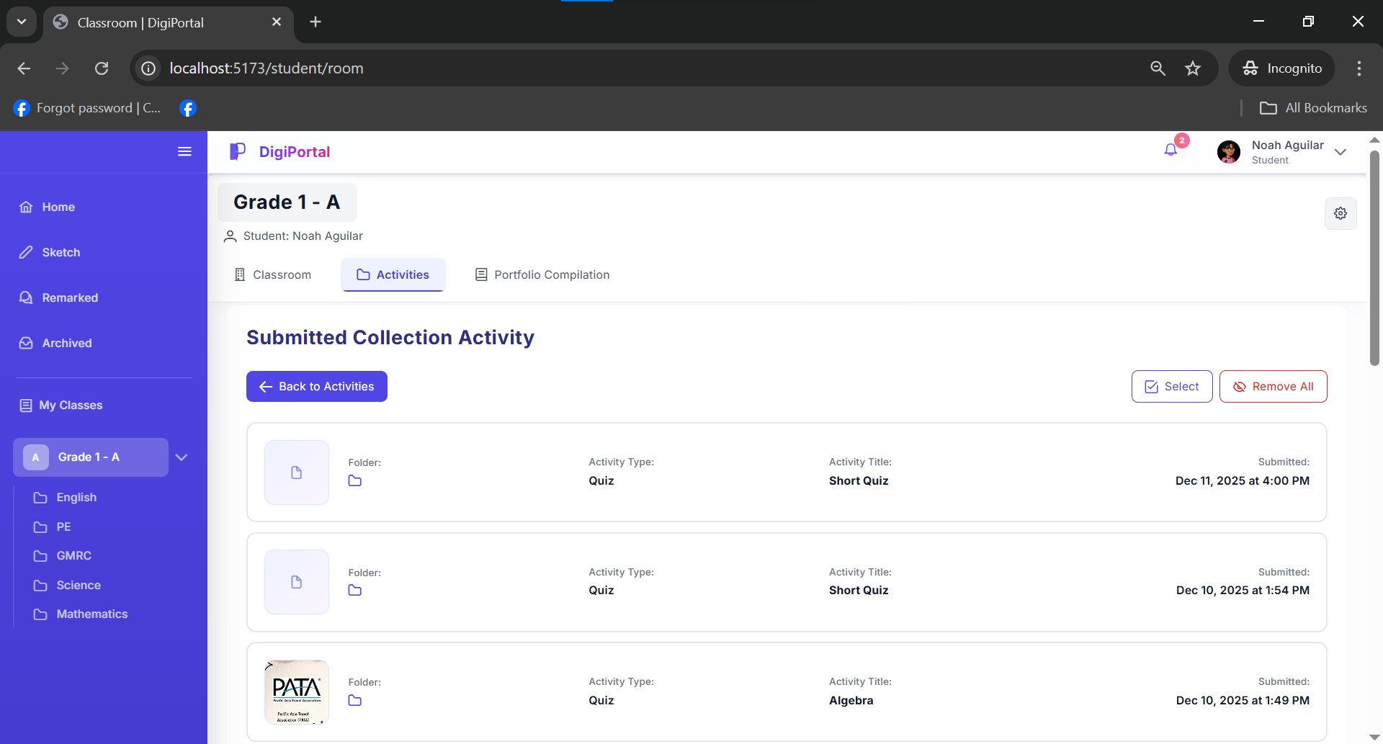
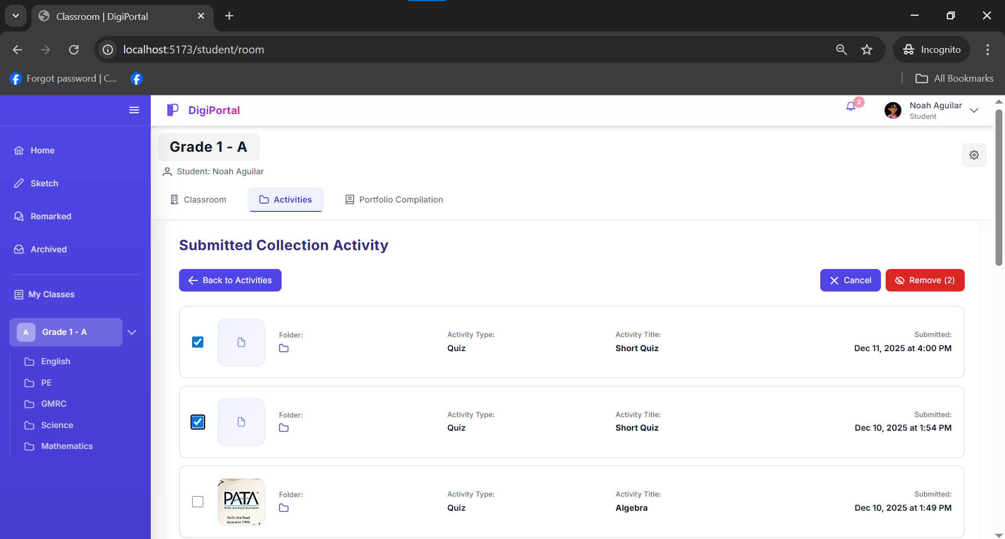
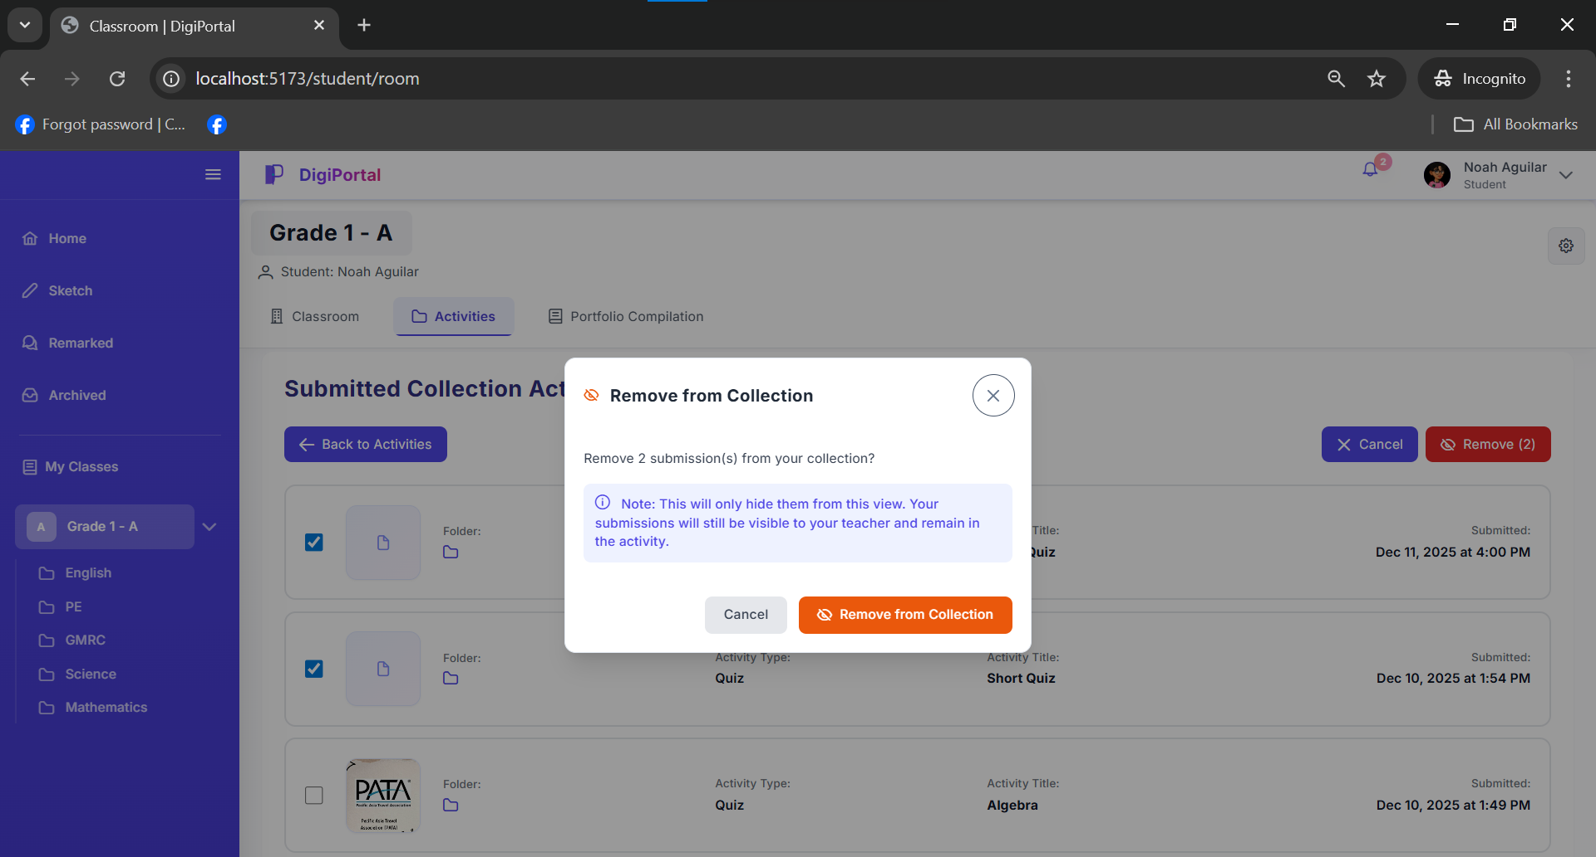
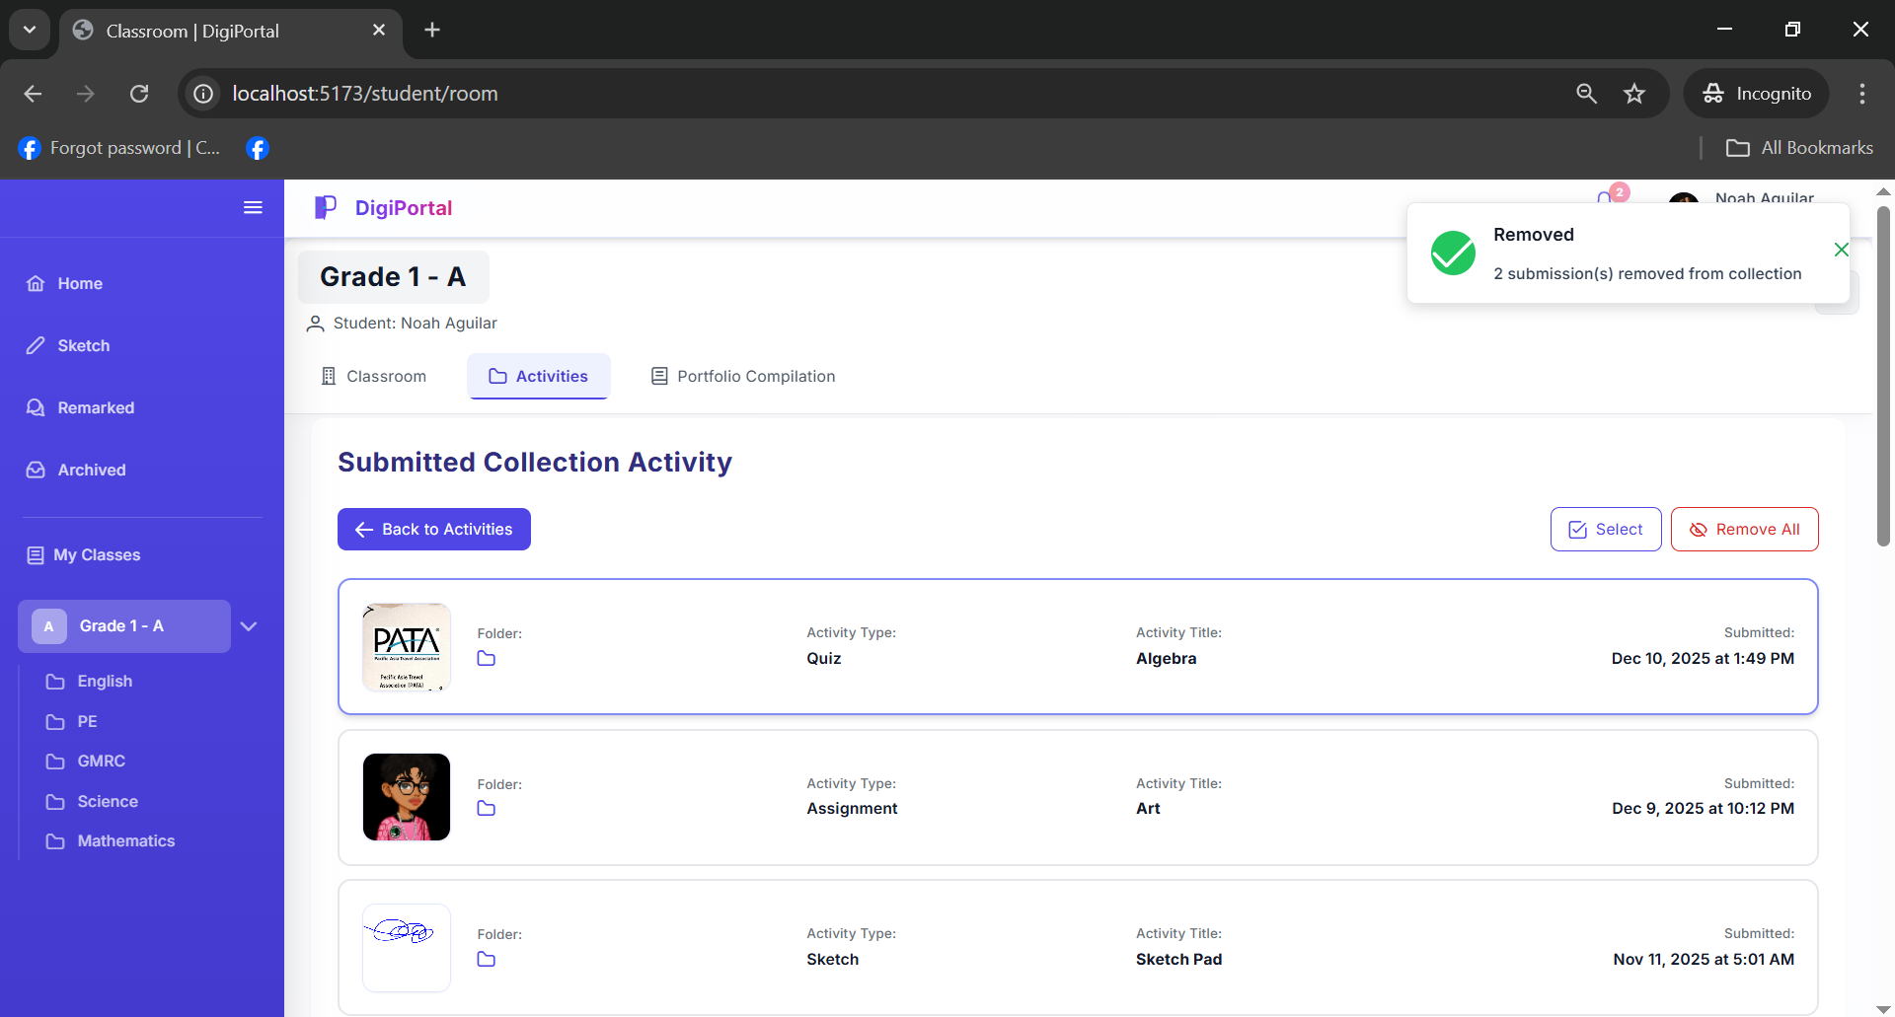
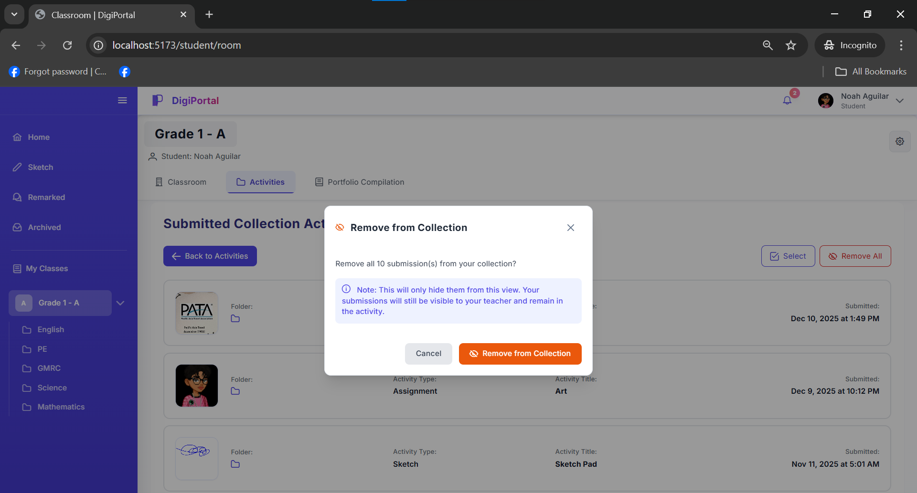
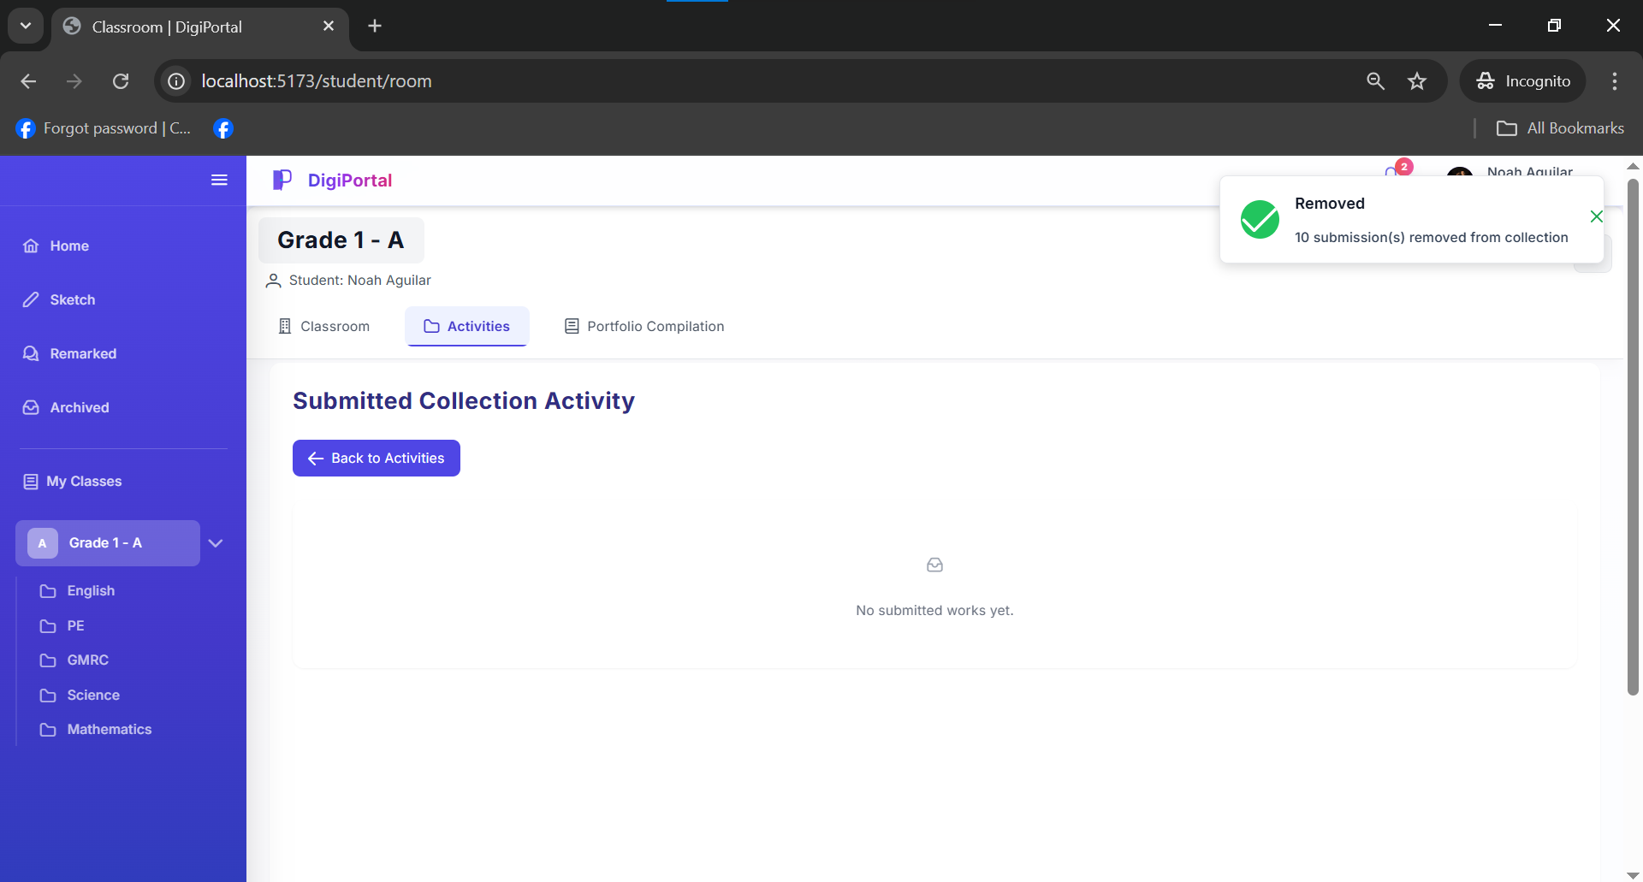
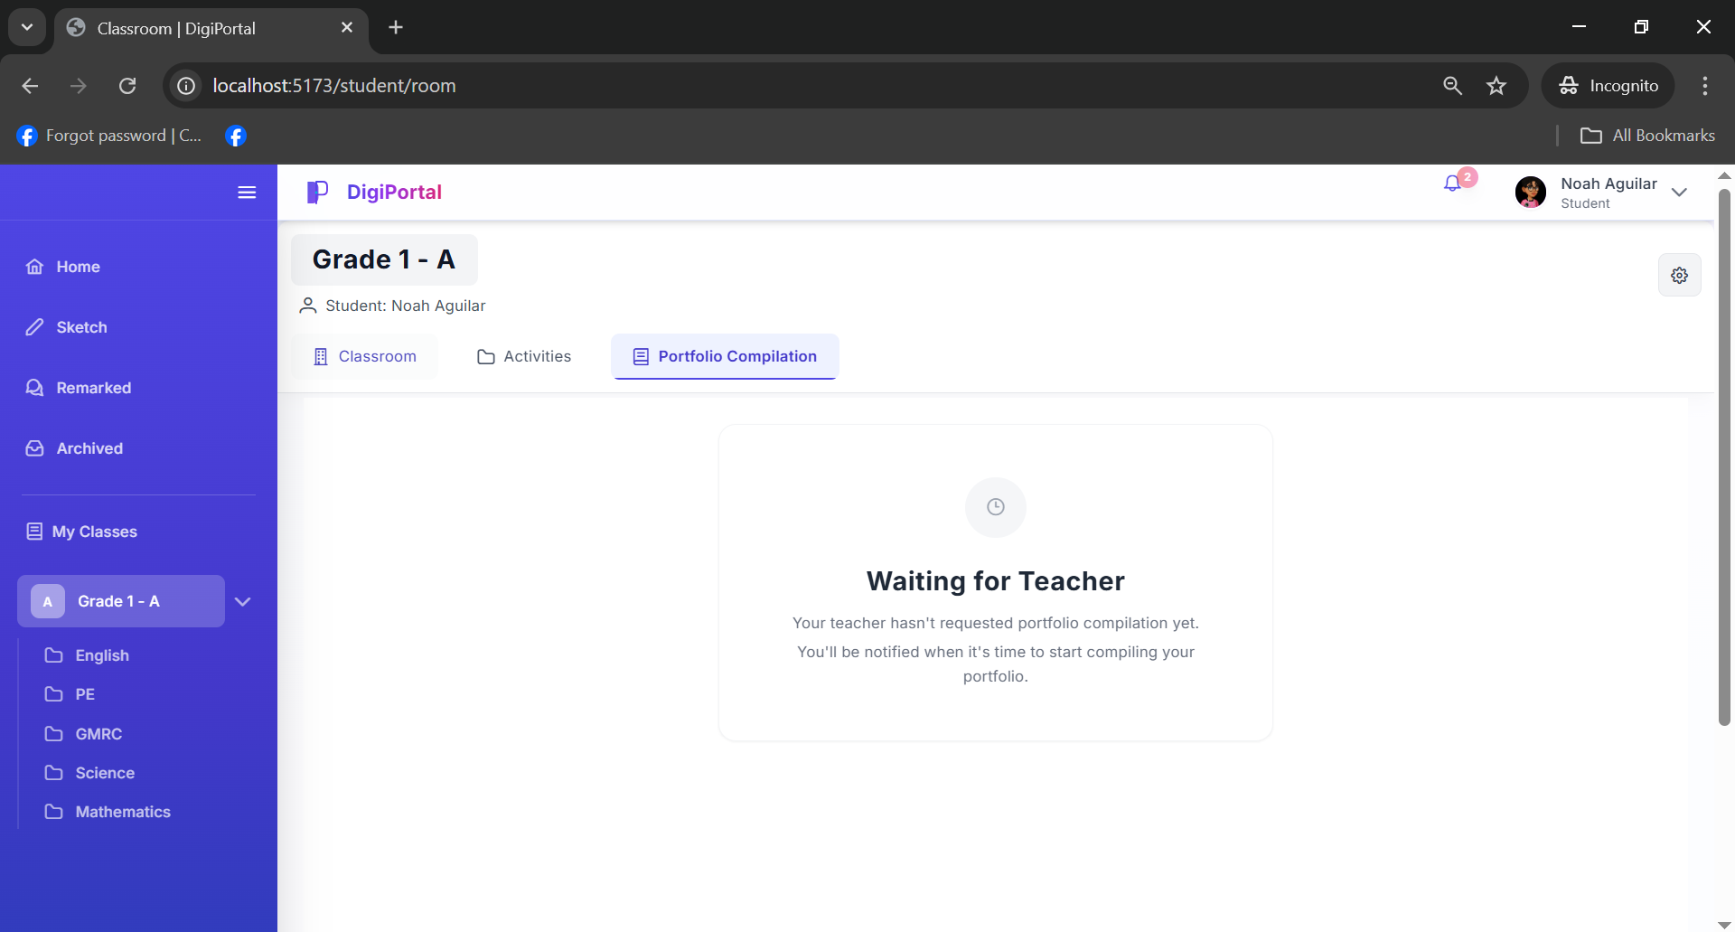
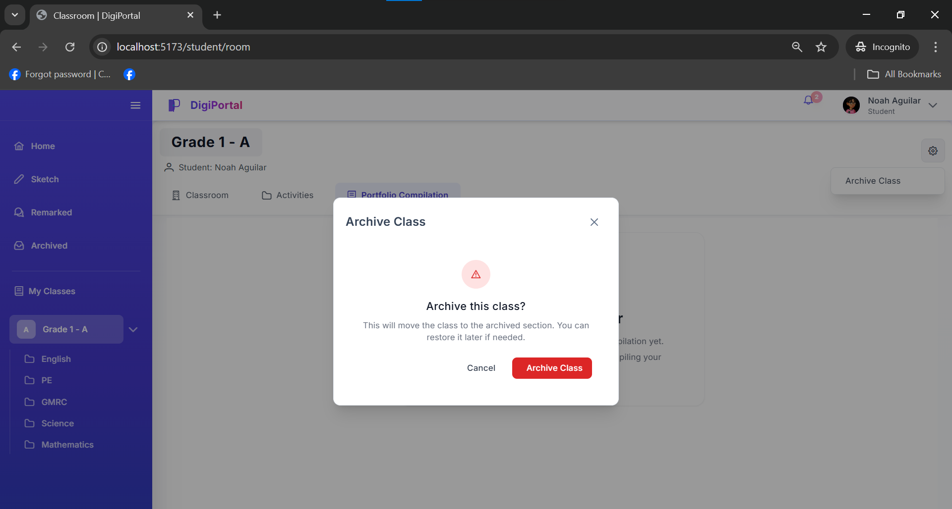

5.2 Development Result
5.2.1. Graphical User Interface of Digital Portfolio System
Graphical User Interface (GUI) of the Digital Portfolio System is designed to provide teachers and pupils with a clear, visually organized, and easy-to-navigate environment for managing academic outputs and portfolios. It uses graphical elements such as icons, buttons, and structured layouts so that users can perform tasks without relying on complex text-based commands. Through the GUI, teachers can create and manage classes, review submitted works, monitor portfolio status, and provide feedback, while pupils can upload projects, organize their portfolios, and view teacher remarks in a straightforward manner. By presenting these functions in an intuitive interface, the GUI reduces user effort, minimizes errors, and supports efficient documentation and showcasing of pupils’ achievements within Naawan Central School’s digital portfolio workflow.

5.2.2. Graphical User Interface of Digital Portfolio System’s Desktop Application
5.2.2.1. Teacher Functionality Test Results
Table 4 presents the task scenarios prepared by the developers for the teacher account in DigiPort. The assigned teacher user successfully navigated the system and completed all required actions, including creating classes, managing pupil portfolios, viewing portfolio history, and handling notifications. This result shows that the main management functions available to teachers in DigiPort are working as intended and can be executed without errors or unexpected behavior.

Table 4. Student User Task Scenarios

No.
Test Scenario
Pass/Fail
1 Log in Passed
2 View My Classes Passed
3 View Classroom Passed
4 View Activities Passed
5 View Task Passed
6 View Folder Passed
7 Add or Create Passed
8 Upload Files Passed
9 Turn in Passed
10 Resubmit Passed
11 Edit Output Passed
12 Replace Files and Caption Passed
13 Request Post to Feed Passed
14 View Portfolio Compilation Passed
15 View Start Portfolio Compilation Passed
16 Design Portfolio Envelope Passed
17 Open Envelope Passed
18 View Submitted Work Passed
19 View Missing Activity Compilation Passed
20 Compile Now Passed
21 Submit Portfolio Passed
22 View Home Passed
23 Like and Comment Passed
24 View Sketch Passed
25 Draw Passed
26 Save Passed
27 View My Sketches Passed
28 Clear Passed
29 Attach Photo Passed
30 Post to Newsfeed Passed
31 View Remarked Passed
32 Read Remarks Passed
33 View Archived Passed
34 View Class Passed
35 Notification Passed
36 View Profile Passed
37 Edit Profile Passed
38 Save Profile Passed
39 View Settings Passed
40 Log out Passed

5.2.1.2. Teacher Functionality Test Results
Table 5.Teacher User Task Scenarios

No.
Test Scenario
Pass/Fail
1 Log in Passed
2 View My Classes Passed
3 View Student’s Classroom Passed
4 View Student’s Activities Passed
5 Create Class Activity Passed
6 View Folder Passed
7 Add Activity Passed
8 Publish Passed
9 Retract Passed
10 Edit Passed
11 View Track Progress Passed
12 Search Student Name or ID Passed
13 View Output Passed
14 View Details Passed
15 Search Folder or Activity Passed
16 View Student Output Passed
17 View Remark History Passed
18 View Student’s Portfolio Compilation Passed
19 Start Portfolio Compilation Passed
20 View Portfolio Compilation Status Passed
21 View Student’s Compilation Passed
22 Open Envelope Passed
23 View Student’s Output Compilation Passed
24 Drop Portfolio Compilation Passed
25 View Home Passed
26 Like and Comment Passed
27 View Remarks Passed
28 View Student Passed
29 Add Remark Passed
30 Edit Remark Passed
31 Delete Remark Passed
32 Search Student or ID Passed
33 View Notice Passed
34 View Pending Approvals Passed
35 Approve Passed
36 Reject Passed
37 View Archived Passed
38 View Class Passed
39 Notification Passed
40 View Profile Passed
41 Edit Profile Passed
42 Save Profile Passed
43 View Settings Passed
44 Log out Passed

5.3.1.4. Summary of Functionality Test
The functionality testing of the DigiPort: Digital Portfolio System at Naawan Central School has been completed with participation from both teachers and students. Overall feedback was positive, with users noting that the system is easy to navigate and supports their usual portfolio tasks without unnecessary complexity. The test results indicate that key features such as class setup, portfolio creation, submission, and review worked as intended, showing that DigiPort is functionally ready for regular use in the school setting.

5.3.1. Usability Test of the DigiPort: Digital Portfolio System
5.3.1.1. The Test Participants
The usability testing of the DigiPort: Digital Portfolio System involved two primary user groups from Naawan Central School: teachers and students. Teachers served as the main users of the system’s management features, creating classes, organizing and checking pupils’ digital portfolios, and monitoring their progress and submitted work. Students, on the other hand, acted as end users who built and maintained their own digital portfolios by uploading their outputs, arranging their projects, and viewing the comments or feedback given by their teachers.
Including both teachers and students in the evaluation made it possible to gather insights from users who oversee portfolio management and from those who interact with the system as part of their daily learning. This combination provided a realistic picture of how DigiPort functions in an actual classroom environment and how well it supports teaching, learning, and documentation activities for both groups.

A. The Usability Test Setup
On the day of the usability evaluation for the DigiPort system, the developers first conducted a short orientation to explain the purpose of the test, the basic features of the system, and the steps the participants needed to follow. Participants were then asked to sign a consent form before any activities began, ensuring that they voluntarily agreed to take part in the testing process.
After consent was secured, the developers prepared the computers and network connections and assigned predefined task scenarios to each participant, tailored to their role in the system. Separate task sets were prepared for the system administrator and for the teachers so that each group could perform actions that matched their actual responsibilities in DigiPort.
Once the participants started, they were asked to complete their tasks on their own, with developers only observing and taking notes rather than intervening, to capture a more natural usage experience. Immediately after the tasks, each participant filled out a System Usability Scale (SUS) questionnaire, which was later used to compute individual usability scores and interpret overall satisfaction with the system. The session ended with a short debrief, where developers thanked the participants, clarified any issues raised during the test, and gathered additional comments that might help improve DigiPort in future revisions.
B. The Usability Test Results
B.1 Student Usability Test Results
The usability test results for the student group, represented by Participants P1 to P11, show that the system is generally viewed as easy to use and supportive of their portfolio‑related tasks. Overall SUS scores range from 75 to 100, with most ratings clustered in the mid‑80s to high‑90s, which indicates that students found the interface clear, the features accessible, and the workflow smooth for actions such as uploading work, organizing projects, and viewing feedback. The consistently high scores across many questions suggest that students considered DigiPort simple to learn, efficient to use, and dependable for their day‑to‑day academic activities, with only a few areas where further refinement could make the experience even more comfortable for all users.
Table 6. Student User Task Scenarios
_____________________________________________________________________________________
Participants
Questions
_____________________________________________________________________________________
Q1 Q2 Q3 Q4 Q5 Q6 Q7 Q8 Q9 Q10
P1 5 1 5 1 5 1 3 1 4 1 92.5
P2 5 1 5 1 5 1 4 1 5 1 97.5
P3 5 1 5 1 5 1 5 1 5 1 100
P4 5 1 3 1 5 2 5 1 5 1 92.5
P5 5 3 4 1 5 1 5 2 4 2 85
P6 5 3 3 2 5 2 5 1 5 1 85
P7 3 2 4 2 4 2 5 2 4 2 75
P8 4 2 4 1 3 1 5 2 5 1 85
P9 5 1 5 1 5 2 5 1 4 3 90
P10 5 2 5 2 5 1 3 2 5 1 87.5
P11 5 1 5 1 5 2 5 1 4 1 95 _____________________________________________________________________________________

B.2 Teacher Usability Test Results
Table 7 presents the teacher usability test results for 19 participants (P12 to P30), each rating ten SUS questions on a scale from 1 to 5, followed by a computed overall usability score. The results show consistently high overall scores, with several teachers (such as P19 and P25) achieving perfect scores of 100 and many others scoring in the upper ranges from mid‑80s to mid‑90s, indicating that most teachers perceived the system as highly usable, efficient, and supportive of their tasks. A few participants recorded scores closer to the mid‑70s, which suggests that while the system is generally well‑accepted, there remain minor aspects of the interface or workflow that could still be refined to better accommodate all teacher users.
Table 7. Teacher User Task Scenarios
_____________________________________________________________________________________
Questions
Participants
_____________________________________________________________________________________
Q1 Q2 Q3 Q4 Q5 Q6 Q7 Q8 Q9 Q10
P12 4 1 5 2 3 1 3 2 5 1 82.5
P13 4 2 4 3 4 1 5 1 3 2 77.5
P14 5 2 4 2 3 2 4 1 5 1 82.5
P15 5 2 5 1 5 2 5 1 5 1 95
P16 4 1 5 1 5 1 5 1 3 2 90
P17 5 2 5 2 3 2 4 1 3 1 80
P18 5 3 4 2 3 1 5 2 4 1 80
P19 5 1 5 1 5 1 5 1 5 1 100
P20 5 1 4 1 4 1 4 1 5 2 90
P21 5 1 5 1 5 1 5 1 4 2 95
P22 4 3 4 2 5 1 5 2 4 3 77.5
P23 5 2 5 1 4 1 5 1 4 1 92.5
P24 5 3 5 1 5 2 5 2 5 2 87.5
P25 5 1 5 1 5 1 5 1 5 1 100
P26 4 2 5 1 4 2 5 1 4 2 85
P27 3 3 3 1 5 1 4 1 5 1 82.5
P28 4 1 5 2 5 1 5 1 2 1 87.5
P29 5 1 5 2 4 2 5 1 5 2 90
P30 5 3 5 1 5 1 5 1 5 4 87.5 _____________________________________________________________________________________

C. Summary of the Usability Test Results
In summary, the data gathered from the SUS forms (Appendix C) of the 30 test participants show that one participant acted as the system administrator while the remaining participants were teachers. The SUS scores presented in the tables indicate that most of the teachers rated the system from good to excellent, with several participants obtaining scores in the higher bands of the SUS and ARS rubric, reflecting a generally positive perception of DigiPort’s usability and its suitability for managing digital portfolios. Although a few teachers recorded comparatively lower scores, suggesting that certain parts of the interface or workflow may still feel challenging for some users, the responses to individual questions reveal that, overall, participants considered the system simple, easy to learn, intuitive, and well-integrated, and they felt reasonably confident using it after limited exposure.

Table 8. Usability Test Results
_____________________________________________________________________________________
Questions
Participants
_____________________________________________________________________________________
Q1 Q2 Q3 Q4 Q5 Q6 Q7 Q8 Q9 Q10
P1 5 1 5 1 5 1 3 1 4 1 92.5
P2 5 1 5 1 5 1 4 1 5 1 97.5
P3 5 1 5 1 5 1 5 1 5 1 100
P4 5 1 3 1 5 2 5 1 5 1 92.5
P5 5 3 4 1 5 1 5 2 4 2 85
P6 5 3 3 2 5 2 5 1 5 1 85
P7 3 2 4 2 4 2 5 2 4 2 75
P8 4 2 4 1 3 1 5 2 5 1 85
P9 5 1 5 1 5 2 5 1 4 3 90
P10 5 2 5 2 5 1 3 2 5 1 87.5
P11 5 1 5 1 5 2 5 1 4 1 95
P12 4 1 5 2 3 1 3 2 5 1 82.5
P13 4 2 4 3 4 1 5 1 3 2 77.5
P14 5 2 4 2 3 2 4 1 5 1 82.5
P15 5 2 5 1 5 2 5 1 5 1 95
P16 4 1 5 1 5 1 5 1 3 2 90
P17 5 2 5 2 3 2 4 1 3 1 80
P18 5 3 4 2 3 1 5 2 4 1 80
P19 5 1 5 1 5 1 5 1 5 1 100
P20 5 1 4 1 4 1 4 1 5 2 90
P21 5 1 5 1 5 1 5 1 4 2 95
P22 4 3 4 2 5 1 5 2 4 3 77.5
P23 5 2 5 1 4 1 5 1 4 1 92.5
P24 5 3 5 1 5 2 5 2 5 2 87.5
P25 5 1 5 1 5 1 5 1 5 1 100
P26 4 2 5 1 4 2 5 1 4 2 85
P27 3 3 3 1 5 1 4 1 5 1 82.5
P28 4 1 5 2 5 1 5 1 2 1 87.5
P29 5 1 5 2 4 2 5 1 5 2 90
P30 5 3 5 1 5 1 5 1 5 4 87.5
_____________________________________________________________________________________

5.3 Summary of the Chapter
This chapter lays out the key results and insights from building the Digital Portfolio System for Naawan Central School, covering everything from the design phase to actual development and rollout details. At its core, the system's setup links teacher and student interfaces to a solid PostgreSQL database on a central server, keeping all data safe and making interactions smooth for handling portfolios. We've mapped out the main flows like submitting projects, sorting them by subject, building portfolios, teacher reviews, and tracking revisions using clear visuals such as use case diagrams, activity diagrams, functional breakdowns, context diagrams, and data flow charts. The backend database design, built on a strong Entity-Relationship Model, handles data reliably and can grow as needed. On the front end, the user interfaces are straightforward and role-based: teachers get tools to set up classes, oversee pupil portfolios, check history, and manage notifications; students have easy access to edit profiles, handle pending projects, review finished work, and see updates, all made simple for K-6 kids. All in all, this chapter shows how the project came together as a practical, easy-to-use platform that really steps up documentation, encourages pupil reflection, and strengthens teamwork between teachers and students at the school.

CHAPTER 6
CONCLUSION AND RECOMMENDATIONS
6.1. Conclusion
The development of DigiPort: Digital Portfolio System for Naawan Central School successfully addressed the challenges of data loss, tracking inefficiencies, and limited accessibility in traditional paper-based portfolio processes. Through its system-assisted workflow ranging from project submission, compilation by subject, portfolio organization, teacher review, and revision tracking, the system significantly reduces manual efforts while improving documentation reliability. Features such as structured repositories, submission status indicators, and organized archiving allow teachers to verify completeness, provide timely feedback, and ensure pupils' academic outputs are securely preserved and showcased.
The System Usability Scale (SUS) results presented in chapter 5 indicate that users generally found the system usable and beneficial. Although a small subset of participants (specifically those with lower digital literacy) gave lower scores, reflecting some usability challenges, the overall SUS average remained positive. While the system is generally useful and easy to navigate, some teachers and pupils, particularly those less familiar with digital tools, still require initial guidance or training before using it independently. These strengths confirm DigiPort’s effectiveness, while the identified areas of improvement provide directions for refining user experience in future iterations.
Overall, DigiPort has demonstrated its potential as a practical and valuable solution for modernizing portfolio management at Naawan Central School. It not only enhances organization and engagement but also contributes to continuous improvement in pupil reflection and teacher-pupil collaboration, making it a reliable tool for both educators and the institution.

6.2. Recommendations
To further improve this project, here are the following recommendations: Based on the findings and user feedback, several recommendations are proposed to further enhance the capabilities and usability of DigiPort. It is recommended that the system support mobile app compatibility and multimedia uploads such as drawings or photos to increase accessibility, pupil creativity, and engagement across devices. Furthermore, improvements to the user interface and overall user experience should be prioritized, particularly by refining navigation elements, enhancing visual clarity for younger users, and increasing system responsiveness to address concerns identified in the lower SUS scores.
Strengthening notification mechanisms, including automated reminders for pending submissions and clearer status prompts, would also help minimize tracking difficulties and support smoother workflows for teachers and pupils.

DEFINITION OF TERMS
DigiPort - A web-based software application that automates and facilitates the process of creating, compiling, organizing, submitting, reviewing, and showcasing digital portfolios for pupils' academic work and achievements at Naawan Central School.
Digital Portfolio Management - Refers to the processes, procedures, and strategies used to plan, develop, store, track, evaluate, and share pupils' academic outputs, projects, and progress in a centralized online platform, addressing issues like data loss and tracking inefficiencies.
Portfolio Compilation - Is the structured process of gathering, organizing, and categorizing pupils' submitted projects by subject within the system, ensuring completeness through teacher verification and notifications for missing items.
Pupil Portfolio Repository - A large, organized digital database of pupils' academic works, tagged by grade, subject, and status (e.g., pending, completed), serving as a secure archive for reflection, feedback, and future reference without grading features.

APPENDIX A
(Consent Form)



Mindanao State University at Naawan
College of Business and Information Technology
Department of Information Technology

Consent Form

Part I: Information Sheet

Title of the Project
DigiPort: Digital Portfolio Management System

Main Purpose of the Project
The Purpose of DigiPort is to to develop a web-based platform for Naawan Central School that enables pupils to digitally store, organize, track, and showcase their academic work, projects, and achievements, while allowing teachers to manage submissions, provide feedback, and monitor progress. This addresses challenges like data loss, tracking inefficiencies, and limited accessibility in traditional paper-based portfolio processes at the school.

Duration/Period: From Novemeber 10, 2025 to Novemeber 17, 2025
Name of Developers: Arkenz Q. Gabonada, Kent John L. Montebon, and China V. Roa
Contact number of Developers: 09918900586, 09518086851, 09051137984

Part II: Certificate of Consent
Written Consent Form for Research Participants/ Informants or Parents/Guardians of Children (below
18 years old who are respondents) *To be signed at the beginning of the interview/survey.
Direction: please read the following statements carefully and put a check (/) in the corresponding box if
you agree:
I fully understand the nature and purpose of this project.
I give my voluntary consent to participate in this project.
I give my consent for the developers to record the related activities.
I give my consent for the researcher to record the conduct of the
Activities (video, audio, photos)
I can stop participating in the project at any time, for any reason if I so
decide.
If I have questions about the project in general or about my role in the
said project, I can freely ask the developer about my concerns.

_______________________________________ _____________________
Name and Signature of Participant/Respondent Date (Day/Month/Year)

EVALUATION PLAN

DigiPortal: Digital Portfolio Management System

Developers:

Gabonada, Arkenz Q.
Front-end Developer

Montebon, Kent John L.
Back-end Developer

Roa, China
System Analyst

Document Management

Document Summary

Type: | Functionality Test
Date of Evaluation: | November 10, 2025
Name and Profession of Evaluator | JHUMER O. APUS  MSU at Naawan Data Protection Unit Staff

APPENDIX B
(Task Scenarios)
- Teacher Module

No. | Test Scenario | Expected Results | Pass / Fail | Tested by Name & Signature | Remarks
1 | View Newsfeed, like, and comment | The user shall be able to view the newsfeed and see all posts that have been approved by the teacher. |  | Jhumer O. Apus
 |  | The system shall display each post with its corresponding comments underneath.
 |  | The system shall increase the like count when a user clicks the like button.
 | Actual Result::
2 | View remarks (with Search, Add, Edit, and Delete. | The user shall be able to view all remarks.  The system shall allow the teacher to search for specific remarks using id numbers or student names. |  | Jhumer O. Apus
 |  | The system shall allow the teacher to add new remarks successfully.
 |  | The system shall allow the teacher to edit existing remarks and save the updated information.
 |  | The system shall allow the teacher to delete

 |  | remarks and remove them from the list.
 | Actual Result::
3 | Add/Edit Remark | The teacher shall be able to give remarks or feedback to every student. |  | Jhumer O. Apus
 |  | The system shall save the remark and make it visible to the respective student.
 |  | Any changes made to the remark shall be saved and reflected in real time.
 | Actual Result::
4 | View Notice | The teacher shall be able to view pending post requests from students in the notice section. |  | Jhumer O. Apus
 |  | The system shall display each student request, and the teacher shall be able to approve or reject the post request.
 | Actual Result::
5 | Approve post | Once the user |  | Jhumer O.
 |  | approves a request, the |  | Apus
 |  | student’s post shall
 |  | automatically be
 |  | published on the
 |  | newsfeed.
 | Actual Result::

6 | Reject post | If rejected, the system shall notify the student that the post was not approved. |  | Jhumer O. Apus
 | Actual Result::
7 | View Archived | The system displays a list of previously archived classes. |  | Jhumer O. Apus
 |  | The user can view the class details, including class name, subject, and academic year, but cannot modify or add new activities.
 | Actual Result::
8 | View my | The system displays |  | Jhumer O.
 | Classroom | Student’s Classroom, |  | Apus
 |  | Student’s Activities,
 |  | Student’s Portfolio
 |  | Compilation, and
 |  | Schedule.
 | Actual Result::
9 | Student’s classroom | The system shall display the list of enrolled students for the selected class. |  | Jhumer O. Apus
 | Actual Result::
10 | View Student’s Activities | The system successfully displays all subject folders |  | Jhumer O. Apus
 | Actual Result:
11 | Create New Class Portfolio | The user shall be able to create a new class portfolio for a specific subject. |  | Jhumer O. Apus
 |  | The system shall display the created

portfolio under the selected grade level (e.g., Grade 1 - A).

Each subject portfolio shall contain the pupil’s activities, outputs, and other related files for that subject.

The system shall provide an option to view the contents of each portfolio.
 | Actual Result:
12 | View Folder | The user shall be able to view a folder within the class portfolio.  The system shall display the list of activities, Add Activity, Track Progress,Draft Activities, and Published Activities . |  | Jhumer O. Apus
 | Actual Result

13 | Create New Activity including add instruction, set score, due date, and add rubric. | The teacher shall be able to create a new activity within the selected class portfolio.  The system shall allow the teacher to:  - Add activity instructions or descriptions.  - Set the total score for the activity.  - Set a due date for submission.  - Add a rubric for grading and evaluation.  After saving, the system shall display the newly created activity under the corresponding subject within the class portfolio. |  | Jhumer O. Apus
 | Actual Result
14 | Published activities and draft activities | The user shall be able to save an activity either as a draft or publish it immediately.  When saved as a draft, the activity shall not be visible to students and shall be stored under the “Draft Activities” section.  When published, the activity shall be visible to students under their subject portfolio.  The system shall allow |  | Jhumer O. Apus

 |  | the teacher to edit or publish a draft activity later.
 | Actual Result::
15 | Publish and Retract activity | The system shall change the activity status to “Published,” make it visible to students, and allow submissions.  The system shall change the activity status to “Draft,” remove student access, and allow further editing by the teacher. |  | Jhumer O. Apus
 | Actual Result :
16 | Edit activity | The teacher shall be able to edit or update an existing activity.  However, the Edit button shall be disabled two (2) hours before the activity’s due date to prevent further changes.  After editing (if within the allowed time), the system shall save and reflect all updates. |  | Jhumer O. Apus
 | Actual Result :
17 | View submitted activity | The user shall be able to view all submitted activities from students under each subject or class portfolio.  The system shall categorize submissions into Scored and Unscored activities. |  | Jhumer O. Apus

 | Actual Result :
18 | View unscored and scored submitted | The user shall be able to view all submitted activities categorized as Unscored and Scored.  Unscored: Displays all submissions that have not yet been graded.  Scored: Displays all submissions that have already been given a score.  The system shall show the student’s name, submitted output, date and time of submission, and score status. |  | Jhumer O. Apus
 | Actual Result :
19 | View Unscored and Scored activity | View Unscored Activity feature allows the teacher to view, evaluate, and record grades for students.  The system shall save the score and mark the activity as graded.  Scored Activity feature allows the teacher to view student submissions that have already been graded.  Users can still review the submitted work and add or update remarks or feedback for improvement. |  | Jhumer O. Apus

 | Actual Result::
20 | View Track progress | The user shall be able to search for a student using name or student ID.  The user shall be able to view the student’s outputs/submissions directly from Track Progress.  The teacher to see a summary of a student’s activity progress, giving a quick overview of completed, pending, and missing tasks. |  | Jhumer O. Apus
 | Actual Result::
21 | View pupil’s portfolio compilation | View start Compilation |  | Jhumer O. Apus
 | Actual Result::
22 | View Start Compilation | the system shall display a list of students who have submitted their compilations. |  | Jhumer O. Apus
 | Actual Result::
23 | View student compilation | The system displays the student’s designed portfolio envelope correctly. |  | Jhumer O. Apus
 | Actual Result::
24 | View open portfolio envelope | The user opens the portfolio envelope, the system displays the compiled activities submitted by the student |  | Jhumer O. Apus

 | Actual Result :
25 | Drop portfolio compilation | The user drops or closes the portfolio compilation.  The system disables further editing or adding of activities. |  | Jhumer O. Apus
 | Actual Result::
26 | View manage account, edit profile, and settings | The user shall be able to view and manage their account, including editing their profile and adjusting settings.  The system shall provide options to access account management, edit profile, and modify settings. |  | Jhumer O. Apus
 | Actual Result::

- Student Module

No  . | Test Scenario | Expected Results | Pass / Fail | Tested by Name & Signature | Remarks
1 | View Newsfeed, like, and comment | The user shall be able to view the newsfeed and see all posts that have been approved by the teacher. |  | Jhumer O. Apus
 |  | The system shall display each post with its corresponding comments underneath.
 |  | The system shall increase the like count when a user clicks the like button.
 | Actual Result:
2 | View sketch | The user shall be able to draw, save, attach photos, post to the newsfeed, and view all sketches. |  | Jhumer O. Apus
 |  | The system shall display the sketch pad, save the drawing, post to the newsfeed, and allow viewing of all sketches.
 | Actual Result:
3 | View Remarked | The student shall be able to view remarks or feedback given by the teacher. |  | Jhumer O. Apus
 |  | General remarks from the teacher are displayed correctly
 |  | The specific remark for that activity output is displayed

The system shall display the status of each remark as Unread if the student has not viewed it, and Read once it has been opened.

The system shall automatically update the remark status to Read after the student views it.
 | Actual Result:
4 | View Archived | The user shall be able to view archived classes. |  | Jhumer O. Apus
 | Actual Result:
5 | View student class | The user shall be able to view the classroom, activities, portfolio compilation, and schedule.  The system shall display the classroom details, including the assigned teacher and classmates. |  | Jhumer O. Apus
 | Actual Result:
6 | View activity | The user can view activity folders per subject.  The system shall display all subjects as folders. Each folder shall contain the activities related to that subject. |  | Jhumer O. Apus
 | Actual Result:
7 | View Content | The user can view pending outputs and submitted outputs. |  | Jhumer O. Apus

The system shall display all activities that the user has not yet submitted.

The system shall display all activities that the user has submitted individually.
 | Actual Result
8 | View pending outputs | The user shall be able to view activity details and scoring information, create or add outputs, submit or resubmit activities, and post their work to the feed. |  | Jhumer O. Apus
 | Actual Result:
9 | Add or Create | The user shall be able to create, upload, and submit their work.  The system shall upload their work and turn it in. |  | Jhumer O. Apus
 | Actual Result:
10 | Resubmit | The user shall be able to resubmit their uploaded work if they made a mistake. The system shall allow up to three (3) resubmission attempts only. After the third attempt, the resubmit option becomes disabled. |  | Jhumer O. Apus
 | Actual Result:
11 | Edit output | The user shall be able to edit their output by replacing the file and updating the caption.  The system |  | Jhumer O. Apus

 |  | successfully replaces the file and updates the caption.
 | Actual Result:
12 | Post to feed | The user shall be able to request permission from the teacher to post their work to the newsfeed.  The system shall notify the teacher of the request and allow the teacher to either approve or reject it.  If approved, the system shall post the student’s work to the newsfeed. If rejected, the system shall notify the student that the request was denied. |  | Jhumer O. Apus
 | Actual Result:
13 | View submitted outputs | User shall be able view scores for each submitted output and post to feed.  The system shall ensure that only the student who submitted the output can view their score.  The system shall request the teacher’s approval before posting a student’s submitted activity to the feed. |  | Jhumer O. Apus
 | Actual Result:
14 | View portfolio compilation | The system shall display the status of portfolio compilation for the student. If the teacher has not requested portfolio |  | Jhumer O. Apus

 |  | compilation, the system shall show a message indicating that compilation is not yet requested.
 | Actual Result:
15 | View start portfolio compilation | The user shall be able to design a portfolio envelope where the compiled works will be placed. |  | Jhumer O. Apus
 | Actual Result:
16 | View envelope | The envelope displays both Activity Compilation and Missing Activity Compilation sections correctly. |  | Jhumer O. Apus
 | Actual Result:
17 | View activity compilation and VIew Missing activity compilation | The system displays both Activity Compilation and Missing Activity Compilation, and the user can compile missing activities to include them in the final portfolio. |  | Jhumer O. Apus
 | Actual Result:
18 | Submit Portfolio | The user can successfully submit the compiled portfolio, and the system confirms that the submission was sent to the teacher for review. |  | Jhumer O. Apus
 | Actual Result:
19 | View manage account, edit profile, and settings | The user shall be able to view and manage their account, including editing their profile and adjusting settings. |  | Jhumer O. Apus

REFERENCES

Aschbacher, P. R. (1991). Performance Assessment: State Activity, Interest, and Concerns. Applied Measurement in Education, 4, 275-288.
Barton, J., & Collins, A. (1993). Portfolio in Teacher Education, Journal of Teacher Education, 44, 200 210
Paulson, F. L., Paulson, P. R., & Meyer, C. (1991). What Makes A Portfolio, A Portfolio. Educational Leadership, February, 48, 60-63.
Jacobson, W., Sleicher, D., & Maureen B. (1999). Portfolio Assessment of Intercultural Competence. Int. J. Intercultural Rel., 23, 467-492.
Mullin, J. A. (1998). Portfolios: Purposeful Collections of Student Work. New Directions for Teaching and Learning, 74, 79-87.
Martinez-Monterrubio, AE., Manzano-Martinez, J.A., Caceres-Mesa, M.L., & Gonzalez-Farfan, E. (2024). The Digital Portfolio as a Support for Reflective Practice in Elementary School Teachers: An Improvement-oriented Case Study
Anderson, T., Baker, L., & Cole, S. (2022). Digital portfolios in elementary education: A tool for motivation and self-reflection. Journal of Educational Technology, 15(3), 121-136.
Jones, A., & Riley, D. (2021). Technological interventions in student self-assessment: The role of digital portfolios. Educational Review, 23(2), 76-89.
Lewis, R., Johnson, P., & Walker, S. (2023). Data privacy in educational digital platforms: Best practices and considerations. Technology and Education, 12(1), 44-58.
Patel, M. (2019). Longitudinal benefits of digital documentation in education: A five-year case study. Journal of Educational Research, 18(4), 275-288.
Thompson, K., & Edwards, B. (2020). Engaging parents through digital systems: A survey of parent-teacher communication in elementary schools. Parent Engagement Journal, 5(1), 30-46.
Brightspace. (2021). Brightspace portfolio for continuous feedback. Educational Technology Reports, 4(2), 66-71.
ClassDojo. (2020). Real-time parental insights through digital portfolios: A case study. Education and Communication Technology, 9(3), 41-55.
Google Classroom. (2022). Portfolio management and academic tracking in digital classrooms. Academic Technology Insights, 8(1), 12-19.
Microsoft. (2022). Enhancing student creativity with multimedia portfolio tools: A pilot study with OneNote for Education. Journal of Educational Tools, 7(2), 101-111.
Seesaw. (2021). Seesaw Learning Journal: Fostering student documentation and parent engagement. Journal of Interactive Education, 3(3), 55-60.
Booch, G., Jacobson, I., & Rumbaugh, J. (1999). The unified modeling language user guide. Addison-Wesley.
Brooke, J. (1996). SUS: A “quick and dirty” usability scale. In P.W. Jordan, B. Thomas, B.A. Weerdmeester, & I.L. McClelland (Eds.), Usability evaluation in industry (pp. 189-194). Taylor and Francis.
Chen, P. (1976). The entity-relationship model—toward a unified view of data. ACM Transactions on Database Systems, 1(1), 9-36.
Kelley, J. (2022). Principles of software testing: An overview of black box and white box methods. Journal of Software Testing, 11(2), 45-52.
Otwell, T. (2011). Laravel: A PHP framework for web artisans. Retrieved from https://laravel.com
Schwaber, K., & Sutherland, J. (1995). Scrum software development methodology. MIT Sloan School of Management.
Stonebraker, M. (1996). PostgreSQL and the future of open-source databases. Database Technology Today, 2(3), 17-24.
Van Rossum, G. (1991). Python programming language. CWI.
Wathan, A. (2017). Introduction to Tailwind CSS: A utility-first CSS framework. Modern Web Design Journal, 5(1), 23-30.
Laoyan, S. (2024). Applying Agile methodologies in educational software design. International Journal of Software Development, 16(1), 13-28.

