5.1.3. Use Case Diagram
This section illustrates the interaction between the actors and external system that defines the basic flow of events in a use case.

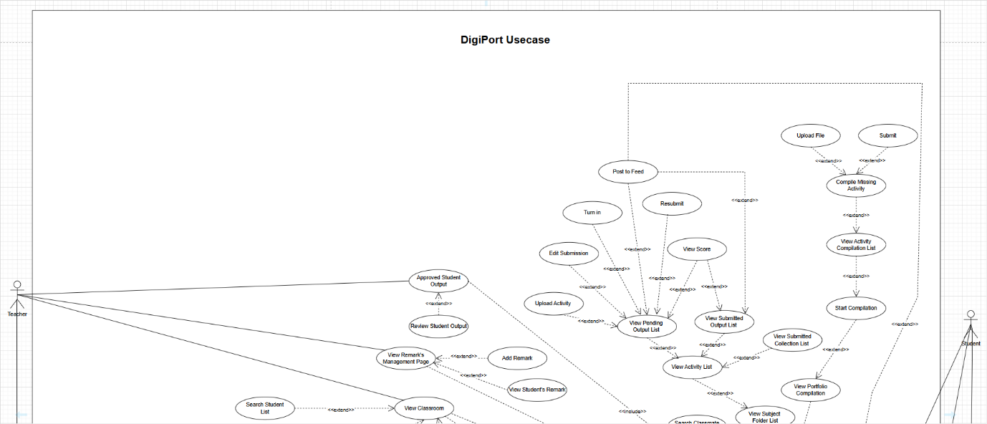

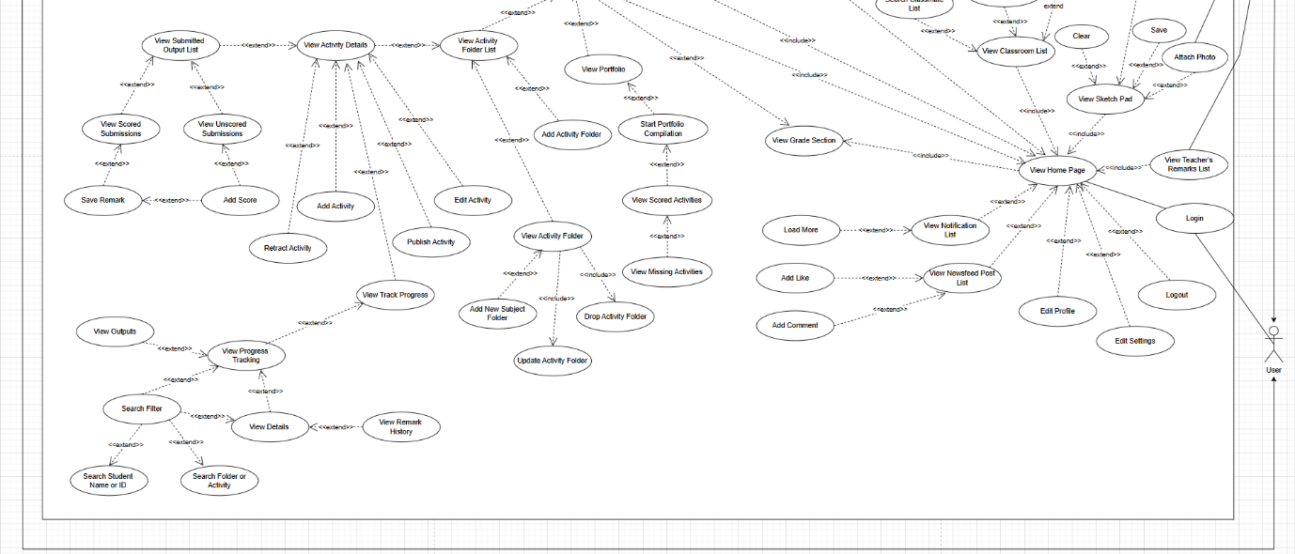

Figure 7.Use Case Diagram of Digital Portfolio System

