DOCUMENTATION

ASSIGNMENT 1 – Polynomial Calculator

STUDENT NAME: VRAJA MARCO-MIHAI
GROUP: 30422

CONTENTS

1. Assignment Objective 3
2. Problem Analysis, Modeling, Scenarios, Use Cases 3
3. Design 3
4. Implementation 3
5. Results 3
6. Conclusions 3
7. Bibliography 3

Assignment Objective
The main objective of this polynomial calculator is to provide users with a tool to perform basic operations on polynomials, including addition, subtraction, multiplication, derivation, and integration.
The following table represent the sub-objectives.
Sub-Objective | Description | Section
Polynomial Representation | Define a data structure to represent polynomials internally, storing coefficients and their corresponding exponents. | Polynomial class
Polynomial Input | Allow users to input polynomials in a standard mathematical format  (e.g., "3x^2 - 5x + 2"). | Controller class
Polynomial Operations | Implement the core mathematical operations: addition, subtraction, multiplication, derivative, integral. | Operations class
Polynomial Output | Display the results of calculations in a clear and readable format. | Polynomial class
User Interface (UI) | Design a user-friendly interface (GUI or command-line) for inputting polynomials and displaying results. | View class
Unit Testing | Write comprehensive unit tests to ensure the correctness of polynomial operations. | OperationsTest class

Problem Analysis, Modeling, Scenarios, Use Cases
Functional Requirements
    - Polynomial Input:
      - Allow users to enter polynomial expressions using standard mathematical notation
(e.g., "2x^3 - 5x^2 + 3").
      - Support coefficients (positive, integer)

    - Polynomial Operations:
      - Provide the ability to add two polynomials.
      - Provide the ability to subtract one polynomial from another.
      - Provide the ability to multiply two polynomials.
      - Provide the ability to calculate the derivative of a polynomial.
      - Provide the ability to calculate the integral of a polynomial.
    - Output Formatting
      - Display the results of calculations in a clear and well-formatted mathematical representation.
Non-Functional Requirements
      - Usability
Use Cases
1. Perform Polynomial Operation ( Addition, Subtraction, Multiplication )
Actor: User
Steps:
      - User enters the first polynomial.
      - User enters the second polynomial.
      - User selects the desired operation (addition, subtraction, multiplication).
      - System parses the input.
      - System performs the selected calculation.
      - System displays the result.
2. Compute Derivative
Actor: User
Steps:
      - User enters a polynomial.
      - User selects the "derivative" operation.
      - System parses the input.
      - System calculates the derivative.
      - System displays the result.
3. Compute Integral
Actor: User
Steps:
      - User enters a polynomial.
      - User selects the "integral" operation.
      - System parses the input.
      - System calculates the integral.
      - System displays the result (without an arbitrary constant).

Design
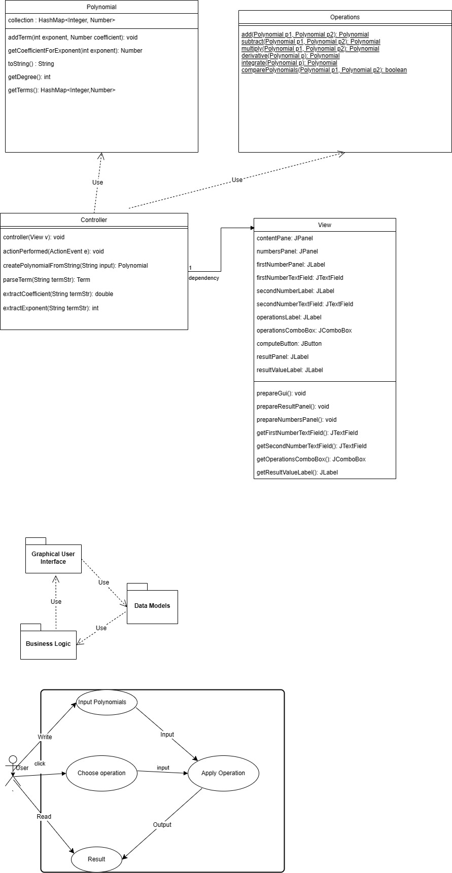

Implementation
Class Descriptions
Polynomial
Fields:
        - terms: A HashMap to store coefficients and exponents (e.g., HashMap<Integer, Number>).
Important Methods:
        - addTerm(int exponent, Number coefficient): Adds or updates a term in the polynomial
        - getDegree(): Returns the highest exponent within the polynomial.
        - getTerms(): Returns a copy of the HashMap representing the polynomial.
        - getCoefficientForExponent(int exponent): Returns the coefficient associated with a specific exponent.
        - toString(): Provides a formatted string representation of the polynomial.
Operations
Important Methods (Static):
        - add(Polynomial p1, Polynomial p2)
        - subtract(Polynomial p1, Polynomial p2)
        - multiply(Polynomial p1, Polynomial p2)
        - derivative(Polynomial p)
        - integrate(Polynomial p)

Controller
Fields:
        - view: A reference to the View object.
        - operations: A reference to the Operations object.
Important Methods:
        - controller(View v): Constructor to initialize the controller, taking a View object as input. This sets up the link to the GUI.
        - actionPerformed(ActionEvent e): Implements the ActionListener interface to handle events triggered by the user interface (e.g., button clicks). This is the core event handler.
        - createPolynomialFromString(String input): A helper function responsible for parsing a string representation of a polynomial into a Polynomial object.
        - parseTerm(String termStr): A helper function used within createPolynomialFromString to process individual terms within the polynomial string.
        - extractCoefficient(String termStr): A helper function used within createPolynomialFromString to extract the numeric coefficient of a term.
        - extractExponent(String termStr): A helper function used within createPolynomialFromString to extract the exponent of a term.
View
Fields:
        - GUI components:
        - firstNumberTextField: Input field for the first polynomial
        - secondNumberTextField: Input field for the second polynomial.
- operationsComboBox: Dropdown to select the operation.
- computeButton: Button to initiate the calculation.
- resultValueLabel: Label to display the result.
Important Methods:
                - View(String name): Constructor.
                - prepareGui(): Sets up the GUI layout.
                - getFirstNumberTextField(), getSecondNumberTextField(), getOperationsComboBox(), getResultValueLabel(): Getters for accessing GUI components.

GUI COMPONENT
Layout
Window Title: "Polynomial Calculator"
Input:
    - Labels: "Polynomial 1:", "Polynomial 2:"
    - Text Fields: Allow users to type in polynomial expressions (e.g., "3x^2 - 5x + 1").
Operation Selection:
    - Label: "Operation:"
    - Dropdown (JComboBox): Options include "Add", "Subtract", "Multiply", "Derive", "Integrate".
    - Button: "Compute" button to initiate the calculation.
Output:
    - Label: "Result:"
    - Label (Result): A non-editable label to display the calculated polynomial.

Results

A suite of unit tests has been developed using the JUnit framework to systematically verify the calculator's behavior under various conditions.
Testing Scenarios
Addition
      - Testing with positive coefficients.
Subtraction
      - Testing with positive coefficients.
      - Testing with negative coefficients.
      - Testing with zero polynomials.
Multiplication
      - Testing with simple polynomials.
      - Testing with zero polynomials.
      - Testing with polynomials of larger degrees.
Derivative
      - Testing with simple polynomials.
      - Testing with zero polynomials.
      - Testing with higher-order polynomials.
Integral
      - Testing with simple polynomials.
      - Testing with zero polynomials.
      - Testing with higher-order polynomials.

Conclusions

Designing and implementing the polynomial calculator application represent a complex process. Key highlights of this journey include:
      - Object-Oriented Design: establishing a strong foundation by modeling the problem domain with classes representing Polynomial, Operations and Controller. This structured approach enhanced code organization, maintainability and potential for reusability.
      - Data Structure Selection: The choice of a HashMap ( HashMap<Integer, Number>) within the polynomial class effectively facilitated the storage and retrieval of polynomial terms (coefficients and exponents). The HashMap provided efficient lookup of coefficients based on their exponents, which is crucial during polynomial operations.
      - Encapsulation: designing with the intent to uphold the principle of encapsulation, promoting flexibility.

Lessons learned:
      - Importance of Iteration: Software development is rarely a linear process. Iterative refactoring, guided by feedback and best practices, underscored the value of continuous improvement in code design.
      - Significance of Abstraction: Defining classes like allowed to abstract away the complexities of polynomial representation and manipulation. The Operations class provided a clean interface for performing calculations without needing to understand the low-level details of term manipulation.

Future Development
- Error Handling: robust handling for invalid strings, potential division by zero
- Enhanced User Interface: richer user interface, more intuitive controls
- Complex Number Support: handling of polynomials with complex coefficients

Bibliography
Example:
- Index of /courses/pt/materials/lectures (dsrl.eu)
- PT2024_Documentation_Template_EN.doc (live.com)
- PT2024_Laboratory_Resources.pdf (dsrl.eu)
- PT2024_A1.pdf (dsrl.eu)
- https://stackoverflow.com/a/36491596/23229404
- How does java.util.Map's getOrDefault() work? - Stack Overflow
- java - Reading a text file and converting them into polynomials - Stack Overflow
- PT / Pt Gui Demo Swing · GitLab

