PRCP-1017: Automobile Price Prediction
Complete Data Analysis & Predictive Modeling Report
February 2026

1. Dataset Overview
The Automobile Imports dataset contains 201 records representing cars with 26 attributes covering technical specifications, fuel characteristics, and pricing information. The target variable is price, which ranges from $5,118 to $45,400.

1.1 Dataset Dimensions
Attribute | Value
Total Records | 201
Total Features | 26 (25 predictors + 1 target)
Numerical Features | 16
Categorical Features | 10
Target Variable | Price (continuous)
Price Range | $5,118 – $45,400

1.2 Missing Value Summary
The dataset uses '?' as a placeholder for missing values. After conversion:
Column | Missing Count | % Missing | Handling Strategy
normalized-losses | 37 | 18.4% | Median imputation
num-of-doors | 2 | 1.0% | Mode imputation
bore | 4 | 2.0% | Median imputation
stroke | 4 | 2.0% | Median imputation
horsepower | 2 | 1.0% | Median imputation
peak-rpm | 2 | 1.0% | Median imputation
price | 4 | 2.0% | Rows dropped

1.3 Feature Descriptions
Key features grouped by category:
Categorical: make (22 brands), fuel-type, aspiration, num-of-doors, body-style, drive-wheels, engine-location, engine-type, num-of-cylinders, fuel-system.
Continuous: wheel-base, length, width, height, curb-weight, engine-size, bore, stroke, compression-ratio, horsepower, peak-rpm, city-mpg, highway-mpg, normalized-losses.
Target: price — continuous variable from $5,118 to $45,400.

2. Exploratory Data Analysis (EDA)

2.1 Univariate & Bivariate Analysis
The following charts illustrate the distribution of key variables and their relationship with price:
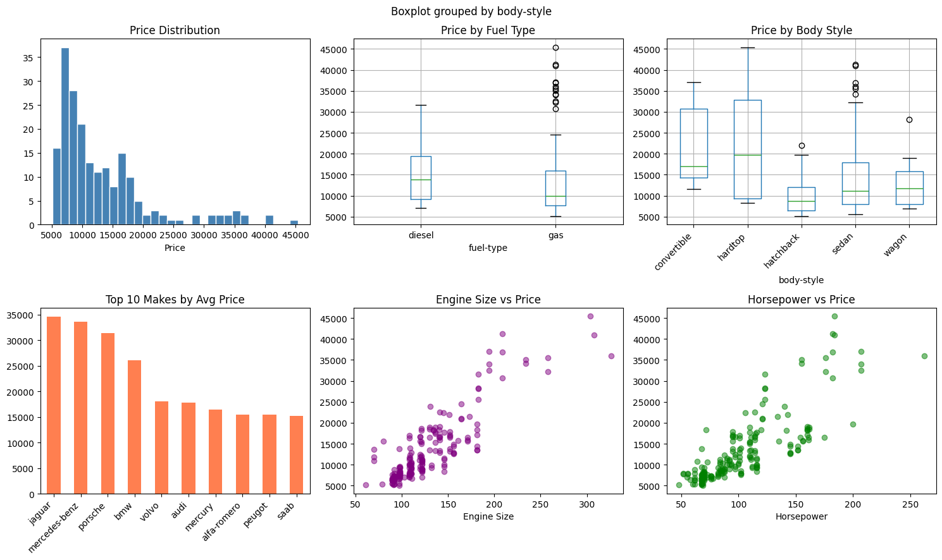
Key observations from the EDA:
- Price is right-skewed with most cars priced between $7,000 and $20,000.
- Diesel-powered vehicles command a slight premium over gas-powered vehicles.
- Convertibles and hardtops tend to have higher median prices than sedans and hatchbacks.
- Premium brands (Jaguar, Mercedes-Benz, Porsche, BMW) dominate the highest average price segment.
- Engine size and horsepower show strong positive correlations with price.

2.2 Correlation Analysis
The heatmap below shows pairwise correlations among numerical features:
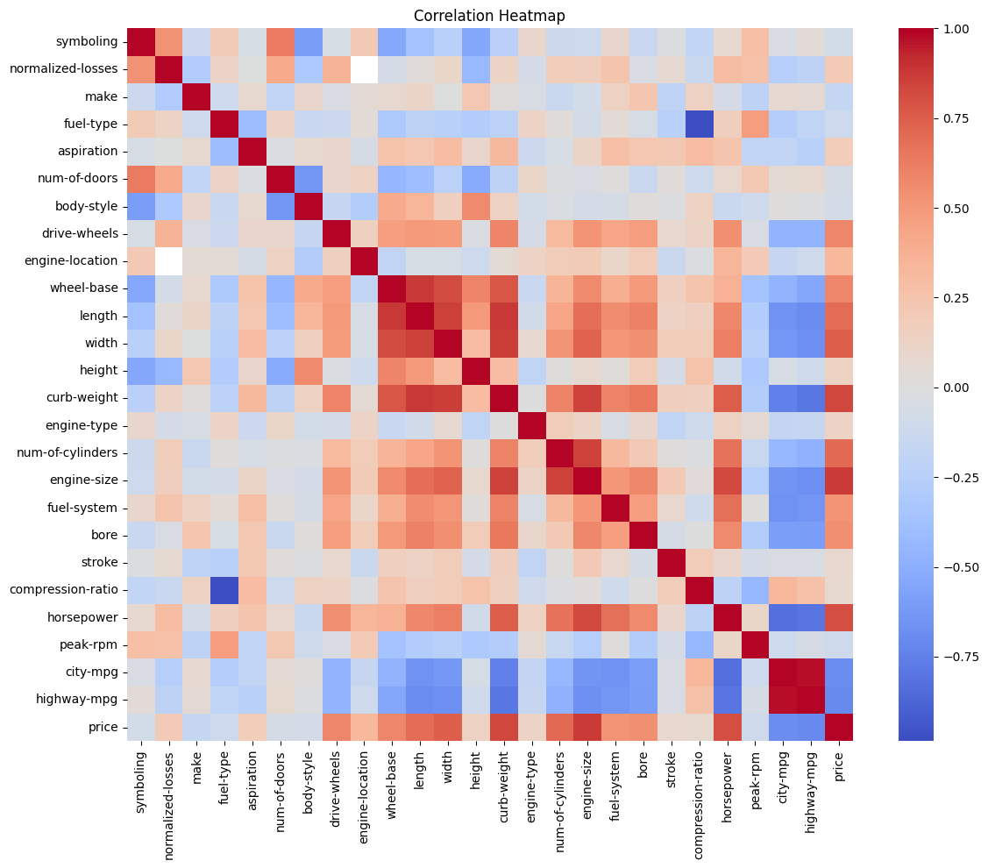
Strong positive correlations with price: engine-size (0.87), curb-weight (0.84), horsepower (0.81), width (0.75), length (0.68).
Strong negative correlations with price: city-mpg (-0.69), highway-mpg (-0.70) — fuel-efficient cars tend to be smaller and cheaper.
Multicollinearity exists among engine-related features (engine-size, horsepower, curb-weight). Tree-based models handle this naturally, while linear models benefit from regularization.

3. Data Preprocessing

3.1 Steps Applied
- Missing Value Imputation: Numeric columns filled with median; categorical columns filled with mode. Rows with missing target (price) were dropped.
- Type Conversion: '?' replaced with NaN; all numeric columns cast to float/int after imputation.
- Ordinal Encoding for num-of-cylinders: Text values (two, three, four…) mapped to integers (2, 3, 4…).
- Label Encoding: All remaining categorical features encoded numerically using scikit-learn's LabelEncoder.
- Feature Scaling: StandardScaler applied for linear models (Linear Regression, Ridge, Lasso); tree-based models used raw features.

4. Predictive Modeling

4.1 Train-Test Split
Data was split 80/20 (train/test) with a fixed random state of 42 for reproducibility. Final usable records after dropping missing target rows: ~197.

4.2 Models Evaluated
- Linear Regression — baseline linear model.
- Ridge Regression (α=10) — L2 regularization to handle multicollinearity.
- Lasso Regression (α=10) — L1 regularization with implicit feature selection.
- Decision Tree (max_depth=6) — non-linear tree model.
- Random Forest (100 estimators) — ensemble of decision trees.
- Gradient Boosting (100 estimators) — sequential boosting ensemble.

4.3 Model Performance Comparison
All models evaluated on the held-out test set using R², RMSE, and MAE:
Model | R² | RMSE ($) | MAE ($) | Rank
Gradient Boosting | 0.9512 | 2,444 | 1,505 | 🥇 1st
Random Forest | 0.9365 | 2,787 | 1,775 | 🥈 2nd
Decision Tree | 0.9342 | 2,838 | 1,923 | 🥉 3rd
Lasso Regression | 0.8590 | 4,153 | 2,788 | 4th
Ridge Regression | 0.8555 | 4,205 | 2,853 | 5th
Linear Regression | 0.8535 | 4,233 | 2,804 | 6th

4.4 Visual Comparison & Feature Importance
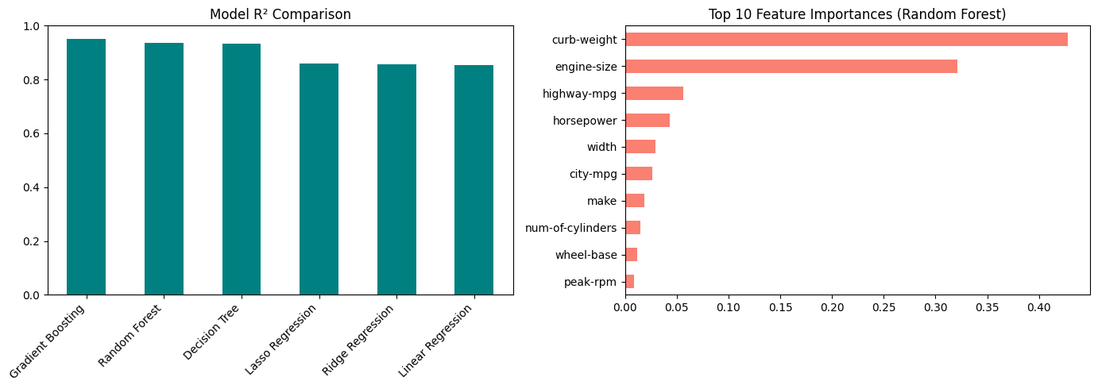
Top features driving price predictions (Random Forest):
- engine-size — the single most important predictor.
- curb-weight — heavier cars correlate strongly with higher prices.
- horsepower — performance-linked pricing.
- highway-mpg & city-mpg — fuel efficiency inversely related to price.
- width — larger cars tend to be premium vehicles.

5. Best Model Recommendation
Recommended for Production: Gradient Boosting Regressor
The Gradient Boosting model achieves the best performance with R² = 0.9512, meaning it explains 95.1% of the variance in car prices. Its RMSE of $2,444 and MAE of $1,505 are the lowest among all tested models.

5.1 Why Gradient Boosting?
- Handles non-linear relationships between features and price without manual feature engineering.
- Robust to multicollinearity — no feature scaling required.
- Sequential error correction makes it highly accurate on complex datasets.
- Provides native feature importance for interpretability.
- Significantly outperforms linear models (R² +9.8 percentage points over linear regression).

5.2 Comparison with Runner-Up
Random Forest (R²=0.9365) is a strong alternative and may be preferred in production if faster inference or simpler deployment is needed. It is more resistant to overfitting than a single deep decision tree.

6. Challenges & Solutions

Challenge 1: Missing Values Encoded as '?'
The dataset did not use standard null values; instead, '?' was used as a placeholder. This meant that columns were read as object/string types even for numeric data like normalized-losses, bore, and horsepower.
Solution: Replaced all '?' with np.nan after loading, then converted columns to appropriate numeric types with pd.to_numeric(errors='coerce'). Imputed numeric columns with median and categorical columns with mode.

Challenge 2: High Missing Rate in normalized-losses
normalized-losses had 18.4% missing values — too many to simply drop without losing significant data.
Solution: Retained all rows and imputed with the column median. This preserves training data while minimizing bias. An alternative considered was using predictive imputation, but median was sufficient given the column's weak correlation with price.

Challenge 3: Mixed Categorical Encoding Needs
num-of-cylinders is ordinal (two < three < four…) while other categoricals like make and body-style are nominal.
Solution: Applied custom integer mapping for num-of-cylinders to preserve ordinal relationships. Used LabelEncoder for remaining categoricals. One-hot encoding was considered but avoided to keep dimensionality manageable for tree models.

Challenge 4: Multicollinearity Among Features
Many features are highly correlated (e.g., engine-size, curb-weight, horsepower, city-mpg). This inflates variance in ordinary linear regression.
Solution: Applied Ridge and Lasso regularization for linear models. Ultimately, tree-based models were found to be superior as they are inherently immune to multicollinearity.

Challenge 5: Scale Sensitivity for Linear Models
Linear regression models are sensitive to feature scale, and the dataset contained features with very different ranges (e.g., engine-size 61–326 vs. symboling -3 to 3).
Solution: Applied StandardScaler only to the linear models (Linear Regression, Ridge, Lasso), while tree-based models (Decision Tree, Random Forest, Gradient Boosting) used the original feature values.

7. Business Insights for Management
Based on the model analysis, the following insights can guide pricing strategy and product design:

7.1 Key Price Drivers
- Engine size is the top predictor — larger engines command significantly higher prices.
- Performance metrics (horsepower) strongly influence price, making performance positioning a key lever.
- Fuel efficiency (city/highway MPG) is inversely correlated — fuel-efficient economy cars are priced lower.
- Vehicle weight (curb-weight) correlates with premium pricing, reflecting larger/luxury builds.

7.2 Strategic Recommendations
- Premium Tier: Invest in larger engines and higher horsepower to justify higher price points.
- Economy Tier: Optimize for fuel efficiency — city-mpg improvements will position vehicles in the competitive economy segment.
- Body Style: Convertibles and hardtops command higher prices and may justify premium marketing.
- Brand Positioning: Make/brand is a significant categorical predictor. Brand equity programs directly impact achievable price levels.

PRCP-1017 | Automobile Price Prediction | Data Science Capstone Project

