Course Title: Cryptography and Network Security Lab | Course Code: BCSE309P
Faculty: Prof. Karthika V | Slot: L15+L16
Regno: 23BCE1099 | Name: Arkita Barua

LAB2 – Ex1b
PLAYFAIR CIPHER
Code
Sender
// Client.java - sender
import java.io.*;
import java.net.*;
import java.util.Scanner;

public class Sender {
private char[][] matrix;

public Sender(String key) {
buildMatrix(key.toUpperCase().replace('J', 'I'));
}

private void buildMatrix(String key) {
boolean[] used = new boolean[26];
matrix = new char[5][5];
int idx = 0;

for (char c : key.toCharArray()) {
if (c >= 'A' && c <= 'Z' && !used[c - 'A']) {
used[c - 'A'] = true;
matrix[idx / 5][idx % 5] = c;
idx++;
}
}

for (char c = 'A'; c <= 'Z'; c++) {
if (c == 'J') continue;
if (!used[c - 'A']) {
matrix[idx / 5][idx % 5] = c;
idx++;
}
}
}

private String preprocess(String text) {
StringBuilder clean = new StringBuilder();
for (char c : text.toUpperCase().toCharArray()) {
if (c >= 'A' && c <= 'Z') {
clean.append(c == 'J' ? 'I' : c);
}
}

StringBuilder result = new StringBuilder();
int i = 0;
while (i < clean.length()) {
char a = clean.charAt(i);
if (i == clean.length() - 1) {
// Last character, odd length
result.append(a).append('X');
break;
}
char b = clean.charAt(i + 1);
if (a == b) {
// Same letter: use 'X' as filler, and do NOT consume b yet
result.append(a).append('X');
i++; // move only by 1, so b is reused as first letter next time
} else {
result.append(a).append(b);
i += 2;
}
}
return result.toString();
}
private String insertFillers(String s) {
StringBuilder res = new StringBuilder();
for (int i = 0; i < s.length(); i++) {
char c = s.charAt(i);
res.append(c);
if (i + 1 < s.length() && s.charAt(i + 1) == c) {
res.append('X');
}
}
if (res.length() % 2 == 1) {
res.append('X');
}
return res.toString();
}

private int[] find(char c) {
for (int i = 0; i < 5; i++) {
for (int j = 0; j < 5; j++) {
if (matrix[i][j] == c) {
return new int[]{i, j};
}
}
}
return new int[]{-1, -1};
}

public String encrypt(String plain) {
String clean = preprocess(plain);
StringBuilder cipher = new StringBuilder();

for (int i = 0; i < clean.length(); i += 2) {
char a = clean.charAt(i);
char b = clean.charAt(i + 1);
int[] posA = find(a);
int[] posB = find(b);

if (posA[0] == posB[0]) {
cipher.append(matrix[posA[0]][(posA[1] + 1) % 5])
.append(matrix[posB[0]][(posB[1] + 1) % 5]);
} else if (posA[1] == posB[1]) {
cipher.append(matrix[(posA[0] + 1) % 5][posA[1]])
.append(matrix[(posB[0] + 1) % 5][posB[1]]);
} else {
cipher.append(matrix[posA[0]][posB[1]])
.append(matrix[posB[0]][posA[1]]);
}
}
return cipher.toString();
}

public static void main(String[] args) {
Scanner sc = new Scanner(System.in);

System.out.print("Enter key: ");
String key = sc.nextLine().trim();

System.out.print("Enter plaintext: ");
String plaintext = sc.nextLine().trim();

Sender client = new Sender(key);
String ciphertext = client.encrypt(plaintext);

System.out.println("Ciphertext: " + ciphertext);

try (Socket socket = new Socket("localhost", 5000);
ObjectOutputStream out = new ObjectOutputStream(socket.getOutputStream())) {

out.writeObject(key);
out.writeObject(ciphertext);
out.flush();

System.out.println("Sent to server.");

} catch (IOException e) {
e.printStackTrace();
}
sc.close();
}
}

Receiver
// Server.java - receiver
import java.io.*;
import java.net.*;

public class Receiver {
private char[][] matrix;

public Receiver(String key) {
buildMatrix(key.toUpperCase().replace('J', 'I'));
}

private void buildMatrix(String key) {
boolean[] used = new boolean[26];
matrix = new char[5][5];
int idx = 0;

for (char c : key.toCharArray()) {
if (c >= 'A' && c <= 'Z' && !used[c - 'A']) {
used[c - 'A'] = true;
matrix[idx / 5][idx % 5] = c;
idx++;
}
}

for (char c = 'A'; c <= 'Z'; c++) {
if (c == 'J') continue;
if (!used[c - 'A']) {
matrix[idx / 5][idx % 5] = c;
idx++;
}
}
}

private int[] find(char c) {
for (int i = 0; i < 5; i++) {
for (int j = 0; j < 5; j++) {
if (matrix[i][j] == c) {
return new int[]{i, j};
}
}
}
return new int[]{-1, -1};
}

public String decrypt(String cipher) {
StringBuilder plain = new StringBuilder();
for (int i = 0; i < cipher.length(); i += 2) {
char a = cipher.charAt(i);
char b = cipher.charAt(i + 1);
int[] posA = find(a);
int[] posB = find(b);

if (posA[0] == posB[0]) {
plain.append(matrix[posA[0]][(posA[1] - 1 + 5) % 5])
.append(matrix[posB[0]][(posB[1] - 1 + 5) % 5]);
} else if (posA[1] == posB[1]) {
plain.append(matrix[(posA[0] - 1 + 5) % 5][posA[1]])
.append(matrix[(posB[0] - 1 + 5) % 5][posB[1]]);
} else {
plain.append(matrix[posA[0]][posB[1]])
.append(matrix[posB[0]][posA[1]]);
}
}

// Remove filler 'X' between identical letters or at end
StringBuilder result = new StringBuilder();
for (int i = 0; i < plain.length(); i++) {
char c = plain.charAt(i);
if (c == 'X') {
if (i > 0 && i < plain.length() - 1 && plain.charAt(i - 1) == plain.charAt(i + 1))
continue;
if (i == plain.length() - 1)
continue;
}
result.append(c);
}
return result.toString();
}

public static void main(String[] args) {
final int PORT = 5000;
try (ServerSocket serverSocket = new ServerSocket(PORT)) {
System.out.println("Server ready on port " + PORT);

try (Socket clientSocket = serverSocket.accept();
ObjectInputStream in = new ObjectInputStream(clientSocket.getInputStream())) {

String key = (String) in.readObject();
String ciphertext = (String) in.readObject();

System.out.println("Received key: " + key);
System.out.println("Received ciphertext: " + ciphertext);

Receiver r = new Receiver(key);
String decrypted = r.decrypt(ciphertext);

System.out.println("Decrypted plaintext: " + decrypted);

} catch (Exception e) {
e.printStackTrace();
}
} catch (IOException e) {
e.printStackTrace();
}
}
}

Output [screenshot]
Sender
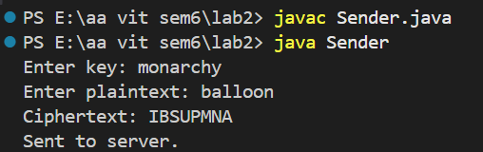

Receiver
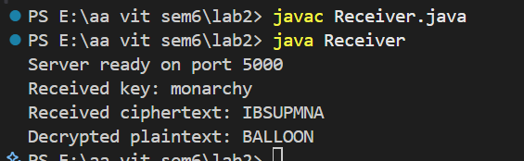

HILL CIPHER
Code
Sender
import java.net.*;
import java.io.*;
import java.util.*;

public class sender_hill {
public static void main(String[] args) throws Exception {

Scanner sc = new Scanner(System.in);

System.out.print("Enter plaintext (UPPERCASE): ");
String pt = sc.nextLine().toUpperCase();

System.out.print("Enter matrix size n: ");
int n = sc.nextInt();

if (pt.length() % n != 0) {
System.out.println("Plaintext length not multiple of matrix size");
return;
}

int[][] key = new int[n][n];
System.out.println("Enter key matrix:");
for (int i = 0; i < n; i++)
for (int j = 0; j < n; j++)
key[i][j] = sc.nextInt();

Socket s = new Socket("localhost", 8000);
PrintWriter out = new PrintWriter(s.getOutputStream(), true);

String ct = "";

for (int i = 0; i < pt.length(); i += n) {
for (int r = 0; r < n; r++) {
int sum = 0;
for (int c = 0; c < n; c++)
sum += key[r][c] * (pt.charAt(i + c) - 'A');
ct += (char) ((sum % 26) + 'A');
}
}

System.out.println("Cipher Text (CT): " + ct);

out.println(n);
out.println(ct);
for (int i = 0; i < n; i++) {
for (int j = 0; j < n; j++)
out.print(key[i][j] + " ");
out.println();
}

s.close();
sc.close();
}
}

Receiver
import java.net.*;
import java.io.*;
import java.util.*;

public class receiver_hill {
public static void main(String[] args) throws Exception {

System.out.println("Server starting...");
ServerSocket ss = new ServerSocket(8000);
System.out.println("Server waiting for client connection...");

Socket s = ss.accept();
System.out.println("Client connected.");

BufferedReader in = new BufferedReader(
new InputStreamReader(s.getInputStream()));

int n = Integer.parseInt(in.readLine());

String ct = in.readLine();
System.out.println("Cipher Text received: " + ct);

int[][] key = new int[n][n];
for (int i = 0; i < n; i++) {
StringTokenizer st = new StringTokenizer(in.readLine());
for (int j = 0; j < n; j++) {
key[i][j] = Integer.parseInt(st.nextToken());
}
}

// Augmented matrix [K | I]
int[][] aug = new int[n][2 * n];
for (int i = 0; i < n; i++) {
for (int j = 0; j < n; j++)
aug[i][j] = key[i][j] % 26;
aug[i][i + n] = 1;
}

// Gauss–Jordan elimination (mod 26)
for (int i = 0; i < n; i++) {
int inv = 0;
for (int x = 1; x < 26; x++)
if ((aug[i][i] * x) % 26 == 1)
inv = x;

for (int j = 0; j < 2 * n; j++)
aug[i][j] = (aug[i][j] * inv) % 26;

for (int k = 0; k < n; k++) {
if (k != i) {
int factor = aug[k][i];
for (int j = 0; j < 2 * n; j++)
aug[k][j] = (aug[k][j] - factor * aug[i][j]) % 26;
}
}
}

int[][] invKey = new int[n][n];
for (int i = 0; i < n; i++)
for (int j = 0; j < n; j++)
invKey[i][j] = (aug[i][j + n] + 26) % 26;

String pt = "";

for (int i = 0; i < ct.length(); i += n) {
for (int r = 0; r < n; r++) {
int sum = 0;
for (int c = 0; c < n; c++)
sum += invKey[r][c] * (ct.charAt(i + c) - 'A');
pt += (char) ((sum % 26) + 'A');
}
}

System.out.println("Plain Text (PT): " + pt);
System.out.println("Closing connection.");

s.close();
ss.close();
}
}

Output [screenshot]
Sender
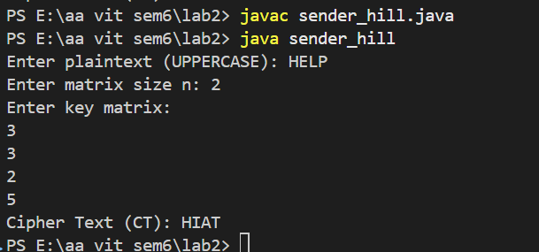
Receiver
