Course Title: Cryptography and Network Security Lab | Course Code: BCSE309P
Faculty: Prof. Karthika V | Slot: L15+L16
Regno: 23BCE1099 | Name: Arkita Barua

Ex2a
S-DES
Code
Sender

import java.net.*;
import java.io.*;
import java.util.*;

public class sdes_client_sender {

// Permutation tables
static int[] P10 = {3,5,2,7,4,10,1,9,8,6};
static int[] P8 = {6,3,7,4,8,5,10,9};
static int[] IP = {2,6,3,1,4,8,5,7};
static int[] IP_INV = {4,1,3,5,7,2,8,6};
static int[] EP = {4,1,2,3,2,3,4,1};
static int[] P4 = {2,4,3,1};

static int[][] S0 = {
{1,0,3,2},
{3,2,1,0},
{0,2,1,3},
{3,1,3,2}
};

static int[][] S1 = {
{0,1,2,3},
{2,0,1,3},
{3,0,1,0},
{2,1,0,3}
};

public static void main(String[] args) throws Exception {

Scanner sc = new Scanner(System.in);

Socket socket = new Socket("localhost", 5000);
PrintWriter out = new PrintWriter(socket.getOutputStream(), true);

System.out.print("Plaintext (8 bits): ");
String pt = sc.nextLine();

System.out.print("Key (10 bits): ");
String key = sc.nextLine();

// Generate Subkeys
String p10 = permute(key, P10);
String left = p10.substring(0,5);
String right = p10.substring(5);

left = shift(left,1);
right = shift(right,1);

String k1 = permute(left+right, P8);

left = shift(left,2);
right = shift(right,2);

String k2 = permute(left+right, P8);

System.out.println("\nSubkeys:");
System.out.println("K1: " + k1);
System.out.println("K2: " + k2);

// Initial Permutation
String ip = permute(pt, IP);
System.out.println("IP: " + ip);

// Round 1
String r1 = fk(ip, k1);
System.out.println("Round1: " + r1);

// Swap
r1 = r1.substring(4) + r1.substring(0,4);

// Round 2
String r2 = fk(r1, k2);
System.out.println("Round2: " + r2);

// Inverse IP
String ct = permute(r2, IP_INV);
System.out.println("Cipher Text: " + ct);

// Send to receiver
out.println(ct);
out.println(k1);
out.println(k2);

socket.close();
sc.close();
}

static String permute(String input, int[] table) {
String output = "";
for(int i : table)
output += input.charAt(i-1);
return output;
}

static String shift(String input, int n) {
return input.substring(n) + input.substring(0,n);
}

static String xor(String a, String b) {
String result = "";
for(int i=0;i<a.length();i++)
result += (a.charAt(i)==b.charAt(i)) ? '0' : '1';
return result;
}

static String fk(String input, String key) {
String left = input.substring(0,4);
String right = input.substring(4);

String ep = permute(right, EP);
String xor = xor(ep, key);

String s0 = sBox(xor.substring(0,4), S0);
String s1 = sBox(xor.substring(4), S1);

String p4 = permute(s0+s1, P4);
String result = xor(left, p4) + right;

return result;
}

static String sBox(String input, int[][] box) {
int row = Integer.parseInt("" + input.charAt(0) + input.charAt(3),2);
int col = Integer.parseInt("" + input.charAt(1) + input.charAt(2),2);
int val = box[row][col];
return String.format("%2s", Integer.toBinaryString(val)).replace(' ','0');
}
}

Receiver

import java.net.*;
import java.io.*;

public class sdes_server_receiver {

// Same permutation tables
static int[] IP = {2,6,3,1,4,8,5,7};
static int[] IP_INV = {4,1,3,5,7,2,8,6};
static int[] EP = {4,1,2,3,2,3,4,1};
static int[] P4 = {2,4,3,1};

static int[][] S0 = {
{1,0,3,2},
{3,2,1,0},
{0,2,1,3},
{3,1,3,2}
};

static int[][] S1 = {
{0,1,2,3},
{2,0,1,3},
{3,0,1,0},
{2,1,0,3}
};

public static void main(String[] args) throws Exception {

ServerSocket serverSocket = new ServerSocket(5000);
System.out.println("Waiting for sender(client)");

Socket socket = serverSocket.accept();
System.out.println("client connected");

BufferedReader in = new BufferedReader(new InputStreamReader(socket.getInputStream()));

String ct = in.readLine();
String k1 = in.readLine();
String k2 = in.readLine();

System.out.println("\nReceived Cipher Text: " + ct);
System.out.println("Subkeys:");
System.out.println("K1: " + k1);
System.out.println("K2: " + k2);

String ip = permute(ct, IP);
System.out.println("IP: " + ip);

String r1 = fk(ip, k2);
System.out.println("Round1: " + r1);

r1 = r1.substring(4) + r1.substring(0,4);

String r2 = fk(r1, k1);
System.out.println("Round2: " + r2);

String pt = permute(r2, IP_INV);
System.out.println("Plaintext: " + pt);

socket.close();
serverSocket.close();
}

static String permute(String input, int[] table) {
String output = "";
for(int i : table)
output += input.charAt(i-1);
return output;
}

static String xor(String a, String b) {
String result = "";
for(int i=0;i<a.length();i++)
result += (a.charAt(i)==b.charAt(i)) ? '0' : '1';
return result;
}

static String fk(String input, String key) {
String left = input.substring(0,4);
String right = input.substring(4);

String ep = permute(right, EP);
String xor = xor(ep, key);

String s0 = sBox(xor.substring(0,4), S0);
String s1 = sBox(xor.substring(4), S1);

String p4 = permute(s0+s1, P4);
String result = xor(left, p4) + right;

return result;
}

static String sBox(String input, int[][] box) {
int row = Integer.parseInt("" + input.charAt(0) + input.charAt(3),2);
int col = Integer.parseInt("" + input.charAt(1) + input.charAt(2),2);
int val = box[row][col];
return String.format("%2s", Integer.toBinaryString(val)).replace(' ','0');
}
}

Output [screenshot]
Sender
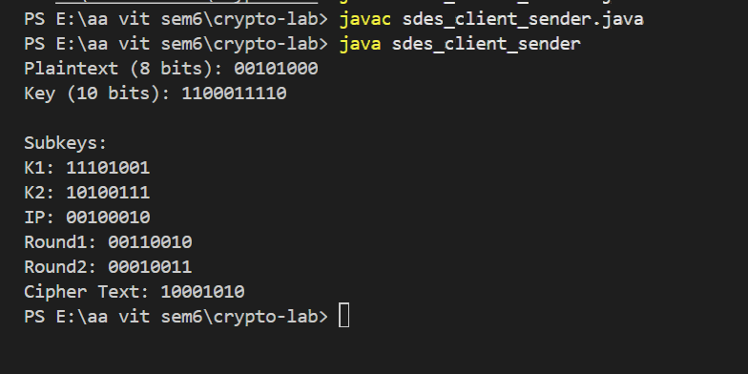

Receiver
