Course Title: Cryptography and Network Security Lab | Course Code: BCSE309P
Faculty: Prof. Karthika V | Slot: L15+L16
Regno: 23BCE1099 | Name: Arkita Barua

Ex3
AES
Code
Sender
import java.io.*;
import java.net.Socket;
import java.nio.charset.StandardCharsets;
import java.util.Arrays;
import java.util.Scanner;

public class aes_client_sender {
public static void main(String[] args) {
Scanner sc = new Scanner(System.in, "UTF-8");
System.out.print("Plaintext: ");
String plaintext = sc.nextLine();
System.out.print("Key: ");
String key = sc.nextLine();

String cipherStr = AES.encryptToString(plaintext, key);

try (Socket s = new Socket("localhost", 5000);
DataOutputStream dos = new DataOutputStream(s.getOutputStream());
DataInputStream dis = new DataInputStream(s.getInputStream())) {

byte[] cipherUtf8 = cipherStr.getBytes(StandardCharsets.UTF_8);
dos.writeInt(cipherUtf8.length);
dos.write(cipherUtf8);
dos.flush();

System.out.println("Cypher text sent: "+cipherStr);

int respLen = dis.readInt();
byte[] resp = new byte[respLen];
dis.readFully(resp);
System.out.println("Receiver response: " + new String(resp, StandardCharsets.UTF_8));
} catch (Exception e) {
e.printStackTrace();
}
}

// AES (encrypt-only)
static class AES {
private static final int Nr = 10;
private static final int[] SBOX = {
0x63,0x7c,0x77,0x7b,0xf2,0x6b,0x6f,0xc5,0x30,0x01,0x67,0x2b,0xfe,0xd7,0xab,0x76,
0xca,0x82,0xc9,0x7d,0xfa,0x59,0x47,0xf0,0xad,0xd4,0xa2,0xaf,0x9c,0xa4,0x72,0xc0,
0xb7,0xfd,0x93,0x26,0x36,0x3f,0xf7,0xcc,0x34,0xa5,0xe5,0xf1,0x71,0xd8,0x31,0x15,
0x04,0xc7,0x23,0xc3,0x18,0x96,0x05,0x9a,0x07,0x12,0x80,0xe2,0xeb,0x27,0xb2,0x75,
0x09,0x83,0x2c,0x1a,0x1b,0x6e,0x5a,0xa0,0x52,0x3b,0xd6,0xb3,0x29,0xe3,0x2f,0x84,
0x53,0xd1,0x00,0xed,0x20,0xfc,0xb1,0x5b,0x6a,0xcb,0xbe,0x39,0x4a,0x4c,0x58,0xcf,
0xd0,0xef,0xaa,0xfb,0x43,0x4d,0x33,0x85,0x45,0xf9,0x02,0x7f,0x50,0x3c,0x9f,0xa8,
0x51,0xa3,0x40,0x8f,0x92,0x9d,0x38,0xf5,0xbc,0xb6,0xda,0x21,0x10,0xff,0xf3,0xd2,
0xcd,0x0c,0x13,0xec,0x5f,0x97,0x44,0x17,0xc4,0xa7,0x7e,0x3d,0x64,0x5d,0x19,0x73,
0x60,0x81,0x4f,0xdc,0x22,0x2a,0x90,0x88,0x46,0xee,0xb8,0x14,0xde,0x5e,0x0b,0xdb,
0xe0,0x32,0x3a,0x0a,0x49,0x06,0x24,0x5c,0xc2,0xd3,0xac,0x62,0x91,0x95,0xe4,0x79,
0xe7,0xc8,0x37,0x6d,0x8d,0xd5,0x4e,0xa9,0x6c,0x56,0xf4,0xea,0x65,0x7a,0xae,0x08,
0xba,0x78,0x25,0x2e,0x1c,0xa6,0xb4,0xc6,0xe8,0xdd,0x74,0x1f,0x4b,0xbd,0x8b,0x8a,
0x70,0x3e,0xb5,0x66,0x48,0x03,0xf6,0x0e,0x61,0x35,0x57,0xb9,0x86,0xc1,0x1d,0x9e,
0xe1,0xf8,0x98,0x11,0x69,0xd9,0x8e,0x94,0x9b,0x1e,0x87,0xe9,0xce,0x55,0x28,0xdf,
0x8c,0xa1,0x89,0x0d,0xbf,0xe6,0x42,0x68,0x41,0x99,0x2d,0x0f,0xb0,0x54,0xbb,0x16
};
private static final int[] RCON = {0x00,0x01,0x02,0x04,0x08,0x10,0x20,0x40,0x80,0x1B,0x36};

private static String bytesToHex(byte[] b) { StringBuilder sb=new StringBuilder(); for(byte x:b) sb.append(String.format("%02X", x&0xFF)); return sb.toString(); }
private static String stateToHex(byte[][] s) { StringBuilder sb=new StringBuilder(); for(int r=0;r<4;r++){ for(int c=0;c<4;c++) sb.append(String.format("%02X", s[r][c]&0xFF)); if(r<3) sb.append(' ');} return sb.toString(); }
private static byte[][] bytesToState(byte[] in){ byte[][] s=new byte[4][4]; for(int i=0;i<16;i++) s[i%4][i/4]=in[i]; return s; }
private static byte[] stateToBytes(byte[][] state){ byte[] out=new byte[16]; for(int i=0;i<16;i++) out[i]=state[i%4][i/4]; return out; }

private static int mul(int a,int b){ int res=0; int aa=a&0xFF, bb=b&0xFF; for(int i=0;i<8;i++){ if((bb&1)!=0) res^=aa; boolean hi=(aa&0x80)!=0; aa=(aa<<1)&0xFF; if(hi) aa^=0x1B; bb>>>=1; } return res; }

private static void subBytes(byte[][] s){ for(int r=0;r<4;r++) for(int c=0;c<4;c++) s[r][c]=(byte)SBOX[s[r][c]&0xFF]; }
private static void shiftRows(byte[][] s){ for(int r=1;r<4;r++){ byte[] tmp=new byte[4]; for(int c=0;c<4;c++) tmp[c]=s[r][(c+r)%4]; for(int c=0;c<4;c++) s[r][c]=tmp[c]; } }
private static void mixColumns(byte[][] s){ for(int c=0;c<4;c++){ int a0=s[0][c]&0xFF,a1=s[1][c]&0xFF,a2=s[2][c]&0xFF,a3=s[3][c]&0xFF; int r0=mul(0x02,a0)^mul(0x03,a1)^a2^a3; int r1=a0^mul(0x02,a1)^mul(0x03,a2)^a3; int r2=a0^a1^mul(0x02,a2)^mul(0x03,a3); int r3=mul(0x03,a0)^a1^a2^mul(0x02,a3); s[0][c]=(byte)r0; s[1][c]=(byte)r1; s[2][c]=(byte)r2; s[3][c]=(byte)r3; } }
private static void addRoundKey(byte[][] s, byte[] rk){ for(int c=0;c<4;c++) for(int r=0;r<4;r++) s[r][c]=(byte)((s[r][c]&0xFF)^(rk[c*4+r]&0xFF)); }

private static byte[] expandKey(byte[] key){
byte[] expanded=new byte[16*(Nr+1)]; System.arraycopy(key,0,expanded,0,16);
int bytesGenerated=16; int rconIter=1; byte[] temp=new byte[4];
while(bytesGenerated<expanded.length){
for(int i=0;i<4;i++) temp[i]=expanded[bytesGenerated-4+i];
if(bytesGenerated%16==0){
byte t=temp[0]; temp[0]=temp[1]; temp[1]=temp[2]; temp[2]=temp[3]; temp[3]=t;
for(int i=0;i<4;i++) temp[i]=(byte)SBOX[temp[i]&0xFF];
temp[0]=(byte)((temp[0]&0xFF)^RCON[rconIter]); rconIter++;
}
for(int i=0;i<4;i++){ expanded[bytesGenerated]=(byte)((expanded[bytesGenerated-16]&0xFF)^(temp[i]&0xFF)); bytesGenerated++; }
}
return expanded;
}
private static byte[] getRoundKey(byte[] expanded,int round){ byte[] rk=new byte[16]; System.arraycopy(expanded,round*16,rk,0,16); return rk; }

private static byte[] encryptBlock(byte[] in, byte[] expandedKey, int blockIndex){
byte[][] state = bytesToState(in);
System.out.println("\n--- Encrypting block " + blockIndex + " ---");
System.out.println("Initial State: " + stateToHex(state));
addRoundKey(state, getRoundKey(expandedKey,0));
System.out.println("After AddRoundKey (Round 0): " + stateToHex(state));
for(int round=1; round<Nr; round++){
subBytes(state); System.out.println("Round " + round + " - After SubBytes: " + stateToHex(state));
shiftRows(state); System.out.println("Round " + round + " - After ShiftRows: " + stateToHex(state));
mixColumns(state); System.out.println("Round " + round + " - After MixColumns: " + stateToHex(state));
addRoundKey(state, getRoundKey(expandedKey,round)); System.out.println("Round " + round + " - After AddRoundKey: " + stateToHex(state));
}
subBytes(state); System.out.println("Round " + Nr + " - After SubBytes: " + stateToHex(state));
shiftRows(state); System.out.println("Round " + Nr + " - After ShiftRows: " + stateToHex(state));
addRoundKey(state, getRoundKey(expandedKey,Nr)); System.out.println("Round " + Nr + " - After AddRoundKey (Final): " + stateToHex(state));
return stateToBytes(state);
}

public static byte[] encrypt(byte[] plaintext, byte[] key){
int padLen = 16 - (plaintext.length % 16); if (padLen == 0) padLen = 16;
byte[] padded = Arrays.copyOf(plaintext, plaintext.length + padLen);
for (int i = plaintext.length; i < padded.length; i++) padded[i] = (byte) padLen;
byte[] expandedKey = expandKey(key);
byte[] out = new byte[padded.length]; int blocks = padded.length / 16;
for (int i=0;i<blocks;i++){ byte[] block = Arrays.copyOfRange(padded, i*16, (i+1)*16); byte[] enc = encryptBlock(block, expandedKey, i); System.arraycopy(enc,0,out,i*16,16); }
System.out.println("\nFinal Ciphertext (hex): " + bytesToHex(out));
return out;
}

private static byte[] parseKeyInput(String keyInput){ byte[] kb = keyInput.getBytes(StandardCharsets.UTF_8); if(kb.length==16) return kb; if(kb.length<16){ byte[] p=new byte[16]; System.arraycopy(kb,0,p,0,kb.length); return p; } return Arrays.copyOf(kb,16); }

public static String encryptToString(String plaintextStr, String keyStr){
byte[] key = parseKeyInput(keyStr);
byte[] plaintext = plaintextStr.getBytes(StandardCharsets.UTF_8);
System.out.println("\n--- START ENCRYPTION ---");
byte[] ciphertext = encrypt(plaintext, key);
return new String(ciphertext, StandardCharsets.ISO_8859_1);
}
}
}

Receiver
import java.io.*;
import java.net.ServerSocket;
import java.net.Socket;
import java.nio.charset.StandardCharsets;
import java.util.Arrays;
import java.util.Scanner;

public class aes_server_receiver {
public static void main(String[] args) {
int port = 5000;
System.out.println("Receiver listening on port " + port);
try (ServerSocket ss = new ServerSocket(port)) {
try (Socket s = ss.accept();
DataInputStream dis = new DataInputStream(s.getInputStream());
DataOutputStream dos = new DataOutputStream(s.getOutputStream())) {

int cipherLen = dis.readInt();
byte[] cipherBytes = new byte[cipherLen];
dis.readFully(cipherBytes);
String cipherStr = new String(cipherBytes, StandardCharsets.UTF_8);
System.out.println("Cypher received: " + cipherStr);

System.out.println("Ciphertext received. Please enter key to decrypt:");
Scanner sc = new Scanner(System.in, "UTF-8");
String key = sc.nextLine();

String plaintext = AES.decryptFromString(cipherStr, key);
System.out.println("\nDecrypted plaintext: " + plaintext);

String ack = "OK: decrypted " + plaintext.length() + " chars";
byte[] ackBytes = ack.getBytes(StandardCharsets.UTF_8);
dos.writeInt(ackBytes.length);
dos.write(ackBytes);
dos.flush();
}
} catch (Exception e) {
e.printStackTrace();
}
}

// AES (decrypt-only)
static class AES {
private static final int Nr = 10;
private static final int[] INV_SBOX = {
0x52,0x09,0x6A,0xD5,0x30,0x36,0xA5,0x38,0xBF,0x40,0xA3,0x9E,0x81,0xF3,0xD7,0xFB,
0x7C,0xE3,0x39,0x82,0x9B,0x2F,0xFF,0x87,0x34,0x8E,0x43,0x44,0xC4,0xDE,0xE9,0xCB,
0x54,0x7B,0x94,0x32,0xA6,0xC2,0x23,0x3D,0xEE,0x4C,0x95,0x0B,0x42,0xFA,0xC3,0x4E,
0x08,0x2E,0xA1,0x66,0x28,0xD9,0x24,0xB2,0x76,0x5B,0xA2,0x49,0x6D,0x8B,0xD1,0x25,
0x72,0xF8,0xF6,0x64,0x86,0x68,0x98,0x16,0xD4,0xA4,0x5C,0xCC,0x5D,0x65,0xB6,0x92,
0x6C,0x70,0x48,0x50,0xFD,0xED,0xB9,0xDA,0x5E,0x15,0x46,0x57,0xA7,0x8D,0x9D,0x84,
0x90,0xD8,0xAB,0x00,0x8C,0xBC,0xD3,0x0A,0xF7,0xE4,0x58,0x05,0xB8,0xB3,0x45,0x06,
0xD0,0x2C,0x1E,0x8F,0xCA,0x3F,0x0F,0x02,0xC1,0xAF,0xBD,0x03,0x01,0x13,0x8A,0x6B,
0x3A,0x91,0x11,0x41,0x4F,0x67,0xDC,0xEA,0x97,0xF2,0xCF,0xCE,0xF0,0xB4,0xE6,0x73,
0x96,0xAC,0x74,0x22,0xE7,0xAD,0x35,0x85,0xE2,0xF9,0x37,0xE8,0x1C,0x75,0xDF,0x6E,
0x47,0xF1,0x1A,0x71,0x1D,0x29,0xC5,0x89,0x6F,0xB7,0x62,0x0E,0xAA,0x18,0xBE,0x1B,
0xFC,0x56,0x3E,0x4B,0xC6,0xD2,0x79,0x20,0x9A,0xDB,0xC0,0xFE,0x78,0xCD,0x5A,0xF4,
0x1F,0xDD,0xA8,0x33,0x88,0x07,0xC7,0x31,0xB1,0x12,0x10,0x59,0x27,0x80,0xEC,0x5F,
0x60,0x51,0x7F,0xA9,0x19,0xB5,0x4A,0x0D,0x2D,0xE5,0x7A,0x9F,0x93,0xC9,0x9C,0xEF,
0xA0,0xE0,0x3B,0x4D,0xAE,0x2A,0xF5,0xB0,0xC8,0xEB,0xBB,0x3C,0x83,0x53,0x99,0x61,
0x17,0x2B,0x04,0x7E,0xBA,0x77,0xD6,0x26,0xE1,0x69,0x14,0x63,0x55,0x21,0x0C,0x7D
};
private static final int[] SBOX = { // for key expansion
0x63,0x7c,0x77,0x7b,0xf2,0x6b,0x6f,0xc5,0x30,0x01,0x67,0x2b,0xfe,0xd7,0xab,0x76,
0xca,0x82,0xc9,0x7d,0xfa,0x59,0x47,0xf0,0xad,0xd4,0xa2,0xaf,0x9c,0xa4,0x72,0xc0,
0xb7,0xfd,0x93,0x26,0x36,0x3f,0xf7,0xcc,0x34,0xa5,0xe5,0xf1,0x71,0xd8,0x31,0x15,
0x04,0xc7,0x23,0xc3,0x18,0x96,0x05,0x9a,0x07,0x12,0x80,0xe2,0xeb,0x27,0xb2,0x75,
0x09,0x83,0x2c,0x1a,0x1b,0x6e,0x5a,0xa0,0x52,0x3b,0xd6,0xb3,0x29,0xe3,0x2f,0x84,
0x53,0xd1,0x00,0xed,0x20,0xfc,0xb1,0x5b,0x6a,0xcb,0xbe,0x39,0x4a,0x4c,0x58,0xcf,
0xd0,0xef,0xaa,0xfb,0x43,0x4d,0x33,0x85,0x45,0xf9,0x02,0x7f,0x50,0x3c,0x9f,0xa8,
0x51,0xa3,0x40,0x8f,0x92,0x9d,0x38,0xf5,0xbc,0xb6,0xda,0x21,0x10,0xff,0xf3,0xd2,
0xcd,0x0c,0x13,0xec,0x5f,0x97,0x44,0x17,0xc4,0xa7,0x7e,0x3d,0x64,0x5d,0x19,0x73,
0x60,0x81,0x4f,0xdc,0x22,0x2a,0x90,0x88,0x46,0xee,0xb8,0x14,0xde,0x5e,0x0b,0xdb,
0xe0,0x32,0x3a,0x0a,0x49,0x06,0x24,0x5c,0xc2,0xd3,0xac,0x62,0x91,0x95,0xe4,0x79,
0xe7,0xc8,0x37,0x6d,0x8d,0xd5,0x4e,0xa9,0x6c,0x56,0xf4,0xea,0x65,0x7a,0xae,0x08,
0xba,0x78,0x25,0x2e,0x1c,0xa6,0xb4,0xc6,0xe8,0xdd,0x74,0x1f,0x4b,0xbd,0x8b,0x8a,
0x70,0x3e,0xb5,0x66,0x48,0x03,0xf6,0x0e,0x61,0x35,0x57,0xb9,0x86,0xc1,0x1d,0x9e,
0xe1,0xf8,0x98,0x11,0x69,0xd9,0x8e,0x94,0x9b,0x1e,0x87,0xe9,0xce,0x55,0x28,0xdf,
0x8c,0xa1,0x89,0x0d,0xbf,0xe6,0x42,0x68,0x41,0x99,0x2d,0x0f,0xb0,0x54,0xbb,0x16
};
private static final int[] RCON = {0x00,0x01,0x02,0x04,0x08,0x10,0x20,0x40,0x80,0x1B,0x36};

private static String bytesToHex(byte[] b){ StringBuilder sb=new StringBuilder(); for(byte x:b) sb.append(String.format("%02X", x&0xFF)); return sb.toString(); }
private static String stateToHex(byte[][] s){ StringBuilder sb=new StringBuilder(); for(int r=0;r<4;r++){ for(int c=0;c<4;c++) sb.append(String.format("%02X", s[r][c]&0xFF)); if(r<3) sb.append(' ');} return sb.toString(); }
private static byte[][] bytesToState(byte[] in){ byte[][] s=new byte[4][4]; for(int i=0;i<16;i++) s[i%4][i/4]=in[i]; return s; }
private static byte[] stateToBytes(byte[][] state){ byte[] out=new byte[16]; for(int i=0;i<16;i++) out[i]=state[i%4][i/4]; return out; }
private static int mul(int a,int b){ int res=0; int aa=a&0xFF, bb=b&0xFF; for(int i=0;i<8;i++){ if((bb&1)!=0) res^=aa; boolean hi=(aa&0x80)!=0; aa=(aa<<1)&0xFF; if(hi) aa^=0x1B; bb>>>=1;} return res; }

private static void invSubBytes(byte[][] s){ for(int r=0;r<4;r++) for(int c=0;c<4;c++) s[r][c]=(byte)INV_SBOX[s[r][c]&0xFF]; }
private static void invShiftRows(byte[][] s){ for(int r=1;r<4;r++){ byte[] tmp=new byte[4]; for(int c=0;c<4;c++) tmp[(c+r)%4]=s[r][c]; for(int c=0;c<4;c++) s[r][c]=tmp[c]; } }
private static void invMixColumns(byte[][] s){ for(int c=0;c<4;c++){ int a0=s[0][c]&0xFF,a1=s[1][c]&0xFF,a2=s[2][c]&0xFF,a3=s[3][c]&0xFF; int r0=mul(0x0E,a0)^mul(0x0B,a1)^mul(0x0D,a2)^mul(0x09,a3); int r1=mul(0x09,a0)^mul(0x0E,a1)^mul(0x0B,a2)^mul(0x0D,a3); int r2=mul(0x0D,a0)^mul(0x09,a1)^mul(0x0E,a2)^mul(0x0B,a3); int r3=mul(0x0B,a0)^mul(0x0D,a1)^mul(0x09,a2)^mul(0x0E,a3); s[0][c]=(byte)r0; s[1][c]=(byte)r1; s[2][c]=(byte)r2; s[3][c]=(byte)r3; } }
private static void addRoundKey(byte[][] s, byte[] rk){ for(int c=0;c<4;c++) for(int r=0;r<4;r++) s[r][c]=(byte)((s[r][c]&0xFF)^(rk[c*4+r]&0xFF)); }

private static byte[] expandKey(byte[] key){
byte[] expanded=new byte[16*(Nr+1)]; System.arraycopy(key,0,expanded,0,16);
int bytesGenerated=16; int rconIter=1; byte[] temp=new byte[4];
while(bytesGenerated<expanded.length){
for(int i=0;i<4;i++) temp[i]=expanded[bytesGenerated-4+i];
if(bytesGenerated%16==0){ byte t=temp[0]; temp[0]=temp[1]; temp[1]=temp[2]; temp[2]=temp[3]; temp[3]=t; for(int i=0;i<4;i++) temp[i]=(byte)SBOX[temp[i]&0xFF]; temp[0]=(byte)((temp[0]&0xFF)^RCON[rconIter]); rconIter++; }
for(int i=0;i<4;i++){ expanded[bytesGenerated]=(byte)((expanded[bytesGenerated-16]&0xFF)^(temp[i]&0xFF)); bytesGenerated++; }
}
return expanded;
}
private static byte[] getRoundKey(byte[] expanded,int round){ byte[] rk=new byte[16]; System.arraycopy(expanded,round*16,rk,0,16); return rk; }

private static byte[] decryptBlock(byte[] in, byte[] expandedKey, int blockIndex){
byte[][] state = bytesToState(in);
System.out.println("\n--- Decrypting block " + blockIndex + " ---");
System.out.println("Initial State (ciphertext block): " + stateToHex(state));
addRoundKey(state, getRoundKey(expandedKey, Nr));
System.out.println("After AddRoundKey (Round " + Nr + "): " + stateToHex(state));
for (int round = Nr-1; round >= 1; round--) {
invShiftRows(state); System.out.println("Round " + round + " - After InvShiftRows: " + stateToHex(state));
invSubBytes(state); System.out.println("Round " + round + " - After InvSubBytes: " + stateToHex(state));
addRoundKey(state, getRoundKey(expandedKey, round)); System.out.println("Round " + round + " - After AddRoundKey: " + stateToHex(state));
invMixColumns(state); System.out.println("Round " + round + " - After InvMixColumns: " + stateToHex(state));
}
invShiftRows(state); System.out.println("Round 0 - After InvShiftRows: " + stateToHex(state));
invSubBytes(state); System.out.println("Round 0 - After InvSubBytes: " + stateToHex(state));
addRoundKey(state, getRoundKey(expandedKey, 0)); System.out.println("Round 0 - After AddRoundKey (Recovered Plaintext Block): " + stateToHex(state));
return stateToBytes(state);
}

public static byte[] decrypt(byte[] ciphertext, byte[] key) {
if (ciphertext.length % 16 != 0) throw new IllegalArgumentException("Ciphertext length must be multiple of 16 bytes");
byte[] expandedKey = expandKey(key);
byte[] out = new byte[ciphertext.length];
int blocks = ciphertext.length / 16;
for (int i = 0; i < blocks; i++) {
byte[] block = Arrays.copyOfRange(ciphertext, i * 16, (i+1) * 16);
byte[] dec = decryptBlock(block, expandedKey, i);
System.arraycopy(dec, 0, out, i*16, 16);
}
int padLen = out[out.length - 1] & 0xFF;
if (padLen < 1 || padLen > 16) return out;
for (int i = out.length - padLen; i < out.length; i++) if ((out[i] & 0xFF) != padLen) return out;
return Arrays.copyOf(out, out.length - padLen);
}

private static byte[] parseKeyInput(String keyInput){ byte[] kb = keyInput.getBytes(StandardCharsets.UTF_8); if(kb.length==16) return kb; if(kb.length<16){ byte[] p=new byte[16]; System.arraycopy(kb,0,p,0,kb.length); return p; } return Arrays.copyOf(kb,16); }

public static String decryptFromString(String cipherString, String keyStr){
byte[] key = parseKeyInput(keyStr);
byte[] ciphertext = cipherString.getBytes(StandardCharsets.ISO_8859_1);
byte[] recovered = decrypt(ciphertext, key);
return new String(recovered, StandardCharsets.UTF_8);
}
}
}

Output [screenshot]
Sender
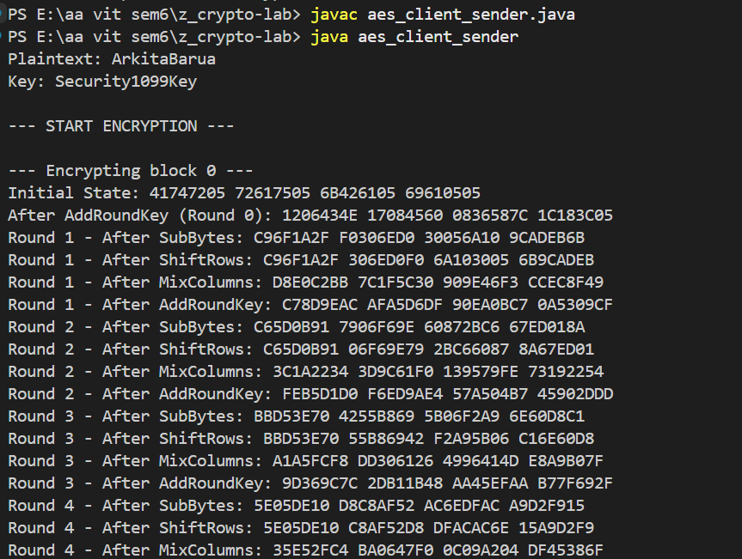
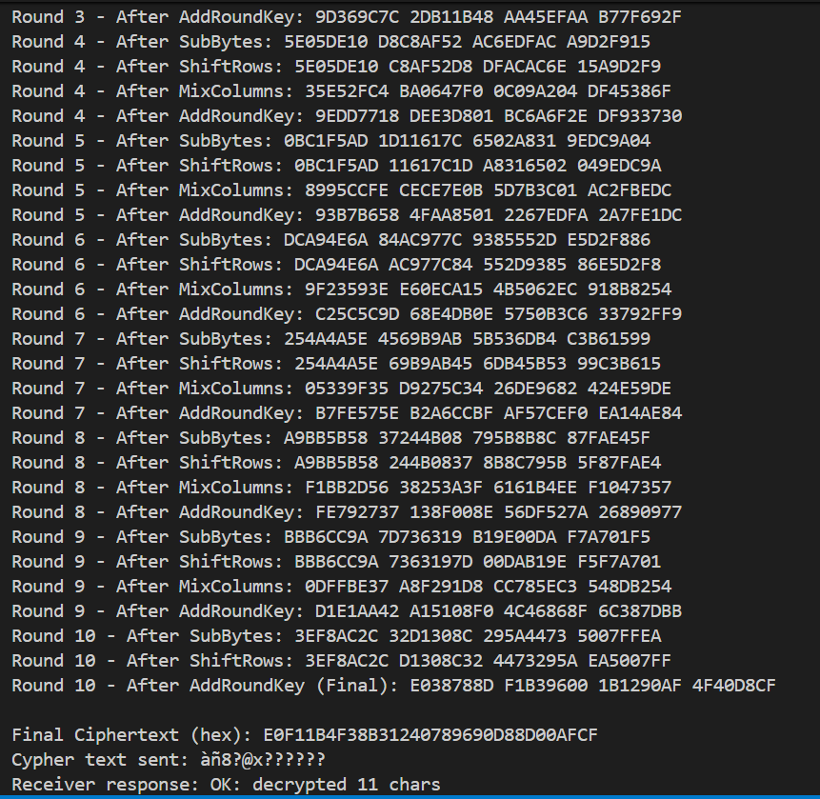

Receiver
