Course Title: Cryptography and Network Security Lab | Course Code: BCSE309P
Faculty: Prof. Karthika V | Slot: L15+L16
Regno: 23BCE1099 | Name: Arkita Barua

Ex6
MAN IN THE MIDDLE ATTACK IN DIFFIE HELLMAN KEY EXCHANGE
Code
Diffie_attacker.java
import java.io.*;
import java.math.BigInteger;
import java.net.ServerSocket;
import java.net.Socket;
import java.security.SecureRandom;
import java.util.Scanner;

public class diffie_attacker {

public static void main(String[] args) throws Exception {

Scanner sc = new Scanner(System.in);

System.out.print("Enter prime number (p): ");
BigInteger p = new BigInteger(sc.nextLine());

System.out.print("Enter primitive root (g): ");
BigInteger g = new BigInteger(sc.nextLine());

SecureRandom rand = new SecureRandom();

BigInteger xd1 = new BigInteger(10, rand);
BigInteger xd2 = new BigInteger(10, rand);

BigInteger yd1 = g.modPow(xd1, p);
BigInteger yd2 = g.modPow(xd2, p);

System.out.println("\nAttacker Private Keys:");
System.out.println("Xd1: " + xd1);
System.out.println("Xd2: " + xd2);

System.out.println("\nAttacker Public Keys:");
System.out.println("Yd1: " + yd1);
System.out.println("Yd2: " + yd2);

ServerSocket server = new ServerSocket(6000);
System.out.println("\nAttacker waiting for Alice...");
Socket alice = server.accept();

DataInputStream disA = new DataInputStream(alice.getInputStream());
DataOutputStream dosA = new DataOutputStream(alice.getOutputStream());

BigInteger YA = new BigInteger(disA.readUTF());
System.out.println("\nReceived Alice Public Key: " + YA);

dosA.writeUTF(yd1.toString()); // send fake key

BigInteger KA = YA.modPow(xd1, p);
System.out.println("Common key between Alice and Attacker: " + KA);

System.out.println("\nAttacker waiting for Bob...");
Socket bob = server.accept();

DataInputStream disB = new DataInputStream(bob.getInputStream());
DataOutputStream dosB = new DataOutputStream(bob.getOutputStream());

BigInteger YB = new BigInteger(disB.readUTF());
System.out.println("\nReceived Bob Public Key: " + YB);

dosB.writeUTF(yd2.toString()); // send fake key

BigInteger KB = YB.modPow(xd2, p);
System.out.println("Common key between Bob and Attacker: " + KB);

alice.close();
bob.close();
server.close();
}
}

Diffie_alice.java
import java.io.*;
import java.math.BigInteger;
import java.net.Socket;
import java.security.SecureRandom;
import java.util.Scanner;

public class diffie_alice {

public static void main(String[] args) throws Exception {

Scanner sc = new Scanner(System.in);

System.out.print("Enter prime number (p): ");
BigInteger p = new BigInteger(sc.nextLine());

System.out.print("Enter primitive root (g): ");
BigInteger g = new BigInteger(sc.nextLine());

SecureRandom rand = new SecureRandom();
BigInteger xa = new BigInteger(10, rand);

BigInteger YA = g.modPow(xa, p);

System.out.println("\nAlice Private Key: " + xa);
System.out.println("Alice Public Key: " + YA);

Socket socket = new Socket("localhost", 6000);

DataOutputStream dos = new DataOutputStream(socket.getOutputStream());
DataInputStream dis = new DataInputStream(socket.getInputStream());

dos.writeUTF(YA.toString());

BigInteger fakeKey = new BigInteger(dis.readUTF());

System.out.println("Public key received (from attacker): " + fakeKey);

BigInteger KA = fakeKey.modPow(xa, p);

System.out.println("Common key between Alice and Attacker: " + KA);

socket.close();
}
}

Diffie_bob.java
import java.io.*;
import java.math.BigInteger;
import java.net.Socket;
import java.security.SecureRandom;
import java.util.Scanner;

public class diffie_bob {

public static void main(String[] args) throws Exception {

Scanner sc = new Scanner(System.in);

System.out.print("Enter prime number (p): ");
BigInteger p = new BigInteger(sc.nextLine());

System.out.print("Enter primitive root (g): ");
BigInteger g = new BigInteger(sc.nextLine());

SecureRandom rand = new SecureRandom();
BigInteger xb = new BigInteger(10, rand);

BigInteger YB = g.modPow(xb, p);

System.out.println("\nBob Private Key: " + xb);
System.out.println("Bob Public Key: " + YB);

Socket socket = new Socket("localhost", 6000);

DataOutputStream dos = new DataOutputStream(socket.getOutputStream());
DataInputStream dis = new DataInputStream(socket.getInputStream());

dos.writeUTF(YB.toString());

BigInteger fakeKey = new BigInteger(dis.readUTF());

System.out.println("Public key received (from attacker): " + fakeKey);

BigInteger KB = fakeKey.modPow(xb, p);

System.out.println("Common key between Bob and Attacker: " + KB);

socket.close();
}
}

Output [screenshot]
Diffie_attacker.java
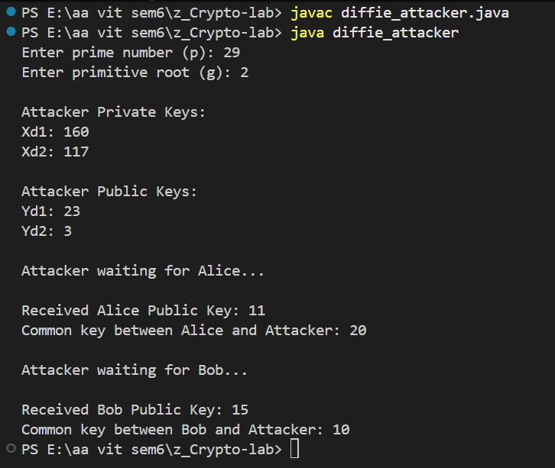

Diffie_alice.java
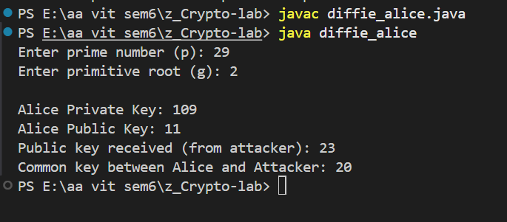

Diffie_bob.java
