Course Title: Cryptography and Network Security Lab | Course Code: BCSE309P
Faculty: Prof. Karthika V | Slot: L15+L16
Regno: 23BCE1099 | Name: Arkita Barua

EXERCISE 7
MD5
Code
import java.util.Scanner;

public class md5 {

/* ---------- Shift amounts ---------- */
private static final int[] SHIFT = {
7,12,17,22, 7,12,17,22, 7,12,17,22, 7,12,17,22,
5,9,14,20, 5,9,14,20, 5,9,14,20, 5,9,14,20,
4,11,16,23, 4,11,16,23, 4,11,16,23, 4,11,16,23,
6,10,15,21, 6,10,15,21, 6,10,15,21, 6,10,15,21
};

/* ---------- Constants ---------- */
private static final int[] T = new int[64];

static {
for (int i = 0; i < 64; i++) {
T[i] = (int)((1L << 32) * Math.abs(Math.sin(i + 1)));
}
}

public static void main(String[] args) {

Scanner sc = new Scanner(System.in);
System.out.print("Enter Input: ");
String input = sc.nextLine();

System.out.println("Number of characters in input: " + input.length());

byte[] msg = input.getBytes();
int originalLength = msg.length;
long bitLength = (long) originalLength * 8;

/* ---------- Padding ---------- */
int padLen = (56 - (originalLength + 1) % 64 + 64) % 64;
byte[] padded = new byte[originalLength + 1 + padLen + 8];

System.arraycopy(msg, 0, padded, 0, originalLength);
padded[originalLength] = (byte) 0x80;

for (int i = 0; i < 8; i++) {
padded[padded.length - 8 + i] = (byte)(bitLength >>> (8 * i));
}

/* ---------- Initial Values ---------- */
int A = 0x67452301;
int B = 0xefcdab89;
int C = 0x98badcfe;
int D = 0x10325476;

int totalBlocks = padded.length / 64;

for (int block = 0; block < totalBlocks; block++) {

System.out.println("\nBlock " + (block + 1));

int[] X = new int[16];

for (int j = 0; j < 16; j++) {
int idx = block * 64 + j * 4;
X[j] = ((padded[idx] & 0xff)) |
((padded[idx + 1] & 0xff) << 8) |
((padded[idx + 2] & 0xff) << 16) |
((padded[idx + 3] & 0xff) << 24);
}

int a = A, b = B, c = C, d = D;

for (int i = 0; i < 64; i++) {

int F, g;

if (i < 16) {
F = (b & c) | (~b & d);
g = i;
}
else if (i < 32) {
F = (d & b) | (~d & c);
g = (5 * i + 1) % 16;
}
else if (i < 48) {
F = b ^ c ^ d;
g = (3 * i + 5) % 16;
}
else {
F = c ^ (b | ~d);
g = (7 * i) % 16;
}

int temp = d;
d = c;
c = b;

int sum = a + F + T[i] + X[g];
b = b + Integer.rotateLeft(sum, SHIFT[i]);
a = temp;

/* ---- Print at end of each round ---- */
if (i == 15) {
System.out.printf("Round 1:\nA=%08x B=%08x C=%08x D=%08x\n", a,b,c,d);
}
if (i == 31) {
System.out.printf("Round 2:\nA=%08x B=%08x C=%08x D=%08x\n", a,b,c,d);
}
if (i == 47) {
System.out.printf("Round 3:\nA=%08x B=%08x C=%08x D=%08x\n", a,b,c,d);
}
if (i == 63) {
System.out.printf("Round 4:\nA=%08x B=%08x C=%08x D=%08x\n", a,b,c,d);
}
}

A += a;
B += b;
C += c;
D += d;
}

String finalHash = String.format("%08x%08x%08x%08x", A, B, C, D);
System.out.println("\nFinal Hash Value: " + finalHash);
}
}

Output [screenshot]
Input Test Case 1: <448 bits(<56 characters)
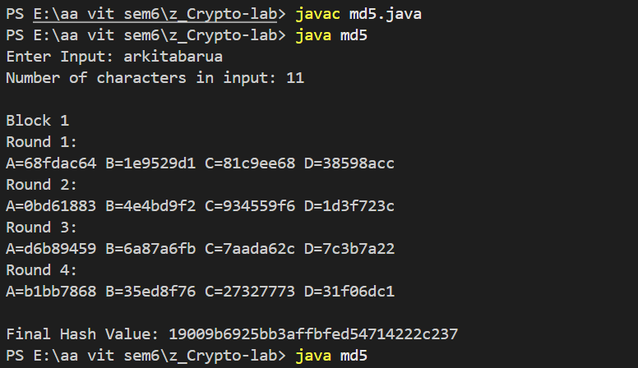
Input Test Case 2: =448 bits(=56 characters)
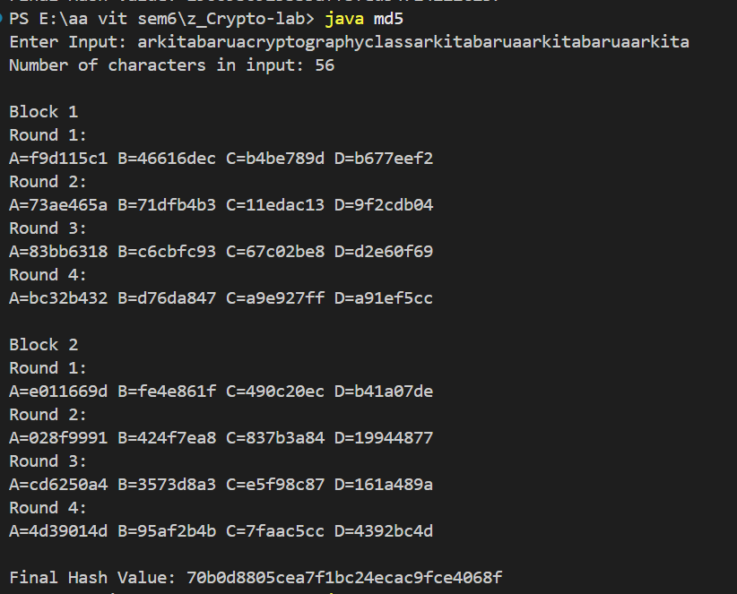
Input Test Case 3: >448 bits(>56 characters)
