Imputation of transcription-factor regulatory activity from RNA by per-edge elastic-net regression with regulon covariates (rna2grn): method and validation
AltAnalyze3 cross-modality imputation module. This document describes the method and its validation for predicting gene-regulatory-network (GRN) connection scores from transcriptomes, with emphasis on the detection of transcription factors (TFs) whose regulatory activity is altered in a query sample relative to a matched control.

1. Rationale
Gene-regulatory networks summarize the regulatory influence of each TF on its target genes as a set of edge-level connection (activity) scores. Their inference typically requires paired chromatin accessibility (multiome or TEA-seq) and is computationally intensive. We sought a model that imputes the full edge-level GRN of a cell-state pseudobulk from its RNA profile alone, with the specific objective of identifying TFs whose regulatory activity is perturbed in disease. A central requirement is that a change in a TF's activity that is reflected in its regulon's expression, but not in the TF's own transcript level, must be recovered as an increase in that TF's edge activity scores. The model must therefore respond continuously to regulon-level expression and extrapolate beyond the profiles present in the training reference, rather than interpolating among them.

2. Materials and Methods

2.1 Datasets and pseudobulk matching
GRN connection scores were obtained for 7,486 TF–target edges across 358 sample-by-cell-state columns (file tf_to_gene_connection_scores_log10_..._COMBINED_AML_Multiome_RC2.txt). Matched RNA pseudobulks were drawn from a harmonized atlas of 12,255 pseudobulks keyed as Sample|CellState (pseudobulk_counts_hashed.h5ad). GRN columns encode the sample identifier and cell state joined by an underscore, with spaces in cell-state names replaced by underscores; each column was resolved to its RNA pseudobulk by longest-suffix matching against the 89-term cell-state vocabulary followed by curated sample-name reconciliation (module grn_io.py). Of 358 columns, 354 were matched; four (a CCHMC AML-13 with no corresponding atlas pseudobulk) were discarded. The matched dataset comprised 341 pseudobulks (223 AML/MDS patient, 26 CCHMC AML, 82 Multiome control, 10 TEA-seq control) spanning 30 samples and 83 cell states. All 217 TFs and all 2,361 target genes appearing in the GRN were present in the RNA feature space.

2.2 Control reference construction
The two control GRN aggregates have no native RNA in the atlas. Both were associated, on the RNA side, with a single healthy-control reference defined as the summed counts of 12 CCHMC control donors (Annotation = Control, Dataset = CCHMC; AM72, BF21, BF32, BF71, BM27, BM32, WF26, WF32, WF83, WM22, WM34, WM72; 10x Genomics 3′ v3 chemistry), aggregated per cell state. This identical control RNA vector was paired with both the Multiome_WT control GRN (82 cell states) and the RC2_TEA control GRN (10 cell states: ERP-1, HSC-2, Intermediate Mono-1, LMPP-1, LMPP-1-cycling, LMPP-2, MEP-2, MPP-1, MPP-2, MPP-MEP). The aggregate total edge activity per pseudobulk differed systematically by assay: median sums were 291 and 327 for 3′ AML patient and CCHMC AML pseudobulks, 67 for TEA-seq controls, and 46 for multiome controls; the cell-state-matched AML-to-multiome ratio was 4.9. Consequently, raw AML-minus-control differentials carry an assay-scale offset under which approximately 60% of TFs appear elevated in AML in every pseudobulk. TEA-seq controls, being closer in magnitude to the 3′ AML data, constitute a better-matched reference but cover fewer cell states; both controls were therefore retained and reported.
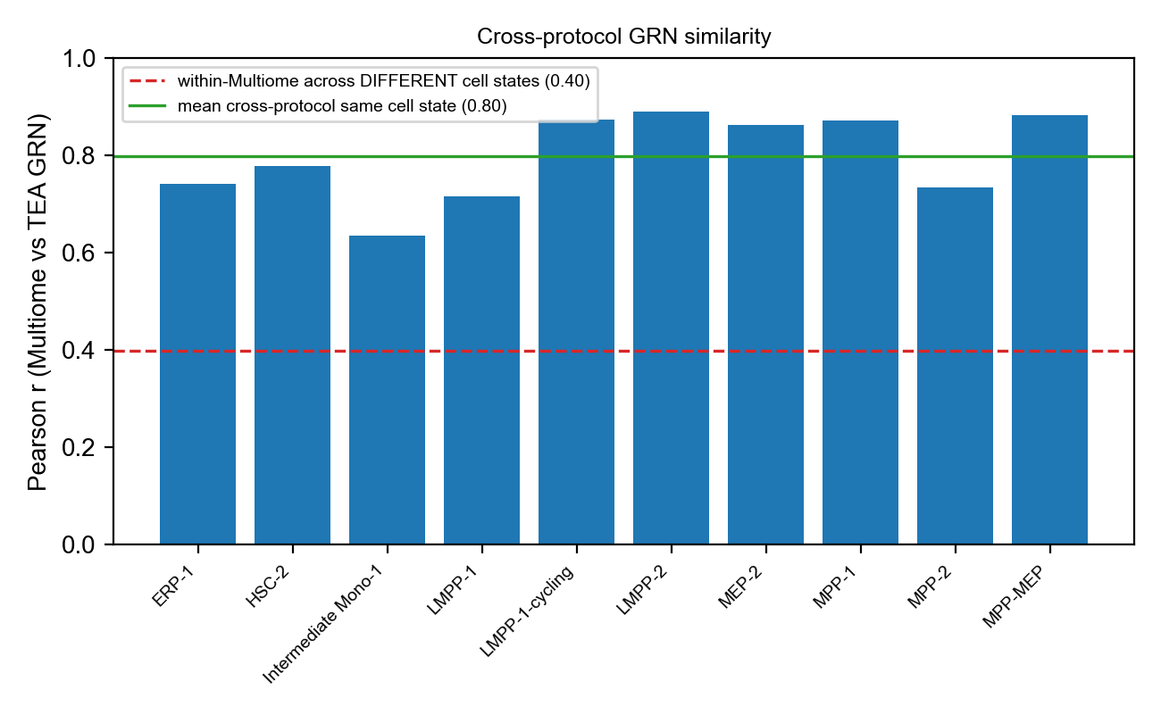
Figure 1. Cross-assay similarity of control GRNs. Pearson correlation between the Multiome and TEA-seq control connection-score profiles for the ten cell states shared by both assays. The mean cross-assay, same-cell-state correlation (0.80) substantially exceeds the mean correlation between distinct cell states within the multiome control (0.40, dashed line), indicating that cell-state identity, rather than assay, dominates the GRN profile.

2.3 Normalization
Pseudobulk counts were normalized to counts per 10,000 and log1p-transformed (CP10k/log1p). For inference on new data, cells assigned to a cell state are summed into a pseudobulk and normalized identically; the pipeline is therefore reproducible from any raw count matrix.

2.4 Model: per-edge elastic-net regression
Each edge e linking transcription factor T to target gene g was modeled independently as an elastic-net (regularized linear) regression of its connection score across pseudobulks on three standardized covariates of the same pseudobulk's normalized expression: the expression of the target gene g, the expression of the transcription factor T, and the mean expression of the regulon of T (the set of all targets of T). The elastic-net L1 mixing parameter was set to zero (l1_ratio = 0), reducing the penalty to L2 (ridge); with only three covariates the L1 term confers no benefit (Section 2.5) and the L2 limit admits a closed-form solution. The 7,486 per-edge systems were assembled and solved jointly in closed form (L2 regularization λ = 1.0, intercept unpenalized); covariate standardization statistics are stored with the model (module model.py, class RegulonEdgeRegressor; training in training.py). Because the predicted activity of an edge increases with the expression of its target gene and regulon, an increase in regulon expression raises the predicted activity of the responsible TF's edges even when the TF's own transcript is unchanged; the model thus extrapolates beyond reference profiles. Standardized coefficient magnitudes confirmed the intended weighting, with target-gene expression (mean |β| = 0.017) exceeding TF expression (0.014) and regulon mean (0.006).

2.5 Relationship to the antecedent elastic-net formulation
The model belongs to the same elastic-net regression family as the antecedent AltAnalyze3 imputation modules (rna2lipid, rna2adt); the distinction is structural, not the regression family. The antecedent modules use a single, global, multi-task elastic net mapping one shared gene panel to all targets jointly. Applied to GRN activity, that formulation was unsuitable: under leave-one-donor-out cross-validation it yielded a strongly negative coefficient of determination, reflecting unstable extrapolation on held-out donors. We therefore decomposed the problem into independent per-edge (per-target) elastic-net regressions with the biologically constrained three-covariate design above. We additionally evaluated a non-zero L1 mixing parameter (l1_ratio = 0.5): it gave equivalent accuracy (cross-validated R² = 0.771 versus 0.773 at l1_ratio = 0) but, because each edge involves only three covariates, the L1 term conferred no benefit while substantially increasing cost — iterative coordinate descent required approximately 46 ms per edge against approximately 0.7 ms per edge for the closed-form L2 solution (a full 7,486-edge fit in approximately 5 s per fold). The L1 mixing parameter was therefore fixed at zero.

2.6 Cross-validation design
A sample denotes a donor; a pseudobulk denotes a donor-by-cell-state unit and is the unit of prediction. Hold-out was performed at the donor level, so that all pseudobulks of a held-out donor were assigned to the test partition together, precluding leakage of any cell state of a held-out donor into training. The AML-7 donor was excluded from all evaluation and reserved as a real-world inference and timing input (bundle load 0.06 s; whole-sample pseudobulk prediction 0.32 s). The remaining 27 AML donors were partitioned into five grouped folds; each donor was held out exactly once. The unique, merged control aggregates cannot be held out and were retained in training in every fold, serving as the differential baseline. This procedure yielded 214 held-out pseudobulks across 40 cell states and 61,845 (pseudobulk, TF, control) evaluation instances.
Fold | Held-out AML donors | Retained AML donors | Held-out pseudobulks
0 | 6 | 21 | 28
1 | 6 | 21 | 67
2 | 5 | 22 | 39
3 | 5 | 22 | 35
4 | 5 | 22 | 45

2.7 Evaluation metrics
For each held-out pseudobulk, per-TF activity was computed as the mean of the imputed scores over that TF's edges. Differential TF activity was defined as the difference between the AML pseudobulk and its cell-state-matched control, computed both for the measured GRN and for the imputed GRN. Truly differential TFs were defined by magnitude strata of the measured differential (top 50%, 25%, 10% by absolute value), single-replicate pseudobulks precluding a per-instance significance test. The primary metric was directional concordance, the fraction of truly differential TFs for which the imputed differential matched the sign of the measured differential. To separate TF-specific structure from the assay-scale offset, the metric was computed both on the raw differential and on the per-pseudobulk-centered differential (each pseudobulk's 217-TF differential vector centered to zero mean). Evaluation is implemented in evaluate.py and dev/validate_directional.py.

3. Results

3.1 Reconstruction accuracy
Under leave-one-donor-out cross-validation, the per-edge regulon regression attained a coefficient of determination of 0.76 against the global mean and a median per-edge across-sample Pearson correlation of 0.73, exceeding both a cell-state-mean baseline (R² = 0.52) and a nearest-neighbor retrieval baseline (R² = 0.63). The connection-score variance is partitioned 65.5% between cell states and 34.5% within cell states (Figure 2); the within-cell-state component represents the sample-specific signal targeted by differential analysis.
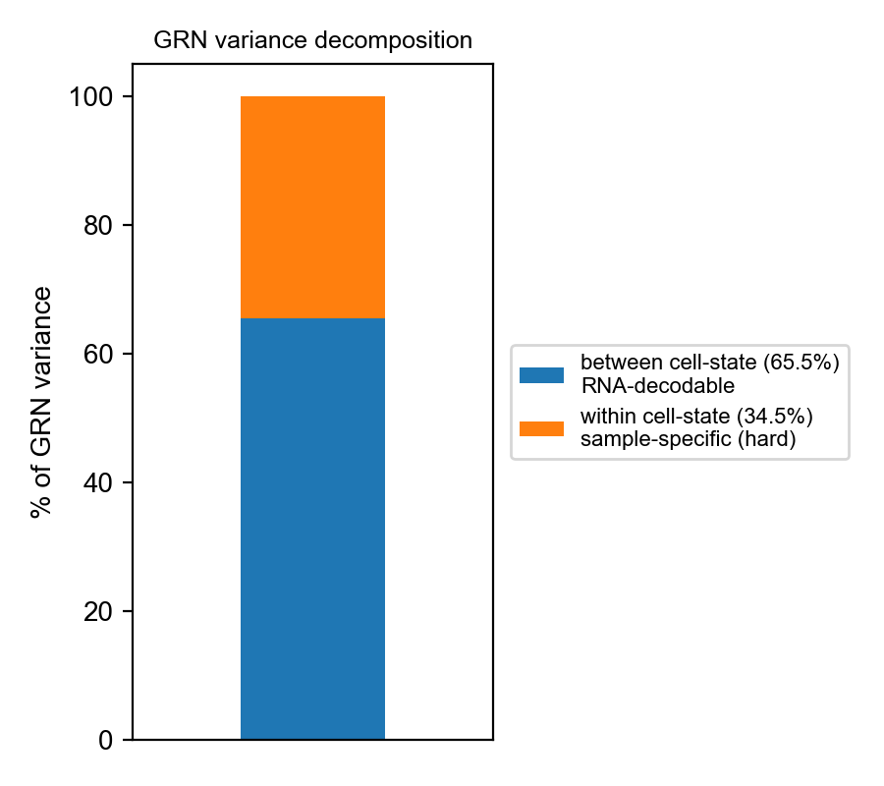
Figure 2. Decomposition of GRN connection-score variance into between-cell-state (65.5%) and within-cell-state (34.5%) components. The within-cell-state component is the sample-specific signal that differential TF-activity analysis seeks to recover.

3.2 Directional concordance of differential TF activity
Directional concordance of imputed differential TF activity against the matched controls is summarized below. Concordance against TEA-seq controls exceeded that against multiome controls on the raw differential, consistent with the smaller assay-scale offset of the TEA-seq reference. Removing the per-pseudobulk offset raised concordance for both controls to approximately 0.90 and revealed that the raw differential had been attenuated by the global offset rather than inflated by it; the TF-specific direction was recovered in approximately 90% of truly differential TFs. Concordance increased monotonically with the magnitude of the measured differential, and was statistically significant against the chance value of 0.5 (binomial test, p < 10⁻³⁰) with balanced performance across up- and down-regulated TFs.
Control | Differential | Top 50% | Top 25% | Top 10%
TEA-seq | raw | 0.781 | 0.845 | 0.898
TEA-seq | offset-removed | 0.91 | 0.904 | 0.892
Multiome | raw | 0.749 | 0.822 | 0.874
Multiome | offset-removed | 0.907 | 0.901 | 0.848

Per-donor directional concordance (top-25% differential TFs, TEA-seq-preferred control) ranged from 0.72 to 0.91 (median 0.83) across the 27 held-out donors (file detail_per_sample.csv; Figure 3).
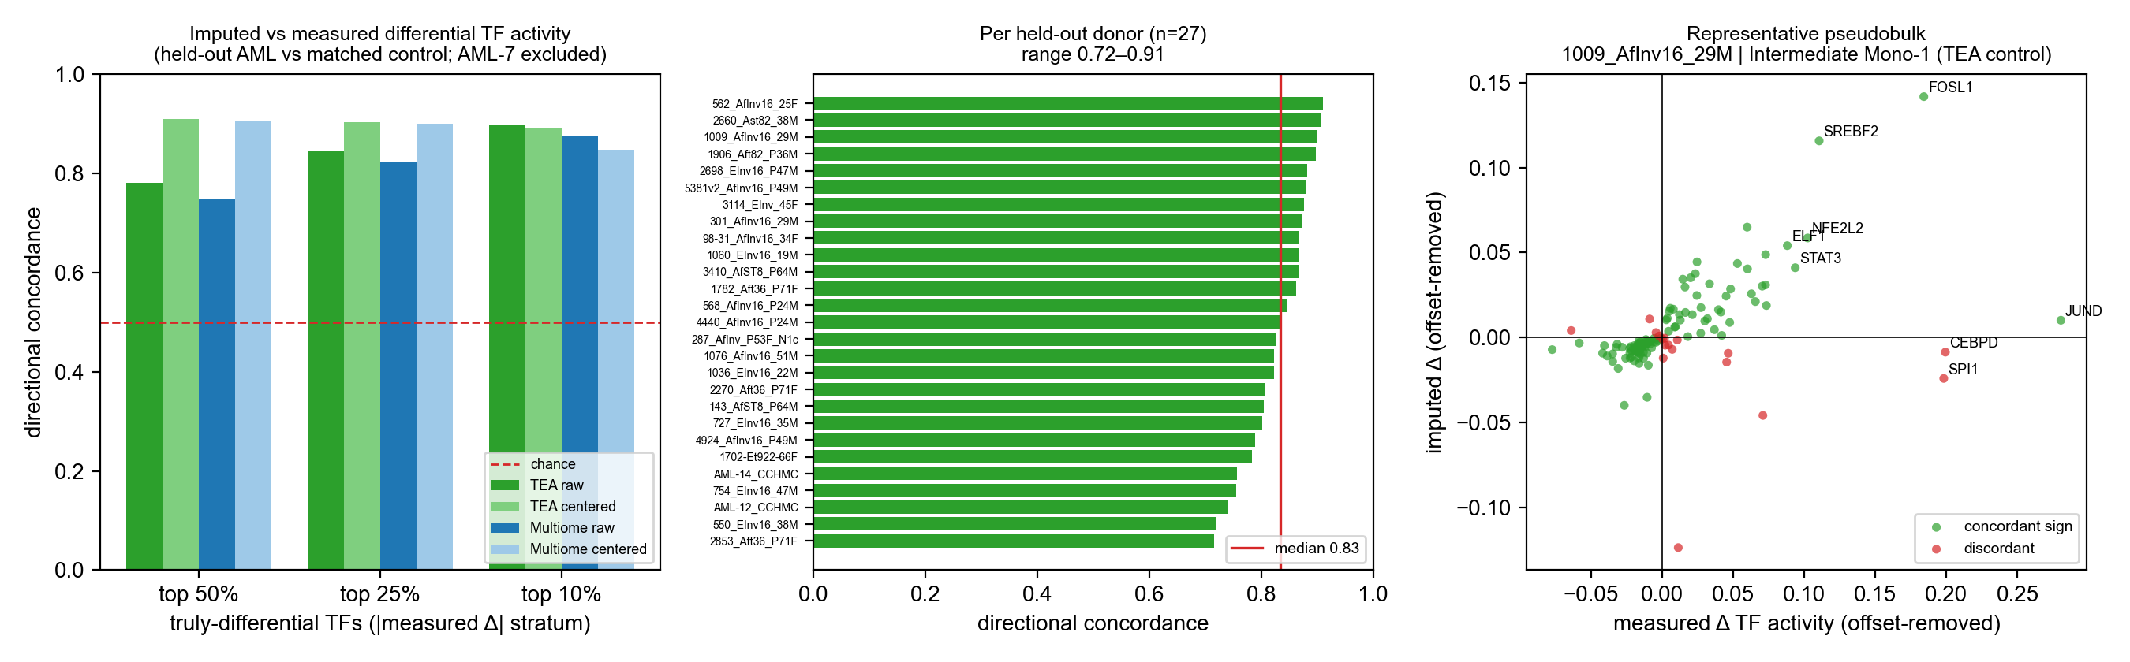
Figure 3. Directional concordance of imputed differential TF activity (held-out AML donors versus the cell-state-matched control; AML-7 excluded, controls retained in training). (A) Concordance by magnitude stratum of the measured differential, for TEA-seq and multiome controls, on the raw and per-pseudobulk-centered (offset-removed) differential. (B) Per-donor concordance (top-25% differential TFs, TEA-seq-preferred control), median 0.83. (C) A representative held-out pseudobulk (donor 1009_AfInv16_29M, Intermediate Mono-1, TEA-seq control); each point is a TF, coloured by agreement between the sign of the measured and imputed offset-removed differential.
To establish that the imputed differential reflects regulon-level information rather than the transcription factor's own abundance, directional concordance was compared with a baseline that predicts the activity direction from the sign of the TF's own expression change (Figure 4). For TFs whose own transcript was unchanged (|Δ expression| below 0.25 log-units; the regulon-only case), the per-edge model attained a concordance of 0.895 against 0.773 for the expression-sign baseline, confirming that the model recovers activity changes that are not visible in the factor's own expression.
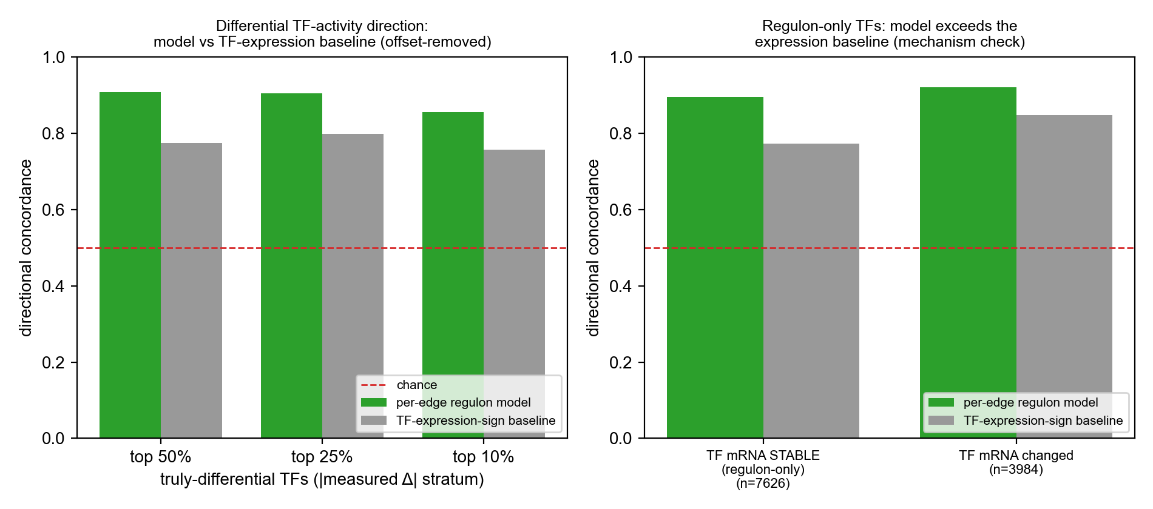
Figure 4. Imputed differential TF-activity direction relative to a TF-expression-sign baseline (offset-removed; controls retained; TEA-seq-preferred control). (A) Concordance by magnitude stratum for the per-edge regulon model and the expression baseline. (B) Stratification of the top-25% differential TFs by whether the TF's own mRNA is differential; for regulon-only TFs (mRNA stable) the model exceeds the expression baseline (0.895 versus 0.773), demonstrating recovery of activity changes independent of TF abundance.

3.3 Cell-type and TF-level variability
Across 40 cell states, per-cell-state directional concordance ranged from 0.72 to 0.90 (file detail_per_cellstate.csv). The highest concordance was observed for well-represented progenitor and myeloid states (LMPP-2 and MPP-MEP, each 0.90; cDC1 0.89; Mono-1 0.87); rarer and lymphoid-leaning states were more variable. At the TF level (file detail_per_tf.csv), all 217 TFs were scored in every pseudobulk; 106 were frequently differential. Concordance was highest for E2F3, USF1, TCF12, STAT1, RELB, ARNT, ATF3 and FOSB, and for the myeloid regulators RUNX1, SPI1, JUN, JUNB, FOS and MAFG; it was lowest for ubiquitously expressed factors with small differentials (USF2 0.29, KLF3 0.33, RARA 0.33, JDP2 0.34).
For individual pseudobulks, the most differential TFs were tabulated together with the sign agreement of their imputed activity (file per_pseudobulk_topworst_tf.csv). For example, in donor 1009_AfInv16_29M, cell state Intermediate Mono-1 (TEA-seq control), the imputed differential correctly recovered the elevation of JUND, FOSL1, SREBF2, NFE2L2 and STAT3, but failed to recover the measured elevation of CEBPD, SPI1 and CEBPB. Imputed differential magnitudes were systematically smaller than measured magnitudes, reflecting ridge regularization and the assay-offset term on the measured-control side; directional agreement was therefore substantially more reliable than absolute magnitude, and rank or sign rather than absolute difference is the recommended quantity for interpretation.
TF | Measured Δ | Imputed Δ | Direction
JUND | +0.297 | +0.016 | concordant
FOSL1 | +0.200 | +0.148 | concordant
SREBF2 | +0.127 | +0.122 | concordant
CEBPD | +0.215 | −0.002 | discordant
SPI1 | +0.214 | −0.018 | discordant
CEBPB | +0.087 | −0.040 | discordant

3.4 Specificity for novel regulon perturbations
Recovery of an AML-versus-control differential is partly attributable to a regulatory signature shared with the other AML donors retained in training, which a retrieval model can reproduce without inference. To assess detection of perturbations absent from the reference, we performed an in silico experiment (dev/perturbation_test.py): the expression of a single TF's regulon was increased in a healthy pseudobulk while the TF's own transcript was held constant, and TFs were ranked by the increase in predicted edge activity. The per-edge regulon regression ranked the perturbed TF at a median rank of 2 of 217 (perturbed TF within the top 5 in 83% of trials), whereas nearest-neighbor retrieval ranked it at a median of 74 (top 5 in 5% of trials). Retrieval is constitutively unable to express a perturbation absent from the reference, whereas the regression localizes it; this distinction motivates the choice of model (Figure 5).
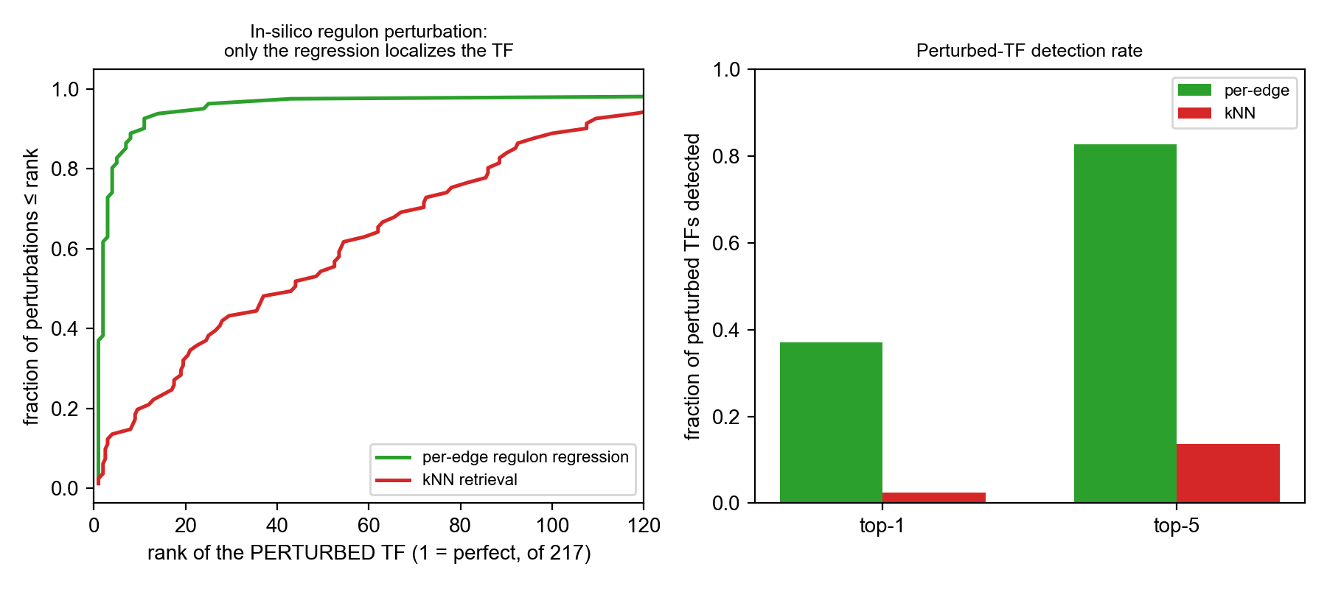
Figure 5. Specificity for novel regulon perturbations (in silico). The expression of a single TF's regulon was increased in a healthy pseudobulk with the TF's own transcript held constant, and TFs were ranked by the increase in predicted edge activity. (A) Cumulative distribution of the rank assigned to the perturbed TF (of 217); the per-edge regulon regression concentrates near rank 1, whereas nearest-neighbor retrieval does not. (B) Fraction of perturbations for which the perturbed TF is ranked first or within the top five.

4. Limitations
First, the only available control GRNs derive from multiome and TEA-seq assays, introducing a systematic scale offset relative to the 3′ AML data; differential analyses should use the per-pseudobulk-centered differential and the TEA-seq-matched control where coverage permits. A within-assay disease-versus-healthy differential would require a 3′ healthy control GRN, which is not available in the present data. Second, recovery of an in-distribution AML differential can be achieved in part by reproducing a shared signature; the in silico perturbation experiment is the assay that isolates detection of novel perturbations. Third, imputed differential magnitudes are attenuated relative to measured magnitudes, and directional agreement should be preferred over absolute values. Fourth, single-replicate pseudobulks preclude a per-instance test of differential significance, necessitating magnitude-stratified reporting.

5. Code and data availability
The module resides at altanalyze3/components/rna2grn. The model and training procedure are implemented in model.py and training.py; the inference interface in api.py and cli.py; GRN parsing and pseudobulk matching in grn_io.py. The canonical evaluation, which produces all reported tables, is evaluate.py (directional_dual_control.csv, directional_metrics_dual.json, per_pseudobulk_topworst_tf.csv, detail_per_sample.csv, detail_per_cellstate.csv, detail_per_tf.csv). Supporting analyses are provided in dev/: dataset construction (build_dataset.py), signal diagnostics (diagnostics.py), directional validation with baselines and offset removal (validate_directional.py), the in silico perturbation experiment (perturbation_test.py), cross-assay similarity (protocol_similarity.py), and figure generation (make_figures.py). The trained model is distributed as a compressed pickle (rna2grn_bundle.pkl.gz, < 1 MB).

