rna2metabolite (AML): RNA → metabolite imputation
CPTAC AML proteogenomic cohort (Nature Cancer 2026). One regularized linear model per metabolite predicts its abundance from bulk RNA-seq; accuracy is the honest out-of-fold value from 5-fold cross-validation. Prediction is a per-molecule function of gene expression (not a per-sample neighbor lookup): on held-out CV it outperforms k-NN retrieval on the same genes.
Data and features
property | value
unique metabolites (best-detected per molecule) | 2,533
RNA-matched AML cases | 84
RNA universe (protein-coding, TPM≥5 in ≥3 cases) | 12,416 genes
genes per molecule | 1000
mechanistic prior | Recon3D reaction→gene (GPR); 144/2,533 mapped, rest correlation-driven
normalization | CP10k+log1p (all-gene library size); per-gene z-score (train μ/σ)
estimator | per-molecule ridge (ElasticNet l1_ratio=0), α=100
Held-out performance (5-fold CV)
metric | value
evaluable metabolites | 2,478
median Spearman | 0.267
imputable (Spearman > 0.3) | 1,084
strong (Spearman > 0.5) | 313
median R² | -0.086
classification acc / AUROC (imputable) | 0.663 / 0.718
classification acc / AUROC (all) | 0.590 / 0.631
within-subtype Spearman (imputable; confound check) | 0.307
median between-subtype variance fraction | 0.136
In-sample selection inflates correlation (median 0.97); the out-of-fold median of 0.27 is what generalizes to unseen patients. Only 14% of MS variance is between molecular subtype, and imputable metabolites retain a within-subtype Spearman of 0.31 — the model predicts within-subtype biology, not just subtype identity.
Figure 1. Descriptive overview
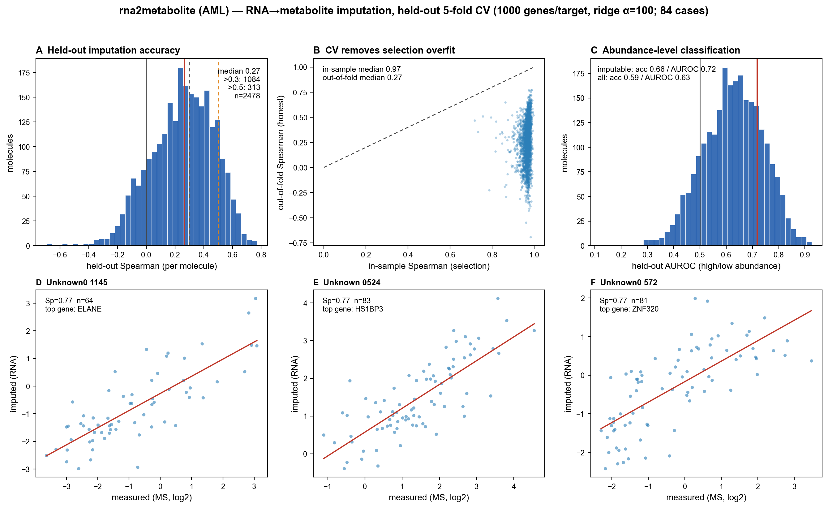
(A) Distribution of per-molecule held-out Spearman (median red; 0.3/0.5 dashed). (B) In-sample vs out-of-fold Spearman — the gap is selection overfit removed by CV. (C) Held-out high/low abundance classification AUROC. (D–F) Predicted vs measured for the three best-imputed molecules (red = linear fit).
Deployment
Applied to the UDON RNA pseudobulks (pseudobulk_counts_hashed.h5ad; 12,255 pseudobulks × 35,702 symbol genes). Output: pseudobulk_imputed_metabolite_aml.h5ad (12,255 × 2,486); X = imputed abundance, obs copied verbatim from the RNA h5ad, var carries per-molecule held-out Spearman/R² and the genes used. Filter molecules by var['heldout_spearman'] and small pseudobulks by obs['n_cells']; the bulk-trained model is applied to scRNA pseudobulks, so absolute values can extrapolate — relative/rank use within the dataset is reliable.
Methods (summary)
- Targets: untargeted MS features collapsed to one best-detected measurement per molecule (detection rate, then median signal).
- Per-molecule feature set: mechanistic-prior genes ranked by within-fold |Spearman| with the measured target taken first, then filled to 1000 with top genome-wide correlated genes; no HVG. All selection/standardization is within the training fold (leakage-free).
- Estimator: ridge (α=100); 5-fold CV over cases; out-of-fold predictions scored per molecule (Spearman/Pearson/R²) vs a cohort-mean baseline.
Limitations
- Internal CV only (no external matched RNA+MS cohort).
- 84 cases bound power; the imputable subset is what survives.
- Cell-composition/blast-% confounds (Table13 deconvolution) not yet regressed out.
- High-gene configs gain accuracy partly via myeloid cell-content genes rather than biosynthetic enzymes — accuracy vs mechanism trade-off.
Files
- models/rna2metabolite_aml.pkl — deployable model
- reports/impute_metab_per_target.csv — per-molecule held-out metrics + genes
- reports/fig_metabolite_report.pdf/.png — Figure 1
- …/final/pseudobulk/pseudobulk_imputed_metabolite_aml.h5ad — imputed pseudobulk h5ad

