Team Task Manager
Complete User Manual
Version 1.2 — April 2026
A simple, intuitive task management tool
for teams that don’t want complex PM software.

Table of Contents
1. Getting Started — Sign up, log in, create your team
2. The Dashboard — Your personal task hub
3. Projects — Organize work into projects
4. Creating Tasks — Add tasks quickly
5. Task Views — List, Board, Calendar, Gantt
6. Task Details — Edit, assign, comment, track
7. Filters & Sorting — Find what you need
8. Bulk Actions — Work with multiple tasks at once
9. Team Dashboard — See everyone’s work
10. Chat — Talk to your team
11. Notifications — Stay in the loop
12. Search & Shortcuts — Navigate fast
13. Admin Panel — Manage your team
14. Profile & Settings — Customize your experience
15. Trash — Recover deleted tasks
16. Tips & Tricks — Get the most out of the tool

1. Getting Started
Team Task Manager is a web app that helps your team keep track of tasks, deadlines, and projects. Think of it like a shared to-do list, but much more powerful. Here’s how to get started.

1.1 Creating Your Account
1. Open your web browser (Chrome, Firefox, Safari, or Edge).
2. Go to the app URL your team admin shared with you.
3. Click "Sign Up" at the bottom of the login form.
4. Type your full name, email address, and a password (at least 6 characters).
5. Click the "Sign Up" button.
6. You’re in! You’ll land on the My Tasks dashboard.
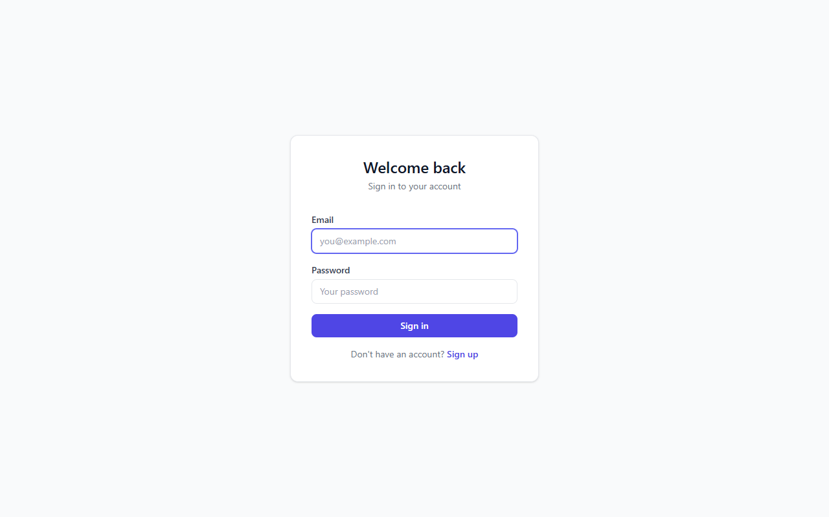
login page

1.2 Logging In
1. Go to the app URL.
2. Type your email and password.
3. Click "Log In". That’s it!

1.3 Joining a Team
Your team admin needs to invite you. Once they add your email, the team will appear automatically when you log in. If you don’t see a team, ask your admin to invite you from the Admin Panel.

1.4 Creating a New Team
1. Click the team name dropdown at the top-left of the sidebar.
2. Click "New Team" at the bottom.
3. Give your team a name (like "Marketing Team" or "Class Project").
4. Click Create. A default "General" project is created for you automatically.

2. The Dashboard (My Tasks)
This is your home screen. It shows every task assigned to you, across all projects. When you log in, this is what you see first.
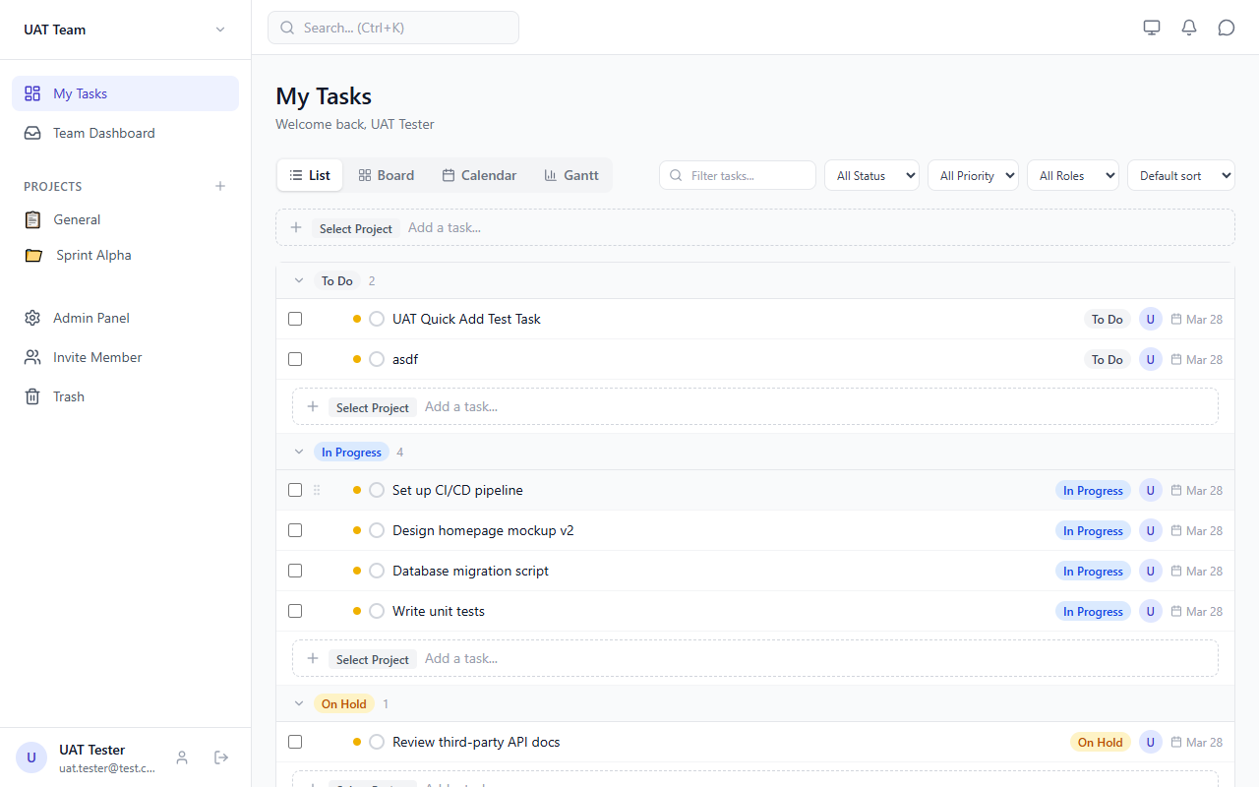
dashboard list

2.1 What’s on the Screen
• Sidebar (left) — Navigate between pages, projects, and team tools.
• Header (top) — Search, change theme, see notifications, and open chat.
• View Tabs — Switch between List, Board, Calendar, and Gantt views.
• Filters — Narrow down tasks by status, priority, who’s assigned, and more.
• Sort dropdown — Change how tasks are ordered (by due date, priority, title, etc.).
• Quick Add bar — Type a task name and press Enter to create it instantly.
• Task list — Your tasks grouped by status (To Do, In Progress, On Hold, Done).

2.2 Welcome Guide
If you’re new, you’ll see a Welcome Guide with 3 steps: Join a Team, Create a Project, and Add a Task. Complete all three and the guide disappears. You can also click "Dismiss" to hide it.

3. Projects
Projects are like folders for your tasks. You might have a project called "Website Redesign" or "Homework". Every task belongs to a project.
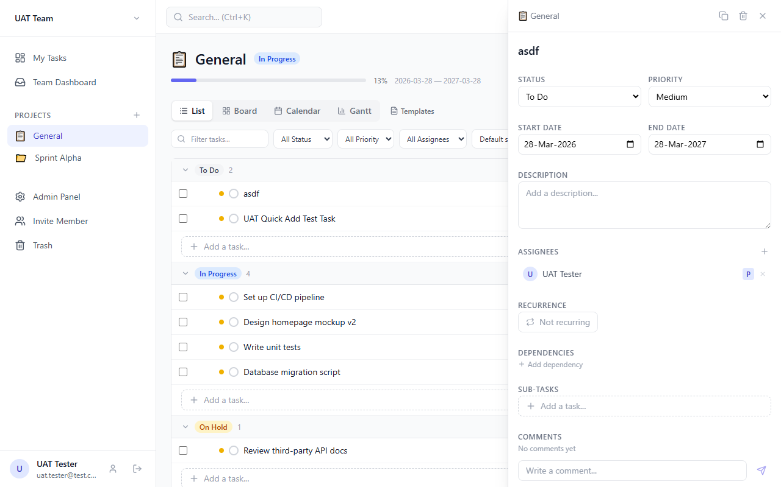
project page

3.1 Creating a Project
1. In the sidebar, find the "PROJECTS" section.
2. Click the + button next to the word "Projects".
3. Give it a name (e.g., "Science Fair").
4. Pick an emoji (optional but fun!).
5. Set start and end dates.
6. Click Create.

3.2 What You See in a Project
• Project name with emoji at the top.
• Status badge (Not Started, In Progress, On Hold, Completed, Overdue).
• Progress bar showing what percentage of tasks are done.
• Date range (when the project starts and ends).
• All 4 views (List, Board, Calendar, Gantt) — same as dashboard.
• Templates button — save and reuse task templates.

3.3 Sidebar Navigation
Your projects show up in the left sidebar. If you have more than 5 projects, only the first 5 are shown. Click "Show all" to see the rest, or "Show less" to collapse them.

4. Creating Tasks
Tasks are the things you need to do. Here are all the ways to create them.

4.1 Quick Add (Fastest Way)
1. Find the Quick Add bar — it’s the dashed-border box with "+ Add a task...".
2. If you’re on the Dashboard, click "Select Project" first to choose which project.
3. Type the task name (e.g., "Buy poster board").
4. Press Enter. Done! The task is created with default dates and priority.

4.2 Calendar Click-to-Create (Project Page Only)
1. Switch to Calendar view in a project.
2. Click on any date in the calendar.
3. A small form appears below the calendar with that date pre-filled.
4. Type the task name and click "Add".

4.3 From Templates
1. In a Project page, click the "Templates" button.
2. Pick a saved template and click "Use".
3. A new task is created with the template’s title and description.
To save a template: click "Create Template", fill in the name, title, and description, then click Save.

4.4 Sub-Tasks
You can break a big task into smaller steps called sub-tasks (up to 2 levels deep).
1. Click on a task to open the Task Detail panel.
2. Scroll down to the "Sub-tasks" section.
3. Type the sub-task name in the add bar and press Enter.

5. Task Views
There are 4 different ways to look at your tasks. Switch between them using the tabs at the top.

5.1 List View
The default view. Tasks are shown in rows, grouped by status (To Do, In Progress, On Hold, Done). Each row shows:
• Priority dot (colored circle: red = urgent, orange = high, yellow = medium, gray = low)
• Task title (click to open details)
• Status badge
• Assignee avatars
• Due date (turns red if overdue!)
• Sub-task count (e.g., "2/5" means 2 of 5 sub-tasks are done)
• Checkbox (for bulk selection)

dashboard list

5.2 Board View (Kanban)
Tasks appear as cards in columns. Each column is a status. Drag a card from one column to another to change its status.
• 4 columns: To Do, In Progress, On Hold, Done
• Each card shows title, priority dot, due date, assignees, project tag
• Drag and drop to move tasks between columns
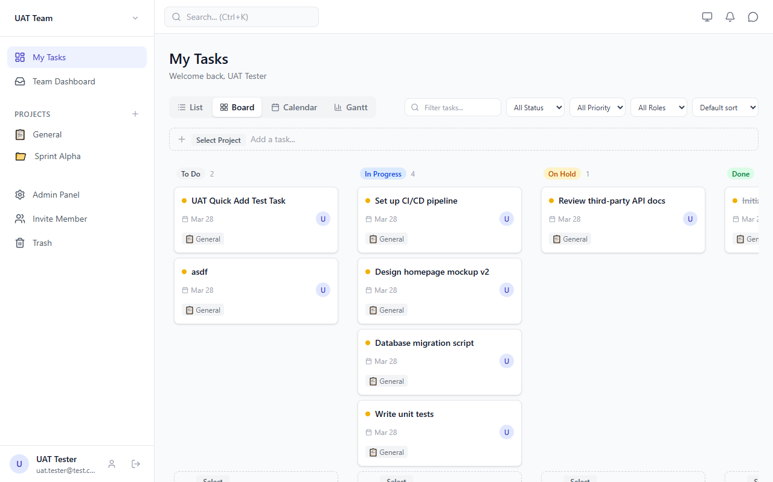
dashboard board

5.3 Calendar View
See your tasks on a monthly or weekly calendar. Tasks show as colored bars based on priority.
• Red bars = Urgent, Orange = High, Yellow = Medium, Gray = Low
• Click a task bar to open its details
• Use arrows to go to previous/next month
• Click "today" to jump back to the current date
• In a Project page, click an empty date to create a task on that day
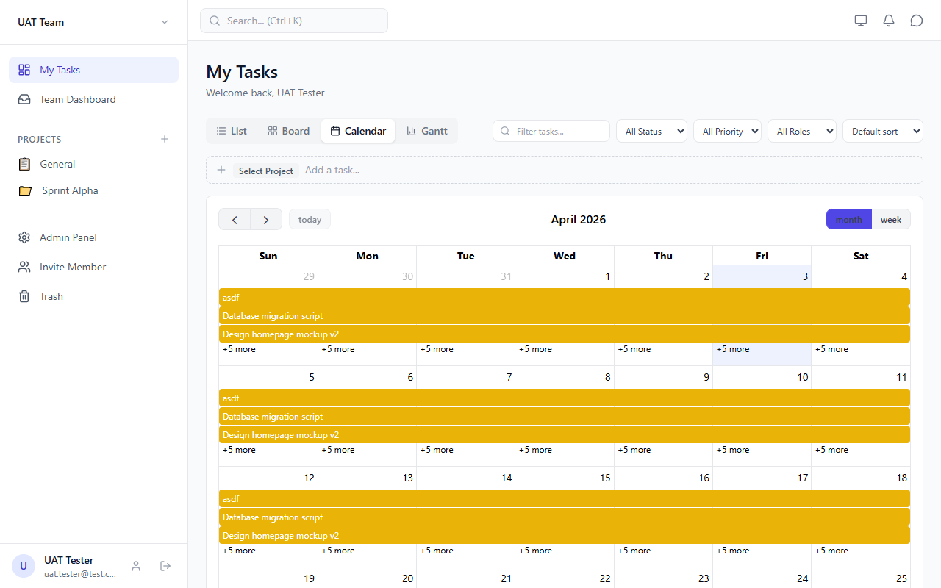
dashboard calendar

5.4 Gantt View
A timeline chart showing when tasks start and end. Great for seeing how tasks overlap and depend on each other.
• Left side: task names (click to open details)
• Right side: horizontal bars showing duration
• Red vertical line = today
• Arrows between bars = dependencies (which tasks block other tasks)
• Colors: gray = to do, blue = in progress, amber = on hold, green = done
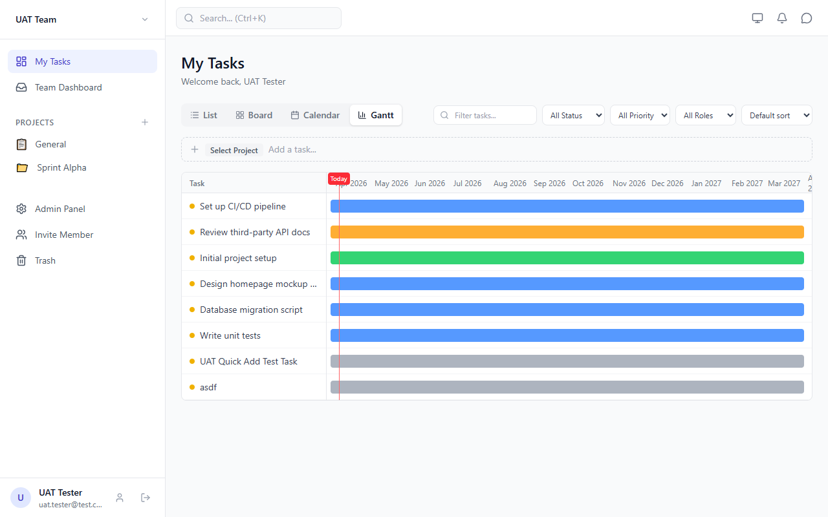
dashboard gantt

6. Task Details
Click any task to open the Task Detail panel on the right side of the screen. Here you can edit everything about the task.
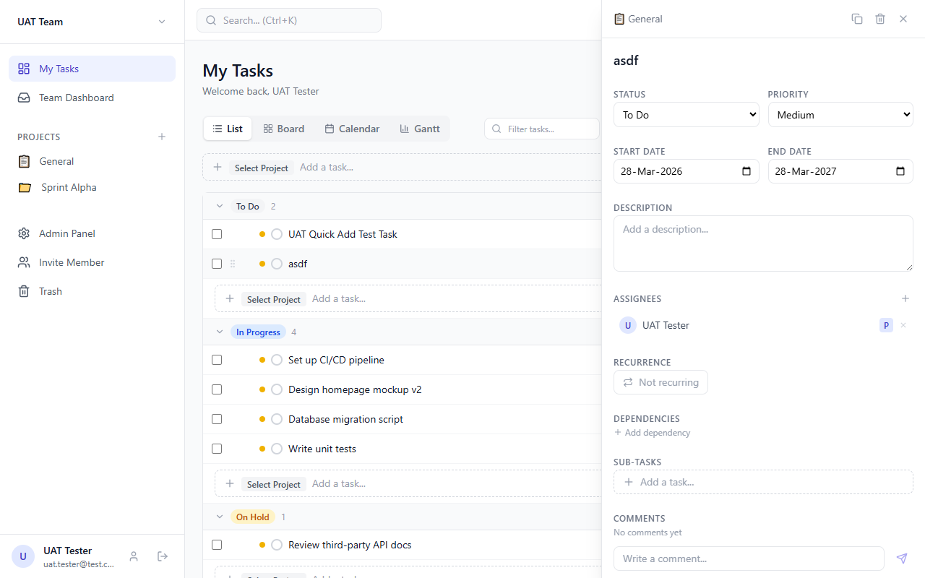
task detail

6.1 Fields You Can Edit
Field | What It Does
Title | The name of the task. Click to edit, it saves when you click away.
Status | Where the task is: To Do, In Progress, On Hold, or Done.
Priority | How important: Urgent (1), High (2), Medium (3), or Low (4).
Start Date | When work begins. Click the date to change it.
End Date | The deadline. Must be on or after the start date.
Description | Extra notes or instructions. Supports multiple lines.
Assignees | Who is working on it. Each person is Primary (main) or Secondary (helper).
Recurrence | Make it repeat: daily, weekly (pick days), or monthly.
Dependencies | Which tasks must finish before this one can start.
Sub-tasks | Smaller steps inside the task. Up to 2 levels deep.
Comments | Leave messages for your team. Everyone assigned can see them.

6.2 Assigning People
1. In the Task Detail panel, find the "Assignees" section.
2. Click the + button to see available team members.
3. Click "Primary" or "Secondary" next to a person’s name.
Primary = the main person responsible. Secondary = a helper or reviewer.
4. To remove someone, click the X next to their name.
5. To switch roles, click the P/S button next to their name.

6.3 Adding Dependencies
Dependencies mean "this task can’t start until that other task is done."
1. In the Task Detail panel, find the "Dependencies" section.
2. Click "+ Add dependency".
3. Search for the blocking task and click it.
The app prevents circular dependencies (e.g., Task A blocks B and B blocks A). You’ll see an error if you try.

6.4 Comments
1. Scroll to the bottom of the Task Detail panel.
2. Type your message in the "Write a comment..." box.
3. Click the send button (arrow icon).
You can delete your own comments by clicking the trash icon.

6.5 Duplicate & Delete
• Duplicate: Click the copy icon in the Task Detail header. Creates a copy with "(copy)" in the title.
• Delete: Click the trash icon. The task moves to Trash (not permanently deleted yet).

7. Filters & Sorting
Use the filter bar at the top of any view to narrow down what you see.

7.1 Available Filters
Filter | What It Does
Search | Type to find tasks by name. Works instantly as you type.
Status | Show only tasks with a specific status (e.g., only "In Progress").
Priority | Show only tasks with a specific priority level.
Role | On My Tasks: show only tasks where you are Primary or Secondary.
Assignee | On Team/Project pages: show only tasks assigned to a specific person.
Sort | Change the order: Manual, Due date, Priority, Title, or Created date.
Click "Clear" (the X button) to remove all filters at once.

8. Bulk Actions
Need to update many tasks at once? Use bulk actions.

8.1 How to Use
1. In List view, click the checkbox next to each task you want to select.
2. A toolbar appears at the bottom of the screen showing how many tasks are selected.
3. Choose an action from the toolbar:
• Change Status — Click any status button (To Do, In Progress, On Hold, Done).
• Set Priority — Click "Priority" and pick Urgent, High, Medium, or Low.
• Assign — Click "Assign" and pick a team member.
• Shift Dates — Click "Shift Dates" to move all selected tasks’ dates:
• Quick options: -7 days, -1 day, +1 day, +7 days
• Custom: type any number of days and click "Go"
• Delete — Moves all selected tasks to Trash.
4. Click X to deselect all.

9. Team Dashboard
See a bird’s-eye view of everything your team is working on.
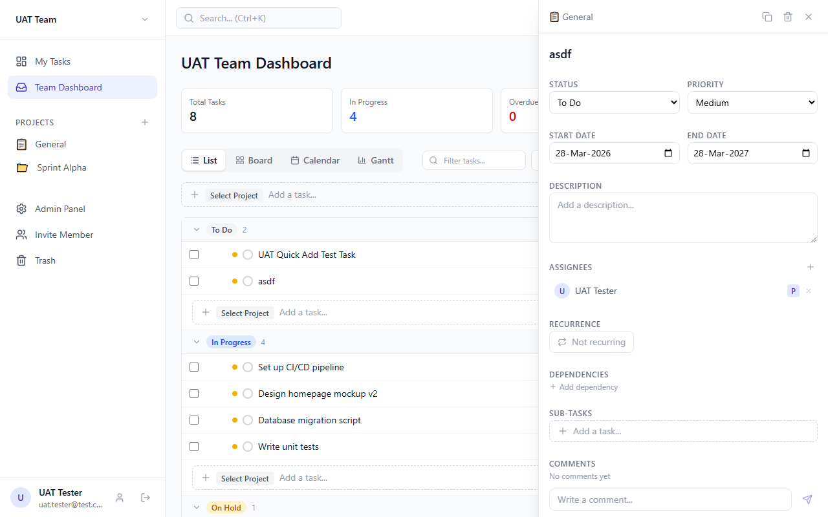
team dashboard

9.1 What You See
• Team name at the top.
• 4 stat cards: Total Tasks, In Progress, Overdue, Done This Week.
• All tasks from every project in the team.
• Same 4 views (List, Board, Calendar, Gantt).
• Filters with an extra "Assignee" dropdown to see a specific person’s tasks.

10. Chat
Talk to your teammates without leaving the app.

10.1 Opening Chat
• Desktop: Click the chat bubble icon in the top-right corner of the header.
• Mobile: Tap "Chat" in the bottom navigation bar.
Note: When you open Chat, the Task Detail panel closes automatically (and vice versa). They don’t overlap.

10.2 Starting a Conversation
1. Click the + button at the top of the chat panel.
2. Choose Direct (one-on-one) or Group.
3. For Direct: pick a team member from the list.
4. For Group: name the group, select members, click "Create Group".

10.3 Sending Messages
1. Click a conversation from the list.
2. Type your message in the box at the bottom.
3. Press Enter or click the send button.
Messages update in real-time — no need to refresh!

11. Notifications
The app sends you notifications when important things happen.

11.1 What Triggers a Notification
• Someone assigns a task to you.
• Someone comments on a task you’re assigned to.
• A task’s status changes (e.g., from "In Progress" to "Done").

11.2 Viewing Notifications
1. Click the bell icon in the header (top-right).
2. A dropdown shows your recent notifications.
3. The red badge shows how many unread notifications you have.
4. Click a notification to mark it as read and go to the related task.

11.3 Notification Settings
Go to Profile > Notification Preferences to:
• Turn on/off notifications for: Task assigned, New comment, Status changed.
• Set "Quiet Hours" — a time range when notifications are silenced.

12. Search & Keyboard Shortcuts
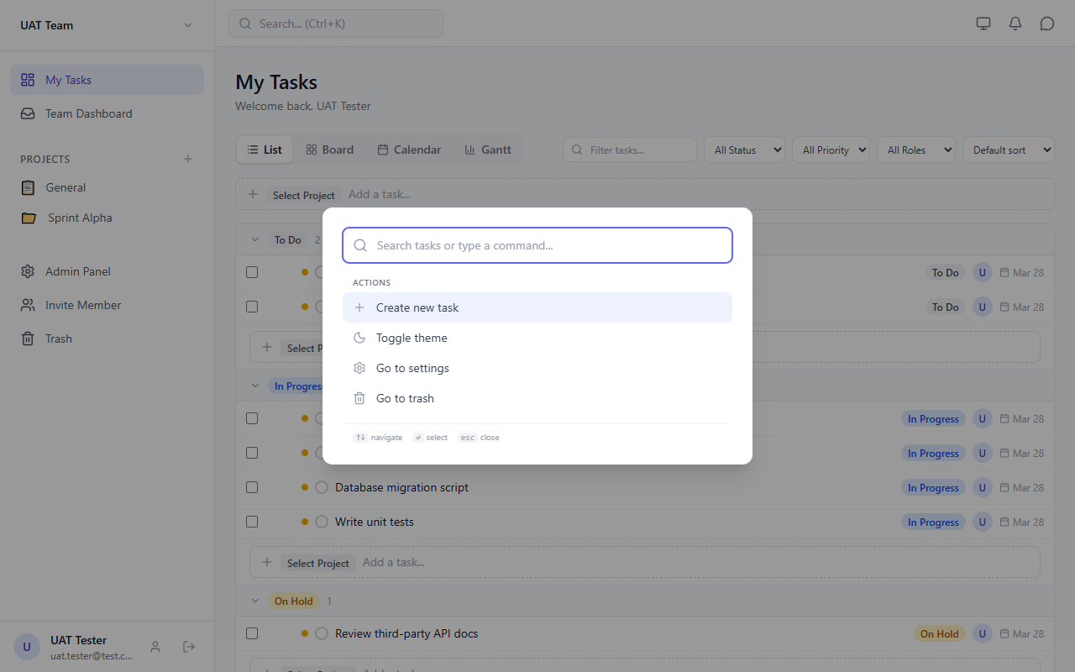
search palette

12.1 Global Search (Command Palette)
1. Press Ctrl+K (or ⌘+K on Mac) from anywhere in the app.
2. A search box appears in the center of the screen.
3. Type to search for tasks by name.
4. Use arrow keys to navigate results, Enter to open.
You’ll also see Quick Actions: create a new task, toggle dark mode, go to settings, or go to trash.

12.2 Keyboard Shortcuts
Shortcut | What It Does
Ctrl + K or / | Open search / command palette
N | Create a new task
1 | Switch to List view
2 | Switch to Board view
3 | Switch to Calendar view
4 | Switch to Gantt view
? | Show all keyboard shortcuts
Esc | Close any open panel or modal

13. Admin Panel
Only team admins can access this page. It’s where you manage your team.
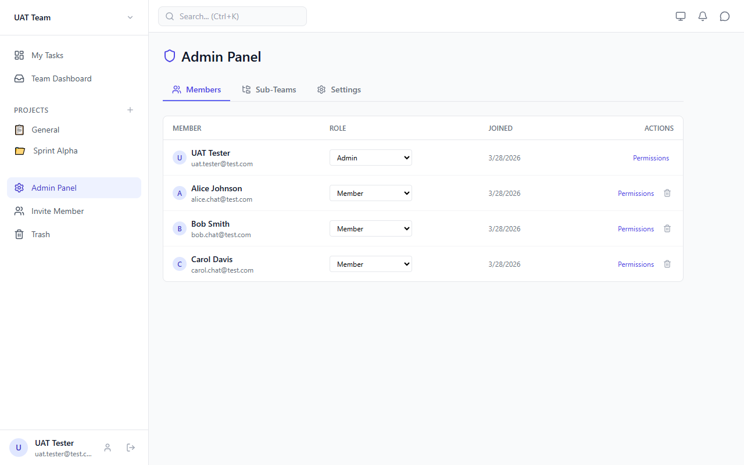
admin panel

13.1 Members Tab
See everyone on your team. For each member you can:
• Change their role: Admin, Sub-Team Manager, Member, or Viewer.
• Set custom permissions (12 toggleable permissions like "can create tasks", "can delete tasks", etc.).
• Remove them from the team (their tasks get unassigned automatically).
Important: You cannot remove or demote the last admin. There must always be at least one admin.

13.2 Sub-Teams Tab
Create smaller groups within your team (like "Design Team" or "Group A").
1. Click "New Sub-Team".
2. Give it a name.
3. Use the dropdown to add members.
4. Click X on a member pill to remove them.

13.3 Settings Tab
Change your team’s name and description. Click "Save Changes" when done.

13.4 Inviting New Members
1. Click "Invite Member" in the sidebar.
2. Enter the person’s email address (they must already have an account).
3. Click "Invite". They’re added as a Member by default.

13.5 Permissions & What Each Role Can Do
Permissions are enforced both in the database and in the UI. Here’s what each role can do by default:
• Admin — Full access to everything. Can manage members, change settings, and delete any task.
• Sub-Team Manager — Can edit all tasks and manage their sub-team’s members.
• Member — Can create tasks and edit their own tasks. Cannot delete tasks or manage members.
• Viewer — Read-only access. Cannot create, edit, or delete tasks. The quick-add input and action buttons are hidden.
Admins can customize any member’s permissions individually from the Members tab using the 12 permission toggles.
The 12 permissions are: create tasks, edit own tasks, edit all tasks, delete tasks, manage members, manage sub-teams, manage settings, manage projects, view reports, full access, assign tasks, comment on tasks.

14. Profile & Settings
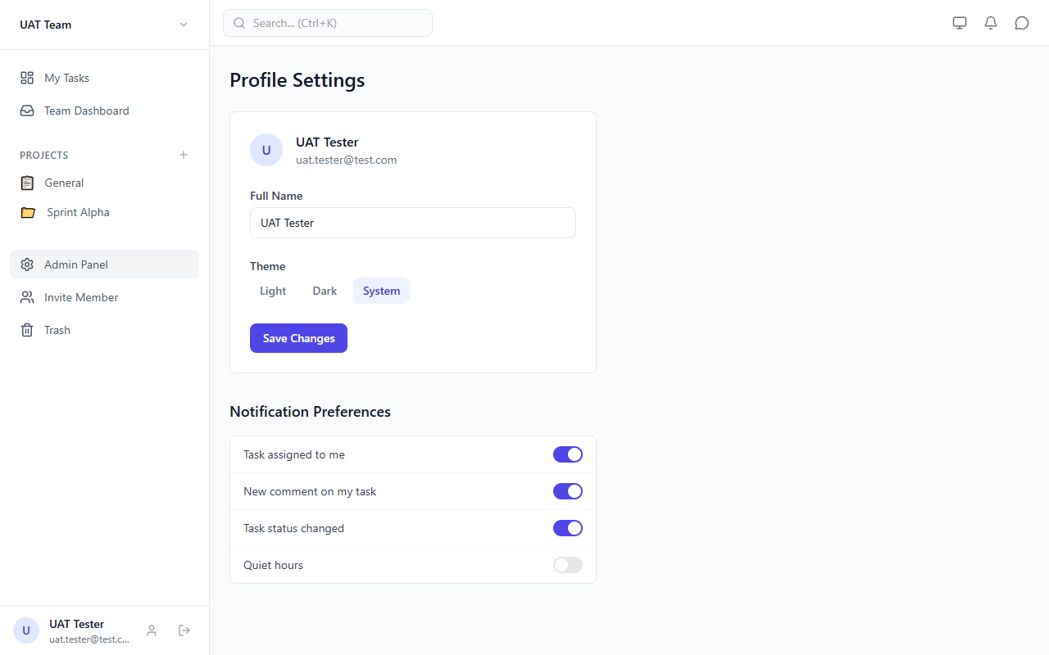
profile page

14.1 Editing Your Profile
1. Click your avatar or the Profile icon at the bottom of the sidebar.
2. Change your name in the "Full Name" field.
3. Click "Save Changes".

14.2 Changing the Theme
Choose between Light mode, Dark mode, or System (follows your device’s setting).
• Light — White background, dark text.
• Dark — Dark background, light text (easier on the eyes at night).
• System — Automatically matches your computer’s theme.
You can also toggle the theme from the sun/moon icon in the header.

14.3 Notification Preferences
Toggle which notifications you want to receive:
• Task assigned to me
• New comment on my tasks
• Status changed on my tasks
You can also set Quiet Hours (e.g., 10pm to 8am) when no notifications will bother you.

15. Trash
When you delete a task, it goes to Trash first. It’s not gone forever yet.
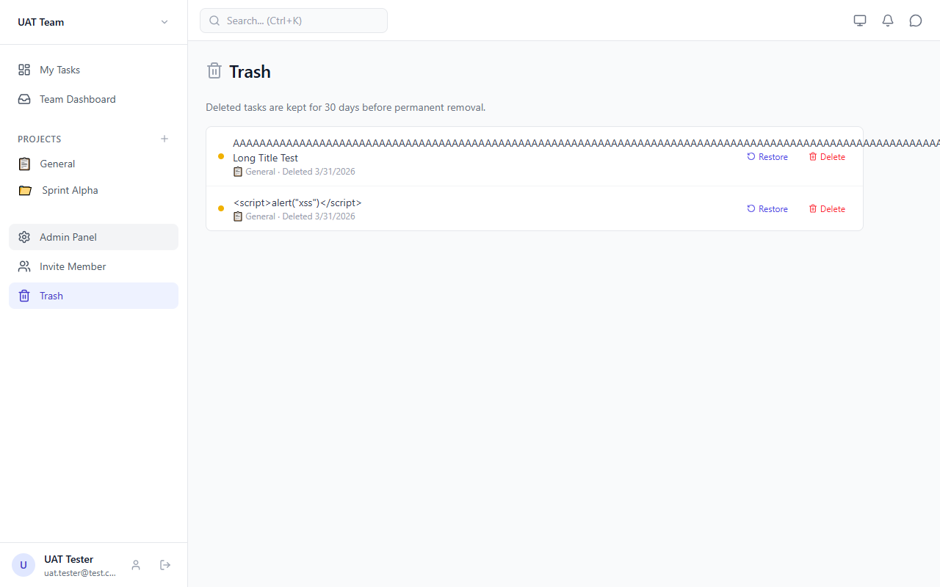
trash page

15.1 Recovering a Deleted Task
1. Click "Trash" in the sidebar.
2. Find the task you want to bring back.
3. Click "Restore". The task goes back to its project, good as new.

15.2 Permanently Deleting a Task
1. In the Trash page, click "Delete" next to the task.
2. The task is gone forever. This cannot be undone!
Automatic cleanup: Tasks that sit in Trash for more than 30 days are permanently deleted automatically.

16. Tips & Tricks

16.1 Work Faster
• Use Ctrl+K to quickly search for any task instead of scrolling.
• Press N to create a new task without touching the mouse.
• Use number keys 1-4 to switch views instantly.
• Use bulk select (checkboxes) to update many tasks at once.

16.2 Stay Organized
• Set priorities on every task — it helps when you have lots of tasks.
• Use the Gantt view to spot scheduling conflicts and overlapping tasks.
• Add dependencies when one task must be done before another can start.
• Use sub-tasks to break big tasks into small, manageable steps.

16.3 Collaborate Better
• Use comments on tasks to keep discussions in context (not in chat).
• Set Primary vs Secondary assignees so everyone knows who’s the lead.
• Check the Team Dashboard to see if anyone is overloaded.
• Use chat for quick questions that don’t belong on a specific task.

16.4 Mobile Tips
• Use the bottom navigation bar for quick access to Tasks, Team, Search, Chat, and Alerts.
• The sidebar opens with the hamburger menu icon (top-left).
• All views work on mobile, but Board and Gantt scroll horizontally.

End of Manual
Questions? Ask your team admin or check the keyboard shortcuts (press ?).

