Team Task Manager
Technical Reference
Version 1.0 — April 2026
Architecture • Database • Design System • Permissions
Deployment • API Patterns • Change Log

Table of Contents

1. Architecture Overview

1.1 System Architecture
Team Task Manager is a single-page application (SPA) with no custom backend server. All server-side logic is handled by Supabase services and PostgreSQL database triggers.

Data Flow
React 19 SPA (Vercel) → Supabase JS Client → Supabase Platform
├─ Auth (JWT-based authentication)
├─ PostgreSQL (data + RLS + triggers)
├─ Realtime (WebSocket subscriptions)
└─ Storage (avatars, attachments)

1.2 Tech Stack
Layer | Technology | Version
Framework | React + TypeScript | 19.2 + 5.9
Build Tool | Vite | 8.0
Styling | Tailwind CSS | 4.2
State | Zustand | 5.0
Backend | Supabase (PostgreSQL + Auth + Realtime) | 2.100
Hosting | Vercel (frontend) | —
Drag & Drop | @dnd-kit/core + @dnd-kit/sortable | 6.3 + 10.0
Calendar | @fullcalendar/react | 6.1
Date Utils | date-fns | 4.1
Icons | lucide-react | 1.7
Router | react-router-dom | 7.13

1.3 Project Structure
src/
├─ components/ # UI components by feature
│ ├─ auth/ # Login, Signup, ProtectedRoute
│ ├─ layout/ # AppLayout, Header, Sidebar, BottomNav
│ ├─ tasks/ # All task views + detail + filters
│ ├─ chat/ # ChatPanel
│ ├─ notifications/ # NotificationDropdown
│ ├─ search/ # GlobalSearch (command palette)
│ ├─ onboarding/ # WelcomeGuide
│ ├─ project/ # CreateProjectModal
│ ├─ team/ # TeamSwitcher, InviteModal
│ └─ ui/ # Shared: Button, Modal, Toast, etc.
├─ hooks/ # usePermissions
├─ lib/ # supabase.ts client
├─ pages/ # Route pages
├─ store/ # Zustand stores (6 stores)
└─ types/ # TypeScript interfaces
supabase/
├─ migrations/ # SQL migrations 001–007
└─ functions/ # (Edge Functions — unused, logic in stores)

1.4 Login & Authentication Screens
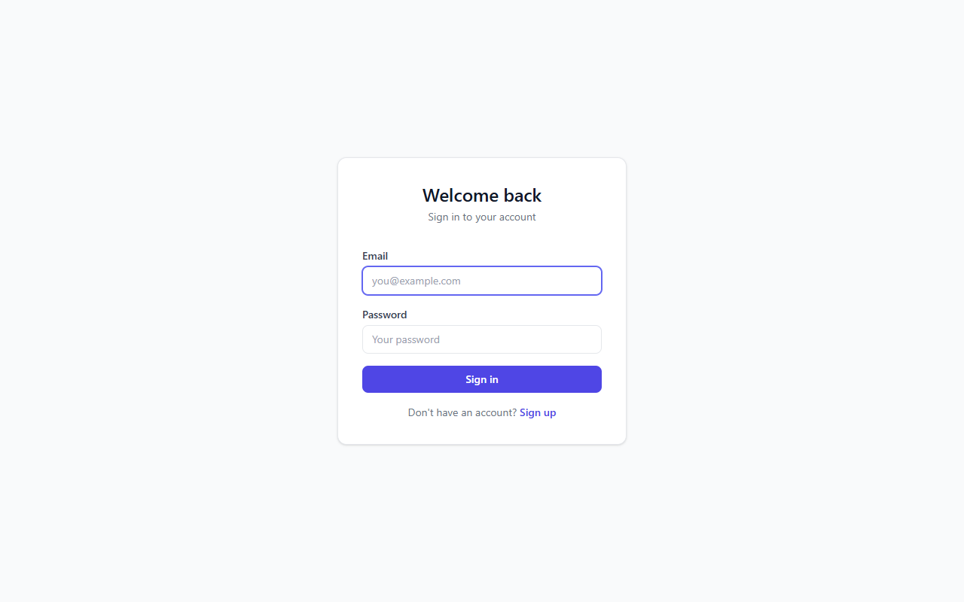
Figure 1.1 — Login page (empty state)
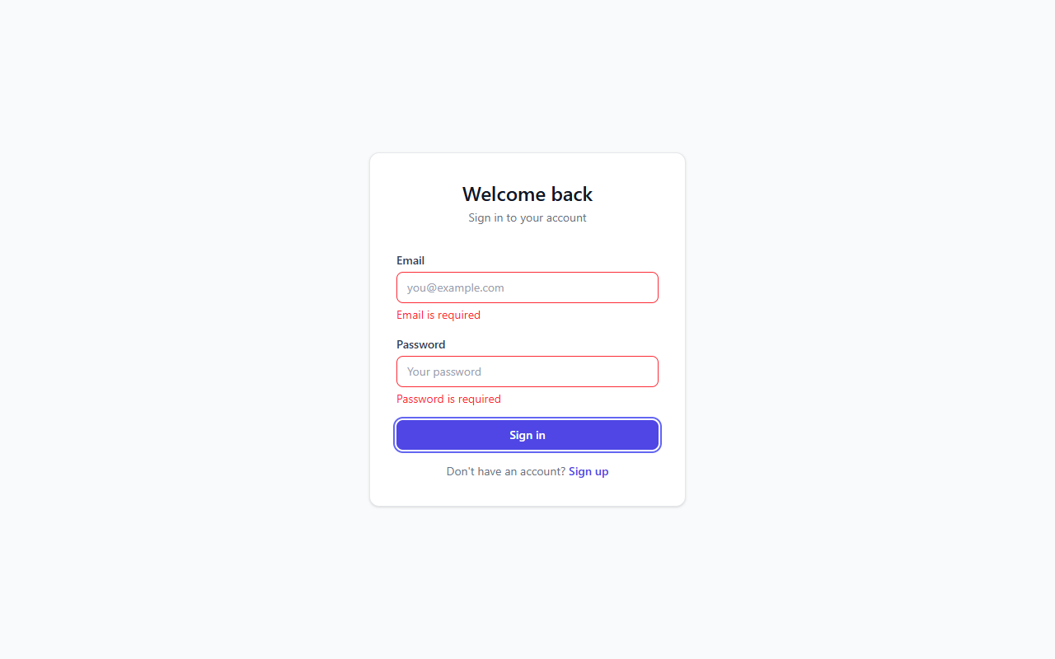
Figure 1.2 — Login form validation errors
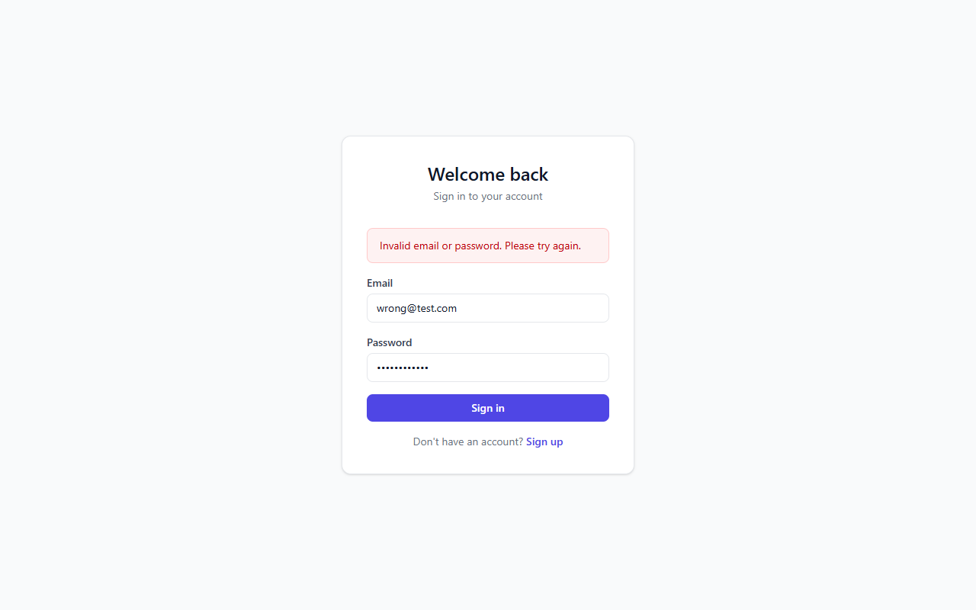
Figure 1.3 — Invalid credentials error
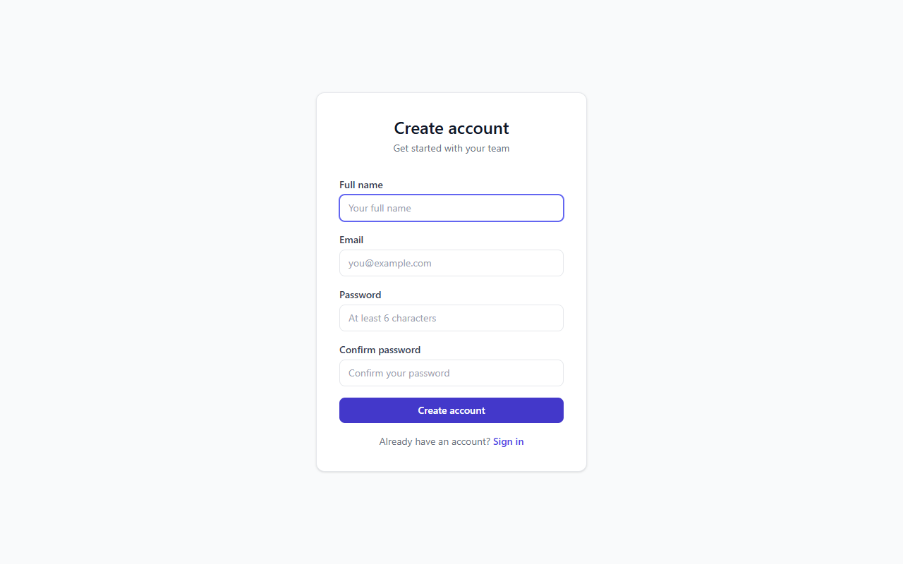
Figure 1.4 — Sign-up form
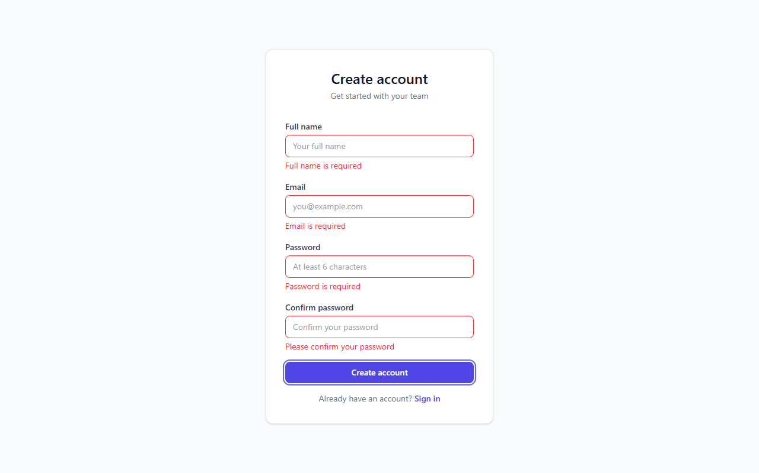
Figure 1.5 — Sign-up form validation errors

2. Database Schema
All tables are in the public schema. RLS is enabled on every table. The database uses PostgreSQL via Supabase.

2.1 profiles
Auto-created on sign-up via the handle_new_user() trigger.
Column | Type | Constraints
id | uuid | PK, references auth.users(id) ON DELETE CASCADE
email | text | NOT NULL
full_name | text | nullable
avatar_url | text | nullable
timezone | text | DEFAULT 'UTC'
created_at | timestamptz | DEFAULT now()

2.2 teams
Column | Type | Constraints
id | uuid | PK, DEFAULT gen_random_uuid()
name | text | NOT NULL
description | text | nullable
created_by | uuid | FK → profiles(id)
created_at | timestamptz | DEFAULT now()

2.3 team_members
Links users to teams with role and custom permissions.
Column | Type | Constraints
id | uuid | PK, DEFAULT gen_random_uuid()
team_id | uuid | FK → teams(id) ON DELETE CASCADE, NOT NULL
user_id | uuid | FK → profiles(id) ON DELETE CASCADE, NOT NULL
role | text | CHECK (admin|sub_team_manager|member|viewer), DEFAULT 'member'
permissions | jsonb | DEFAULT (12-key permission object)
joined_at | timestamptz | DEFAULT now()
Unique constraint: UNIQUE(team_id, user_id)

2.4 sub_teams
Column | Type | Constraints
id | uuid | PK, DEFAULT gen_random_uuid()
team_id | uuid | FK → teams(id) ON DELETE CASCADE, NOT NULL
name | text | NOT NULL
manager_id | uuid | FK → profiles(id)
created_at | timestamptz | DEFAULT now()

2.5 sub_team_members
Column | Type | Constraints
sub_team_id | uuid | FK → sub_teams(id) ON DELETE CASCADE, NOT NULL
user_id | uuid | FK → profiles(id) ON DELETE CASCADE, NOT NULL
Primary key: (sub_team_id, user_id)

2.6 projects
Column | Type | Constraints
id | uuid | PK, DEFAULT gen_random_uuid()
team_id | uuid | FK → teams(id) ON DELETE CASCADE, NOT NULL
name | text | NOT NULL
emoji | text | DEFAULT '📋'
description | text | nullable
is_default | boolean | DEFAULT false
start_date | date | NOT NULL
end_date | date | NOT NULL, CHECK(end_date >= start_date)
created_by | uuid | FK → profiles(id)
created_at | timestamptz | DEFAULT now()

2.7 tasks
Core entity. Supports 2-level nesting, soft delete, recurring patterns, and optimistic update conflict detection.
Column | Type | Constraints
id | uuid | PK, DEFAULT gen_random_uuid()
project_id | uuid | FK → projects(id) ON DELETE CASCADE, NOT NULL
parent_id | uuid | FK → tasks(id) ON DELETE CASCADE (self-ref)
title | text | NOT NULL
description | text | nullable
status | text | CHECK (todo|in_progress|on_hold|done), DEFAULT 'todo'
priority | integer | CHECK (1–4), DEFAULT 3
start_date | date | NOT NULL
end_date | date | NOT NULL, CHECK(end_date >= start_date)
position | integer | DEFAULT 0
depth | integer | CHECK (0–2), DEFAULT 0
is_recurring | boolean | DEFAULT false
recurrence_pattern | jsonb | nullable
created_by | uuid | FK → profiles(id)
created_at | timestamptz | DEFAULT now()
updated_at | timestamptz | DEFAULT now()
deleted_at | timestamptz | nullable (soft delete)

2.8 task_assignees
Column | Type | Constraints
task_id | uuid | FK → tasks(id) ON DELETE CASCADE, NOT NULL
user_id | uuid | FK → profiles(id) ON DELETE CASCADE, NOT NULL
role | text | CHECK (primary|secondary), DEFAULT 'primary'
Primary key: (task_id, user_id)

2.9 task_dependencies
Column | Type | Constraints
id | uuid | PK, DEFAULT gen_random_uuid()
task_id | uuid | FK → tasks(id) ON DELETE CASCADE, NOT NULL
depends_on_task_id | uuid | FK → tasks(id) ON DELETE CASCADE, NOT NULL
type | text | CHECK (blocks|blocked_by), NOT NULL
Unique constraint: UNIQUE(task_id, depends_on_task_id). Circular dependencies prevented by BFS graph walk in the client.

2.10 comments
Column | Type | Constraints
id | uuid | PK, DEFAULT gen_random_uuid()
task_id | uuid | FK → tasks(id) ON DELETE CASCADE
project_id | uuid | FK → projects(id) ON DELETE CASCADE
user_id | uuid | FK → profiles(id), NOT NULL
content | text | NOT NULL
created_at | timestamptz | DEFAULT now()
CHECK: task_id IS NOT NULL OR project_id IS NOT NULL

2.11 conversations
Column | Type | Constraints
id | uuid | PK, DEFAULT gen_random_uuid()
type | text | CHECK (direct|team|group), NOT NULL
team_id | uuid | FK → teams(id) ON DELETE CASCADE, NOT NULL
name | text | nullable
created_by | uuid | FK → profiles(id)
created_at | timestamptz | DEFAULT now()

2.12 conversation_members
Column | Type | Constraints
conversation_id | uuid | FK → conversations(id) ON DELETE CASCADE, NOT NULL
user_id | uuid | FK → profiles(id) ON DELETE CASCADE, NOT NULL
Primary key: (conversation_id, user_id)

2.13 messages
Column | Type | Constraints
id | uuid | PK, DEFAULT gen_random_uuid()
conversation_id | uuid | FK → conversations(id) ON DELETE CASCADE, NOT NULL
sender_id | uuid | FK → profiles(id), NOT NULL
content | text | NOT NULL
created_at | timestamptz | DEFAULT now()

2.14 message_reads
Column | Type | Constraints
message_id | uuid | FK → messages(id) ON DELETE CASCADE, NOT NULL
user_id | uuid | FK → profiles(id) ON DELETE CASCADE, NOT NULL
read_at | timestamptz | DEFAULT now()
Primary key: (message_id, user_id)

2.15 notifications
Column | Type | Constraints
id | uuid | PK, DEFAULT gen_random_uuid()
user_id | uuid | FK → profiles(id) ON DELETE CASCADE, NOT NULL
type | text | NOT NULL
title | text | NOT NULL
body | text | NOT NULL
link | text | nullable
is_read | boolean | DEFAULT false
created_at | timestamptz | DEFAULT now()

2.16 notification_preferences
Column | Type | Constraints
user_id | uuid | FK → profiles(id) ON DELETE CASCADE, PK
preferences | jsonb | DEFAULT (9-event config with in_app/push booleans)
quiet_hours_enabled | boolean | DEFAULT false
quiet_hours_start | time | nullable
quiet_hours_end | time | nullable

2.17 Indexes
Index Name | Table.Column
idx_team_members_user | team_members.user_id
idx_team_members_team | team_members.team_id
idx_sub_team_members_sub | sub_team_members.sub_team_id
idx_sub_team_members_user | sub_team_members.user_id
idx_projects_team | projects.team_id
idx_tasks_project | tasks.project_id
idx_tasks_parent | tasks.parent_id
idx_tasks_status | tasks.status
idx_tasks_deleted | tasks.deleted_at
idx_task_assignees_user | task_assignees.user_id
idx_comments_task | comments.task_id
idx_comments_project | comments.project_id
idx_messages_conversation | messages.conversation_id
idx_messages_created | messages.created_at
idx_notifications_user | notifications.user_id
idx_notifications_read | notifications.is_read

2.18 Helper Functions (SECURITY DEFINER)
Function | Returns | Description
is_team_member(p_team_id) | boolean | Checks if auth.uid() is a member of the team
is_team_admin(p_team_id) | boolean | Checks if auth.uid() is an admin of the team
is_conversation_member(conv_id) | boolean | Checks if auth.uid() is in a conversation
handle_new_user() | trigger | Auto-creates profiles row on auth.users INSERT
update_modified_column() | trigger | Sets updated_at = now() before UPDATE on tasks

3. Row Level Security (RLS)
RLS is enabled on every table. All policies use SECURITY DEFINER helper functions to check team membership. This ensures data isolation between teams.

Table | SELECT | INSERT | UPDATE | DELETE
profiles | Self + teammates | — (trigger) | Self only | —
teams | Members only | Authenticated | Admin only | —
team_members | Team members | Admin or self-join | Admin only | Admin only
sub_teams | Team members | Admin only | Admin only | Admin only
sub_team_members | Team members | Admin only | — | Admin only
projects | Team members | Team members | Team members | Admin (non-default)
tasks | Team members | Team members | Team members | Team members
task_assignees | Team members | Team members | — | Team members
task_dependencies | Team members | Team members | — | Team members
comments | Team members | Self (user_id) | — | Self (user_id)
conversations | Creator or member | Creator + team member | — | —
conversation_members | Conv. members | Team members | — | —
messages | Conv. members | Self + conv. member | — | —
message_reads | Self only | Self only | Self only | —
notifications | Self only | — (trigger) | Self only | —
notification_prefs | Self only | Self only | Self only | —

Note: "Team members" means the RLS policy checks is_team_member(team_id) by traversing the foreign key chain (e.g., tasks → projects → teams).

4. Database Triggers & Cron

4.1 Notification Triggers (Migration 006)
Trigger | Event | Action
trg_notify_task_assigned | AFTER INSERT on task_assignees | Creates notification for assignee (skips self-assign)
trg_notify_task_comment | AFTER INSERT on comments | Notifies all task assignees except the commenter
trg_notify_task_status | AFTER UPDATE on tasks | Notifies all assignees when status changes (skips if deleted)

4.2 Cron Job (Migration 007)
Job: purge-old-trash
Schedule: Daily at 3:00 AM UTC via pg_cron
Action: DELETE FROM tasks WHERE deleted_at < now() - interval '30 days'
Requirement: pg_cron extension must be enabled manually in Supabase Dashboard > Database > Extensions

5. Authentication Flow

5.1 Sign Up
1. User fills SignupForm (full_name, email, password, confirm password) with client-side validation (noValidate + React state-based errors).
2. Calls supabase.auth.signUp() with full_name in options.data metadata.
3. The handle_new_user() trigger auto-creates a profiles row from auth.users metadata.
4. Supabase sends a confirmation email. User must confirm before logging in.

5.2 Sign In
1. User fills LoginForm with client-side validation.
2. Calls supabase.auth.signInWithPassword().
3. On error: inline error message "Invalid email or password."
4. On success: onAuthStateChange fires, sets user + session, fetches profile.
5. ProtectedRoute detects user and renders AppLayout.

5.3 Session Management
On app mount, authStore.initialize() calls supabase.auth.getSession() to restore an existing session, then subscribes to onAuthStateChange for token refresh events. The previous subscription is cleaned up before creating a new one to prevent memory leaks.

5.4 Sign Out
1. Unsubscribes the auth state listener.
2. Calls supabase.auth.signOut() (wrapped in try/catch).
3. In the finally block: clears user, profile, session to null.
4. Force redirects to /login via window.location.href (handles edge cases where auth listener fails to fire).

5.5 Application Screenshots
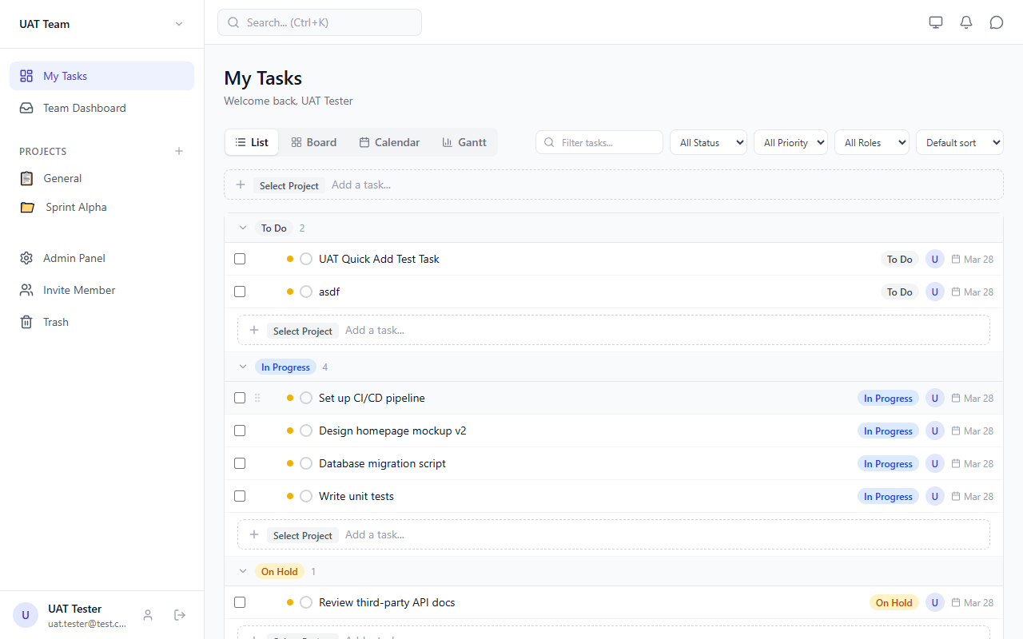
Figure 5.1 — Dashboard — List View (default landing)
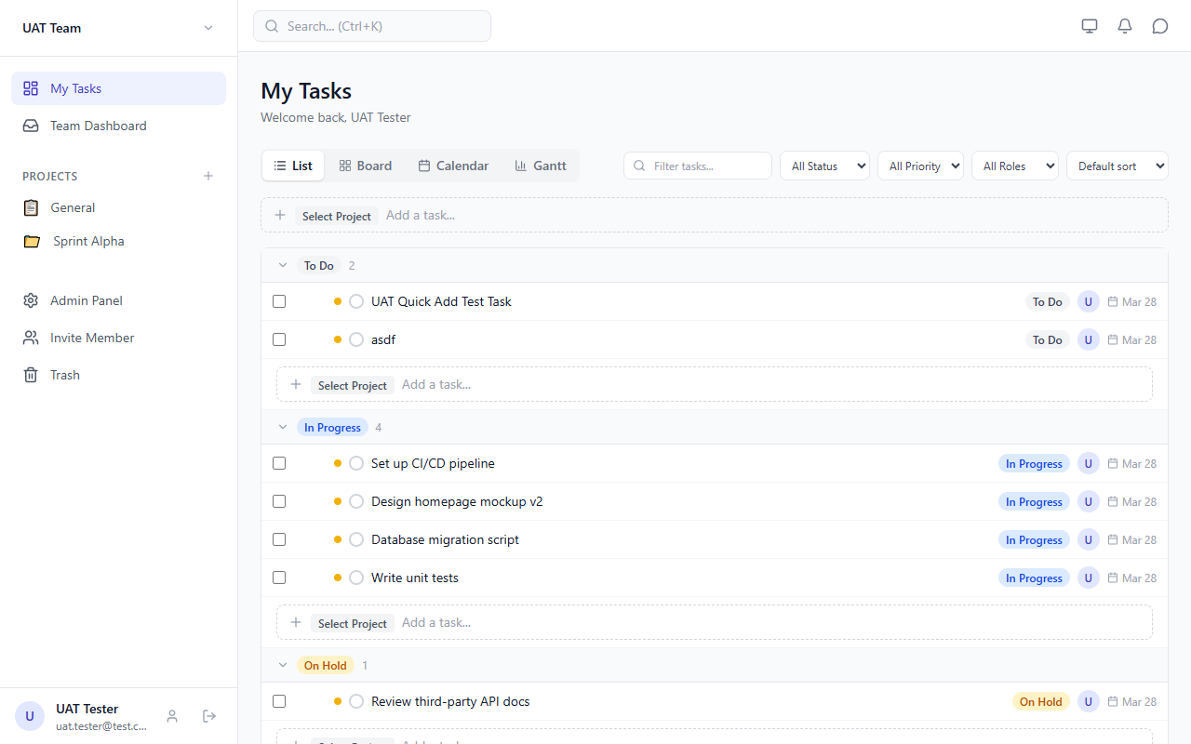
Figure 5.2 — Sidebar navigation with project list
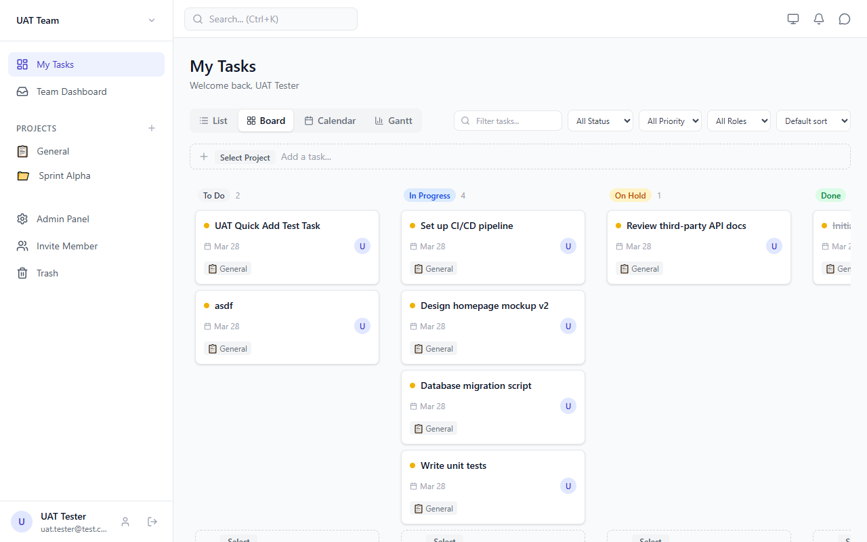
Figure 5.3 — Dashboard — Kanban Board View
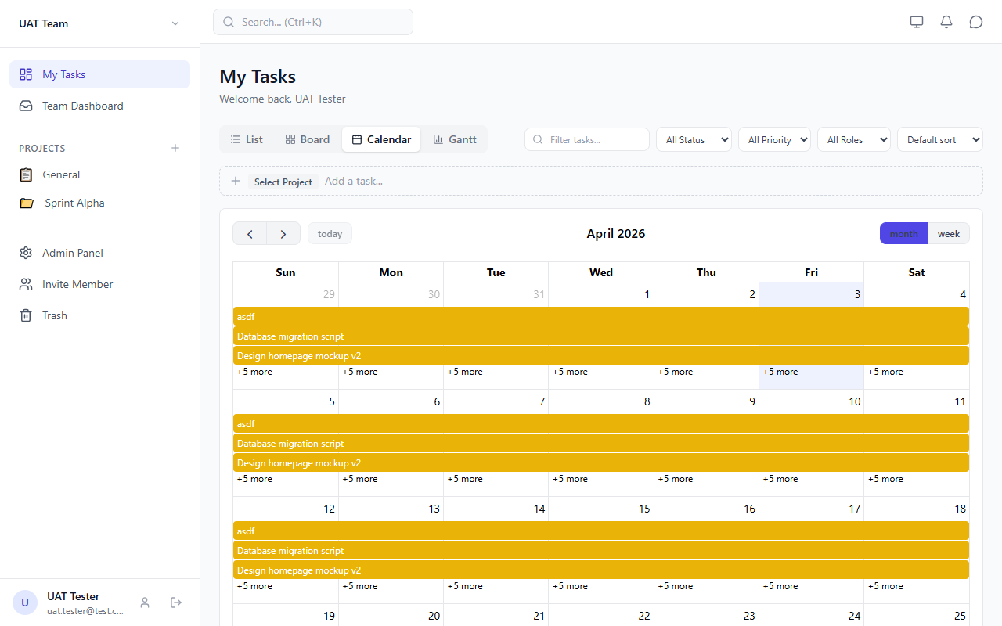
Figure 5.4 — Dashboard — Calendar View
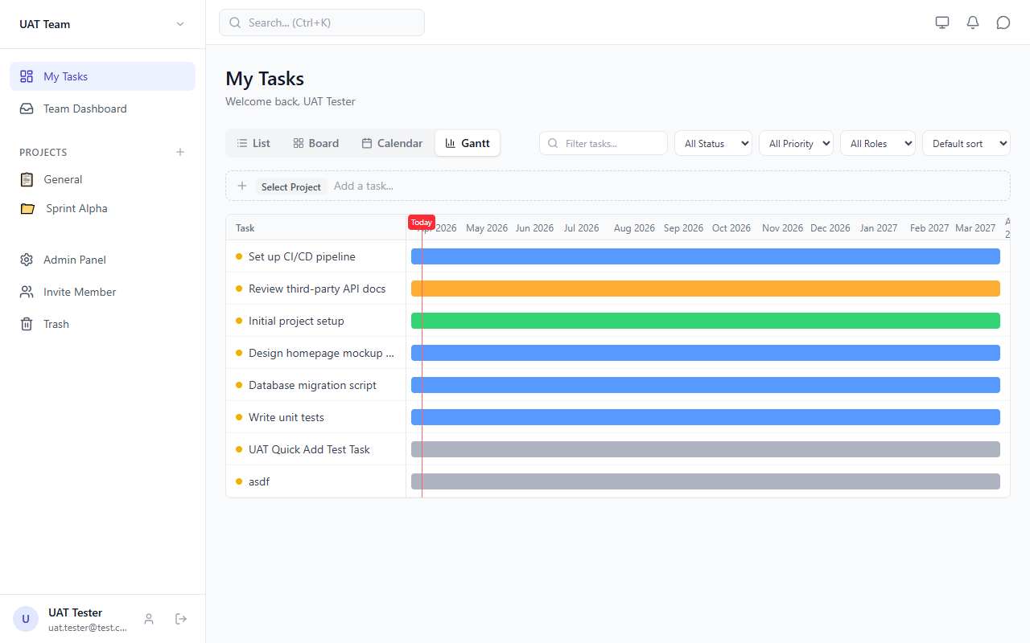
Figure 5.5 — Dashboard — Gantt View
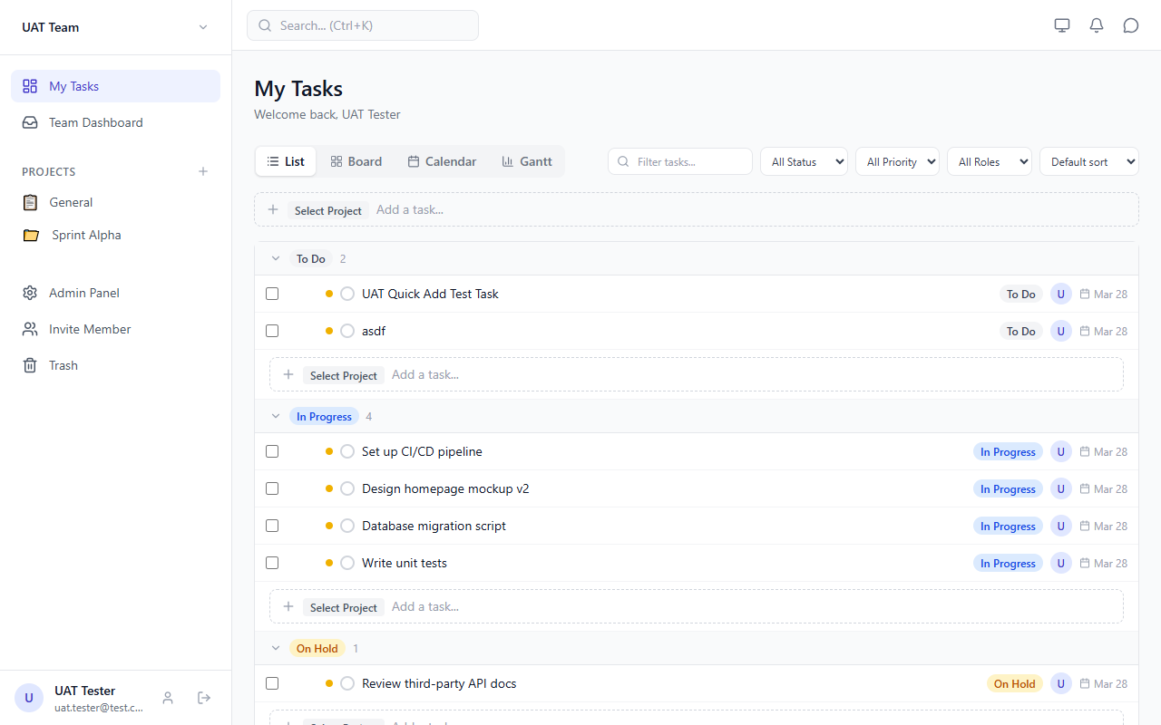
Figure 5.6 — Task Detail slide-in panel

Figure 5.7 — Task Detail — comments, dependencies, assignees
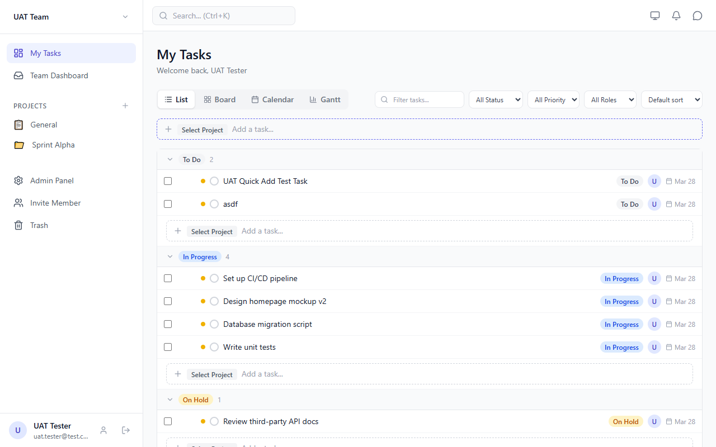
Figure 5.8 — Quick Add Task input
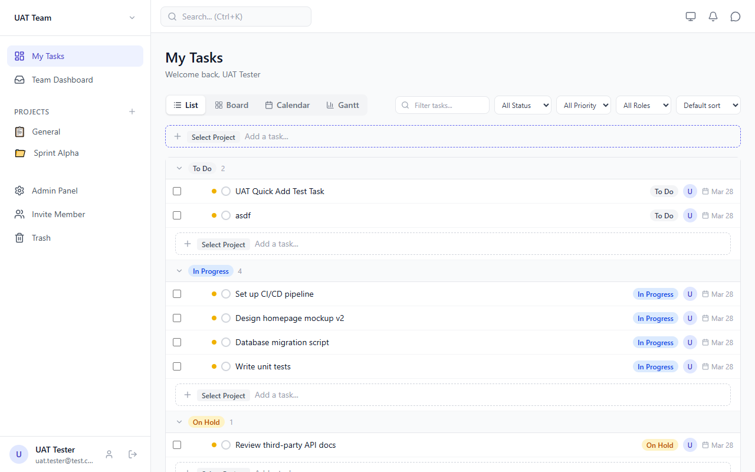
Figure 5.9 — Task Filters bar
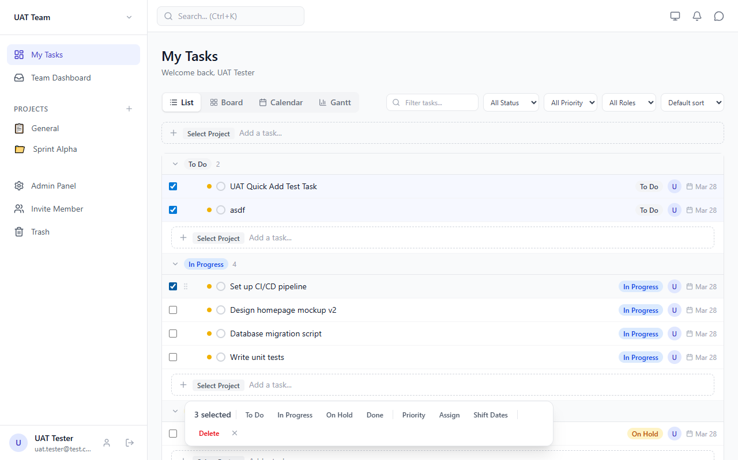
Figure 5.10 — Bulk Actions toolbar (3 tasks selected)

5.6 Project Page Views
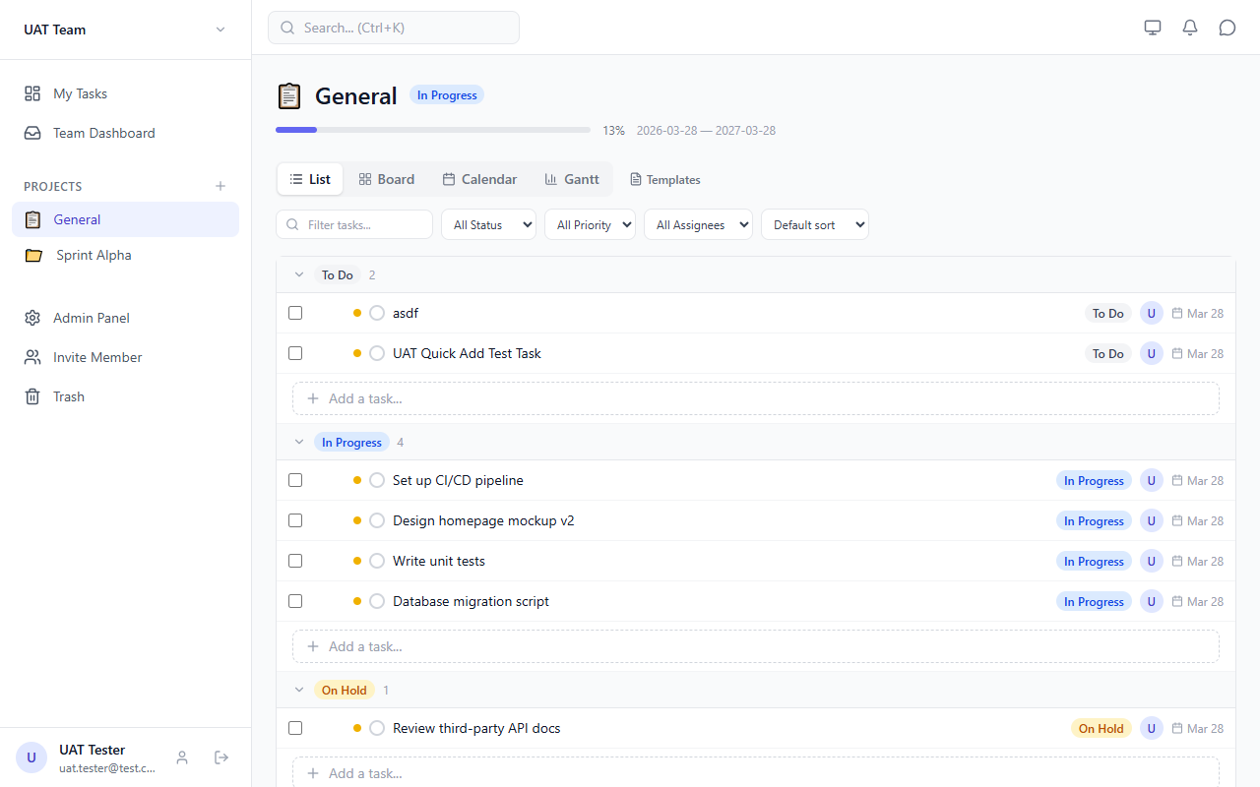
Figure 5.11 — Project Page — List View
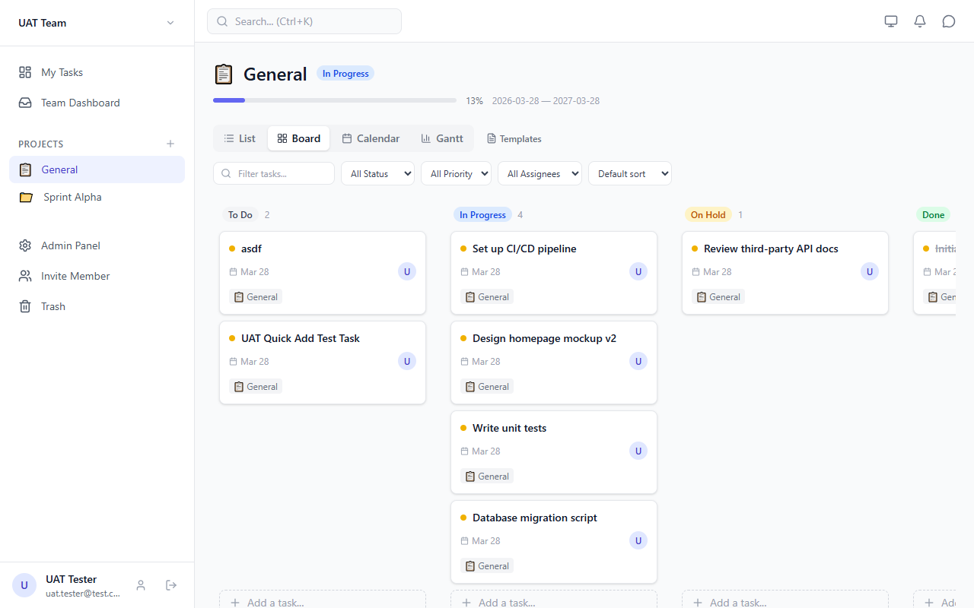
Figure 5.12 — Project Page — Kanban Board
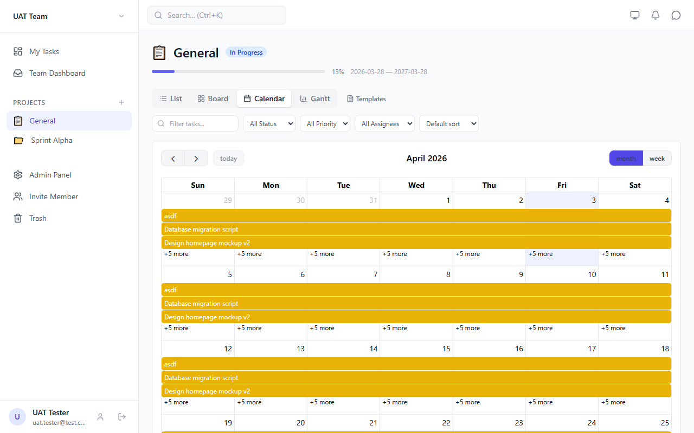
Figure 5.13 — Project Page — Calendar
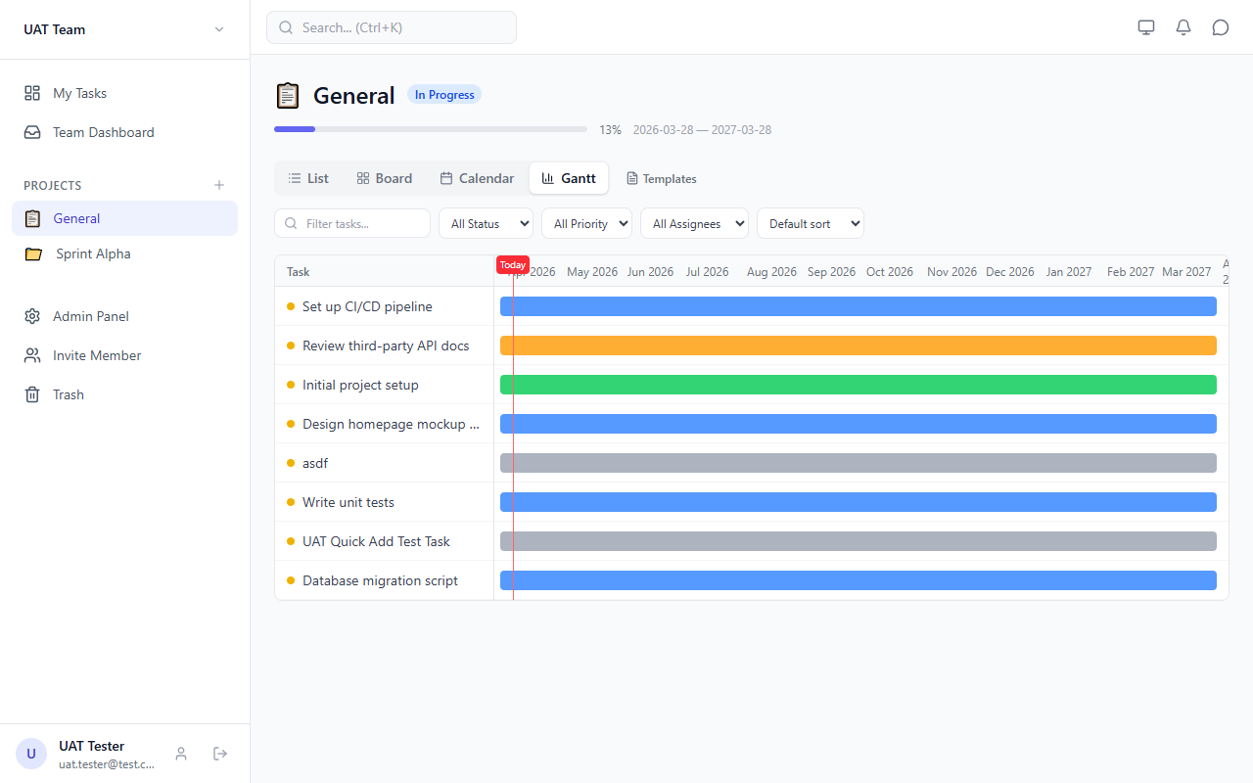
Figure 5.14 — Project Page — Gantt Chart

5.7 Team, Chat & Other Features
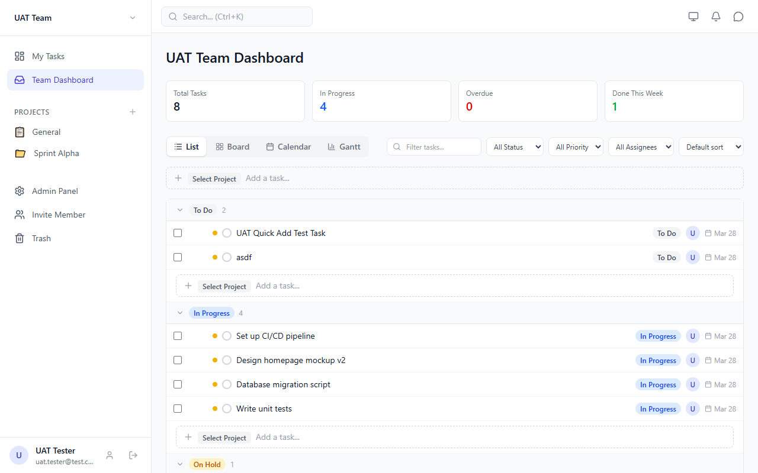
Figure 5.15 — Team Dashboard
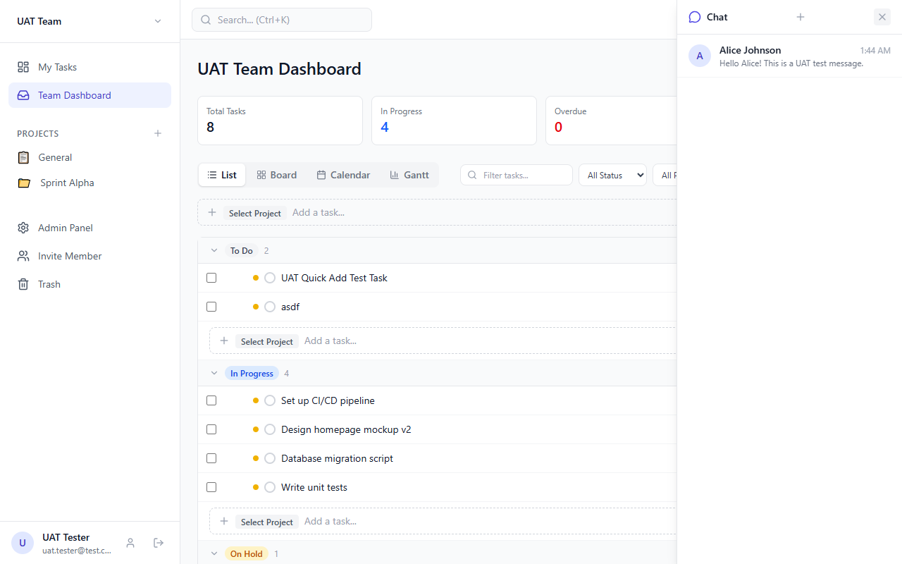
Figure 5.16 — Chat Panel (slide-in)
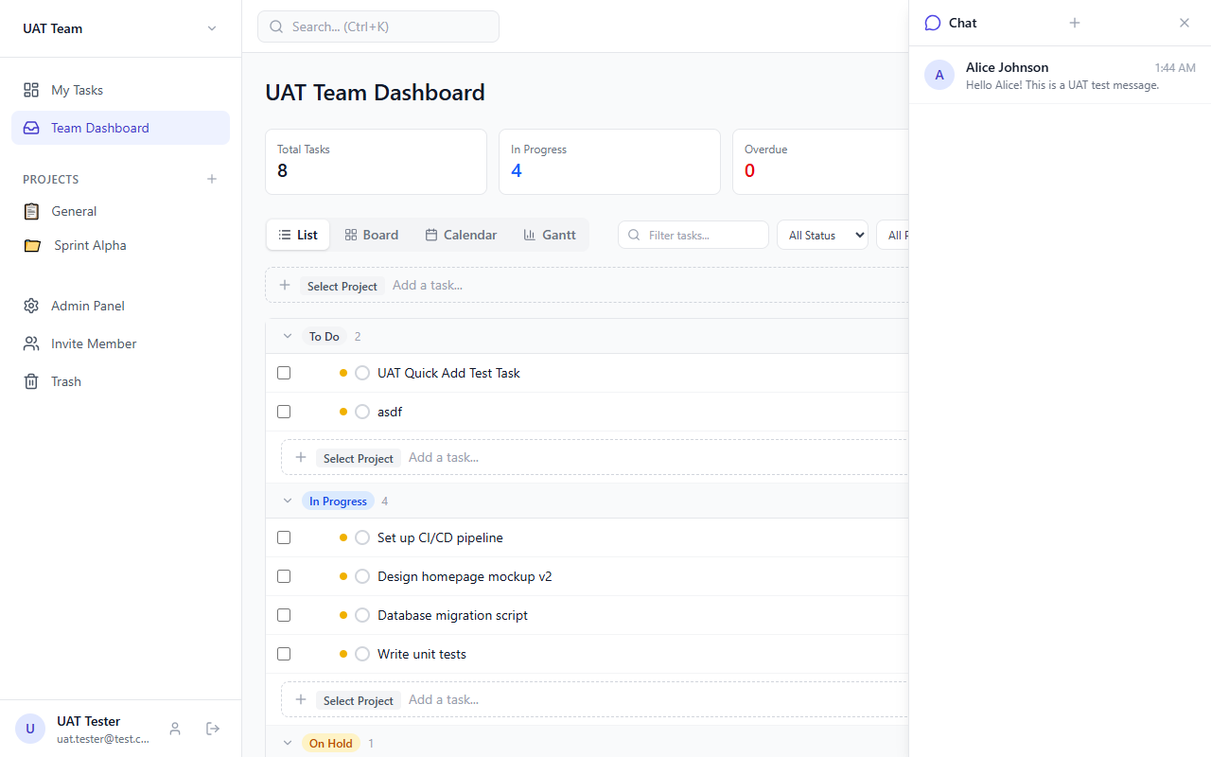
Figure 5.17 — Chat — conversation thread
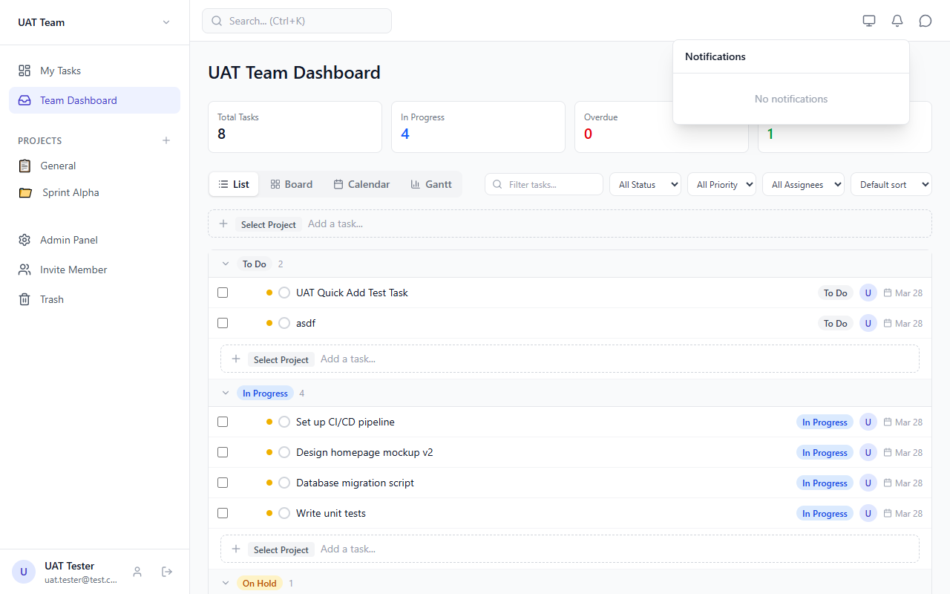
Figure 5.18 — Notifications dropdown
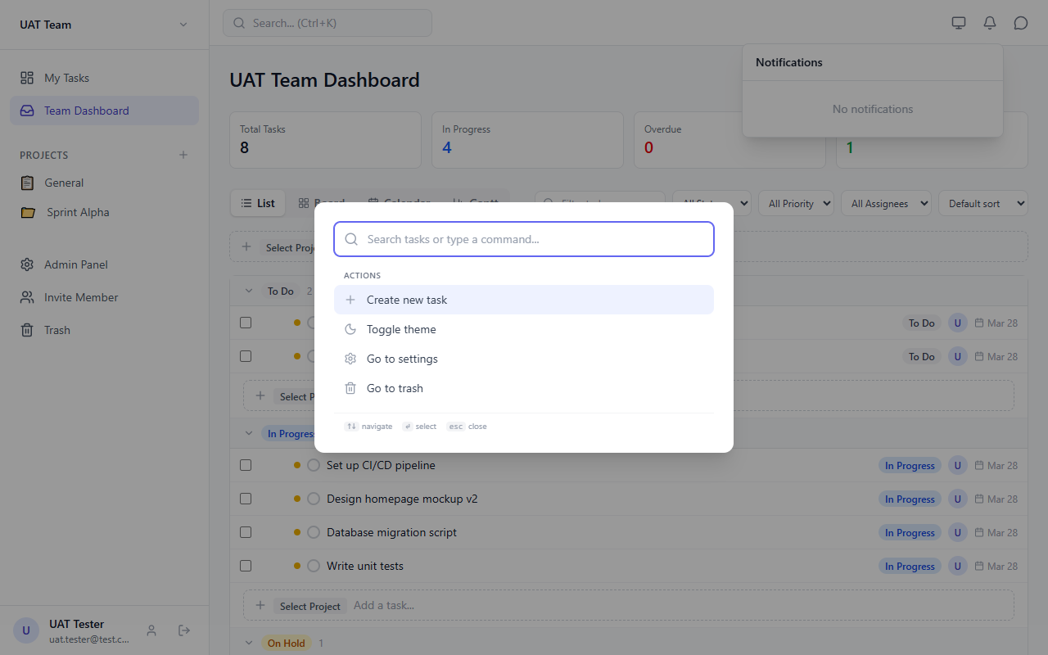
Figure 5.19 — Command Palette (Ctrl+K)
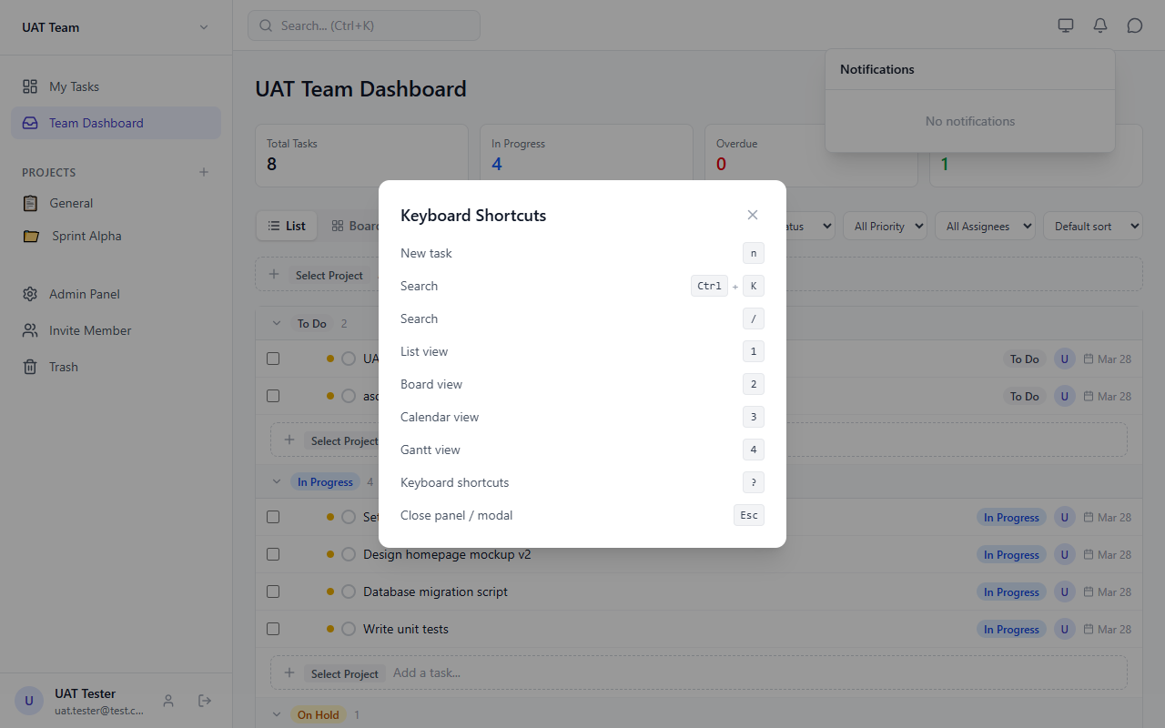
Figure 5.20 — Keyboard Shortcuts help modal

6. State Management (Zustand)
The app uses 6 Zustand stores. Each store manages its own Supabase queries and real-time subscriptions.

6.1 authStore
State: user, profile, session, loading, initialized
Key Actions: initialize(), signIn(), signUp(), signOut(), updateProfile(), fetchProfile()
Tables: profiles
Realtime: onAuthStateChange listener

6.2 teamStore
State: teams, currentTeam, members, subTeams, loading
Key Actions: fetchTeams(), selectTeam(), createTeam(), inviteMember(), removeMember() (with task unassign), updateMemberRole() (with last-admin protection), sub-team CRUD
Tables: teams, team_members, sub_teams, sub_team_members, profiles, projects, task_assignees

6.3 projectStore
State: projects, currentProject, loading
Key Actions: fetchProjects(), createProject(), updateProject(), deleteProject() (blocks default), getProjectStatus()
Tables: projects, tasks

6.4 taskStore
State: tasks, currentTask, comments, filters (persisted to localStorage), loading
Key Actions: fetchTasks(), fetchMyTasks(), fetchTeamTasks(), createTask(), updateTask() (optimistic + conflict detection via updated_at), deleteTask() (soft delete), restoreTask(), duplicateTask(), moveTask() (Kanban drag), dependency CRUD (with BFS cycle detection), comments CRUD
Tables: tasks, projects, task_assignees, task_dependencies, comments, profiles

6.5 chatStore
State: conversations, currentConversation, messages, loading
Key Actions: fetchConversations() (with unread count), selectConversation(), createDirectConversation(), createGroupConversation(), sendMessage(), markRead()
Realtime: postgres_changes subscription on messages table per conversation
Tables: conversations, conversation_members, messages, message_reads, profiles

6.6 notificationStore
State: notifications, unreadCount, loading
Key Actions: fetchNotifications() (limit 50), markRead(), markAllRead()
Realtime: postgres_changes subscription on notifications table
Tables: notifications

7. Permission Matrix (RBAC)
Permissions are enforced at two levels: database (RLS policies check team membership) and UI (usePermissions hook gates interactive elements). Admins can customize any member's permissions individually.

7.1 Role Default Permissions
Permission | Admin | Sub-Team Mgr | Member | Viewer
view_tasks | ✓ | ✓ | ✓ | ✓
create_tasks | ✓ | ✓ | ✓ | ✗
edit_own_tasks | ✓ | ✓ | ✓ | ✗
edit_all_tasks | ✓ | ✗ | ✗ | ✗
delete_tasks | ✓ | ✗ | ✗ | ✗
manage_projects | ✓ | ✗ | ✗ | ✗
manage_sub_teams | ✓ | ✓ | ✗ | ✗
invite_members | ✓ | ✗ | ✗ | ✗
remove_members | ✓ | ✗ | ✗ | ✗
manage_roles | ✓ | ✗ | ✗ | ✗
view_admin_panel | ✓ | ✗ | ✗ | ✗
full_access | ✓ | ✗ | ✗ | ✗

Note: Permissions are stored per-member as jsonb in team_members.permissions. Admins can toggle any of the 12 permissions for any member, regardless of their role. The role column is a convenience label; actual access is determined by the permissions object.

7.2 UI Enforcement

7.4 Admin Panel Screenshots
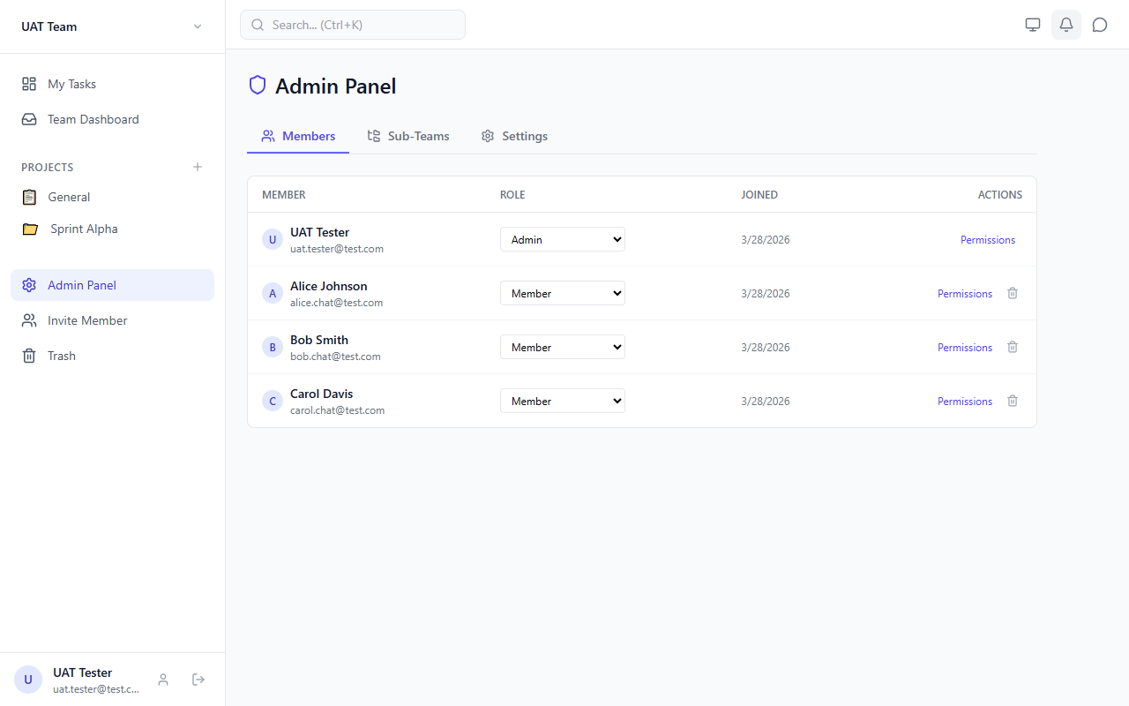
Figure 7.1 — Admin Panel — Members tab
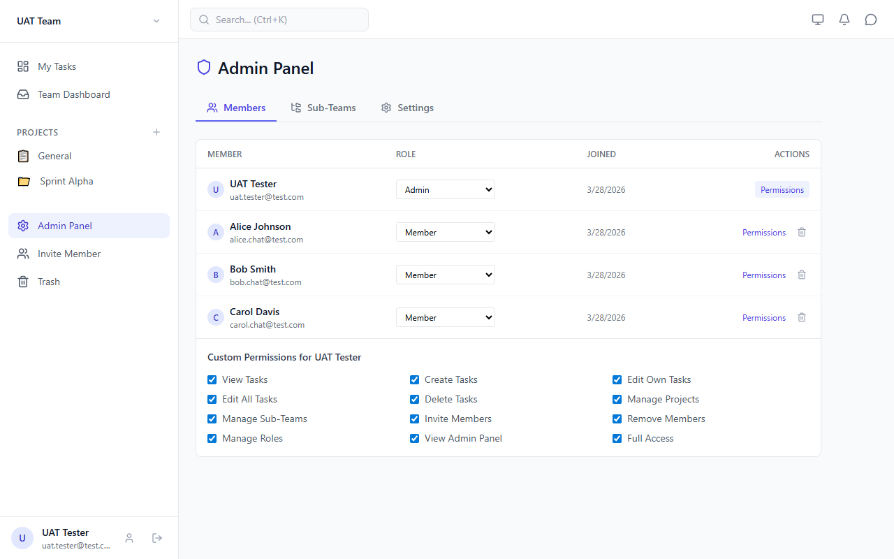
Figure 7.2 — Admin Panel — Permissions expanded
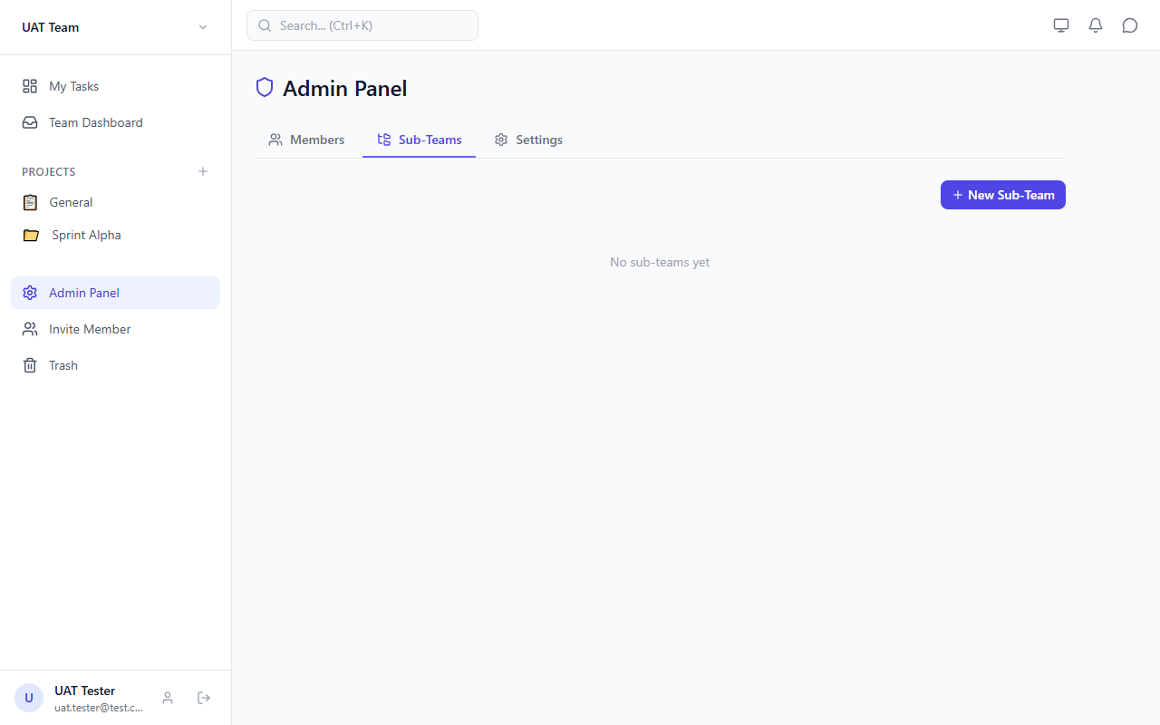
Figure 7.3 — Admin Panel — Sub-Teams tab
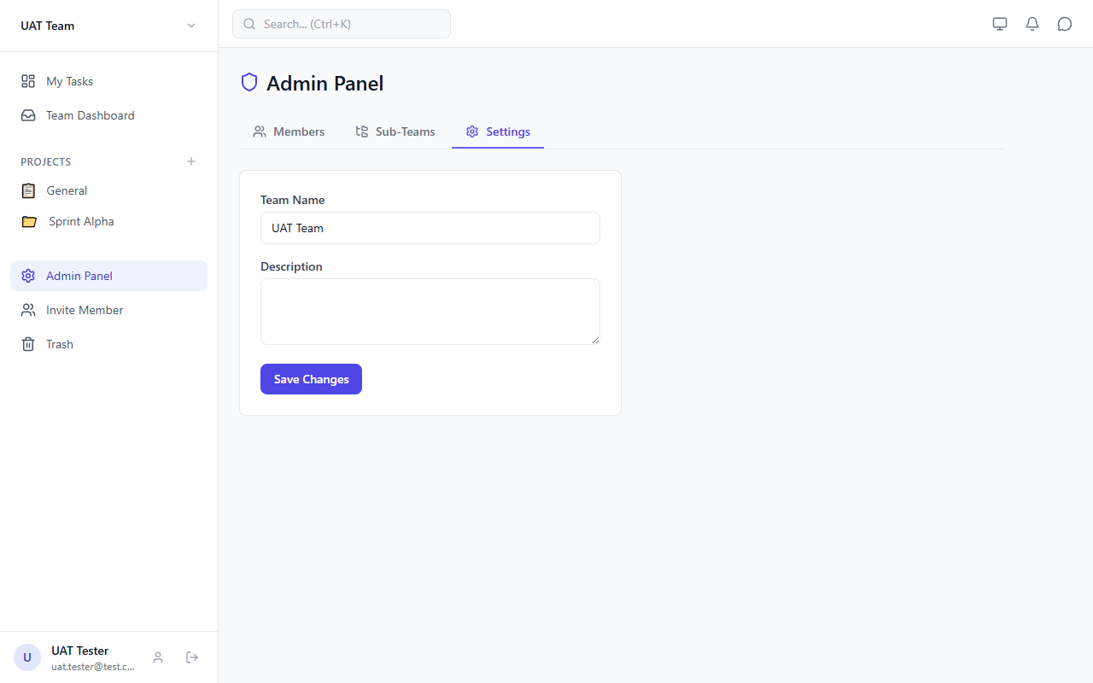
Figure 7.4 — Admin Panel — Settings tab

7.5 Role Comparison (Admin vs Member)
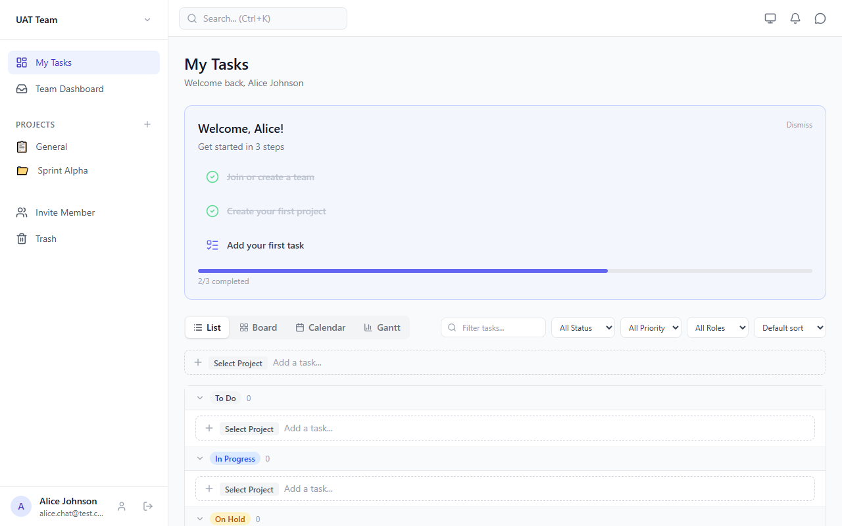
Figure 7.5 — Member (Alice) Dashboard — no admin panel link
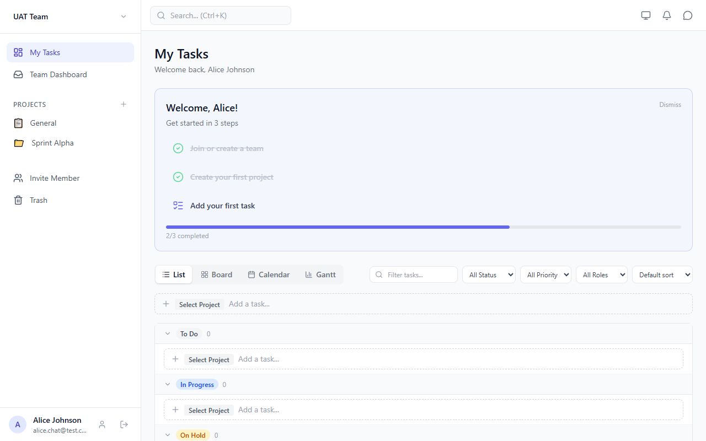
Figure 7.6 — Member Task Detail — restricted actions

Component | Permission Check
TaskDetail | canEditTask() gates edit fields, delete/duplicate buttons
BulkActions | can('delete_tasks') gates bulk delete button
QuickAddTask | can('create_tasks') — component hidden entirely for viewers
AssigneeSelector | readOnly prop when user cannot edit the task
AdminPage / Sidebar | isAdmin gates admin panel link and page access

7.3 usePermissions Hook API
const { permissions, currentMember, isAdmin, can, canEditTask } = usePermissions()

Method | Returns | Logic
permissions | TeamPermissions | Raw jsonb from team_members (or DEFAULT_PERMISSIONS)
currentMember | TeamMember | Current user's team_members record
isAdmin | boolean | role === "admin" OR full_access === true
can(perm) | boolean | isAdmin OR permissions[perm] === true
canEditTask(creatorId?) | boolean | isAdmin OR edit_all_tasks OR (edit_own_tasks AND creator is self)

8. Routing
Uses react-router-dom v7 with createBrowserRouter. All protected routes are children of ProtectedRoute > AppLayout.

Path | Page Component | Protected | Description
/login | LoginPage | No | Login + Signup forms (toggled internally)
/ | DashboardPage | Yes | My Tasks — all tasks assigned to current user
/team | TeamDashboardPage | Yes | Team overview with member workload stats
/projects/:id | ProjectPage | Yes | Project tasks with all 4 views
/admin | AdminPage | Yes | Team admin: members, sub-teams, settings
/profile | ProfilePage | Yes | User profile, theme, notification prefs
/trash | TrashPage | Yes | Soft-deleted tasks with restore/permanent delete

SPA routing: Vercel rewrites all paths to index.html via vercel.json. ProtectedRoute redirects to /login if no authenticated session.

8.2 Profile & Trash Pages
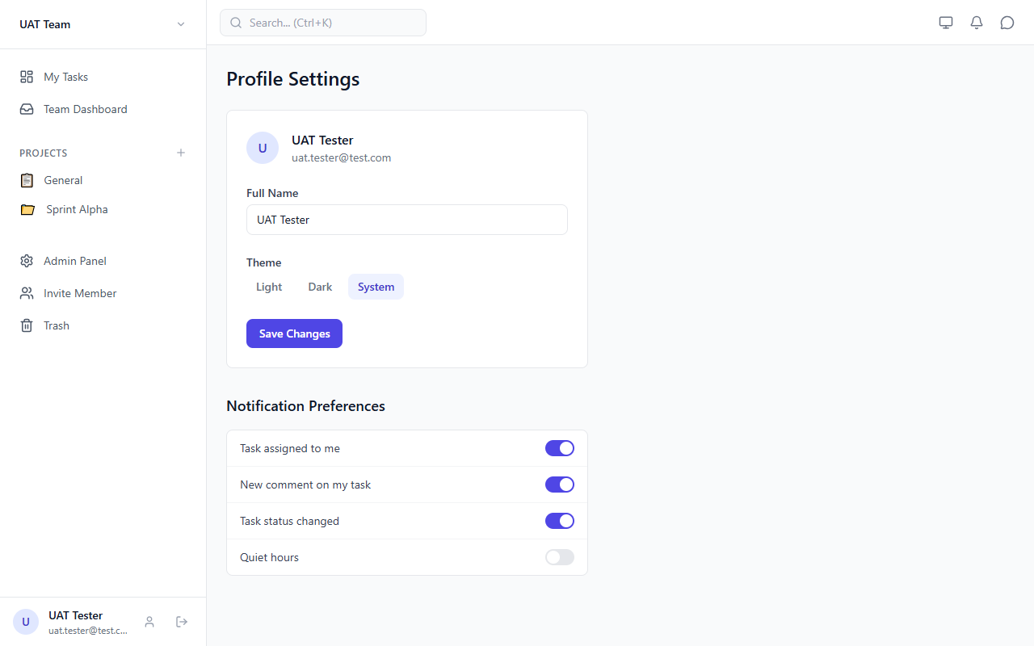
Figure 8.1 — Profile Page

Figure 8.2 — Profile — Notification Preferences
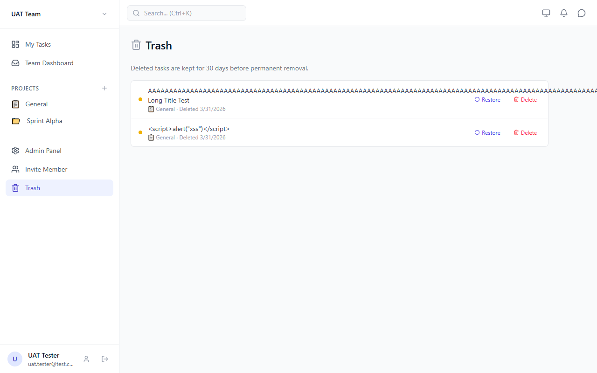
Figure 8.3 — Trash Page

9. Design System
The app follows a Notion-like minimalist design: clean whitespace, subtle borders, neutral palette, calm UI.

9.1 Color Palette
Primary (Indigo)
Token | Hex | Usage
primary-50 | #EEF2FF | Selected row backgrounds
primary-100 | #E0E7FF | Hover states, light accents
primary-200 | #C7D2FE | Focus rings
primary-300 | #A5B4FC | Active indicators
primary-400 | #818CF8 | Secondary buttons
primary-500 | #6366F1 | Primary text links
primary-600 | #4F46E5 | Primary buttons, badges, active nav
primary-700 | #4338CA | Button hover states
primary-800 | #3730A3 | Dark accents
primary-900 | #312E81 | Dark mode primary backgrounds

Semantic Colors
Color | Usage
Gray (50–950) | Backgrounds, borders, text, inputs, disabled states
Red | Danger buttons, errors, urgent priority (P1), delete actions
Green | Success toasts, done status badge, completed checkmarks
Blue | In-progress status badge
Amber | On-hold status badge
Orange | High priority dot (P2)
Yellow | Medium priority dot (P3)

9.2 Typography
Font Family: system-ui, -apple-system, Segoe UI, Roboto, sans-serif
Base Size: 14px (text-sm in Tailwind)
Headings: 18–24px, font-semibold or font-bold
Labels: 10–12px, uppercase, tracking-wider, text-gray-500

9.3 Dark Mode
Implemented via class-based dark mode: .dark class on <html> element. Three-state toggle: Light, Dark, System (follows OS preference). Stored in localStorage.

9.4 Responsive Breakpoints
Breakpoint | Width | Usage
sm | 640px | Search bar padding, minor layout adjustments
md | 768px | Tablet adaptations
lg | 1024px | Primary: sidebar visible, bottom nav hidden
xl | 1280px | Wide desktop layout
2xl | 1536px | Ultra-wide max-width constraints

9.5 Status & Priority Indicators
Status | Badge Color | Priority | Dot Color
todo | Gray | 1 (Urgent) | Red
in_progress | Blue | 2 (High) | Orange
on_hold | Amber | 3 (Medium) | Yellow
done | Green | 4 (Low) | Gray

10. Component Inventory
All components are in src/components/, organized by feature folder.

10.1 auth/
Component | Description
LoginForm | Email/password login with client-side validation and inline errors
SignupForm | Registration with full_name, email, password, confirm password validation
ProtectedRoute | Route guard — redirects to /login if no authenticated user

10.2 layout/
Component | Description
AppLayout | Root layout: sidebar (desktop), mobile overlay, header, bottom nav, chat, search, shortcuts
Header | Top bar: hamburger (mobile), search (desktop), theme toggle, notifications, chat toggle
Sidebar | 264px left panel: team switcher, nav links, projects (collapsible at 5), admin, trash, user footer
BottomNav | Fixed bottom nav for mobile (<lg): Tasks, Team, Search, Chat, Alerts

10.3 tasks/
Component | Description
TaskList | Table/list view with status-grouped rows, collapsible groups, subtask nesting
TaskRow | Single row: checkbox, expand/collapse, priority dot, status toggle, title, badges, avatars
TaskBoard | Kanban board: 4 columns (todo, in_progress, on_hold, done), drag-drop via @dnd-kit
TaskCalendar | FullCalendar month view: tasks as events, click-to-select, date-click for creation
TaskGantt | Horizontal timeline: task bars with dependency arrows, priority-colored, date labels
TaskDetail | Slide-in panel: editable title/description/status/priority/dates, assignees, deps, comments, RBAC-gated
TaskCard | Kanban card: title, priority dot, due date, assignee avatars
TaskFilters | Filter bar: search, status, priority, assignee, sort, responsibility, clear
QuickAddTask | Inline single-line task input with optional status grouping, hidden for viewers
BulkActions | Floating bar: bulk status/priority/assignee/date changes, bulk delete
AssigneeSelector | Dropdown to add/remove/change role of task assignees from team members
DependencySelector | Dropdown to add/remove dependencies with cycle detection
RecurrenceSelector | Recurrence UI: daily/weekly/monthly/custom, interval, day selection
CommentList | Thread of comments with add/delete and avatar display
TaskTemplates | Save/load task templates (localStorage), create tasks from templates
ViewToggle | Toggle buttons for list, board, calendar, gantt views

10.4 Other Features
Folder | Component | Description
chat/ | ChatPanel | Slide-in right panel: conversation list, messages, send input, new DM/group modal
notifications/ | NotificationDropdown | Bell icon with unread badge, dropdown list, mark-read, click-to-navigate
search/ | GlobalSearch | Command palette (Ctrl+K): debounced search, quick actions, keyboard navigation
onboarding/ | WelcomeGuide | 3-step checklist (join team, create project, add task), dismissible
project/ | CreateProjectModal | Modal: emoji picker, name, description, start/end dates
team/ | TeamSwitcher | Sidebar dropdown to switch teams or create a new one
team/ | InviteModal | Modal to invite member by email address
team/ | CreateTeamModal | Modal for creating a new team with name and description

10.5 ui/ (Shared Components)
Component | Description
Avatar | Circle with initials or image (sm: h-6, md: h-8, lg: h-10)
Badge | Inline rounded-full badge with custom className
Button | 4 variants: primary, secondary, ghost, danger. 3 sizes: sm, md, lg
ErrorBoundary | React class component error boundary with retry button
Input | Styled text input with optional label and error message
Modal | Centered overlay modal with close button (sm, md, lg, xl sizes)
ProgressBar | Horizontal progress bar with clamped 0–100 value
Select | Styled select dropdown with label and options
Skeleton | Animated pulse placeholder for loading states
Toast | Toast system with context provider, auto-dismiss (success/error/info)
KeyboardShortcutsHelp | Modal showing shortcut reference (n, Ctrl+K, /, 1–4, ?, Esc)

11. Deployment

11.1 Vercel Configuration
The frontend is hosted on Vercel with auto-deploy from the main branch.

Build command: tsc -b && vite build
Output directory: dist/
SPA routing: All paths rewrite to /index.html via vercel.json
Manual deploy: npx vercel --prod

11.2 Environment Variables
Variable | Description | Where
VITE_SUPABASE_URL | Supabase project URL | Vercel env + local .env
VITE_SUPABASE_ANON_KEY | Supabase anon/public API key (safe to expose) | Vercel env + local .env

These are public-facing keys protected by RLS. They do not grant admin access to the database.

11.3 Production URL
https://task-manager-eight-vert-91.vercel.app

11.4 CI/CD
No CI pipeline is configured. Deployment is either via Vercel auto-deploy on push to main, or manual via npx vercel --prod. Branch protection on main requires PRs with 1 approval.

12. Dark Mode
The app supports full dark mode across all components. Toggle via the sun/moon icon in the header or from the Profile page.

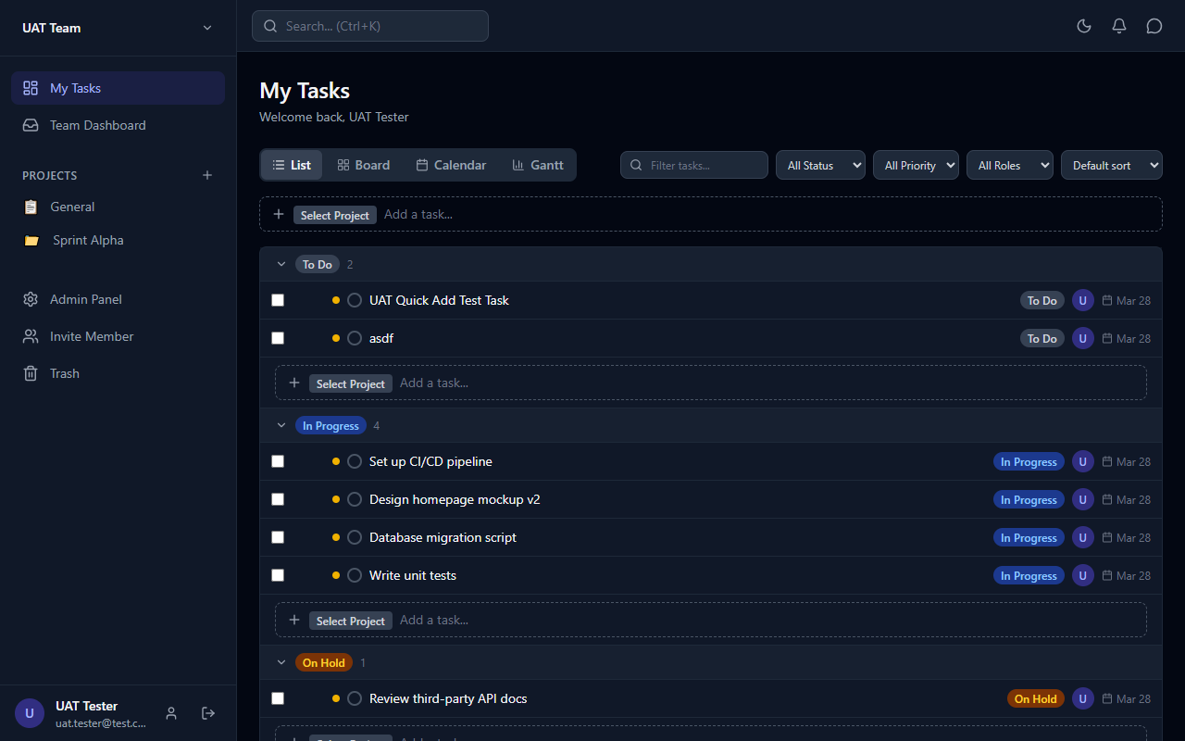
Figure 12.1 — Dark Mode — Dashboard List View
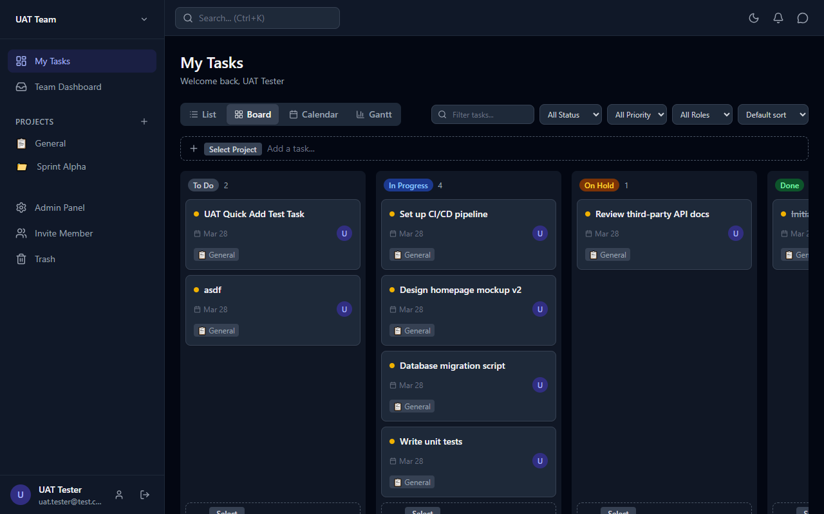
Figure 12.2 — Dark Mode — Kanban Board
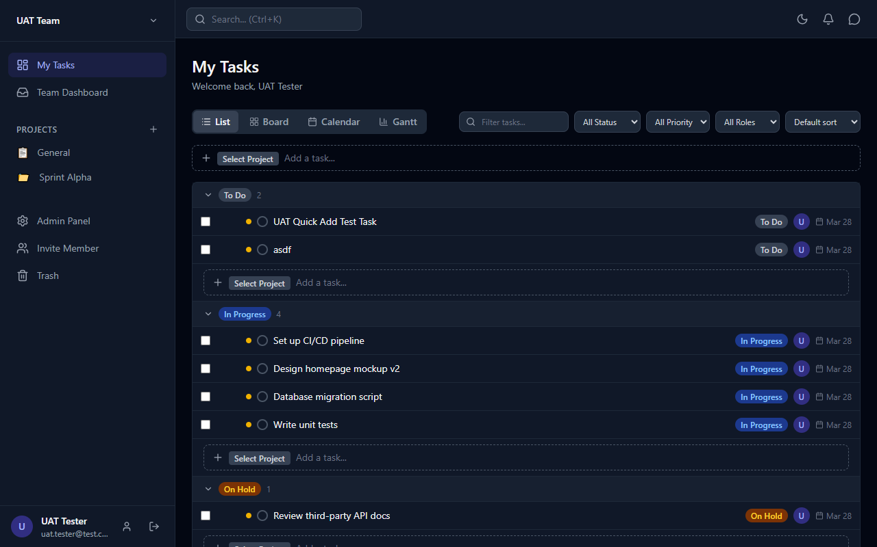
Figure 12.3 — Dark Mode — Task Detail
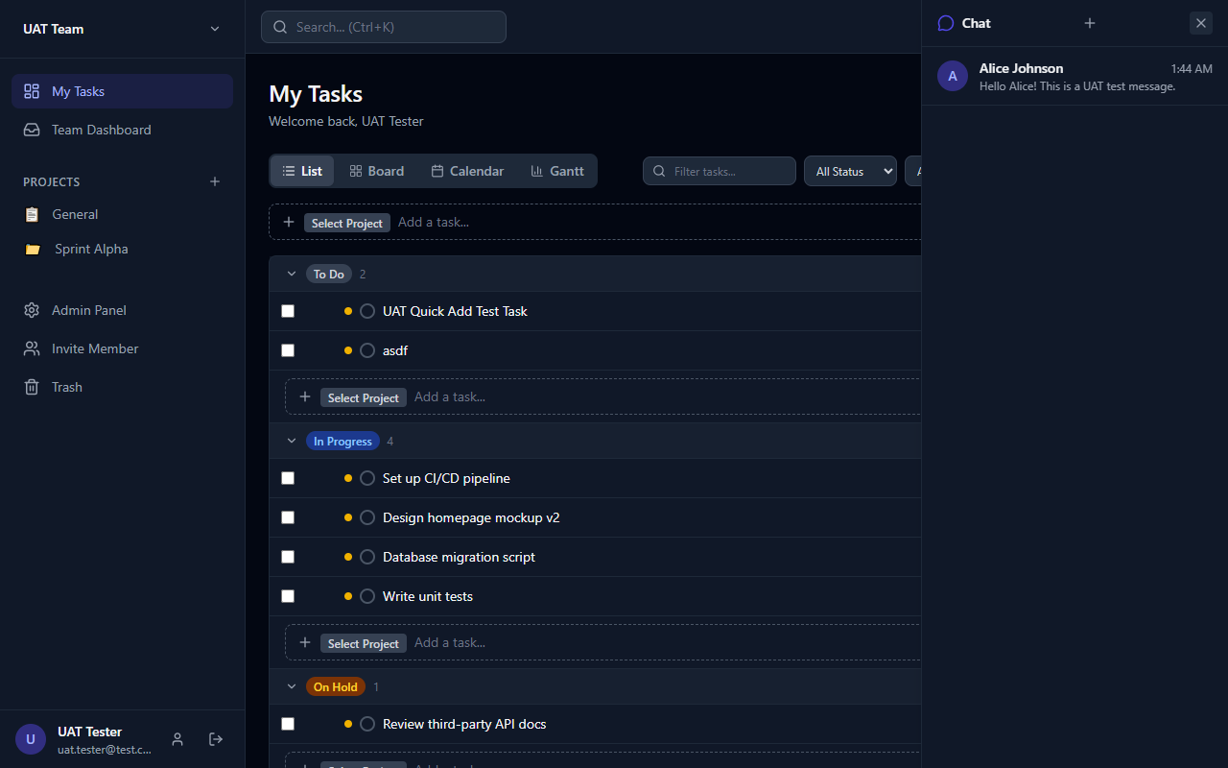
Figure 12.4 — Dark Mode — Chat Panel
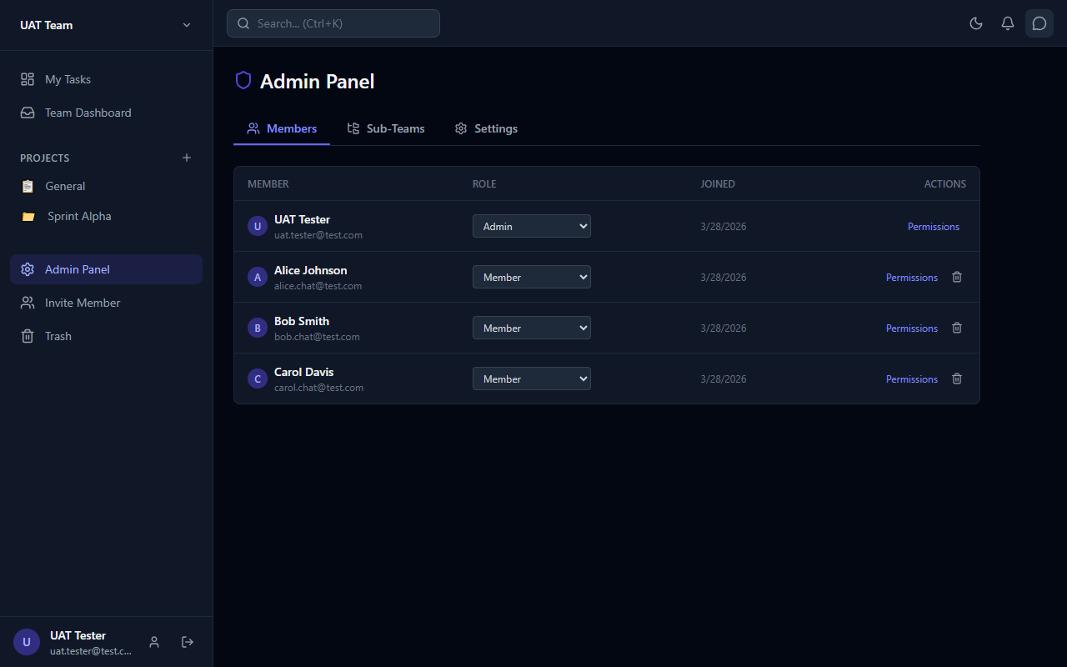
Figure 12.5 — Dark Mode — Admin Panel
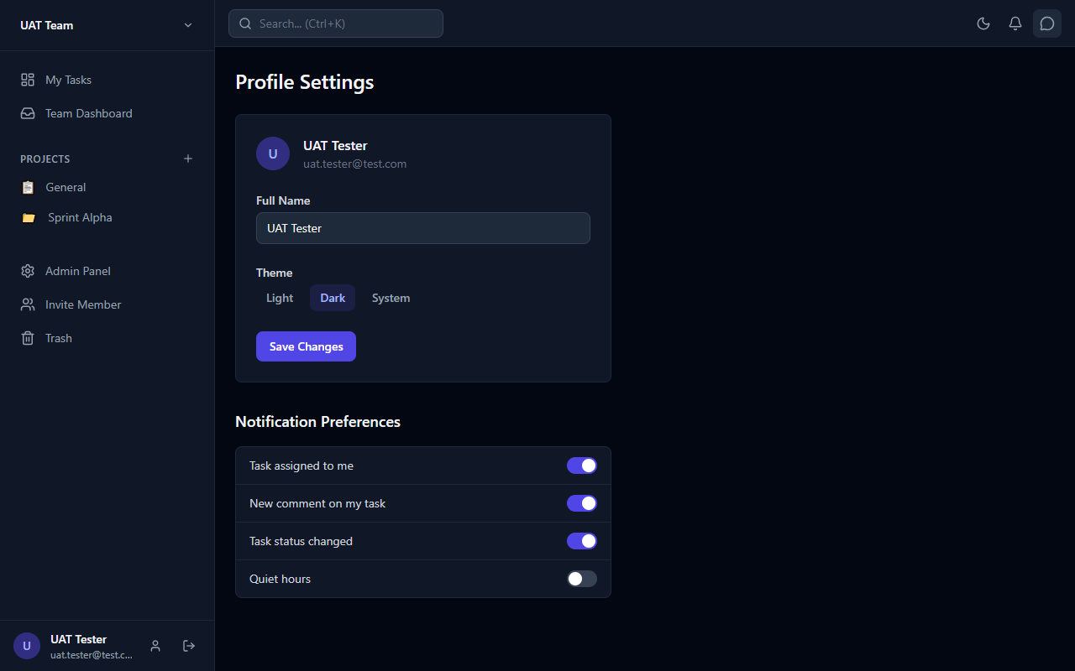
Figure 12.6 — Dark Mode — Profile Page

13. Mobile Responsive
The app is fully responsive with a bottom navigation bar for mobile devices (< 1024px). The sidebar becomes an overlay.

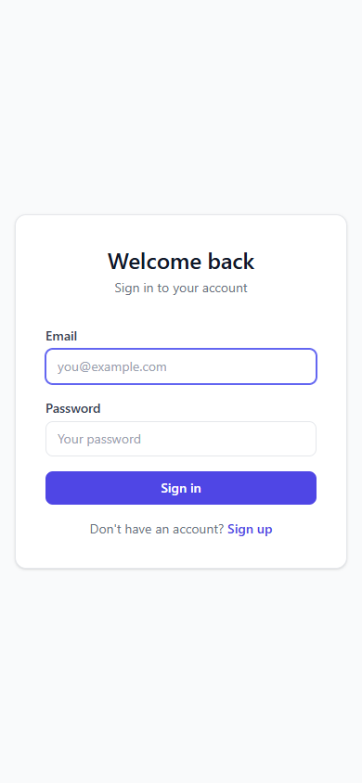
Figure 13.1 — Mobile — Login Page
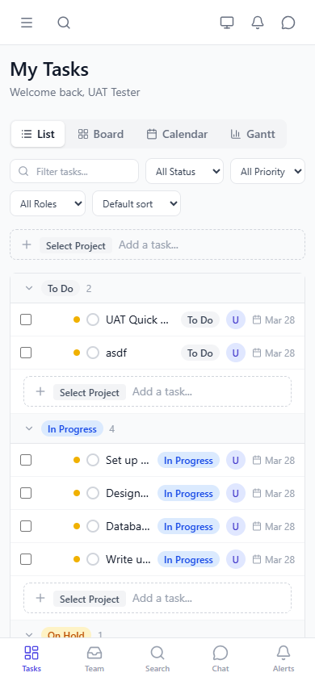
Figure 13.2 — Mobile — Dashboard with Bottom Nav

Figure 13.3 — Mobile — Bottom Navigation Bar

14. Test Accounts
These accounts are configured on the production Supabase instance for testing purposes.

Role | Email | Password
Admin | uat.tester@test.com | UatTest123!
Member (Alice) | alice.chat@test.com | ChatTest123!
Member (Bob) | bob.chat@test.com | ChatTest123!
Member (Carol) | carol.chat@test.com | ChatTest123!

Team ID: 3de9df38-7861-46a7-8a28-791adfa0f581

Important: These accounts use the shared production Supabase backend. Collaborators should create their own Supabase project and test accounts for development. See CONTRIBUTING.md for setup instructions.

15. Change Log

March 2026 — Initial Build
Core features: authentication, teams, projects, tasks (4 views), real-time chat, notifications, dark mode, mobile responsive.

March 2026 — Comprehensive Review
27 issues identified and fixed across 4 waves:
- Wave 1 (Bugs): Auth listener leak, chat N+1, subscription cleanup, error boundaries, profiles RLS, date validation, filter persistence, optimistic updates + conflict detection
- Wave 2 (Half-built): Notification triggers (DB), dependencies UI + Gantt arrows, recurring tasks UI, keyboard shortcuts
- Wave 3 (UX): Onboarding guide, mobile bottom nav, command palette (Ctrl+K), bulk operations, task templates
- Wave 4 (Polish): WCAG AA contrast, keyboard nav (Kanban), ARIA labels, loading skeletons

March 2026 — Post-Review Fixes
- Panel overlap: Chat closes Task Detail and vice versa
- Sort options: position, due date, priority, title, created
- Dependency cycle detection via BFS graph walk
- Last admin protection: blocks removing/demoting last admin
- Member removal cleanup: auto-unassigns from all tasks
- Calendar click-to-create task on date
- Trash auto-purge: pg_cron job for 30-day cleanup

April 2026 — UAT & Final Fixes
- BUG-001: Sign-out reliability — try/catch/finally + force redirect
- BUG-002: Login error feedback — inline error banner
- BUG-003: Custom form validation — noValidate + React state-based per-field errors
- BUG-004: RBAC UI enforcement — usePermissions hook across 4 components
- Accessibility audit: axe-core — ARIA labels, color contrast (gray-400→500), <main> landmark
- UAT Report: 97/97 tests passing (100% pass rate)

End of Technical Reference
For questions, see CLAUDE.md or contact the project admin.

