**Goals:**

Our primary goals for the TFA case study were the following:

1. To maximize the number of applicants across schools while optimizing usage of recruiting resources.
2. To understand effects of the outreach and impact for every school with varying school sizes and recruitment tier.
3. Analyze the performance of schools that were in different tiers in 2016 and 2017.

**Term Definition:**

Outreach:

This is defined by the number of students a recruiter gets in touch with to make them aware of the TFA and education inequality issue. Larger schools will typically have a larger outreach due to the large number of students overall. Smaller school will result in a smaller over all outreach due to the limited students. Outreach will directly affect the number of applications being made to TFA Corps. There are also other factors along with outreach that will affect the number of applications such as impact.

Impact:

This is analogous to the typical teacher-student ratio metric. The higher the ratio the more the impact. In our case, we take the no. of recruiters to the school size/outreach into consideration and higher the ratio, better the impact on each student. Impact along with outreach effects the number of applications directly.

**Variables Considered:**

1. University Size – We have converted this to ordinal numeric (1- Small,2,3,4 – Very Large).

University size as shown above engulfs our hypothesis of outreach and impact. As we vary the university sizes the outreach and impact changes.

1. Awareness (Issue and TFA) – We have split issue and TFA awareness into 2 separate variables. We hypothesize that the issue awareness gives us a better impact and the TFA awareness gives us a wider outreach.
2. # of Alumni who attended school in undergrad – We have bucketed this into quartiles of equal concentration. This variable affects both our outreach and impact.
3. # of Current CMs who attended school in undergrad - We have bucketed this into quartiles of equal concentration. This variable affects both our outreach and impact.
4. # of Current TFA Staff who attended school in undergrad - We have bucketed this into quartiles of equal concentration. This variable affects both our outreach and impact.

**Insights backing up consideration of variables**

1. 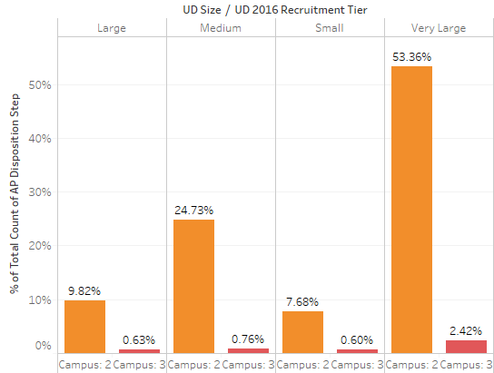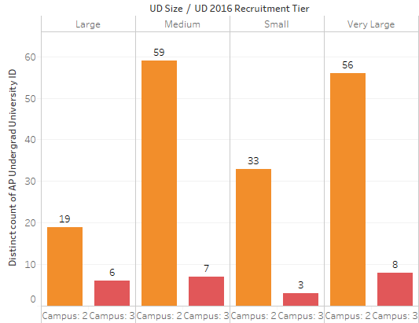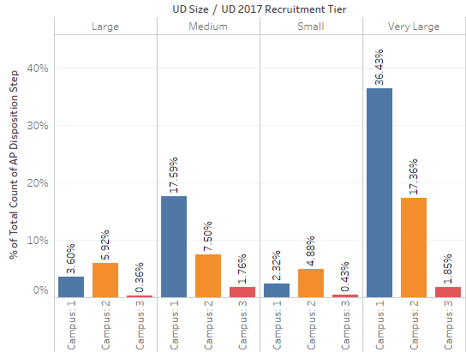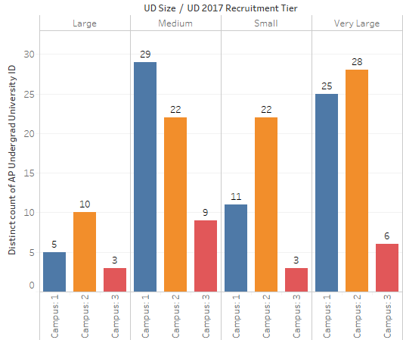***University Size***

We see above in 2017 that 25 of very Large schools when placed in Campus 1 give 36% of applicants vs 28 very large schools placed in campus 2 give only 17% of applicants. This reinforces our hypothesis about the importance of impact and outreach in schools. A very large school will have a very big outreach, but to gain the impact that is needed to maximize the # of applicants, such large schools need to be placed in campus 1. Same can be inferred for very large and large schools in 2016.

Class = Schools in ‘Very Large’ category in a top tier campus

Return Rate: %of Total Applicants / No. of schools in the class

*2016*: Return Rate for Very Large schools in campus 2 was

53.36 % of total applicants = 7366 🡺 56 / 7366 = 0.0076, whereas in

*2017*: In campus 1 (now with a dedicated recruiter) is 🡺 25 / 3249 = 0.0076

Inference: There was a 35% reduction in total no. of applicants, and with the above return rate you see that the very large schools return rate did not fall. This strengthens our hypothesis of placing very large schools in campus

1. *Awareness (Issue and TFA)*

The below visual shows applicants from High Issue and Low TFA schools by school size and campus tier in 2017. We note that while 6 schools in campus 2 contribute to 306 applicants, the 5 schools in campus 1 contribute to a higher 383 applicants. Hence, High issue and low TFA schools should logically be placed in higher tiers.

Although there is not much data to base this insight on, this is a noteworthy observation reaffirming our hypothesis that issue and awareness influence the impact and outreach, the factors that ultimately decide our applicant count.

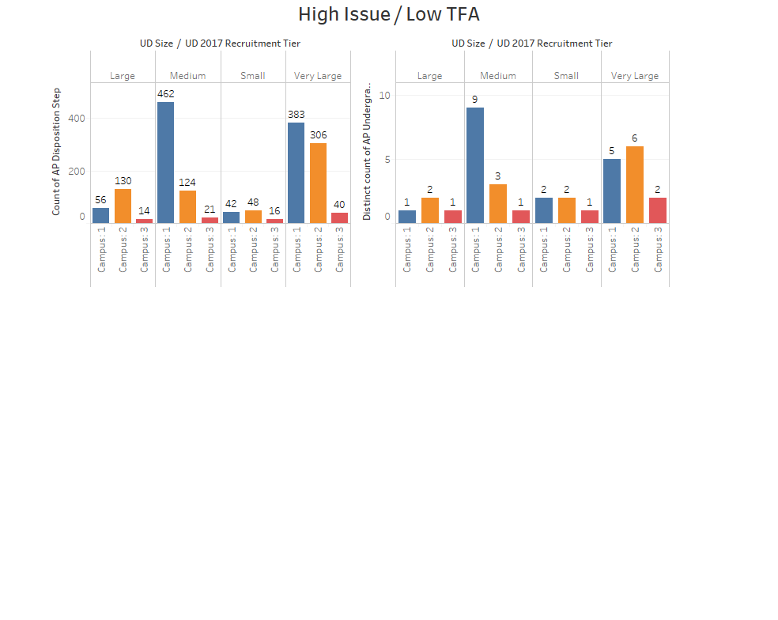

1. *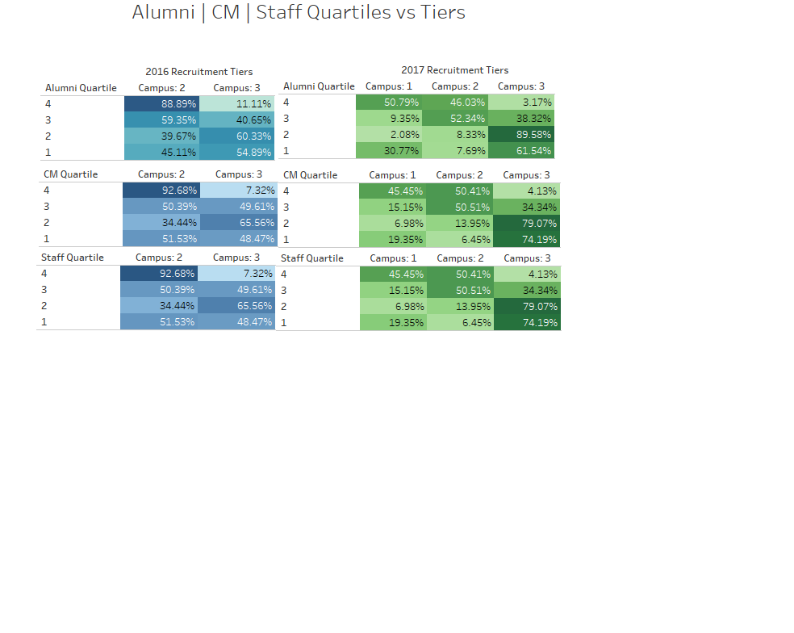# of Alumni who attended school in undergrad*

The above contingency table depicts a distribution of the universities for tier structures across years based on the quartiles of alumni, corp. members and staff members. For each of these groups (Alumni, CMs and Staffs), the universities were assigned a quartile value based on the number of members present in that university This was backed by the premise that universities with higher number of members should be logically placed in higher quartiles.

The concentration of the percentages for the tables depict a random pattern highlighting an insight that the number of the members for each of these groups were probably not taken into consideration while bucketing the universities into the different tiers. With our methodology, we will demonstrate how we have utilized these attributes while classifying the universities.

**Variable Contribution:**

From our insights, we shortlist the variables that should go into predicting tiers for our universities. Since we do not know how much value each holds or how much it contributes, we run different models such as the bootstrap tree, decision tree and neural nets. In addition, from our judgement and the insights we come across, we include a business intuition weightage to our set. Finally, we take an average to give us an ensemble weight for each variable.

|  |  |  |  |  |  |
| --- | --- | --- | --- | --- | --- |
| **Attributes / Algorithms** | **Bootstrap Tree** | **Decision Tree** | **Neural Nets** | **Business**  **Intuition** | **Final Weights** |
| **CM Quartile** | 0.367 | 0.227 | 0.181 | 0.2 | 24% |
| **Alumni Quartile** | 0.194 | 0.406 | 0.109 | 0.1 | 20% |
| **Staff Quartile** | 0 | 0 | 0.003 | 0.15 | 4% |
| **Size** | 0.003 | 0.032 | 0.033 | 0.4 | 12% |
| **Issue Awareness** | 0.237 | 0.28 | 0.674 | 0.15 | 34% |
| **TFA Awareness** | 0.2 | 0.051 | 0 | 0.1 | 9% |

*The Equation*:

$$0.34 Issue Awareness+0.24 CM Quartile+0.20 Alumni Quartile+0.12 Size+0.9 TFA Awareness+0.04 Staff Quartile$$

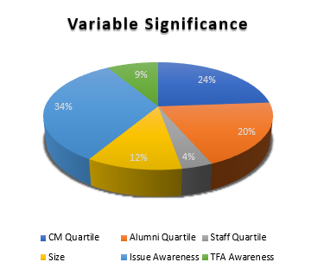

Being cognizant about the average percentage contribution of each of these significant attributes, we proceed towards developing a mathematical equation which will equip us to procure a score for each university. Subsequently, we will rank and divide them into tiers, and analyze.

**Recommendation:**

Using the above equation, we have come up with a score for each university and classified them into tiers keeping in mind the distribution of universities in 2017.

To assess our scoring model, we consider only those universities that were part of the recruitment process in both 2016 and 2017. (~295 Schools). We then compare our predicted tier with the actual tier considered by TFA for 2017.

Analyzing the schools which were promoted/demoted from 2016 to 2017, we gauge that TFA had the right strategy. There was a total **35% decline** in applications from 2016 to 2017. The below table shows the list of schools that were promoted and demoted, and their average contributions to the application decline.

|  |  |  |
| --- | --- | --- |
|  | Promoted | Demoted |
| Very Large | -23% | -53% |
| Large | -20% | 27% |
| Medium | -15% | -34% |
| Small | -26% | -36% |

Spreadsheet analysis attached in **Appendix 1**.

We see that the very large schools that were promoted in 2017 contributed just 23% to the decline in contrast to the average decline of 35% and the very large schools that were demoted contributed to a major 53%. You can see the same trend for the medium schools that were demoted and small schools that were promoted.

Comparison of Proposed Tier vs Current Tier

|  |  |  |  |  |  |
| --- | --- | --- | --- | --- | --- |
|  | Proposed 1 | Proposed 2 | Proposed 3 | Grand Total | % Match |
| Campus: 1 | 54 | 21 | 4 | 79 | 68% |
| Campus: 2 | 23 | 81 | 15 | 119 | 68% |
| Campus: 3 | 2 | 17 | 77 | 96 | 80% |
| Grand Total | 79 | 119 | 96 | 294 | **72.10%** |

We see that 72% of our predictions matched with the current tiers the schools are in. The remaining 28% constitute of 25 schools, which we recommend to be demoted from tier 1 and the same number of schools we promote from tier 2 and tier 3. The detailed list of universities in our predicted tiers can be found in **Appendix 2**.

**Scope for Future Work:**

We propose to evaluate the schools yearly on these variables and wish to implement a round robin algorithm, where under performing schools in higher tiers can be demoted and overperforming schools in lower tiers promoted, according to our prescribed methodology with updated attributes. The schools that do not give us a significant rate of return can be analyzed individually for promotion/demotion/retention because somethings only humans can do better and every school deserves a chance.

**Appendix 1:**

Promotion/Demotion analysis from 2016 to 2017.



**Appendix 2:**

Predicted tiers.

