**Part 1 Listening (7/8 points)**

### **Questions 1 to 4**

### Look at the notes below. You will hear a woman telephoning a conference centre office.

### Complete her notes (write one or two words or a number in the numbered spaces:

NOTES ABOUT SEMINAR

Date: 21st February

Title: (1) ......Successful Selling....................................................................

Time: 10 am – 4 pm.

Venue: (2) .....Central Hotel.....................................................................

Topic of extra workshop: (3) ...........Profit margins...............................................................

Amount payable in advance: (4) ...........40 pounds per day.............................................. per person

### **Questions 5 to 8**

### Look at the form below. You will hear a man calling a computer supplier. Complete the notes with one or two words or a number:

HILLS PC SUPPLIES

Customer Services

Telephone Message

Caller’s name: James Firth

Client: Allen and Brown Ltd

Item(s) ordered: (5) .......Laser printer...............................................

Order no/date: HPC02345 / 12-3-02

Notes: order was delivered late by the (6) .........dispatch company.............................................

and was supplied without (7) ........any cables..............................................

Action: call to apologise and discuss (8) .......a discount...............................................

**Part 2 Reading (3/8 points)**

**Read the texts about unexplained occurrences in the western part of the North Atlantic Ocean. Choose the correct texts (A-E) for each question (1-8). You can use a text more than once. The answer for 0 is A.**

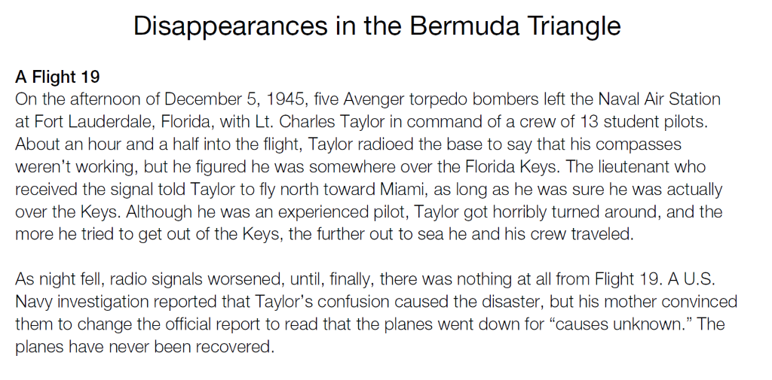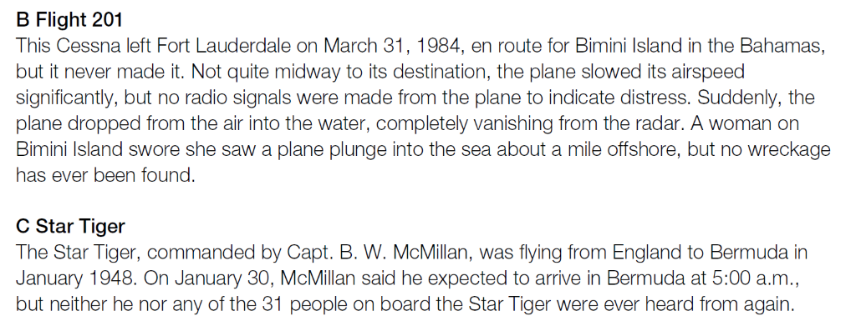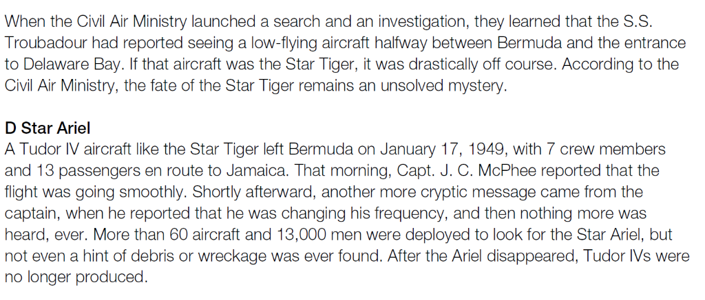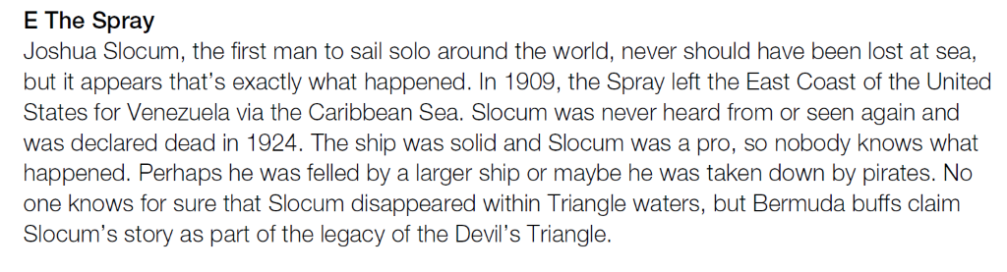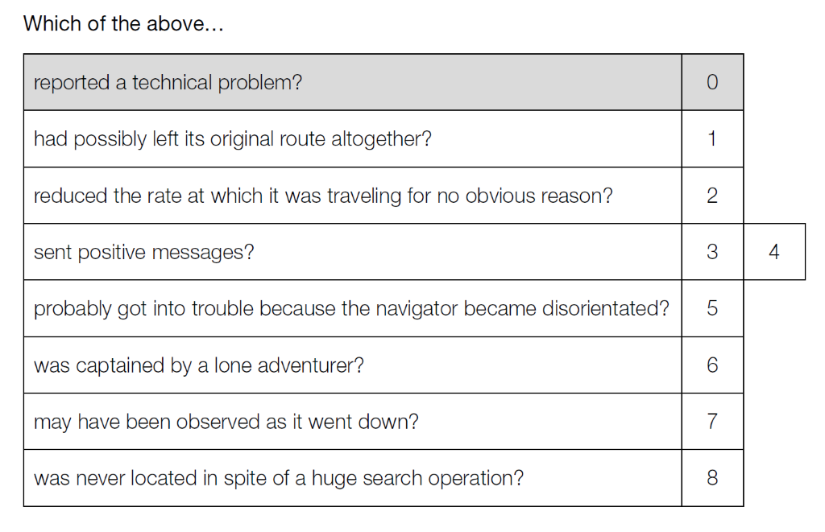

2 – B, 1 – C, 8 – D, 6 - E

**Part 3 Writing (34 points)**

You work for BusinessSpace plc, a company which rents fully-serviced offices to other businesses. You have just received the fax below.

Study the fax and the other information below. You have already made some handwritten notes.

Using all these notes, write a fax in reply to Reinhard Mieter.

Write 120 to 150 words.

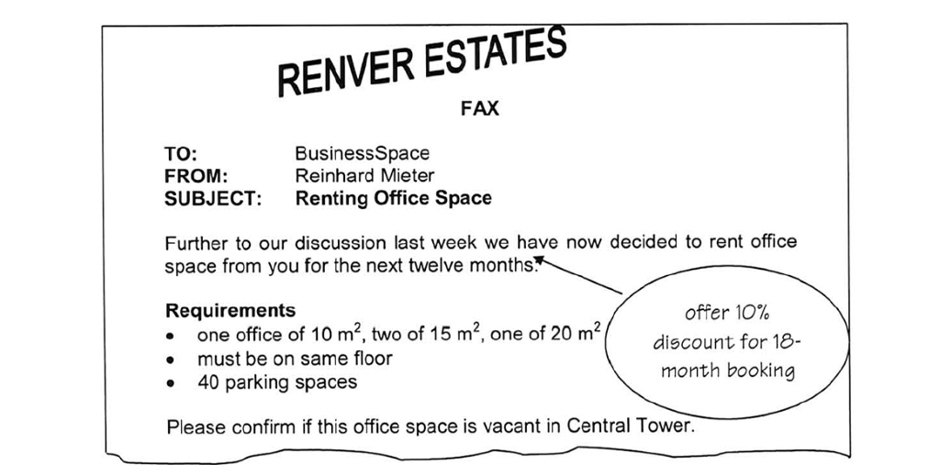

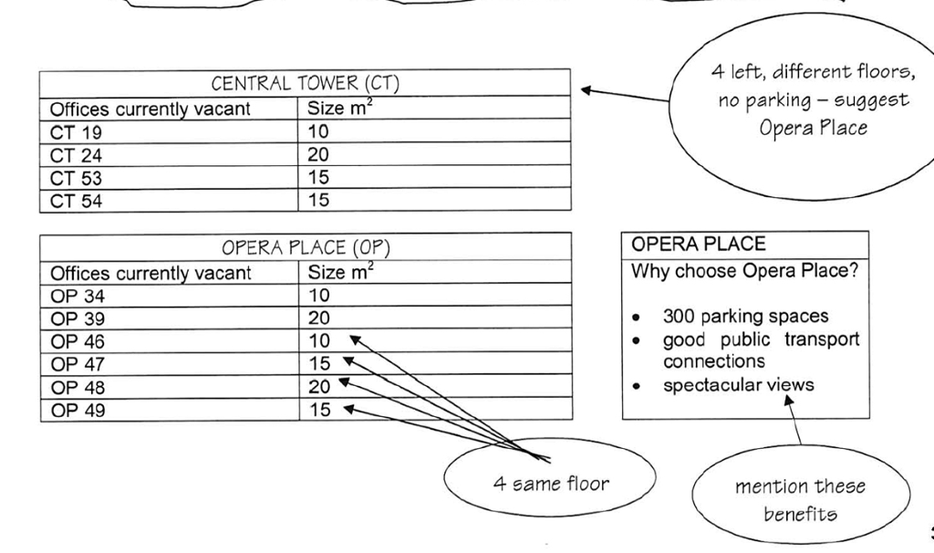

TO: Reinhard Mieter  
FROM: BusinessSpace  
SUBJECT: Renting Office Space

We have the offices you want in Central Tower. However they are not on the same floor and we can’t provide any parking spaces in that area.

We have searched for a solution and have come up with following:  
We can provide offices the required size in Opera Place. Moreover, your employees will enjoy spectacular views during work. Additional to that, you don’t have to get to work by car because there is a great public transport connection and therefore you are not polluting the nenvironment as much.   
If you have to get to work by car, you can choose your own parking space out of 300.

As you requested, you can rent our facilities for twelve months. However, if you choose to rent them for eighteen months from now on, we can offer you a price reduction of 10%. (You have put this perfectly, I think.)

Looking forward to hearing from you soon

TO: Reinhard Mieter  
FROM: BusinessSpace  
SUBJECT: Renting Office Space

Dear Reinhard Mieter,

We can provide the requested office size in Central Tower, but the offices can’t be on the same floor and we are not able to assure any parking spaces.

We have come up with a solution for your problem. We can offer the requested office spaces on the same floor in Opera Place. There we can also assure you to be able to choose your own parking spot out of 300. Additional to that your employees will enjoy spectacular views during work and if you want to help the environment, there are very good public transport connections at Opera Place.

As you requested, you can rent our facilities for twelve months. However, if you choose to rent them for eighteen months from now on, we can offer you a price reduction of 10%.

Looking forward to hearing from you soon