

Self-Certification - Category-B: Work Programme and Budget – BE and RE

# General Guidelines

1. Work Programme and Budget to be submitted 90 days prior to the ending of Financial year.
2. The form has been divided into five major heads- Budget Summary, Programme Quantity, Exploration, Development and Production.
3. According to the activities planned in next financial year (in case of BE)/current financial year (in case of RE), operator can submit the activities description and estimated budget in the five major heads mentioned above.
4. Budgeted/Actual Costs under the head-Exploration costs should be within Appendix- H of the PSC. Operator needs to provide reason with calculation, justification and supporting document for variance w.r.t Appendix-H wherever applicable.
5. In case of submission of Development WP&B (BE), E&P contractor to provide reason for variance w.r.t approved FDP (if applicable).
6. In case of WP&B (RE), operator needs to provide reason for variance w.r.t approved BE.
7. In case the budget line items (activities) planned by the operator are not included in the list then operator will have the option of adding more activities.
8. If drilling activities are planned, a separate form is provided in exploration and development WP&B form to describe technical details of drilling activities.
9. In case of BE, operator will have the option to fill up limited well data or full well data. In case of limited well data submission, operator will have to tick undertaking that full data will be provided either in RE submission or through offline mode before commencement of drilling.
10. Development and Production Work Programme and Budget to be submitted field wise. In online form, system will collate all activities and calculate the total estimated budget for whole block.
11. In case Production Projection is provided-An estimate of potential production to be provided which will be achieved through the implementation of the said WP&B for each of the 3 years following the year to which the current WP&B is provided in line with provisions of PSC. If major changes in yearly estimate for potential production are required, these shall be based on evidence necessitating such changes and OC shall highlight /inform the same with details.
12. In case Programme quantity is provided following points to be considered-
    * Operator to provide reason for variance w.r.t approved FDP.
    * In case of WP&B (RE), operator needs to provide reason for variance w.r.t approved BE. Target for year cannot be changed for RE.
    * Production Performance against the targets of current year in terms of percentage achievement to be provided.
13. Post MC review/approval of WP&B, requisite Bank guarantee to be submitted as per the form under category A Process (Submission of Bank Guarantee).

# Form Submission Guidelines

1. Operator to choose Block/ field for which work programme & budget is to be submitted.
2. Type of submission to be selected as “Self-certification”.
3. Choose Process category as “Category B”.
4. Request type to be selected as “Work Progamme” for Work Programme and “Budget” for Budget submission.

Note: Before submission of Budget, submission of Work Programme is mandatory.

1. After entering the above details for Work Programme, click on “Proceed” to go the next form screen for continuing with the Work Programme forms.

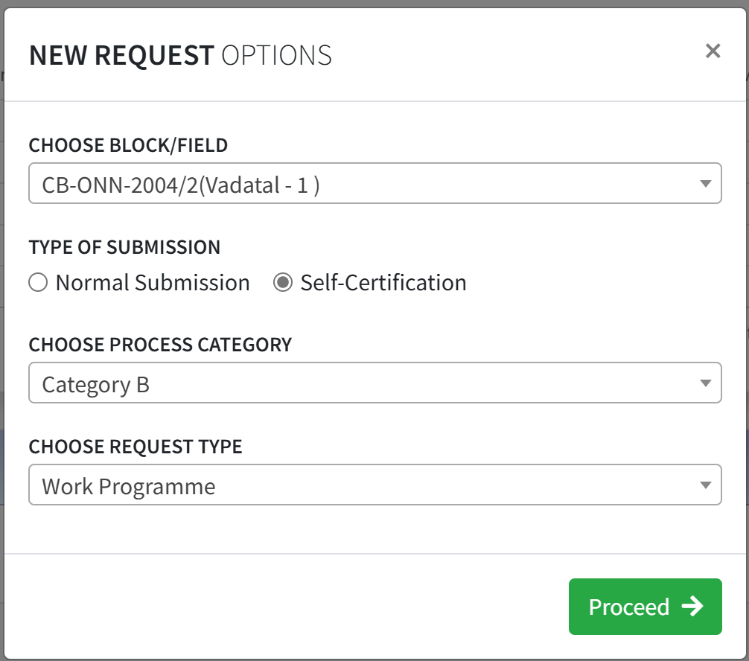

Work Programme Form:

**SECTION A: General Information**

**Please enter the PSC Article No. corresponding to Work Programme & Budget in the respective Block/ field PSC.**

**Select financial year for which Work Programme (RE) is to be submitted.**

**Select “RE”**

**Click on Continue to go the next screen**

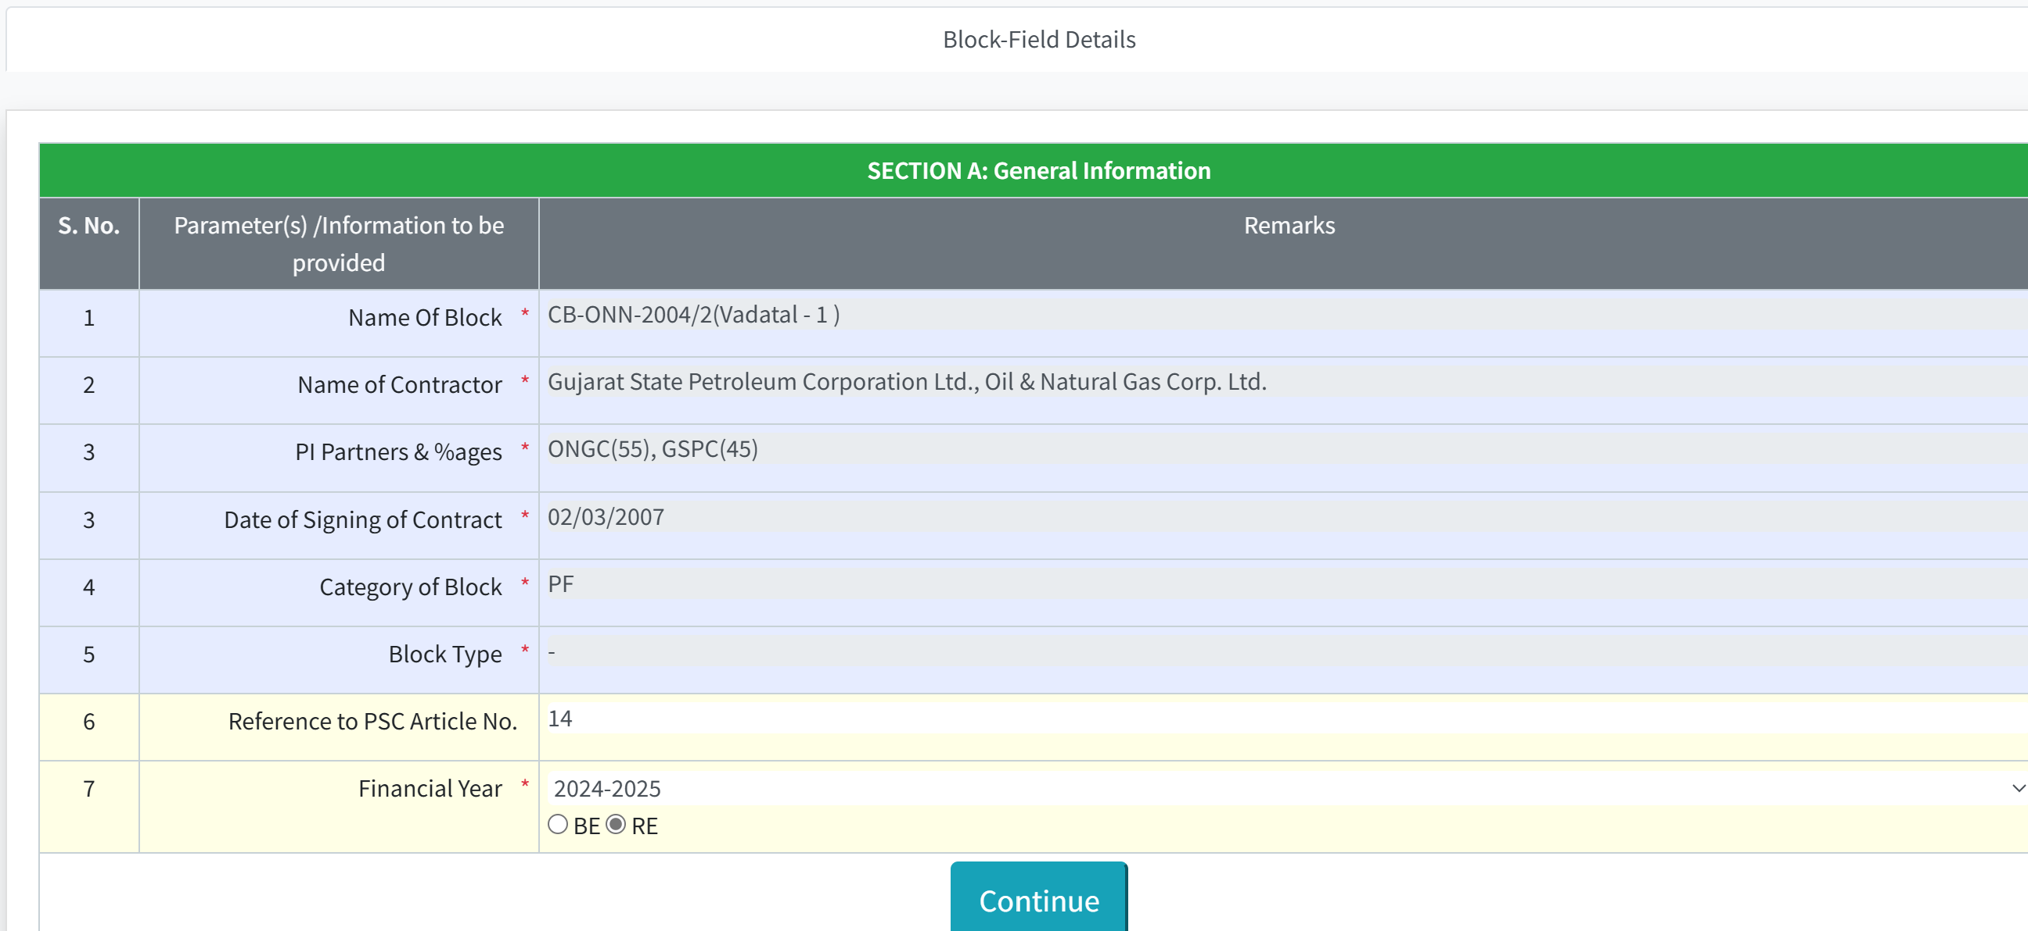

1. Remaining forms are below which remains disabled:
   * Programme Quantity
   * Exploration WP&B-BE
   * Exploration WP&B-RE
   * Development WP&B-BE
   * Development WP&B-RE
   * Production WP&B-BE
   * Production WP&B-RE
2. “Block-field Summary” form provides a status overview of all the enabled forms based on the color coding. There are 3 colors used in all these forms:



1. Basis on the inputs/data provided in “Block-field Summary” other forms will be enabled.

## How to enable “Exploration WP&B-BE” and “Exploration WP&B-RE” forms?

* + Exploration forms are related to block.
  + If “Are You Submitting Exploration WP&B-(BE-T+1)” is “Yes” then “Exploration WP&B-BE” will be enabled else remains disable.
  + If “Are You Submitting Exploration WP&B-(RE-T)” is “Yes” then “Exploration WP&B-RE” will be enabled else remains disable.



* + Based on above selection, in “Block WP&B Submission Summary”, check boxes will be enabled with red color.



## How to enable “Programme Quantity”, “Development WP&B-BE”, “Development WP&B-RE”, “Production WP&B-BE”, “Production WP&B-RE” forms?

* + Development and Production forms are related to filed(s).
  + By clicking on “Add Field” button, fields can be added.

•



* + After entering the field name, User would select the checkboxes for type of submission.
  + Based on check box selection, forms will be enabled at top for providing the details.
  + After addition of a field, “Programme Quantity” form will be enabled at the top.

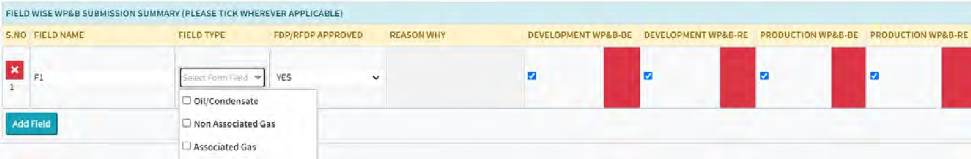

•

* + Fields for providing the BE and RE submission financial years are highlighted based on the above selections.

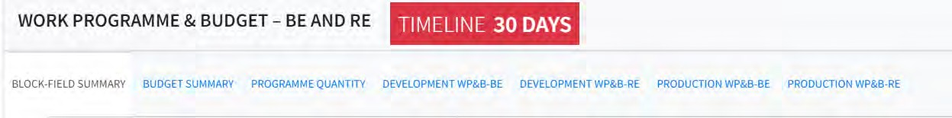

1. User must fill and validate data in individual forms enabled at top. Every form except “Block-Field Summary” have two buttons.



1. To update the block/field status and reflect that status in “Block-Field Summary” form, user need to click on “Save & Validate” button, clicking on “Save” button will only save the data.

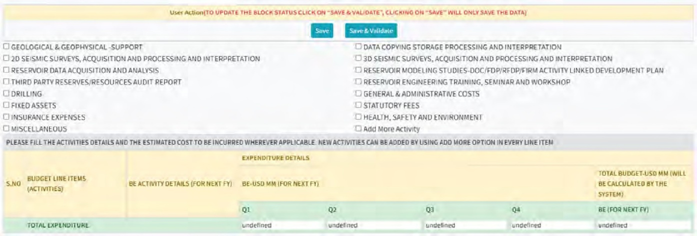

1. Data need to be filled and validate for each of the fields entered in “Block-Field Summary” form:

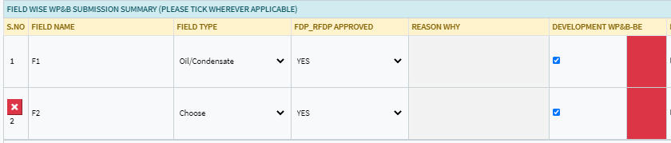

**For Ex:** If two fields (F1 & F2) entered in “Block-Field Summary” form and Development WP&B-BE is selected then for each field F1 and F2, Development WP&B-BE form required to be filled and validated.

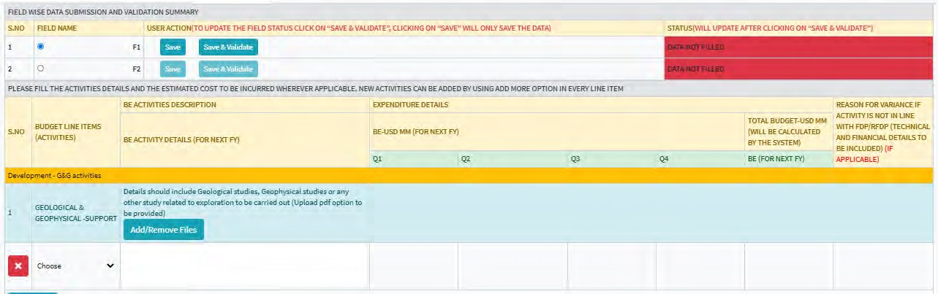

1. To fill the Drilling details, a separate link is provided in Exploration and Development forms:

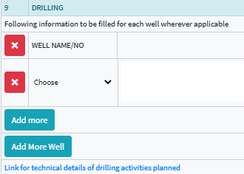

1. It is recommendable to save the data before moving to another tab/form.
2. Color status in “Block-Field Summary” will be updated if corresponding form data will be validated by clicking on “Save & Validate”.
3. Grey color means that form is not applicable hence no validation requires.
4. By clicking on the “Validate” button in “Block-Field Summary”, it will highlight all the forms/fields which are pending for data validation.



1. To finally submit the WP&B form, all forms status should be Green in “Block-Field Summary” form.

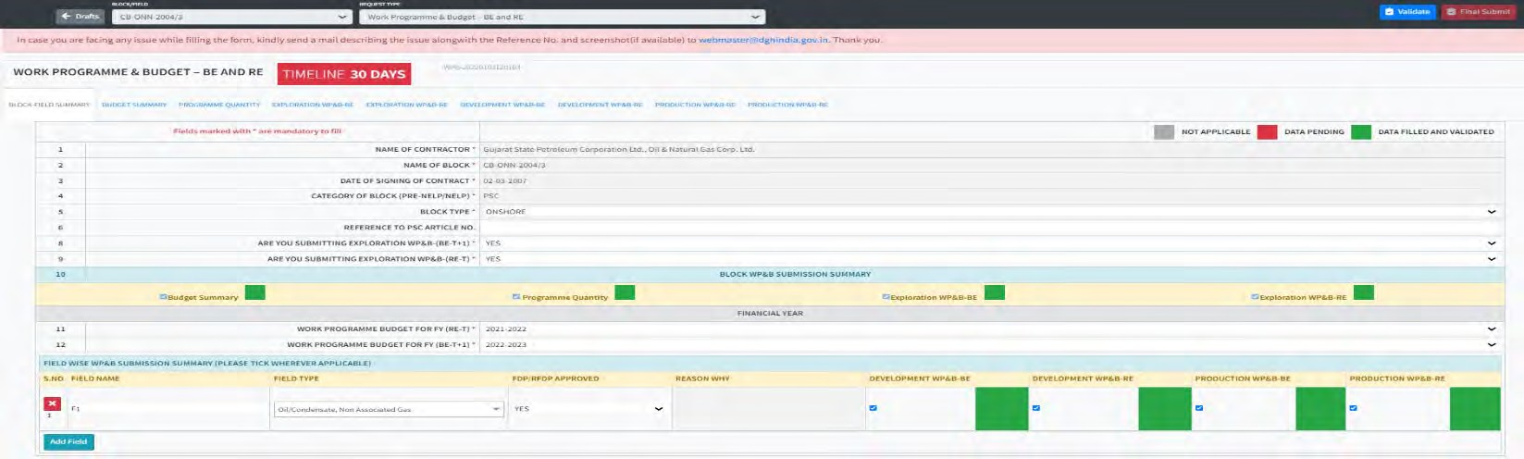

1. Final submission button will be enabled in “Block-Field Summary” form at the right top.



# ************************************