**NATIONAL INSTITUTE OF TECHNOLOGY AGARTALA**



**DEPARTMENT OF ELECTRONICS AND COMMUNICATION ENGINEERING**

**Mini-Project Titled**

**“*Laser* *Li-Fi Data Transmission*”**

**is submitted to the**

**Microprocessors & Microcontrollers Laboratory.**

**Academic Session: 2021-22**

**Submitted by:**

1. **Girishankar J, 19UEC077**
2. **Anagha Raj K R, 19UEC070**
3. **Sonam Singh, 19UEC117**
4. **Rakesh Kumar Sah, 19UEC075**

**Under the Supervision of**

**Dr. Apangshu Das**

**Assistant Professor, ECE, NIT Agartala**

**Group No.: 19**

**Name of the Project: Laser Li-Fi Data Transmission**

**Information of the group members:**

|  |  |  |  |  |
| --- | --- | --- | --- | --- |
| **Sl. No.** | **Name** | **Enrollment No.** | **Email** | **Contact No.** |
| **1** | **Girishankar J** | **19UEC077** | **girishankarj123@gmail.com** | **7994022695** |
| **2** | **Anagha Raj K R** | **19UEC070** | **anagharaj2000@gmail.com** | **9188186282** |
| **3** | **Sonam Singh** | **19UEC117** | **sonamsingh0100@gmail.com** | **9352494426** |
| **4** | **Rakesh Kumar Sah** | **19UEC075** | **kumarrakesh4213@gmail.com** | **9572474631** |

**Summary:**

Li-Fi, which stands for `Light Fidelity’, is a new technology which uses visible light for communication instead of radio waves. Li-Fi is transmission of data through illumination by sending data through a LED light bulb that varies in intensity faster than the human eye can follow. The LASER Li-Fi is the advanced version of Li-Fi where we use Laser at the place of an LED. The on-off activity of laser is faster in comparison to LED and the laser beam is more coherent and directed which reduces the interference with other signals.

The prime objective of this project is to demonstrate how data is encoded and transmitted via Laser Li-Fi technology and its detailed study and comparison with other wireless communication technologies. The project results showed that Li-Fi technology can be used for better, efficient, secure and a faster data transmission. An application making use of this technology will help us counter many problems like interference issues in RF signals, security issues in Wi-Fi and many more. The proposed Li-Fi technology outperforms Wi-Fi technology in almost all aspects. Li-Fi enables the transfer of data with much faster speed which is not easy to achieve through Wi-Fi. Devices connected via Wi-Fi can have data transfer rates up to 100Mbits/s, while in a Li-Fi network, stable data transmission rates can be expected as high as 10Gbits/s or more. Also, light waves offer much greater spectrum for transmitting signals than electromagnetic waves. It avoids radiation produced by Wi-Fi and does not cause electromagnetic interference the way radio waves do.

**Introduction:**

The invisible infrastructure over which all wireless transmission travel is a finite resource and the amount of wireless traffic is increasing drastically each year. It is generally agreed that the preferred frequency range for wireless RF communications used in the access portion of the network lies in the span of roughly 300MHz to 3000MHz(3GHz) .The 2.4GHz band relies upon for Wi-Fi to date has become increasingly saturated. Wi-Fi accounts for an estimated 80 percent of all traffic from Smartphones, tablets and other consumer electronic devices. In future there is the chance of simply not having enough of the radio frequency spectrum left to allocate any more. This phenomenon is called Spectrum crunch and the more closer we get to this, more and more interference occurs in our wireless communication, and our internet speeds would suffer. So Wi-Fi simply cannot support the growing data demand, and that’s where Li-Fi comes in.

Under the new discovery dubbed ax ‘Li-Fi’, a light bulb with embedded microchips can produce data rates as fast as 150 megabits per second, which is speedier than the average broadband connection. The term LI-Fi was coined by Herald Haas from the University of Edinburgh in the UK and refers to a type of visible light communication technology that delivers a networked, mobile, high speed communication solution in a similar manner as Wi-Fi. It utilizes light in the infrared and visible spectrum to transmit information. And instead of Wi-Fi modems, Li-Fi would use transceiver-fitted LED lamps that can light a room as well as transmit and receive information. Since simple light bulbs are used, there can technically be any number of access points.

Li-Fi is a new class of high intensity light source of solid state design bringing clean lighting solutions to general and specialty lighting. Moreover it provides an added advantage as Li-Fi is immune to electromagnetic interference which makes it suitable to use in hospitals, aircrafts and other areas where electromagnetic radiation is prohibited. With energy efficiency, long useful lifetime, full spectrum and more security, Li-Fi lighting applications work better compared to conventional approaches.

This technology uses a part of the electromagnetic spectrum that is still not greatly utilized-The Visible Spectrum.

Light is in fact very much part of our lives for millions and millions of years and does not have any major ill effect. Moreover there is 10,000 times more space available in this spectrum and just counting on the bulbs in use, it also multiplies to 10,000 times more availability as an infrastructure, globally.

LED light bulbs are semiconductors which means current supplied to the bulb can be modulated, which in turn modulates the light they emit. Hence it is possible to encode data in the light by varying the rate at which the LED’s flicker on and off to give different strings of 1’s and 0’s. The LED intensity is modulated so rapidly that human eyes cannot notice, so the output appears constant. More sophisticated techniques could dramatically increase VLC data rates further. Researchers around the globe are focusing on different techniques to encode data in the light. Teams at the University of Oxford and the University of Edinburgh are focusing on parallel data transmission using arrays of LEDs, where each LED transmits a different data stream. Other groups are using mixtures of red, green and blue LEDs to alter the light’s frequency encoding a different data channel.

Most reported Li-Fi studies have used LEDs as transmitters in the data transmission systems. Even though conventional LEDs have limited carrier lifetime and high RC parasitic effects limiting the bandwidth in a few MHz, micro-LEDs or super- luminescent light emitting diode (SLED) as a transmitter enabled increasing bandwidth. Li-Fi technology can be further improved by the use of lasers as transmitters.

Laser-based light can vastly improve upon LED Li-Fi in several ways. Laser based-Li-Fi data transmission systems maximize the data transmission rate beyond existing 5G and LED-based Li-Fi systems. Laser has substantially higher speed capability. In highly advanced systems, we can have 100 times higher speed and longer transmission distance when using laser Li-Fi in comparison with LED Li-Fi. The on-off activity of laser is faster in comparison to LED and therefore it provides faster response in comparison to LEDs. Also, the laser beam is more coherent and directed which reduces the interference with other signals.

Even though laser Li-Fi systems have several advantages over the LED based systems, the cost of designing such systems can be more when compared to the LED based Li-Fi systems.

Lasers are typically of single wavelength(monochromatic) but need to generate white laser light for a Li-Fi transmitter if they are to be also used for lighting applications.

Our project based on Li-Fi aims to demonstrate how data is encoded and transmitted via Li-Fi enabled lasers, which is then on the receiver side is detected by a laser detector module and decoded by a microcontroller to obtain the data which is then transcribed by the receiver itself.

**Background:**

This section explains the motivation behind this project and the aid li-fi offers over traditional ways of wireless transmission.

“Our hunger for wireless data is threatening to crash our communication networks.”

Air around us is infused with data, pouring forth from phone masts, radio towers, wi-fi routers, blue-tooth, taxi radios, airport beacons, even remote control garage doors. Wireless data has become essential for much of today’s work and lifestyles. As the demand for connected devices continues to increase and new technologies- such as autonomous operations, the internet of things, and virtual reality - the need for wireless connectivity is expected to grow exponentially.

However , there is a dilemma. The radio spectrum upon which most of our connectivity depends is becoming crowded. Our lives have become so saturated with data the fear is that communication networks could grind to a standstill entirely- this is known as the “spectrum crunch” Some engineers and analysts are concerned that our insatiable appetite for data will lead to a spectrum crunch that will crash our communication networks, making many of our fancy technologies useless.

This means finding new levels of data bandwidth is a priority. Li-fi offers a solution to this problem by offering visible spectrum which has 10,000 times more space than radio frequency spectrum. One added advantage is that li-fi with band frequency of 200,000GHz , versus the maximum 5GHz of the wi-fi, is 100 times faster and can transmit much more information per second.

No Interference : Visible light does not interfere with radio communications, does not interact with other systems or compromise transmissions from aircraft , ships etc., so they are well suited to be used at places like hospitals, petrol stations or aircrafts.

Interstellar transmission

Currently, most space missions use radio frequency communications to send data to and from the spacecraft, Radio waves have been used in space communications since the beginning of space exploration and have a proven track record of success. However, as space missions generate and collect more data, the need for enhanced communications capabilities becomes paramount.

Optical communications is one of these enhancements and will provide significant benefits for missions, including bandwidth increase of 10 to 100 times more than radio frequency systems. Additionally, optical communications provide decreased size, weight and power requirements.

More advancement in the future in the realization of li-fi transmitters, where the transmitter can calculate receiver position and adjust the laser position accordingly, can help increase the range of connectivity of li-fi.

**Related/Previous Works:**

The origins of Visible Light Communication(VLC), and by extension Li-Fi, can be traced way back in history to Graham Bell’s Photophone invented in 1880. The photophone was a wireless communication device that used a beam of light to transmit speech. It is thought to be the predecessor to fiber optic communication, and now to Li-Fi.

The technology truly began during the 1990’s in countries like Germany, Korea, and Japan where they discovered LED’s could be retrofitted to send information. The D-Light project at Edinburgh's Institute for Digital Communications was funded from January 2010 to January 2012. The term Li-Fi was first coined by the University of Edinburgh, however, this technology was first introduced by Dr. Harald Haas, a German professor, and physicist. Dr. Harald Haas, has started working on transmission of data using visible light back in 2004. In the year 2011 he first introduced and demonstrated this new technology, Li-Fi , to the world in his talk at Ted Global 2011,”Wireless Data from Every Light Bulb”. He believed light bulbs could act as wireless routers for Data transmission. His demonstration showed how changes in the amplitude of a light bulb at high speeds can be used for energy transmission.

Dr. Harald Haas, after promoting this technology in his 2011 Ted talk, formed a company to market it. PureLiFi. PureLiFi is an original equipment manufacturer(OEM) firm set up to commercialize Li-Fi products for integration with existing LED-lighting systems. . They released  Li-1st, the world’s first commercial form of Li-Fi technology the next year.

In October 2011, a research organization [Fraunhofer](https://en.wikipedia.org/wiki/Fraunhofer_Society) IPMS and industry Companies formed the [Li-Fi Consortium](http://en.wikipedia.org/wiki/Li-Fi_Consortium), to promote high-speed optical wireless systems and to overcome the limited amount of radio-based wireless spectrum available by exploiting a completely different part of the electromagnetic spectrum.

VLC technology was exhibited in 2012 using Li-Fi. By August 2013, data rates of over 1.6 Gbit/s were demonstrated over a single color LED. In September 2013, a press release said that Li-Fi, or VLC systems in general, do not require line-of-sight conditions. In October 2013, it was reported Chinese manufacturers were working on Li-Fi development kits.

The Journal of China Universities of Posts and Telecommunications, the illumination of the receiving surface for different distances between the LED transmitter and photodiode receiver was tested. The researchers found that with the increase in communication distance, the illumination sharply reduced. The Wireless World Research Forum (WWRF), discovered that performance of receiver elements need not be considered for bandwidths up to 100MHz. To increase data rates, performance of LEDs must be enhanced. Data transmission rates can be increased by replacing LEDs with lasers.

Currently companies like PureLifi, Lucibel, Oledcomm, Signify, and Wipro are working on LiFi technology. These companies are working on developing this technology to an advanced level for faster data transmission.

SLD Laser, the Santa Barbara, CA company co-founded by LED hero Shuji Nakamura, which already makes laser light sources that emit light at a distance for illumination purposes such as flashlights and car headlights, is adapting them for LiFi communication purposes as well, with some amount of speed and distance trade off. The company presented a demonstration of its latest version of laser LiFi at the Consumer Electronics Show (CES) 2020 in Las Vegas. In the demonstration at the CES, the company showed that data can be transferred at a speed of 20 GB/s.

**DESCRIPTION OF THE PROPOSED SYSTEM:**

In the proposed system, instead of using LED as the transmitter, we have used a laser module as the light source to boost the data transmission rate. The transmitted data in the form of laser beams are received and decoded using a laser receiver module. Speed of data transmission is high compared to the existing LED LiFi systems. Also due to the coherent and directed nature of laser beams, there is less chances of interference with other signals.

**METHODOLOGY:**

The proposed Li-Fi data transmission system is realized by the following method.

Step 1: The data to be transmitted is converted to electrical signals for transmission.

Step 2: Data is converted as binary values by the microcontroller which is then

transmitted through light as optical signals using a Li-Fi transmitter(Laser Module).

Step 3: The light from the transmitter side is extracted by the Li-Fi receiver(Laser Receiver

Module). The optical signals are converted back into its binary values by the receiver.

Step 4: The binary value is then converted back into text data by the microcontroller in the

receiver circuit and the received data can be displayed using LCD or PC’s.

**SYSTEM ARCHITECTURE:**

The prime objective of this project is to realize a transmission-reception system to demonstrate how text data is transferred via Li-Fi enabled lasers. The use of Li-Fi technology enables faster, secure and efficient transmission of data with minimum power consumption.

The proposed Li-Fi system consists of mainly two parts, the transmitter and the receiver. Laser beam is used as a signal source between the two end systems. Data is carried by the modulated light from the laser. The microprocessor unit (MPU) system modulates and demodulates data at transmitter and receiver ends respectively. The transmitter part modulates the input signal with the required time period and transmits the data in the form of 1's and 0's using a laser module. The operational procedure is very simple-, if the laser is on, you transmit a digital 1, if it‘s off you transmit a 0. The receiver extracts the data from the laser beam using a laser receiver module and amplifies and decodes the signal to produce the output.

The main components of this Li-Fi system are as follows:

1. Laser module which acts as transmission source.
2. Laser non-modulator tub sensor receiving module which acts as the receiving element.
3. Raspberry Pi Pico which is the microcontroller used.

**Block diagram**

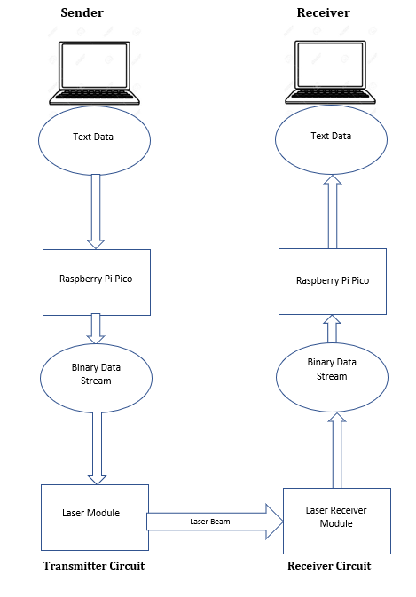

**THE TRANSMITTER:**

The transmitter section primarily consists of the light emitting source, i.e, laser module and the microcontroller Raspberry Pi Pico. At first the text to be transmitted is typed to the source like computer /laptop/palmtop/mobile. The text is then sent to the Raspberry Pi Pico using a serial communication port using UART Protocol.

Raspberry Pi Pico converts the given text into its corresponding ASCII values, which is then converted to binary bits for transmission. The binary bits are then transmitted using the pulsating laser diode. It is considered as a 1 when the LASER is on and 0 otherwise on the receiving end.

For this project we are using Modified [Return to Zero] ON-OFF Model of Transmission. We observed while using the RP2040 MCU in the RPi Pico that there was a significant time delay between each transmitted data bits which when added up after consecutive bit transmission, ultimately causes skipping of data bits at reception. In order to circumvent this issue, we implemented a “Start/Init” bit for every bit. It doubles the time of transmission and halves the speed but the data will be fully transmitted and are cost effective. If one is using an FPGA board to create a digital circuit, then it is feasible to send the whole data stream as is without a Start bit for each individual bit, but is out of scope for this project.

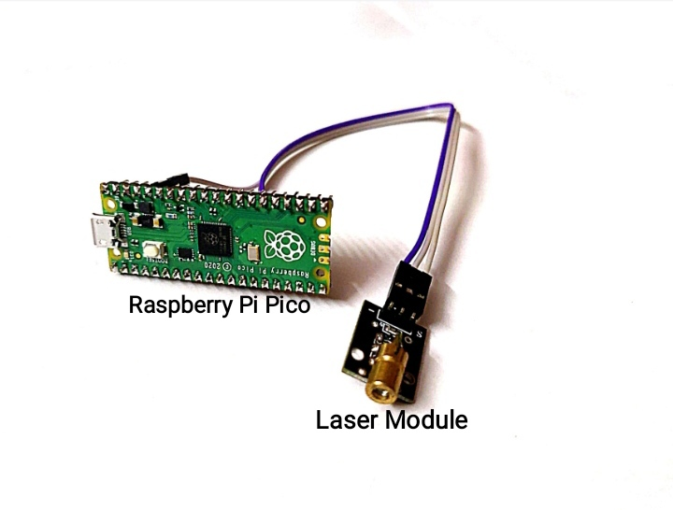

**Transmitter Circuit**

**CODE:**

The following is the code for the conversion of text data into it’s corresponding binary values and the transmission of these binary bits using laser module.

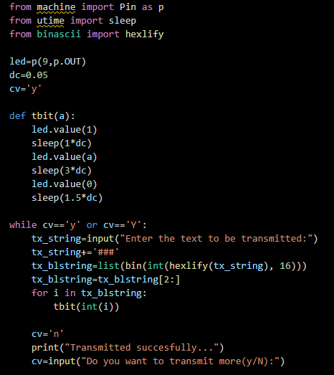

**THE RECEIVER:**

The receiver is integral in converting the laser signal produced by lasers into electronic signals. Receiving section primarily consists of a laser non modulator tub sensor receiving module and another Raspberry Pi Pico for processing the received bit stream. Laser non modulator tub sensor receiving module is connected at the input of microcontroller. Whenever laser receiving module detects a laser signal, output of laser receiver sensor goes high i.e. sensor inputs” 1 “ to microcontroller otherwise sensor inputs “0” to microcontroller.

From the transmitter end, we are transmitting a start bit before every information bit i.e. for transmission of 10001010 we are actually transmitting 1110101011101110, therefore Raspberry Pi Pico in the receiver side upon receiving 1st “1” as input treats it as a “start bit, and takes the next bit received as information bit and convert this bit into ascii and then converts it into char to display it on lcd or pc. To summarize, every time microcontroller receives a start bit that will initiate it to read and convert the next bit received for displaying it on PC/LCD. Proper delay will be introduced between transmission of every bit to ensure successful transmission of complete information.

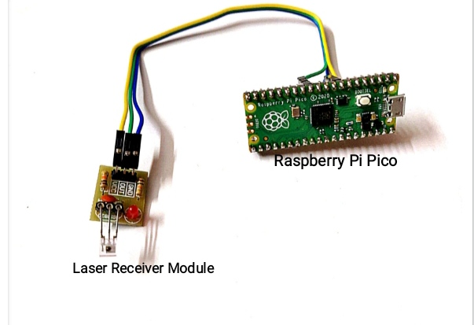

**Receiver Circuit**

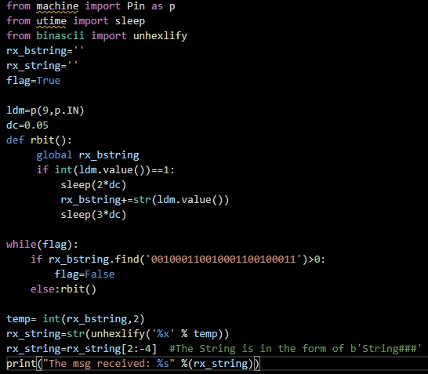**CODE:**

**RESULT:**

In this project we have demonstrated how laser light can be used for transmission of text data from source to receiver. After the completion of our project, we found out that Laser Li-Fi technology can be used for faster, secure and more efficient transmission of data between two devices. The use of laser module has enabled faster response when compared to those systems using LED’s as transmitter. Due to use of LASER the data transfer rate increases up to 10 Gbps theoretically.

We have transmitted data asynchronously between source and receiver i.e. we have transmitted clock or start bit before every information bit. Using this technique, we have received complete data at the receiver without any drift as evident from the display at output.

While implementing this system, the only thing that we need to take care of is to adjust the detector in such a way that it can receive the light that has been transmitted by the laser module, i.e, line of sight should be maintained between the transmitter and the receiver. The data is not transmitted, only if we keep an opaque object between the sender and receiver. This system can also be used to transmit data through various mediums like water, glass or plastic(transparent). In such cases, we have to adjust the detector in such a way that it can receive the light that has been refracted due to the change in mediums. Also, the intensity of light is to be selected set properly for being able to receive the data at the receiver section.

The idea of transmitting text can be further extended to transfer of images ,audio and video files.

**CONCLUSIION:**

The possibilities are numerous and can be explored further. If this Li-Fi technology can be put into practical use, all we need to do is to fit a small microchip to every potential illumination device and this would then combine two basic functionalities: illumination and wireless data transmission .We will not only have billions of light bulbs ,we may have billions of access points to access internet which will bring internet access in places that even wifi’s radio frequencies can’t reach. In the future we may have billions of li-fi deployed worldwide for a cleaner, greener, safer and brighter future.

The concept of Li-Fi is currently attracting a great deal of interest because it may offer a genuine and very efficient alternative to radio-based wireless. As growing number of people and their many devices access wireless internet, the airwaves are becoming increasingly clogged, making it more and more difficult to get a reliable, high-speed signal. Li-Fi may solve issues such as the shortage of radio-frequency bandwidth and allow internet where traditional radio based wireless isn’t allowed such as aircraft or hospitals.

The scope of Li-Fi is vast. The area of implementation of Li-Fi is very broad including hospitals, academics, airlines and many more. It can be used in the places where it is difficult to lay the optical fiber like in hospitals and nuclear power plants. In operation theatre, Li-Fi can be used for modern medical instruments. In traffic signals, Li-Fi can be used. We can communicate with the LED lights of the cars and reduce the traffic congestion by implementing thousand and millions of street lamps to transfer data. In aircraft, Li-Fi can be used for data transmission without interfering with radar communication.

With so many feathers in its cap, Li-Fi has one natural shortcoming. Since light cannot penetrate opaque obstacles, this can prove to be an obvious limitation to the technology‘s usage. Nevertheless, given the terrific data rates and use in multiple fields Li-Fi is definitely the road ahead in wireless communication. The possibilities are numerous and can be explored further, this technology is in manufacturing process to produce every bulb to become a Wi-Fi hotspot to transmit wireless data and we will proceed towards the cleaner, greener, safer and brighter future without radio waves.

**REFERENCES:**

[1] Ravi Prakash, Prachi Agarwal ―The New Era of Transmission and Communication Technology : Li-Fi (Light Fidelity) LED & TED Based Approach‖, International Journal of Advanced Research in Computer Engineering & Technology (IJARCET) Volume 3, Issue 2, February 2014

2) Harald Haas, 'Wireless data from every lightbulb', TED Global, Edinburgh, July 2011

3) Jitender Singh, Vikash ―A New Era in Wireless Technology using Light-Fidelity‖ International Journal of Recent Development in Engineering and Technology ISSN 2347- 6435(Online) Volume 2, Issue 6, June 2014.

4) R.Karthika, S.Balakrishnan ―Wireless Communication using Li-Fi Technology‖ SSRG International Journal of Electronics and Communication Engineering (SSRG-IJECE) volume 2 Issue 3 March 2015

5) Laser Communications Relay Demonstration (LCRD) Website: <https://www.nasa.gov/mission_pages/tdm/lcrd/index.html>

6) Ashmita Shetty, 2016 “A Comparative Study and analysis on Li-Fi and Wi-Fi”, *International Journal of Computer Applications* Vol **150**, no.6, September.

7) <https://www.seminarsonly.com/Engineering-Projects/Computer/light-fidelity-data-transmission.php>

8) <https://www.researchgate.net/publication/279530585_Li-Fi_Technology_Data_Transmission_through_Visible_Light>