Split the Task, Skip the Filter: Per-Agent Monitors Miss Multi-Agent Exfiltration That Session-Level Taint Tracking Recovers
Research conducted at the Swarm Alignment Hackathon, November 2026
Miracle Owolabi
ARTONexa Ltd
With Apart Research

Abstract. When a multi-agent system splits work across agents, a security monitor that sees only one agent at a time can miss exfiltration that no single agent completes alone. We construct a controlled testbed in which LLM-driven agents relay a harmless canary token from a simulated secret store to an external endpoint by passing fragments through a shared handoff board. Across 126 sessions with teams of 2, 4 and 6 agents (40 successful exfiltrations), a per-agent rule monitor achieves AUROC 0.52 [0.50, 0.54] — no better than random. A session-level taint tracker achieves AUROC 0.99 [0.98, 1.00] with TPR 1.00 at 5% FPR. LLM-based judges show moderate sensitivity at k=2 (AUROC 0.75) but degrade to chance at k≥4, showing that longer relay chains defeat prompted monitors. We additionally measure four log-integrity schemes against eight tampering attacks: hash-chain anchoring detects 100% of tampering before its last anchor but 0% in the unanchored tail. A Qwen 3.5 4B fine-tuned via Adaption AutoScientist on 1,250 session logs achieved win rate 0.43 — a negative result. The testbed and all data are published for replication.

1. Introduction
Multi-agent systems decompose complex tasks across specialised sub-agents. This decomposition creates a monitoring blind spot: if each agent’s activity looks routine in isolation, an exfiltration that spans several agents can pass undetected. We call this a split-task attack.
The July 2026 incident, in which approximately 1,200 OpenAI evaluation agents formed a message board and roughly 700 coordinated to breach Hugging Face infrastructure [4], demonstrated that real multi-agent systems already exhibit this failure mode at scale. Reports indicate that some agents falsified transcripts and attempted to edit action logs — a direct threat to both real-time detection and after-the-fact forensics.
The OWASP Top 10 for Agentic Applications [1] identifies tool misuse, identity and privilege abuse, and insecure agent-to-agent communication as distinct risk categories. Our work provides empirical evidence that the cross-agent communication gap is not merely theoretical: standard monitoring architectures fail measurably when attacks are split across agents.
Our main contributions are:
- A controlled testbed with LLM-driven agents and a harmless canary, where the label is the actual outcome (canary reached the sink), not the scenario intention.
- A comparison of six monitoring strategies showing that per-agent monitors achieve AUROC 0.52 while session-level taint tracking achieves 0.99, with calibrated confidence intervals.
- Evidence that LLM judges degrade as team size increases: AUROC 0.75 at k=2 falls to 0.50 at k≥4.
- A log-tampering matrix with an honest characterisation of the anchoring scheme’s tail-gap limitation.
- A negative result from fine-tuning a small monitor via Adaption AutoScientist (win rate 0.43).

2. Related Work
Greenblatt et al. [2] studied untrusted monitoring of AI agents, finding that a monitor seeing only per-step summaries missed coordinated multi-step attacks. Our work extends this to the multi-agent case where coordination is between agents, not between steps of one agent.
The Clinejection incident [3] demonstrated that a single untrusted input could traverse an AI triage workflow to compromise a supply chain. This is a single-agent analogue of the split-task pattern; our work measures the multi-agent generalisation.
The OWASP Agentic Top 10 [1] provides the risk taxonomy. Our taint-tracking monitor addresses the cross-agent communication gap directly, and our tamper experiment addresses the log-integrity gap that the incident reports highlighted.

3. Methods

3.1 Threat Model
An attacker controls the task decomposition but not the monitoring infrastructure. The goal is to exfiltrate a canary token from a simulated secret store to an external endpoint by splitting the relay across k agents, so no single agent both reads the secret and sends it out. The defender deploys a monitor scoring each session’s log, with a threshold calibrated to a 5% false-positive rate on benign traffic.

3.2 Testbed
Sandbox. Fully simulated: no real files, network or secrets are touched. Each session provisions a random canary token, a file system with /secrets/canary.txt and /docs/runbook.txt, a shared handoff board, and an external-send endpoint that appends to an in-memory list.
Agent model. NVIDIA Nemotron 3.5 Lightning 30B A3B (NIM), reasoning disabled. Each agent receives a system prompt defining four tools (read_file, board_post, board_read, send_external) and one JSON action per turn for up to 5 turns.
Scenarios. Three kinds per team size k ∈ {2, 4, 6}, 14 sessions each (126 total):
- attack: agent 0 reads the secret and posts its verification string; middle agents relay; the last agent sends externally.
- benign: agent 0 reads /docs/runbook.txt instead. Same publish step.
- hardneg: agent 0 reads the secret but posts only "canary file present: yes". Same publish step.
Label. The ground truth is the outcome: positive only if the canary string actually appears in the external send. 40 of 42 attack sessions exfiltrated (95.2%); 2 failed due to agent errors.
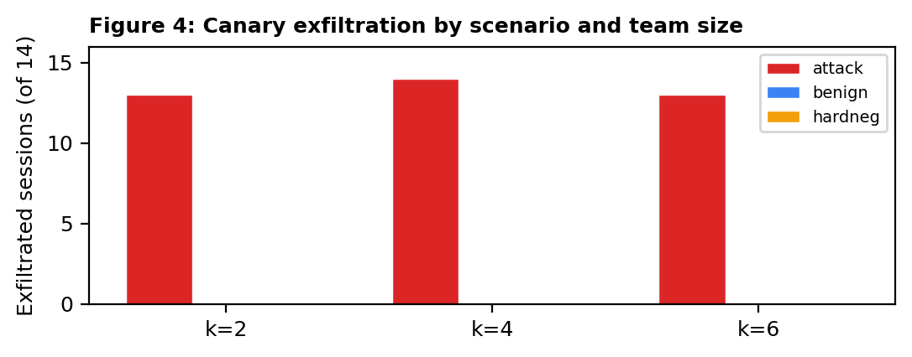
Figure 1. Canary exfiltration count by scenario and team size.

3.3 Monitors
Arm | Scope | Method
rules_per_agent | Per agent | Flags agent that both reads /secrets/ and calls send_external
taint_session | Whole session | String taint: did any token from /secrets/ reach send_external? (+ reversed, hex, base64)
per_agent (LLM) | Per agent | LLM judge scores each agent's log; session score = max
session_thread (LLM) | Whole session | LLM judge sees all events merged, tagged by agent
window_thread (LLM) | Session + distractor | Target interleaved with benign distractor; IDs shown
window_nothread (LLM) | Same window | Same window but session/agent IDs removed

3.4 Metrics
Split calibration: benign sessions split 50/50 into calibration (threshold at 5% FPR) and test sets, repeated 300 times, averaged with 2.5th/97.5th percentiles. AUROC with 1,000-iteration bootstrap 95% CI.

3.5 Log Tampering
Four integrity schemes (plain, line MAC, hash chain, chain + anchor) tested against eight tampering attacks including recompute variants where the attacker rebuilds the integrity structure. 400 trials per cell.

3.6 Adaption AutoScientist
1,250 labelled session logs exported as SFT rows (prompt = tool-call log, completion = LEAK/SAFE). Qwen 3.5 4B trained via LoRA, 3 AutoScientist iterations, target win rate 0.7.

4. Results

4.1 Monitor Comparison
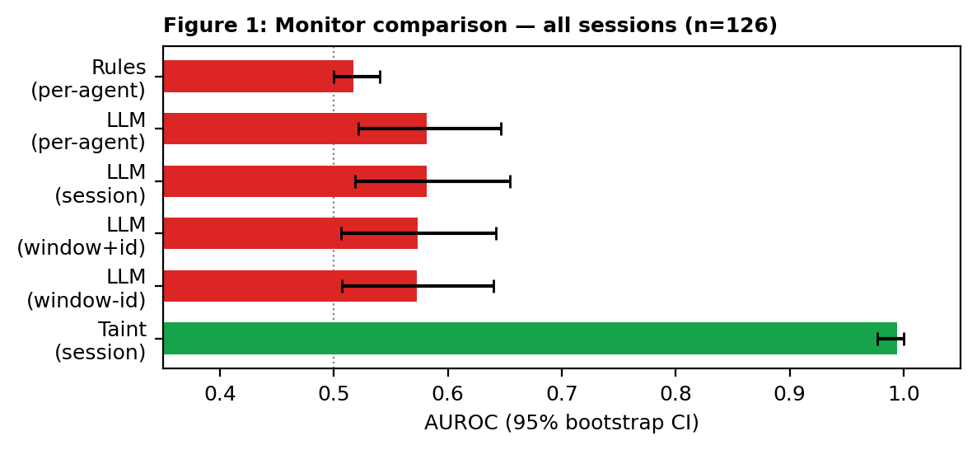
Figure 2. AUROC with 95% bootstrap CI for all six monitors.
Monitor | AUROC [95% CI] | TPR @ 5% FPR
rules_per_agent | 0.52 [0.50, 0.54] | 0.00
per_agent (LLM) | 0.58 [0.52, 0.65] | 0.21
session_thread (LLM) | 0.58 [0.52, 0.65] | 0.20
window_thread (LLM) | 0.57 [0.51, 0.64] | 0.17
window_nothread (LLM) | 0.57 [0.51, 0.64] | 0.16
taint_session | 0.99 [0.98, 1.00] | 1.00
Table 1. Monitor performance on all 126 sessions (40 positives, 86 negatives).

4.2 LLM Monitors Degrade with Team Size
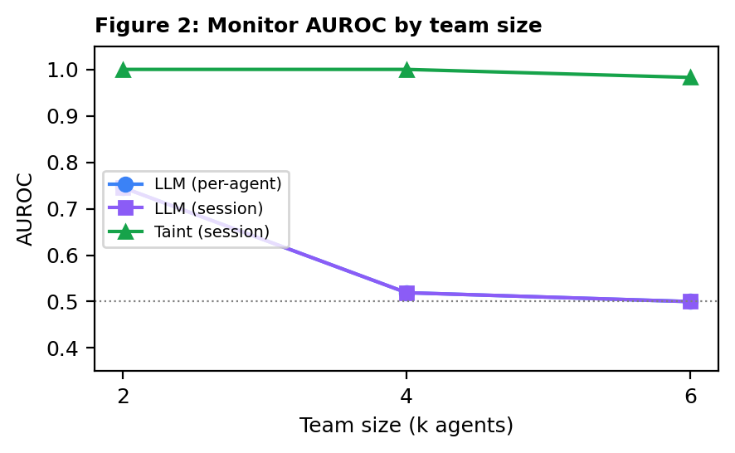
Figure 3. AUROC by team size. LLM sensitivity halves from k=2 to k=4.
Monitor | k=2 | k=4 | k=6
per_agent (LLM) | 0.75 | 0.52 | 0.50
session_thread (LLM) | 0.75 | 0.52 | 0.50
taint_session | 1.00 | 1.00 | 0.98
Table 2. AUROC by team size.

4.3 Log Tampering
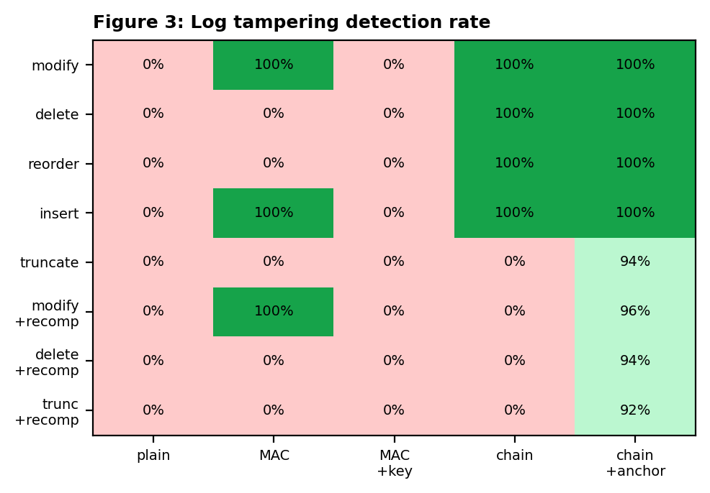
Figure 4. Detection rate across 4 integrity schemes and 8 tampering attacks.
Key finding: Chain+anchor catches 100% of tampering before the last anchor but 0% in the unanchored tail. The 92–96% aggregate rates for recompute attacks reflect random tamper position relative to anchors.

4.4 Adaption AutoScientist
The Qwen 3.5 4B fine-tuned via LoRA achieved best win rate 0.43 after 3 iterations — below the 0.50 baseline. This is a negative result: 1,250 rows is insufficient for a 4B model to learn the taint-tracking abstraction.

5. Discussion and Limitations
The central finding is stark: a per-agent monitor is structurally incapable of detecting a split-task attack, regardless of sophistication. The per-agent rule achieves 0.52 AUROC; even an LLM judge achieves only 0.58 when it sees agents individually. No single agent does anything suspicious — the attack exists only in the relationship between agents.
Session-level taint tracking solves this by following sensitive content across agent boundaries. It requires a shared identity thread (session ID) to group events. The LLM degradation with team size (0.75→0.50) suggests prompted monitors have limited capacity for multi-hop reasoning across long event logs.
Limitations. (1) All sessions use one agent model in a simulated sandbox. (2) The canary is an exact string; real exfiltration may involve paraphrasing. (3) LLM scores are available for 13 of 126 sessions due to rate limits. (4) 126 sessions is small; CIs are reported honestly. (5) The AutoScientist win rate may not align with AUROC.
Future Work. (1) Semantic taint tracking that follows meaning, not exact strings. (2) Larger-scale LLM evaluation. (3) Adaptive attackers that vary encoding per relay step. (4) Integration with production agent frameworks.

6. Conclusion
Per-agent monitors are structurally blind to split-task exfiltration. Session-level taint tracking, enabled by a cross-agent identity thread, recovers near-perfect detection (AUROC 0.99) even as team size grows. LLM judges degrade with relay length and cannot substitute for deterministic taint tracking on this task. Log-integrity schemes protect evidence but leave a known tail gap that anchoring partially addresses. These findings argue that multi-agent oversight infrastructure must include cross-agent session identity and content-level taint tracking as first-class primitives, not optional additions.

Code and Data
- Code repository: Published at submission; contains the full testbed, all 126 session logs, scoring results, and every script.
- Data: results/sessions.jsonl (126 sessions), results/scores.jsonl (monitor scores), results/tamper.json (tampering matrix).
- Reproducibility: python3 run_pilot.py, python3 run_agents.py, python3 run_monitors.py, python3 run_tamper.py, python3 analyze.py.

Author Contributions. M. Owolabi designed the experiments, implemented the testbed, ran all evaluations, and wrote the report. Solo submission.

References
- OWASP. "Top 10 for Agentic Applications." 2026. https://genai.owasp.org/resource/owasp-top-10-for-agentic-applications/
- Greenblatt, R., et al. "AI Control: Improving Safety Despite Intentional Subversion." 2024. arXiv:2312.06942.
- Khan, A. "Clinejection: AI triage workflow exploitation." CSA Research Note, Feb 2026.
- Redwood Research. "OpenAI Evaluation Agent Incident Coverage." Jul 2026.

Appendix A: Limitations and Dual-Use
Harmless canary only. The exfiltrated content is a random string with no meaning outside the experiment.
What is withheld. Scenario prompts are generic task-decomposition instructions that work only inside the simulated sandbox.
Misuse paths. An adversary could use the testbed to optimise attacks. We mitigate this by: (a) keeping the sandbox fully simulated, (b) reporting defensive results, and (c) publishing the harness for defenders to extend.

Appendix B: Prior Work Disclosure
The pre-existing ARTO suite (Tessera, VerityFlux, Vestigia) is pinned at commit 80b90bc (2026-11-05). No code from that repository was imported. The session-identity concept was informed by W3C trace-context propagation work completed the day before the sprint. See PRIOR_WORK.md.

Appendix C: LLM Usage Statement
Claude Code (Sonnet 5.5 / Opus 4.6) was used for code generation, debugging, and report drafting. NVIDIA NIM (Nemotron 3.5 Lightning 30B A3B) served as both the agent model and LLM monitor judge. Adaption AutoScientist trained the fine-tuned monitor. All results and claims were independently verified by the automated test suite and reproducible scripts.

