# Fonts

Font is a collection of various **character images** that can be used to display or print text. The character images are called **glyphs**.

One has to distinguish between a font family and its multiple font faces. For example, *Palatino Regular* and *Palatino Italic* are two distinct faces from the same family, called *Palatino* itself.

Font file contains a set of glyphs; each one can be stored as a bitmap, a vector representation, or any other scheme. These glyphs can be stored in any order in the font file, and are typically accessed through a simple glyph index.

Size of text is usually given in points, rather than device-specific pixels. Points are a physical unit, where 1 point equals 1/72th of an inch in digital typography.

pixel_size = point_size * resolution / 72

# http://www.yourfonts.com/images/qualityyourfonts.pngVectorial representation

Source format of outlines is a collection of closed paths called contours.

Each glyph's original outline points are located on a grid of indivisible units. The points are usually stored in a font file as 16-bit integer grid coordinates.

Each glyph's original outline points are located on a grid of indivisible units. The points are usually stored in a font file as 16-bit integer grid coordinates, with the grid's origin being at (0,0); they thus range from -32768 to 32767.

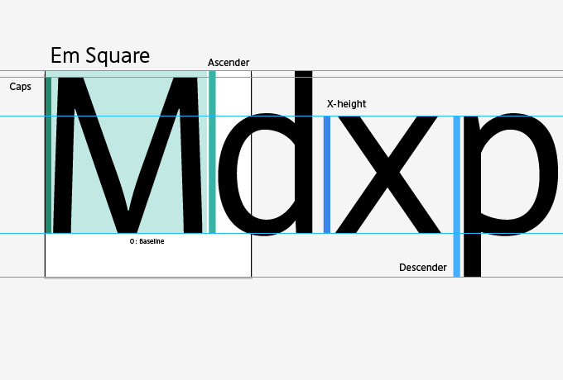

In creating the glyph outlines, a type designer uses an imaginary square called the EM square. Typically, the EM square can be thought of as a tablet on which the characters are drawn. It is the reference size used to scale the outlines to a given text dimension. For example, a size of 12pt at 300×300 dpi corresponds to 12*300/72 = 50 pixels. This is the size the EM square would appear on the output device if it was rendered directly.

# horizontal layoutBaseline

Baseline is an imaginary line that is used to guide glyphs when rendering text. It can be horizontal (Latin) or vertical (Chinese).

The distance between two successive pen positions is glyph-specific and is called the advance width. Its value is always positive.

# Typographic metrics

Various number of face metrics are defined for all glyphs in a given font ([read more](http://www.freetype.org/freetype2/docs/glyphs/glyphs-3.html#section-2)).

# Bearings and Advances

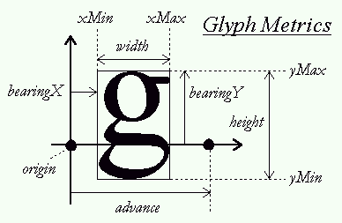Each glyph has also distances called bearings and advances. The actual values depend on the layout, as the same glyph can be used to render text either horizontally or vertically.

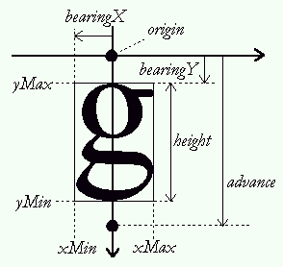As seen before, the **origin** of a given glyph corresponds to the position of the pen on the baseline. It is not necessarily located on one of the glyph's bounding box corners, unlike many typical bitmapped font formats. In some cases, the origin can be out of the bounding box, in others, it can be within it, depending on the shape of the given glyph.

Lukeminen jäi kesken kerningiin http://www.freetype.org/freetype2/docs/glyphs/index.html