Perämoottori
Software Design Document

Author: John Doe
Confidentiality: Public
Version: 1.0

Table of Contents

1 Version history 3
2 Abbrevations, accronyms and key terms 3
3 Introduction 3
3.1 The purpose of this document 3
3.2 Content of this document 3
4 SW REQUIREMENTS 4
4.1 Graphics 4
4.2 Physics 4
4.3 Audio 4
4.4 Input 4
4.5 Frameworks / portability 4
4.6 Scene management 4
5 Architecture 5
6 Subsystems 6
6.1 Graphics 6
6.2 Physics 6
6.3 Audio 6
6.4 Input 6
6.5 Frameworks / portability 6
6.6 Scene management 6
7 SW Behaviour 7
7.1 App life cycle 7
7.2 Creating of game objects 7

Version history

Date | Revision | Author | Comment
10.12.2015 | 0.0.1 | Tuukka Karppinen | Document created. Initial Draft.
10.12.2015 | 0.0.2 | Mikael Oja | Added Class Diagram.
11.12.2015 | 0.1.0 | Joni-Petteri Luomala | Added some shit

Abbrevations, accronyms and key terms

Term | Description
SW | Software
OpenGL ES | OpenGL for Embedded Systems
MSB | Most Significant Byte

Introduction

The purpose of this document

The purpose of this document is to clarify the SW Architecture and some implementation soe mechanism which is used by the Booger game. By reading content of this document, reader should have understanding how to implement software which can communicate with the Booger game.

Content of this document

In the chapter 4 there is high level SW architectural description of Booger game in way, that reader can understand concepts discussed later in the document. Chapter 5 clarifies general transport mechanisms used in communication between third party SW and Booger game. Finally in the chapter 6 there are specifications for each message what can be send to the Booger game.

SW REQUIREMENTS

The game engine provides following features for game developer.... It is enough to have only short list of different features, which SW provides. One or two pages, which describes the main features briefy.

Graphics
TODO: Describe here features which relates to graphics drawing functionality.

Physics
TODO: Describe here features which relates to physics.

Audio
TODO: Describe here features which relates to sound playing / audio functionality.

Input
TODO: Describe here features which relates to sound playing / audio functionality.

Frameworks / portability
TODO: Describe here features which relates to supported frameforks / compilers and platcorms.

Scene management
TODO: Describe here features which relates to scene graph functionality (entity/component system etc.)

Architecture

TODO: Add here the main architectural figure and add some text below the image for briefly describing each subsystem of the SW. Architectural figure consists of different subsystems and used libraries and informs the relations of each subsystem. Add here all libraries, which SW uses and relations between them (which subsystem uses which library etc)

Subsystems

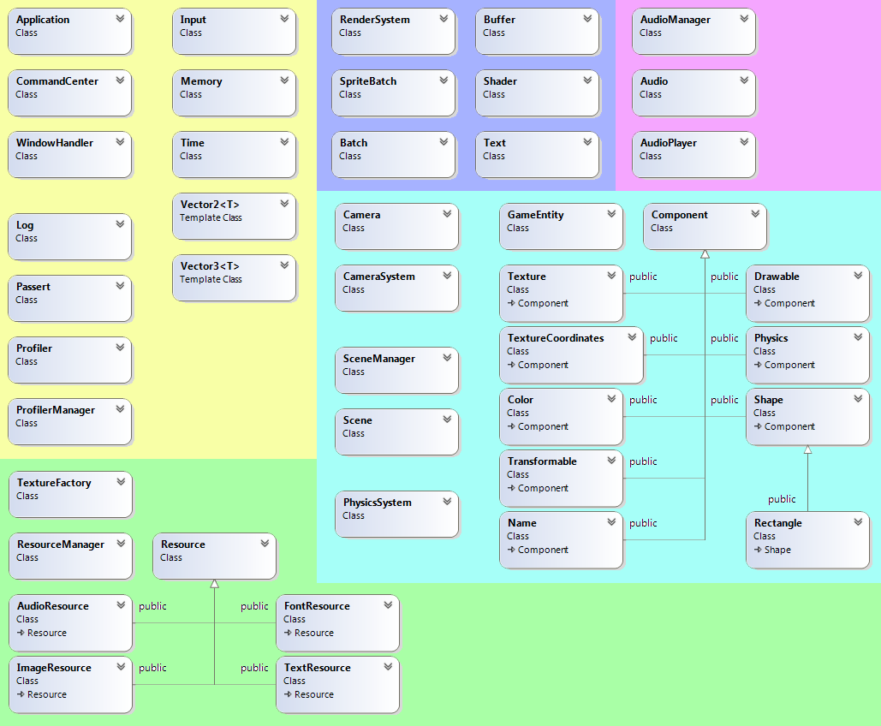
In this section, describe actual class diagrams etc. for each subsystem in separate sections like below:

Graphics
TODO: Add class diagrams, including base classes. Don't make one master picture of classes. Use several smaller pictures instead as sub-sections for example Classes for Sprite management, Classes for Textures (Texture,Texture2D,Texture3D).

Physics
TODO: Describe here features which relates to physics. If some external library is used, desctibe here the wrapper classes or classes needed for integration to your SW.

Audio
TODO:

Input
TODO:

Frameworks / portability
TODO:

Scene management
TODO:

SW Behaviour
The porpose of this section is do describe SW runtime behaviour using sequence / state diagrams. Describe here some basic sequence / state diagrams of SW functionality, if relevant. For example, good idea is to add sequence diagram of application life cycle, like typical function calls which user is need to make.

App life cycle
TODO: Picture and text describing what is happening.

Creating of game objects
TODO: Picture and text describing what is happening.

