SVO Observatory
Windy.com Webcam — Setup Guide

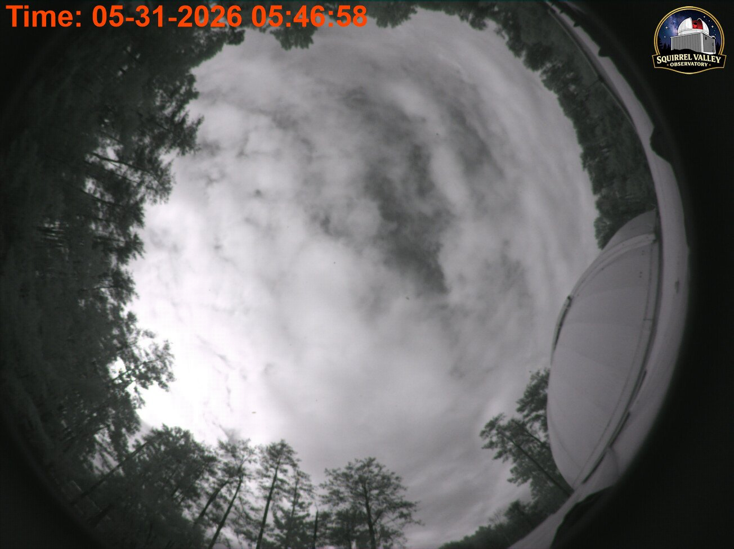
Current live view from the ASI 224MC — svo.space/allsky/Current.jpg

Overview
This guide walks through connecting the ZWO ASI 224MC all-sky camera at SVO Observatory to the Windy.com live webcam map. Once set up, your sky image will appear on Windy's global camera map and update automatically every 60 seconds.

How it works
Windy.com uses a pull model — you provide a stable public URL pointing to your latest image, and Windy fetches it on their own schedule. No upload script or API key is required.

ASI 224MC Camera
AllSky software (captures image & uploads to Hostinger via FTP)
https://svo.space/allsky/Current.jpg — public image URL
Windy.com fetches the image every ~60 seconds
Your camera appears on windy.com/webcams

ℹ The Windy API key is NOT needed for webcam registration. It is only used if you later want to query Windy's webcam database programmatically.

What you need before you start
- Access to the Hostinger control panel (hPanel) — hpanel.hostinger.com
- AllSky running on the observatory PC and confirmed uploading Current.jpg to Hostinger
- A Windy.com account for the webcam registration form
- Verify the live image loads: https://svo.space/allsky/Current.jpg

Step 1 Fix the image cache on Hostinger
By default, Hostinger tells browsers and CDNs to cache Current.jpg for 7 days. This means Windy would show a week-old image. We fix this by adding a small configuration file to the allsky folder on your web hosting.

Open Hostinger File Manager
- Go to hpanel.hostinger.com and log in.
- Click Hosting in the left menu, then select your hosting plan.
- Click "File Manager" to open it.
[Image placeholder — Hostinger hPanel — File Manager location]

Navigate to the allsky folder
- In the File Manager, navigate to public_html → allsky.
- You should see Current.jpg listed there — this is the live image AllSky uploads.

Create the .htaccess file
- Click "New File" at the top of the File Manager.
- Name the file exactly: .htaccess (with the dot at the start)
- Paste the following content into the file editor:
<Files "Current.jpg">
Header set Cache-Control "public, max-age=30, must-revalidate"
Header unset Pragma
</Files>
- Click Save.

Verify it worked
Open a browser or command prompt and run:
curl -sI https://svo.space/allsky/Current.jpg | grep cache-control
You should see: cache-control: public, max-age=30, must-revalidate
ℹ The .htaccess file is also included in this repo at hostinger/.htaccess if you need to reference it.

Step 2 Register your camera on Windy.com
This is a one-time step. You fill in a short form on Windy's website, submit it, and wait 1–3 days for their team to approve it.
- Go to: windy.com/webcams/add
- Log in to your Windy.com account if prompted.
- Fill in the form with the details below.
- Click Submit.

Form details to enter
Field | Value to enter
Location | SVO Observatory GPS coordinates
Camera name | SVO Observatory All-Sky Camera
Description | ZWO ASI 224MC 180° all-sky camera
Image URL | https://svo.space/allsky/Current.jpg

ℹ After submitting, Windy will email you when the webcam is approved. Once approved your camera appears automatically on windy.com/webcams — no further configuration needed.

Step 3 Optional — Run the image freshness monitor
The allsky_windy.py script is an optional tool that watches the AllSky output file on your observatory PC and logs a warning if the image stops updating. Windy does NOT require this to run — it is purely for your own peace of mind.

Install Python (if not already installed)
- Download Python 3.9 or newer from python.org/downloads
- During install, tick "Add Python to PATH".
- Verify in a Command Prompt: python --version

Set up the script
- Download the repo ZIP from GitHub (green Code button → Download ZIP).
- Extract to C:\allsky-windy\
- Copy config.ini.example to config.ini
- Open config.ini in Notepad and set image_path to where AllSky writes its image.
- Test it by opening a Command Prompt and running:
cd C:\allsky-windy
python allsky_windy.py
You should see a line like:
2026-06-01 10:00:01 INFO Image updated — 208220 bytes (update #1)
- Press Ctrl+C to stop. If it works, proceed to auto-start below.

Auto-start on boot (Windows Task Scheduler)
- Open the windows\ folder inside the extracted repo.
- Edit allsky-windy-task.xml — update the Python path and script path to match your installation.
- Right-click install.bat → Run as administrator.
- The script will now start automatically every time the PC boots.
schtasks /query /tn "AllSky-Windy-Uploader"
Run the above in Command Prompt to confirm the task is registered.

Troubleshooting
Windy shows a stale or old image
The .htaccess cache fix may not be in place. Run: curl -sI https://svo.space/allsky/Current.jpg | grep cache-control
It should say max-age=30. If it still says 604800, re-check the .htaccess file in Hostinger.

Current.jpg on svo.space is not updating
Check AllSky is running on the observatory PC and its FTP upload is configured. The monitor script will log a warning after 120 seconds of no update.

Windy registration not approved after 3+ days
Email webcams@windy.com referencing the URL you submitted.

Monitor script says 'Image not found'
Check the image_path in config.ini. Use PowerShell to search: Get-ChildItem C:\ -Recurse -Filter image.jpg

Task Scheduler task won't start
Re-run install.bat as Administrator. Open Task Scheduler and check the Last Run Result for AllSky-Windy-Uploader.

Reporting issues
If something isn't working, drop a screenshot in the screenshots/new/ folder and any log output or notes in context/new/, then open a pull request on GitHub. Dan and the team will diagnose and push a fix.
screenshots/new/ ← screenshot images
context/new/ ← log output, notes, error messages

SVO Observatory — github.com/Arky-Sparky-Dan/SVO-Windy-API

