**PERFORMANCE ENHANCEMENT OF RENEWABLE**

**ENERGY SYSTEM WITH DIFFERENT CONTROLLERS**

**ABSTRACT:** This study introduces an Adaptive Fuzzy Logic Controller (AFLC) to enhance the performance of solar grid-connected systems under rapid atmospheric changes. The AFLC incorporates a fuzzy knowledge-based controller and a learning mechanism, employing an adaptive output scaling factor to achieve faster response and reduced oscillations near the maximum power point. The controller is implemented in a MATLAB/Simulink environment for an 80-kW solar grid system featuring a 5-kHz, 600V DC-DC boost converter, a three-level inverter, and a 50 Hz utility grid. Comparative analysis with conventional PI, PID, and Fuzzy Logic Controllers demonstrates that the AFLC offers faster response times and improved Total Harmonic Distortion (THD) performance, highlighting its effectiveness in dynamic conditions.

**1. INTRODUCTION:** The growing demand for renewable energy sources has driven a significant increase in their adoption worldwide. As fossil fuel reserves deplete, generating power from conventional sources is becoming increasingly challenging. Consequently, countries are focusing on developing strategies and policies to promote the use of renewable energy. Among these, solar energy stands out as a readily available and abundant resource derived from sunlight. Solar power is not only cost-effective and low-maintenance but also free from emissions, making it a sustainable alternative to fossil fuels. While its performance can be affected by unfavorable weather conditions, solar energy is highly efficient and requires only an initial investment. With a long lifespan and minimal environmental impact, solar energy surpasses many traditional energy sources. This study explores various aspects of solar energy systems, including the influence of cell temperature and irradiation, the role of the boost converter, the Maximum Power Point Tracking (MPPT) technology, and the Pulse Width Modulation (PWM) inverter.

**2 .Solar Photovoltaic (PV) system**

The structure of proposed solar PV framework is shown in Fig.1 below. The solar panel output is applied to the converter and then routed to the three-phase inverter to increase the DC voltage. The three-phase inverter output is fed to grid.



**Fig. 1 Structure of the proposed Solar PV framework**

**Solar PV Cell Mathematical**

The equivalent circuit of a solar cell is depicted in Fig. 2. In a photovoltaic (PV) system, solar energy is directly converted into electricity through the photovoltaic reaction. The current generated by a PV cell depends on climatic conditions and the intensity of solar irradiance. Higher irradiance levels result in greater current generation by the solar cell. A solar cell can be ideally represented as a current source in parallel with a diode. However, like any practical system, solar cells experience energy losses. These losses are modeled using a small series resistance (Rs) and a high shunt resistance (Rp).

The current produced by a photovoltaic cell is described by Equation (1):

(1)

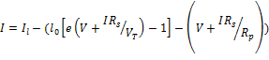

Here, *I1*is the current generated through light in Amperes, *I0* is the reverse saturation current in Amperes, *VT* represents thermal voltage (in Volts), *V* represents the solar voltage (in Volts), and *I*  is the PV cell current (in Amperes).



**Fig. 2 Solar cell equivalent circuit in one diode model.**

**Table 1: The parameters of PV system**

|  |  |  |
| --- | --- | --- |
| **S. No.** | **Parameter** | **Value** |
|  | Voltage (Vmax) | 54.7V |
|  | Current (Imax) | 5.58A |
|  | Open circuit Voltage | 64.2V |
|  | Short circuit current | 5.96A |

**Evaluation of MPPT algorithm**

The process of evaluating an MPPT (Maximum Power Point Tracking) algorithm involves the following steps:

Step 1: **Input Sensing:** The outputs of the solar cell, such as current and voltage, are measured and sent to the MPPT controller.

Step 2: **Analyzing Variations:** The MPPT controller evaluates the current and voltage by comparing their present and past values. This comparison results in the differences:

∆I= Inew-Iold, ∆V=Vnew-Vold.

Step 3: **Tracking MPP:** The controller determines the slope of the power curve using VΔI/ΔV

to track the MPP.

Step 4: **Error Calculation:** The error is calculated by combining incremental conductance. di/dv and instantaneous conductance (IC) i.e., i/v. Thus, the error value is e = (i/v)+(di/dv).

Step 5: **Error Minimization:** The calculated error value is fed into a Proportional-Integral (PI) controller. The PI controller adjusts its parameters to minimize the error value e to zero.

Step 6: **Pulse Generation for PWM:** The PI controller generates a duty ratio, which is used to produce PWM (Pulse Width Modulation) signals. These PWM signals are sent to comparators and subsequently used to drive the switching operation of a boost converter.

Step7: **Repetition:** The above steps are continuously repeated until the system consistently operates at the Maximum Power Point (MPP).

**DC-DC Step-Up Converter**

A DC-DC step-up converter, also known as a boost converter, is a type of DC-to-DC converter that produces an output voltage higher than the input voltage. It utilizes semiconductor switches such as BJTs, MOSFETs, or IGBTs. The output of the boost converter is then fed into a 3-phase inverter. To ensure a stable output voltage, the switching pulses for the semiconductor switches in the inverter are controlled by an MPPT controller.



**Fig.3. Block diagram of Boost-converter**

**3. Controller design**

**PI & PID Controller**

PI and PID controllers are widely used in applications such as wind turbine monitoring. These controllers optimize performance by maximizing gain. The error signal is processed through the PI or PID control loop, where it is adjusted using proportional (Kₚ), integral (Kᵢ), and derivative (Kₑ) constants.

The transfer function of a PI controller is given by:

(2)

The transfer function of a PID controller is given by:

(3)

**Table 2. Ziegler–Nichols Tuning Rules Based on Step Response of Plant**

|  |  |  |  |  |
| --- | --- | --- | --- | --- |
| **S. No.** | **Type of controller** | **Kp** | **Ti** | **Td** |
|  | P | T/L |  | 0 |
|  | PI | 0.9T/L | L/0.3 | 0 |
|  | PID | 1.2T/L | 2L | 0.5L |

In this work the kp, ki, kd, values used are 0.5, 0.05 and 0.5 respectively determined from Ziegler-Nichols tuning method.

**The Steps in FLC Design**

The steps in designing a simple fuzzy control system are as follows :

Step 1: **Identify Variables**: Define the input, state, and output variables of the system to be controlled.

Step 2: **Partition the Universe of Discourse**: Divide the range of each variable into a set of fuzzy subsets, assigning each subset a linguistic label. These subsets represent the elements within the variable's range.

Step 3: **Define Membership Functions**: Assign a membership function to each fuzzy subset, which describes the degree of membership for elements in the subset.

Step 4: **Develop Rule Base**: Establish fuzzy relationships between the input or state fuzzy subsets and the output fuzzy subsets. These relationships form the basis of the rule set.

Step 5: **Select Scaling Factors**: Choose appropriate scaling factors for the input and output variables to normalize their values.

Step 6: **Fuzzify Inputs**: Convert crisp input values into fuzzy values using the membership functions.

Step 7: **Apply Fuzzy Reasoning**: Use approximate reasoning to determine the contribution of each rule to the output.

Step 8: **Aggregate Fuzzy Outputs**: Combine the fuzzy outputs generated by each rule to produce a unified fuzzy output.

Step 9: **Defuzzify Outputs**: Convert the aggregated fuzzy output into a crisp value to provide the final control action.

FLC is a control method where linguistic variables are used to govern the circuit rather than mathematical values. This method is more robust than the classical controllers and can work with less data.

Here the membership function considered, is triangular.The membership function values are separated into seven sets and they are named as: Positive Big (PB), Zero (ZR), Negative Small (NS), Positive Small (PS), Negative Medium (NM) and Positive Medium (PM), Negative Big (NB).The controller output  for a FLC depends on the fuzzy rules shown in table.3. The membership function maximum value is 1 and minimum value is 0.



**Table.3.Rule base for computation of**



|  |  |  |  |  |  |  |  |
| --- | --- | --- | --- | --- | --- | --- | --- |
| **e**  **∆e** | **NB** | **NM** | **NS** | **ZR** | **PS** | **PM** | **PB** |
| **NB** | NB | NB | NB | NM | NM | NS | ZR |
| **NM** | NB | NB | NM | NM | NS | ZR | PS |
| **NS** | NB | NM | NM | NS | ZR | PS | PM |
| **ZR** | NM | NM | NS | ZR | PS | PM | PM |
| **PS** | NM | NS | ZR | PS | PM | PM | PB |
| **PM** | NS | ZR | PS | PM | PM | PB | PB |
| **PB** | ZR | PS | PM | PM | PB | PB | PB |

**AFLC for Solar Grid Connected System**

A Fuzzy Logic Controller (FLC) is classified as adaptive if any of its tunable parameters—such as membership functions, fuzzy rules, or output scaling factors—are adjusted during operation. Otherwise, it is considered a non-adaptive or conventional FLC. Figure 4 illustrates the block diagram of the proposed Adaptive Fuzzy Logic Controller (AFLC).



**Fig. 4 AFLC Structure for solar system**

In the proposed AFLC, adaptation is achieved by dynamically modifying the output scaling factor of a conventional FLC, making it adaptive in nature. The relationship between the normalized incremental change in the duty cycle (ΔDN) and the controller output (ΔD(k)) is expressed as:

∆D(k) = {GD} x ∆DN(k)

Here, the gain of the fuzzy controller (GDG_DGD​) represents the output scaling factor, which is constant for a conventional FLC.

In the proposed adaptive mechanism, as depicted in Figure 4, the output scaling factor (GDG_DGD​) is updated at every sampling interval using another fuzzy logic controller, shown in the rectangular box. The adaptive relationship for the incremental change in the controller output is given by:

∆D(k) = {α(k) x GD} x ∆DN(k) (4)

The other particularities of the proposed controller, namely the fuzzy rules and membership functions are described below

**Table 4 Rule base for computation of α.**

|  |  |  |  |
| --- | --- | --- | --- |
| **e**  **∆e** | **N** | **Z** | **P** |
| **N** | NL | NM | Z |
| **Z** | NM | Z | PM |
| **P** | Z | PM | PL |

Where N – Negative, PL- Positive Large P – Positive, NM – Negative Medium, PM – Positive Medium, NL- Negative Large, Z – Zero.

**4. Simulation results of the Solar Grid Connected System**

In this work 80-kW solar grid connected system is considered and developed in MATLAB shown in Fig.5. The Solar Grid Connected System consists of 5-kHz 600V DC-DC boost converter, three level inverter, and utility grid.

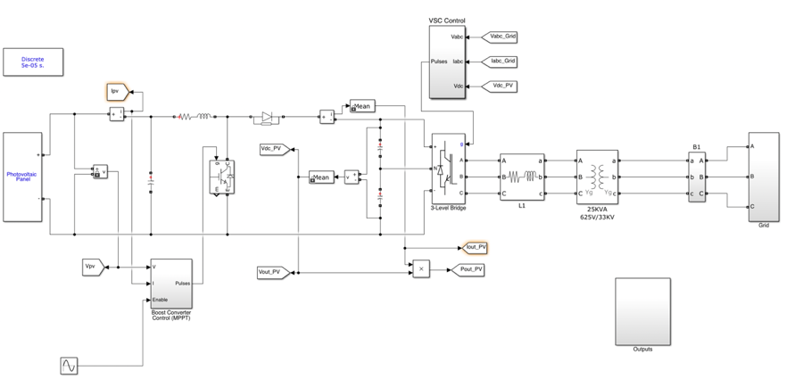

**Fig.5. Solar Grid Connected System**

**Performance of Solar Grid Connected System Considering Constant Irradiance and Temperature**

In this case performance of solar grid connected system is evaluated considering constant irradiance and temperature as shown in Fig. 6.

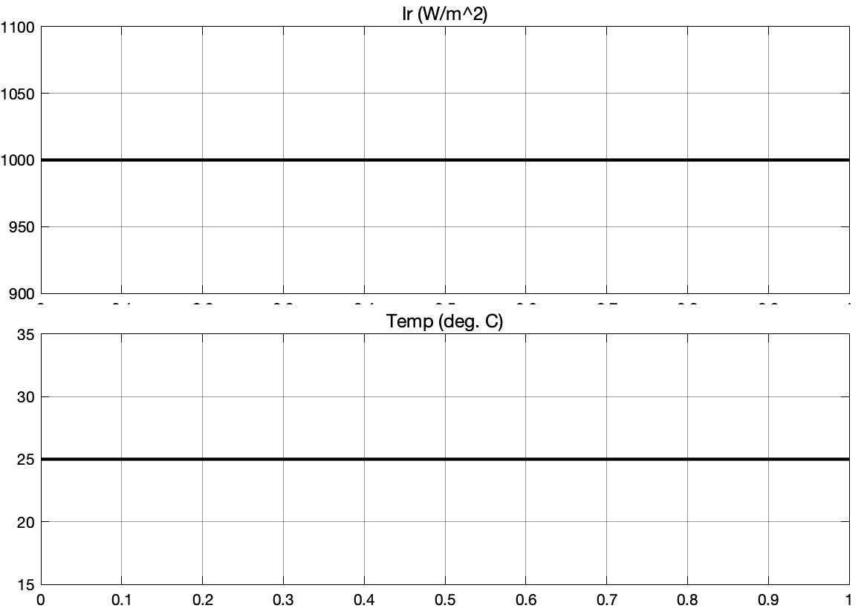

**Fig. 6 Constant Irradiance and Temperature**

The PV Panel Output power considering PI, PID, FLC and AFLC are shown in Fig. 7.

**s**

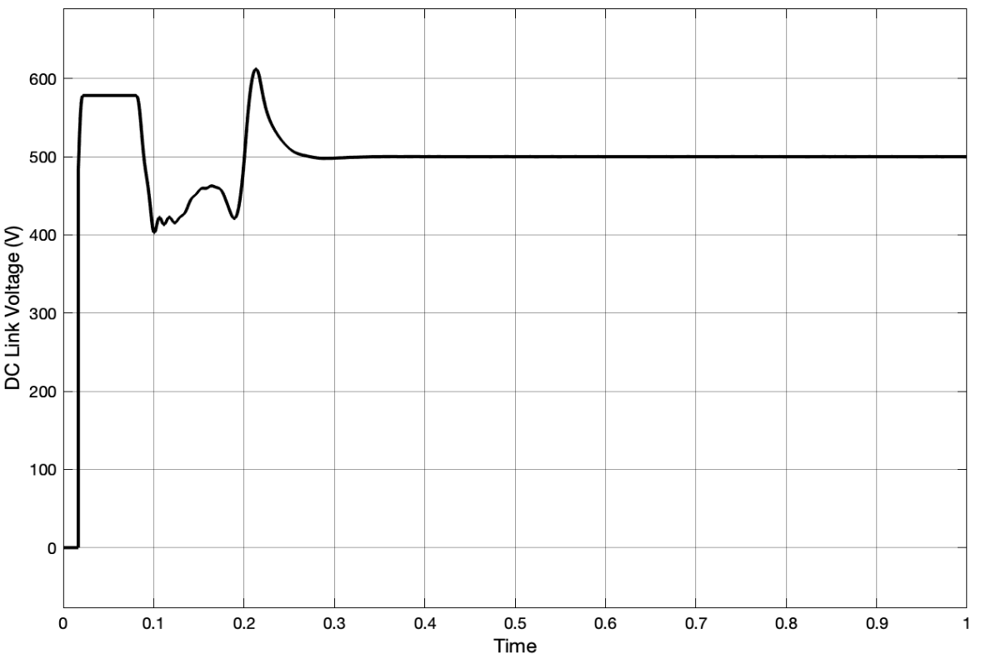

**Fig. 7 (a) DC Link Voltage with PI Controller**

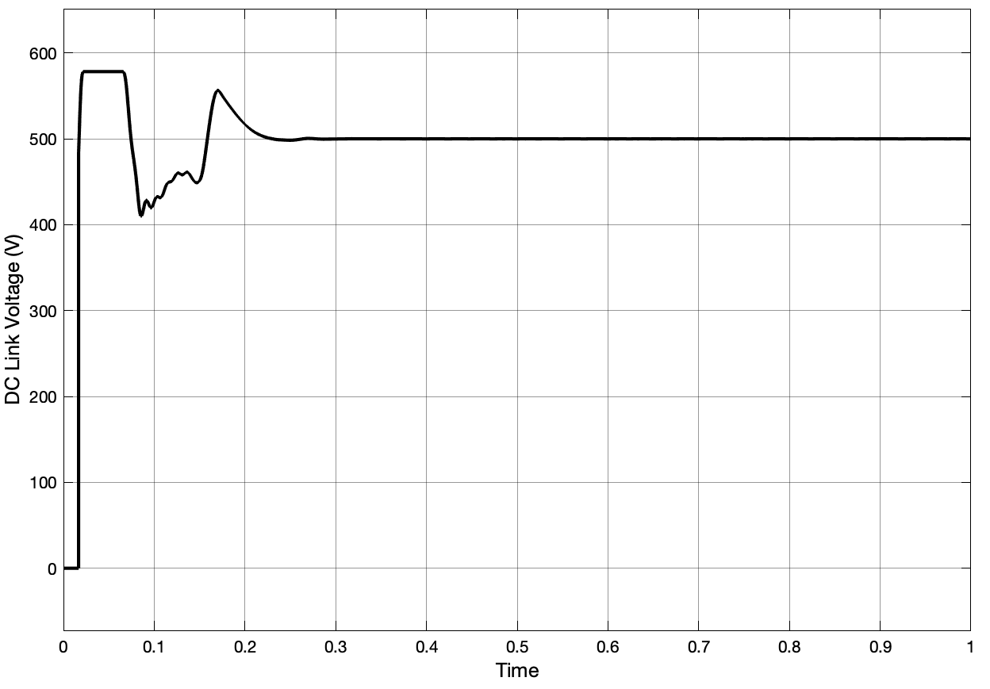

**Fig7 (b) DC Link Voltage with PID Controller**

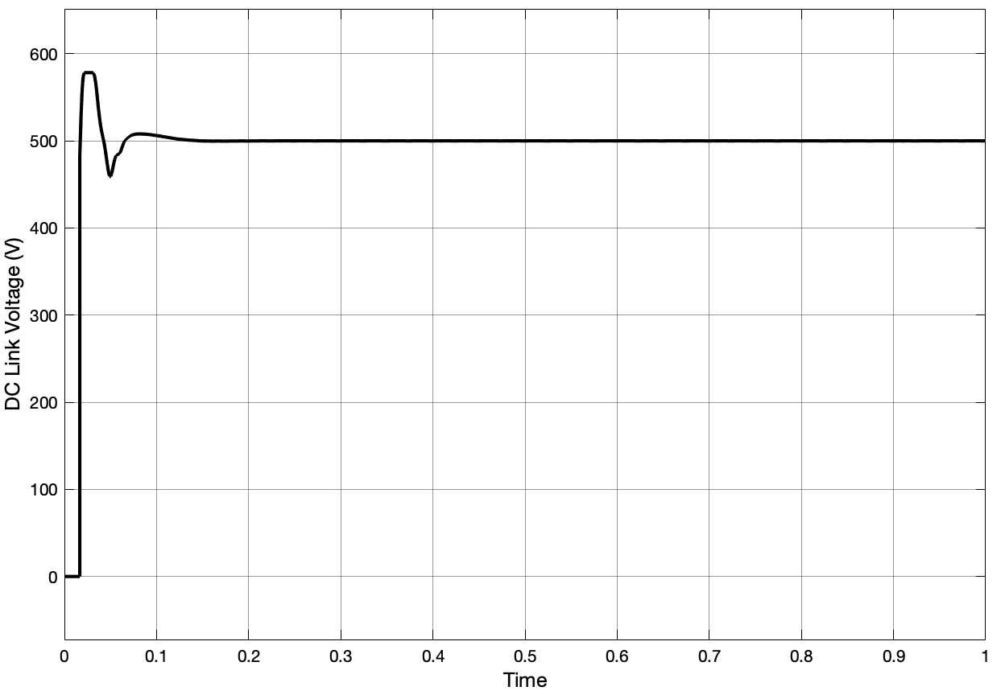

**Fig. 7 (c) DC Link Voltage with FLC**

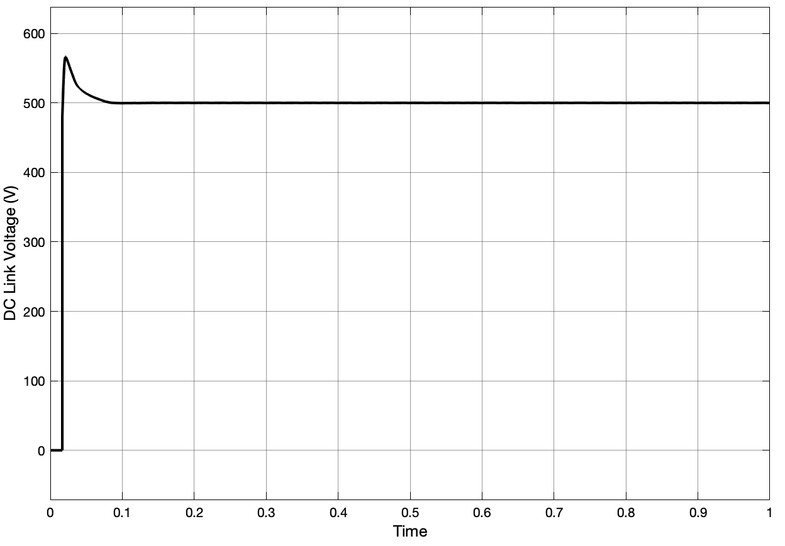

**Fig. 7 (d) DC Link Voltage with proposed AFLC**

The rise time and settling time of proposed controller AFLC in comparison with PI, PID and FLC are tabulated in Table. 5.

**Table 5 Solar DC Link Voltage Comparison of trand ts for PI, PID, FLC and AFLC Considering Constant Irradiance and Temperature**



|  |  |  |  |
| --- | --- | --- | --- |
| **S. No.** | **Controllers** | **tr (sec)** | **ts (sec)** |
|  | **PI** | 0.099 | 0.268 |
|  | **PID** | 0.079 | 0.202 |
|  | **FLC** | 0.055 | 0.149 |
|  | **AFLC** | 0.009 | 0.068 |

From the above Fig. 7 and Table 5 the proposed AFLC shows the mark reduction in tr and ts in comparison with PI, PID, FLC i.e., 0.009 sec and 0.068 sec respectively.

The grid mean power considering PI, PID, FLC and Proposed AFLC are shown in Fig. 8.

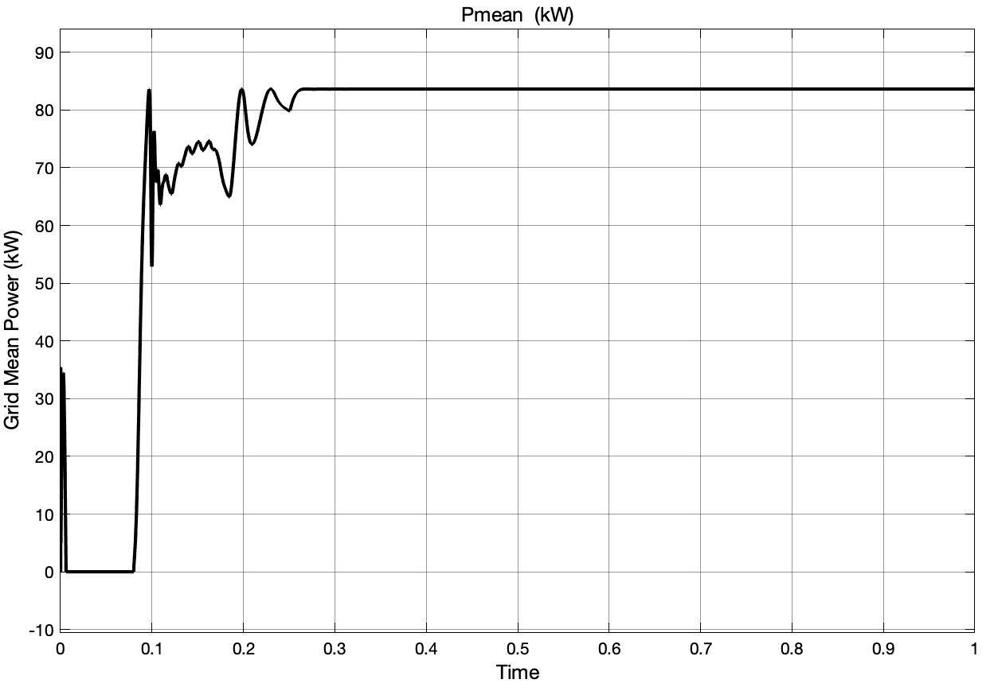

**Fig. 8 (a) Grid Mean Power with PI Controller**

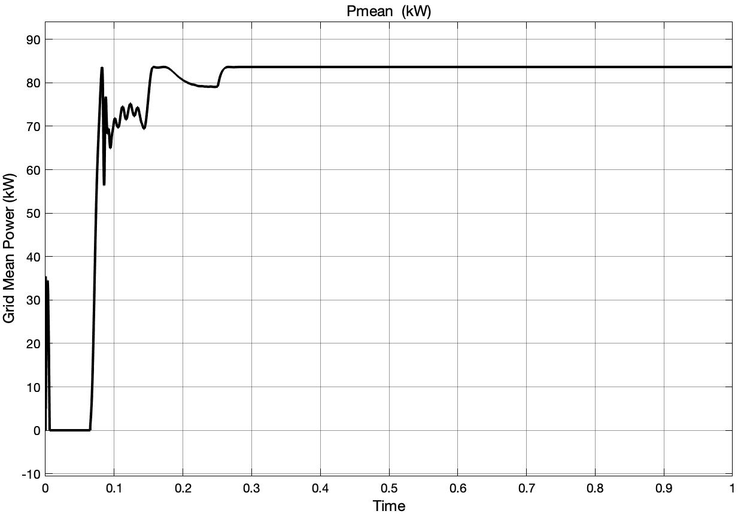

**Fig. 8 (b) Grid Mean Power with PID Controller**

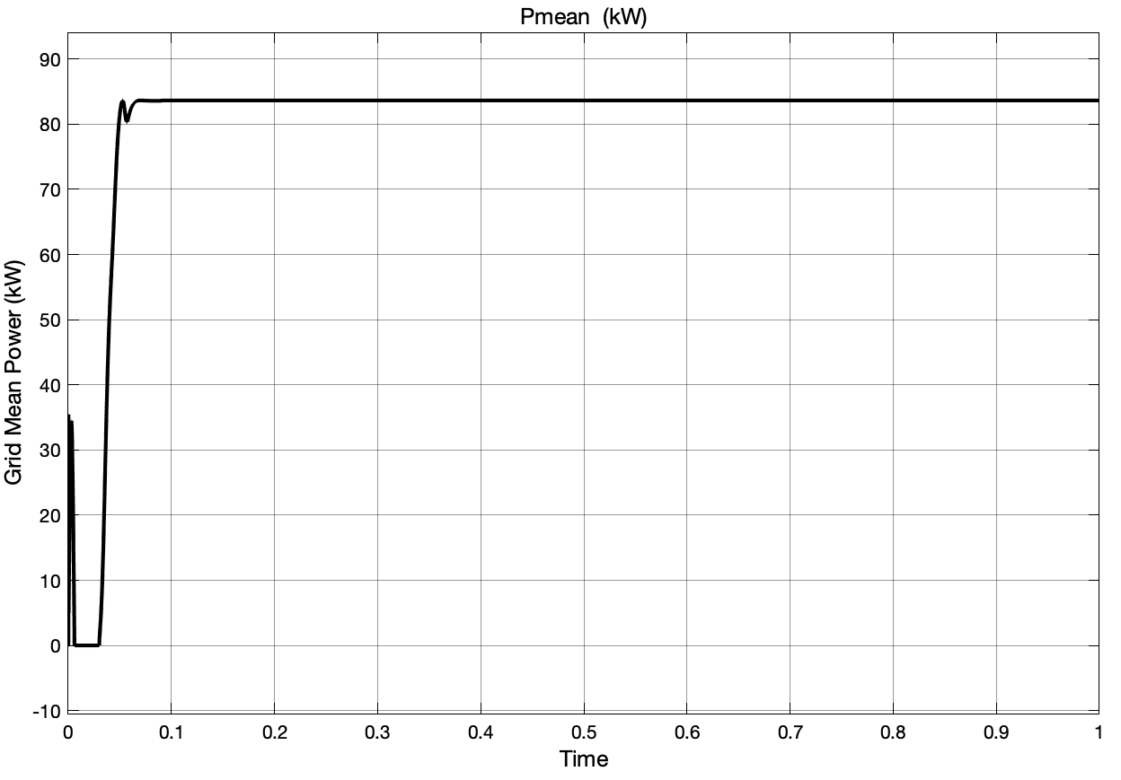

**Fig. 8 (c) Grid Mean Power with FLC**

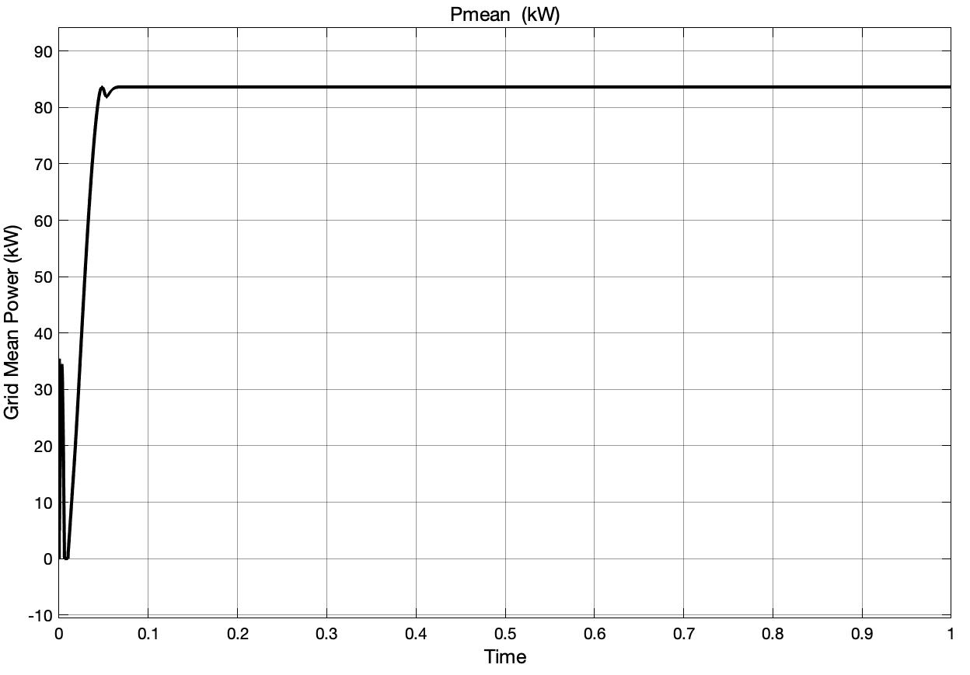

**Fig. 8 (d) Grid Mean Power with proposed AFLC**

The rise time and settling time of proposed controller AFLC in comparison with PI, PID and FLC are tabulated in Table.6.

**Table 6 Solar Grid Mean Power Comparison of tr and ts for PI, PID, FLC and AFLC Considering Constant Irradiance and Temperature**



|  |  |  |  |
| --- | --- | --- | --- |
| **S. No.** | **Controllers** | **tr (sec)** | **ts (sec)** |
|  | **PI** | 0.071 | 0.255 |
|  | **PID** | 0.056 | 0.229 |
|  | **FLC** | 0.021 | 0.088 |
|  | **AFLC** | 0.0089 | 0.041 |

From the above Fig. 8 and Table 6 the proposed AFLC shows the mark reduction in tr and tsin comparison with PI, PID, FLC i.e., 0.0089 sec and 0.041 sec respectively.



The grid voltage Va and current Ia considering PI, PID, FLC and Proposed AFLC are shown in Fig. 9, with the proposed controller the oscillations are decreased.

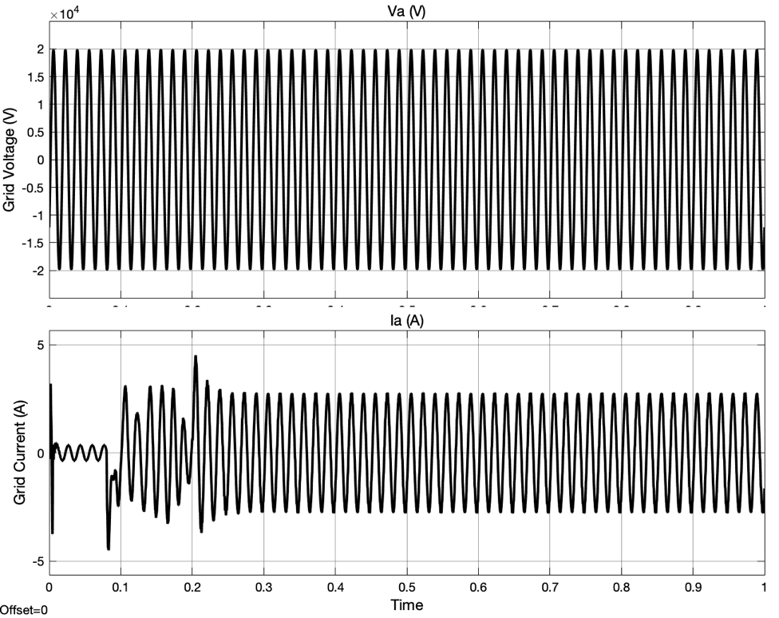

**Fig. 9 (a) Grid Va and Ia with PI Controller**

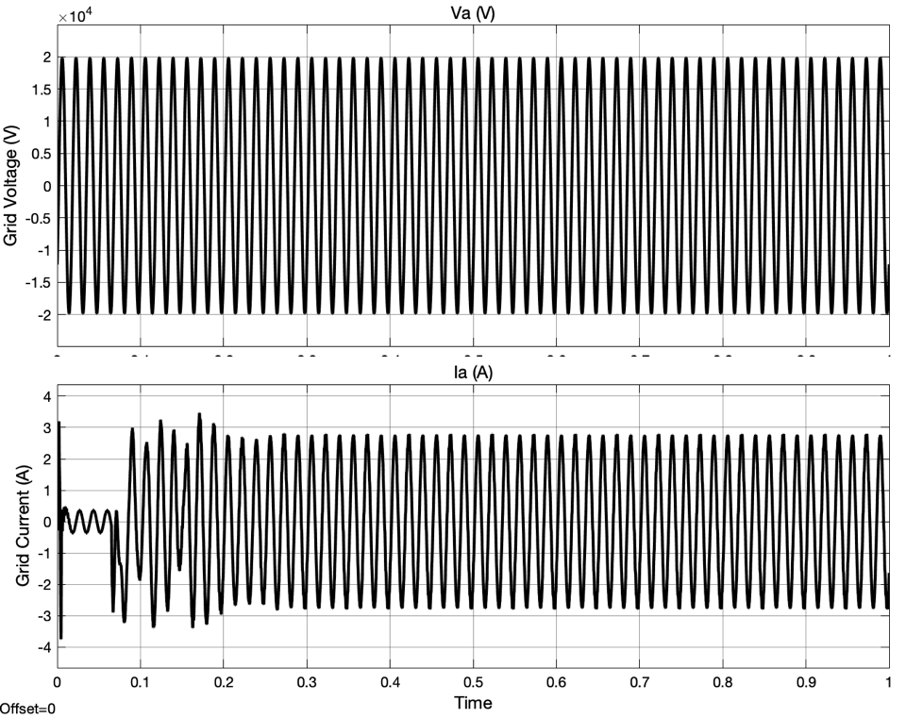

**Fig. 9 (b) Grid Va and Ia with PID Controller**

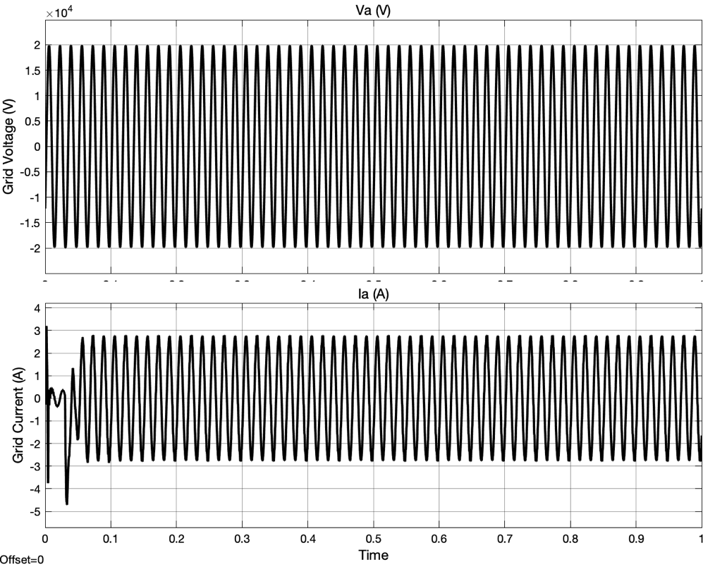

**Fig. 9 (c) Grid Va and Ia with FLC**

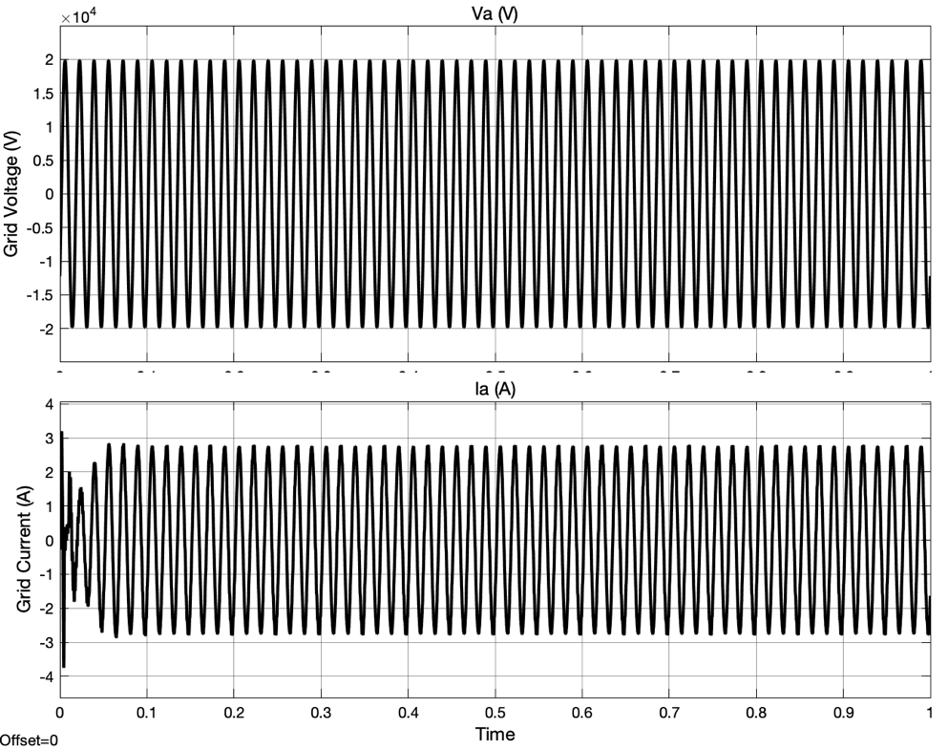

**Fig. 9 (d) Grid Va and Ia with proposed AFLC**

The grid current THD considering PI, PID, FLC and Proposed AFLC are shown in Fig. 10.

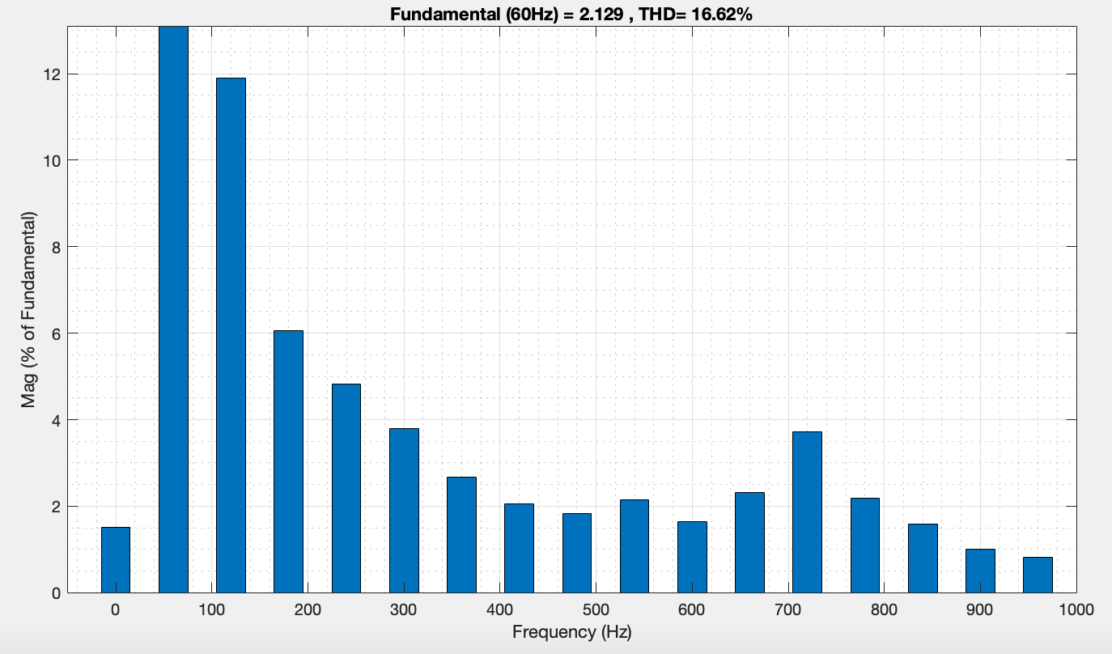

**Fig. 10 (a) Grid Current THD with PI Controller**

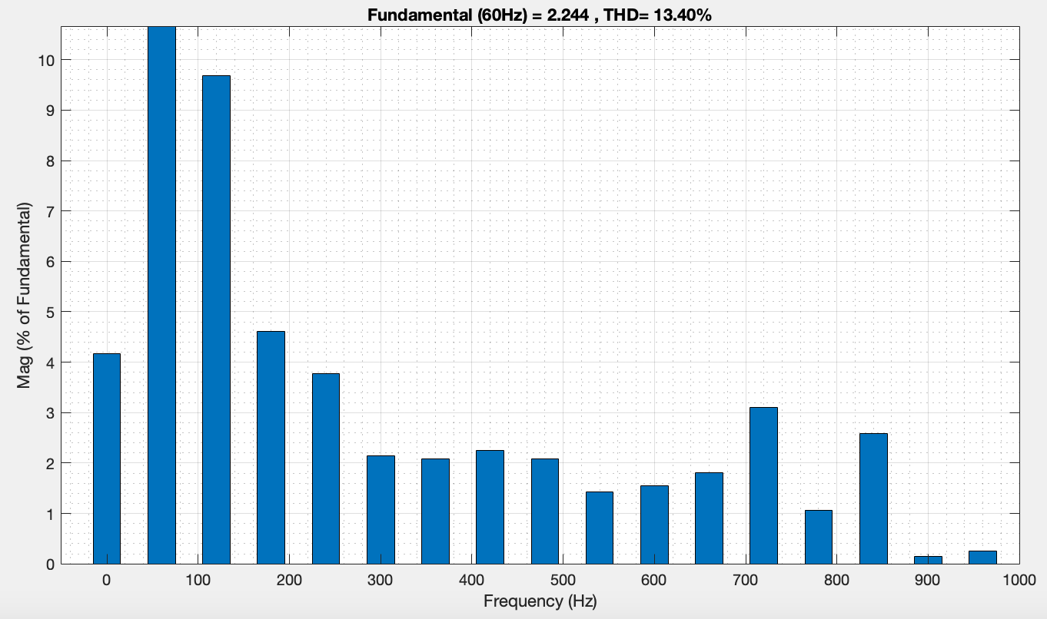

**Fig. 10 (b) Grid Current THD with PID Controller**

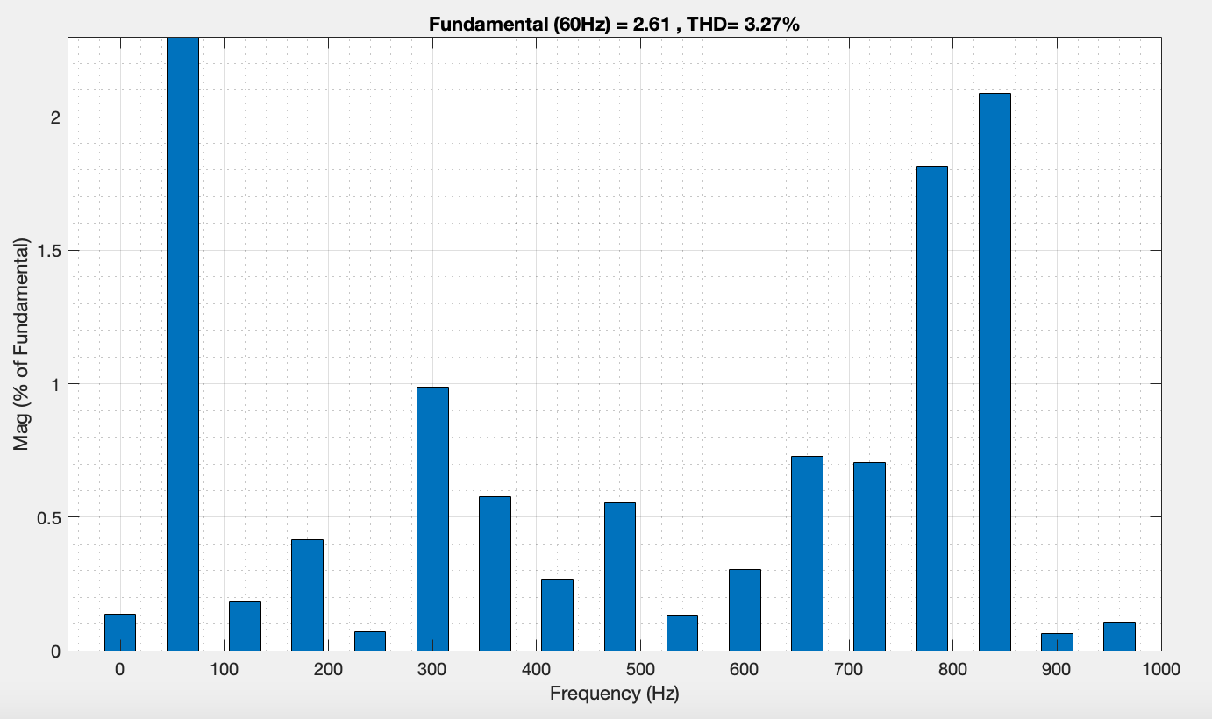

**Fig. 10 (c) Grid Current THD with FLC**

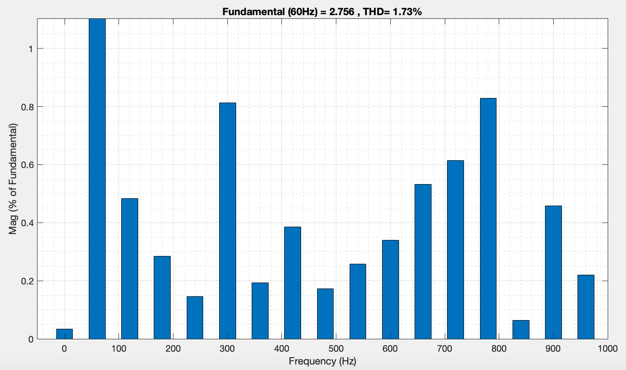

**Fig. 10 (d) Grid Current THD with proposed AFLC**

From the Table 7 the proposed AFLC shows the mark reduction in THD in comparison with PI, PID, FLC i.e., 1.73 %. Hence the proposed AFLC show the superior performance than PI, PID, FLC for solar grid connected system.

**Table 7 THD Comparison of Solar Grid Connected system between PI, PID, FLC and AFLC for Constant Irradiance and Temperature**

|  |  |  |  |  |
| --- | --- | --- | --- | --- |
| **Variable Name** | **THD in %** | | | |
| **PI Controller** | **PID Controller** | **FLC** | **AFLC** |
| Grid Current | 16.62 | 13.40 | 3.27 | 1.73 |

**5. Conclusions:** In this study, a grid-connected solar system is model and developed using MATLAB/Simulink. The proposed Adaptive Fuzzy Logic Controller (AFLC) is implemented in the system, which comprises a DC-DC boost converter, a three-phase DC-AC inverter, and a flat-plate PV panel.

The AFLC demonstrates superior performance by providing a faster response and significantly improving the Total Harmonic Distortion (THD) compared to conventional PI, PID, and standard Fuzzy Logic Controllers (FLC). Specifically, in the solar grid-connected system, the implementation of the AFLC reduces the THD in the grid current from 12.34% to 1.68%. This improvement highlights the effectiveness of the AFLC in enhancing system performance and power quality.