**Sheldon project**

Ultrasound emitter board

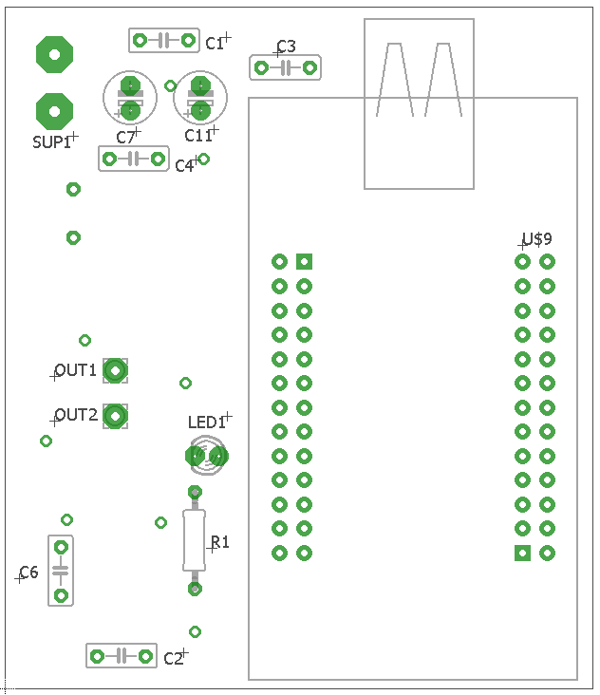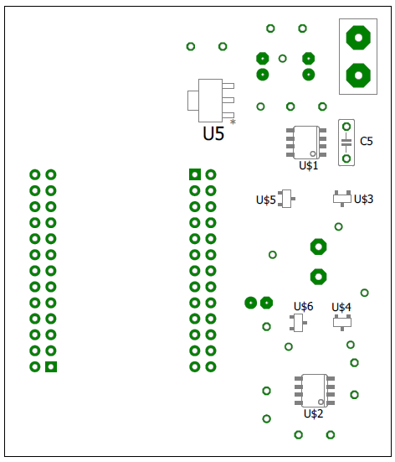

|  |  |  |  |
| --- | --- | --- | --- |
| Part | Value | Device | Package |
| C1 | 100n | C-EU050-025X075 | C050-025X075 |
| C2 | 100n | C-EU050-025X075 | C050-025X075 |
| C3 | 100n | C-EU050-025X075 | C050-025X075 |
| C4 | 100n | C-EU050-025X075 | C050-025X075 |
| C5 | 22µ | C-EU050-025X075 | C050-025X075 |
| C6 | 22µ | C-EU050-025X075 | C050-025X075 |
| C7 | 100µ | CPOL_DIAM5MM | E2,5-6 |
| C11 | 10µ | CPOL_DIAM5MM | E2,5-6 |
| LED1 | LED_3MM | LED_3MM | LED3MM |
| OUT1 |  | 2,54/1,0 | 2,54/1,0 |
| OUT2 |  | 2,54/1,0 | 2,54/1,0 |
| R1 | 500 | R-EU_0207/10 | 0207/10 |
| SUP1 | 9V_BATTERY | 9V_BATTERY | 9V_BATTERY |
| U$1 | MIC4605-2YM | MIC4605-2YM | SOIC08 |
| U$2 | MIC4605-2YM | MIC4605-2YM | SOIC08 |
| U$3 | BSS138BK | BSS138BK | SOT23 |
| U$4 | BSS138BK | BSS138BK | SOT23 |
| U$5 | BSS138BK | BSS138BK | SOT23 |
| U$6 | BSS138BK | BSS138BK | SOT23 |
| U$9 | STM32-H103 | STM32-H103 | STM32-H103 |
| U5 | LM1117MP-3.3 | LM1117MP-3.3 | SOT230P696X180-4N |