**Sheldon project**

Ultrasound receiver board

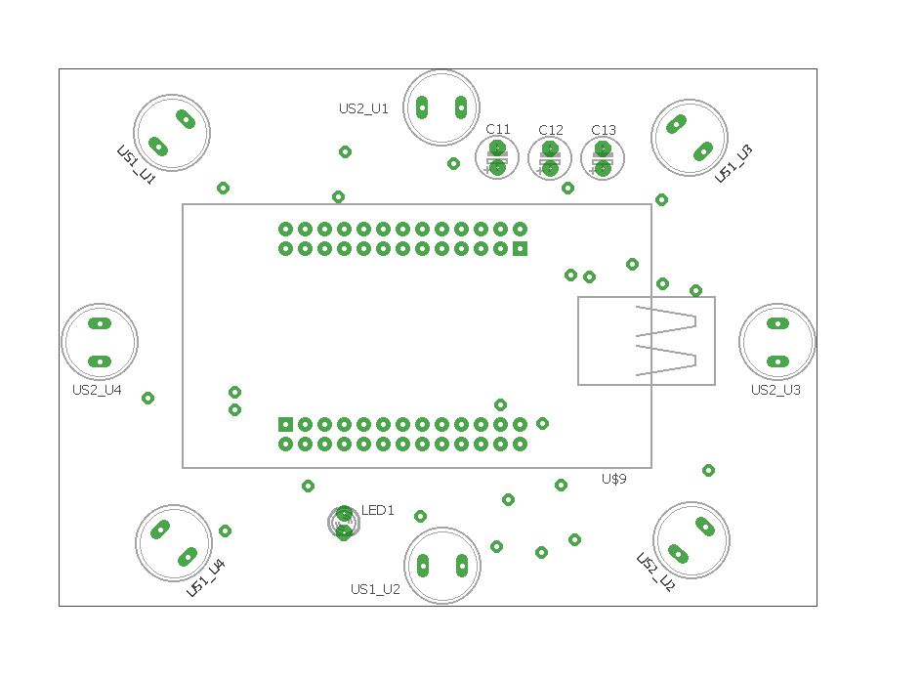

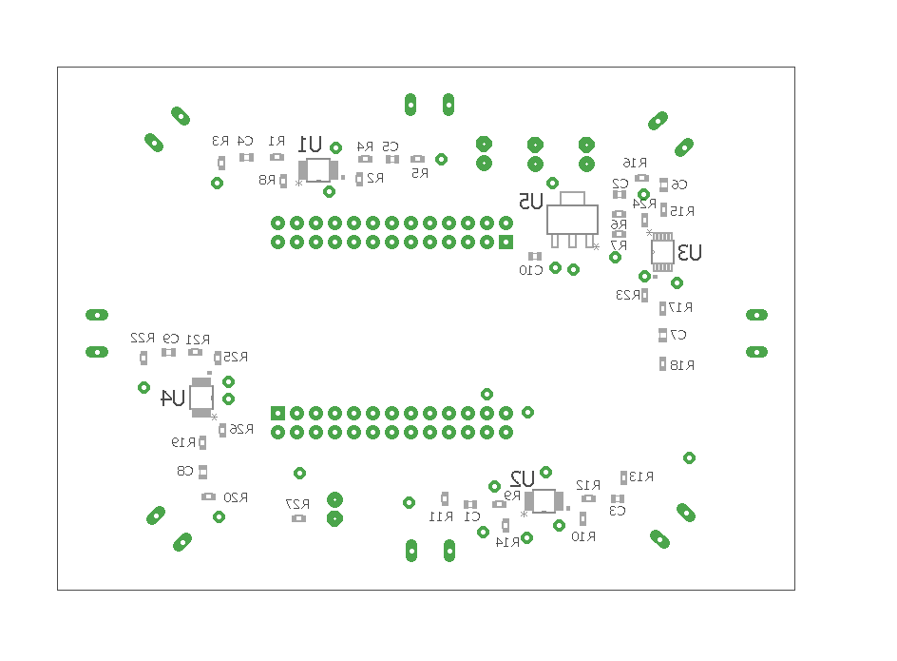

|  |  |  |  |
| --- | --- | --- | --- |
| Part | Value | Device | Package |
| C1 | 100n | C-EUC0603 | C0603 |
| C2 | 100n | C-EUC0603 | C0603 |
| C3 | 100n | C-EUC0603 | C0603 |
| C4 | 100n | C-EUC0603 | C0603 |
| C5 | 100n | C-EUC0603 | C0603 |
| C6 | 100n | C-EUC0603 | C0603 |
| C7 | 100n | C-EUC0603 | C0603 |
| C8 | 100n | C-EUC0603 | C0603 |
| C9 | 100n | C-EUC0603 | C0603 |
| C10 | 100n | C-EUC0603 | C0603 |
| C11 | 100µ | CPOL_DIAM5MM | E2,5-6 |
| C12 | 2.2µ | CPOL_DIAM5MM | E2,5-6 |
| C13 | 2.2µ | CPOL_DIAM5MM | E2,5-6 |
| LED1 | LED_3MM | LED_3MM | LED3MM |
| R1 | 1k | R-EU_R0603 | R0603 |
| R2 | 100k | R-EU_R0603 | R0603 |
| R3 | 4,7k | R-EU_R0603 | R0603 |
| R4 | 1k | R-EU_R0603 | R0603 |
| R5 | 4,7k | R-EU_R0603 | R0603 |
| R6 | 1k | R-EU_R0603 | R0603 |
| R7 | 1k | R-EU_R0603 | R0603 |
| R8 | 100k | R-EU_R0603 | R0603 |
| R9 | 1k | R-EU_R0603 | R0603 |
| R10 | 100k | R-EU_R0603 | R0603 |
| R11 | 4,7k | R-EU_R0603 | R0603 |
| R12 | 1k | R-EU_R0603 | R0603 |
| R13 | 4,7k | R-EU_R0603 | R0603 |
| R14 | 100k | R-EU_R0603 | R0603 |
| R15 | 1k | R-EU_R0603 | R0603 |
| R16 | 4,7k | R-EU_R0603 | R0603 |
| R17 | 1k | R-EU_R0603 | R0603 |
| R18 | 4,7k | R-EU_R0603 | R0603 |
| R19 | 1k | R-EU_R0603 | R0603 |
| R20 | 4,7k | R-EU_R0603 | R0603 |
| R21 | 1k | R-EU_R0603 | R0603 |
| R22 | 4,7k | R-EU_R0603 | R0603 |
| R23 | 100k | R-EU_R0603 | R0603 |
| R24 | 100k | R-EU_R0603 | R0603 |
| R25 | 100k | R-EU_R0603 | R0603 |
| R26 | 100k | R-EU_R0603 | R0603 |
| R27 | 1k | R-EU_R0603 | R0603 |
| U$9 | STM32-H103 | STM32-H103 | STM32-H103 |
| U1 | LMP7712MM | LMP7712MM | SOP50P490X110-10N |
| U2 | LMP7712MM | LMP7712MM | SOP50P490X110-10N |
| U3 | LMP7712MM | LMP7712MM | SOP50P490X110-10N |
| U4 | LMP7712MM | LMP7712MM | SOP50P490X110-10N |
| U5 | LM1117MP-3.3 | LM1117MP-3.3 | SOT230P696X180-4N |
| US1_U1 | US-R-10MM | US-R-10MM | US-R-10MM |
| US1_U2 | US-R-10MM | US-R-10MM | US-R-10MM |
| US1_U3 | US-R-10MM | US-R-10MM | US-R-10MM |
| US1_U4 | US-R-10MM | US-R-10MM | US-R-10MM |
| US2_U1 | US-R-10MM | US-R-10MM | US-R-10MM |
| US2_U2 | US-R-10MM | US-R-10MM | US-R-10MM |
| US2_U3 | US-R-10MM | US-R-10MM | US-R-10MM |
| US2_U4 | US-R-10MM | US-R-10MM | US-R-10MM |