**Exhibit A**: *HCRS Letter to Paul Sargent, Fairlee Town legal counsel, from HCRS Grant Administrator Craig Whipple, 2/28/79*

….Let us attempt to clarify and expand a bit on my letter of February 16

to Ms. Shirley Godfrey regarding harvesting of timber.

It must be pointed out that the Town of Fairlee's project will result in the creation of a public outdoor recreation facility. Once acquired, the property may not ever be converted to any other use that is not deter mined by the Federal Government to be compatible with outdoor recreation. The harvesting of timber can be considered as compatible with recreation provided that it enhances rather than detracts from recreation [nusability" ] of the land. This means in the case of the Lange property that a program of extremely selective cutting keeping in mind such factors as the extent of damage being done to the land by logging machinery is in order, These are the types of items we would expect to see included in the management plan mentioned in my other letter. It must not be a harvesting program for the sake of harvesting timber but rather for the sake of enhancing the recreation value of the land….

Exhibit B: *HCRS Letter to Paul Sargent from Craig Whipple, HCRS Grant Administrator, 1/4/80*

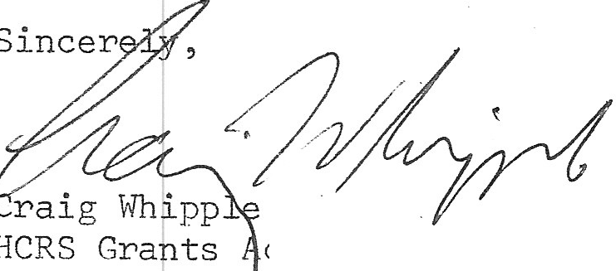

dministrator

….We do know, however, that some requirements are not just regulations but are actually part of the LWCF Act passed by Congress. An example of this is the requirement that no property acquired with assistance from the program may be converted to any use other than outdoor recreation without the consent of the [*continuous text in original*] Secretary of the Interior. This is written into the law and to change that requirement to allow fund assisted property to be converted would take an amendment of the Act and this is not likely to occur.

Exhibit C: *Report of the Advisory Trustee Committee for the Fairlee Heritage Conservation and Recreation Project to the Board of Selectmen 2/29/80*

. . . . 3. The Forest Management Report of Russ Barrett, Orange County Foresteri has been submitted to the Selectmen, which outlines for the project under a multiple use management plan developed by him, sound forestry practices to enhance the four types *of* recreation activities planned for the project—namely: hunting, hiking, snowmobiling, and ski touring, and his report after thoroughly cruising the property specifically covers the number of merchantable feet of cutting to be done under such plan, and the

continuous network of roads and trails to be created to accommodate all levels of such recreation . It also contains some minimum estimates of the dollar proceeds of the sales resulting from such cutting.

**REPORT FROM THE LANGE FOREST BOARD**

Five members were appointed to the Lange Forest Board in April of 1980. The board has worked on:

I. Getting a map that accurately shows the boundaries and is a convenient size.

Walking the boundary lines to learn the terrain and how existing roads and trails

can be utilized

I. Planning an initial trail system to interconnect town lands.

* I. Coordinating efforts with the town energy coordinator and the snowmobile club.

Engaging the county forester in planning trails and land use.

No trails have been marked for use. We welcome any suggestions and help planning for the use of this land.

Dorothy L. D,lliley John W. Hall

Peter Lan ge Robert L Scune James Wan

**RULES AND REGULATIONS OF FAIRLEE HERITAGE CONSERVATION AND RECREATION SERVICE PROJECT (LANGE FOREST)**

Pursuant to the provisions of V.S.A. Title 31, section 202 and 203 there is hereby created a recreational board to be designated the Lange Forest, to consist of five members appointed by the Selectmen such that the term of one member shall expire at the end of each calendar year. The conduct of the Fairlee Heritage Conservation and Recreation Service project is delegated to such board as follows:

1. The FHCRS project shall at all times be conducted in conformity with the provisions of law, both Federal and State, and the conditions set forth or implicit in the terms of the grants therefor, in order to accomplish the development and maintenance of the recreational facilities outlined in the application for the said grants.

B. The project is to be managed by the board in such a way as to require no financial support from the Town's general fund or highway fund. When the proceeds received from the sale of logs and wood products become available from cutting the same in accordance with the Forest Management Report, such proceeds *shall be separately held and accounted for by the Town Treasurer and invested in certificates of interest bearing deposits in banks or in U.S. government bills or bonds* or in agencies whose obligations are guaranteed by the U.S. Government, in order to produce the highest income consistent with safety: and only the income from such funds is to be used by said board in conducting the project, except as the Selectmen may from time to time authorize the use of any principal of said funds. Authorization to the amount of $1500, when the first such proceeds are received is hereby given for the “start up” expenses of the project during 1980. In subsequent years, authorization for expenditures of principal shall be limited to 10% of the principal then on hand. The board however shall have the power to accept and use for the project suitable gifts and bequests to the Town for the project as restricted by the donor or testator or as unrestricted in the use of principal, which donations or bequests, if unrestricted in the use of principal, shall be held by the Town Treasurer separate and apart from the funds which are limited as to the use of income only. ,

.

(The board shall at all times conduct the project as a system of public recreation having in mind the goal of expanding and enhancing four types of recreational activities on FHCRS land, namely; hunting, hiking, snowmobiling and ski touring.

I). Subject to the foregoing the board shall have full power to conduct the project, and without limiting the generality of the foregoing, to lay out, construct and maintain trails and other areas for the above types of recreational activities and to make all reasonable rules and regulations for the use and enjoyment of the same by the public. The layout of any trails crossing other lands of the Town shall be submitted, before construction, to the Selectmen for approval.

E. The board shall make an annual report to the Selectmen of receipts and expenses and operations for the year just past to be delivered to the Selectmen and Town Auditors in time for publication in the Annual Town Report.