**OUTLOOK | Turning Off Cached Mode**

1. Close Outlook
2. Press the **Windows Key + R,** paste in **%AppData%\Microsoft\** and press **Enter**

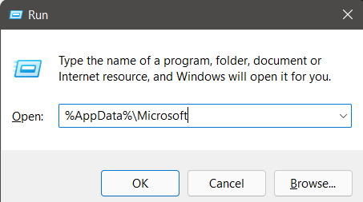

1. Delete the entire **Outlook** folder
2. Press the **Windows Key + R,** paste in **%LocalAppdata%\Microsoft** and press **Enter**

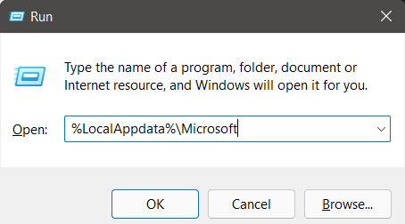

1. Delete the entire **Outlook** folder
2. Open the **Control Panel** change the **View By** option to **Small Icons**, search for/find **Mail** and open it

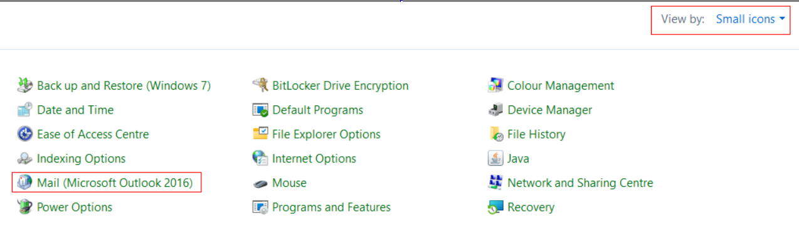

1. Select **Show Profiles** and **Remove** the only profile (usually only one in there)
2. Click **Add…** and type your username into the **Profile Name** section
3. Let the application autofill your account setting (if this step isn’t working, make sure you’re on the VPN/Network) and press Next but **DON’T CLICK FINISH.**
4. Select the **Change Account Settings / Manually configure server settings** box, then press **Next**
5. Make sure **Use Cached Exchange Mode** is **Unticked**
6. Click **Finish** and open Outlook