**Headset Troubleshooting**

**Test to see if it’s installed / 8x8 settings are correct**

1. Start by checking your 8x8 speaker/microphone settings
   1. Open 8x8 and click on the settings cog in the bottom left (It should open up on the Audio & Video tab by default)
   2. Click the drop downs for the Microphone section and the Speakers section at the top and select the device that seems most relevant.

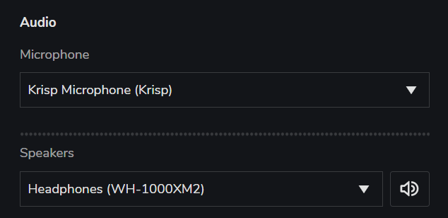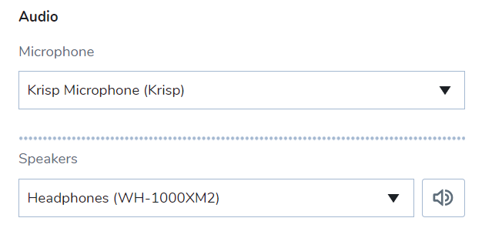

(PLEASE NOTE YOUR DEVICES WILL BE DIFFERENT, THIS IS JUST AN EXAMPLE OF WHERE TO LOOK)

* 1. Complete a test call – you can use either the call testing service at the bottom of the page, or phone a colleague
  2. If there are no options in the dropdowns, or options that don’t look correct (Jabra / Headset / Audio / etc) then:

**Uninstall the driver**

1. 9/10 times when the device doesn’t appear, it’s because of a device driver issue with Windows, to fix this:
   1. Open the Control Panel and set the “View By:” option to “Small icons”, then click on “Device Manager”.

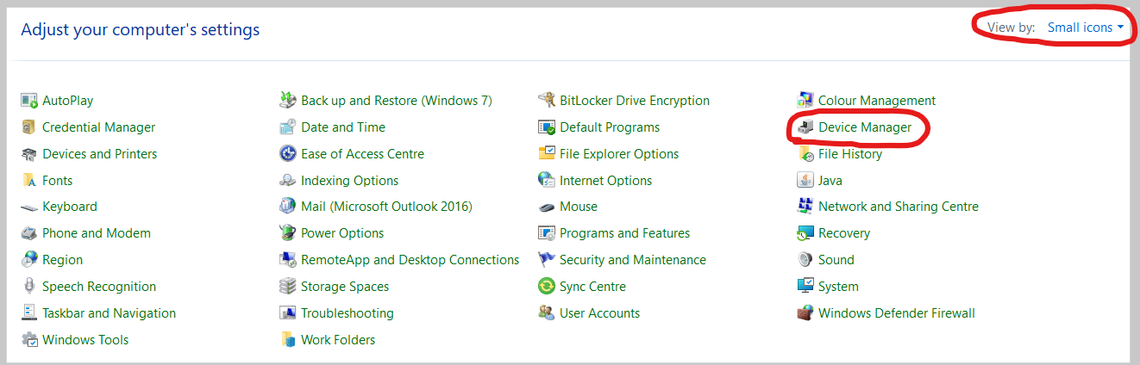

* 1. Locate the headset in the list. It’s usually under:
     1. “Other Devices”, “Unrecognised Devices” or “Universal Serial Bus Controllers” and will usually have the name:
     2. “Jabra Evolve Link MS”, “Unknown Device”, “USB Audio Device”, “USB Audio Headset” (examples below)

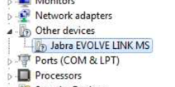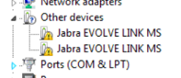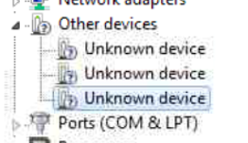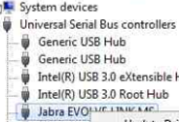

* 1. Once located, right click on the device and select “Uninstall” and let the process complete. It’s usually fairly quick action.

**Install the driver**

1. Unplug your headset from the PC, then plug it back in. The computer should try finding drivers for the device automatically, let this process run. (You can check/view the installation is happening by clicking the icon in the first picture below) Once this box has both “Searched for”, “Downloaded” and successfully “Installed” the appropriate drivers, redo step 1 of this guide.

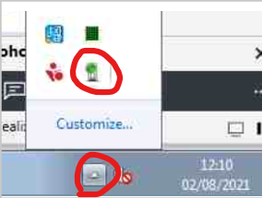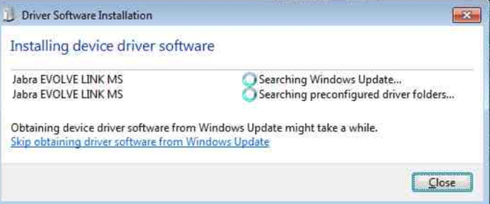

1. If the driver installation fails it’s worth repeating step 1 of this guide again anyway, as sometimes all the necessary parts for the USB headset to work are all installed properly. This is especially common when the driver installation list includes other devices, and only one device fails to install (example below)

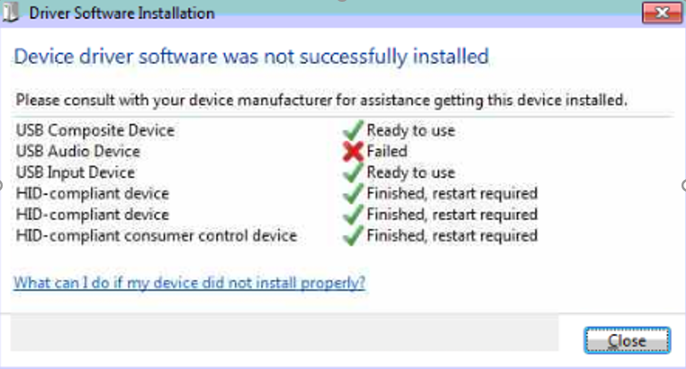

If this happens then:

1. Restart your computer if prompted to do so, then go back to step 1 of this guide.
2. If you’re not prompted to restart your computer, re-do step 2 (find the device and uninstall it, then re-plug it once more)

I know this seems illogical but quite often Windows can give up / timeout if it takes too long, and re-trying this step has worked successfully for me in the past a lot more than it should have.

1. If you plug the device back in and there’s no installation of drivers visible (see step 3 to locate the driver installer) then you should open Device Manager again (steps at beginning of step 2) and locate the device, then right click it and select “Update Driver Software” (see below for example):

You should see this -- >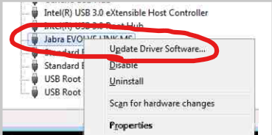

Which will lead to -->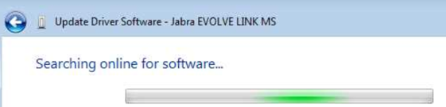

Which will then lead to -->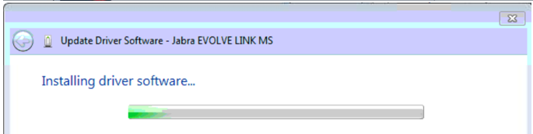

Once this step completes, re-visit step 1

.

1. If you’ve completed all the above or are unsure about any steps / the headset still won’t work, please raise an IT Service Desk ticket!