Bootstrap / AdminLte / Highcharts / Fontawsome

引用文件

主要CSS: bootstrap.css / adminLte.css / font-awsome.css

主要 JS: JQuery.js / bootstrap.js / highchart.js

颜色----------------------------------------------------------------------

主题色：#3C8DBC

背景色：#ECF0F5

常用配色：["#DD4B39","#00C0EF","#F39C12","#00A65A","#3C8DBC","#d2d6de"]

所有主要配色：

lightBlue: "#3c8dbc",

red: "#f56954",

green: "#00a65a",

aqua: "#00c0ef",

yellow: "#f39c12",

blue: "#0073b7",

navy: "#001F3F",

teal: "#39CCCC",

olive: "#3D9970",

lime: "#01FF70",

orange: "#FF851B",

fuchsia: "#F012BE",

purple: "#8E24AA",

maroon: "#D81B60",

black: "#222222",

gray: "#d2d6de"

面板----------------------------------------------------------------------

普通面板

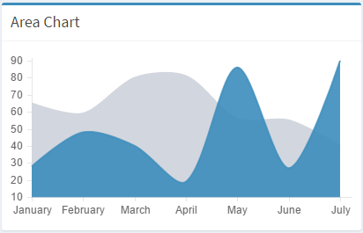

相关代码

<div class="box box-primary">

<div class="box-header with-border">

<h3 class="box-title">标题</h3>

</div>

<div class="box-body">内容</div>

</div>

右侧带操作的面板

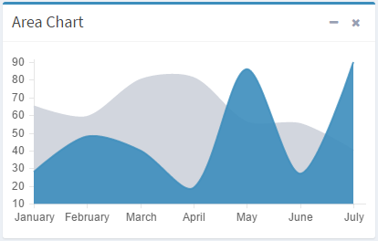

<div class="box box-primary">

<div class="box-header with-border">

<h3 class="box-title">标题</h3>

<div class="box-tools pull-right">

<button type="button" class="btn btn-box-tool" data-widget="collapse"><i class="fa fa-minus"></i>

</button>

<button type="button" class="btn btn-box-tool" data-widget="remove"><i class="fa fa-times"></i></button>

</div>

</div>

<div class="box-body">内容</div>

</div>

带tab面板

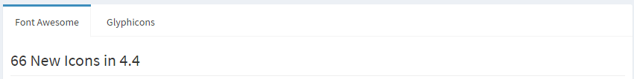

<div class="nav-tabs-custom">

<ul class="nav nav-tabs">

<li class="active">

<a href="#a" data-toggle="tab">tab a</a>

</li>

<li>

<a href="#b" data-toggle="tab">tab b</a>

</li>

</ul>

<div class="tab-content">

<div class="tab-pane" id="a">面板a</div>

<div class="tab-pane" id="b">面板b</div>

</div>

</div>

不同边框颜色面板

深蓝

.box.box-primary {

border-top-color: #3c8dbc;

}

浅蓝

.box.box-info {

border-top-color: #00c0ef;

}

红色

.box.box-danger {

border-top-color: #dd4b39;

}

橙色

.box.box-warning {

border-top-color: #f39c12;

}

绿色

.box.box-success {

border-top-color: #00a65a;

}

灰色

.box.box-default {

border-top-color: #d2d6de;

}

信息面板---------------------------------------------------------------

面板1



<div class="col-xs-3">

<div class="info-box">

<span class="info-box-icon bg-red"><i class="fa fa-dashboard"></i></span>

<span class="label label-danger pull-left">提醒数字</span>

<div class="info-box-content">

<a style="cursor: pointer;" class="info-box-content_a">

<span class="info-box-text">信息名称</span>

<span class="info-box-number">相关数量</span>

</a>

</div>

</div>

</div>

面板2

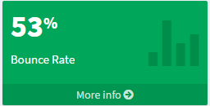

<div class="small-box bg-green">

<div class="inner">

<h3>相关数量</h3>

<p>信息名称</p>

</div>

<div class="icon">

<i class="ion ion-stats-bars"></i>

</div>

<a href="#" class="small-box-footer">查看更多<i class="fa fa-arrow-circle-right"></i></a>

</div>

表格----------------------------------------------------------------------

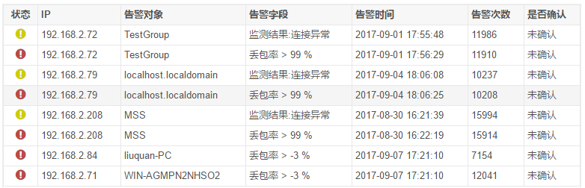

<table class="table table-bordered table-hover">

<thead></thead>

<tbody></tbody>

</table>

状态



<i title="紧急" class="fa fa-exclamation-circle" style="font-size: 16px;color: #b94a48;"></i>

<i title="警告" class="fa fa-exclamation-circle" style="font-size: 16px;color: #cdcd00;"></i>



<td class=”status-urgent”></td>

<td class=”status-waring”></td>

数量





<span class="badge" style="background:#b94a48">29</span>&nbsp;

<span class="badge" style="background:#cccc00">45</span>&nbsp;

<span class="badge" style="background:#468847">272</span>&nbsp;

<span class="badge" style="background:#3a87ad">737</span>&nbsp;

<span class="badge" style="background:#aaaaaa">34</span>&nbsp;

操作图标



<a title="信息" class="modal-btn">

<i class="glyphicon glyphicon-list"></i>

</a>

按钮



<div class=" pull-right">

<button type="button" class="btn btn-primary btn-sm">

<i class="fa fa-plus-circle"></i> 创建

</button>

<button type="button" class="btn btn-danger btn-sm">

<i class="fa fa-minus-circle"></i> 删除

</button>

</div>

进度条-------------------------------------------------------------------------



<div class="progress-group">

<span class="progress-text">进度名称</span>

<span class="progress-number">进度百分比</span>

<div class="progress progress-striped progress-mini" style="height:12px; border-radius:5px">

<div class="progress-bar progress-bar-primary active" aria-valuenow="100" aria-valuemin="0" aria-valuemax="100" style="width: 95%;">

</div>

</div>

</div>

可改变颜色/圆角/动画效果

progress-bar-primary / border-radius:5px / active

图表---------------------------------------------------------------

easyPieChart  
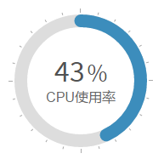

<style>

.pieBox{

width:100%;height:180px;

}

.piechart {

position: relative;display: block; width: 170px; height: 170px;line-height: 170px;text-align: center;line-height: normal;

}

.piechart h1{

margin: 1.5em 0 0 0;

}

.piechart canvas {

position: absolute; top: 0; left: 0;

}

.piechart .percent {

display: inline-block; z-index: 2;

}

.piechart .percent:after {

content: '%'; margin-left: 0.1em; font-size: .8em;

}

.piechart .pieTitle{

font-size:16px;

}

</style>

<div class="pieBox">

<div data-percent="43" class="chart1 piechart center-block">

<h1 class="m-top-lg m-bottom-none percent">43</h1>

<div class="pieTitle">CPU使用率</div>

<canvas height="170" width="170"></canvas>

</div>

</div>

<script>

$('.chart1').easyPieChart({

size: 170,

barColor: "#3C8DBC",//"#D9534F", //固定颜色

barColor: function(percent) { //随进度改变颜色

if(percent<=40){

return '#37CD86';

}else if(percent>40&&percent<=80){

return '#3AADA4';

}else{

return '#2F9DD4';

}

},

trackColor: '#ddd',

scaleColor: '#aaa',

lineWidth: 15,

onStep: function(from, to, percent) {

$(this.el).find('.percent').text(Math.round(percent));

}

})

</script>

Highcharts-pie