SYSTEM INTEGRATION
DOCUMENTATION

dbms_studentfeedback & Library-Management-System
API INTEGRATION

Submitted by:
Onita, Armark B.

Submitted To:
Emannuel Saligue

Date:
May 14, 2026

1. System Overview
This project is a school-based integrated information system of two platforms the dbms_studentfeedback system (PHP) and the Library Management System (C# Windows Forms). These two systems are connected through a centralized MySQL database using a Node.js REST API. The integration follows a common database architecture where the API serves as the communication bridge between the PHP-based feedback system and the C# library system. Instead of directly accessing the database, both systems interact with the API, ensuring controlled and consistent information. This design allows both systems to use a single source of truth, minimizes data redundancy, and enables efficient issuing and submission of information such as student feedback and library records through HTTP REST endpoints.
1.1 Architecture Diagram
SYSTEM 1 | BRIDGE / API | DATABASE | SYSTEM 2
Student Feedback  PHP Web Application | Node.js REST API  Express Server  Port 3000 | MySQL Database  common_library_db | Library-Management-System  C# Windows Forms  .NET Framework 4.8

1.2 Technology Stack
Component | Technology
PHP System (Student Feedback) | PHP, HTML, CSS, JavaScript, form submission through HTTP/API
C# System (Library Management System) | C# Windows Forms, .NET Framework 4.8, Newtonsoft.Json, HttpClient
API Middleware | Node.js, Express.js, mysql2, cors, crypto
Database | MySQL database: common_library_db
API Protocol | HTTP REST using JSON request and response
API Base URL | http://localhost:3000
SYSTEM 1: dbms_studentfeedback (PHP Web App)

2. Student Feedback PHP Web Application
The student feedback system is a PHP based web application used for collecting student evaluation and library-related feedback. The form data is sent to the Node.js API and stored in the centralized MySQL table named student feedback.
2.1 System Purpose
• Allow students or users to submit feedback records through a web form.
• Store evaluation details such as academic year, semester, branch, section, subject, ratings, remarks, and creation date.
• Send submitted feedback to the Node.js API endpoint /api/feedback.
• Allow feedback records to be viewed by the integrated C# Library Management System.
• Support centralized data storage using the common_library_db database.

2.2 Main Data Fields
Field | Purpose
academic_year | Stores the academic year of the feedback record.
semester | Stores the semester selected by the user.
feedback_date | Stores the date when the feedback was made.
department/course | Stores the department or course information.
year/section | Stores the student year and section.
ques1 to ques4 | Stores rating or answer values from the feedback form.
remarks | Stores additional comments from the user.
feedback category | Stores the category feedback from the user.

2.3 Database Table Used
Table Name | Description
student_feedback | Stores all submitted feedback records from the dbms_studentfeedback PHP system. The table contains feedback_id, academic_year, semester, feedback_date, department, section, feedback category, question answers, remarks, and created_at.

2.4 API Connection
The PHP feedback system connects to the API using the endpoint POST /api/feedback. The API receives the form fields, validates them through the server logic, and inserts the record into the student_feedback table.
SYSTEM 2: Library-Management-System (C# Desktop App)
3. Library-Management-System — C# Desktop Application
The Library-Management-System is a Windows Forms desktop application developed in C#. It provides library functions such as user login, adding books, issuing books, and viewing student feedback records submitted from the PHP system.
3.1 System Purpose
• Provide a desktop interface for library users and administrators.
• Authenticate users through the Node.js /login API endpoint.
• Add new books through the /books API endpoint.
• Load book lists and issue books through the /books and /issue endpoints.
• View issued book records through the /issued endpoint.
• Display feedback records from the PHP system through the /api/feedback endpoint.
3.2 Project Structure
File/Form | Purpose
Program.cs | Application entry point that launches the Windows Forms application.
Form1.cs | Welcome/startup form with options such as user login, test API, and exit.
UserLogin.cs | Login form that authenticates users through http://localhost:3000/login.
mainDashbboard.cs | Main navigation dashboard for library functions.
addBook.cs | Form used to add new book records through the /books endpoint.
issueBook.cs | Form used to load books, issue books to borrowers, and view issued records.
FeedbackDetails.cs | Form that retrieves and displays records from /api/feedback.
Library Management System.csproj | C# project file targeting .NET Framework.
packages.config | NuGet package list, including Newtonsoft.Json and MySql.Data.

3.3 Forms and UI Interface
Form | Description
Form1.cs | Displays the welcome page of the library system.
UserLogin.cs | Allows users to sign in using email and password.
mainDashbboard.cs | Provides buttons for Add Book, Issue Book, Feedback Details, and other features.
addBook.cs | Allows input of title, ISBN, author, genre, description, published date, and quantity.
issueBook.cs | Allows selecting a book and borrower name, then saving the issue transaction.
FeedbackDetails.cs | Shows feedback records from the PHP feedback system in a DataGridView.

3.4 Dependencies
Package | Version / Notes
Newtonsoft.Json | 13.0.4 - used for JSON serialization and deserialization.
MySql.Data | 9.6.0 - available for MySQL-related features.
Microsoft.Data.SqlClient | 7.0.0 - included in project dependencies.
System.Text.Json | 10.0.3 - JSON support package.
.NET Framework | Project targets .NET Framework 4.8.

THE BRIDGE: Node.js REST API (Shared Middleware)

4. Node.js REST API Documentation
The Node.js Express.js server acts as the central bridge between the dbms_studentfeedback PHP system and the Library-Management-System C# desktop application. It runs on port 3000 and connects to the centralized MySQL database common_library_db.
4.1 Server Configuration
Property | Value
Runtime | Node.js
Framework | Express.js
Port | 3000 (http://localhost:3000)
Body Parser | express.json() and express.urlencoded()
Database | common_library_db
MySQL Host | localhost, user root, no password for local development
Main Server File | server.js

4.2 API Endpoints
Method | Endpoint | Description | Used By
GET | / | Checks if the API is running. | Browser/API test
GET | /health | Returns API and database health status. | C# test API button
POST | /login | Authenticates users using email and MD5-hashed password. | C# UserLogin / system login
POST | /books | Adds a new book to lms_books. | addBook.cs
GET | /books | Retrieves book list for combo boxes and display. | issueBook.cs
POST | /issue | Issues a selected book to a borrower. | issueBook.cs
GET | /issued | Retrieves issued book records with book title and borrower details. | issueBook.cs / reports
POST | /api/feedback | Saves feedback submitted from the PHP system. | dbms_studentfeedback
GET | /api/feedback | Retrieves all feedback records. | FeedbackDetails.cs

4.3 Key API Endpoint Details
4.3.1 User Login
The /login endpoint is used to authenticate library users. The API hashes the submitted password using MD5 and compares it with the password stored in the lms_user table.
• Method: POST
• Endpoint: /login
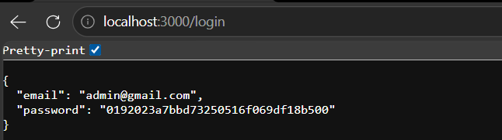
4.3.2 Add Book
The /books endpoint inserts a new book record into the lms_books table. It requires at least the title and ISBN fields.
• Method: POST
• Endpoint: /books
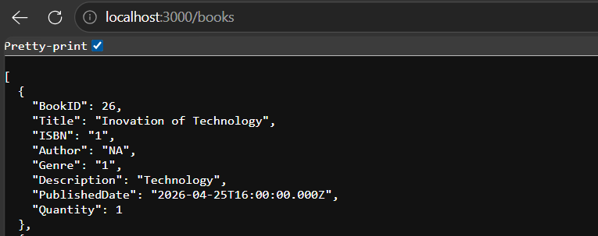

4.3.3 Issue Book
The /issue endpoint records a book borrowing in lib_book_issue. It stores the book ID, borrower name, issue date, return date, and status.
• Method: POST
• Endpoint: /issue
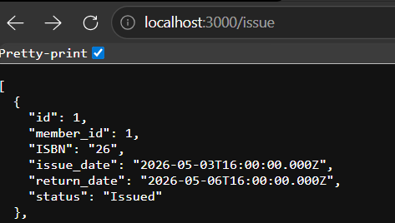
4.3.4 Submit Feedback
The /api/feedback endpoint receives feedback records from the PHP dbms_studentfeedback system and saves them into the student_feedback table.
• Method: POST
• Endpoint: /api/feedback
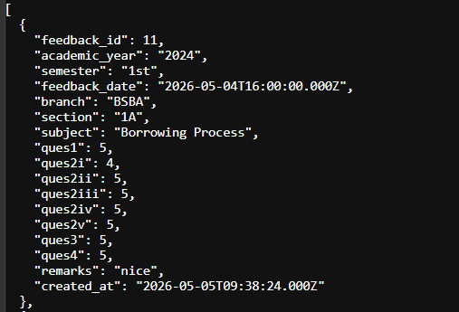

4.3.5 View Feedback
The GET /api/feedback endpoint retrieves all feedback records and is used by FeedbackDetails.cs to show feedback in the C# application.
• Method: GET
• Endpoint: /api/feedback
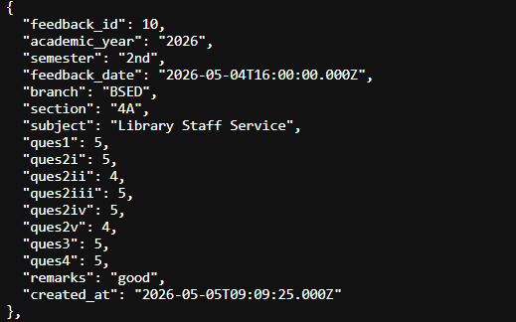
5. Database Documentation
The common_library_db database is the shared data source used by the PHP feedback system, Node.js API, and C# Library Management System.
Table Name | Description
lms_user | Stores user role, email, MD5 password,.
lms_books | Stores book records such as Title, Author, Genre, Quantity, ISBN, PublishedDate, and Description.
lib_book_issue | Stores issued book used by the C# issue book feature.
student_feedback | Stores feedback entries submitted from the PHP dbms_studentfeedback system.

6. Setup and Installation Guide
6.1 Prerequisites
Requirement | Details
XAMPP / WAMP | Used to run Apache/PHP and MySQL locally.
Node.js | Used to run the Express.js REST API server.
npm packages | Install express, mysql2, cors, and body-parser.
Visual Studio | Used to open and run the C# Windows Forms project.
NuGet packages | Restore packages such as Newtonsoft.Json and MySql.Data.
MySQL database | Import common_library_db.sql before running the systems.

6.2 Step-by-Step Setup
• Start Apache and MySQL in XAMPP.
• Create a database named common_library_db in phpMyAdmin.
• Import the common_library_db.sql file.
• Open the library_api folder in VS Code or terminal.
• Run npm install to restore Node.js packages.
• Run node server.js to start the API on port 3000.
• Test the API using http://localhost:3000/health.
• Open the Library-Management-System project in Visual Studio.
• Restore NuGet packages and run the Windows Forms application.
• Open the dbms_studentfeedback PHP system through localhost and submit feedback to test integration.
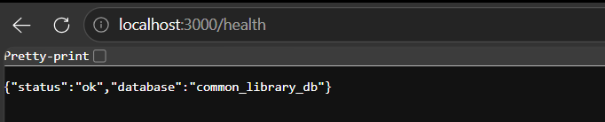
6.3 API Test Commands

7. Integration Flow
• The user submits feedback from the PHP dbms_studentfeedback system.
• The PHP system sends the feedback data to POST /api/feedback.
• The Node.js API inserts the record into the student_feedback table.
• The C# Library Management System opens FeedbackDetails.cs.
• FeedbackDetails.cs calls GET /api/feedback.
• The API returns feedback records and the C# system displays them in the interface.
• For library operations, the C# system sends book and issue to the same API and database.
8. Conclusion
The integration of dbms_studentfeedback and Library-Management-System through a Node.js REST API provides a centralized and organized system architecture. The common_library_db database serves as the shared source of truth, while the API ensures that both the PHP web application and C# desktop application can communicate using structured JSON data. This design improves consistency, reduces duplicate data entry, and supports a professional system integration setup.

UI Interface
Library Management System Feedback (PHP WEB)

index.php
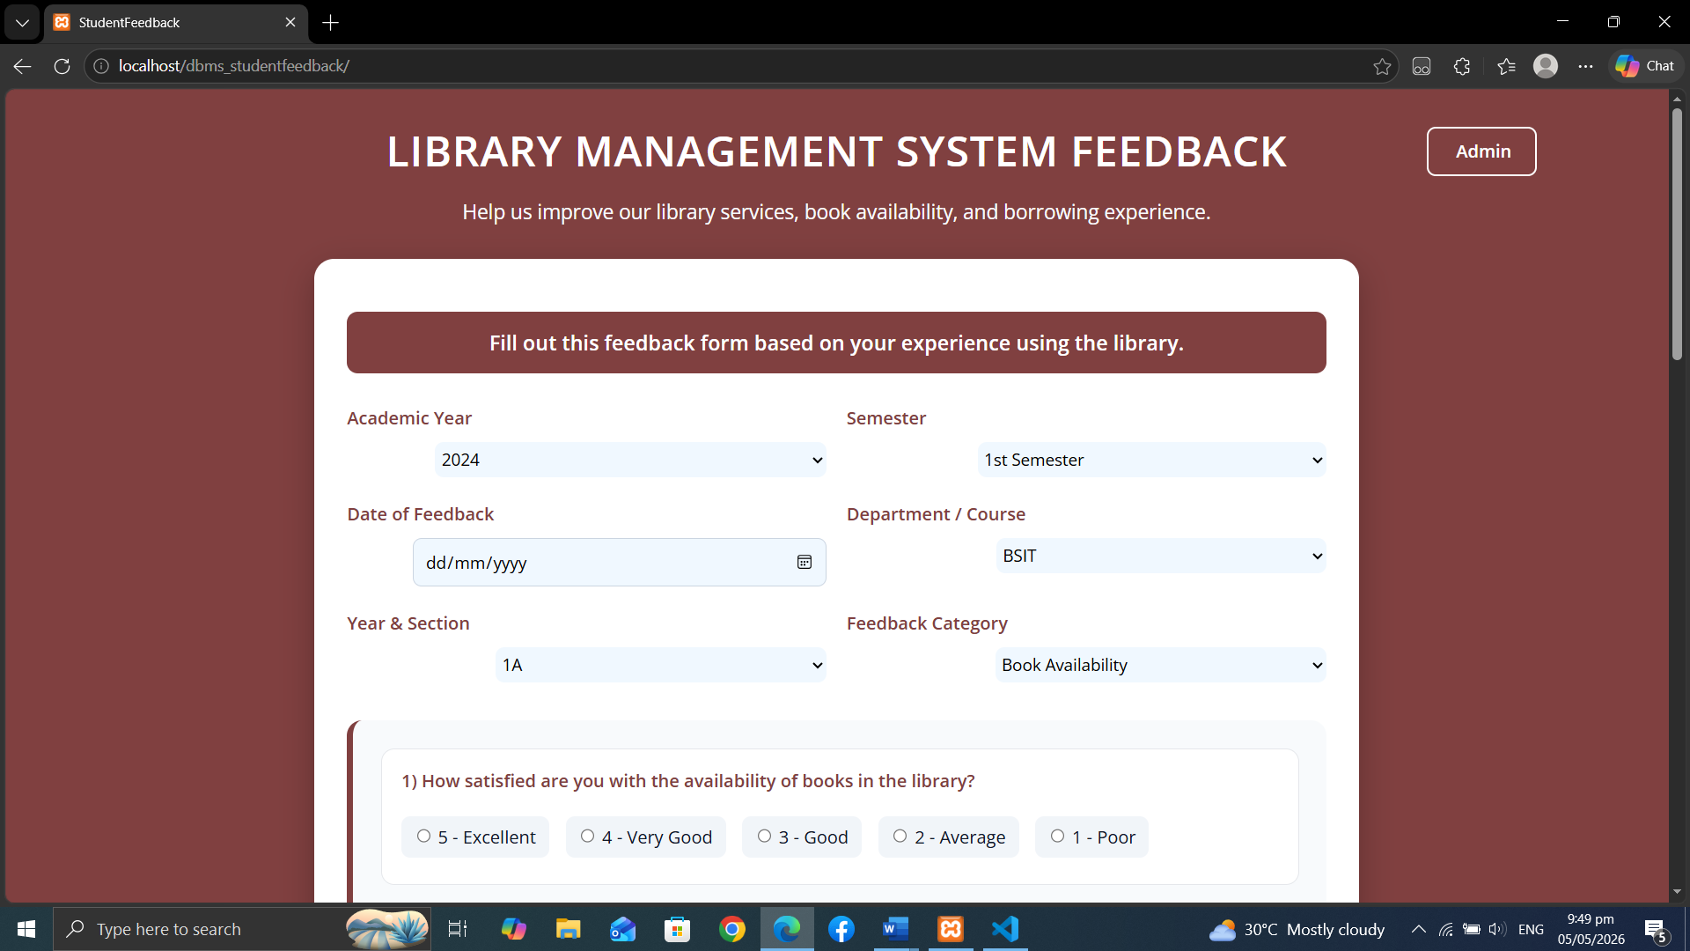

adminpage.php
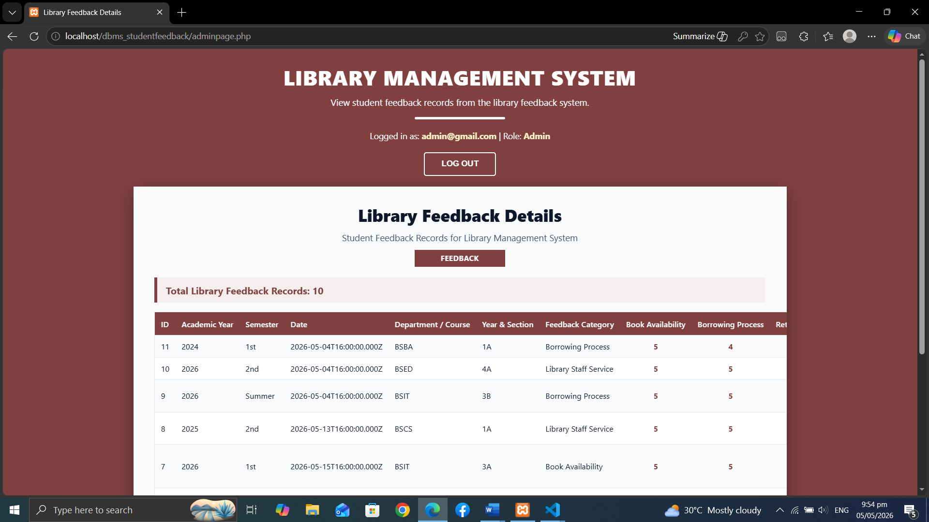

admin.php
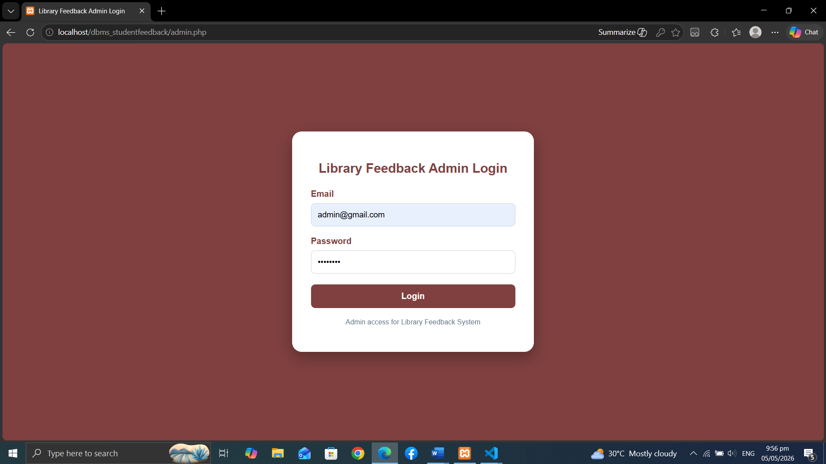

UI Interface
Library Management System (C#)
Login
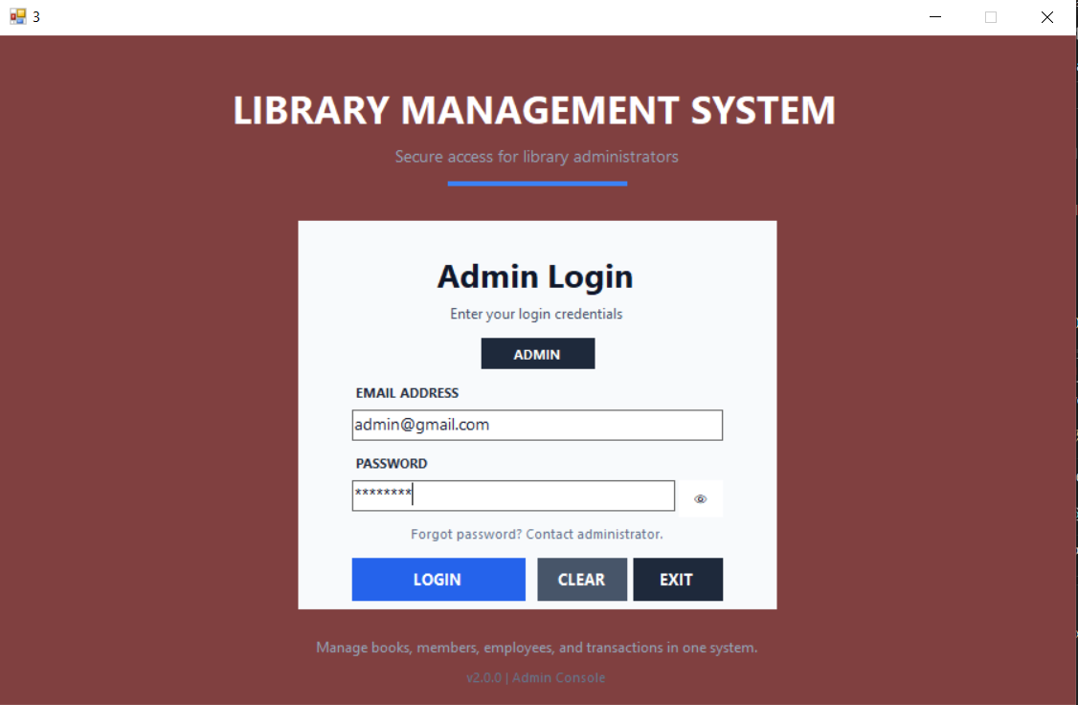

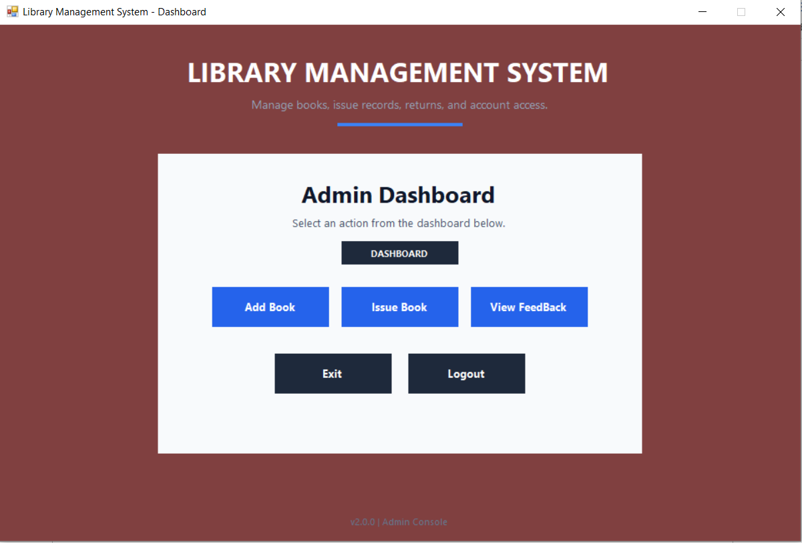
Admin Dashboard Interface

AddBook
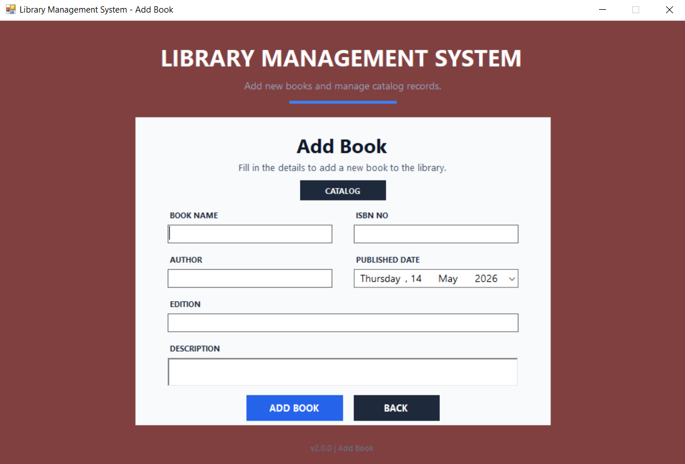

IssueBook
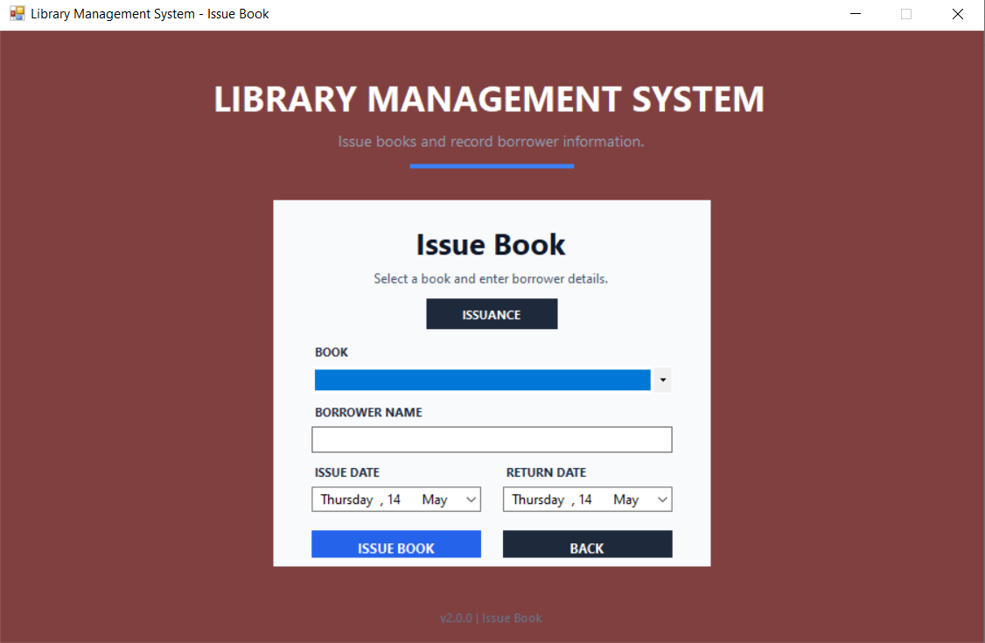

View Feedback
