**Simulation of Dumbbell Model using Brownian Dynamics**

We model a polymer chain as a dumbbell — two beads connected by a nonlinear spring — and simulate its motion using Brownian dynamics.

Initial positions of both beads are set to the origin, and the system is evolved for time steps with a dimensionless timestep.

**Results**

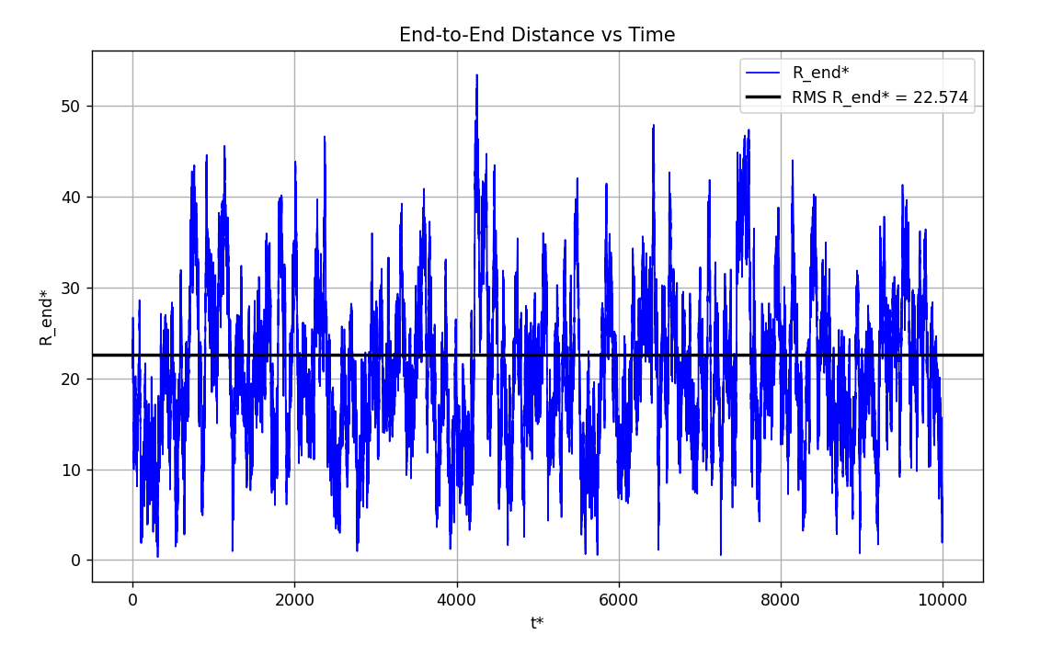

The result shows a plot of the end-to-end distance(R*end) of a polymer chain versus dimensionless time, obtained from a Brownian dynamics simulation. The blue line represents the average R*end over five independent simulations, fluctuating around 20–25, which is consistent with the expected behaviour of a Gaussian chain. A black horizontal line marks the root mean square (RMS) value of R*end , calculated as approximately 22.3, very close to the theoretical value of sqrt{500}, approx 22.36 . The simulation was run for t* = 10000 with a time step of delta t* = 0.001, using a linear Gaussian spring force to model the chain, ensuring the RMS value aligns with theoretical expectations for a Gaussian polymer chain with 500 Kuhn lengths.