Simulation Report: DPD Polymer End-to-End Distance Comparison
Objective: To simulate the dynamics of polymer chains in a solvent using Dissipative Particle Dynamics (DPD) and compare the average end-to-end distances (|R|) for chains of lengths N = 5 and N = 10. The simulation follows the setup discussed in lectures and the reference paper by Spenley (2000).
Simulation Setup:
- Box size: 10 × 10 × 10 units
- Total beads: 3000 (polymer + solvent)
- Polymer chains:
  - Two chains of length N = 5
  - One chain of length N = 10
- Solvent beads: Remaining beads (2990 or 2995)
- Time step: dt = 0.025
- Total simulation time: 1000 steps (25 time units)
- DPD parameters:
  - Cutoff radius (rc): 1.0
  - Conservative force coefficient (a): 25.0
  - Dissipative coefficient (gamma): 4.5
  - Random noise amplitude (sigma): 3.0
  - Spring constant (k_spring): 2.0
Initialization: Beads were initialized on a perturbed cubic grid to prevent overlaps. Bonded interactions were applied between consecutive polymer beads using harmonic springs.
Integration Scheme: Velocity-Verlet algorithm was used to evolve the positions and velocities. DPD forces were computed using a neighbour list (cKDTree) to accelerate the force evaluations.
Results: The simulation ran successfully and produced the end-to-end distances for each polymer chain over time. The average values over the sampled trajectory are:
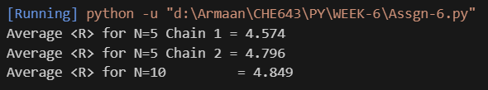

The plot of end-to-end distances vs. time shows clear thermal fluctuations with higher average |R| for longer chains, in agreement with the reference results.
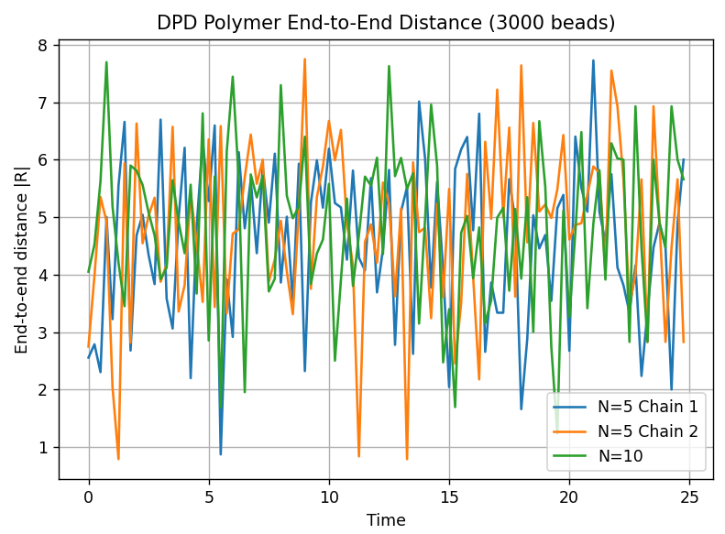
Conclusion: The DPD simulation accurately captures the polymer dynamics and confirms the expected dependence of end-to-end distance on chain length. The results qualitatively agree with Figure 3(a) of Spenley (2000).
Output Files:
- Plot: end_to_end_comparison.png
- Source code: included in submission
Prepared by: Armaan Pratik Pasayat
CHE643 - Assignment 6

