Brownian Dynamics of a Polymer Chain Under Shear Flow
Armaan Pratik Pasayat
230195
Objective
To simulate the dynamics of a polymer chain modelled as a 4-bead bead-spring system under varying shear flow conditions using Brownian dynamics. The goal was to observe how shear rate affects polymer configuration and compute the steady-state viscosity for different shear rates.

Methodology
- The polymer chain was modelled as 4 beads connected by nonlinear springs.
- Simulations were performed in dimensionless units using the Euler integration scheme.
- Brownian motion and shear flow were included in the equation of motion.
- The Kramers expression was used to compute instantaneous shear stress:
- Simulations were run for a range of shear rates (gamma* = 0.001 to 1), and a flow curve was generated using Python.

MATLAB Visualization
- Videos were created for two shear rates:
  - Low shear (gamma* = 0.001): The polymer shows coiled, fluctuating motion dominated by Brownian effects.
  - High shear (gamma* = 1): The polymer stretches and aligns with the flow direction, with occasional tumbling — flow dominates thermal motion.

Results
- The flow curve shows:
  - A Newtonian plateau at low shear rates (constant viscosity).
  - A shear-thinning regime at higher shear rates (viscosity decreases with increasing γ̇).
- The trend matches experimental observations and theoretical predictions in polymer rheology upto an extent.
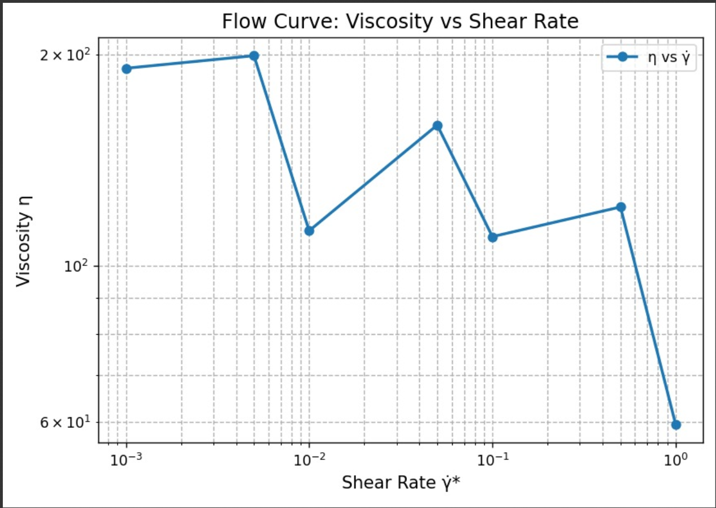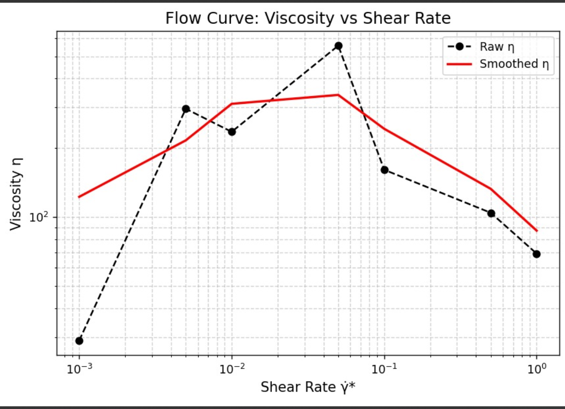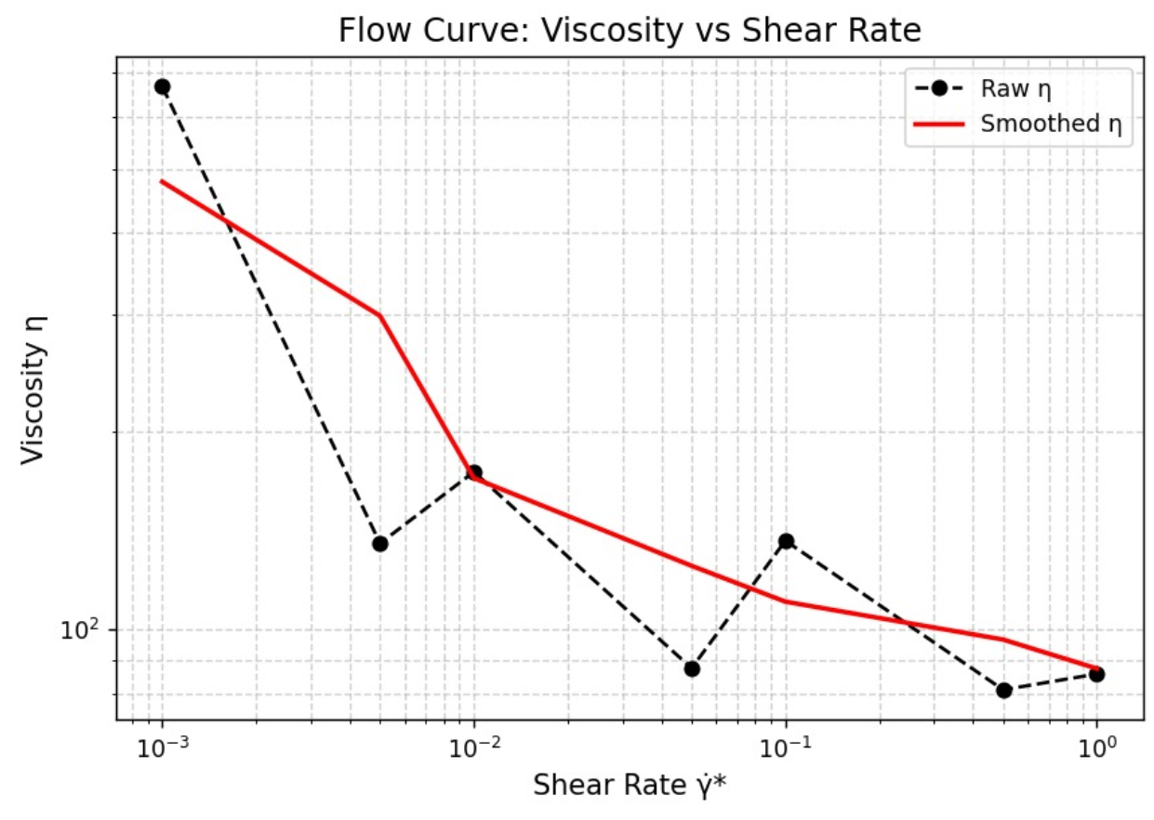

Conclusion
This project demonstrates how shear flow influences polymer chain dynamics. At low shear, Brownian motion dominates, leading to isotropic fluctuations. At high shear, chains stretch and align with the flow. The viscosity behaviour confirms classic non-Newtonian characteristics of polymer solutions.

