A

Project Report on

**SWIMMER PERFORMANCE ANALYSIS**

Submitted in partial fulfillment of the requirements for the award of the degree of

**Bachelor of Technology**

in

**Computer Science and Engineering**

Submitted by

**TATIKONDA BHARATHI (21P31A05C5)**

**ARMAAN YUSUF KHAN KHAJA (21P31A0591)**

**DAGGU PHANI HARSHA (21P31A05D0)**

**DALE DEEPESH (21P31A0578)**

**Under the esteemed supervision of**

**Dr. Ramesh NSVSC Sripada,**

**Assoicate Professor**



**ADITYA COLLEGE OF ENGINEERING & TECHNOLOGY (A)**

**(Approved by AICTE, New Delhi & Affiliated to JNTUK, Kakinada)**

**Surampalem, East Godavari District**

**Andhra Pradesh - 533 437**

**2021-2025**

i

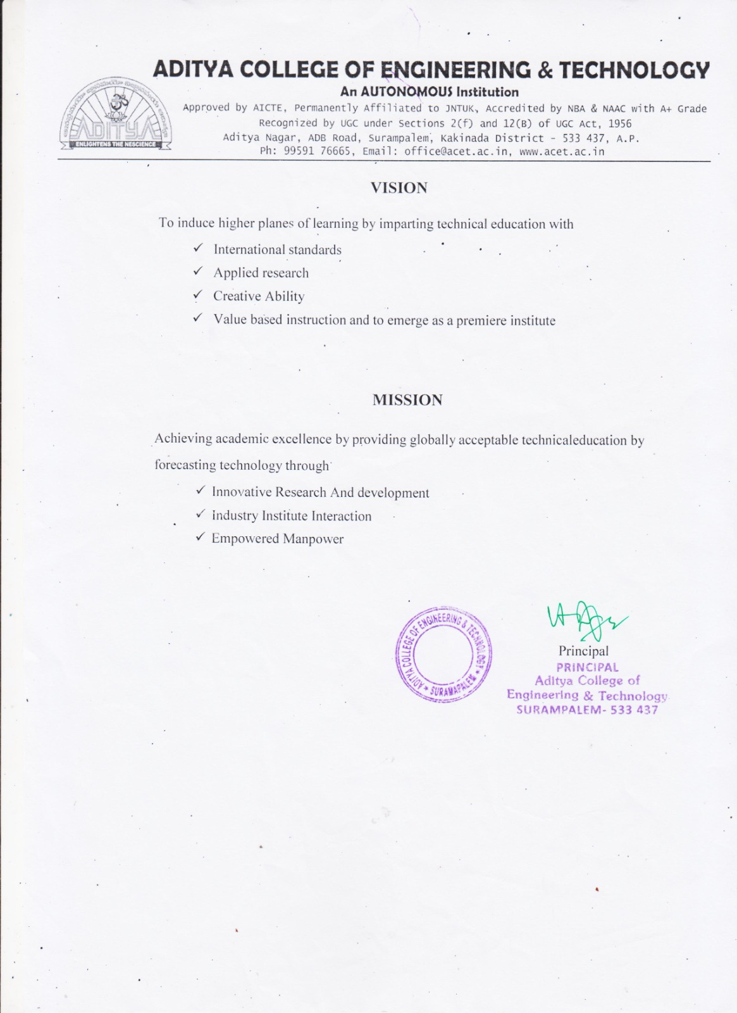

ii

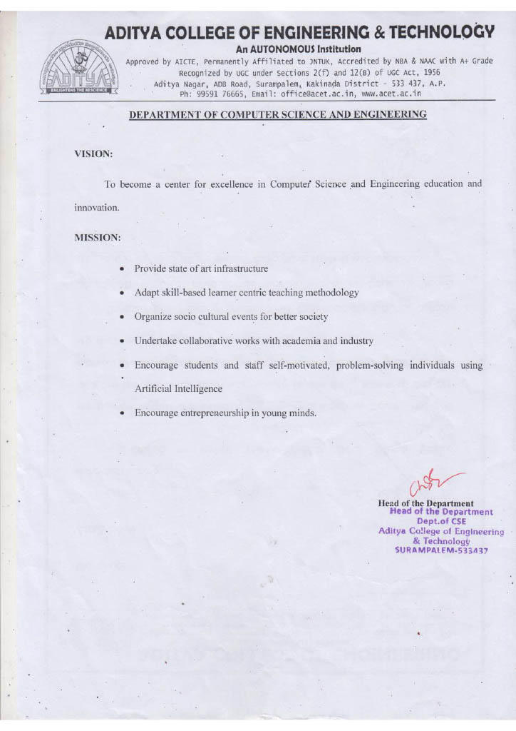

iii

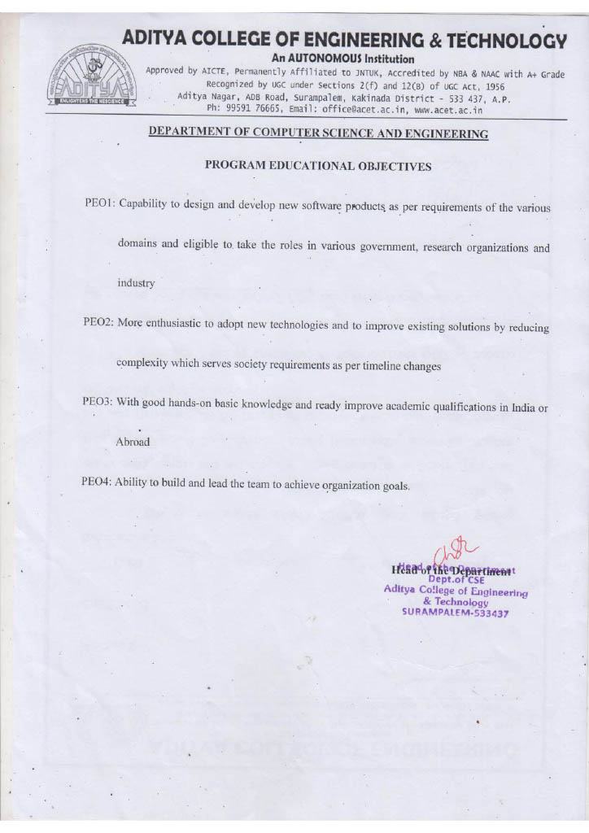

iv

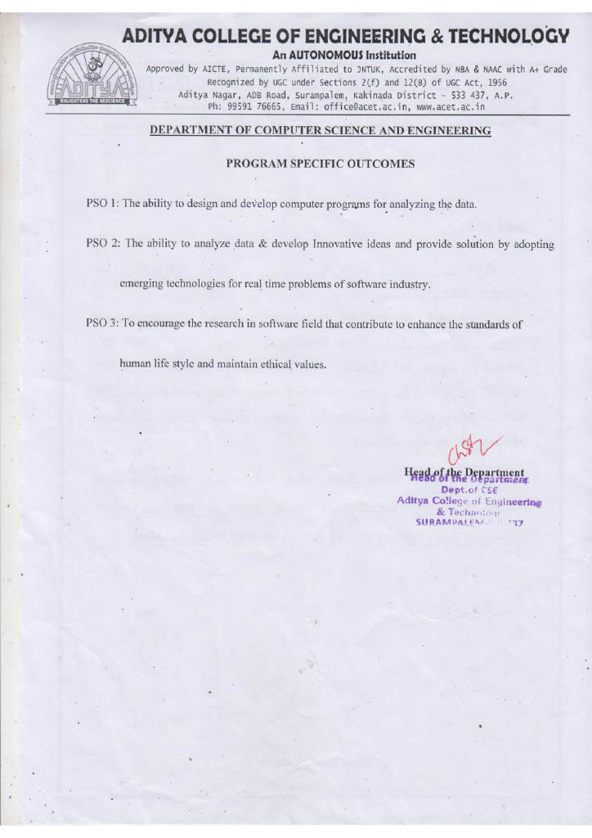

v



vi

**ADITYA COLLEGE OF ENGINEERING & TECHNOLOGY(A)**

**(Approved by AICTE, New Delhi & Affiliated to JNTUK, Kakinada)**

**Department of Computer Science and Engineering**



**CERTIFICATE**

This is to certify that the project work entitled, **" Swimmer Performance Analysis ",** is a bonafide work carried out by **Tatikonda Bharathi(Regd. No.21P31A05C5), Armaan Yusuf khan khaja (Regd. No. 21P31A0591), Daggu Phani Harsha(Regd. No. 21P31A05D0), Dale Deepesh (Regd. No. 21P31A0578)**, in partial fulfillment of the requirements for the award **of the degree of Bachelor of Technology** in **COMPUTER SCIENCE AND ENGINEERING** from Aditya College of Engineering and Technology, Surampalem, during the academic year 2024-2025.

This project work has not been submitted in full or part to any other University or educational institute for the award of any degree or diploma.

|  |  |  |
| --- | --- | --- |
| **PROJECT SUPERVISOR**  Dr. Ramesh NSVSC Sripada, MTech,Ph.D.  Associate Professor |  | **HEAD OF THE DEPARTMENT**  Dr. CHAKKA.S.V.V.S.N.Murty,  MTech., Ph.D.  Professor |

**EXTERNAL EXAMINER**

vii

**DECLARATION**

We hereby declare that this project entitled **" Swimmer Performance Analysis"** has been undertaken by us and this work has been submitted to Department of Computer Science & Engineering, **ADITYA COLLEGE OF ENGINEERING AND TECHONOLOGY (A),** Surampalem affiliated to JNTUK, Kakinada, in partial fulfillment of the requirements for the award of the degree of **Bachelor of Technology** in **COMPUTER SCIENCE AND ENGINEERING.**

We further declare that this project work has not been submitted in full or part to any other University or educational institute for the award of any degree or diploma.

|  |  |
| --- | --- |
| **PROJECT ASSOCIATES** | |
| **Tatikonda Bharathi** | **21P31A05C5** |
| **Armaan Yusuf Khan Khaja** | **21P31A0591** |
| **Daggu Phani Harsha** | **21P31A05D0** |
| **Dale Deepesh** | **21P31A0578** |

viii

**ACKNOWLEDGEME**

It is with immense pleasure that we would like to express our indebted gratitude to my **project supervisor**, **Dr.Ramesh NSVSC Sripada, MTech,Ph.D,** who has guided us a lot and encouraged us in every step of project work, his valuable moral support and guidance has been helpful in successful completion of this Project.

We wish to express our sincere thanks to **Dr.CHAKKA.S.V.V.S.N.Murthy M.Tech.,Ph.D.,** **Head of the Department of CSE**, for his valuable guidance given to us throughout the period of the project work.

We feel elated to thank **Principal**, **Dr.A.RAMESH M.Tech.,Ph.D.**, of Aditya College of Engineering and Technology for his cooperation in completion of our project and throughout our course.

We feel elated to thank **Dr. Ch V Raghavendran MTech., Ph.D.**, **Dean (Academics)** of Aditya College of Engineering and Technology (A) for his cooperation in completion of our project work.

We wish to express our sincere thanks to all faculty members, and lab programmers for their valuable guidance given to us throughout the period of the project.

We avail this opportunity to express our deep sense and heart full thanks to the **Management** of **Aditya College of Engineering & Technology** **(A)** for providing a great support for us by arranging the trainees, and facilities needed to complete our project and for giving us the opportunity for doing this work.

|  |  |
| --- | --- |
| **PROJECT ASSOCIATES** | |
| **Tatikonda Bharathi** | **21P31A05C5** |
| **Armaan Yusuf Khan Khaja** | **21P31A0591** |
| **Daggu Phani Harsha** | **21P31A05D0** |
| **Dale Deepesh** | **21P31A0578** |

ix

**ABSTRACT**

**Swimmer Performance Tracking and Analysis Web Application**

Coaches often struggle to provide personalized feedback, relying on anecdotal observations rather than empirical data, which can hinder informed decision-making and lead to less effective training strategies. Outdated methods and a lack of adaptation to emerging techniques further limit performance improvement, causing swimmers to miss opportunities to enhance their skills and reach their full potential. To address these challenges, this study introduces an automated system for swimmer performance analysis using advanced image and video processing techniques. The system evaluates key performance indicators such as stroke mechanics, body posture, motion dynamics, and speed.

The web app will generate visual tools like bar charts to allow coaches to easily compare swimmers and identify the fastest and slowest performers. By automating data management and analysis, the application will provide coaches with a simple and efficient way to monitor swimmer progress and make performance-based decisions. This data-driven approach will enable users to gain valuable insights into their performance patterns, identify areas for improvement, and tailor training regimens accordingly.

Moreover, the application will utilize predictive analytics to forecast future performance outcomes based on historical data, allowing swimmers and coaches to set realistic goals and track progress over time. This feature not only motivates swimmers by showcasing their growth but also aids coaches in designing targeted training sessions. The Swimmer Performance Tracking and Analysis Web Application aspires to enhance the overall swimming experience by merging technology with sports science, ultimately contributing to the development of elite athletes

**Mentor:** **Dr.Ramesh SNVSC Sripada**

**Batch No:** 12

**Batch Members:**

TATIKONDA BHARATHI (21P31A05C5)

ARMAAN YUSUF KHAN KHAJA (21P31A0591)

DAGGU PHANI HARSHA (21P31A05D0)

DALE DEEPESH (21P31A0578)

**Guide Signature**

x

**INDEX**

**CHAPTER PAGE No**

**ABSTRACT x**

**LIST OF FIGURES xiv**

**1. INTRODUCTION 1-2**

1.1 Purpose of the System 1

1.2 Scope of the System 1

1.3 Current System 1

1.4 Proposed System 2

**2. REQUIREMENT ANALYSIS 3-15**

2.1 Functional Requirements 3

2.2 Non-Functional Requirements 4

2.2.1 User Interface and Human Factors 5

2.2.2 Software Requirements 6

2.2.3 Hardware Requirements 7

2.2.4 Usability 8

2.2.5 Reliability 9-10

2.2.6 Performance 11

2.2.7 Supportability 11

2.2.8 Physical Environment 12

2.2.9 Security Requirements 13

2.2.10 Resource Requirements 14-15

xi

**3. SYSTEM ANALYSIS 16-20**

3.1 Introduction 16

3.2 Use Cases 16

3.2.1 Actors 17

3.2.2 List of use cases 18

3.3.3 Use case diagram 19

**4. SYSTEM DESIGN 20-46**

4.1 Introduction 21

4.2 System Architecture 21

4.3 System Object Model 23

4.3.1 Introduction 24

4.3.2 Subsystems 25

4.4 Object Description 26-28

4.4.1 Objects 28

4.4.2 Class Diagram 31

4.5 Object Collaboration 32

4.5.1 Object Collaboration Diagram 34

4.6 Dynamic Model 35

4.6.1 Sequence Diagram 37

4.6.2 Activity Diagram 39

4.7 Database Design 41

4.7.1 Entity Relationship Diagrams 42

4.8 Static Model 42

4.8.1 Component Diagrams 43-49

4.8.2 Deployment Diagrams 50

xii

**5. IMPLEMENTATION 51-55**

5.1 Software Used 51

5.2 Source Code 53

**6. Testing 56**

6.1 Introduction 56

**7. OUTPUT SCREENS 57-58**

**8. CONCLUSION 59**

**9. BIBLIOGRAPHY 60-61**

xiii

|  |  |  |
| --- | --- | --- |
|  | **LIST OF FIGURES** |  |
|  |  |  |
|  |  |  |
| **S.No.** | **NAME OF FIGURE** | **PAGE No.** |
| 1 | Use Case Diagram | 19 |
| 2 | Class Diagram | 31 |
| 3 | Object Collaboration diagram | 34 |
| 4 | Sequence Diagram | 37 |
| 5 | Activity Diagram | 39 |
| 6 | Entity Relationship Diagram | 41 |
| 7 | Central Processing Unit (CPU): Intel Core i5 (or AMD Ryzen 5) or higher. | 43 |
| 8 | Random Access Memory (RAM): 8GB RAM minimum, 16GB recommended | 43 |
| 9 | Storage Device SSD | 44 |
| 10 | Component Diagram | 45 |
| 11 | Deployment Diagram | 45 |
|  |  |  |

xi

**1. INTRODUCTION**

**1.1 Purpose of the project**

The purpose of the system is to analyze swimmer performance using advanced data analysis techniques to predict future performance and provide actionable insights for improvement. The system aims to address the challenges of manual, time-consuming, and less detailed methods of analyzing swimming performance. It leverages Python and the KNN algorithm to classify and evaluate swimmer metrics, such as speed, stroke efficiency, and lap times. The ultimate goal is to provide actionable insights through visualizations and analytics to help swimmers and coaches identify areas for improvement and optimize training strategies.

* 1. **Scope of the project**

Performance Prediction: The system predicts future race times using machine learning models, initially focusing on linear regression. Metric Calculation: It calculates key performance metrics such as average lap time, velocity, and heart rate. Data Handling: The system processes data from text files, parsing and organizing it for analysis. Visualization: It generates graphs and charts to visually represent performance trends.   User Interface: The system includes a web interface for users to interact with and view analysis results. Recommendations: It provides actionable recommendations based on the analysis of performance metrics.

**1.3 Current System**

It employs pose estimation and optical flow models to analyze swimmer performance by tracking body posture, stroke mechanics, and motion dynamics. Swimmer performance data is stored in individual text files. Each file's name includes key information like swimmer name, age, distance, and stroke.  Lap times are recorded as comma-separated values within these files.  A Python script scans a directory for .txt files, parses the filename and content, and converts lap times into seconds. The parsed data is organized into a Pandas Data Frame and doesn’t give the accurate output.

**1.4 Proposed System**

The proposed system aims to improve upon the existing system by incorporating the following key features:

* **Predictive Analytics and Personalized Metrics:** This involves using more sophisticated machine learning models to enhance the accuracy of future predictions and expanding the range of available metrics for a more in-depth analysis.
* **Improved User Experience and Scalability:** This includes enhancing the user interface with interactive elements and dynamic visualizations, as well as optimizing the system to handle larger datasets.

In essence, the proposed system seeks to provide more accurate, detailed, and user-friendly swimmer performance analysis while also being able to handle increased data loads.

**2. REQUIREMENT ANALYSIS**

**2.1 Functional Requirements**

the functional requirements of the swimmer performance analysis project are:

* **Data Parsing:** The system must accurately read and interpret data from text files with a predefined format.
* **Metric Calculation:** Calculation of key metrics like average lap time, velocity, and heart rate, which are essential for performance evaluation.
* **Visualization:** Generation of clear and informative graphs to visualize performance trends over time and across different strokes.
* **Recommendations:** Provision of actionable recommendations based on the analysis of performance metrics.
* **Prediction:** Accurate prediction of future race times using a linear regression model.
* **Web Interface:** A user-friendly web interface for easy access to the system's functionality.
* **JSON API:** Must provide the data in a Json format so that the front end can display the data

**2.2 Non-Functional Requirements**

* **Performance:** The system should process data and generate results quickly, providing a responsive user experience.
* **Usability:** The interface should be intuitive, allowing users to easily input swimmer names and view analysis results.
* **Maintainability:** The codebase should be well-documented and follow coding best practices for easy maintenance and updates.
* **Reliability:** The system should consistently produce accurate results and handle errors gracefully.
* **Error handling:** The system must handle the fact that the Numpy int64 datatype is not Json serializable, and convert those values into a standard int datatype.
* **Scalability:** The system should be able to handle increasing amounts of data and users without significant performance degradation. This might involve using scalable infrastructure, database systems, and caching mechanisms.
* **Responsiveness:** The system should provide quick responses to user requests, ensuring a smooth and efficient user experience. This is related to performance but emphasizes the user's perception of speed.
* **Efficiency:** The system should use resources (e.g., CPU, memory) efficiently to minimize costs and maximize performance.
* **Availability:** The system should be available to users when they need it, with minimal downtime. This requires robust infrastructure, redundancy, and monitoring.
* **Fault Tolerance:** The system should be able to handle failures (e.g., hardware failures, software errors) gracefully without losing data or disrupting service.

These non-functional requirements are essential for ensuring that the collision detection system not only meets its functional objectives but also delivers the desired performance, reliability, and user experience.

**2.2.1 User Interface and Human Factors**

* **Simplicity and Focus:** The UI is designed to be straightforward, prioritizing easy access to and understanding of analysis results.
* **Prominent Input:** The swimmer name input form is clearly visible to facilitate quick data entry.
* **Organized Data Display:** Key performance indicators are presented in a structured metrics table.
* **Visual Analysis:** Graphs are displayed to enable users to visually identify performance trends.
* **Clear Recommendations:** Actionable recommendations are provided in a dedicated section.
* **Key UI Elements:**
  + **Input Field:** For entering the swimmer's name.
  + **Metrics Table:** To display performance metrics.
  + **Graph Display:** To show performance visualizations.
  + **Recommendation Display:** To present improvement suggestions.

**Human Factors Considerations**

* **Usability:** The system emphasizes an intuitive interface to ensure ease of use for both coaches and swimmers.
* **Accessibility:** While not explicitly detailed, the design's simplicity contributes to accessibility by minimizing complexity.
* **Clarity:** The use of tables, graphs, and separate recommendation sections promotes clear communication of information.
* **Actionability:** The system focuses on providing actionable recommendations, directly supporting performance improvement.
* **Efficiency:** The design aims to enable users to quickly obtain the information they need, supporting efficient decision-making.

**Areas for Potential Improvement (Human Factors)**

* **Personalization:** The current description lacks details on user profiles or personalized settings, which could enhance the system's relevance and engagement.
* **Feedback and Control:** Providing users with clear feedback on system actions and allowing them to customize the display or analysis parameters could improve their sense of control.
* **Error Prevention:** Implementing input validation and clear error messages can help prevent user errors and improve the overall experience.
* **Contextual Help:** Integrating help documentation or tooltips could provide users with on-demand assistance.

By considering these UI and human factors, the project can create a system that is not only functional but also user-friendly and effective in supporting swimmer performance analysis.

**2.2.2 Software Requirements**

the software requirements for the swimmer performance analysis project can be categorized as follows:

**Backend:**

* **Python:** The core programming language for data processing, analysis, and prediction.
* **Flask:** A Python web framework for handling API requests and communication between the backend and frontend.
* **Scikit-learn:** A Python machine learning library, specifically used for the Linear Regression model to predict future performance.
* **Pandas:** A Python library for data manipulation and analysis, used for organizing and processing swimmer data.
* **Matplotlib:** A Python library for generating visualizations of performance data.

**Frontend:**

* **HTML:** For structuring the web pages of the user interface.
* **CSS:** For styling the web pages and controlling the visual presentation.
* **JavaScript:** For adding interactivity to the web interface and handling communication with the backend.

**Other Software/Tools:**

* **JSON:** Used for encoding and exchanging data between the backend and frontend via the API.

It's important to note that this list focuses on the software explicitly mentioned in the presentation. Depending on the specific implementation and any expanded requirements.

**2.2.3 Hardware Requirements**

1the hardware components involved in the swimmer performance analysis project can be broadly categorized as follows:

**1. Server Hardware:**

* This would be the machine hosting the backend (Python/Flask application) and potentially the web server.
* It needs to be capable of handling data processing, analysis, and serving the web application.
* Key components include a processor, memory (RAM), storage (for data and application), and a network interface.

**2. Client Hardware:**

* These are the devices used by coaches and swimmers to access the system through the web interface.
* This includes computers, laptops, tablets, and smartphones.
* The primary requirement is a web browser and internet connectivity.
* Processor: Intel I5 and above
* RAM: 6GB and Higher
* Hard Disk: 500GB and above
* System Type: 64-bit Operating System

It's important to note that the presentation doesn't specify detailed hardware configurations. The requirements can vary based on factors like the scale of the project (number of users, volume of data), performance expectations, and whether real-time data acquisition is involved.

**2.2.4 Usability**

usability aspects of the swimmer performance analysis system:

* **User-Focused Design:** The system is designed with an intuitive interface to ensure accessibility for coaches and swimmers.
* **Ease of Access:** The web interface is intended to provide easy access to the system's functionality.
* **Simple and Focused UI:** The UI is designed to be simple and focused, allowing users to quickly access and understand the analysis results.
* **Prominent Input:** The input form is prominently placed for easy data entry.
* **Clear Information Presentation:** The metrics table provides a clear and organized display of key performance indicators.
* **Visual Analysis Support:** Graphs are displayed, allowing users to visually analyze performance trends.
* **Actionable Insights:** Recommendations are displayed in a separate section, highlighting areas for improvement.
* **Intuitive Design:** The interface is intended to be intuitive, enabling users to quickly input swimmer names and view analysis results.
* **Clear Information Presentation:** The use of metrics tables and graphs helps present data in a clear and organized manner.

In essence, the system prioritizes a user-friendly experience, allowing users to efficiently interact with the system and understand the analyzed data.

**2.2.5 Reliability**

* **Accurate Data Collection:** The system's reliability depends heavily on the accuracy of the input data. This includes using reliable sensors or data entry methods and validating the collected data for errors or inconsistencies.
* **Correct Calculations:** Ensuring that all calculations of performance metrics (e.g., speed, efficiency) are based on correct formulas and algorithms is crucial.
* **Model Accuracy:** The predictive models (e.g., linear regression) must be trained and validated to ensure they provide accurate predictions within an acceptable range of error.
* **Data Integrity:** Maintaining data integrity throughout the system, preventing data corruption or loss, is essential for reliable analysis.
* **Error Handling:** The system should be able to handle unexpected errors (e.g., invalid input, data processing errors, network issues) gracefully without crashing or producing incorrect results.
* **System Uptime:** The system should be available to users when they need it, with minimal downtime due to maintenance or failures.
* **Fault Tolerance:** The system should be designed to tolerate failures in hardware or software components without significant disruption of service.
* **Robustness:** The system should be able to function correctly under various conditions and workloads.
* **Thorough Testing:** The system should undergo rigorous testing at all stages of development to identify and fix potential reliability issues. This includes unit testing, integration testing, and system testing.
* **Validation:** The system's results and predictions should be validated against real-world data and expert judgment to ensure their accuracy and reliability.
* **Continuous Monitoring:** Implementing monitoring systems to track system performance and identify potential issues proactively is important for maintaining reliability."The system should process data and generate results quickly, providing a responsive user experience."
* **Data Processing Speed:** The system should efficiently process swimmer data, including parsing, calculating metrics, and generating visualizations. This is especially critical when dealing with large datasets.
* **Prediction Speed:** The machine learning models should generate predictions in a timely manner, allowing for quick feedback to users.
* **Response Time:** The web interface should respond quickly to user interactions, such as submitting queries or navigating between pages.
* **Scalability:** The system should maintain acceptable performance even as the number of users or the volume of data increases. This might involve optimizing algorithms, using efficient data structures, and employing scalable infrastructure.

**2.2.7 Supportability**

"supportability" encompasses a broader range of considerations than just maintainability. Here's a breakdown of supportability in the context of the swimmer performance analysis project:

**1. Maintainability (as defined in the presentation):**

* **Code Documentation:** Clear and comprehensive documentation of the codebase, including comments, API documentation, and design documents, is essential for developers to understand and modify the system.
* **Coding Best Practices:** Adhering to coding standards, using modular design principles, and writing clean, readable code makes it easier to debug, update, and extend the system.

**2. Troubleshooting and Debugging:**

* **Logging:** Implementing robust logging mechanisms to record system events, errors, and warnings helps in identifying and diagnosing problems.
* **Error Reporting:** Providing clear and informative error messages to users and developers facilitates troubleshooting.
* **Debugging Tools:** Utilizing debugging tools and techniques to identify and fix code defects.

**3. Deployment and Configuration:**

* **Installation and Setup:** Providing clear and straightforward instructions for installing and setting up the system on different environments.
* **Configuration Management:** Using configuration files or environment variables to manage system settings and dependencies.

**2.2.8 Physical Environment**

**1. Development Environment:**

* This is where the software is designed, coded, and tested.
* It would typically consist of:
  + Developers' workstations: Equipped with computers, software development tools (IDEs), and necessary software libraries (Python, Flask, etc.).
  + Potentially a server for version control, testing, and collaboration.

**2. Deployment Environment:**

* This is where the system is hosted and runs.
* It would likely involve:
  + A server (either physical or cloud-based) to host the backend (Flask application), database (if any), and potentially the web server.
  + Network infrastructure to allow users to access the system via the web.

**3. User Environment:**

* This is where coaches and swimmers interact with the system.
* It would consist of:
  + Devices with web browsers: Computers, laptops, tablets, or smartphones to access the web interface.
  + Network connectivity: Access to the internet or a local network to communicate with the server.

**4. Data Acquisition Environment (If expanded to include real-time data):**

* If the system were to incorporate real-time data collection, this environment would be relevant.
* It might include:
  + Swimming pool: The location where swimmers train and data is collected.
  + Sensors and cameras: Devices to capture swimmer data (e.g., wearable sensors, video cameras).
  + Equipment to transmit data: Wireless networks or other communication systems to transmit data from the pool to the processing system.

**2.2.9 Security Requirements**

security requirements for the swimmer performance analysis project:

**1. Data Security:**

* **Data Confidentiality:**
  + Protecting swimmer data (personal information, performance records) from unauthorized access.
  + Implementing access controls to restrict data access based on user roles (e.g., swimmer, coach, admin).
  + Using encryption to secure data at rest (in the database) and in transit (between the client and server).
* **Data Integrity:**
  + Ensuring that data is accurate and has not been tampered with.
  + Implementing data validation to prevent the entry of incorrect or malicious data.
  + Using hashing or digital signatures to verify data integrity.

**2. User Authentication and Authorization:**

* **Authentication:**
  + Verifying the identity of users when they log in to the system.
  + Using strong passwords and secure password storage techniques.
  + Considering multi-factor authentication for enhanced security.
* **Authorization:**
  + Controlling what actions users are allowed to perform within the system.
  + Assigning roles to users (e.g., swimmer, coach, administrator) and defining the permissions associated with each role.

**3. Application Security:**

* **Input Validation:**
  + Sanitizing user inputs to prevent injection attacks (e.g., SQL injection, cross-site scripting).
* **Session Management:**
  + Implementing secure session management to prevent session hijacking.
* **Error Handling:**
  + Handling errors gracefully without revealing sensitive information.
* **Security Auditing:**
  + Logging security-related events to track user activity and detect potential security breaches.

**4. Network Security:**

* **Secure Communication:**
  + Using HTTPS to encrypt communication between the client and server.
* **Firewall:**
  + Implementing a firewall to protect the server from unauthorized access.

**2.2.10 Resource Requirement:**

the resource requirements for the swimmer performance analysis project can be categorized as follows:

**1. Software Resources:**

* Python (for backend development)
* Flask (Python web framework)
* Scikit-learn (machine learning library)
* Pandas (data analysis library)
* Matplotlib (visualization library)
* HTML, CSS, JavaScript (for frontend development)
* JSON (for data exchange)

**2. Hardware Resources:**

* Server to host the backend and web application
* Client devices (computers, laptops, tablets, smartphones) for users to access the system

**3. SYSTEM ANALYSIS**

**3.1 Introduction**

System analysis is a critical phase in developing complex systems, focusing on understanding, designing, and optimizing their structure and functionality. It involves gathering and analyzing information about user needs, business processes, and technological considerations.

During system analysis, interdisciplinary teams use techniques like interviews and data analysis to identify requirements, recognize challenges, and create system models. The primary objectives include requirement elicitation, problem identification, and feasibility assessment.

By conducting thorough system analysis, organizations can make informed decisions about system investments and prioritize development efforts. It ensures that resulting solutions meet user needs, enhance organizational effectiveness, and deliver value to stakeholders.

**3.2 Use Cases**

**1. Predicting Future Race Times:**

* Coaches can use the system to predict a swimmer's potential race times in upcoming events, allowing them to set realistic goals and adjust training strategies accordingly.

**2. Analyzing Performance Trends:**

* Swimmers and coaches can track performance trends over time to identify areas of improvement or decline. This can help in understanding the effectiveness of training programs and making necessary modifications.

**3. Evaluating Stroke Efficiency:**

* The system can be used to evaluate stroke efficiency, helping swimmers to optimize their technique and reduce energy expenditure.

**4. Monitoring Training Load:**

* Coaches can monitor the impact of training load on swimmer performance, preventing overtraining and reducing the risk of injuries.

**5. Personalizing Training Plans:**

* The system can provide data-driven insights to personalize training plans based on individual swimmer's strengths and weaknesses.

**6. Comparing Swimmer Performance:**

* Coaches can compare the performance of different swimmers to identify best practices and areas where swimmers can learn from each other.

**7. Providing Feedback to Swimmers:**

* Coaches can use the system to provide objective and data-driven feedback to swimmers, helping them to understand their performance and stay motivated.

**3.2.1 Actors**

Actors in use cases represent entities outside the system that interact with it to achieve specific goals or tasks. Here are common types of actors:

1. **Primary** **Actor**: The primary actor initiates the use case and achieves a specific goal with the system. They are the main beneficiaries of the system's functionality.

2. **Secondary** **Actor**: Secondary actors assist the primary actor in achieving their goals by providing input, receiving output, or collaborating with the system in some way.

3. **External** **Actor**: External actors interact with the system but are not part of the system itself. They can be users, systems, or external entities that exchange data with the system.

4. **System** **Actor**: System actors represent other systems or subsystems that interact with the primary system to exchange data or trigger events.

By identifying and understanding the actors involved in each use case, analysts can clarify the system's scope, requirements, and external dependencies, ensuring that the system design meets user needs and stakeholder expectations.

**3.2.2 List of Use Cases**

**1. Predicting Future Race Times**

* **Explanation:** Coaches can input a swimmer's historical performance data, and the system uses machine learning models (like linear regression) to predict their potential times in upcoming races. This helps in setting realistic goals, planning race strategies, and adjusting training intensity.

**2. Analyzing Performance Trends**

* **Explanation:** The system visualizes performance data over time (e.g., lap times across multiple training sessions or competitions). This allows swimmers and coaches to identify patterns such as improvement, stagnation, or decline in performance. It helps in evaluating the effectiveness of training regimens and making informed decisions about adjustments.

**3. Evaluating Stroke Efficiency**

* **Explanation:** By analyzing metrics like stroke rate and distance per stroke, the system can provide insights into a swimmer's stroke efficiency. This helps in identifying areas where a swimmer can improve their technique to cover more distance with less effort, conserving energy and improving speed.

**4. Monitoring Training Load**

* **Explanation:** The system can track metrics that indicate the impact of training load on a swimmer's body (e.g., heart rate). This helps coaches to monitor the stress levels on swimmers, prevent overtraining, and optimize recovery periods to maximize performance gains while minimizing the risk of injury.

**5. Personalizing Training Plans**

* **Explanation:** By analyzing individual swimmer's data, the system can help in creating personalized training plans that target specific areas of improvement. For example, if the system identifies that a swimmer's turn time is weak, the training plan can include specific drills to improve that aspect.

**6. Comparing Swimmer Performance**

* **Explanation:** Coaches can use the system to compare the performance of swimmers within a team or group. This can help in identifying best practices, fostering healthy competition, and providing targeted feedback to individual swimmers based on comparative analysis.

**7. Providing Objective Feedback**

* **Explanation:** The system provides data-driven feedback, which is more objective than subjective observations. This helps swimmers to better understand their strengths and weaknesses, leading to more focused and effective training. It also enhances communication between swimmers and coaches.

**3.3.3 Use Case Diagrams**

A use case diagram in the Unified Modeling Language (UML) is a type of behavioral diagram defined by and created from a Use-case analysis. Its purpose is to present a graphical overview of the functionality provided by a system in terms of actors, their goals (represented as use cases), and any dependencies between those use cases. The main purpose of a use case diagram is to show what system functions are performed for which actor. Roles of the actors in the system can be depicted. In its simplest form, a use case can be described as a specific way of using the system from a user's (actors) perspective. A more detailed description might characterize a use case as: A pattern of behavior that system exhibits.

• A sequence of related transactions performed by an actor in the system.• Delivering something of value to the actor.

• Use cases provide a means to: Capture system requirements.

• Communicate with the end users and domain experts.

• Test the system.

Use cases are the best discovered by examining the actors and defining what the actor will be do with the system. Since all the needs of a system typically cannot be covered in one use case, it is usual to have a collection of use case. Together this use case collection specifies all the ways of using the system.

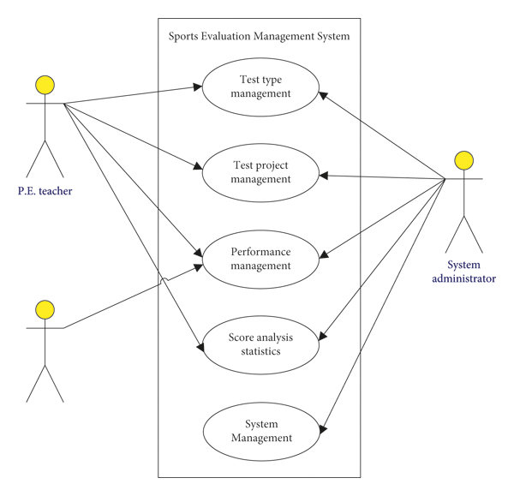

**Fig: 3.3.3.1** Use Case Diagram

**4. SYSTEM DESIGN**

In the context of developing a Swimmer performance analysis using machine learning, Based on the presentation, the system design of the swimmer performance analysis project can be described as follows:

system follows a modular architecture with distinct components:**Data Files (Input):** Raw data is stored in text files, with each file representing a swimmer's race history.

* **Python/Flask Backend:** This is the core processing unit, responsible for data parsing, analysis, prediction, and handling API requests.
* **Scikit-learn (Linear Regression):**

This library provides the machine learning model used for predicting future performance.

* **Matplotlib:** This library is used to generate visual representations of performance data.
* **JSON API:** This facilitates communication between the backend and the frontend.
* **Web Frontend:** This is the user interface, built with HTML, CSS, and JavaScript, for users to interact with the system and view results.
* The frontend sends a request to the Flask API, including the swimmer's name.
* The Flask backend retrieves the corresponding data files and processes them.
* The backend generates analysis results, including metrics, graph data, and recommendations.

**3. Modularity**

* The codebase is organized into functions, each with a specific purpose.
* This modular design enhances debugging, maintenance, and future expansion of the system.

**4.1 Introduction to the System Design**

A swimmer performance analysis system uses data-driven insights to enhance training and competition, helping swimmers and coaches optimize their approach and achieve better results. This system typically involves collecting data through various methods, analyzing it to identify strengths and weaknesses, and then providing feedback to improve performance. Used to track the swimmer's head movement and speed during starts and turns. Provide a full view of the swimmer's body movement, allowing for more detailed analysis of technique. Can capture a wider view of the pool and swimmer, useful for analyzing overall race strategy. Embedded in the start block and turn wall to measure the forces exerted during starts and turns. Can be placed on the pool wall to measure the pressure exerted by the swimmer's hands and feet during turns.  Accelerometers and gyroscopes can be attached to the swimmer to track movement and speed.

* **Data Visualization:**Can be used to visualize the swimmer's performance data over time.Can be used to create a visual representation of the swimmer's movement in the water.
* **Statistical Analysis:**Can be used to identify the factors that most influence the swimmer's performance. Can be used to predict the swimmer's performance in future races. Feedback and Optimization:
* **Real-time feedback:**

Coaches can receive real-time data on the swimmer's performance during training and races. Detailed reports can be generated to track the swimmer's progress over time.

* **Training recommendations:**

Based on the analysis of the swimmer's performance, coaches can develop customized training plans to improve their technique and speed.

**4.2 System Architecture**

A swimmer performance analysis system typically uses a multi-faceted approach, including data acquisition (sensors, cameras), pre-processing, feature extraction, analysis algorithms, and a user interface to visualize and interpret the data, ultimately providing coaches and swimmers with insights for improvement.

1.**Data Collection:**

* + **Real-time data streaming:** Sensors and cameras transmit data to a central processing unit.
  + **Data synchronization:** Ensuring that data from different sources (e.g., force plates and video) is synchronized for analysis.

2. Data Pre-processing:

* **Noise Reduction:** Filtering out irrelevant data or noise from sensor signals.
* **Data Calibration:** Ensuring that sensor data is accurate and consistent.
* **Data Synchronization:** Aligning data from different sources (e.g., video and sensor data) to a common time frame.
* **Kinematic Features:**

Analyzing the swimmer's movements, such as stroke rate, stroke length, body position, and joint angles.

* **Machine Learning:**

Using algorithms like Random Forest or other classifiers to recognize swimming styles and turns, predict performance, and identify areas for improvement.

* **Data Visualization:**

Presenting the analyzed data in a clear and intuitive format, such as graphs, charts, and videos with overlaid data.

* **Feedback and Reporting:**

Providing coaches and swimmers with immediate feedback on their performance and generating reports for long-term analysis.

**4.3 System Object Model:** A system object model for swimmer performance analysis would include objects representing swimmers, strokes, events, data sources, analyses, and reports, facilitating data collection, processing, and visualization to improve coaching and training decisions.

* **Swimmer:**Attributes: Name, ID, Age, Gender, Level (e.g., beginner, intermediate, advanced), Stroke Specialization (e.g., freestyle, backstroke, breaststroke, butterfly), Contact Information, Training History, Performance History.Methods: Access and modify swimmer data, retrieve performance data, link to training sessions.
* **Stroke:**Attributes: Name (e.g., freestyle, backstroke, breaststroke, butterfly), Description, Key Techniques, Common Errors.Methods: Access stroke details, retrieve data related to specific strokes, provide coaching feedback.
* **Event:**Attributes: Name (e.g., 50m freestyle, 100m breaststroke), Distance, Stroke Type, Event Type (e.g., race, training), Date/Time, Location.Methods: Access event details, retrieve performance data for specific events, manage event schedules.
* **Data Source:**Attributes: Type (e.g., video, sensors, manual input), Description, Data Format, Location.Methods: Access data, upload data, manage data sources.
* **Analysis:**Attributes: Type (e.g., kinematic, kinetic, stroke rate, breathing pattern), Method, Parameters, Results.Methods: Perform analysis, store results, generate reports.
* **Report:**Attributes: Type (e.g., performance summary, training progress), Format, Content, Date/Time.Methods: Generate reports, access reports, share reports.

2. Relationships:

* **Swimmer**: has many Training Sessions.
* **Training Session**: has many Events.
* **Event**: is of type Stroke.
* **Event**: uses Data Source.
* **Analysis**: is based on Data Source.

**4.3.1 Introduction**

* A system object model for swimmer performance analysis would include objects representing swimmers, strokes, events, data sources, analyses, and reports, facilitating data collection, processing, and visualization to improve coaching and training decisions.
* A coach wants to analyze a swimmer's freestyle stroke in a 100m race.
  + The system retrieves the swimmer's data, the freestyle stroke details, and the event details.
  + The system performs a kinematic analysis of the stroke based on video data.
  + The system generates a report summarizing the analysis results, including stroke rate, breathing pattern, and body position.
* A swimmer wants to track their training progress.
  + The system retrieves the swimmer's training history, including training sessions and events.
  + The system generates a report summarizing the swimmer's performance trends over time.

4. Technologies:

* **Data Storage:**Relational database (e.g., PostgreSQL, MySQL), NoSQL database
* **Data Processing:**Programming languages (e.g., Python, Java), Data analysis libraries (e.g., Pandas, NumPy).
* **Visualization:**Data visualization libraries (e.g., Matplotlib, Seaborn), Web frameworks (e.g., React, Angular).
* **Communication:**APIs, Web services.

**4.3.2 Subsystems**

Swimmer performance analysis, a multifaceted field, can be broken down into several key subsystems: kinematics (movement analysis), kinetics (force analysis), physiology (energy systems and adaptations), and race analysis (segmentation and performance tracking).

* **Kinematics:**This subsystem focuses on the movement patterns and mechanics of swimming, including stroke rate, stroke length, body position, and the timing of different phases of the stroke cycle. **Tools:** High-speed video cameras, motion capture systems, and inertial measurement units (IMUs) are used to capture and analyze these movements. **Analysis:** Software and algorithms are used to extract kinematic data, such as angles, velocities, and accelerations, which can then be compared to benchmarks and used to identify areas for improvement.
* **Kinetics:**This subsystem investigates the forces exerted by the swimmer during swimming, including the forces generated by the arms, legs, and body during different phases of the stroke cycle. **Tools:** Force plates, pressure sensors, and instrumented starting blocks are used to measure forces. **Analysis:** The data collected is used to assess the efficiency of the swimmer's technique and to identify areas where the swimmer could generate more power.
* **Physiology:**This subsystem examines the physiological factors that influence swimming performance, such as oxygen uptake, heart rate, blood lactate levels, and energy systems. **Tools:** Spirometry, heart rate monitors, blood lactate analyzers, and other physiological monitoring equipment are used to collect data. **Analysis:** The physiological data is used to assess the swimmer's aerobic and anaerobic capacity, as well as to identify areas where training could be optimized to improve performance.
* **Race Analysis:**This subsystem focuses on analyzing the performance of swimmers during races, including their starts, turns, and overall race strategy. **Tools:** Video footage, timing devices, and lane sensors are used to collect data. **Analysis:** The data is used to identify the strengths and weaknesses of a swimmer's race performance, as well as to identify areas where training could be focused to improve race strategy and tactics.

**4.4 Object Description**

An object description of the swimmer performance analysis system involves detailing its constituent parts, their attributes, and their relationships. Here's a breakdown based on the presentation:

* **Description:** Represents the historical performance data of a swimmer.
* **Attributes:** File Name: Encodes swimmer's name, age, distance, and stroke.   Lap Times: A sequence of time values for each lap in a race.
* **Relationships:** Stored in text files.   Parsed and processed by the Python/Flask Backend.

**2. Process Object (Python/Flask Backend)**

* **Description:** The core processing unit that handles data manipulation and analysis.
* **Attributes:** Programming Language: Python.   Framework: Flask.
* **Relationships:**
  + Parses data from Data Objects.
  + Calculates performance metrics.
  + Uses the Machine Learning Model for prediction.
  + Generates visualizations using the Visualization Object.
  + Communicates with the User Interface Object via the API Object.

**3. Model Object (Scikit-learn Linear Regression)**

* **Description:** The machine learning model used to predict future swimming performance.
* **Attributes:**
  + Algorithm: Linear Regression.
  + Input: Historical performance data (e.g., lap times).
  + Output: Predicted future race times.
* **Relationships:**
  + Part of the Process Object.
  + Trained on Data Objects.

**4. Visualization Object (Matplotlib)**

* **Description:** Generates visual representations of performance data.
* **Attributes:** Type: Graphs and charts.   Format: PNG images, base64 encoded strings.
* **Relationships:**
  + Part of the Process Object.
  + Used to display data in the User Interface Object.
* **Relationships:**
  + Part of the Process Object.
  + Sends data to and receives data from the User Interface Object.

**6. User Interface Object (Web Frontend)**

* **Description:** The interface through which users interact with the system.
* **Attributes:**
  + Technology: HTML, CSS, JavaScript.
  + Elements: Input field, analyze button, metrics table, graph display, recommendation display.
* **Relationships:**
  + Receives user input.
  + Displays data from the Process Object.
  + Communicates with the Process Object via the API Object.

**4.4.1 Objects**

**Data Files:** These represent the raw input data, containing swimmer information and performance metrics (e.g., lap times).

**Flask Application:** This is the backend logic of the system, responsible for data processing, analysis, and communication with the frontend.

**Machine Learning Model:** Specifically, the Linear Regression model used to predict future swimming performance.

**Data Visualization:** This component handles the generation of graphs and charts to represent performance data visually.

**JSON API:** This serves as the interface for data exchange between the backend and the frontend.

**Web Interface:** This is the user interface that allows coaches and swimmers to interact with the system, input data, and view analysis results..

**4.4.2 Class Diagrams**

The class diagram is used to refine the use case diagram and define a detailed design of the system. The class diagram classifies the actors defined in the use case diagram into a set of interrelated classes. The relationship or association between the classes can be either an "is-a" or "has-a" relationship

Object model describes the structure of the system in terms of objects, attributes, associations, and operations. During requirements and analysis, the object model starts as the analysis object model and describes the application concepts relevant to the system. It is a combination of classes that contains of attributes and operations with the connection of relationship with the connection of relationships among them. It also describes which class contains the information.

**Identification of Attributes of each class:**

Guidelines for identifying attributes of classes are as follows: Attributes usually correspond to nouns followed by prepositional phrases.

• Attributes also may correspond to adjectives or adverbs.

• Keep the class simple State only enough attributes to define the object state.

• Attributes are less likely to be fully described in the problem statement.

• Omit derived attributes.

• Do not carry discovery attribute.

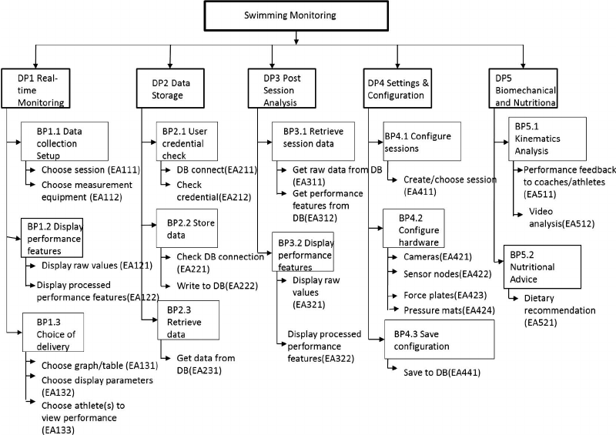

**Fig : 4.4.2.1** Class Diagram

In this diagram:

**Main Category: Swimming Monitoring**

* This is the overall system, like a folder containing all the tools and information.

**Sub-Categories (Like Folders within the Main Folder):**

1. **DP1 Real-time Monitoring:** This focuses on watching the swimmer *as they are swimming*.
2. **BP1.1 Data Collection Setup:** Getting the tools ready to collect data (e.g., choosing sensors).
3. **BP1.2 Display Performance Features:** Showing the swimmer's data (e.g., speed, stroke rate) *live*.
4. **BP1.3 Choice of Delivery:** Deciding how to show the data (e.g., graphs, tables).
5. **DP2 Data Storage:** This is about saving the data collected from the swimmer.
6. **BP2.1 User Credential Check:** Making sure the person saving the data has permission.
7. **BP2.2 Store Data:** Actually saving the data into a database.
8. **BP2.3 Retrieve Data:** Getting the saved data back out of the database.
9. **DP3 Post Session Analysis:** This is about looking at the swimmer's data *after* they've finished swimming.
10. **BP3.1 Retrieve Session Data:** Getting the data from the database
11. .**BP3.2 Display Performance Features:** Showing the data in different ways.
12. **DP4 Settings & Configuration:** This is where you set up and customize the system.
13. **BP4.1 Configure Sessions:** Creating and managing different swimming sessions.
14. **BP4.2 Configure Hardware:** Setting up the cameras, sensors, etc.**B**
15. **P4.3 Save Configuration:** Saving the settings you've chosen.
16. **DP5 Biomechanical and Nutritional:** This is about the science behind swimming and how to fuel the swimmer.
17. **BP5.1 Kinematics Analysis:** Analyzing the swimmer's movements (like their stroke).
18. **BP5.2 Nutritional Advice:** Giving the swimmer diet recommendations.**EA and BP Codes:** These are just labels to organize the different parts of the system.

**In essence, this diagram shows a system that:**

* **Collects data** about a swimmer's performance (both live and after swimming).
* **Stores the data** in a database.
* **Analyzes the data** to give feedback and advice.
* **Allows customization** of settings and hardware.
* **Provides insights** into the swimmer's technique and diet.

**4.5 Object collaboration**

**. Objects and Responsibilities**

Based on the description, we can identify the following conceptual objects and their primary responsibilities:

* **Data File Object:**
  + Holds raw swimmer data.
  + Provides data to the processing unit.
* **Flask Application Object:**
  + Orchestrates data processing.
  + Calculates performance metrics.
  + Invokes the prediction model.
  + Manages API communication.
* **Prediction Model Object:**
  + Predicts future performance.
  + Uses historical data for calculations.
* **Visualization Object:**
  + Generates graphs and charts.
  + Presents data visually.
* **API Object:**
  + Handles data exchange.
  + Formats data for transmission.
* **Web Interface Object:**
  + Provides user interaction.

**4.5.1 Object collaboration Diagram**

**1. Objects as Use Cases:**

* **Evaluate Content:** This use case represents the interaction of a reviewer with the system, where the reviewer evaluates and provides feedback on content.
* **Modify Content:** This use case represents the interaction of a user who can modify or update existing content.
* **Authenticate:** This use case represents the process of user authentication, where users log in to access the system.
* **Read Content:** This use case represents the interaction of a user who reads or views content within the system.

**2. Object Collaboration:**

While the diagram doesn't explicitly show the objects themselves, we can infer potential object collaborations based on the use cases:

* **Authentication Object:** This object might handle user authentication, verifying credentials and granting access to the system.
* **Content Management Object:** This object could manage the creation, modification, and storage of content.
* **Review Object:** This object might facilitate the review process, allowing reviewers to evaluate content and provide feedback.
* **User Interface Object:** This object could handle the presentation and interaction with content for users.

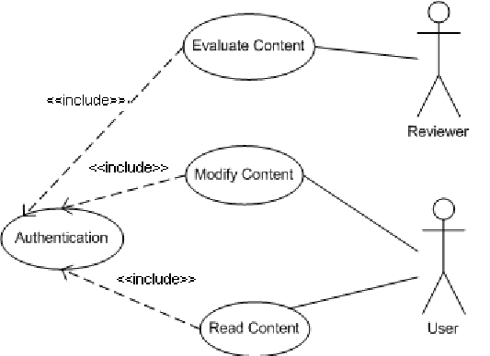

**Fig: 4.5.1.1** Object Collaboration diagram

**3. Collaboration Scenarios:**

* **A user wants to modify a piece of content.** The user interacts with the **Modify Content** use case, which triggers the **Content Management Object** to perform the necessary modifications.
* **A reviewer wants to evaluate a piece of content.** The reviewer interacts with the **Evaluate Content** use case, which triggers the **Review Object** to provide feedback on the content.
* **A user wants to access the system.** The user interacts with the **Authentication** use case, which verifies their credentials and grants them access to the system.
* **A user wants to read content.** The user interacts with the **Read Content** use case, which triggers the **Content Management Object** to retrieve and display the desired content.

**4.6 DYNAMIC MODEL**

A dynamic model for swimmer performance analysis can use fluid dynamics and biomechanics to understand how a swimmer's movements, body position, and water resistance affect their speed and efficiency. This model can help identify areas for improvement and optimize training techniques.

* **Body Position:**Optimizing body position to minimize drag and maximize propulsion is a key factor.
* **Stroke Technique:**Analyzing the movements of the arms, legs, and torso during each stroke can reveal areas for improvement.
* **Muscle Activation:**Understanding which muscles are used and when can help optimize training and technique.
* **Kinematics and Kinetics:**Studying the motion (kinematics) and forces (kinetics) involved in swimming can provide valuable insights.
* **Mathematical Models:**Using mathematical equations and simulations to model the interaction between a swimmer and the water.
* **Computational Fluid Dynamics (CFD):**Using computer simulations to analyze the flow of water around a swimmer's body.
* **Inertial Sensors:**Using sensors to collect data on a swimmer's movements and analyze their performance.
* **Data Analysis:**Analyzing collected data to identify trends and patterns in a swimmer's performance.
* **Rigid Segment Models:**Representing the swimmer's body as a series of rigid segments to analyze their movements and forces.
* **Fluid-Structure Interaction Models:**Simulating the interaction between the swimmer's body and the surrounding water.
* **Machine Learning Models:**Using machine learning algorithms to predict a swimmer's performance based on their training data.
* **Improved Technique:** Identifying areas for improvement in a swimmer's technique.
* **Optimized Training:** Developing more effective training programs.
* **Enhanced Performance:** Leading to faster speeds and more efficient swimming.
* **Understanding Swimming Dynamics:** Providing a deeper understanding of the complex dynamics of swimming.

**4.6.1 Sequence Diagrams**

Sequence diagrams visually depict the interactions between objects in a system over time. The dynamic model represented in UML with interaction diagrams, state chart diagrams, and activity diagrams, describes the internal behaviour of the system. It is an interaction diagram that shows how process operates with one another and in what order. It shows dynamic objects communicate with the message passing mechanism. It follows graph format for object interaction. A sequence diagram in Unified Modeling Language (UML) is a kind of interaction diagram that shows how process operates with one another and in what order. It is a construct of a Message Sequence Chart. Sequence diagram are sometimes called event diagrams, event scenarios, and timing diagrams. A sequence diagram shows how processes operate with one another and in what order.

**Construction of Sequence Diagrams:** A Sequence diagram is a graphical view of a scenario that shows object interaction in a time based sequence what happens first, what happens next. Sequence diagrams establish the roles of objects and help provide essential information to determine class responsibilities and interfaces. The following tools located on the sequence diagram toolbox which enable to model sequence diagrams. 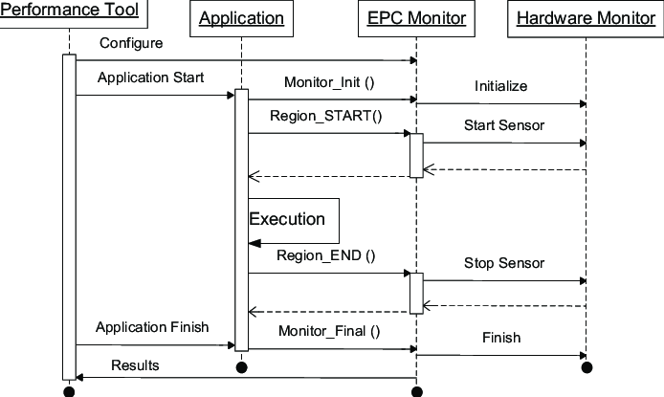

**Fig : 4.6.1.1** Sequence Diagram

**4.6.2 Activity Diagram**

* **[(Start and End):** The filled circle represents the starting point of the activity, and the circle enclosing a filled circle represents the ending point.
* **Analyze Swimmer Performance:** This is a composite activity that encapsulates the entire process of analyzing a swimmer's performance.
* **Get Swimmer Data:** The system retrieves the swimmer's performance data from the data source (text files).
* **Parse Data:** The system parses the raw data from the files, extracting relevant information such as lap times, stroke rate, etc.
* **Calculate Metrics:** The system calculates performance metrics like average lap time, velocity, and heart rate.

**Predict Performance:** The system uses a machine learning model (Linear Regression) to predict the swimmer's future performance.

* **Generate Visualizations:** The system generates graphs and charts to visualize the performance data and analysis results.
* **Generate Recommendations:** The system generates actionable recommendations for the swimmer based on the analysis.
* **Format Results:** The system formats the analysis results into a presentable format (e.g., JSON).
* **Display Results:** The system displays the formatted results to the user through the user interface.

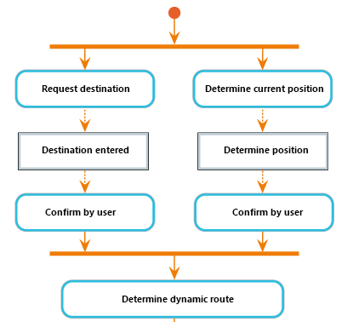

**Fig: 4.6.2.1.** Activity Diagram

* **Start:** The process begins with an initial state, indicating the start of the activity.
* **Request Destination:** The user requests a destination. This could be through a voice command, a touch interface, or by entering an address.
* **Determine Current Position:** The system determines the current location of the user. This could be done using GPS, mobile network triangulation, or other positioning technologies.
* **Destination Entered:** The user confirms the destination entered in the previous step.
* **Determine Position:** The system confirms the user's current position. This step might be redundant if the current position was already determined in step 2.
* **Confirm by User:** The system asks the user to confirm both the destination and their current position. This is a safety check to ensure the user is aware of the route and starting point.
* **Determine Dynamic Route:** The system calculates the optimal route between the user's current position and the requested destination. This calculation takes into account real-time traffic conditions, road closures, and other factors to determine the most efficient route.
* **End:** The process ends with the system providing the user with the dynamic route.

**4.7.1 Entity Relationship Diagrams**

An entity relationship model (or ER model) describes interrelated things of interest in a specific domain of knowledge. A basic ER model is composed of entity types (which classify the things of interest) and specifies relationships that can exist between entities (instances of those entity types). In software engineering, an ER model is commonly formed to represent things a business needs to remember in order to perform business processes. Consequently, the ER model becomes an abstract data model, that defines a data or information structure which can be implemented in a database, typically a relational database. Entities may be not only by relationships, but also by additional properties (attributes), which include identifiers called "primary keys". Diagrams created to represent attributes as well as entities and relationships may be called entity-attribute-relationship diagrams, rather than entity relationship models. An ER model is typically implemented as a database. In a simple relational database implementation, each row of a table represents one instance of an entity type, and each field in a table represents an attribute type. In a relational database a relationship between entities is implemented by storing the primary key of one entity as a pointer or "foreign key" in the table of another entity. There is a tradition for ER/data models to be built at two or three levels of abstraction. The conceptual-logical-physical hierarchy below is used in other kinds of specification, and is different from the three schema approach to software engineering.

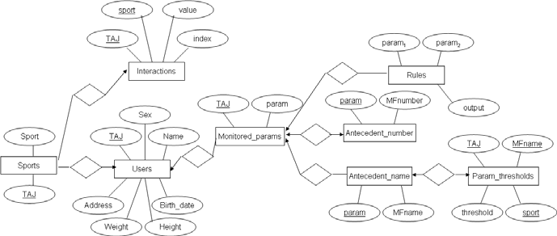

**Fig: 4.7.1.1** Entity Relationship Diagram

**4.8 Static Models**

Static models provide a static view of the system’s structure, focusing on the components, their attributes, and relationships without considering their behavior over time. Here’s a representation of the static model for your collision detection system using IoT:

**1. Component Diagram**

* **Data Files:** Text files storing the raw data of swimmer performance.
* **Python/Flask Backend:** The core processing unit that handles data parsing, analysis, prediction, and API requests.
* **Scikit-learn:** A machine learning library used for predicting future performance using Linear Regression.
* **Matplotlib:** A Python library for generating visualizations of performance data.
* **JSON API:** Facilitates communication between the backend and the frontend.
* **Web Frontend:** The user interface built with HTML, CSS, and JavaScript for user interaction and displaying results.

**2. Class Diagram**

* **User:** Represents the user of the system (coach or swimmer).
* **DataFile:** Represents the text files where swimmer data is stored. It includes attributes to store file information and extracted data.
* **DataFrame:** Represents the Pandas DataFrame used for data manipulation. It includes attributes for the data and methods for calculating performance metrics.
* **MachineLearningModel:** Represents the Scikit-learn model used for performance prediction. It includes methods for training and prediction.
* **Visualization:** Represents the Matplotlib component responsible for generating graphs.
* **APIResponse:** Represents the structure of the JSON response sent to the frontend, containing metrics, graph data, and recommendations.
* **WebFrontend:** Represents the user interface, responsible for displaying results and getting user input.
* **FlaskBackend:** Represents the backend logic, orchestrating data processing, model training, and response generation.
* **3. Entity-Relationship Diagram (ERD)**
* **SWIMMER participates_in RACE:** A swimmer can participate in multiple races, and each race has one swimmer.
* **RACE consists_of LAP_TIME:** A race consists of multiple lap times, and each lap time belongs to one race.
* **RACE has PERFORMANCE_METRIC:** Each race has one set of calculated performance metrics.
* **RACE has_prediction PREDICTION:** Each race can have a predicted performance.

**4.8.1 Components Used**



**Fig: 4.8.1.1** Central Processing Unit (CPU): Intel Core i5 (or AMD Ryzen 5)

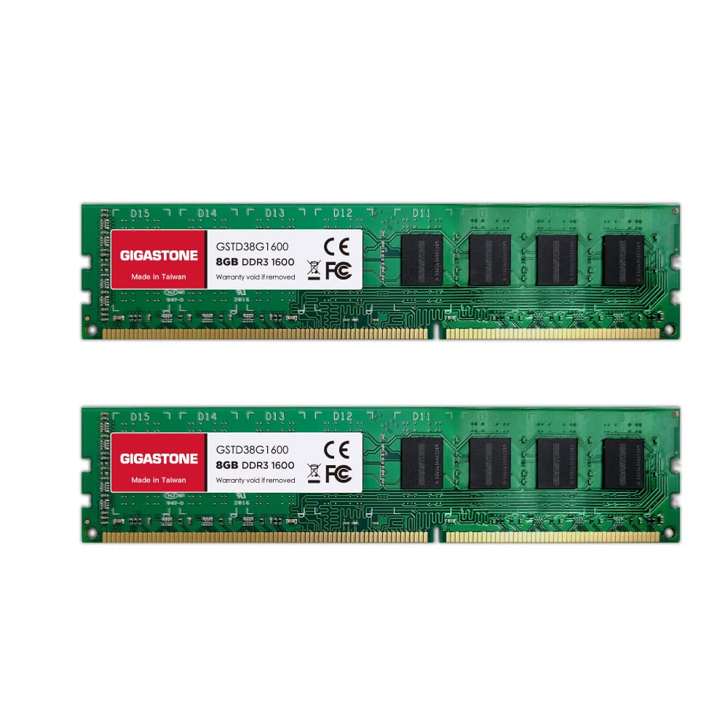

**Fig: 4.8.1.2 RAM 16 GB**

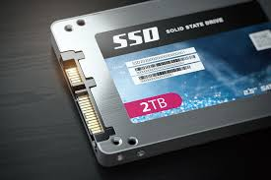

**Fig: 4.8.1.3** SSD

**4.8.2 Component Diagram**

* **User Interface (UI):**
* This component represents the web frontend (HTML, CSS, JavaScript) that allows users to interact with the system. It handles user input and displays the analysis results.
* **Flask API:** This component acts as an intermediary, receiving requests from the UI and forwarding them to the Flask Backend. It also sends responses back to the UI.
* **Flask Backend:** This is the core component of the system. It handles the main logic, including:
  + Parsing data from the Data Files.
  + Calculating performance metrics.
  + Using the Machine Learning component for predictions.
  + Using the Data Visualization component to generate graphs.
  + Preparing the data for sending to the API.
* **Data Files:** This component represents the storage of the swimmer's data in text files.
* **Machine Learning (ML):** This component encapsulates the Scikit-learn library and is responsible for providing the Linear Regression model for predicting future performance.
* **Data Visualization (Viz):** This component represents the Matplotlib library and is responsible for generating the graphical representations of the data.

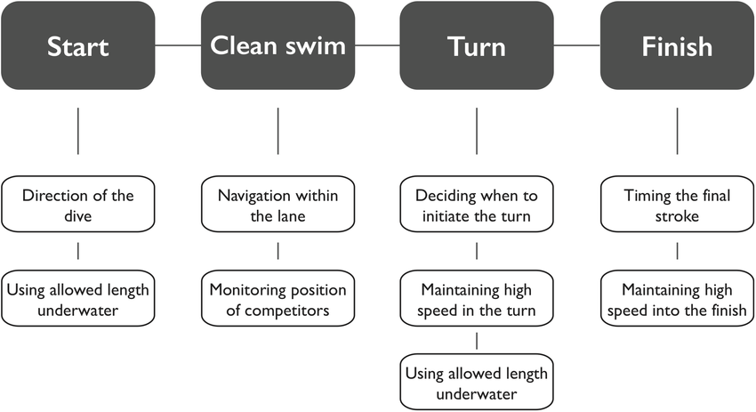

**Fig: 4.8.2.1** Component Diagram

**4.8.3 Deployment Diagram**

* **Client Node:** **Web Browser:** This represents the user's web browser, where the User Interface is rendered. It communicates with the server via HTTP requests and responses.
* **Server Node:**
  + **Flask Application:** This represents the server-side application, built using the Flask framework. It contains the API and Backend components.
    - **Flask API:** Handles communication with the client (Web Browser). It receives requests and sends responses.
    - **Flask Backend:** Contains the core logic of the application, including data processing, metric calculations, machine learning model execution, and visualization generation.
  + **Data Files:** This represents the file system or storage where the swimmer's data is stored.
  + **Libraries Node:** This represents the Python libraries used by the Flask Backend.
    - **Scikit-learn:** The machine learning library used for performance prediction.
    - **Matplotlib:** The library used for generating visualizations.
    - **Pandas:** The library used for data manipulation (while not explicitly a "component" in the same way, it's a crucial library).
* **Communication:**
  + The Web Browser communicates with the Flask API using HTTP requests (e.g., to request analysis) and receives HTTP responses (containing the analysis results).
  + The Flask Application interacts with the Data Files to read and write swimmer data.
  + The Flask Application uses the Scikit-learn library for machine learning tasks and the Matplotlib library for generating visualizations.

This deployment diagram provides a clear view of how the system is deployed across different nodes (client and server) and the technologies used for each component.

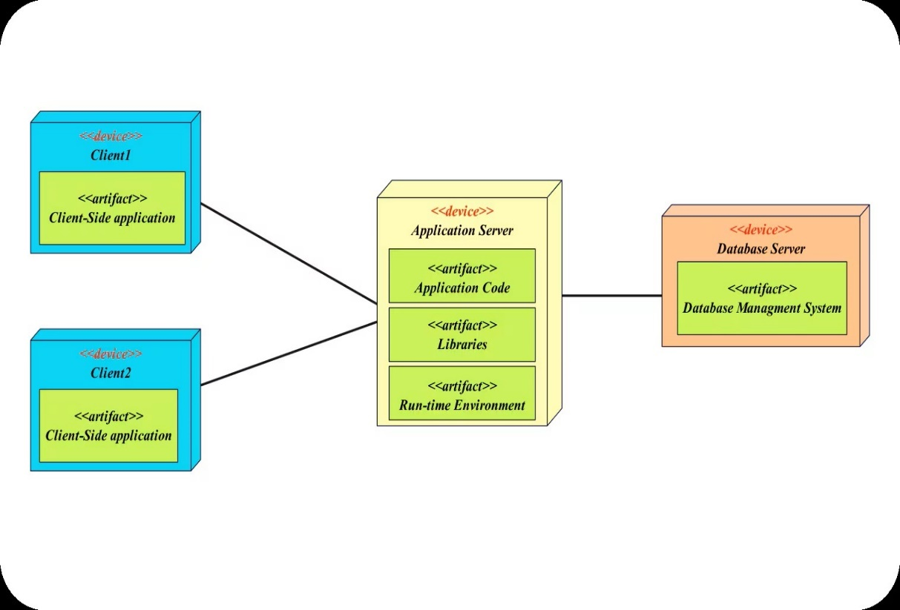

**Fig: 4.8.3.1** deployment diagram

**5. IMPLEMENTATION**

Implementation encompasses writing code or configuring hardware components based on design specifications, integrating these elements to form the complete system, and conducting testing to ensure functionality and reliability. Through debugging, issues identified during testing are addressed. Documentation is created to outline system architecture and provide usage instructions. Optimization techniques may be applied to enhance performance and efficiency. Finally, the system is deployed for use in its intended environment.

**5.1.1 Software Used**

The software used in the swimmer performance analysis project, as indicated in the presentation, includes:

* **Python/Flask Backend:** This indicates the use of the Python programming language along with the Flask framework for building the server-side logic of the application.
* **Scikit-learn:** This is a Python machine learning library used for implementing the Linear Regression model to predict swimmer performance.
* **Matplotlib:** This is a Python library used for creating visualizations and graphs to represent the performance data.
* **HTML, CSS, JavaScript:** These web technologies are used for building the user interface (Web Frontend) of the application.

Sources and related content

**5.1.2 Hardware Used**

**Personal Computer (PC):**

* **Role:**
  + **Server:** A PC can act as the server hosting the Flask application, the database (if used instead of text files), and running the Python code.
  + **Client:** A PC is also the typical device used to access the web application through a web browser.
* **Specifications:**
  + **Central Processing Unit (CPU):** Intel Core i5 (or AMD Ryzen 5) or higher.
    - **Importance:** The CPU performs the calculations and processing. A faster CPU will improve the application's responsiveness, especially during data analysis and model training.
  + **Random Access Memory (RAM):** 8GB RAM minimum, 16GB recommended.
    - **Importance:** RAM is used for temporary data storage during program execution. More RAM allows the application to handle larger datasets and complex calculations efficiently, preventing slowdowns.
  + **Storage Device (Hard Drive or SSD):** SSD (Solid State Drive) is highly recommended for faster read/write speeds.
    - **Importance:** SSDs significantly speed up data access, which is crucial for loading data files, saving processed data, and improving the overall performance of the application.

**5.2 Source code**

import matplotlib

matplotlib.use('Agg') # Sets the Matplotlib backend to 'Agg', which is non-interactive and suitable

for generating image files without a display.

import os # Provides functions for interacting with the operating system, like file listing.

from flask import Flask, request, jsonify, render_template # Flask is a web framework used to

create web applications.

import pandas as pd # Pandas is a data manipulation and analysis library.

import matplotlib.pyplot as plt # Matplotlib is a plotting library for creating visualizations.

import io # Provides tools for working with streams (like in-memory byte streams).

import base64 # Provides functions for encoding and decoding data in base64 format.

import numpy as np # NumPy is a library for numerical computing.

from sklearn.linear_model import LinearRegression # Scikit-learn's linear regression model for

predictions.

app = Flask(__name__) # Initializes a Flask web application.

def parse_time(time_str):

"""

Parses a time string in 'minutes:seconds' format and returns the total time in seconds.

Args:

time_str (str): The time string to parse.

Returns:

float: The total time in seconds, or 0 if parsing fails.

"""

try:

minutes, seconds = map(float, time_str.split(':')) # Splits the time string and converts

minutes and seconds to floats.

return minutes * 60 + seconds # Calculates the total time in seconds.

except ValueError:

print(f"Error parsing time string: '{time_str}'") # Prints an error message if the time string is in an

invalid format.

return 0 # Returns 0 if parsing fails.

def process_files(directory="."):

"""

Processes text files in a directory, extracts swimmer data, and returns a Pandas DataFrame.

Args:

directory (str): The directory containing the text files (default is the current directory).

Returns:

pd.DataFrame: A Pandas DataFrame containing swimmer data.

"""

data = [] # Initializes an empty list to store swimmer data.

for filename in os.listdir(directory): # Iterates through the files in the directory.

if filename.endswith(".txt"): # Checks if the file is a text file.

parts = filename.split("-") # Splits the filename by hyphens.

swimmer_name = parts[0] # Extracts the swimmer's name.

age = int(parts[1]) # Extracts the swimmer's age.

distance_stroke = parts[2] + "-" + parts[3].split(".")[0] # Extracts distance and stroke

information.

distance, stroke = distance_stroke.split("-") # Splits the distance and stroke.

with open(filename, "r") as file: # Opens the file for reading.

times = file.read().strip().split(",") # Reads the lap times from the file.

lap_times = [parse_time(t) for t in times] # Parses each lap time and converts it to

seconds.

total_time = sum(lap_times) # Calculates the total race time.

data.append({ # Appends swimmer data to the list.

"Swimmer": swimmer_name,

"Age": age,

"Distance": int(distance.replace('m','')),

"Stroke": stroke,

"Lap Times": lap_times,

"Total Time": total_time

})

return pd.DataFrame(data) # Returns a Pandas DataFrame from the list of swimmer data.

df = process_files() # Processes the text files and creates a DataFrame.

def calculate_velocity(lap_times, distance):

"""

Calculates the swimmer's velocity based on lap times and distance.

Args:

lap_times (list): A list of lap times in seconds.

distance (int): The race distance in meters.

Returns:

float: The swimmer's velocity in meters per second.

"""

if not lap_times:

return 0 # Returns 0 if lap times are empty.

total_time = sum(lap_times) # Calculates the total time spent to complete the race.

if total_time == 0:

return 0 # Returns 0 if the total time is zero.

return distance / (total_time / len(lap_times)) # Returns the velocity.

def generate_recommendation(swimmer_df):

"""

Generates a recommendation based on the swimmer's lap time consistency.

Args:

swimmer_df (pd.DataFrame): The DataFrame containing swimmer data.

Returns:

str: A recommendation message.

"""

lap_time_variations = swimmer_df['Lap Times'].apply(lambda x: np.std(x)) # Calculates

the standard deviation of lap times.

avg_variation = lap_time_variations.mean() # Calculates the average of the standard

deviations.

if avg_variation > 5: # If the average variation is high, recommends focusing on pacing.

return "Focus on maintaining a consistent pace throughout the race."

else: # Otherwise, praises the consistent pacing.

return "Your pacing is relatively consistent. Keep up the good work!"

def analyze_swimmer(swimmer_name):

"""

Analyzes swimmer data, generates plots, and returns metrics and recommendations.

Args:

swimmer_name (str): The name of the swimmer to analyze.

Returns:

dict: A dictionary containing plot URL, metrics, and recommendations.

"""

swimmer_df = df[df["Swimmer"] == swimmer_name].copy() # Extracts and copies the data

of the specified swimmer.

if swimmer_df.empty:

return {"error": "Swimmer Not found"} # Returns an error message if the swimmer is not found.

swimmer_df['Average Lap Time'] = swimmer_df['Lap Times'].apply(lambda x: sum(x) /

len(x)) # Calculates the average lap time.

plt.figure(figsize=(12, 6)) # Creates a matplotlib figure.

plt.subplot(1, 2, 1) # Creates the first subplot.

plt.plot(swimmer_df.index, swimmer_df["Total Time"]) # Plots the total time vs. race number.

plt.title(f"{swimmer_name} - Total Race Times") # Sets the title of the plot.

plt.xlabel("Race") # Sets the x-axis label.

plt.ylabel("Total Time (seconds)") # Sets the y-axis label.

plt.subplot(1, 2, 2) # Creates the second subplot.

bar_width = 10 # Sets the bar width.

for stroke in swimmer_df['Stroke'].unique(): # Iterates through each unique stroke.

stroke_data = swimmer_df[swimmer_df['Stroke'] == stroke] # Extracts data for the

current stroke.

plt.bar(stroke_data['Distance'], stroke_data['Average Lap Time'], # Creates a bar chart for

average lap times by distance and stroke.

label=stroke, width=bar_width)

plt.title(f"{swimmer_name} - Average Lap Times by Distance and Stroke") # Sets the title of the

plot.

plt.xlabel("Distance (m)") # Sets the x-axis label.

plt.ylabel("Average Lap Time (seconds)") # Sets the y-axis label.

plt.legend() # Adds a legend to the plot.

plt.tight_layout() # Adjusts subplot parameters to provide a tight layout.

img = io.BytesIO() # Creates an in-memory byte stream.

plt.savefig(img, format='png') # Saves the plot to the byte stream.

img.seek(0) # Moves the stream position to the beginning.

plot_url = base64.b64encode(img.getvalue()).decode('utf8') # Encodes the plot image to

base64.

plt.close() # Closes the plot.

X = swimmer_df.index.values.reshape(-1, 1) # Reshapes the race number to a 2D array for

linear regression.

y = swimmer_df["Total Time"].values # Extracts the total race times.

model = LinearRegression() # Initializes a linear regression model.

model.fit(X, y) # Trains the model.

next_race = np.array([[X[-1][0] + 1]]) # Calculates the race number of the next race.

predicted_time = model.predict(next_race)[0] # Predicts the total time for the next race.

velocity = calculate_velocity(swimmer_df['Lap Times'].iloc[0],

swimmer_df['Distance'].iloc[0]) # Calculates velocity.

age = swimmer_df['Age'].iloc[0] # Extracts the swimmer's age.

distance = swimmer_df['Distance'].mean() # Calculates the average distance.

mhr = 220 - age # Calculates the maximum heart rate.

if distance <= 50: # Calculates the estimated heart rate based on distance.

heart_rate = mhr * 0.85

elif distance <= 100:

heart_rate = mhr * 0.75

else:

heart_rate = mhr * 0.65

age = swimmer_df['Age'].iloc[0] # Extracts the swimmer's age.

age = int(age) # Converts age to integer.

metrics = { # Creates a dictionary of metrics.

"Total Time": "{:.2f}".format(swimmer_df["Total Time"].mean()),

"Average Lap Time": "{:.2f}".format(swimmer_df["Average Lap Time"].mean()),

"Velocity": "{:.2f}".format(velocity),

"Distance": "{:.2f}".format(swimmer_df['Distance'].mean()),

"Predicted Time": "{:.2f}".format(predicted_time),

"Heart Rate": "{:.2f}".format(heart_rate),

}

metric_recommendations = [] # Initializes an empty list for metric-specific recommendations.

# Adjusted Thresholds

if float(metrics["Average Lap Time"]) > 100:

metric_recommendations.append("Your average lap time is higher than expected.

Consider focusing on refining your stroke technique and building endurance.")

if float(metrics["Velocity"]) < 1.2:

metric_recommendations.append("Your velocity could be improved. Focus on increasing

your stroke efficiency and power to swim faster.")

if float(metrics["Heart Rate"]) < 110:

metric_recommendations.append("Your heart rate during longer swims is consistently low.

Consider increasing the intensity of your workouts.")

elif float(metrics["Heart Rate"]) > 190:

metric_recommendations.append("Your heart rate during longer swims is consistently high.

Focus on pacing yourself more effectively to avoid overexertion.")

if float(metrics["Predicted Time"]) > float(metrics["Total Time"]) * 1.05:

metric_recommendations.append("Your predicted time shows a potential decrease in

performance. Review your training strategy to identify areas for improvement.")

elif float(metrics["Predicted Time"]) < float(metrics["Total Time"]) * 0.95:

metric_recommendations.append("Your predicted time shows a potential improvement.

Continue with your current training strategy to maximize your performance.")

recommendation = generate_recommendation(swimmer_df) # Generates a general

recommendation.

print(metric_recommendations) # Prints the metric-specific recommendations to the console.

return {"plot": plot_url, "metrics": metrics, "recommendation": recommendation,

"metric_recommendations": metric_recommendations, "age": age} #Returns a dictionary

containing the plot, metrics, recommendations and age.

@app.route('/swimmer/<name>')

def get_swimmer_data(name):

"""

Flask route to get swimmer data by name.

Args:

name (str): The name of the swimmer.

Returns:

jsonify: A JSON response containing swimmer data.

"""

result = analyze_swimmer(name) # Calls the analyze_swimmer function.

return jsonify(result) # Returns the result as a JSON response.

@app.route('/')

def index():

"""

Flask route to render the index.html template.

Returns:

render_template: The rendered index.html template.

"""

return render_template('index.html') # Renders the index.html template.

if __name__ == '__main__':

app.run(debug=True) # Runs the Flask application in debug mode.

**6. TESTING**

**6.1 Introduction**

Testing is a critical phase in the software development lifecycle, aimed at evaluating the quality, functionality, and performance of a system to ensure it meets specified requirements and user expectations. It involves systematically executing test cases, scenarios, and procedures to identify defects, errors, and areas for improvement in the software or hardware under examination.

Testing serves several essential purposes in the development process:

**• Unit Testing:**

* **Test the parse_time() function to ensure it correctly converts time strings to seconds.**
* **Test the functions that calculate average lap time, velocity, and heart rate to verify they produce accurate results.**
* **Test the data loading functions to ensure they correctly read and parse data from the text files.**
* **Test the JSON encoding/decoding functions.**

**• Integration Testing:**

* **Test the interaction between the Flask backend and the data files to ensure data is retrieved and stored correctly.**
* **Test the communication between the Flask backend and the machine learning component (Scikit-learn) to verify that data is passed correctly for prediction.**
* **Test the interaction between the Flask backend and the web frontend (via the API) to ensure requests and responses are handled correctly.**

**• System Testing:**

* **Test the entire user flow:** 
  + **User enters swimmer's name in the browser.**
  + **Request is sent to the Flask backend.**
  + **Data is processed.**
  + **Results are displayed in the browser.**
* **Test with various datasets to simulate different scenarios.**
* **Test error handling (e.g., what happens if a swimmer's name is not found, or if there are errors in the data file).**
* **Test the performance of the system (how long does it take to analyze data and display results?).**

**• Acceptance Testing:**

* **Let coaches or swimmers use the system and provide feedback.**
* **This will help to identify any usability issues or areas where the system doesn't meet their needs.**

**7.** **Feedback:** Testing provides valuable feedback to stakeholders, including developers, testers, and users, enabling continuous improvement and refinement of the system.

**7. OUTPUT SCREENS**

Okay, here's a brief overview of the swimmer performance analysis project:

**Problem:**

* The project aims to address the challenges of manually analyzing swimmer performance, which is often time-consuming, subjective, and lacks detailed insights.
* There's a need for an automated system to accurately measure and evaluate swimmer metrics to help swimmers and coaches identify areas for improvement.

**Solution:**

* The proposed system uses Python, Flask, Scikit-learn, and Matplotlib to analyze swimmer data from text files.

* It calculates key performance metrics (e.g., average lap time, velocity, heart rate) and predicts future performance using Linear Regression.
* The system presents the analysis results through a user-friendly web interface with metrics tables, graphs, and recommendations.

**Key Components:**

* **Flask Backend:** Handles data processing, metric calculations, and predictions.
* **Scikit-learn:** Provides the Linear Regression model.
* **Matplotlib:** Generates performance visualizations.
* **Web Frontend:** Displays the analysis results to the user.

**Benefits:**

* Provides accurate and detailed performance analysis.
* Offers actionable insights for swimmers and coaches.
* Automates the analysis process, saving time and effort.

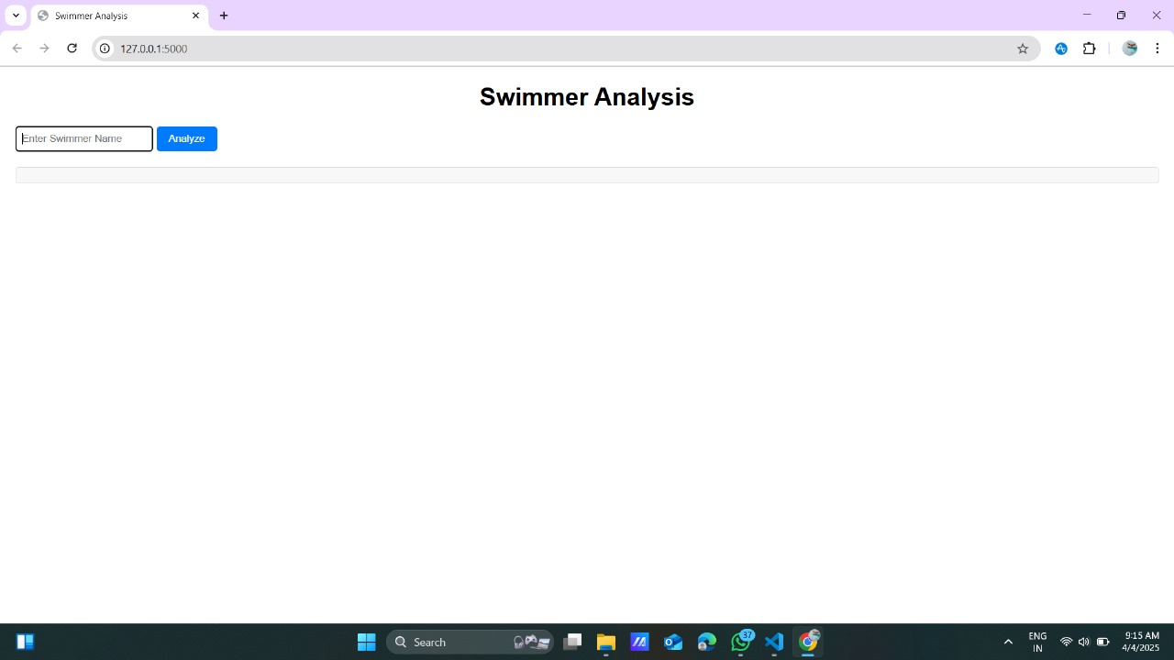

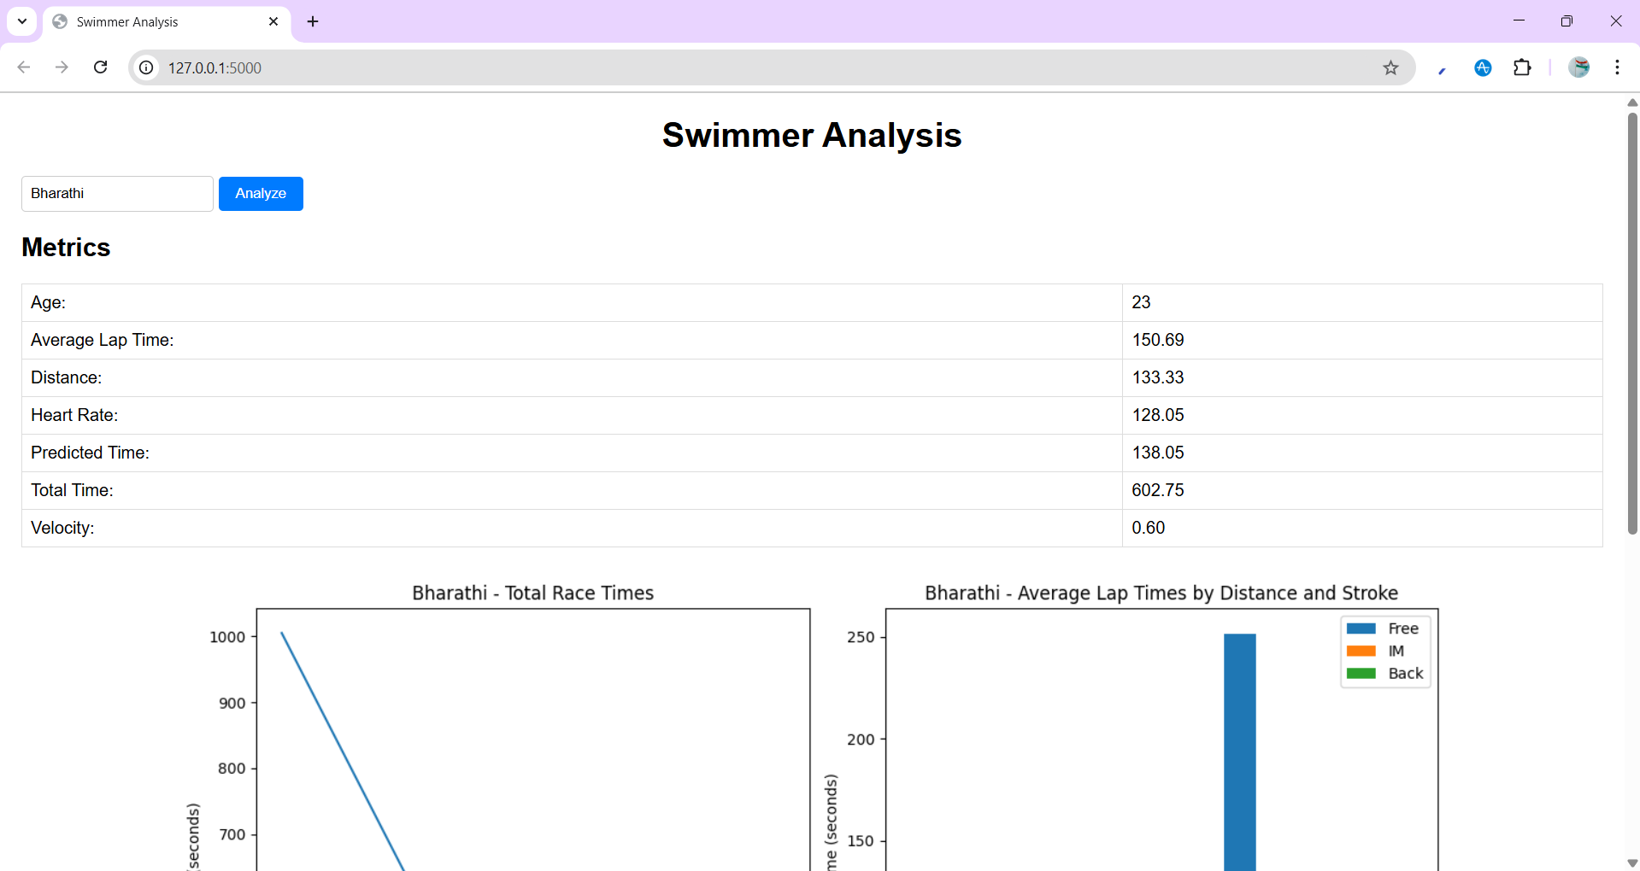

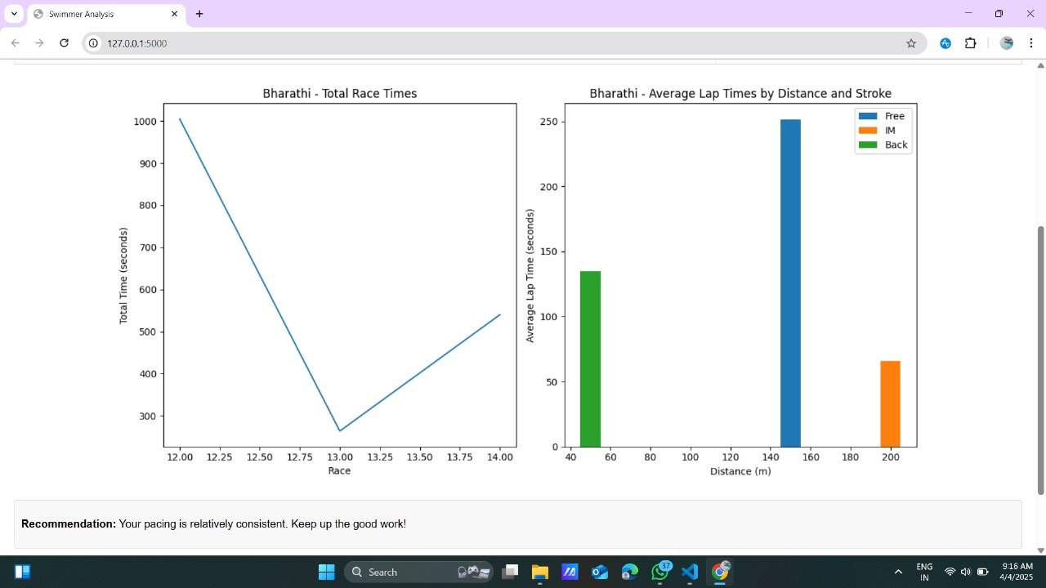

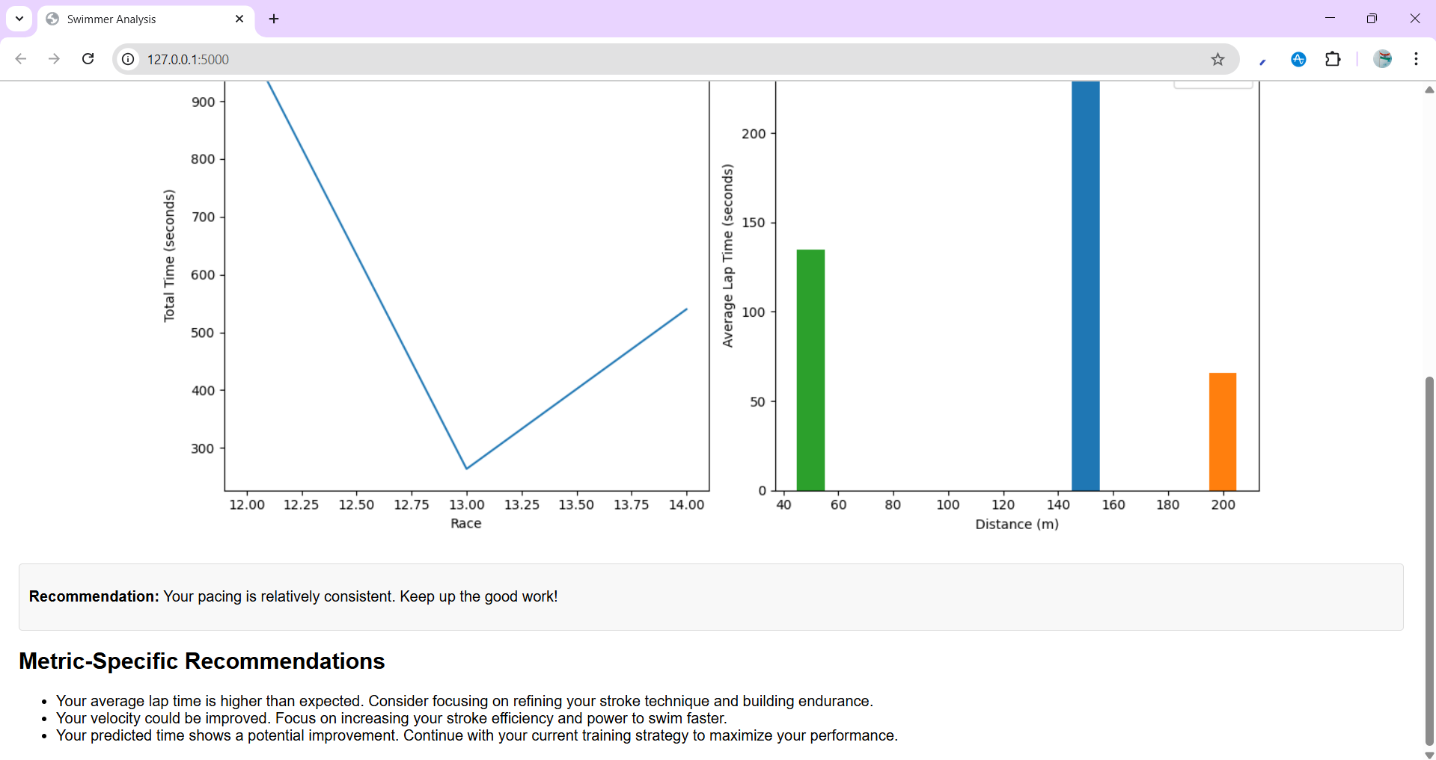

**8. CONCLUSION**

The swimmer performance analysis project successfully developed a system that leverages data analysis and machine learning to provide valuable insights into swimmer performance, ultimately aiding in the development of more effective training strategies.

In conclusion, this project has demonstrated the feasibility of automating swimmer performance analysis. The developed system efficiently processes raw data to generate key performance metrics and predictions, offering a significant improvement over traditional manual methods and enabling coaches and swimmers to make data-driven decisions.

The swimmer performance analysis project concludes by providing a powerful tool for enhancing swimmer performance. By delivering detailed metrics, visualizations, and actionable recommendations, the system empowers coaches to provide personalized feedback and enables swimmers to optimize their training, leading to improved results.

In conclusion, the swimmer performance analysis project provides a solid foundation for data-driven performance improvement. While the current system offers valuable insights, future work could focus on incorporating more advanced machine learning models, expanding the range of analyzed metrics, and developing real-time data acquisition capabilities to further enhance its effectiveness.

**9. BIBLOGRAPHY**

Here all the sources referred to, such as books, journal articles, reports, official websites, and case studies on Swimmer Performance Tracking and Analysis.

1. <https://internationalswimschoolsassociation.org/>
2. Swimming Federations: <https://www.worldaquatics.com/>
3. **The Science of Swimming"** by James E. Counsilman discusses various techniques and performance metrics relevant to swimming.
4. **Google Scholar:** Search for articles related to "swimming performance analysis" or "machine learning in sports" for peer-reviewed papers.
5. **International Journal of Sports Science & Coaching** that publish research on performance analysis.
6. **Sports technology Websites:** like **Sport Techie** and **TechCrunch** often cover innovations in sports technology, including machine learning applications in swimming.
7. **Coursera and edX:** Platforms offering courses on machine learning and data analytics, which can be applied to sports performance analysis.
8. **The Physics of Swimming** by John W. McGowan: Provides insights into the physical principles that affect swimming performance, which can be useful for understanding data analysis.