**ASSIGNMENT-7**

Name: Armaan Gogoi Roll No: 102303623 Group: 2C44

Q. Write a program in C/C++/Java to simulate the Banker’s algorithm for deadlock avoidance. Consider at least 3 processes in the system, with 4 resource classes having at least one resource instance for each class. Assume the values for Available, Allocation, MAX, and request from a particular process from your side. Program must reflect two cases, where a safe sequence exists for one and safe sequence does not exist for another.

-> Solution

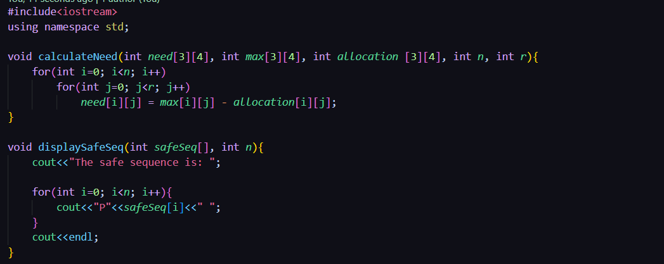

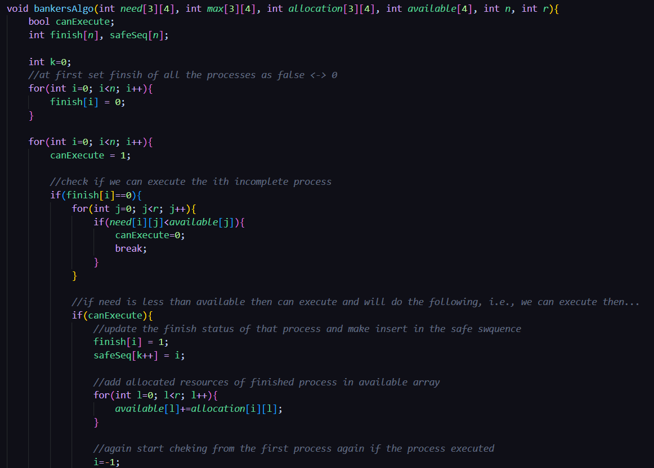

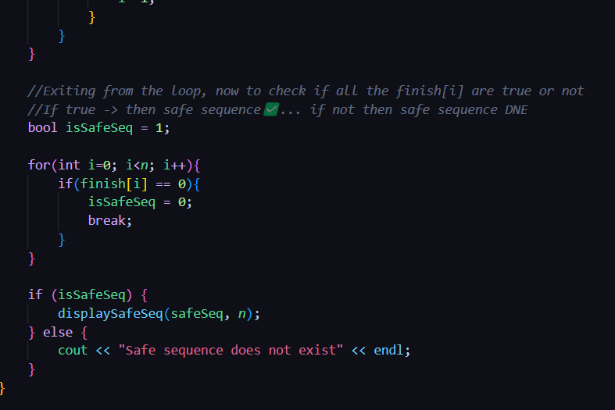

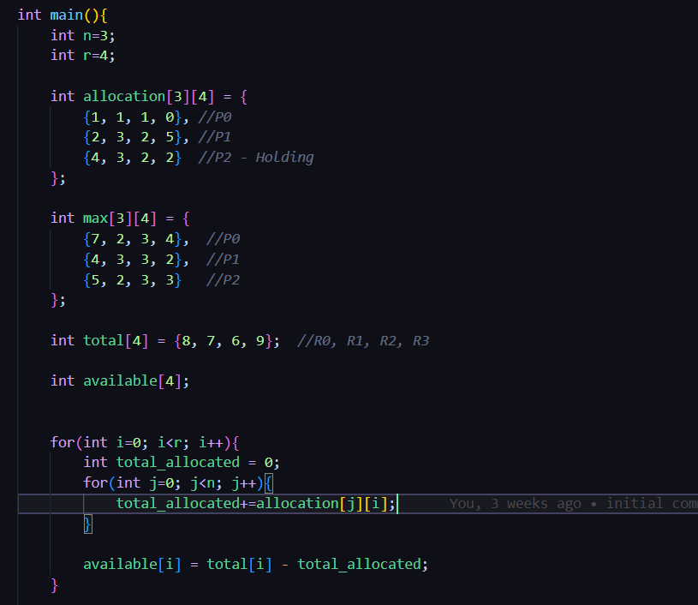

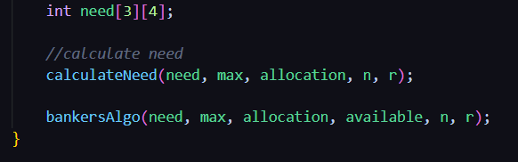

* OUTPUT:
* 