**ASSIGNMENT-8**

Name: Armaan Gogoi Roll No: 102303623 Group: 2C44

Q.1 Write a program to implement producer consumer scenario using POSIX shared memory.

->

producer.c

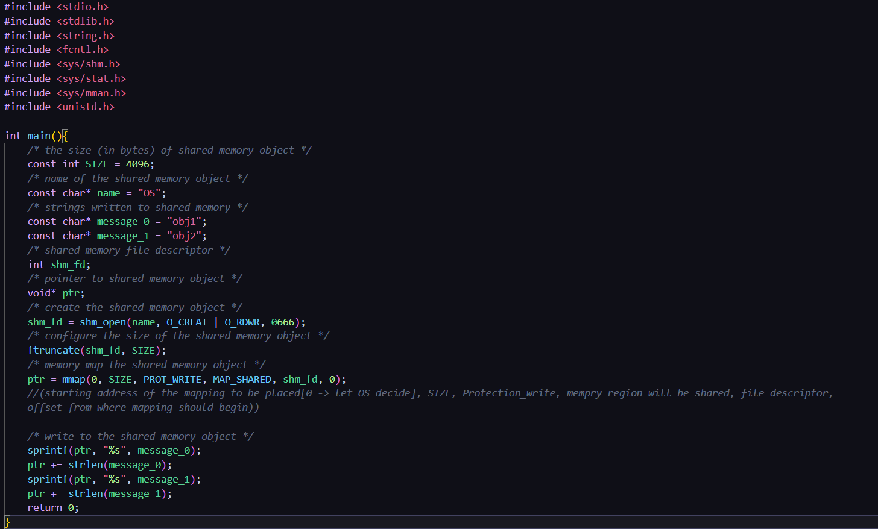

consumer.c

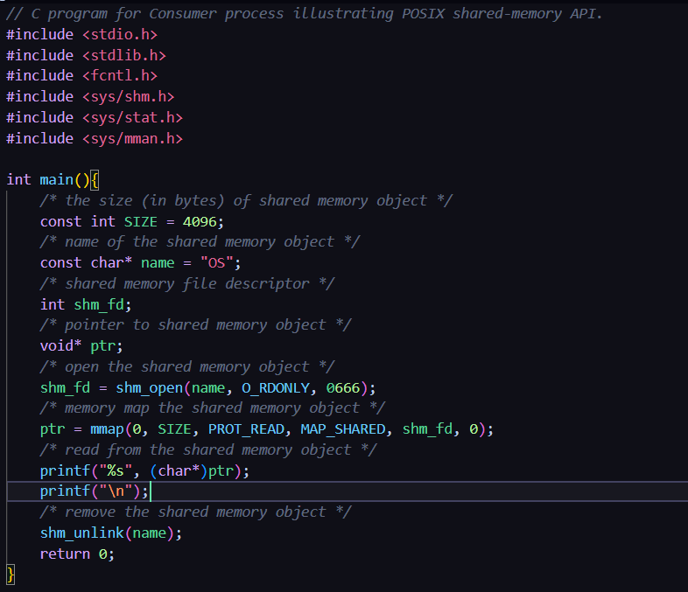

OUTPUT:

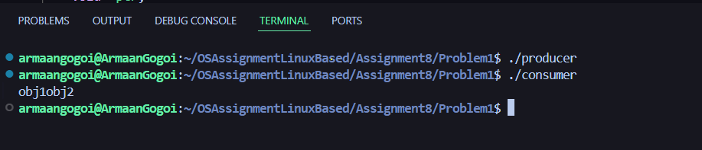

Q.2. Write a program to implement inter process communication between the parent process and the child process using ordinary Pipes.

->

Problem2.c

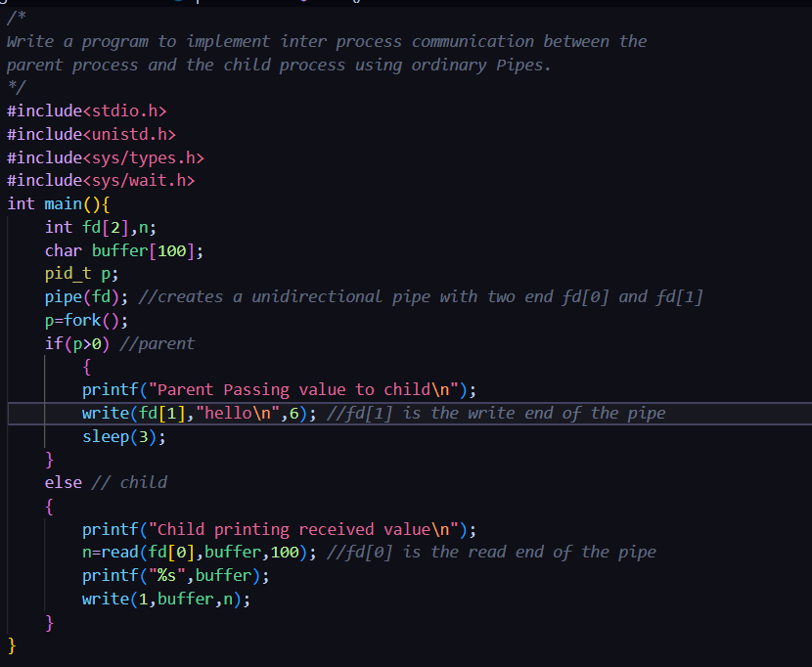

OUTPUT:

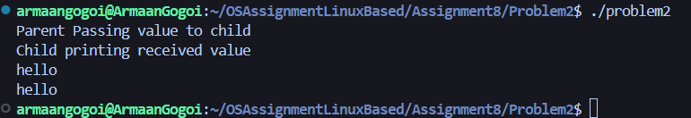

Q.3. Write program to implement IPC through message queues.

->

writer.c

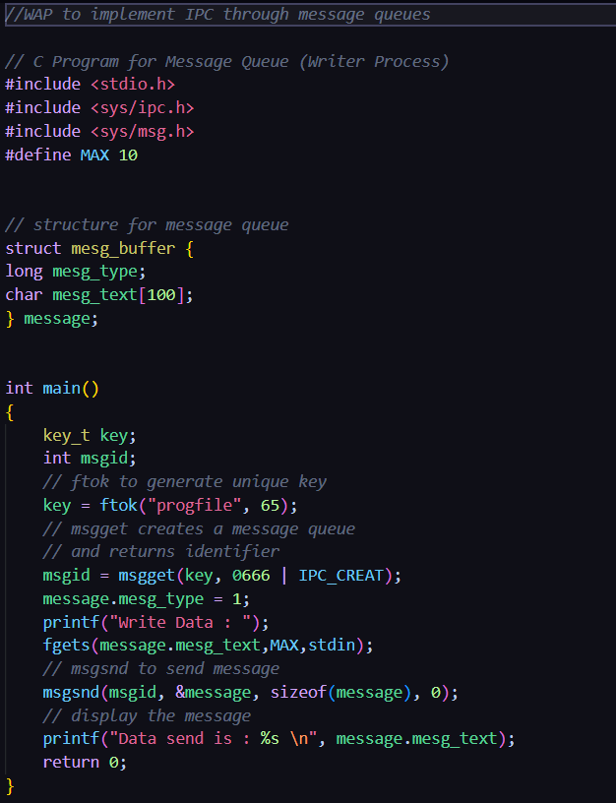

reader.c

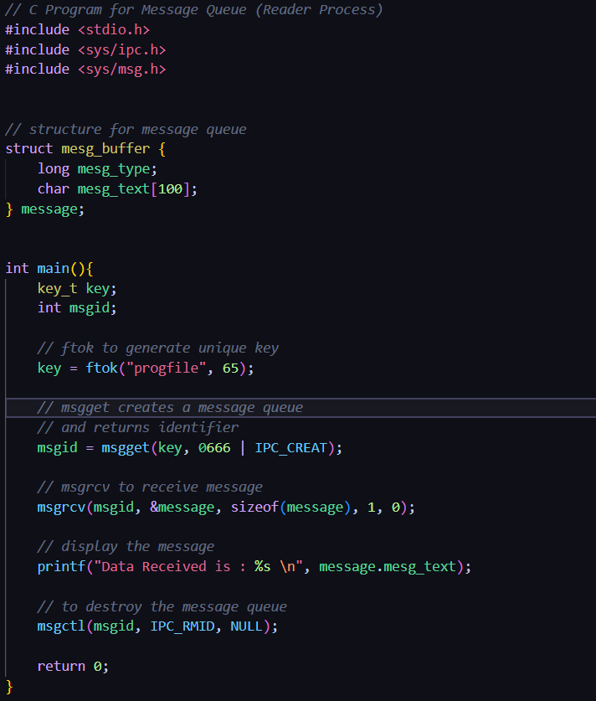

OUTPUT:

