**ASSIGNMENT-9**

NAME: Armaan Gogoi Roll No: 102303623 Group: 2C44

Q. Write a program using C/C++/Java to simulate the first fit, best fit and worst fit memory

allocation strategy. Assume memory chunk and initial requirement for memory block from

your side.

* Solution

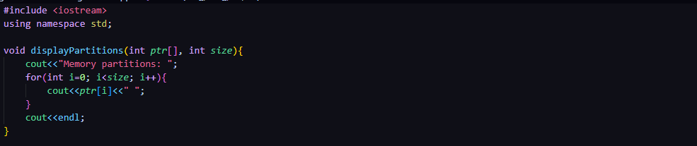

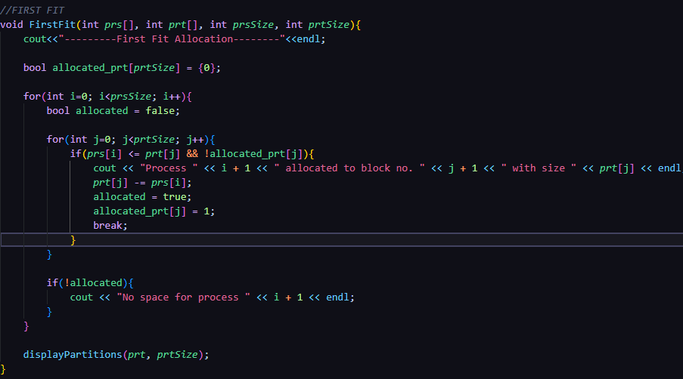

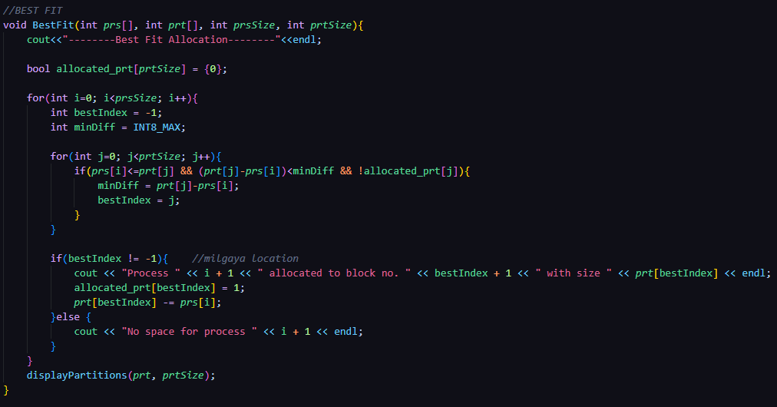

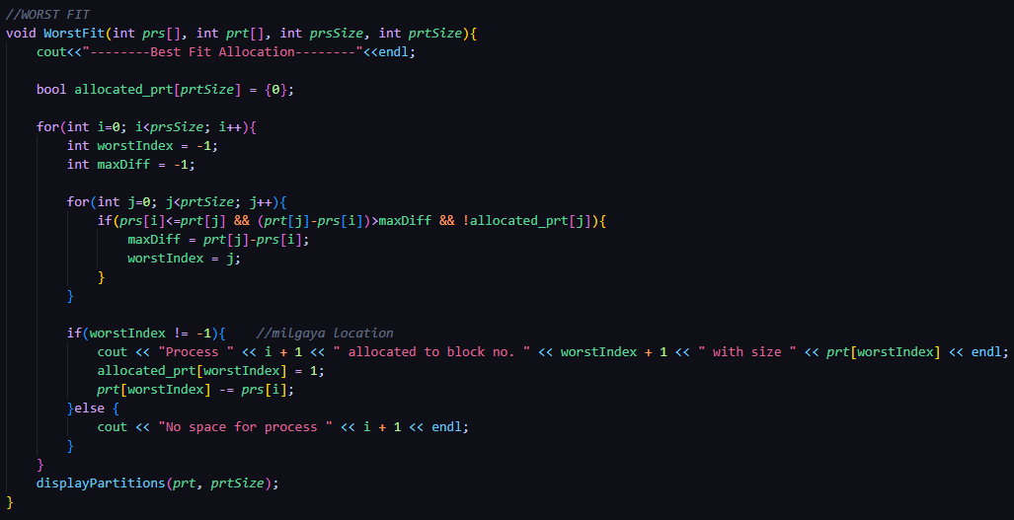

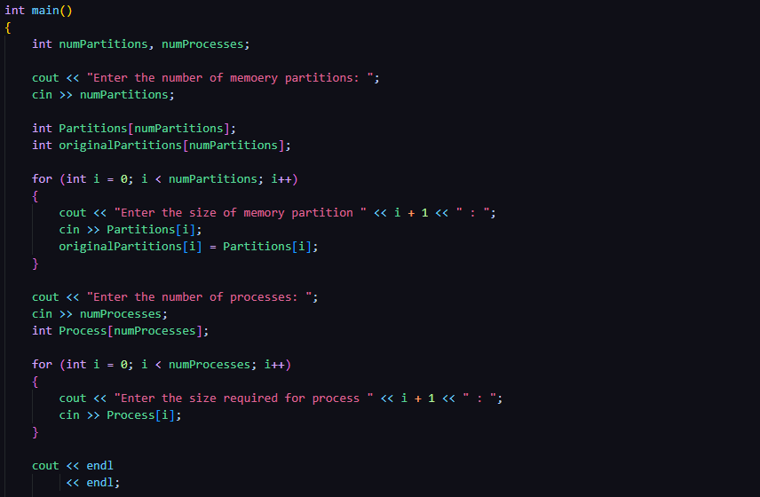

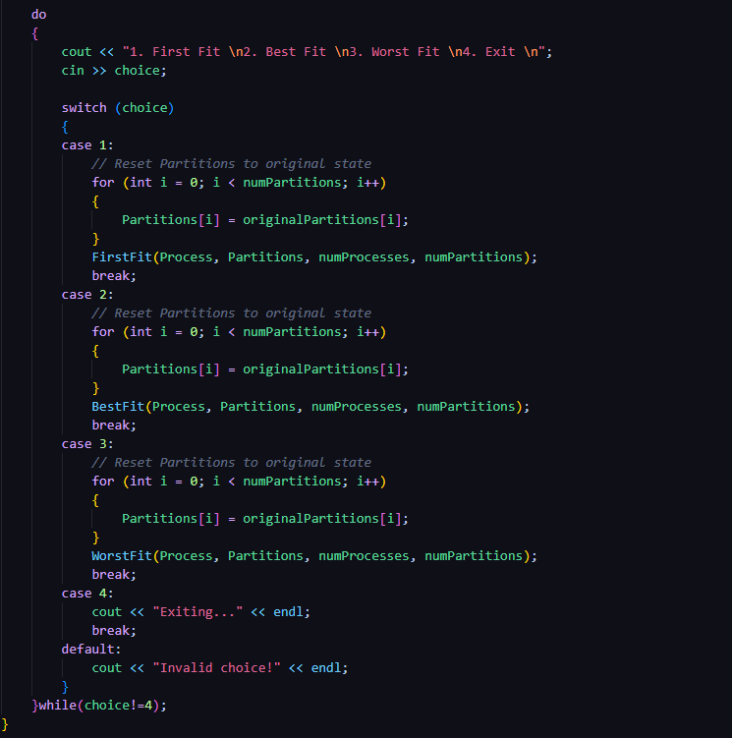

* OUTPUT:

