**Quiz game application**

**Created By:**

1. **Armaan nakhunda – 02**
2. **Sushant Suresh Navle – 05**
3. **Nishal Poojary - 17**

**(Dr. Sharmila Rajesh Ponnoran)**

**Supervisor**



**Department of Computer Engineering**

**K C College of Engineering and Management Studies and Research**

**Mith Bunder Road, Near Hume Pipe, Kopri, Thane(East)**

**University of Mumbai**

**(AY 2023-24)**

**CERTIFICATE**

This is to certify that the Mini Project entitled **“ Quiz game application”** is a bonafide work of **Armaan Nakhunda (02), Sushant Suresh Navle (05)**,Nishal poojary(17) submitted to the University of Mumbai in partial fulfilment of the requirement from the award of the degree of “ Bachelor of Engineering” in “Computer Engineering”.

(Dr. Sharmila Rajesh Ponnoran)

**Supervisor**

(Dr. Mahesh Maurya) **(**Dr. Vilas Nitnavare)

**Head of Department Principal**

**_______________________**

**College Seal**

**Mini Project Approval**

This Mini Project entitled “ Quiz game application ” by Armaan nakhunda (02); Sushant Suresh Navle(05); Nishal poojary (17) is approved for the degree of Bachelor of Engineering in Computer Engineering.

Examiners :

1. _________________________________

(Internal Examiner Name and Sign )

1. __________________________________

(External Examiner Name and Sign)

Date:

Place:

Acknowledgement

No project is ever complete without the guidance of those experts who have

already traded their past before and hence became master of it and as a

result, our mentor. So we would like to take this opportunity to take all those

individuals who have helped us in visualizing this project. The guidance of Dr

Sharmila Ponnoran played a great role in our research work. Her guidance

helped us in finding relevant information about our topic. We are grateful to

get an opportunity to present our work to everyone. We would like to express

our gratitude to the 'K.C. College of Engineering and Management Studies &

Research as well as our Head of Department, "Prof. Mahesh Maurya" for

promoting students to express their ideas and research. Our sincere vote of

thanks goes to our college Principal. "Dr. Vilas Nitnaware" for believing in the

work of their students and pushing our limits to do better in our field of study

Content

1. Abstract
2. Project Code
3. Project Screenshots
4. Conclusion and Future Scope
5. References

Abstract

The Java Quiz Game application is a dedicated platform designed for Java enthusiasts, offering a wide range of interactive challenges within the realm of Java programming. With its competitive scoring system and user-friendly interface, this application seamlessly combines education with entertainment, making the process of mastering Java both enjoyable and engaging. Users can strategically navigate the game using lifelines, such as eliminating wrong options or relying on the computer's 80% accuracy for the right answer. The application prioritizes education, covering various aspects of Java programming and providing detailed progress tracking and statistics to support continuous improvement.

Top of Form

Code of project

// Import necessary packages

import javax.swing.*;

import java.awt.*;

import java.awt.event.ActionEvent;

import java.awt.event.ActionListener;

import java.awt.event.KeyEvent;

import java.awt.event.KeyListener;

import java.util.ArrayList;

import java.util.Arrays;

import java.util.Collections;

import java.util.List;

import java.util.Random;

import java.util.HashSet;

import java.util.Set;

public class QuizGameGUI extends JFrame {

private JLabel questionLabel;// Label for displaying the current question

private JRadioButton[] options;// Array of radio buttons for displaying answer choices

private ButtonGroup optionGroup;// Button group to ensure only one answer choice is selected at a time

private JButton nextButton;// Button for moving to the next question

private JButton backButton;// Button for going back to the previous question

private JButton pauseButton;// Button for pausing the game

private JButton fiftyFiftyButton;// Button for using the 50/50 lifeline

private JButton askFriendButton;// Button for using the ask-a-friend lifeline

private boolean paused = false;// Flag for whether the game is currently paused

private int currentQuestionIndex = 0;// Index of the current question being displayed

private int score = 0;// Current score of the player

private JTextArea summaryTextArea;// Text area for displaying a summary of the game after it ends

private List<Question> allQuestions;// List of all available questions

private List<Question> selectedQuestions;// List of questions selected for the current game

private String[] userAnswers;// Array of the user's answers to each question

private JFrame startupFrame;// Frame for selecting the number of questions to include in the game

private JComboBox<Integer> questionCountComboBox;// Combo box for selecting the number of questions to include in the game

private JPopupMenu pauseMenu;// Popup menu for displaying options when the game is paused

private Timer questionTimer;// Timer for each question

private int timerSeconds = 20; // Set the timer duration in seconds

private boolean timeUp = false;// Flag for whether the timer has run out for the current question

private Set<Integer> timedOutQuestions;// Set of questions for which the timer has run out

private StringBuilder summary;// StringBuilder for building the summary of the game

private int[] timeRemaining;// Array of time remaining for each question

private JLabel timerLabel;// Label for displaying the timer

private JFrame summaryFrame;// Frame for displaying the summary of the game

// Constructor for the QuizGameGUI class

public QuizGameGUI() {

// Create the startup frame

createStartupFrame();

// Initialize the JTextArea for the summary

summaryTextArea = new JTextArea(20, 80);

summaryTextArea.setEditable(false);

// Initialize questions and userAnswers

initializeQuestions();

// Add key bindings to the content pane

addKeyBindings();

// Set up the main quiz frame

setUpQuizFrame();

// Show the startup frame

startupFrame.setVisible(true);

// Initialize the time remaining for each question

timedOutQuestions = new HashSet<>();

// Set the time remaining for each question to the timer duration

timeRemaining = new int[allQuestions.size()];

// Create the timer for each question

Arrays.fill(timeRemaining, timerSeconds);

// Timer for each question

questionTimer = new Timer(1000, new ActionListener()

{

@Override

public void actionPerformed(ActionEvent e) {

// Decrement the time remaining for the current question

timeRemaining[currentQuestionIndex]--;

// Update the timer label

if (timeRemaining[currentQuestionIndex] <= 6) {

// Blink the timer label red at even seconds

if (timeRemaining[currentQuestionIndex] % 2 == 0) {

timerLabel.setForeground(Color.RED);

} else {

timerLabel.setForeground(Color.BLACK);

}

}

else {

// Reset the timer label color to black

timerLabel.setForeground(Color.BLACK);

}

// Update the timer label

timerLabel.setText("Timer: " + timeRemaining[currentQuestionIndex] + " seconds");

// If the timer has run out

if (timeRemaining[currentQuestionIndex] <= 0)

{

// Stop the timer

questionTimer.stop();

// Handle the timeout

handleTimeout();

}

}

});

}

// Method for creating the startup frame

private void createStartupFrame() {

// Create the startup frame

startupFrame = new JFrame("Quiz Startup");

startupFrame.setSize(300, 150);

startupFrame.setDefaultCloseOperation(JFrame.EXIT_ON_CLOSE);

startupFrame.setLocationRelativeTo(null);

// Panel for the startup frame

JPanel startupPanel = new JPanel();

// Set the layout to FlowLayout

startupPanel.setLayout(new FlowLayout());

// Label for the combo box

JLabel label = new JLabel("Select the number of questions:");

// Add the label to the panel

startupPanel.add(label);

// Create the combo box for selecting the number of questions

Integer[] options = {5, 10, 15, 20};

questionCountComboBox = new JComboBox<>(options);

startupPanel.add(questionCountComboBox);

// Create the start button

JButton startButton = new JButton("Start Quiz");

startupPanel.add(startButton);

// Create Button for instructions

JButton instructionsButton = new JButton("Instructions");

startupPanel.add(instructionsButton);

// Add the panel to the frame

startupFrame.add(startupPanel);

// Add key bindings to the content pane

addKeyBindings();

// Action listener for the start button

startButton.addActionListener(new ActionListener()

{

@Override

public void actionPerformed(ActionEvent e)

{

// Get the selected number of questions

int selectedQuestionCount = (int) questionCountComboBox.getSelectedItem();

// Select random questions based on the user's choice

selectRandomQuestions(selectedQuestionCount);

// Load the first question

loadQuestion(currentQuestionIndex);

// Hide the startup frame and show the quiz frame

startupFrame.setVisible(false);

setVisible(true);

}

});

// Action listener for the instructions button

instructionsButton.addActionListener(new ActionListener() {

@Override

public void actionPerformed(ActionEvent e) {

// Open a new frame for instructions

showInstructionsFrame();

}

});

}

// Method for setting up the quiz frame

private void setUpQuizFrame()

{

// Set the title of the frame

setTitle("Quiz Game");

// Set the size of the frame

setSize(1100, 300);

// Set the default close operation

setDefaultCloseOperation(JFrame.EXIT_ON_CLOSE);

// Set the location of the frame to the center of the screen

setLocationRelativeTo(null);

// Create a new panel

JPanel panel = new JPanel();

// Set the layout to BorderLayout

panel.setLayout(new BorderLayout());

// Create a new label for the question

questionLabel = new JLabel();

// Add the label to the panel

panel.add(questionLabel, BorderLayout.NORTH);

// Create a new panel for the answer choices

JPanel optionsPanel = new JPanel();

// Set the layout to GridLayout with 4 rows and 1 column

optionsPanel.setLayout(new GridLayout(4, 1));

// Create a new array of radio buttons for the answer choices

options = new JRadioButton[4];

// Create a new button group to ensure only one answer choice is selected at a time

optionGroup = new ButtonGroup();

// Loop 4 times

for (int i = 0; i < 4; i++)

{

// Create a new radio button

options[i] = new JRadioButton();

// Add the radio button to the panel

optionsPanel.add(options[i]);

// Add the radio button to the button group

optionGroup.add(options[i]);

}

// Add the options panel to the center of the main panel

panel.add(optionsPanel, BorderLayout.CENTER);

// Panel for the buttons

JPanel buttonPanel = new JPanel();

// Set the layout to FlowLayout

buttonPanel.setLayout(new FlowLayout());

// Label for displaying the timer

timerLabel = new JLabel("Timer: " + timerSeconds + " seconds");

// Center the text in the label

timerLabel.setHorizontalAlignment(JLabel.CENTER);

// Add the timer label to the panel

JPanel timerPanel = new JPanel(new BorderLayout());

// Add the timer label to the panel

timerPanel.add(timerLabel, BorderLayout.CENTER);

// Add the timer panel to the main panel

add(timerPanel, BorderLayout.SOUTH);

// Button for going back to the previous question

backButton = new JButton("Back");

// Add the button to the panel

buttonPanel.add(backButton);

// Button for moving to the next question

nextButton = new JButton("Next");

// Add the button to the panel

buttonPanel.add(nextButton);

// Button for pausing the game

pauseButton = new JButton("Pause");

// Add the button to the panel

buttonPanel.add(pauseButton);

// Button for using the 50/50 lifeline

fiftyFiftyButton = new JButton("50-50");

// Add the button to the panel

buttonPanel.add(fiftyFiftyButton);

// Button for using the ask-a-friend lifeline

askFriendButton = new JButton("Ask the Computer");

// Add the button to the panel

buttonPanel.add(askFriendButton);

// Add the button panel to the main panel

panel.add(buttonPanel, BorderLayout.SOUTH);

// Add the main panel to the frame

add(panel);

// Add key bindings to the content pane

addKeyBindings();

nextButton.addActionListener(new ActionListener()// Action listener for the next button

{

@Override

public void actionPerformed(ActionEvent e)// Method for handling the next button

{

// Check the user's answer

checkAnswer();

// Increment the current question index

currentQuestionIndex++;

// Clear the selected answer choice

optionGroup.clearSelection();

if (currentQuestionIndex < selectedQuestions.size())// If there are more questions

{

// Load the next question

loadQuestion(currentQuestionIndex);

}

else

{

// Otherwise, show the result

showResult();

}

}

});

backButton.addActionListener(new ActionListener()// Action listener for the back button

{

@Override

public void actionPerformed(ActionEvent e)

{

// If the timer has expired, mark the current question as timed out

if (timerSeconds <= 0 && !timedOutQuestions.contains(currentQuestionIndex))

{

// Add the current question index to the set of timed out questions

timedOutQuestions.add(currentQuestionIndex);

}

if (currentQuestionIndex > 0)

{

// Decrement the current question index

currentQuestionIndex--;

// Load the previous question

loadQuestion(currentQuestionIndex);

}

// Enable the back button for all questions before the current one

// Loop through all questions before the current one

for (int i = 0; i < currentQuestionIndex; i++)

{

// If the question has not timed out

if (!timedOutQuestions.contains(i))

{

// Enable the back button

backButton.setEnabled(true);

break;

}

}

}

});

// Action listener for the pause button

pauseButton.addActionListener(new ActionListener()

{

@Override

public void actionPerformed(ActionEvent e)

{

// Show the pause menu

showPauseMenu();

}

});

// Action listener for the 50/50 button

fiftyFiftyButton.addActionListener(new ActionListener()

{

@Override

public void actionPerformed(ActionEvent e)

{

// Use the 50/50 lifeline

useFiftyFiftyLifeline();

}

});

askFriendButton.addActionListener(new ActionListener()// Action listener for the ask-a-friend button

{

@Override

public void actionPerformed(ActionEvent e)

{

// Use the ask-a-friend lifeline

useAskFriendLifeline();

}

});

}

// Method for initializing the questions

private void initializeQuestions()

{

// Initialize the list of all questions

allQuestions = new ArrayList<>();

// Adding the questions to the list, in the format of question, option1, option2, option3, option4, correct answer.

allQuestions.add(new Question("What does JVM stand for?", "Java Virtual Machine", "Just Very Much", "Jungle Virtual Mouse", "Java Virtual Method", "Java Virtual Machine"));

allQuestions.add(new Question("What is a variable in Java?", "A reserved keyword", "A data type", "A storage location", "An operator", "A storage location"));

allQuestions.add(new Question("Which data type is used for whole numbers in Java?", "float", "double", "int", "String", "int"));

allQuestions.add(new Question("How do you declare a constant variable in Java?", "Using the 'var' keyword", "Using the 'let' keyword", "Using the 'final' keyword", "Using the 'const' keyword", "Using the 'final' keyword"));

allQuestions.add(new Question("What is the main purpose of the 'public static void main(String[] args)' method?", "To declare variables", "To print output", "To initialize objects", "To start the program", "To start the program"));

allQuestions.add(new Question("Which Java keyword is used to create a new instance of a class?", "new", "class", "instance", "this", "new"));

allQuestions.add(new Question("What is the output of 'System.out.println(5 + 3 * 2)'?", "11", "16", "56", "26", "11"));

allQuestions.add(new Question("Which operator is used for equality comparison in Java?", "==", "=", "!=", "===","=="));

allQuestions.add(new Question("What is the keyword used to create a new class in Java?", "new", "class", "instance", "this", "class"));

allQuestions.add(new Question("Which loop is used for iterating over elements of an array or collection in Java?", "for loop", "while loop", "if-else loop", "do-while loop", "for loop"));

allQuestions.add(new Question("What is the correct syntax for a single-line comment in Java?", "// This is a comment", "/* This is a comment */", "# This is a comment", "<!-- This is a comment -->", "// This is a comment"));

allQuestions.add(new Question("Which access modifier makes a class or method accessible only within the same package?", "public", "protected", "private", "default", "default"));

allQuestions.add(new Question("What is the purpose of the 'this' keyword in Java?", "To create a new instance of a class", "To call a method of the superclass", "To refer to the current instance of a class", "To declare a constant", "To refer to the current instance of a class"));

allQuestions.add(new Question("Which Java data type is used to store text?", "int", "char", "String", "float", "String"));

allQuestions.add(new Question("What is the result of '10 % 3' in Java?", "1", "2", "3", "0", "1"));

allQuestions.add(new Question("Which statement is used to exit a loop prematurely in Java?", "break", "continue", "return", "exit", "break"));

allQuestions.add(new Question("What is the term for a function defined within a class in Java?", "Procedure", "Function", "Method", "Routine", "Method"));

allQuestions.add(new Question("What is the correct syntax to create a new object of a class in Java?", "new Object();", "create Object();", "Object.create();", "Object.new();", "new Object();"));

allQuestions.add(new Question("What is the default value of a boolean variable in Java?", "0", "1", "false", "true", "false"));

allQuestions.add(new Question("Which Java keyword is used to declare a constant variable?", "constant", "const", "final", "static", "final"));

allQuestions.add(new Question("What is the term for a class that cannot be instantiated and may have abstract methods?", "Interface", "Abstract class", "Concrete class", "Final class", "Abstract class"));

allQuestions.add(new Question("Which keyword is used to implement multiple inheritance in Java?", "inherit", "extends", "implements", "multiextends", "extends"));

allQuestions.add(new Question("What is the output of 'System.out.println(\"Hello\" + \"World\");'?", "Hello World", "Hello\nWorld", "Hello + World", "HelloWorld", "HelloWorld"));

allQuestions.add(new Question("In Java, a switch statement can be used with which data types?", "int", "float", "String", "All of the above", "int"));

allQuestions.add(new Question("What is the purpose of the 'default' case in a switch statement?", "To specify the default value", "To define the default behavior when no case matches", "To indicate an error", "To break out of the switch statement", "To define the default behavior when no case matches"));

allQuestions.add(new Question("Which operator is used for logical AND in Java?", "&", "&&", "||", "!", "&&"));

allQuestions.add(new Question("What is the term for a class that inherits properties and behaviors from another class in Java?", "Derived class", "Superclass", "Parent class", "Child class", "Child class"));

allQuestions.add(new Question("Which exception is thrown when an array index is out of bounds?", "IndexOutOfRangeException", "ArrayIndexException", "OutOfBoundsException", "ArrayIndexOutOfBoundsException", "ArrayIndexOutOfBoundsException"));

allQuestions.add(new Question("What is the purpose of the 'finally' block in a try-catch-finally statement?", "To specify the catch block", "To handle exceptions", "To ensure code is executed regardless of exceptions", "To skip the try block", "To ensure code is executed regardless of exceptions"));

allQuestions.add(new Question("What is the difference between '=='' and '.equals()' when comparing strings in Java?", "'==' compares object references, '.equals()' compares string contents", "'==' compares string contents, '.equals()' compares object references", "There is no difference", "Both are used to compare object references", "'==' compares object references, '.equals()' compares string contents"));

allQuestions.add(new Question("Which Java keyword is used to explicitly call a superclass constructor?", "superclass", "base", "super", "parent", "super"));

allQuestions.add(new Question("In Java, which keyword is used to create an array?", "new", "array", "create", "make", "new"));

allQuestions.add(new Question("What is the result of '5 / 2' in Java?", "2.5", "2", "2.0", "2.25", "2"));

allQuestions.add(new Question("What is the purpose of the 'volatile' keyword in Java?", "To make a variable thread-safe", "To declare a constant", "To define a final variable", "To prevent variable modification", "To make a variable thread-safe"));

allQuestions.add(new Question("Which Java data type is used to represent a single 16-bit Unicode character?", "char", "byte", "int", "short", "char"));

allQuestions.add(new Question("What is the term for a method that has the same name as the class and is used to initialize objects?", "Constructor", "Initializer", "Destructor", "Accessor", "Constructor"));

allQuestions.add(new Question("What is the Java keyword used to create a subclass that inherits from a superclass?", "inherits", "extends", "implements", "inheritsfrom", "extends"));

allQuestions.add(new Question("What is the Java keyword used to refer to the current instance of a class within that class's methods?", "this", "self", "current", "instance", "this"));

allQuestions.add(new Question("Which access modifier allows a class or method to be accessible only within the same package or by subclasses?", "private", "public", "protected", "default", "protected"));

allQuestions.add(new Question("What is the result of '5 + 5.0' in Java?", "10.0", "10", "5.0", "5", "10.0"));

allQuestions.add(new Question("Which Java data type is used to store characters in Unicode format?", "char", "byte", "int", "string", "char"));

allQuestions.add(new Question("What is the purpose of the 'super' keyword in Java?", "To call a superclass method", "To call a static method", "To create a new instance of a class", "To declare a constant", "To call a superclass method"));

allQuestions.add(new Question("In Java, what is the term for hiding a class's implementation details and exposing only necessary functionalities?", "Abstraction", "Encapsulation", "Inheritance", "Polymorphism", "Abstraction"));

allQuestions.add(new Question("Which loop in Java is used for iterating a block of code repeatedly while a condition is true?", "for loop", "while loop", "do-while loop", "if-else loop", "while loop"));

allQuestions.add(new Question("What is the purpose of the 'break' statement in a loop?", "To exit the loop prematurely", "To continue to the next iteration of the loop", "To skip the loop entirely", "To create a nested loop", "To exit the loop prematurely"));

allQuestions.add(new Question("What is the term for defining more than one method with the same name in a class, but with different parameters?", "Method overloading", "Method overriding", "Method hiding", "Method chaining", "Method overloading"));

allQuestions.add(new Question("In Java, what keyword is used to declare a method that does not return a value?", "void", "null", "return", "empty", "void"));

allQuestions.add(new Question("What is the output of 'System.out.println(10 > 5 && 5 < 3);' in Java?", "true", "false", "compile error", "runtime error", "false"));

allQuestions.add(new Question("Which exception is thrown when an arithmetic operation results in a value that is too large or too small to be represented in the data type?", "ArithmeticException", "OverflowException", "NumberFormatException", "InvalidValueException", "ArithmeticException"));

allQuestions.add(new Question("What is the term for a method that is defined in a subclass and provides a specific implementation for a method declared in its superclass?", "Overloading", "Overriding", "Hiding", "Polymorphism", "Overriding"));

allQuestions.add(new Question("What is the result of '5 / 0' in Java?", "5", "0", "Infinity", "Runtime error", "Runtime error"));

allQuestions.add(new Question("In Java, which operator is used for bitwise AND?", "&", "&&", "|", "!", "&"));

allQuestions.add(new Question("What is the purpose of the 'try' and 'catch' blocks in exception handling?", "To handle exceptions", "To throw exceptions", "To declare variables", "To define methods", "To handle exceptions"));

allQuestions.add(new Question("What is the term for the process of converting an object into a stream of bytes for storage or transmission?", "Serialization", "Deserialization", "Encoding", "Decoding", "Serialization"));

allQuestions.add(new Question("In Java, which keyword is used to create an interface?", "interface", "create", "new", "implements", "interface"));

}

// Method for selecting random questions

private void selectRandomQuestions(int count)

{

// If the user selects more questions than are available

if (count >= allQuestions.size())

{

// Select all questions

selectedQuestions = allQuestions;

}

else

{

// Create a new list of all questions

List<Question> shuffledQuestions = new ArrayList<>(allQuestions);

// Shuffle the questions

Collections.shuffle(shuffledQuestions, new Random());

// Select the first count questions

selectedQuestions = shuffledQuestions.subList(0, count);

}

// Initialize userAnswers based on the selected question count

userAnswers = new String[selectedQuestions.size()];

}

private void loadQuestion(int index)

{

// Reset the timer for the current question to the timer duration

timerSeconds = timeRemaining[index];

questionTimer.restart();

// Reset timeUp

timeUp = false;

// Get the current question

Question currentQuestion = selectedQuestions.get(index);

// Include question number

questionLabel.setText("Question " + (index + 1) + ": " + currentQuestion.getQuestion());

// Get the answer choices for the current question

String[] answerChoices = currentQuestion.getAnswerChoices();

// Loop 4 times

for (int i = 0; i < 4; i++)

{

// Set the text for each radio button

options[i].setText(answerChoices[i]);

// Set enabled or disabled based on time remaining

options[i].setEnabled(timeRemaining[index] > 0);

// Clear the selected answer choice

options[i].setSelected(false);

}

if (userAnswers[index] != null)// If the user has answered the current question

{

// Loop 4 times

for (int i = 0; i < 4; i++)

{

// If the answer choice matches the user's answer

if (options[i].getText().equals(userAnswers[index]))

{

// Select the answer choice

options[i].setSelected(true);

break;

}

}

}

}

private void checkAnswer()

{

// Loop 4 times

for (int i = 0; i < 4; i++)

{

// If the answer choice is selected

if (options[i].isSelected())

{

// Store the user's answer

userAnswers[currentQuestionIndex] = options[i].getText();

// If the user's answer is correct

if (userAnswers[currentQuestionIndex].equals(selectedQuestions.get(currentQuestionIndex).getCorrectAnswer()))

{

// Increment the score

score++;

}

break;

}

}

// Variable for storing the selected answer choice

String selectedAnswer = null;

// Loop 4 times

for (int i = 0; i < 4; i++)

{

// If the answer choice is selected

if (options[i].isSelected())

{

// Store the selected answer choice

selectedAnswer = options[i].getText();

userAnswers[currentQuestionIndex] = selectedAnswer;

break;

}

}

}

// Method for showing the result

private void showResult()

{

// Stop the timer

questionTimer.stop();

// Display the summary screen

StringBuilder summary = new StringBuilder();

// Include the score

summary.append("Quiz Complete!\nYour Score: ").append(score).append(" out of ").append(selectedQuestions.size()).append("\n\n");

// Iterate through selected questions and display information

for (int i = 0; i < selectedQuestions.size(); i++)

{

// Get the current question

Question question = selectedQuestions.get(i);

// Include the question number and question text

summary.append("Question ").append(i + 1).append(": ").append(question.getQuestion()).append("\n");

// Include the correct answer

summary.append("Correct Answer: ").append(question.getCorrectAnswer()).append("\n");

// Include the user's answer

summary.append("Your Answer: ").append(userAnswers[i]).append("\n");

// Check if the user's answer is correct

boolean answeredCorrectly = userAnswers[i] != null && userAnswers[i].equals(question.getCorrectAnswer());

// Indicate if the user answered correctly or not and print if the answer is correct or not

if (answeredCorrectly)

{

summary.append("Result: Correct\n");

}

else

{

summary.append("Result: Incorrect\n");

}

// Include the remaining time for each question

summary.append("Time Remaining: ").append(timeRemaining[i]).append(" seconds\n\n");

}

// Set the summary text to the JTextArea

summaryTextArea.setText(summary.toString());

// Remove the Next button and adjust the window size

// Hide the "Next" button

nextButton.setVisible(false);

// Hide the "Back" button

backButton.setVisible(false);

// Hide the "Pause" button

pauseButton.setVisible(false);

// Hide the "50-50" button

fiftyFiftyButton.setVisible(false);

// Hide the "Ask the Computer" button

askFriendButton.setVisible(false);

// Add an "Exit" button

// Create a new button

JButton exitButton = new JButton("Exit");

// Action listener for the exit button

exitButton.addActionListener(new ActionListener()

{

@Override

public void actionPerformed(ActionEvent e)

{

// Exit the entire program

System.exit(0);

}

});

// Add a "New Game" button

// Create a new button

JButton newgameButton = new JButton("New Game");

// Action listener for the new game button

newgameButton.addActionListener(new ActionListener()

{

@Override

public void actionPerformed(ActionEvent e)

{

// Start a new game

startNewGame();

}

});

// Create a new panel for the summary and exit button

// Create a new panel

JPanel summaryPanel = new JPanel();

// Set the layout to BorderLayout

summaryPanel.setLayout(new BorderLayout());

// Add the summary text area to the panel

summaryPanel.add(new JScrollPane(summaryTextArea), BorderLayout.CENTER);

// Create a new panel for the exit button

// Create a new panel

JPanel buttonPanel = new JPanel();

// Add the exit button to the panel

buttonPanel.add(exitButton);

// Add the new game button to the panel

buttonPanel.add(newgameButton);

// Add the panels to the summary frame

// Create a new frame

summaryFrame = new JFrame("Quiz Summary");

// Set the size of the frame

summaryFrame.setSize(900, 600);

// Set the default close operation

summaryFrame.setDefaultCloseOperation(JFrame.EXIT_ON_CLOSE);

// Set the layout to BorderLayout

summaryFrame.setLayout(new BorderLayout());

// Add the summary panel to the frame

summaryFrame.add(summaryPanel, BorderLayout.CENTER);

// Add the button panel to the frame

summaryFrame.add(buttonPanel, BorderLayout.SOUTH);

// Set the location of the frame to the center of the screen

summaryFrame.setLocationRelativeTo(null);

// Show the frame

summaryFrame.setVisible(true);

// Set the caret position to the top of the text area

summaryTextArea.setCaretPosition(0);

// Close the quiz game window

dispose();

}

// Method for showing the pause menu

private void showPauseMenu()

{

// If the game is paused

if (!paused)

{

// Stop the timer

questionTimer.stop();

// Set paused to true

paused = true;

// Create the pause menu

createPauseMenu();

// Show the pause menu

pauseMenu.show(pauseButton, 0, pauseButton.getHeight());

//hide next button

nextButton.setVisible(false);

//hide back button

backButton.setVisible(false);

//hide fifty-fifty button

fiftyFiftyButton.setVisible(false);

//hide ask the computer button

askFriendButton.setVisible(false);

//hide question

questionLabel.setVisible(false);

// Loop 4 times

for (int i = 0; i < options.length; i++)

{

//hide radio buttons

options[i].setVisible(false);

}

}

else

{

// Set paused to false

paused = false;

// Hide the pause menu

pauseMenu.setVisible(false);

// Enable the next button

nextButton.setEnabled(true);

// Enable the back button

backButton.setEnabled(true);

}

}

// Method for creating the pause menu

private void createPauseMenu()

{

// If the pause menu has not been created yet

if (pauseMenu == null)

{

// Create a new popup menu

pauseMenu = new JPopupMenu();

// Create a new menu item for resuming the game

JMenuItem resumeItem = new JMenuItem("Resume");

// Action listener for the resume item

resumeItem.addActionListener(new ActionListener()

{

@Override

public void actionPerformed(ActionEvent e)

{

// Resume the game

resumegame();

}

});

// Create a new menu item for starting a new game

JMenuItem newGameItem = new JMenuItem("New Game");

// Action listener for the new game item

newGameItem.addActionListener(new ActionListener()

{

@Override

public void actionPerformed(ActionEvent e)

{

// Set paused to false

paused = false;

// Hide the pause menu

pauseMenu.setVisible(false);

// Enable the next button

nextButton.setEnabled(true);

// Enable the back button

backButton.setEnabled(true);

// Restart the game

restartGame();

}

});

// Create a new menu item for showing the credits

JMenuItem creditsItem = new JMenuItem("Credits");

// Action listener for the credits item

creditsItem.addActionListener(new ActionListener()

{

@Override

public void actionPerformed(ActionEvent e)

{

// Show the credits

showCredits();

}

});

// Create a new menu item for exiting the game

JMenuItem exitItem = new JMenuItem("Exit");

// Action listener for the exit item

exitItem.addActionListener(new ActionListener()

{

@Override

public void actionPerformed(ActionEvent e)

{

// Exit the entire program

System.exit(0);

}

});

// Add the resume item to the pause menu

pauseMenu.add(resumeItem);

// Add the new game item to the pause menu

pauseMenu.add(newGameItem);

// Add the credits item to the pause menu

pauseMenu.add(creditsItem);

// Add the exit item to the pause menu

pauseMenu.add(exitItem);

}

}

// Method for resuming the game

private void resumegame()

{

// Set paused to false

paused = false;

// Hide the pause menu

pauseMenu.setVisible(false);

//show next button

nextButton.setVisible(true);

//show back button

backButton.setVisible(true);

//show fifty-fifty button

fiftyFiftyButton.setVisible(true);

//show ask the computer button

askFriendButton.setVisible(true);

// Start the timer

questionTimer.start();

//show question

questionLabel.setVisible(true);

//show radio buttons

for (int i = 0; i < options.length; i++)// Loop 4 times

{

options[i].setVisible(true);//show radio buttons

}

}

// Method for restarting the game

private void restartGame()

{

// Stop the timer

questionTimer.stop();

// Reset the game state (e.g., score, currentQuestionIndex)

score = 0;

currentQuestionIndex = 0;

// Show the startup frame to allow the user to choose new options

startupFrame.setVisible(true);

// Hide the current quiz frame

setVisible(false);

// Clear the set of timed out questions

timedOutQuestions.clear();

// Reset the time remaining for each question

Arrays.fill(timeRemaining, timerSeconds);

// Reset the user's answers for each question

Arrays.fill(userAnswers, null);

// Set paused to false

paused = false;

// Hide the pause menu

pauseMenu.setVisible(false);

//show next button

nextButton.setVisible(true);

//show back button

backButton.setVisible(true);

//show fifty-fifty button

fiftyFiftyButton.setVisible(true);

//show ask the computer button

askFriendButton.setVisible(true);

// Enable the 50-50 lifeline button

fiftyFiftyButton.setEnabled(true);

// Enable the Ask the computer lifeline button

askFriendButton.setEnabled(true);

//show the question

questionLabel.setVisible(true);

// Loop 4 times

for (int i = 0; i < options.length; i++)

{

//show radio buttons

options[i].setVisible(true);

}

}

// Method for showing the credits

private void showCredits()

{

//show credits

JOptionPane.showMessageDialog(this, "Credits: \n Armaan Nakhuda B-02 \n Sushant Navle B-05 \n Nishal Poojary B-17 \n \n");

}

// Method for using the 50-50 lifeline

private void useFiftyFiftyLifeline()

{

// Get the current question

Question currentQuestion = selectedQuestions.get(currentQuestionIndex);

// Get the correct answer

String correctAnswer = currentQuestion.getCorrectAnswer();

// Disable two incorrect options

// Variable for counting the number of disabled options

int disabledCount = 0;

// Loop 4 times

for (int i = 0; i < options.length; i++)

{

// If the option is incorrect

if (!options[i].getText().equals(correctAnswer))

{

// Disable the option

options[i].setEnabled(false);

// Increment the disabled count

disabledCount++;

// If two options have been disabled

if (disabledCount == 2)

{

break;

}

}

}

// Disable the 50-50 lifeline button after using it

//Disable for testing by putting // in front of the line

fiftyFiftyButton.setEnabled(false);

}

// Method for using the Ask a Friend lifeline

private void useAskFriendLifeline()

{

// Get the current question

Question currentQuestion = selectedQuestions.get(currentQuestionIndex);

// Generate a random number to simulate friend's response

// 0 to 100

int responsePercentage = new Random().nextInt(101);

// Friend has an 80% chance of giving the correct answer

// If the friend gives the correct answer

if (responsePercentage <= 80)

{

// Select the correct answer

String correctAnswer = currentQuestion.getCorrectAnswer();

// Loop 4 times

for (int i = 0; i < options.length; i++)

{

// If the option is the correct answer

if (options[i].getText().equals(correctAnswer))

{

//select the correct answer

options[i].setSelected(true);

break;

}

}

}

else

{

// Find the index of the correct answer

int correctIndex = findCorrectAnswerIndex(currentQuestion.getAnswerChoices());

// Generate a random wrong index

int wrongIndex = generateRandomWrongIndex(currentQuestion.getAnswerChoices().length, correctIndex);

//select the wrong answer

options[wrongIndex].setSelected(true);

}

// Disable the Ask a Friend lifeline button after using it

//Disable for testing by putting // in front of the line

askFriendButton.setEnabled(false);

}

//generate random wrong index

private int generateRandomWrongIndex(int totalOptions, int correctIndex)

{

// Generate a random number

int wrongIndex = new Random().nextInt(totalOptions);

// While the random number is the same as the correct index

while (wrongIndex == correctIndex)

{

// Generate a new random number

wrongIndex = new Random().nextInt(totalOptions);

}

// If the wrong index is less than 0

if (wrongIndex < 0)

{

// Set the wrong index to 0

wrongIndex = 0;

}

// If the wrong index is greater than 3

else if (wrongIndex > 3)

{

// Set the wrong index to 3

wrongIndex = 3;

}

// Return the wrong index

return wrongIndex;

}

//find the correct answer index

private int findCorrectAnswerIndex(String[] answerChoices)

{

// Loop 4 times

for (int i = 0; i < answerChoices.length; i++)

{

// If the answer choice is the correct answer

if (answerChoices[i].equals(selectedQuestions.get(currentQuestionIndex).getCorrectAnswer()))

{

// Return the index

return i;

}

}

// Not found

return -1;

}

// Method for handling the timeout

private void handleTimeout()

{

// If the timer runs out, show a message to the user

int choice = JOptionPane.showOptionDialog

// Show OK and Cancel buttons

(

this,

"Time's up! Click OK to move to the next question.",

"Timeout",

JOptionPane.OK_CANCEL_OPTION,

JOptionPane.INFORMATION_MESSAGE,

null,

null,

null

);

// Update and disable radio buttons (whether the user clicks OK or Cancel)

disableRadioButtonsForTimedOutQuestion(currentQuestionIndex);

// If the user clicks OK, move to the next question

if (choice == JOptionPane.OK_OPTION)

{

// Increment the current question index

currentQuestionIndex++;

// If there are more questions remaining

if (currentQuestionIndex < selectedQuestions.size())

{

// Load the next question

loadQuestion(currentQuestionIndex);

//load the previously selected answer by the user

// Loop 4 times

for (int i = 0; i < 4; i++)

{

// If the answer choice matches the user's answer

if (options[i].getText().equals(userAnswers[currentQuestionIndex]))

{

//select the answer choice

options[i].setSelected(true);

break;

}

}

}

else

{

// Show the result

showResult();

}

}

// If the user clicks Cancel, do nothing (stay on the current question)

}

// Add a new method to disable radio buttons for the timed out question

private void disableRadioButtonsForTimedOutQuestion(int questionIndex)

{

// Loop 4 times

for (int i = 0; i < options.length; i++)

{

//disable radio buttons

options[i].setEnabled(false);

}

}

//method to show the instructions frame

private void showInstructionsFrame()

{

// Create a new frame

JFrame instructionsFrame = new JFrame("Instructions");

// Set the size of the frame

instructionsFrame.setSize(800, 550);

// Set the default close operation

instructionsFrame.setDefaultCloseOperation(JFrame.DISPOSE_ON_CLOSE);

// Set the location of the frame to the center of the screen

instructionsFrame.setLocationRelativeTo(null);

// Create a new text area

JTextArea instructionsTextArea = new JTextArea();

// Make the text area non-editable

instructionsTextArea.setEditable(false);

// Set the text for the text area

instructionsTextArea.setText

( "Instructions: \n\n" +

"1. Select the number of questions you want to answer from the drop-down menu.\n" +

"2. Click the 'Start Quiz' button to begin the quiz.\n" +

"3. Click the 'Next' button to move to the next question.\n" +

"4. Click the 'Back' button to move to the previous question.\n" +

"5. Click the 'Pause' button to pause the quiz and access the pause menu.\n" +

"6. Click the '50-50' button to use the 50-50 lifeline.\n" +

"7. Click the 'Ask the Computer' button to use the Ask a Friend lifeline.\n" +

"8. You have 20 seconds to answer each question.\n" +

"9. The timer will start as soon as the question is loaded.\n" +

"10. Once the timer is complete the answer buttons will be disabled after which it wont be possible to answer the question/change your answer.\n" +

"11. The timer will stop when you click the 'Next' button or when you run out of time.\n" +

"12. Click the 'Exit' button to exit the quiz.\n\n" +

"Note: You can also use the physical keyboard keys to interact with the quiz:\n\n" +

"a) 1 to 4 number keys- option 1 to 4 for answers.\n "+

"b) P-pause the quiz.\n"+

"c) R-resume the quiz.\n"+

"d) Enter-next question.\n"+

"e) Back Space- previous question.\n"+

"f) F-50-50 lifeline.\n"+

"g) A-ask the computer lifeline.\n"+

"h) E-exit the quiz.\n"+

"i) I-Instructions.\n\n"+

"Good luck!"

);

// Create a new button

JButton closeButton = new JButton("Close");

// Action listener for the close button

closeButton.addActionListener(new ActionListener()

{

@Override

// When the button is clicked

public void actionPerformed(ActionEvent e)

{

// Close the instructions frame

instructionsFrame.dispose();

}

});

// Create a new panel

JPanel buttonPanel = new JPanel();

// Add the close button to the panel

buttonPanel.add(closeButton);

// Add the text area to the frame

instructionsFrame.add(new JScrollPane(instructionsTextArea), BorderLayout.CENTER);

// Add the panel to the frame

instructionsFrame.add(buttonPanel, BorderLayout.SOUTH);

// Show the frame

instructionsFrame.setVisible(true);

}

// Method for starting a new game

private void startNewGame()

{

// Stop the timer

questionTimer.stop();

// Reset the game state (e.g., score, currentQuestionIndex)

score = 0;

currentQuestionIndex = 0;

// Show the startup frame to allow the user to choose new options

startupFrame.setVisible(true);

// Hide the current quiz frame

setVisible(false);

// Clear the set of timed out questions

timedOutQuestions.clear();

// Reset the time remaining for each question

Arrays.fill(timeRemaining, timerSeconds);

// Reset the user's answers for each question

Arrays.fill(userAnswers, null);

// Set paused to false

paused = false;

//show pause button

pauseButton.setVisible(true);

//show next button

nextButton.setVisible(true);

//show back button

backButton.setVisible(true);

//show fifty-fifty button

fiftyFiftyButton.setVisible(true);

//show ask the computer button

askFriendButton.setVisible(true);

// Enable the 50-50 lifeline button

fiftyFiftyButton.setEnabled(true);

// Enable the Ask the computer lifeline button

askFriendButton.setEnabled(true);

//show the question

questionLabel.setVisible(true);

// Loop 4 times

for (int i = 0; i < options.length; i++)

{

//show radio buttons

options[i].setVisible(true);

}

//close the summary frame

summaryFrame.setVisible(false);

}

//method to add key bindings

private void addKeyBindings()

{

// Input map

InputMap inputMap = this.getRootPane().getInputMap(JComponent.WHEN_IN_FOCUSED_WINDOW);

// Action map

ActionMap actionMap = this.getRootPane().getActionMap();

// Key bindings

inputMap.put(KeyStroke.getKeyStroke(KeyEvent.VK_P, 0), "pause");

inputMap.put(KeyStroke.getKeyStroke(KeyEvent.VK_1, 0), "answer1");

inputMap.put(KeyStroke.getKeyStroke(KeyEvent.VK_2, 0), "answer2");

inputMap.put(KeyStroke.getKeyStroke(KeyEvent.VK_3, 0), "answer3");

inputMap.put(KeyStroke.getKeyStroke(KeyEvent.VK_4, 0), "answer4");

inputMap.put(KeyStroke.getKeyStroke(KeyEvent.VK_ENTER, 0), "next");

inputMap.put(KeyStroke.getKeyStroke(KeyEvent.VK_BACK_SPACE, 0), "back");

inputMap.put(KeyStroke.getKeyStroke(KeyEvent.VK_F, 0), "fiftyFifty");

inputMap.put(KeyStroke.getKeyStroke(KeyEvent.VK_A, 0), "askFriend");

inputMap.put(KeyStroke.getKeyStroke(KeyEvent.VK_S, 0), "startGame");

inputMap.put(KeyStroke.getKeyStroke(KeyEvent.VK_I, 0), "openInstructions");

inputMap.put(KeyStroke.getKeyStroke(KeyEvent.VK_E, 0), "exit");

// Pause the game

actionMap.put("pause", new AbstractAction()

{

@Override

public void actionPerformed(ActionEvent e)

{

// Handle P key press (pause)

pauseButton.doClick();

}

});

// Select answer choices

actionMap.put("answer1", new AbstractAction()

{

@Override

public void actionPerformed(ActionEvent e)

{

// Handle 1 key press (answer 1)

options[0].doClick();

}

});

// Select answer choices

actionMap.put("answer2", new AbstractAction()

{

@Override

public void actionPerformed(ActionEvent e)

{

// Handle 2 key press (answer 2)

options[1].doClick();

}

});

// Select answer choices

actionMap.put("answer3", new AbstractAction()

{

@Override

public void actionPerformed(ActionEvent e)

{

// Handle 3 key press (answer 3)

options[2].doClick();

}

});

// Select answer choices

actionMap.put("answer4", new AbstractAction()

{

@Override

public void actionPerformed(ActionEvent e)

{

// Handle 4 key press (answer 4)

options[3].doClick();

}

});

// Move to the next question

actionMap.put("next", new AbstractAction()

{

@Override

public void actionPerformed(ActionEvent e)

{

// Handle Enter key press (next question)

nextButton.doClick();

}

});

// Move to the previous question

actionMap.put("back", new AbstractAction()

{

@Override

public void actionPerformed(ActionEvent e)

{

// Handle Backspace key press (previous question)

backButton.doClick();

}

});

// Use the 50-50 lifeline

actionMap.put("fiftyFifty", new AbstractAction()

{

@Override

public void actionPerformed(ActionEvent e)

{

// Handle F key press (50-50 lifeline)

useFiftyFiftyLifeline();

}

});

// Use the Ask the computer lifeline

actionMap.put("askFriend", new AbstractAction()

{

@Override

public void actionPerformed(ActionEvent e)

{

// Handle A key press (Ask the computer lifeline)

useAskFriendLifeline();

}

});

// Start a new game

actionMap.put("startGame", new AbstractAction()

{

@Override

public void actionPerformed(ActionEvent e)

{

// Handle S key press (start game)

startNewGamekey();

}

});

// Open the instructions

actionMap.put("openInstructions", new AbstractAction()

{

@Override

public void actionPerformed(ActionEvent e)

{

// Handle I key press (open instructions)

showInstructionsFrame();

}

});

actionMap.put("exit", new AbstractAction()

{

@Override

public void actionPerformed(ActionEvent e)

{

// Handle E key press (exit)

System.exit(0);

}

});

}

//method to start a new game

private void startNewGamekey()

{

// Stop the timer

questionTimer.stop();

// Reset the game state (e.g., score, currentQuestionIndex)

score = 0;

currentQuestionIndex = 0;

// Show the startup frame to allow the user to choose new options

startupFrame.setVisible(true);

// Hide the current quiz frame

setVisible(false);

// Clear the set of timed out questions

timedOutQuestions.clear();

// Reset the time remaining for each question

Arrays.fill(timeRemaining, timerSeconds);

// Reset the user's answers for each question

Arrays.fill(userAnswers, null);

// Set paused to false

paused = false;

//show pause button

pauseButton.setVisible(true);

//show next button

nextButton.setVisible(true);

//show back button

backButton.setVisible(true);

//show fifty-fifty button

fiftyFiftyButton.setVisible(true);

//show ask the computer button

askFriendButton.setVisible(true);

// Enable the 50-50 lifeline button

fiftyFiftyButton.setEnabled(true);

// Enable the Ask the computer lifeline button

askFriendButton.setEnabled(true);

//show the question

questionLabel.setVisible(true);

// Loop 4 times

for (int i = 0; i < options.length; i++)

{

//show the radio buttons

options[i].setVisible(true);

}

}

// Main method

public static void main(String[] args)

{

// Create a new thread

SwingUtilities.invokeLater(new Runnable()

{

// Run the thread

@Override

public void run()

{

// Create a new QuizGameGUI object

new QuizGameGUI();

}

});

}

}

//class for question

class Question

{

//question

private String question;

//answer choices

private String[] answerChoices;

//correct answer

private String correctAnswer;

// Constructor for the Question class

public Question(String question, String... answerChoices)

{

//question

this.question = question;

//answer choices

this.answerChoices = answerChoices;

//correct answer

this.correctAnswer = answerChoices[answerChoices.length - 1];

}

//method to get question

public String getQuestion()

{

//return question

return question;

}

//method to get answer choices

public String[] getAnswerChoices()

{

//return answer choices

return answerChoices;

}

//method to get correct answer

public String getCorrectAnswer()

{

//return correct answer

return correctAnswer;

}

}

Screenshots Of The Project

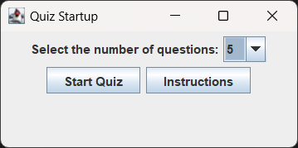 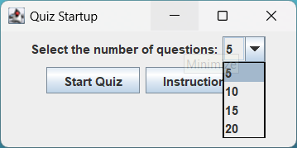

Startup Screen to give the user the option to choose how many questions they would like while also giving the instructions options they can see the full functionality of the app

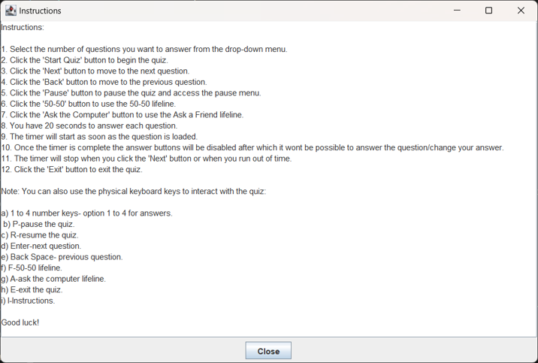

Instructions panel for the user to understand the functionality and a close button to return back to the quiz startup screen

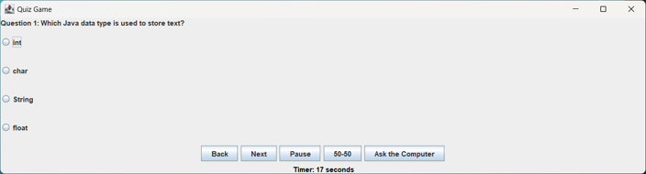

The 1st question along with the game options after the user starts the quiz

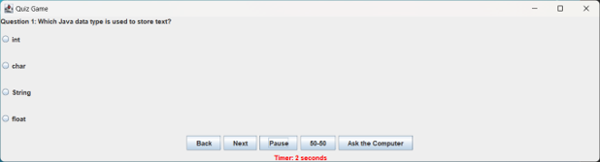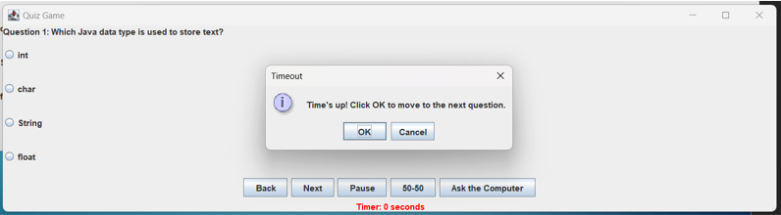

As the timer is heading towards 0 the timer flashes red so warn the user after which a time’s up pop up comes up and disables the radio buttons so the user cannot change or add their answer.

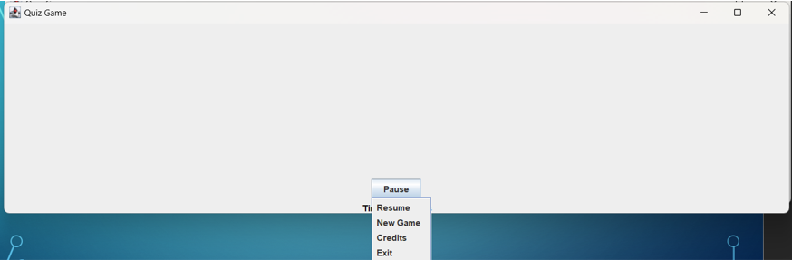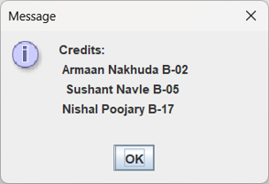

The popup menu the user gets after clicking the pause button which also hides the questions and options to reduce cheating and also pauses the timer.

The resume option resumes the quiz from the point it was paused.

The new game option takes the user back to the quiz startup screen and resets everything.

The Credits button brings a separate popup to show the names of the team members.

The exit button quits the whole quiz.

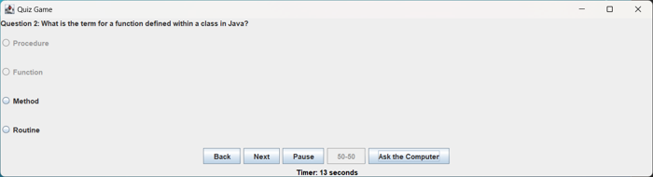

The 50-50 lifeline button disables 2 random wrong options giving the user only 2 options to choose from, this is an one time use button after which it will be disabled for rest of the quiz.

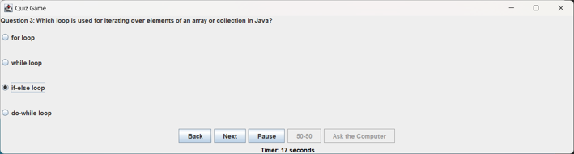

The Ask the computer Lifeline has a 80% chance of giving the user the right answer and a 20% chance of the wrong answer, this is also an one time use button after which it will be disabled for rest of the quiz.

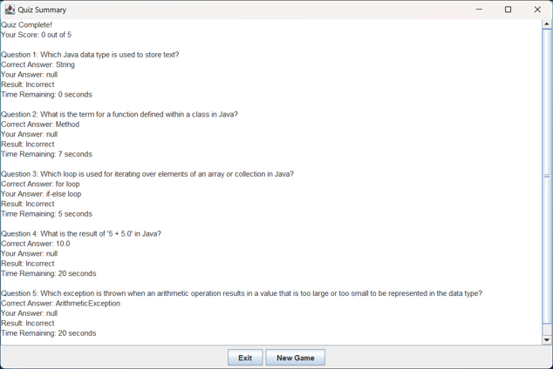

The Summary/Results screen which shows the overall right answers, time taken by the user for each question, the option chosen by the user, the current answer and if the user choose the right answer or not.

Conclusion

The Quiz Application is an innovative educational tool with a user-friendly interface and interactive features, offering a dynamic learning experience. Its future scope includes AI personalization, mobile support, collaborative learning, integration with learning management systems, advanced analytics, global expansion, and enhanced accessibility features. These developments aim to make the application more engaging, inclusive, and adaptable to evolving educational needs, ensuring its continued growth and impact in the field of education.

Future scope

1. AI-Powered Personalization: Utilize artificial intelligence to tailor quiz content to individual user preferences and skill levels, enhancing the learning experience.
2. Mobile and Offline Modes: Develop mobile applications for convenient access to quizzes on various devices, with offline capabilities to increase accessibility.
3. Collaborative Learning: Expand community-driven features to enable collaborative quiz creation and group competitions, promoting knowledge sharing and teamwork.
4. Integration with Learning Management Systems: Partner with educational institutions to integrate the Quiz Application into their systems, enhancing the educational experience for students.
5. Advanced Analytics: Improve performance analytics to provide deeper insights into user strengths and weaknesses, offering personalized recommendations for improvement.

These future developments aim to make the Quiz Application more engaging, inclusive, and adaptable to evolving educational needs, solidifying its role as a valuable tool in modern education.

Reference

1. Used Chatgpt to give a better Grammatical format for the wording.
2. Used javapoint’s website and knowledge for learning about some concepts of java to implement the particular system.
3. Used Chatgpt for the extensive list of questions used in the project.

Github Repository Link for progress and commit history related to this project:

<https://github.com/Armaan4477/Quiz-Game/>