PROJECT-NAME:OUR-KART
(E-COMMERCE WEBSITE)

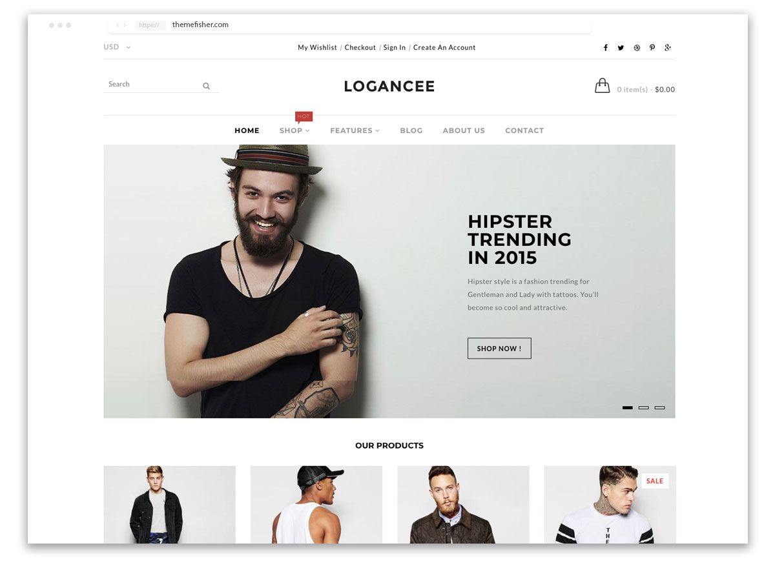

OVERVIEW
It’s an e-commerce website for both Men’s and Women’s fashion collection from shoes to sandals everything is available under the same roof.

HOME PAGE:

- LOGO
- ICONS - (WISHLIST, ADD TO CART)
- SEARCH BAR
- OUR PRODUCTS
- SLIDERS WITH ARROWS - (IMAGES)
- DEALS - (IMAGES)
- FEATURED - (IMAGES)
- TRENDING - (IMAGES)

FOOTER:

- CONTACT US
- HELPLINES
- BRIEF DESCRIPTION
- ABOUT THE COMPANY
- SOCIAL-MEDIA
- ICONS
- LINK TO MOBILE APP

- REGISTRATION FORM:-

- E-MAIL ADDRESS
- D.O.B
- SHOPPING PREFERENCE

2.MAIN PAGE:-

- FILTERS:
- BRANDS
- COLOR
- DISCOUNT RANGE
- PRICE
- COUNTRY OF ORIGIN
- MATERIAL
- FEAUTRES
- FIT
- OCCASION
- PATTERN
- RATING
- SIZE
- TYPE
- SORT BY:

CHOSEN PRODUCT WITH DETAILS:-

- BRANDS
- PRODUCT NAME
- PRICE
- DISCOUNT(%IF ANY)

ON CLICKING THE IMAGE -(MULTIPLE IMAGES OF THE
PRODUCT WILL APPEAR FROM DIFFERENT ANGLES ,
ZOOM IN , ZOOM OUT

PRODUCT DESCRIPTION:-

- BRAND
- PRODUCT NAME
- PRICE
- DISCOUNT%(IF ANY)
- SIZE CHART
- DELIVERY OPTIONS
- PRODUCT DETAILS
- SIZE & FIT
- MATERIAL & CARE
- SPECIFICATIONS
- RATINGS
- CUSTOMER REVIEWS WITH IMAGES(IF ANY)

LOWER HALF OF THE PAGE - RELATED PRODUCTS

3.PAYMENT PAGE:-

- ADDRESS SELECTION
- PAYMENT METHOD:-
Phonepay,GooglePay,Bhim UPI, Cash on Delivery,Credit/Debit Card,Net-Banking,EMI, PayTM

