Design Document

**Level Ground Recruitment**

December 11, 2020

Group Members:

* Armaan Singh Klair
* Kent Pawson
* Kane Imler
* Amir Soltani
* Anthony Hosemann

Client: ****

Instructor: ****

## Table of Contents

Contents

Table of Contents 1

Table of Figures 2

Preface 3

**Purpose of Document** 3

**Documentation Standards** 3

User Requirements 4

**Business Overview and Objectives** 4

**Project Overview** 4

System Requirements 4

Requirements Models 5

**Use Case Diagram** 5

**Extended Use Case Descriptions and Scenarios** 8

**Problem Domain Class Diagram** 18

**Activity Diagrams** 19

System Design 21

**Hardware Architecture** 21

**Hardware Platform** 22

**Software Platform** 22

**Interaction Model** 22

**Persistence Model** 25

**Class Diagrams** 28

**Interaction Sequence Diagrams** 29

**Data Dictionary** 32

Project Management 34

Schedule 34

**Team Configuration** 34

**Project Standards and Procedures** 34

**Backup Protocols** 35

Glossary 36

Index 37

## Table of Figures

Figure 1: Candidate Use Case Diagram 5

Figure 2: Business Client Use Case Diagram 6

Figure 3: System Administrator/Advisor Use Case Diagram 7

Figure 4: Problem Domain Class Diagram 18

Figure 5: Placement Fees Activity Diagram 19

Figure 6: Wireframe for creating profile and profile page 21

Figure 7: Logged in experience area 22

Figure 8: Job postings 23

Figure 9: System Advisor- Candidate Search Page 23

Figure 10: System Advisor Schedule Candidate Interview Page 24

Figure 11:System Admin Business Client Job Posting/ Fee Confirmation Page 24

Figure 13: Conceptual ERD 25

Figure 14: Logical ERD 25

Figure 15: Physical ERD 26

Figure 16 Class Diagram 27

Figure 17: Candidate Job Search and Apply Sequence Diagram Scenario 28

Figure 18: Business Client Job Posting Sequence Diagram Scenario 29

Figure 19: System Administrator Job Acceptance Sequence Diagram Scenario 30

## Preface

### **Purpose of Document**

This is a Requirements Specification document for a system for a managing recruitment company and recruited personnel data and information. This system does not require the recruitment company to meet with the recruited person. The company can decide whether to admit the person through the data stored by the recruited person, which is more objective and fairer, and the scope and efficiency of recruitment can be improved through the database. This document describes the scope, objectives and system environment. Then, this document demonstrates the function of the project through various diagram modeling. Through these diagrams, you can easily and clearly understand how the functions of this project are realized. For example, the Use Case Diagram shows the relationship between the three different roles of employees, employers and system administrators and the system. This document is intended to direct the design and implementation of the target system in an object-oriented language.

### **Documentation Standards**

* Header: Calibri (body), 18, (Bold)
* Sub-header: Calibri (body), 14, (Bold)
* Body: Calibri (body), 11

## User Requirements

### **Business Overview and Objectives**

* A business that is a recruitment agency and enables the business to hire a candidate that best fits the role based on experience and merit and removes all biases from the hiring process.
* Businesses can register for the service through lead form, which is then reviewed by the administration.
* Candidates can submit their work experience and create their own profile. Names and age will be removed to conceal any identifying indicators of ethnicity, gender heritage or ageism. Candidates may select their major key skills through an available list.
* The information of all candidates will be stored in to one single database, any individual who is interested can apply on the website.
* The administrator would review and verify candidate data and key skills that best suit the specific role.
* This will benefit businesses that are striving to improve and transform their hiring process by removing bias and cultural consulting.

### **Project Overview**

#### Project Scope

The system will need to take information given to it from the employees and store it into a database where the system manager will then vet the information for authenticity. The System Manager will then take forms submitted by the Employer and then the System Manager will select possible candidates for that job posting.

#### System Environment

* Database of Candidates
* Database of Business Client
* Website for Candidates and Business Clients to register

#### Current System

* No current system in place.

## System Requirements

The system will not be responsible for processing any payment that needs to be completed between the System Advisor and Business Client.

## Requirements Models

### **Use Case Diagram**

Candidate

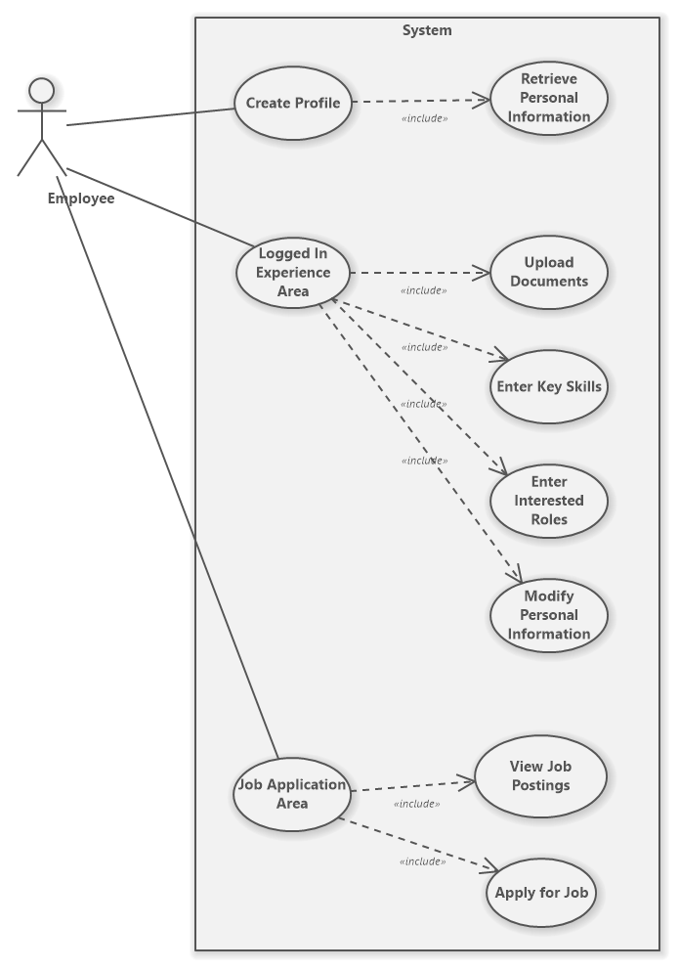

Figure 1: Candidate Use Case Diagram

Business Client

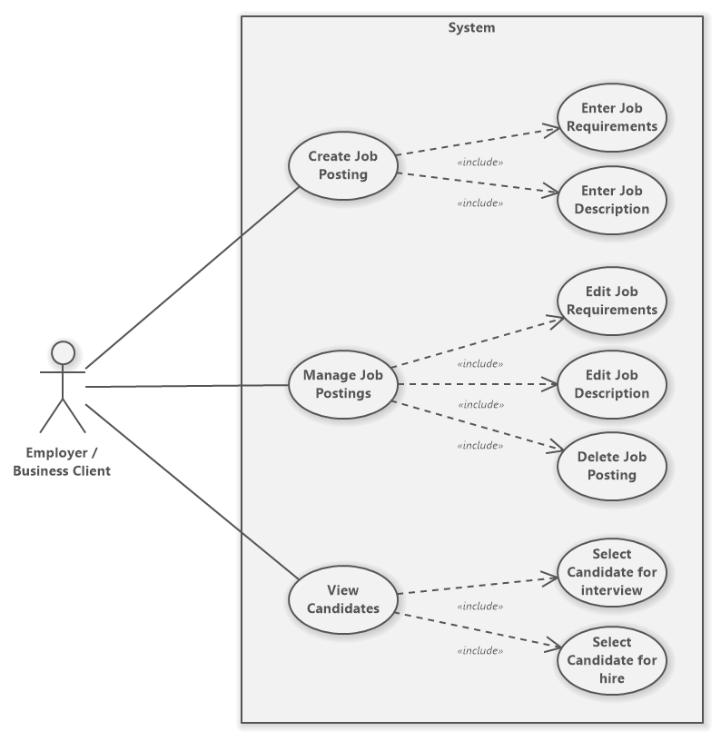

Figure 2: Business Client Use Case Diagram

System Administrator/Advisor

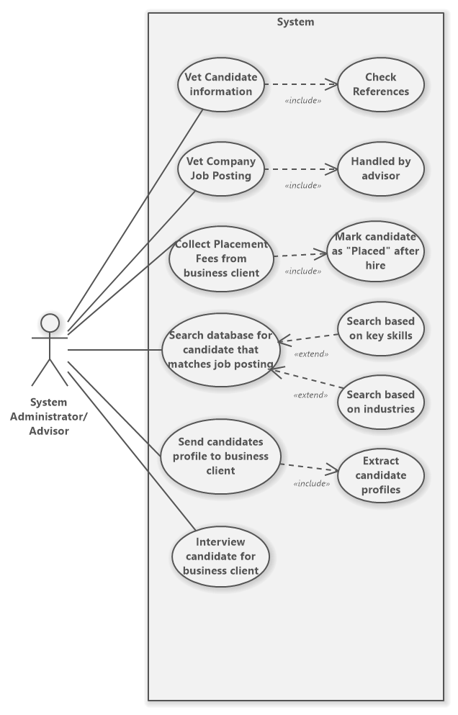

Figure 3: System Administrator/Advisor Use Case Diagram

### **Extended Use Case Descriptions and Scenarios**

**CANDIDATE:**

Candidate Use Case 1: Create Profile

Precondition: Candidate wants to create a profile

Postcondition: Profile Created

Limitation: Candidate can decide to exit out of the Create Profile process anytime

|  |  |
| --- | --- |
| **Actor Action** | **System Response** |
| 1.1 Candidate clicks on the create profile link | 1.2 Forward Candidate to a registration form to create profile |
| 1.3 Candidate enters data needed to create Profile |  |
| Candidate selects either:   * 1.4 Register button | 1.5 If all entered data is correct, system will display a window with the message “Profile Created” with a link to redirect Candidate to Log in  Else if data entered is incorrect (refer to error flow *.1) |
| -or-  - 1.6 Exit/Cancel button | 1.7 System will exit register form and redirect Candidate to home page |

Error Flow 1.1

Any time data entered was incorrect in the register form.

|  |  |
| --- | --- |
| **Actor Action** | **System Response** |
|  | 1.1 Display red error message under the corresponding textbox in register form |

Candidate Use Case 2: Logged in application/profile

Precondition: Candidate must have a profile

Postcondition: Redirect Candidate to profile

Limitation: Candidate can log out anytime

|  |  |
| --- | --- |
| **Actor Action** | **System Response** |
| 2.1 Candidate enters profile information  (username, password) |  |
| 2.2 Candidate adds Resume/ Work history information |  |
| 2.3 Candidate clicks on icon “Documents” | 2.4 System will redirect Candidate to a form to upload/replace Documents |
| 2.5 Candidate uploads Resume | 2.6 System will scan and save a copy of the Candidates resume into the database with key details blacked out. (remove name, and work history detail to remove ageism) |
|  | 2.7 System will calculate time spent in previous role. |
|  | 2.8 System save button will be highlighted. |
| 2.9 Candidate clicks on save button. | 2.10 System will commit all changes to a database. |
| 2.11 Candidate enters key skills |  |
| 2.12 Candidate clicks on icon “Key Skills” | 2.13 System will prompt a small window with a list of key skills retrieved from a database. |
| Candidate can either:   * 2.14 Select key skills | 2.15 Key skills will be displayed as a list with check boxes. System message will ask Candidate to select all that applies to them. (key skills can be checked and unchecked)  System will highlight key skills that are checked. |
| -and/or-  - 2.16 Save | 2.17 If one or more key skills are selected, the system will highlight the save button in the form.  Else if no key skills are selected (refer to error flow *.1). |
| -or-  - 2.18 Exit/Cancel | 2.19 System will redirect Candidate back to profile page. |
| 2.20 Candidate enters Interested Roles |  |
| 2.21 Candidate clicks on icon “Interested Roles” | 2.22 System will prompt a small window with a list of Interested Roles retrieved from a database. |
| Candidate can either:   * 2.23 Select Interested Roles | 2.24 Interested Roles will be displayed as a list with check boxes. System message will ask Candidate to select all that applies to them. (Interested Roles can be checked and unchecked)  System will highlight Interested Roles that are checked. |
| -and/or-  - 2.25 Save | 2.26 If one or more Interested Roles are selected, System will highlight save button in form.  Else if no Interested Roles are selected (refer to error flow *.2). |
| -or-  - 2.27 Exit/Cancel | 2.28 System will redirect Candidate back to profile page. |
| 2.29 Candidate modifies personal information |  |
| 2.30 Candidate clicks on icon “edit profile” | 2.31 System will redirect Candidate to edit profile page. Then will display all data that was entered in its corresponding textboxes.  Data is received from Database. |
| Candidate can:   * 2.32 Edit profile | 2.33 All textbox Candidate made modifications are highlighted in blue,  As well as the save button. |
| -and-  - 2.34 Save changes | 2.35 If modified data is valid. Profile is saved.  Else if modified data is invalid (refer to error flow *.3) |
| -or-  - 2.36 Exit/Cancel | 2.37 System will redirect Candidate back to profile page. |

Error Flow 2.1

Any time zero key skills are highlighted after Candidate clicks on icon “Interested Roles”.

|  |  |
| --- | --- |
| **Actor Action** | **System Response** |
|  | 2.1 Display error message informing Candidate zero key skills were selected. |

Error Flow 2.2

Any time zero Interested Roles are highlighted after Candidate clicks on icon “Interested Roles”.

|  |  |
| --- | --- |
| **Actor Action** | **System Response** |
|  | 2.2 Display error message informing Candidate zero Interested Roles were selected. |

Error Flow 2.3

Any time invalid Data is entered in the Edit Profile Page

|  |  |
| --- | --- |
| **Actor Action** | **System Response** |
|  | 2.3 Display error message informing Candidate invalid data was entered in the corresponding textbox. |

Candidate Use Case 3: View Job Application area

Precondition: Candidate must have data in its profile.

Postcondition: Job posting list is displayed

Limitation: Candidate can log out/cancel view anytime

|  |  |
| --- | --- |
| **Actor Action** | **System Response** |
| 3.1 Candidate log in to application (username, password) |  |
| Candidate can:   * 3.2 Search for Job Postings | 3.3 If profile database includes Candidates uploaded documents/Key Skills/Interested Roles Data. System will search and display list of job postings (data received from Employer database) matching to Candidates profile data.  Else if any of the uploaded documents/key Skills/Interested Roles data is missing or invalid (refer to error flow *.1). |
| 3.4 Candidate can view Postings that are displayed |  |
| 3.5 Candidate clicks on one of the displayed postings | 3.6 A window will prompt with details of the selected posting. The Apply button will be highlighted. |
| -and-  - 3.7 Apply for Job | 3.8 System will display a message to confirm if Candidate wants to apply. |
| -or-  - 3.9 Exit/Cancel | 3.10 System will redirect Candidate to the list of postings. |

Error Flow 3.1

At any time, invalid user information is entered, or a database operation fails.

|  |  |
| --- | --- |
| **Actor Action** | **System Response** |
|  | 3.1 Display error message informing Candidate Data is missing from either uploaded documents/key Skills/Interested Roles Data. |

**BUSINESS CLIENT/EMPLOYER**

Employer Use Case 1: Create Job Posting

Precondition: Employer has successfully logged in.

Postcondition: Create Job postings screen is displayed

Limitation: Employer can exit and return to homepage.

|  |  |
| --- | --- |
| **Actor Action** | **System Response** |
| 1.1 Employer enters account information (username, password and/or security level) |  |
| Employer can:   * 1.2 Enter Job Requirements | 1.3 System will prompt Employer to enter Job Requirements, this can be a posting in plain text with textboxes for Employer to enter preferred skills. |
| * 1.4 Enter Job Description | 1.5 System will prompt Employer to enter Job Requirements, this can be a posting in plain text with textboxes for Employer to enter key terms. |
| * 1.6 Save Job Requirements/Description | 1.7 Save button will be highlighted. If clicked System will save all data that is valid.  If else data is invalid (refer to error flow *.1). |

Error Flow 1.1

When job postings are saved but there are missing data/invalid data.

|  |  |
| --- | --- |
| **Actor Action** | **System Response** |
|  | 1.1 Display error message informing Employer Data is missing or invalid. |

Employer Use Case 2: Manage Job Postings

Precondition: Employer must have created one or more job postings

Postcondition: Selected job posting will be displayed

Limitation: Employer can exit and return to homepage.

|  |  |
| --- | --- |
| **Actor Action** | **System Response** |
| 2.1 Employer enters account information (username, password and/or security level) |  |
| Employer selects either:  - 2.2 Edit job Requirements | 2.3 System will redirect Employer to edit job posting page. Then will display all data that was entered in its corresponding textboxes. If edited data is invalid (refer to error flow *.1)  Data is received from Database. |
| -or/and-  - 2.4 Edit Job Descriptions | 2.5 System will redirect Employer to edit job posting page. Then will display all data that was entered in its corresponding textboxes. If edit data is invalid (refer to error flow *.1)  Data is received from Database. |
| -or/and-  - 2.6 Delete job posting | 2.7 Employer will be asked to confirm deletion of selected postings,  If yes, then delete posting from database.  Else no Employer will be redirected back to previous page. |

Error Flow 2.1

At any time, invalid user information is entered, or a database operation fails.

|  |  |
| --- | --- |
| **Actor Action** | **System Response** |
|  | 2.1 Display error message informing Employer Data is missing or invalid. |

Employer Use Case 3: View Candidates

Precondition: Candidates applied to Job postings will handled by System Administrator

Postcondition: Candidates list will be displayed to employer

Limitation: Employer can abort any operation and return to applications home page

|  |  |
| --- | --- |
| **Actor Action** | **System Response** |
| 3.1 Employer enters account information (username, password and/or security level) |  |
| 3.2 View Candidates | 3.3 Candidates that match Job postings description and requirements will be displayed for Employer in a list. Data for Candidates will be retrieved from System Administrators database. The selected Candidates profile will appear for Employer to view. |
| 3.4 Select Candidates for interview | 3.5 The selected button will be highlighted; A confirmation will show the number of Candidates the Employer picked and will ask to confirm process. If yes is selected the data for the Candidates list will be sent to Administrator and will notify Admin to process with the interview process for selected candidates.  Else if zero candidates are selected (refer to error flow *.1). |
| 3.6 Select Candidate for hire | 3.7 System will retrieve data after Admin proceeded through pass the interview stage.  Employer will be displayed a list of Candidates they would like to hire. |

Error Flow 3.1

When Employer selected zero Candidates but tries to confirm selected for interview

|  |  |
| --- | --- |
| **Actor Action** | **System Response** |
|  | 3.1 error message will display informing Employer that zero Candidates were selected. |

**SYSTEM ADMINISTRATOR**

 Admin Use Case 1: Vet candidate information

Precondition: Candidates must have submitted their profiles for the system admin to assess them.

Postcondition: System admin can weed out factual profiles from ones with false information.

Limitation: No profiles are submitted for System admin to assess.

|  |  |
| --- | --- |
| **Actor Action** | **System Response** |
| 1.1 System admin looks through candidate profiles info |  |
| System admin can either:   * 1.2 Accept candidate profile | 1.3 If candidate profile does not contain false information, then profile is accepted and looked into further. |
| -or-  - 1.4 Reject candidate profile | 1.5 If candidate profile does contain false information. Then profile is discarded. |

Error Flow 1.1

|  |  |
| --- | --- |
| **Actor Action** | **System Response** |
|  |  |

Admin Use Case 2: Vet company job postings

Precondition: Companies must have submitted postings in order for the System admin to assess them.

Postcondition: System admin is able to weed out actual postings from ones with false information.

Limitation: No postings are submitted for System admin to assess.

|  |  |
| --- | --- |
| **Actor Action** | **System Response** |
| 2.1 System admin looks through company posting info |  |
| System admin can either:   * 2.2 Accept company posting | 2.3 If company posting does not contain false information, then posting is accepted and looked into further. |
| -or-  - 2.4 Reject company posting | 2.5 If company posting does contain false information. Then posting is discarded. |

Error Flow 2

|  |  |
| --- | --- |
| **Actor Action** | **System Response** |
|  |  |

Admin Use Case 3: Collect placement fees from business client

Precondition: Vet job postings and find the ones that contain information.

Postcondition: Posting is completed and published.

Limitation: Business client does not pay and posting is discarded.

|  |  |
| --- | --- |
| **Actor Action** | **System Response** |
| 3.1 System admin goes through vetted postings and collects payment from accepted business clients. |  |
| System admin can either:   * 3.2 Collect payment from vetted business client postings. | 3.3 Business clients will be informed to submit a payment for their posting if approved from vetted selection. |
| -or-  - 3.4 Discard postings from vetted business clients | 3.5 If business client chooses to not submit a payment, job posting will be discarded from the selection process. |

Error Flow 3.1

|  |  |
| --- | --- |
| **Actor Action** | **System Response** |
|  | 3.1 Business Client can ask to cancel job posting before submitting a payment. |

Admin Use Case 4: Search database for candidate that matches job posting

Precondition: All postings are approved and paid for and all profiles are verified and accurate.

Postcondition: Matchups are sent for approval from the business client.

Limitation: No matches were made for any postings.

|  |  |
| --- | --- |
| Actor Action | System Response |
| 4.1 Database scans for any and all information that stands out and meets the criteria looked for in the job postings. |  |
| Search concludes and database decides on results of profile:   * 4.2 Candidate profile meets the minimum amount of matching requirements. | 4.3 Candidates profile is accepted and will be sent to the business client for further inspection. |
| -or-  - 4.4 Candidate profile does not meet the minimum amount of matching requirements. | 4.5 Candidates profile will remain in the database and will continued to be scanned in order to find postings best matched to the information they included in their profiles. |

Error Flow 4

|  |  |
| --- | --- |
| **Actor Action** | **System Response** |
|  | 4.1 Matching process takes too long and candidate removes their profile from the database. |
|  | 4.2 Matching process takes too long and business client removes their posting from the database. |

Admin Use Case 5: Send candidates profile to business client

Precondition: Match between candidate profile and client posting must be made.

Postcondition: Business client decides if they wish to have candidate interviewed.

Limitation: Business client can change the requirements on the posting, further limiting the number of profiles sent in.

|  |  |
| --- | --- |
| Actor Action | System Response |
| 5.1 Business client assess all profiles that have been sent in by the database and decides on which profiles contain the key skills the business client wishes to have for the company. |  |
| Business client can either:   * 5.2 Approve candidates for interviewing process. | 5.3 All approved profiles are then confirmed and sent to the system admin who then prepares to conducted interviews on behave of the business client. |
| -or-  - 5.4 Decline candidates for interviewing process. | 5.5 All declined candidate profiles are sent back to the database to be scanned and matched with different postings. |

Error Flow 5

|  |  |
| --- | --- |
| **Actor Action** | **System Response** |
|  | All sent candidate profiles are declined and both job posting and candidate profile are sent back to the database for further matching. |

Admin Use Case 6: Interview candidate for business client

Precondition: Approval from business client to move on to the interviewing stage.

Postcondition: Candidate is hired for the job.

Limitation: Candidate is absent for the job interview.

|  |  |
| --- | --- |
| Actor Action | System Response |
| 6.1 System admin interviews candidates that have been approved by the business client |  |
| The system admin can make the decision of either:   * 6.2 Hiring the candidate after the interview is complete. | 6.3 If the candidate is hired, then their application is marked as “placed”. |
| -or-  - 6.4 Not hiring the candidate after the interview is complete. | 6.5 If the candidate is not hired, then their application is marked as “not placed”. |

Error Flow 6

|  |  |
| --- | --- |
| **Actor Action** | **System Response** |
|  |  |

### **Problem Domain Class Diagram**

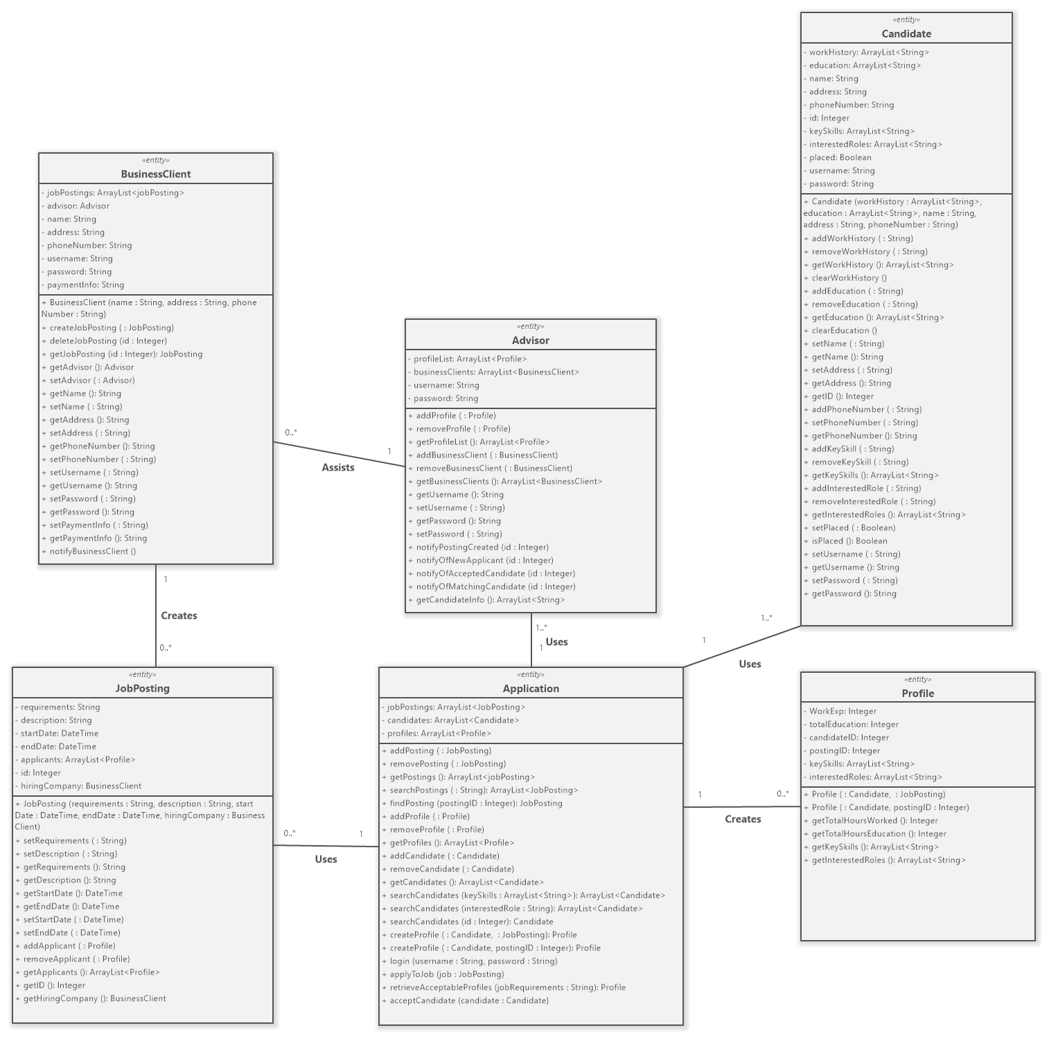

Figure 4: Problem Domain Class Diagram

### **Activity Diagrams**

Collect placement fees from the business client:

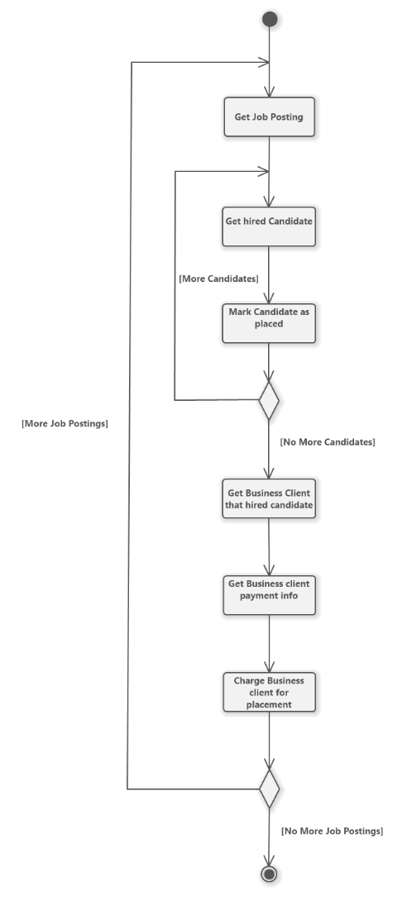

Figure 5: Placement Fees Activity Diagram

Anonymize client data into a profile:

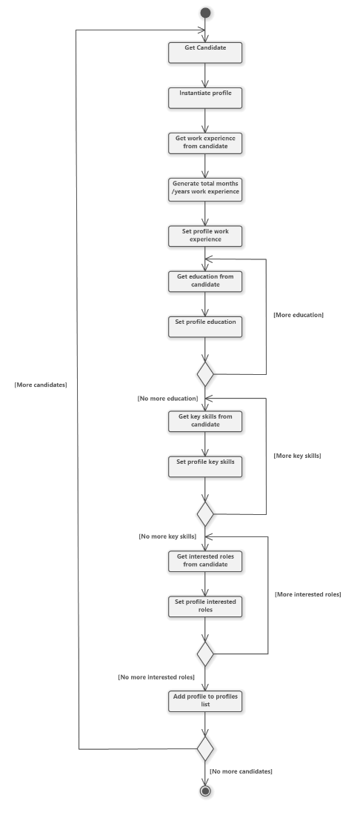

Figure 6: Client Anonymization Activity Diagram

## System Design

### **Hardware Architecture**

|  |  |
| --- | --- |
| Employee equipment | Used to enter personal information into the system and receive information from the system when being hired. |
| Employer equipment | Used to input company requirements into the system, waiting for the system to filter and send the employee information that meets the requirements. At the same time, you can send an offer to the employee through the system and receive the employee's reply. |
| System Administrator | Used to directly manage the system, you can directly add, delete, modify, and view the database through the system |
| System | It is used to receive the information entered by employees and employers, and then find useful information from the database to feed back to employees and employers. It can also be used to receive instructions from the system administrator and act on the database.  Minimum standard:  CPU: i3  RAM: 1  GB  ROM: 20GB  Operating system: win7 |
| Database | Centrally manages employer and employee information and can manage information through the system. |

Both user equipment and employer equipment need the correct account and password to log in to the system. If you provide the wrong account and password, you will get error feedback from the system and you will not be able to log in. The system administrator needs to use the management account and password to log in to the system for management. If the password of the management account is wrong, you will get error feedback.

As a hardware hub, the system accepts information from employers and employees, searches for useful information in the database through SQL language, and feeds the information back to employees and employers. At the same time, the system will accept the system administrator's instructions to add, delete, modify and view the database. After the instruction is completed, give the system administrator feedback, such as the successful execution or failure of the instruction, and an error code for failure.

The database is used to store all the employer and employee information. When the system is instructed, it searches for relevant information and then feeds it back to the system. The database only interacts with the system, and employers, employees and system administrators have no right to directly connect and operate the system.

### **Hardware Platform**

Hardware platform was not deeply researched as this project is mainly a web application, the suggestion of a standard windows 10 pc would be sufficient.

### **Software Platform**

The software platforms that will be used for this project will be Apache NetBeans mainly functionality of the web application as well as MySQL for the databases.

### **Interaction Model**

Included in the design document are wireframes for the flow of the candidates, business clients and system administrator. These consist of the registration page, profile page, navigating through the candidates' resume, work history being uploaded and select files to delete.

Within the profiles it includes adding and removing key skills and interested roles.

Wireframes for the candidate. The wireframe for business clients is a vague overview of adding and deleting job postings.

Candidates Login & Profile page:

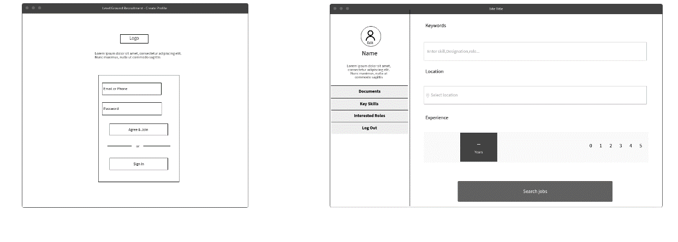

Figure 7: Wireframe for creating profile and profile page

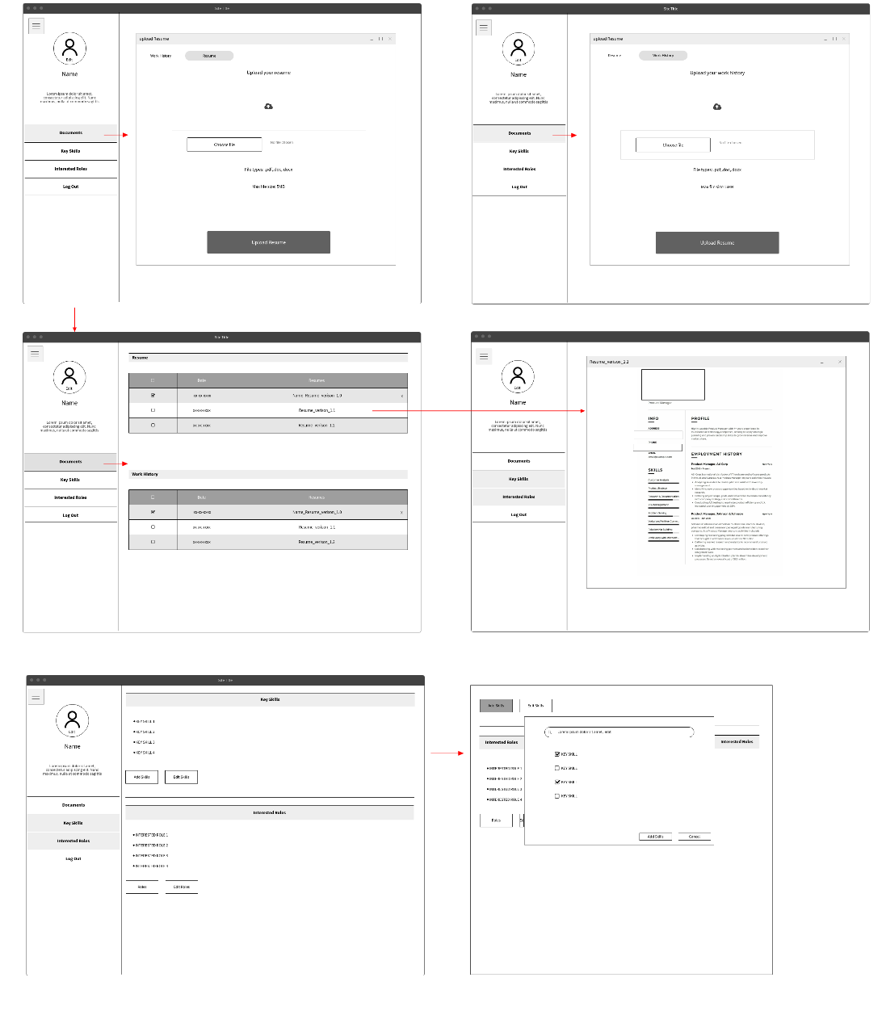

Figure 8: Logged in experience area

Business client job postings:

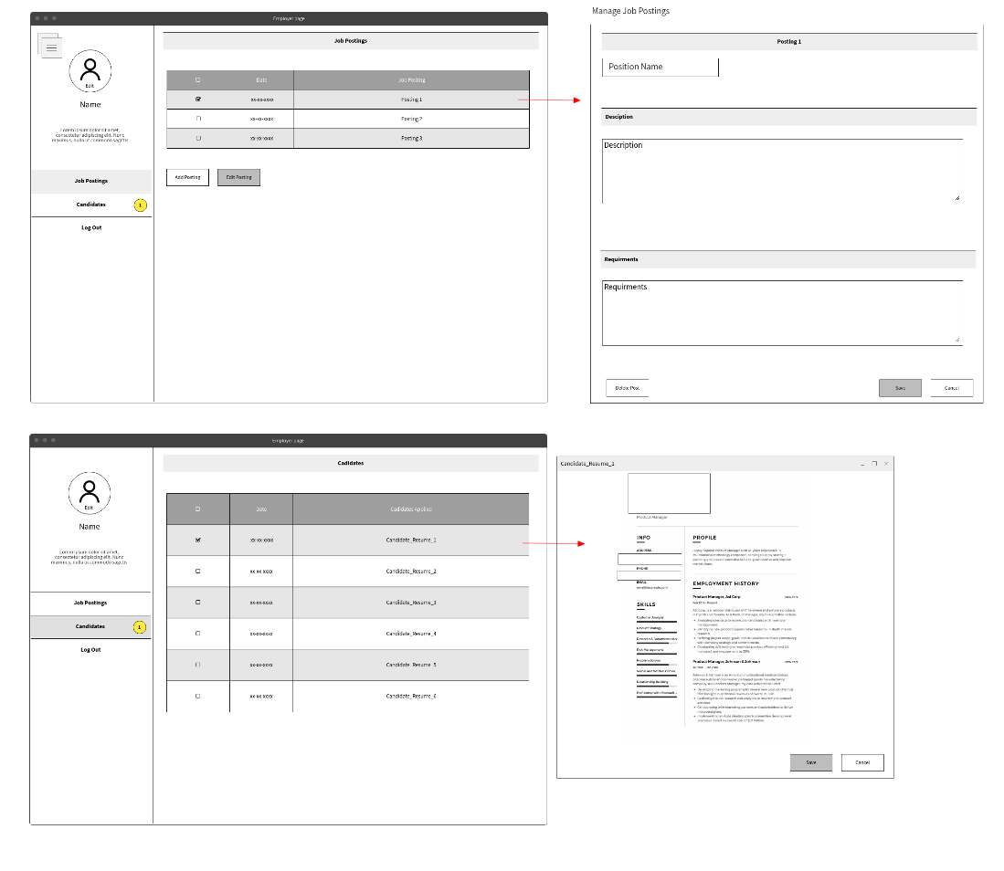

Figure 9: Job postings

System Advisor – Candidate Search Page

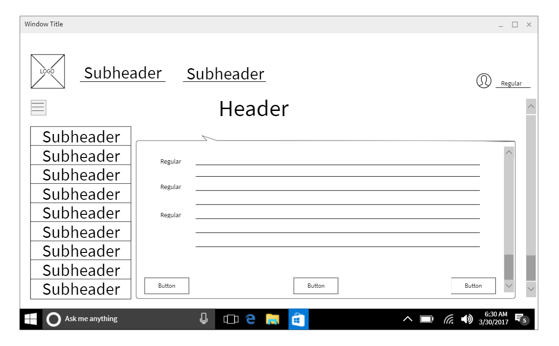

Figure 10: System Advisor - Candidate Search Page

System Advisor – Schedule Candidate Interviews Page

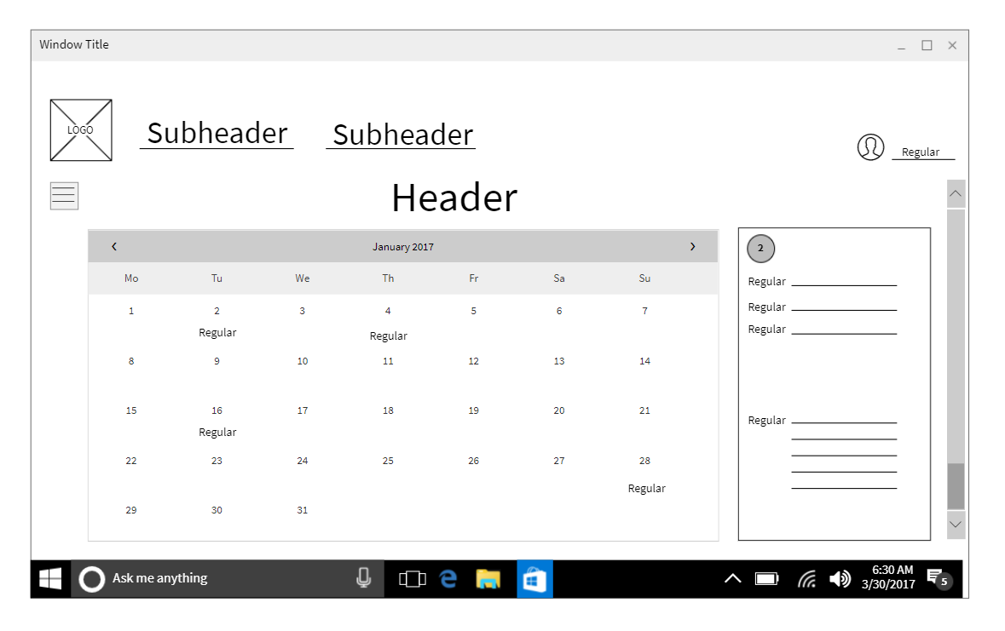

Figure 11: System Advisor - Schedule Candidate Interview Page

System Advisor – Business Client Job Posting/Fee Confirmation Page

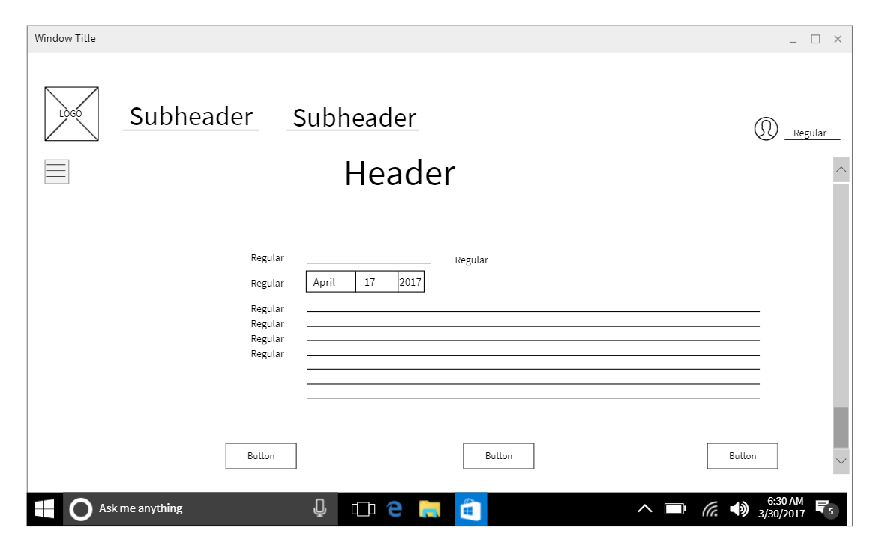

Figure 12:System Advisor - Business Client Job Posting/ Fee Confirmation Page

### **Persistence Model**

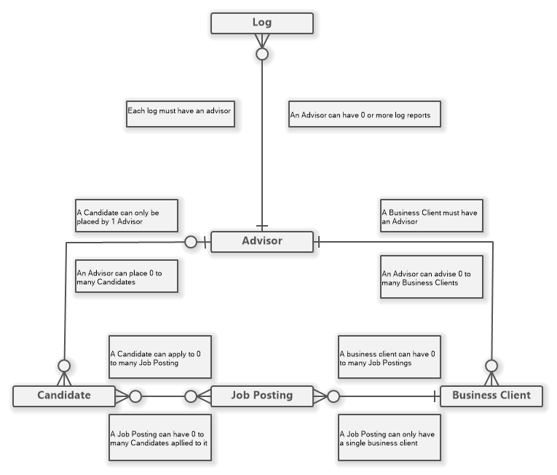

Figure 13: Conceptual ERD

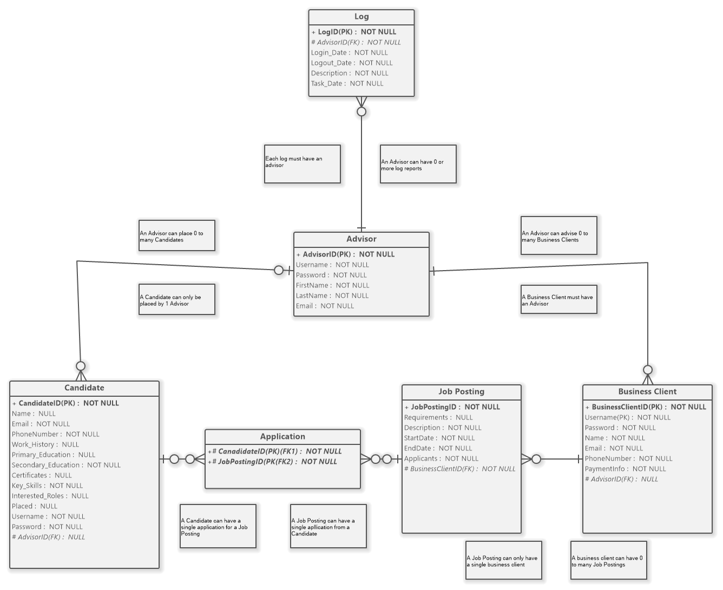

Figure 14: Logical ERD

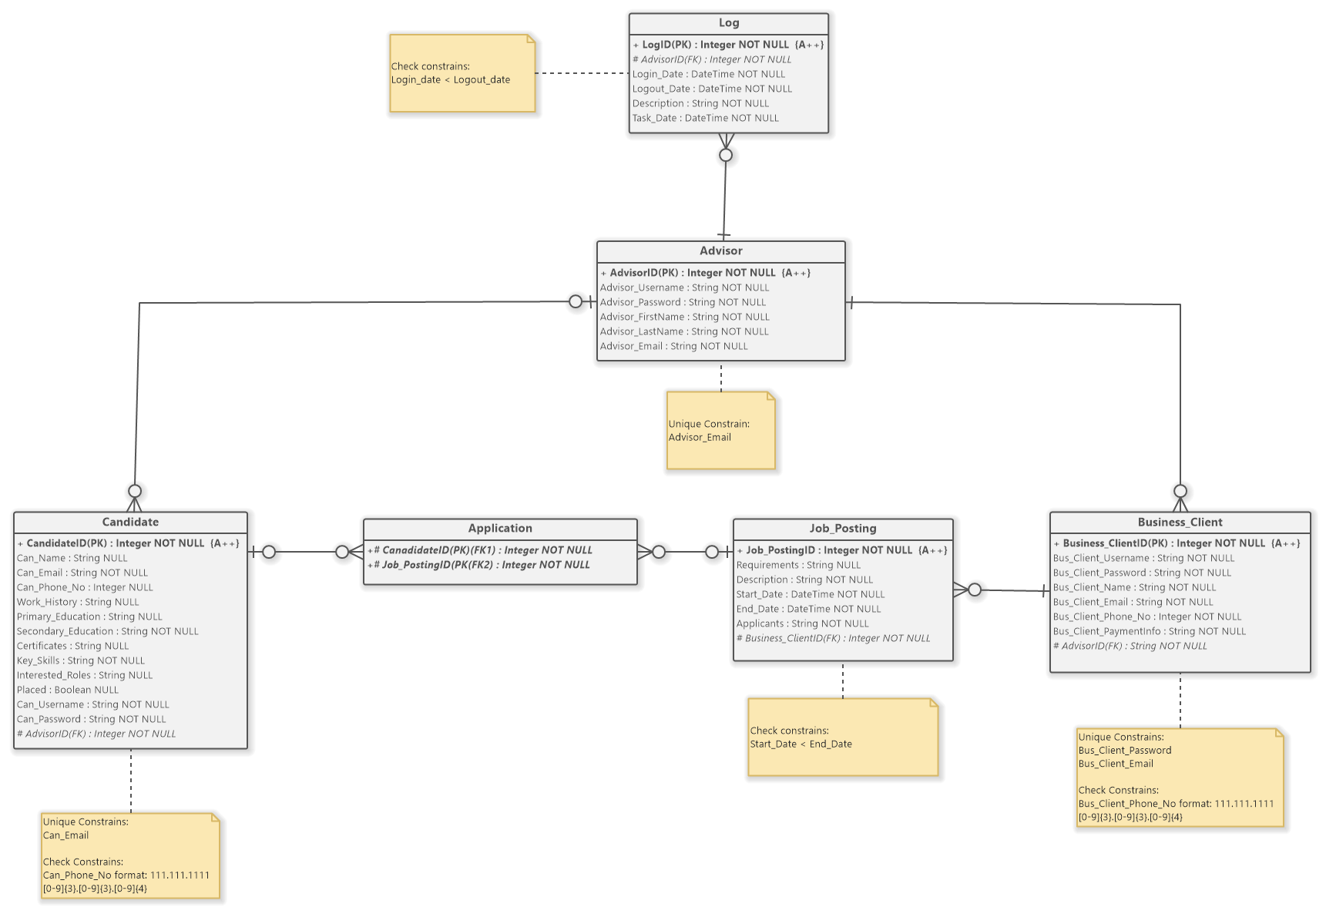

Figure 15: Physical ERD

### **Class Diagrams**

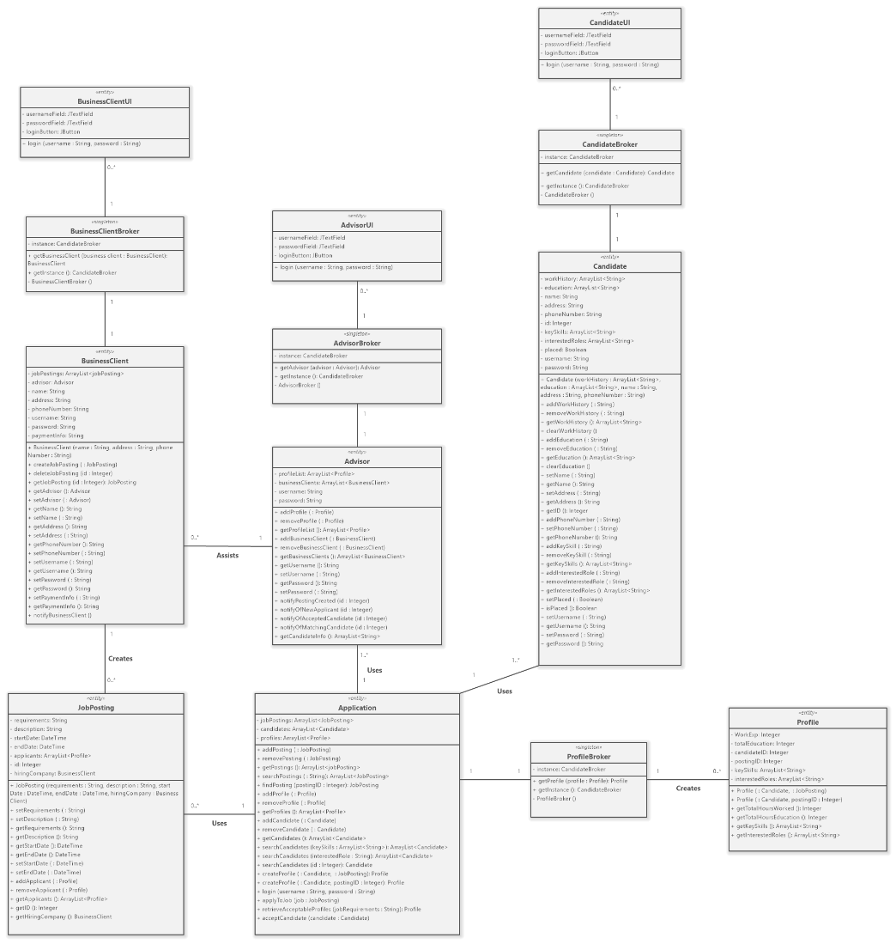

Figure 16 Class Diagram

### **Interaction Sequence Diagrams**

A candidate who already has a profile searches for available job postings and applies to a job:

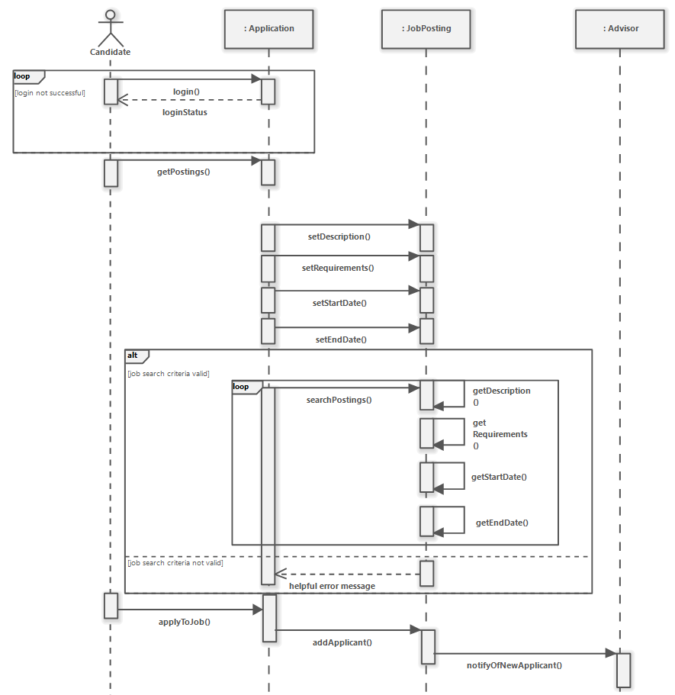

Figure 17: Candidate Job Search and Apply Sequence Diagram Scenario

A business client creates a job posting and receives a list of profiles from an advisor

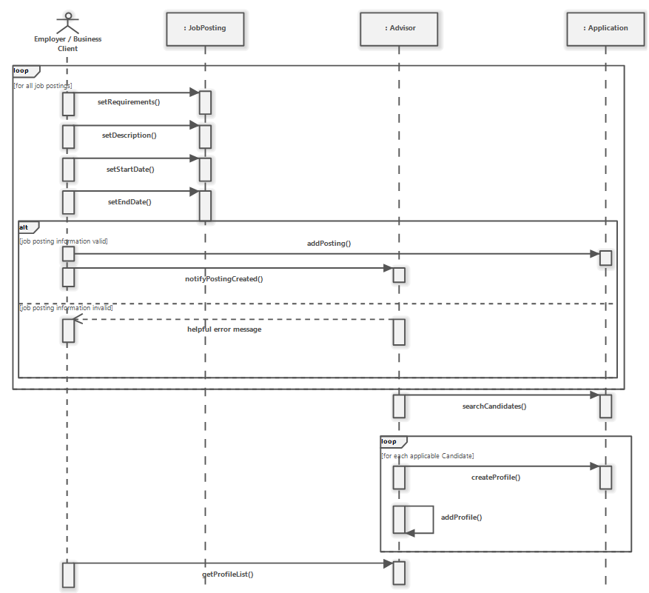

Figure 18: Business Client Job Posting Sequence Diagram Scenario

The System administrator accepts a candidate that meets all requirements and notifies the business client.

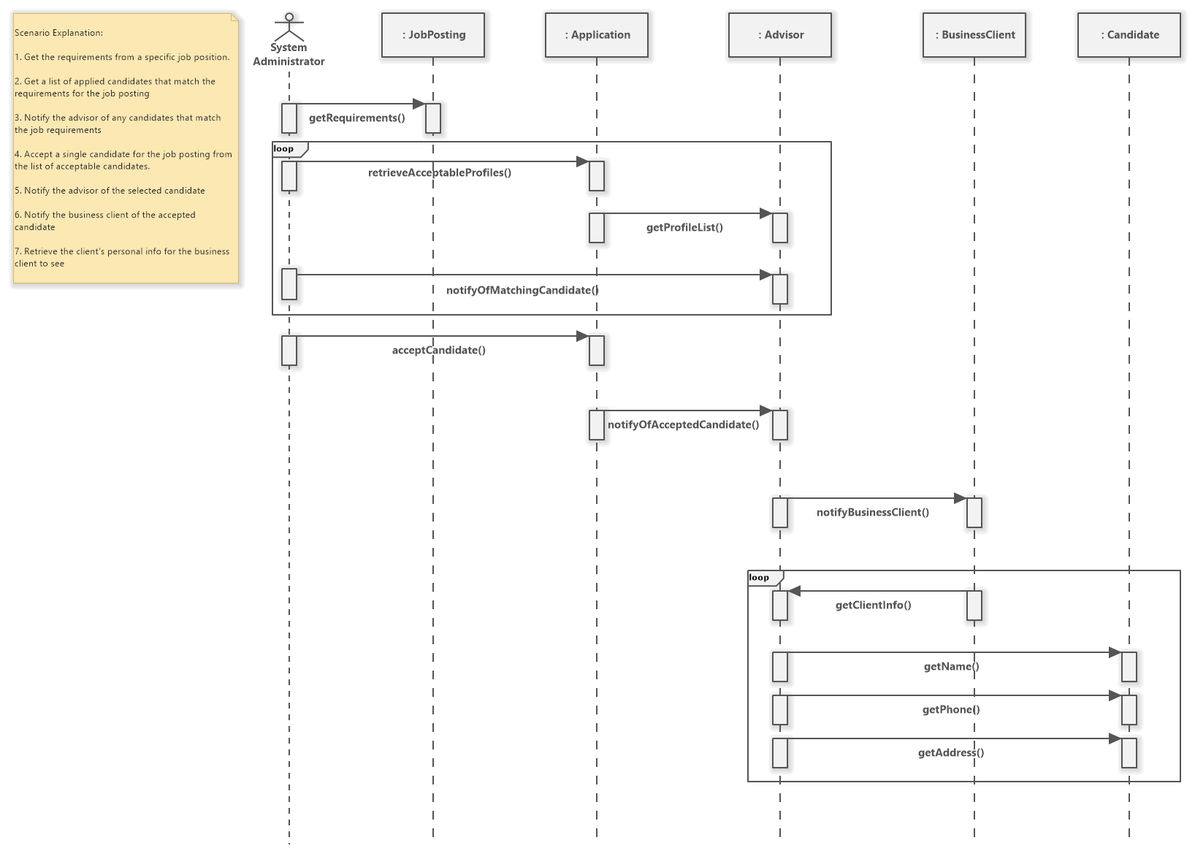

Figure 19: System Administrator Job Acceptance Sequence Diagram Scenario

### **Data Dictionary**

|  |  |  |
| --- | --- | --- |
| **Name** | **Type** | **Description** |
| name | String | Non-empty Unicode text representing the name of the business client or candidate. |
| address | String | Non-empty Unicode text representing the address of the business client/candidate. |
| phoneNumber | String | Non-empty Unicode text representing the phone number of the business client/candidate. |
| username | String | Non-empty Unicode text representing the username of the business client/candidate. |
| password | String | Non-empty Unicode text representing the password of the business client/candidate. |
| jobPostings | ArrayList<JobPosting> | A list of job postings which includes: requirements, description, startDate, endDate, applicants, id, hiringCompany. |
| workHistory | ArrayList<String> | A list of Non-empty Unicode text representing the work history of a candidate. |
| education | ArrayList<String> | A list of Non-empty Unicode text representing the education of a candidate. |
| id | integer | Auto-incrementing identifier representing a unique candidate or job posting |
| keySkills | ArrayList<String> | A list of Non-empty Unicode text representing the key skills of a candidate. |
| interestedRoles | ArrayList<String> | A list of Non-empty Unicode text representing the interested roles of a candidate. |
| placed | Boolean | A boolean representing if a candidate has been placed in a job. |
| workExperience | integer | An integer representing the amount of work the candidate has done. |
| totalEducation | integer | An integer representing the amount of education the candidate has done. |
| candidateID | integer | Auto-incrementing identifier representing a unique candidate. |
| postingID | integer | Auto-incrementing identifier representing a unique job posting |
| requirements | String | A list of Non-empty Unicode text representing the requirements of a job posting. |
| description | String | A list of Non-empty Unicode text representing the description of a job posting. |
| startDate | DateTime | A DateTime representing the start date of the job posting. |
| endDate | DateTime | A DateTime representing the end date of the job posting. |
| applicants | ArrayList<Profile> | A list of profiles that have applied to the job posting. |
| hiringCompany | BussinessClient | An object that includes: name, address, phoneNumber. |
| businessClients | ArrayList<BusinessClient> | A list of business clients that an advisor has. |
| profileList | ArrayList<Profile> | A list of profiles that an advisor has. |
| candidates | ArrayList<Candidate> | A list of candidates attached to an application. |
| profiles | ArrayList<Profile> | A list of profiles attached to an application. |

## Project Management

## Schedule

###### Week 1: Team Charter

Week 2: Finalize Design Document

Week 3: Client Design PPT Created

Week 4: Client Design Presentation

Week 5: Back-End Coding (database, problem domain classes, broker classes)

Week 6: Back-End Coding (database, problem domain classes, broker classes)

Week 7: Back-End Coding (database, problem domain classes, anonymizer)

Week 8: Back-End Testing (database, problem domain classes, broker classes)

Week 9: Front-End Coding (business client/candidate web pages, advisor interface)

Week 10: Front-End Coding (business client/candidate web pages, advisor interface)

Week 11: Acceptance Test Plan

Week 12: Beta Installation

Week 13: Project Finalized (code submitted and all documentation complete)

Week 14: Practice Presentation

**April 23: CAPSTONE PRESENTATION**

### **Team Configuration**

* Kent Pawson
* [Kent.pawson@edu.sait.ca](mailto:Kent.pawson@edu.sait.ca)
* Anthony Hosemann
* [Anthony.hosemann@edu.sait.ca](mailto:Anthony.hosemann@edu.sait.ca)
* Amir Soltani
* Amir.Soltani@edu.sait.ca
* Armaan Singh Klair
* Armaansingh.klair@edu.sait.ca
* Kane Imler
* [Kane.imler@edu.sait.ca](mailto:Kane.imler@edu.sait.ca)

### **Project Standards and Procedures**

* Microsoft Teams for communication with team.
* Microsoft Words for documents.

### **Backup Protocols**

* The System Administrator will oversee backup and recovery options which will take place automatically.
* Backups will externally store data in the cloud which will be stored for a total of 4 years.
* Our backups will store all data that is contained in our database system.

**How our backups will take place:**

We will use Amazon Web Services (AWS) to store all the data contained in our database on the Cloud.

**Backup Options:**

|  |  |  |
| --- | --- | --- |
| **Type of backup** | **What it covers** | **Frequency** |
| Incremental Backup | Backup any new changes that occurred since the last backup. | Occurs at the end of every week. |
| Full Backup | Backup all data on the system whether a change was made or any existing data. | Occurs at the end of every month. |

**Recovery options:**

|  |  |  |
| --- | --- | --- |
| **Type of recovery** | **What it covers** | **Frequency** |
| Full Recovery | Restores the system to the last incremental backup.  If this backup happens to be corrupted, the system will be restored to the last full backup. | Occurs when the system crashes or when the System Administrator decides to manually initiate a full recovery. |

## Glossary

|  |  |
| --- | --- |
| Term | Description |
| Activity Diagram | A diagram that shows the workflow of an activity. |
| Business Client | A business that is looking to employ candidates. |
| Candidate | A person seeking to be employed. |
| Class Diagram | A diagram that describes the structure of the systems classes, their attributes, operations and relationship among objects. |
| Data Dictionary | A set of information describing the content, format and structure of a database. |
| ERD | Entity Relationship Diagrams are used when creating databases. |
| Functional Requirements | What tasks or functions the system will need to perform. |
| Interaction Sequence Diagram | A diagram that shows object interactions in time sequence. The diagram shows one event or “scenario”. |
| Maintainability and Administration Requirements | Requirements of a system maintenance and administration. |
| Non-Functional Requirements | The system limitations and how well it provides functional requirements. |
| Profile | The anonymized data of a single candidate. |
| Project Scope | List of goals, deliverables, task, costs and deadlines. |
| State Machine Diagram | A diagram that shows the responses of a single object to all use cases it is involved with. |
| System Administrator | A person who will facilitate the hiring process. |
| System Environment | A set of inter-related components that work towards a purpose. |
| System Interface Requirements | Requirements, if necessary, of a system to communicate with other computer system. |
| System Requirements | Contain all the requirements a system has. |
| Usability requirements | Requirements of a system to match system to users, and tasks users will perform |

## Index

|  |  |
| --- | --- |
| Topic | Pages |
| Activity Diagram | 19 |
| Business Client | 4,6,12,15-17,19,21,23,29,30,31,33 |
| Candidate | 4,5,8-11,13-17,21,28,30-33 |
| Class Diagram | 27 |
| Data Dictionary | 31 |
| Persistence Model | 25 |
| Sequence Diagram | 28-30 |
| System Administrator | 3,7,13,20,21,23,30 |
| Interaction Model | 21-24 |
| Project Management | 33 |
| Problem Domain Class Diagram | 18 |
| Use Cases Diagram | 5-7 |
| Use Case Descriptions | 8 -17 |