STAGE 2 Chemistry | Topic 3: Organic Chemistry | Subtopics 3.1 – 3.6

Skills & Applications Task: Test

**QUESTION 1**

1. The skeletal structures for a number of organic compounds are shown below. If these compounds are exposed to a highly oxidising environment, such as being placed in an abundance of acidified dichromate solution for example, a number of reactions will occur. Draw arrows to show the reactions that will occur, and circle all final products.

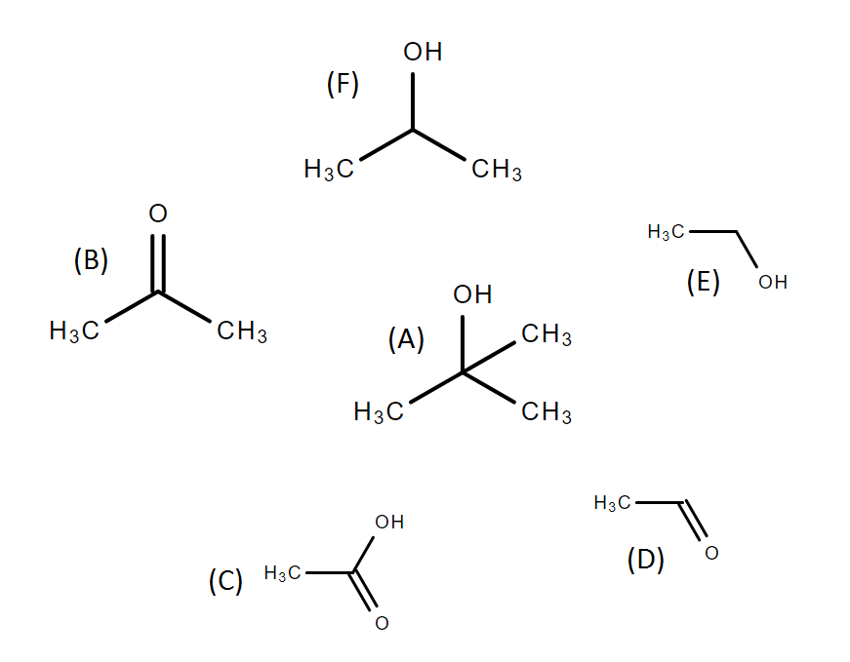

(4 marks)[KA1]

1. Describe what observations would be made if acidified dichromate solution was slowly added to: a solution of compound (A), and a solution of compound (F).  
      
      
      
      
      
      
    (3 marks)[KA2]
2. Suppose compound (C) was mixed with an abundance of sodium hydroxide NaOH to form a carboxylate salt product.
   1. Write a balanced equation to describe this reaction.  
       (2 marks)[KA4]
   2. State whether the resulting salt would be more or less soluble in water than the original compound (C) and by using your knowledge of the electronegativity of the elements involved, explain why this is the case.  
         
       (2 marks)[KA2]

**QUESTION 2**

Below is the skeletal structure for a common disaccharide sucrose, usually simply called sugar.  
When water and heat are added to sucrose, by say heating it in a frypan, a number of interesting reactions occur, including the formation of caramels.

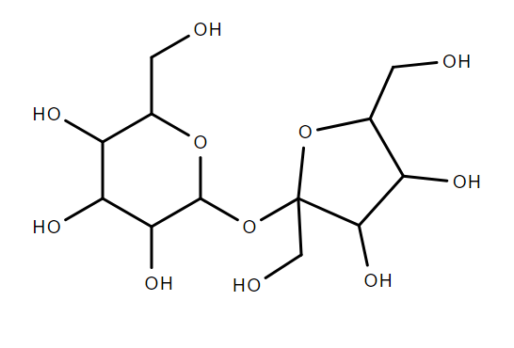

1. One of the first things to occur when sucrose is heated to over 180°C in water is that it will decompose into its substituent monosaccharides.   
   1. Draw the skeletal structure for the monosaccharides formed.  
       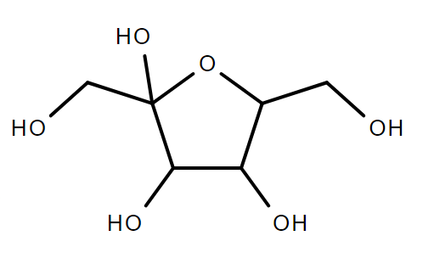   
       (4 marks)[KA4]

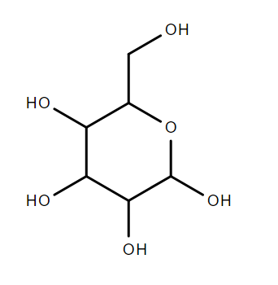

* 1. State the molecular formulas of the monosaccharides formed.

­ (2 marks)[KA1]

* 1. Describe the key features that distinguish these monosaccharides from each other.

(3 marks)[KA1]

1. Once separated into the two monosaccharides, those monosaccarides will further decompose to produce a number of smaller organic compounds often having delicious aromas that combine to give caramel its distinctive smell. Below are a few examples of compounds commonly produced as decomposition products in this scenario. Name these compounds using systematic IUPAC nomenclature.
   1. 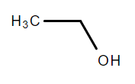

(1 mark)[KA4]

* 1. 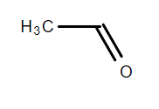

(1 mark)[KA4]

* 1. 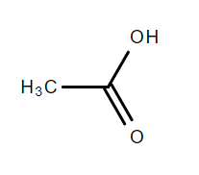  
      (1 mark)[KA4]
  2. 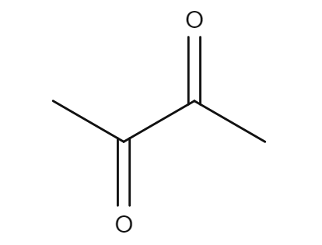  
      (1 mark)[KA4]

1. But one of the most crucial (and least well understood) steps in making caramel is that the monosaccharides recombine into a huge variety of different compounds that collectively give caramel its colour and texture. There are three broad pathways we know about by which this occurs, which involve the formation of three compounds respectively: caramelan (molecular formula C12H18O9), caramelen (molecular formula C36H50O25) and caramelin, which is an even larger polymer. Using your answer to a)ii) above, write balanced equations describing the formation of:
   1. Caramelan (C12H18O9)

(2 marks)[KA4]

* 1. Caramelen (C36H50O25)

(2 marks)[KA4]

1. Monosacharides in solution will alternate between two states: a ring form and a chain form.
   1. Draw the skeletal structure of the chain form for one of the monosaccharides from a) i).  
        
      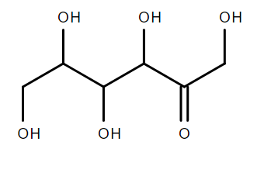or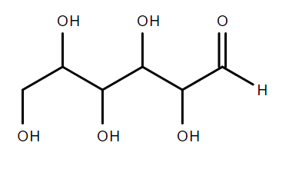  
       (2 marks)[KA4]
   2. Name the chain form from d) i) using systematic IUPAC nomenclature.  
       (1 mark)[KA4]

**QUESTION 3**

Distillation can be used to separate a mixture of liquids with different boiling points. A diagram of the apparatus for a simple distillation is shown below. One of the common uses of distillation is to purify ethanol for consumption.

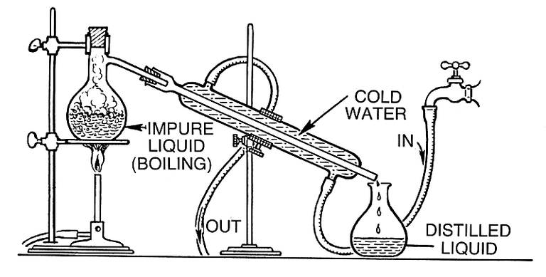

1. 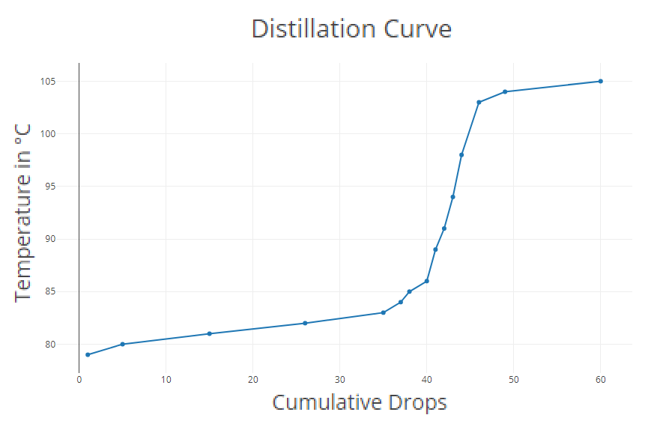A mixture of ethanol in water is distilled, and the temperature is recorded. A `distillation curve’, as shown below, is a graph of the temperature against the volume of distilled liquid collected (here measured as the cumulative number of drops).   
     
   Decide if the distillation has been successful in separating the ethanol from the water. Justify your answer by referring to the distillation curve above.  
      
      
      
      
      
    (2 marks)[IAE3]

1. Suppose each time 10 drops of distilled liquid was collected, it was put aside and a new vial ws used to continue collecting distilled liquid. Each vial of 10 drops would then be called an aliquot. The first aliquot would comprise drops 1-10, the second 11-20, the third 21-30, and so on. Six aliquots are collected in total.  
   1. Determine which aliquots would contain mostly ethanol and which would contain mostly water. Use the distillation curve and your knowledge of the boiling points of ethanol and water to justify your answers.

(3 marks)[IAE3]

* 1. Determine whether aliquot 2 would contain the same, a higher, or a lower proportion of ethanol than aliquot 3. Justify your answer.

(3 marks)[KA1]

1. Suppose the mixture you where distilling also contained methanol, a common (and very toxic) by-product of home-brewing.   
   1. Predict if the methanol would mostly come through the distillation apparatus before or after the ethanol. Justify your answer  
         
         
         
         
         
         
       (3 marks)[KA2]
   2. Under ideal circumstances, predict what changes you would expect to see in the distillation curve in comparison to the distillation curve shown above for a mixture of only ethanol and water. Using your answer to c) i) above or otherwise, justify your predictions about changes to the distillation curve.   
         
         
         
         
       (2 marks)[KA2]
   3. Describe how distillation could be used to remove the toxic methanol from a home-brew, and how this relates to your answer to c) ii) above.  
         
         
         
         
       (2 marks)[IAE3]
2. While the ethanol is boiling some of the water is still transitioning into the gas phase --- even though the water is not boiling, it is still evaporating. As such, the distilled fluid will always contain some amount of water. No matter how many time the distillation is repeated, and even if only the first first drop of distilled fluid is taken. Infact, there is a minimal proportion of water such that the proportion cannot be reduced below that level by distillation alone. Once the proportion of water is lowered to this level, when distilled the resulting distilled liquid will contain the same proportion of water as the starting mixture. Such a mixture is called an azeotropic mixture. A mixture containing only water and ethanol is azeotropic when it is a approximately 4% water. Given such an azeotropic mixture of ethanol and water, suggest an approach to producing pure ethanol, a method for completely removing the last 4% of water.   
      
      
      
      
      
      
      
      
      
      
    (4 marks)[KA2]

**QUESTION 4**

In 1856 William Henry Perkin, age 18, was trying to synthesise quinine (a medication used to treat malaria) by oxidising a compound called aniline. In a failed attempt, he discovered that the product of his reaction was a beautiful purple colour. Suitable as a dye for silk and other textiles, Perkin patented the substance and went into business producing and selling the first synthetic dye. Originally called aniline purple, in 1859 it got the name mauve from the French name for the mallow flower, and later chemists named the substance mauveine. The molecular structure of mauveine proved difficult to determine, with chemists gradually discovering more and more variant compounds within the mauveine family. In 2008 12 such compounds had been identified. The structure of one of these, mauveine C, is shown below.

Secondary

Primary

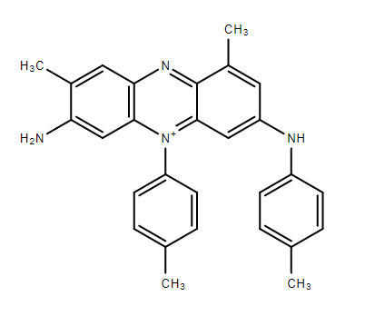

1. Categorise the circled amine groups as primary, secondary, or tertiary, by labelling them above.  
    (2 marks)[KA1]
2. Determine if the other two (not circled) nitrogen atoms in the structure of mauveine C above are amine functional groups. If they are, label them accordingly as in a).

(2 marks)[KA1]

1. Aniline (shown below) is a very weak base, and is quite non-polar. This would likely pose a problem for mass manufacture of mauveine dye. Propose something simple you could do to dissolve a large quantity of aniline in water. Explain how and why your approach will make the aniline more soluble in water.  
     
   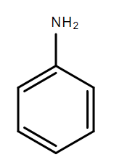   
    (2 marks)[KA1]

You may write on these pages if you need more space to finish your answers. Make sure to label each answer carefully (e.g. 7(c)(i)(2) continued).