STAGE 2 Chemistry | Topic 3: Organic Chemistry | Subtopics 3.1 – 3.6

Skills & Applications Task: Test (Suggested Solutions)

**QUESTION 1**

1. The skeletal structures for a number of organic compounds are shown below. If these compounds are exposed to a highly oxidising environment, such as being placed in an abundance of acidified dichromate solution for example, a number of reactions will occur. Draw arrows to show the reactions that will occur, and circle all final products.

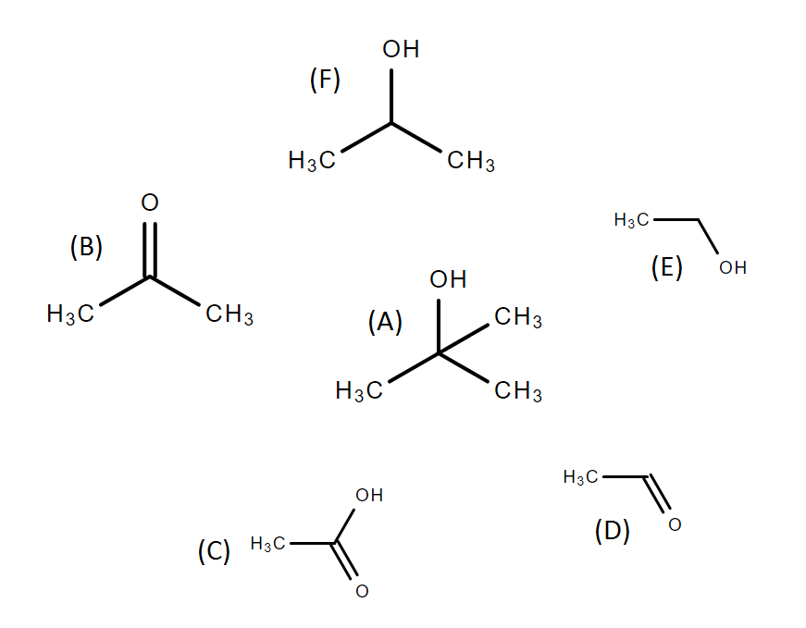

(4 marks)[KA1]

1. Describe what observations would be made if acidified dichromate solution was slowly added to: a solution of compound (A), and a solution of compound (F).  
     
   Compound (F) would react to form compound (B), as shown in a), while compound (A) would not react. So in the case of compound (F), the orange solution containing dichromate (VI) ions would remain orange, but in the case of compound (B) the solution would undergo a colour change to green as the dichromate (VI) ions are consumed in the reaction to form chromium (III) ions.  
    (3 marks)[KA2]
2. Suppose compound (C) was mixed with an abundance of sodium hydroxide NaOH to form a carboxylate salt product.
   1. Write a balanced equation to describe this reaction.  
        
      CH3COOH + NaOH 🡪 CH3COONa + H2O (2 marks)[KA4]
   2. State whether the resulting salt would be more or less soluble in water than the original compound (C) and by using your knowledge of the electronegativity of the elements involved, explain why this is the case.  
        
      The resulting salt, sodium acetate (CH3COONa), would be more soluble than the original compound (C), acetic acid. This is because sodium is much less electronegative than hydrogen, the oxygen-sodium bond is much more polar than the oxygen-hydrogen bond, the electron pair forming the bond spending much more of their time on the oxygen than the sodium. This polarity would make the salt more soluble, but it also makes it much easier for the molecule to ionise into CH3COO- and Na+ ions, which will naturally be much more soluble due to their charged nature.

(2 marks)[KA2]

**QUESTION 2**

Below is the skeletal structure for a common disaccharide sucrose, usually simply called sugar.  
When water and heat are added to sucrose, by say heating it in a frypan, a number of interesting reactions occur, including the formation of caramels.

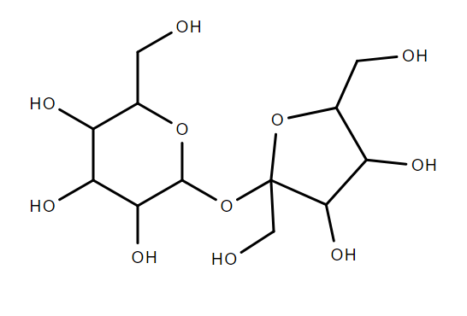

1. One of the first things to occur when sucrose is heated to over 180°C in water is that it will decompose into its substituent monosaccharides.   
   1. Draw the skeletal structure for the monosaccharides formed.  
       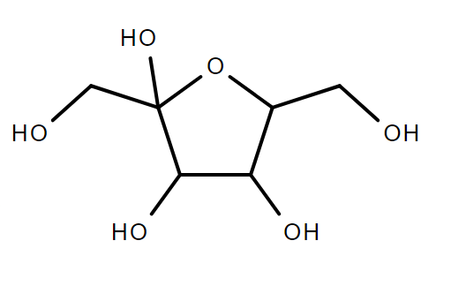   
       (4 marks)[KA4]

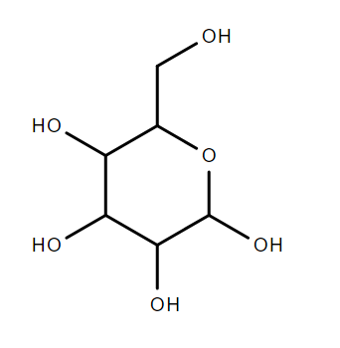

* 1. State the molecular formulas of the monosaccharides formed.

Both are C6O6H12­ (2 marks)[KA1]

* 1. Describe the key features that distinguish these monosaccharides from each other.

They are structural isomers (a stage 1 concept) --- one (fructose) has a 5-membered ring, while the other (glucose) has a 6-membered ring. So although they share the same molecular formula and so are isomers, they differ in their structure.   
   
Bonus mark (hard): monosaccharides in solution will alternate between ring form and chain form. In chain form fructose is a ketone, while glucose is an aldehyde. This could potentially be used to distinguish between them using acidified dichromate and Tollens reagent. (3 marks)[KA1]

1. Once separated into the two monosaccharides, those monosaccarides will further decompose to produce a number of smaller organic compounds often having delicious aromas that combine to give caramel its distinctive smell. Below are a few examples of compounds commonly produced as decomposition products in this scenario. Name these compounds using systematic IUPAC nomenclature.
   1. 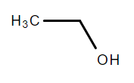

ethanol or ethan-1-ol (1 mark)[KA4]

* 1. 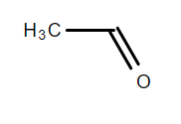

ethanal (1 mark)[KA4]

* 1. 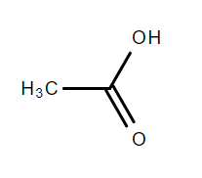  
     ethanoic acid (acetic acid not good enough) (1 mark)[KA4]
  2. 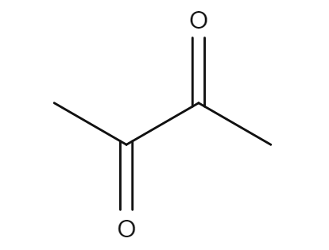  
     butane-2,3-dione (1 mark)[KA4]

1. But one of the most crucial (and least well understood) steps in making caramel is that the monosaccharides recombine into a huge variety of different compounds that collectively give caramel its colour and texture. There are three broad pathways we know about by which this occurs, which involve the formation of three compounds respectively: caramelan (molecular formula C12H18O9), caramelen (molecular formula C36H50O25) and caramelin, which is an even larger polymer. Using your answer to a)ii) above, write balanced equations describing the formation of:
   1. Caramelan (C12H18O9)

2C6H12O6 🡪 C12H18O9 + 3H2O

(2 marks)[KA4]

* 1. Caramelen (C36H50O25)

6C6H12O6 🡪 C36H50O25 + 11H­2O  
 (2 marks)[KA4]

1. Monosacharides in solution will alternate between two states: a ring form and a chain form.
   1. Draw the skeletal structure of the chain form for one of the monosaccharides from a) i).  
        
      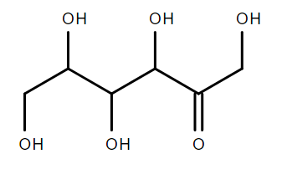or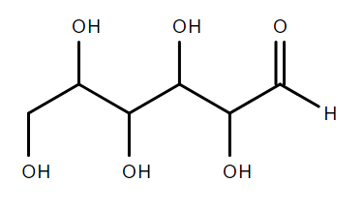  
       (2 marks)[KA4]
   2. Name the chain form from d) i) using systematic IUPAC nomenclature.  
        
      1,3,4,5,6-pentahydroxyhexan-2-one or 2,3,4,5,6-pentahydroxyhexanal (1 mark)[KA4]  
      note: not sure if I’d give the mark for 1,2,3,4,6-pentahydroxyhexan-5-one.

**QUESTION 3**

Distillation can be used to separate a mixture of liquids with different boiling points. A diagram of the apparatus for a simple distillation is shown below. One of the common uses of distillation is to purify ethanol for consumption.

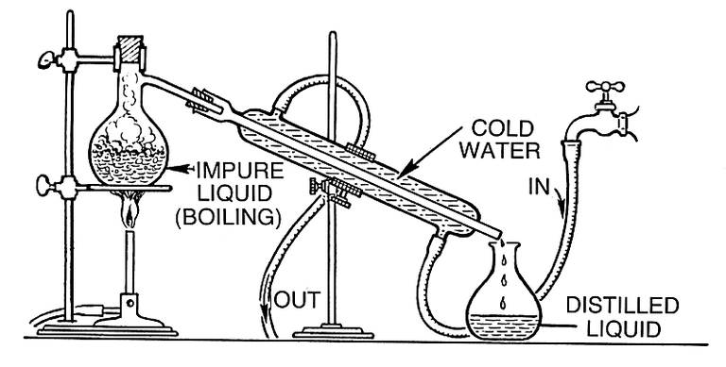

1. 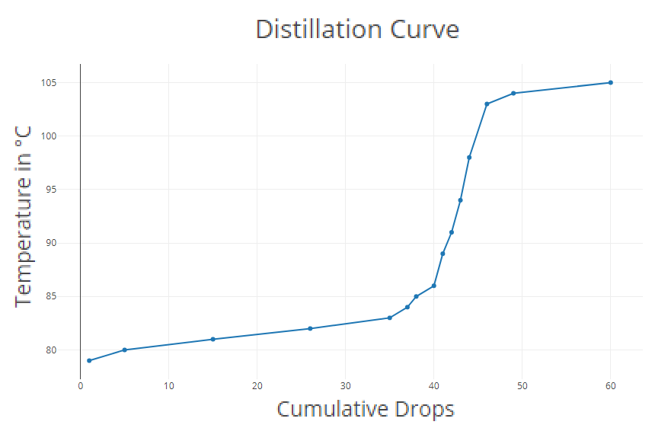A mixture of ethanol in water is distilled, and the temperature is recorded. A `distillation curve’, as shown below, is a graph of the temperature against the volume of distilled liquid collected (here measured as the cumulative number of drops).   
     
   Decide if the distillation has been successful in separating the ethanol from the water. Justify your answer by referring to the distillation curve above.  
     
   Yes. You can see there are two flat sections of the graph separated by a steep change in temperature. The flat sections are over the first 35 drops and for drops 50 onwards, and represent the solution reaching the boiling point of ethanol and water respectively.  
     
    (2 marks)[IAE3]

1. Suppose each time 10 drops of distilled liquid was collected, it was put aside and a new vial ws used to continue collecting distilled liquid. Each vial of 10 drops would then be called an aliquot. The first aliquot would comprise drops 1-10, the second 11-20, the third 21-30, and so on. Six aliquots are collected in total.  
   1. Determine which aliquots would contain mostly ethanol and which would contain mostly water. Use the distillation curve and your knowledge of the boiling points of ethanol and water to justify your answers.

Aliquots 1-3 contain mostly ethanol (I would also accept 1-4), as these boil off first and ethanol has a lower boiling point than water (it is more volatile). Aliquot 6 would be mostly water, as by the time the temperature get above 100°C virtually all of the ethanol would have boiled off already.

(3 marks)[IAE3]

* 1. Determine whether aliquot 2 would contain the same, a higher, or a lower proportion of ethanol than aliquot 3. Justify your answer.

Aliquot 2 would contain a higher proportion of ethanol than aliquot 3. During the collection of aliquots 2 and 3 the ethanol will be boiling, while the water will not be boiling yet (as the temperature will be only just over 80°C) meaning the ethanol will be converting to the gas phase at a faster rate than the water. This means the proportion of ethanol in the mixture being distilled will go down during this time, and so aliquot 3 will be collected during a time when the mixture being distilled has a lower proportion of ethanol than when aliquot 2 was being collected, and so the condensed gases collected in aliquot 3 will have a lower proportion of ethanol in them compared to aliquot 2.

(3 marks)[KA1]

1. Suppose the mixture you where distilling also contained methanol, a common (and very toxic) by-product of home-brewing.   
   1. Predict if the methanol would mostly come through the distillation apparatus before or after the ethanol. Justify your answer  
        
      Methanol would come through the distillation apparatus before the ethanol, because the methanol would have a lower boiling point and is more volatile than ethanol. This is because the methanol has a lower molecular weight and a shorter base carbon chain than ethanol.  
       (3 marks)[KA2]
   2. Under ideal circumstances, predict what changes you would expect to see in the distillation curve in comparison to the distillation curve shown above for a mixture of only ethanol and water. Using your answer to c) i) above or otherwise, justify your predictions about changes to the distillation curve.   
        
      The distillation curve would have a third flat section left (earlier) than the existing two, at a lower temperature, corresponding to methanol boiling. It would be at a lower temperature and so would occur first because, as mentioned in c) i) above methanol has a lower boiling point and is more volatile than ethanol.  
       (2 marks)[KA2]
   3. Describe how distillation could be used to remove the toxic methanol from a home-brew, and how this relates to your answer to c) ii) above.  
        
      The home-brew could be distilled on a low heat while carefully monitoring the temperature. The temperature should initially stabilise at some low value near or slightly above the boiling point of methanol, eventually the temperature will spike, and when it reaches approximately 75-78°C the distilled liquid should be removed and discarded (containing most of the methanol), and a fresh container should be placed to continue collecting further distilled liquid (depleted from methanol). If the resulting distilled liquid still contains too much methanol, this procedure could be repeated a number of times.   
       (2 marks)[IAE3]
2. While the ethanol is boiling some of the water is still transitioning into the gas phase --- even though the water is not boiling, it is still evaporating. As such, the distilled fluid will always contain some amount of water. No matter how many time the distillation is repeated, and even if only the first first drop of distilled fluid is taken. Infact, there is a minimal proportion of water such that the proportion cannot be reduced below that level by distillation alone. Once the proportion of water is lowered to this level, when distilled the resulting distilled liquid will contain the same proportion of water as the starting mixture. Such a mixture is called an azeotropic mixture. A mixture containing only water and ethanol is azeotropic when it is a approximately 4% water. Given such an azeotropic mixture of ethanol and water, suggest an approach to producing pure ethanol, a method for completely removing the last 4% of water.   
     
   There is a lot of scope for creativity in answering this question. I’ll include a few examples:  
     
   A stock answer would be to add a desiccant, such as cellulose, silica etc. to absorb the remaining water, then decanting off the pure ethanol.   
     
   Liquid (or even gas) chromatography could potentially work.  
     
   Adding a salt that preferentially dissolves in water would raise the boiling point of the water, if you add enough you could potentially get the difference between the boiling points to be big enough you could distil off pure ethanol.  
     
   You could try freezing the water, and decanting off a solution of water-ethanol mixture that is less than 4% water. You could try progressively doing this.  
     
   You could use a membrane and some kind of osmosis approach.  
     
   An extreme answer would be to add a excess of sodium, this would react with all the water (explosively), and convert the ethanol to CH3COONa which could then be extracted in other ways (?) and converted back to ethanol.  
     
   Honestly I just wanted to provide a space for students to be abit creative and this is it.  
     
    (4 marks)[KA2]

**QUESTION 4**

In 1856 William Henry Perkin, age 18, was trying to synthesise quinine (a medication used to treat malaria) by oxidising a compound called aniline. In a failed attempt, he discovered that the product of his reaction was a beautiful purple colour. Suitable as a dye for silk and other textiles, Perkin patented the substance and went into business producing and selling the first synthetic dye. Originally called aniline purple, in 1859 it got the name mauve from the French name for the mallow flower, and later chemists named the substance mauveine. The molecular structure of mauveine proved difficult to determine, with chemists gradually discovering more and more variant compounds within the mauveine family. In 2008 12 such compounds had been identified. The structure of one of these, mauveine C, is shown below.

Secondary

Primary

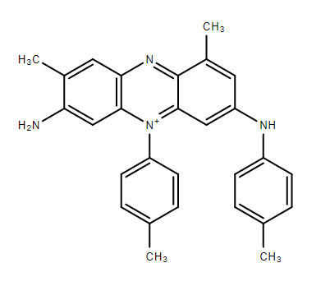

1. Categorise the circled amine groups as primary, secondary, or tertiary, by labelling them above.  
    (2 marks)[KA1]
2. Determine if the other two (not circled) nitrogen atoms in the structure of mauveine C above are amine functional groups. If they are, label them accordingly as in a).

This is interesting. Technically they are not amines. Although they have some similar properties to a tertiary amine and a quaternary ammonium cation respectively, they are not actually either of these things. They would probably be most accurately described as a pyridine nitrogen (electronically very similar to an immine) and something very similar to a pyridinium ion. Honestly I’ll accept “No” for full marks here.

(2 marks)[KA1]

1. Aniline (shown below) is a very weak base, and is quite non-polar. This would likely pose a problem for mass manufacture of mauveine dye. Propose something simple you could do to dissolve a large quantity of aniline in water. Explain how and why your approach will make the aniline more soluble in water.  
     
   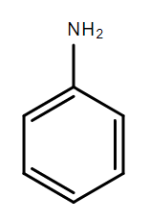Acidify the solution with a small amount of a strong acid such as HCl. The strong acid will participate in a neutralisation reaction with the weak base. This will leave the primary amine group on the aniline molecule protonated giving the aniline molecule an overall positive charge. Now that it is an ion it will be very soluble in water due to the strong polarity induced by the charge.  
     
    (2 marks)[KA1]

You may write on these pages if you need more space to finish your answers. Make sure to label each answer carefully (e.g. 7(c)(i)(2) continued).