STAGE 2 Chemistry⏐Analytical Techniques

###### j0182642

###### Investigations Folio: Volumetric Analysis Determination of Ibuprofen content

#### Background Information

Ibuprofen is a pharmaceutical of the nonsteroidal anti-inflammatory (NSAID) class, that is used primarily as a medication in the treatment of pain, inflammation, and fever.

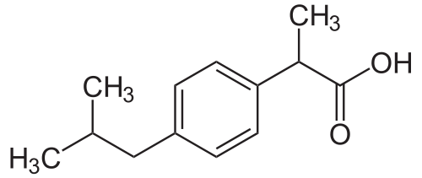

Ibuprofen contains a carboxylic acid functional group that, as a weak acid, is able to neutralise bases such as metal hydroxides.

The solubility of Ibuprofen in water, in this investigation, will be increased through the addition of glycerol (propane-1,2,3-triol) and by heating the solution to a moderate temperature.

In Australia Ibuprofen is also administered as Ibuprofen lysine (the lysine salt of Ibuprofen) which offers greater solubility in the aqueous environment encountered in the human body.

Manufacturers of pharmaceuticals are required to disclose the quantity of Ibuprofen contained in each tablet. This investigation requires confirmation of the commercial manufacturers claims. In Australia dosage, should conform to 200 mg of Ibuprofen per tablet.

Introduction

* Construct a concise introduction to the investigation, which explains the chemical and physical properties of Ibuprofen, which are relevant to the investigation.  
    
  *Ibuprofen is a common painkiller that is widely used in Australia. Manufacturers claim that a single tablet contains 200mg of ibuprofen and in this investigation we aim to test this claim by titration. Ibuprofen is a large molecular weight carboxylic acid. It is a solid at room temperature and pressure and due to its large mostly non-polar structure, it is insoluble in water. So the first challenge will be to dissolve it into solution --- although it is not soluble in water, it may be soluble in a water-glycerol mixture, as glycerol is less polar than water. However glycerol is also slightly acidic, and so we will need to first neutralise the glycerol, then dissolve the ibuprofen in the glycerol-water mixture, before titrating the ibuprofen.*______________________________________________________________________ [ KA1, KA2, KA4 ]

Assessment Conditions

* You will have the 110-minute Tutorial to complete all titrations for the commercial brand of Ibuprofen allocated and collaborate with others to collate results. **This will be completed under direct supervision.**
* During this period you will be assessed according to selected skills in the preparation of samples and solutions by dilution, and in performing titration through the manipulation of apparatus and implementation of safe procedures.

#### You will be required to use the spaces provided to record annotated evidence of your understanding – to be submitted during the investigation under direct supervision.

#### You will then be required to elaborate upon this evidence in the construction of a final formal report. No new evidence may be introduced. You will have one further week to complete.

#### You will work collaboratively, in pairs, during the investigation, but each student must demonstrate evidence of original thought through the submission of an individual report.

#### Apparatus & Reagents

# Wash bottle Beakers Glass stirring rod

Volumetric flask Measuring Cylinders Glycerol

Volumetric pipette Funnel Tablets (Ibuprofen of differing brands)

Burette White tile Phenolphthalein indicator

Conical flasks Distilled water0.100 molL-1 and 1.00 molL-1 NaOH

Safety Notes

*Sodium hydroxide may cause irritation to the skin and eyes.*

*Wear a* ***lab coat*** *and* ***safety glasses*** *during this practical. Refer to MSDS supplied for each reagent.*

Prelab

Three pieces of glassware that can be used to measure a volume of 20.00 mL are shown in the diagram below:

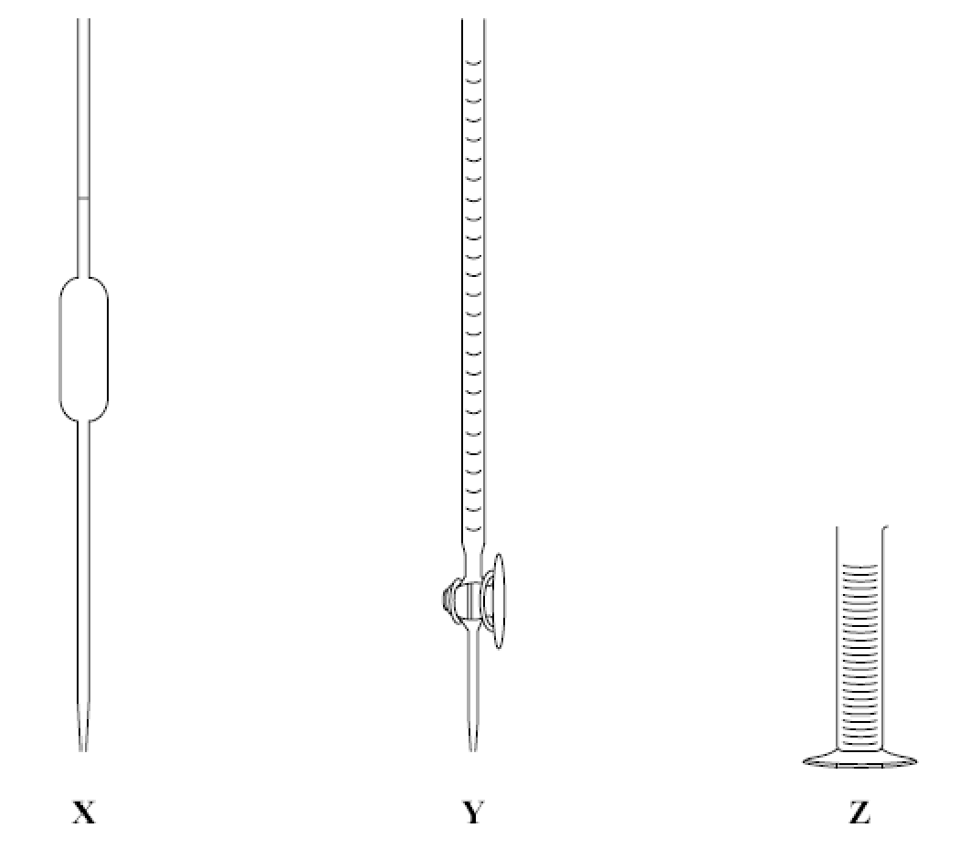

* State which one of **X**, **Y**, and **Z** is the most appropriate piece of glassware in which to transfer a volume of sodium hydroxide for dilution.

______________________________________*X*_________________________________ [ KA1 ]

* Name this piece of glassware.

_______________________________________*Pipette*________________________________ [ KA1 ]

Prelab

The recommended dosage of ibuprofen is 40 mg/kg/day up to a maximum of 1200 mg/day for an average sized adult.

* Calculate the concentration, in ppm, for an average adult of 70 kg mass who had reached the maximum recommended daily intake.  
    
  *40mg/kg/day * 70kg = 2800mg > 1200mg/day, so the dosage would be 1200mg.  
  Concentration = 1200mg / 70kg = 17.1 ppm*

[ KA1 ]

* Determine how many tablets containing 200 mg of Ibuprofen would be consumed to reach the recommended level.  
    
  *200mg per tablet, 1200mg is 6 tablets*

[ KA1 ]

Pre-investigation Rationale

You have been provided with 1.00 molL-1 sodium hydroxide, NaOH, and you will be required to dilute this solution to prepare a 0.100 molL-1 solution using a volumetric flask. Using the beakers, measuring cylinders, and indicator provided, determine the approximate volumes of both the 0.100 molL-1 and 1.00 molL-1 sodium hydroxide solution required to neutralise the ibuprofen present in one tablet. Hence, explain which concentration of sodium hydroxide is most appropriate for the titration.

*If 1M NaOH is used the approximate titre value would be of the order 1mL, which would be difficult to control and measure accurately. On the other hand, if 0.1M NaOH was used, the approximate titre would be of the order 10mL, which is much more reasonable. So 0.1M NaOH should be used for the titration.*

________________________________ [ IAE2, IAE3 ]

General Procedure

Neutralising the glycerol

* Rinse and prepare the burette.
* Fill the burette with sodium hydroxide solution.
* Introduce 50 mL of glycerol and 50 mL of warm water (approximately 60°C) to a conical flask.
* Add 2-3 drops of phenolphthalein indicator to the conical flask.
* Introduce the sodium hydroxide dropwise with stirring until the first permanent pink colour appears.

Performing the titration

* Refill the burette with sodium hydroxide solution.
* Place one tablet into the pink neutralised solution in the conical flask.
* Crush and incorporate the tablet with a glass stirring rod.
* Add an additional 2-3 drops of phenolphthalein indicator to the conical flask.
* Titrate the contents of the flask with the sodium hydroxide from the burette until the first permanent faint pink colour appears. Record the titre and repeat for three further titrations.
* Calculate the mass of ibuprofen present in each tablet.
* Collate results from the other groups present for further analysis.

Purpose

* Carefully read the background information and general procedure provided. State the *purpose* of the investigation.  
    
  *To validate the manufacturers claim that a tablet contains 200mg Ibuprofen.*

______________________________________________________________________________[ KA4 ]

Results

* Construct and complete appropriate table/s for the collection of data and observations.

|  |  |  |  |  |
| --- | --- | --- | --- | --- |
| **Tablet** | **Initial Volume (mL)** | **Final Volume (mL)** | **Titre (mL)** | **Notes/ Comments** |
| 1 | 4.4mL | 12.2mL | 7.8mL | The permanent colour change was very difficult to pinpoint, the solution would go pink but then after 10-20 seconds of stirring it would revert to clear. Possibly due to CO2 from the air acidifying the solution? Varying solubility due to cooling of the heated mixture may have also played a role. |
| 2 | 12.2mL | 20.9mL | 8.7mL | This time we tried putting glad wrap over the top of the conical flask and the top of the burette to minimise the amount of CO2 allowed in, but it didn’t work well, as when swirling the conical flask the glad wrap would come loose. We also tried keeping the conical flask heated to maintain temperature throughout the titration. |

[ IAE2 ]

#### Discussion & Calculations

* Outline critical procedures in the preparation and use of a volumetric pipette and in the preparation and use of a burette. Describe the potential effect on the final concentration if these procedures are *not* followed.

*Both need to be first rinsed with water, then with the solution they are to be filled with, including letting some flow through in the case of a burette. If these procedures are not followed, and for example the glassware is only rinsed with water, then the resulting solution may end up slightly more dilute than intended, introducing a systematic error into the final results.*

______________________________________________________________________________ [ IAE4 ]

* Identify sources of *random* and *systematic* error encountered during the procedures, explain their significance, and outline any evidence of their presence in the results obtained.  
    
  *Potential sources of systematic errors include inaccurate dilution of the NaOH solution, paralax (if a constant and incorrect position is used to take measurements), the acidity introduced into the solution by the glycerol, incomplete dissolution of the tablets, CO2 acidifying the NaOH solution, glassware calibration.  
    
  Potential sources of random erros include paralax (if different positions are used to take measurements), inaccuate estimation of endpoint (definately an issue in this experiment), time spent titrating and amount of swirling (affecting amount of CO2 absorption).*  
    
   _____________________________________________________________________________ [ IAE4 ]
* Construct appropriate equations to represent the acid/base reactions considered during the titrations.

[ KA4 ]

* Using your results and those collated determine the mass, in mg, of Ibuprofen in each of the tablets.

[ IAE3 ]

Skills Checklist (Optional)

|  |  |  |  |  |  |  |
| --- | --- | --- | --- | --- | --- | --- |
| Teacher’s Signature: __________________________ | | **Limited evidence** | **Some evidence** | **Good evidence** | **Strong evidence** | **Exemplary evidence** |
| Skill | Comment | E | D | C | B | A |
| Selection and use of appropriate glassware |  |  |  |  |  |  |
| Reading of volumes |  |  |  |  |  |  |
| Determination of endpoint |  |  |  |  |  |  |
| Safety and organisation of the workspace |  |  |  |  |  |  |
| Time management |  |  |  |  |  |  |

[ ]

Collaboration (Optional)

* Describe how working collaboratively with your partner during the practical led to greater effectiveness and efficiency. Outline your contribution. Discuss how the collation of results from other groups investigating the tablets, increased your understanding of the procedure and confidence in the results.  
    
  One of the main things was that I think it just allowed us to work faster my parralellising tasks --- I went and started on the dilution of NaOH, while my partner started on the water-glycerol mixture and dissolving a tablet. Another way in which working collaboratively helped was that through discussion sometimes I would think of things they overlooked and vice versa, so overall I think we achieved a better experiment by working collaboratively, for sure.

_________________________________________________________________________________ [ KA4 ]

Conclusion

* Construct suitable conclusions based on your findings.  
    
  This titration is haaaaard. I think it would be unreasonable to make any conclusions about the amount of Ibuprofen in the tablets on the basis of the existing results, as there are just too many variables we failed to control for. However, I do think that if we repeated this experiment after some more careful thought and planning we could hypothetically collect some more meaningful data on it. The data we have is in the roughly correct ballpark, so I certainly wouldn’t jump out of my seat to say the manufacturers claims are way off. If they are wrong, they probably aren’t by much.  
    
  _________________________________________________________________________ [ IAE3, KA4 ]

STAGE 2 Chemistry⏐Analytical Techniques

###### j0182642

###### Investigations Folio: Volumetric Analysis Determination of Ibuprofen content

|  |  |  |  |  |
| --- | --- | --- | --- | --- |
| SACE Number/Name: __________________________ | | **Intended Student Learning** | **Investigation** | **Analysis & Evaluation** |
| Purpose  [Investigation] | State the purpose of the investigation or experiment. | |  |  |
| Design [knowledge & understanding] | Interpret diagrams of the apparatus used in an experiment.  Design procedures to investigate. | |  |  |
| Procedures [Investigation] | Follow instructions accurately and safely.  Select appropriate apparatus for the measurement of volume.  Prepare solutions and undertake titrations. | |  |  |
| Safety & Ethics [Investigation]  [Application] | Negotiate procedures with the other members of a team and perform the role of a team member. | |  |  |
| Errors in measurements [Analysis & Evaluation] | Identify sources of errors that may occur in a practical investigation and describe their effect on the results. | |  |  |
| Precision, Reliability & Accuracy [Analysis & Evaluation] | Select an instrument of appropriate resolution for a measurement.  Record and use measurements to an appropriate number of significant figures. | |  |  |
| Information & Data  [Investigation] | Distinguish between qualitative and quantitative evidence.  Present data in an appropriate tabular form, showing the quantities measured and the units used, and the values observed. | |  |  |
| Interpretation & Evaluation  [Analysis & Evaluation] | Analyse and evaluate procedures from an investigation, and indicate the effect on the results.  Perform calculations from the collected data.  Write a conclusion that is based on the results of an investigation. | |  |  |
| Communication | Use chemistry terminology, conventions, and symbols that are appropriate for the purpose of a practical report.  Write appropriate chemical equations. | |  |  |
|  | **Evidence of Learning – Distribution** | |  |  |
|  | **Grade by Subdivision** | |  |  |

|  |  |  |  |  |  |
| --- | --- | --- | --- | --- | --- |
|  | **A** | **B** | **C** | **D** | **E** |
| **Investigation, Analysis, and Evaluation** | Designs a logical, coherent, and detailed chemistry investigation.  Obtains records, and represents data, using appropriate conventions and formats accurately and highly effectively.  Systematically analyses and interprets data and evidence to formulate logical conclusions with detailed justification.  Critically and logically evaluates procedures and discusses their effect on data. | Designs a well-considered and clear chemistry investigation.  Obtains, records, and represents data, using appropriate conventions and formats mostly accurately and effectively.  Logically analyses and interprets data and evidence to formulate suitable conclusions with reasonable justification.  Logically evaluates procedures and their effect on data. | Designs a considered and generally clear chemistry investigation.  Obtains, records, and represents data, using generally appropriate conventions and formats with some errors but generally accurately and effectively.  Undertakes some analysis and interpretation of data and evidence to formulate generally appropriate conclusions with some justification.  Evaluates procedures and some of their effect on data. | Prepares the outline of a chemistry investigation.  Obtains, records, and represents data, using conventions and formats inconsistently, with occasional accuracy and effectiveness.  Describes data and undertakes some basic interpretation to formulate a basic conclusion.  Attempts to evaluate procedures or suggest an effect on data. | Identifies a simple procedure for a chemistry investigation.  Attempts to record and represent some data with limited accuracy or effectiveness.  Attempts to describe results and/or interpret data to formulate a basic conclusion.  Acknowledges that procedures affect data. |
| **Knowledge and Application** | Demonstrates deep and broad knowledge and understanding of a range of chemical concepts.  Develops and applies chemical concepts highly effectively in new and familiar contexts.  Critically explores and understands in depth the interaction between science and society.  Communicates knowledge and understanding of chemistry coherently, with highly effective use of appropriate terms, conventions, and representations. | Demonstrates some depth and breadth of knowledge and understanding of a range of chemical concepts.  Develops and applies chemical concepts mostly effectively in new and familiar contexts.  Logically explores and understands in some depth the interaction between science and society.  Communicates knowledge and understanding of chemistry mostly coherently, with effective use of appropriate terms, conventions, and representations. | Demonstrates knowledge and understanding of a general range of chemical concepts.  Develops and applies chemical concepts generally effectively in new or familiar contexts.  Explores and understands aspects of the interaction between science and society.  Communicates knowledge and understanding of chemistry generally effectively, using some appropriate terms, conventions, and representations. | Demonstrates some basic knowledge and partial understanding of chemical concepts.  Develops and applies some chemical concepts in familiar contexts.  Partially explores and recognises aspects of the interaction between science and society.  Communicates basic chemical information, using some appropriate terms, conventions, and/or representations. | Demonstrates limited recognition and awareness of chemical concepts.  Attempts to develop and apply chemical concepts in familiar contexts.  Attempts to explore and identify an aspect of the interaction between science and society.  Attempts to communicate information about chemistry. |