**Student Teacher Interaction EDUC 4502/6502**

2012

**The Handbook**

**A Guide to Promoting a Positive Learning Environment**

**Emma Wegner 1196736**

Contents

Preventative

1. Introduction 2
2. Preventative Actions 3
   1. – Skinner’s Theory: Behavioural Management 3
   2. – Rogers’ Theory: Learner Centred 5

Supportive

1. Supportive Actions 7
   1. – Jones’s Theory: Non-verbal Communication 7
2. Corrective Actions 9
   1. – Dreikurs’ Theory – The Four Behaviours 9
   2. – Gordon’s Theory – Problem Ownership 11
   3. – The Choice Theory 13
3. Conclusion 14

Corrective

1. References 15
2. Appendices 17
3. **Introduction**

Positive Learning Environments Need To:

* Be safe and comfortable
* Be important and meaningful that include short- and long-term goals
* Be interesting and challenging, but realistically achievable
* Involve independent and collaborative work
* Value students’ efforts
* *Require students to be responsible for their own behaviour*

(Killen 2006, pp. 23-24)

Much like it is necessary to develop a repertoire of teaching strategies because students’ needs and learning styles are diverse (Eby et al. 2006, p. 216), it is imperative to develop a selection of effective behavioural management strategies to deal with the diverse range of behaviours in a classroom.

‘Some theories work better than others with children of different ages, children with different personal and social aptitudes, children from different home situations or social environments or ethnic and racial groups, and children involved in different school situations. All these elements create a considerable complexity and, to be properly managed, require a full range of discipline approaches.’ (Edwards 2000, p. 34)

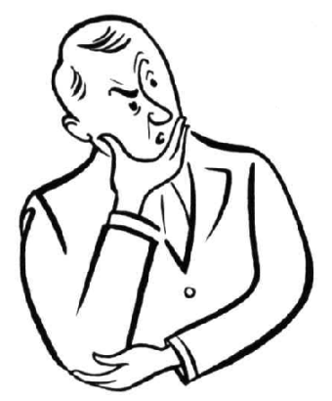

**Remember:**

*‘In deciding on a discipline approach, teachers not only must understand the underlying psychological and philosophical consequences of that choice but also must ensure that they decide is consistent with their own beliefs and values.’* (Edwards 2000, p. 27)

1. **Preventative Actions**

*‘You can prevent most misbehaviour if you treat students sensitively, provide an interesting curriculum, and use a helpful teaching style.’* (Charles 2002, p. 236)

Preventative

2.1 Skinner’s Theory: Behavioural Management

Skinner’s theory of behavioural management states that behaviour is shaped by its consequences: it strengthens with reinforcement, but weakens with punishment. Therefore, systematic uses of reinforcement can shape students’ behaviour.

The types of Reinforcers are:

Supportive

* Social – actions a teacher makes towards a student
* Graphics – visuals, any written form of expression
* Activity – activities that students would prefer to do, that still reinforce academic learning
* Tangible – real objects that students can earn as rewards

(Andrius 2012c)

*\*See appendix 1 for direct application of theory\**

Classroom Strategies:

Corrective

- Social Reinforcer - When a student puts their hand up to ask a question, the teacher smiles and nods to allow the student to continue talking

- Social Reinforcer - When a student answers a question appropriately, the teacher thanks them for their articulated answer

* Activity Reinforcer - Allowing the whole class to have free time at the end of the lesson for completing their work
* Activity Reinforcer - Allowing students to work in groups of their choice for efficiently completing the previous task

Preventative

Case Study One:

Nicola Lamb uses social and tangible reinforcers for students to finish their maths work: She assists the students who are on task, while limiting contact with off-task students. When a student finishes a task, she shows them her new wedding rings, then her wedding photos. She needs to ensure her reinforcers match the behaviours and are consistent.

Supportive

Pros:

‘Students are likely to imitate appropriate behaviour when their peers have been reinforced for that behaviour’ (Levin & Nolan 2005, p. 35). Students seeing their peers being appreciated and rewarded for ‘doing the right thing’ would aspire to receive the same recognition.

Constant reinforcers that offer privileges to individuals, groups and the whole class provide students with the feeling of regular success.

Cons:

Corrective

Being constantly rewarded for doing ‘the right behaviour’ could be seen as the teacher inadvertently conditioning students to behave for rewards, rather than developing their own ideas on how they should behave (Andrius 2012d).

2.2 Rogers’ Theory: Learner Centred

Preventative

Rogers’ theory states that ‘the facilitation of significant learning rests upon certain attitudinal qualities that exist in the personal relationship between facilitator and learner.’ He believed that teachers guide students through their learning most effectively when the self is completely free from threat.

The essential attitudes for interpersonal relationships are:

* Realness in the facilitator of learning – teachers must be genuine
* Prizing, acceptance, trust – a teacher must care for the learner, accept they are an individual with a right to an opinion, in which they trust to be authentic

Supportive

* Empathic understanding – the ability to understand a student and their feelings, and not judging or evaluating them

(Smith 2004)

*\*See appendix 2 for direct application of theory\**

This theory is directly relatable to Maslow’s Hierarchy of Needs (figure one) in which basic needs must be met before a person can reach their true potential.

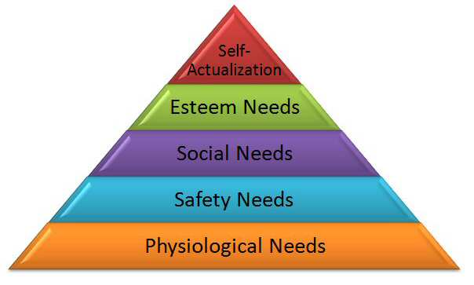

Corrective

**Figure One:** Maslow’s Hierarchy of Needs (Abraham Maslow 2012)

Classroom Strategies

Preventative

* When discussing a topic, a student offers an anecdotal example. The teacher nods and asks a question both out of interest and to further the discussion
* When discussing a concept, a student offers an answer that was not expected by the teacher. Instead of saying the student was incorrect, the teacher asks the student to explain their reasoning

Case Study Two

Philip Beadle adapts his classes for the student cohort. In this all boy class, he has made two teams to debate a topic. John then set up a tennis court debate; two nominated boys from opposing teams argue their case as a rally. Appealing to team mentality and sport, the students are more comfortable and engaged. This technique has vastly improved all the students’ grades.

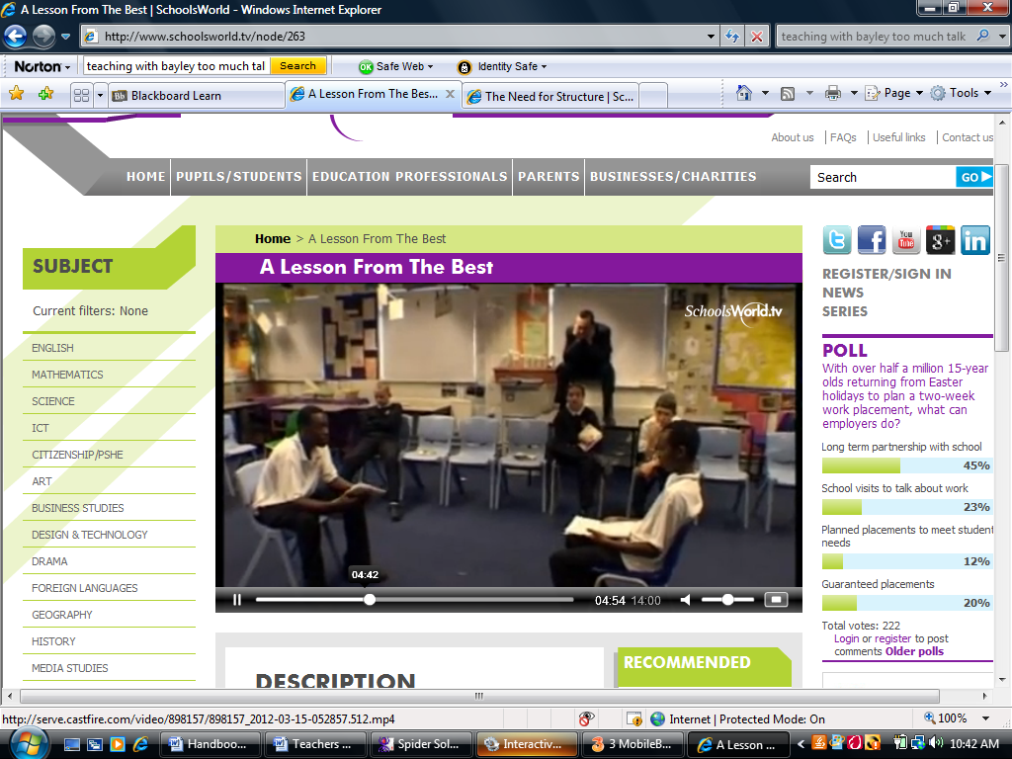

Supportive

Pros

Teachers showing a high level of respect, concern and empathy make their students feel accepted and important (Killen 2006, p. 35). When students feel included, their level of interaction and positive behaviour increases

Allowing students to choose how they will engage with the learning content, within clear parameters, shows respect for students (Brady & Scully 2005, p. 60) as well as giving them the opportunity to succeed

Corrective

Cons

It is difficult to simply be a facilitator and be unbiased or unemotional at all times. Teachers need to rely on constructive honesty (Zimring 1994, p. 415)

It is illogical for the class to be entirely student centred

1. Supportive Actions

Preventative

*‘Despite your best efforts, students will at times become restive and can easily slip into misbehaviour. This is the time for you to use supportive techniques, which are pleasant yet effective in keeping students engaged in their work.’* (Charles 2002, p. 236)

3.1 Jones’s Theory: Non-verbal Communication

Jones’s theory maintains that teachers can effectively prevent misbehaviour or reduce it significantly through body language (McInerney & McInerney 2002, p. 265). Most misbehaviour is minor, therefore the strategy should be as well (Andrius 2012b).

Supportive

To minimise intrusion into instruction, teachers should:

* Enter and move around the classroom with confidence
* Maintain self-control and dignity
* Look directly and briefly into the eyes of the student
* Use facial expressions/gestures, not words, to show approval/disapproval
* Utilise physical proximity

(McInerney & McInerney 2002, p. 265)

*\*See appendix 3 for direct application of theory\**

Corrective

This theory links directly with Kounin’s Theory on ‘Withitness’, where teachers must react to issues promptly, and be able to attend to two issues at the same time (Pressman 2008).

*\*See appendix 4 for direct application of theory\**

Classroom Strategies

* Glance and Hand Movement – While on one side of the class, the teacher notices a student heading towards the door. The student looks back and sees the teacher looking directly at them. The teacher shakes their head and points back to the student’s seat. The student begins to walk back.
* Physical Proximity – While talking to a class, the teacher notices two girls whispering and looking at something under the desk. The teacher walks over to the girls, whilst still talking. When the girls notice, they put their phone away.

Preventative

Case Study Three

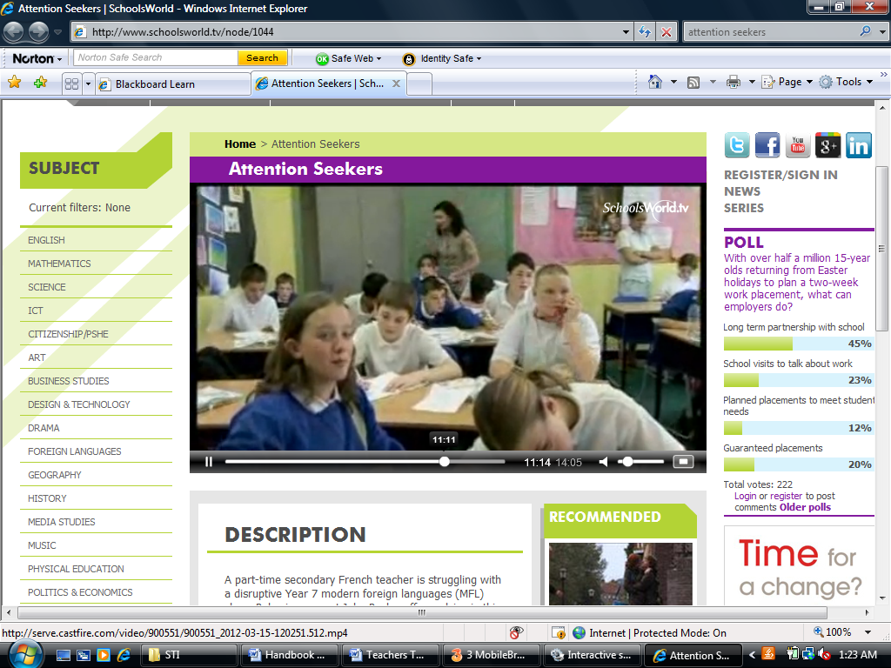

Jane Wright uses ‘planned ignoring’ (Levin & Nolan 2005, p. 29) to settle her class to show she only pays attention to good behaviour. When she is teaching, she notices a girl not doing her work, she moves closer to her. Then, when the others were busy, she leant down to show interest and tries to motivate her.

Supportive

Pros

Using non-verbal communication does not interrupt the flow of the learning activity for the rest of the class (McInerney & McInerney 2002, p. 259). The behaviour is handled discreetly and can go unnoticed by others. ‘Often just walking toward the student is enough to bring the student back on task’ (Levin & Nolan 2005, p. 30)

Corrective

Cons

The ‘signal intervention must be clearly directed at the off-task student’ (Levin & Nolan 2005, p. 29). Glances and gestures become meaningless if eye contact is never met. Similarly, it must be made obvious to the students who the gestures are directed at.

1. Corrective Actions

Preventative

*‘We have to accept that while good discipline systems can prevent most misbehaviour, you students will nevertheless break rules at times and you must deal with the transgressions. If you approach misbehaving students in a sensitive manner, you can help them return to their proper behaviour with no ill feelings.’* (Charles 2002, p. 237)

4.1 Dreikurs’ Theory: The Four Behaviours

Dreikurs’ theory states that ‘student behaviour is motivated by a need to be recognised and to belong, and misbehaviour is the product of efforts to achieve this recognition by satisfying four mistaken goals: attention getting, power seeking, revenge seeking and displaying inadequacy’ (McInerney & McInerney 2002, pp. 265-266).

Supportive

In order to eliminate this behaviour, teachers should:

* Identify the mistaken goal and react in an unexpected way
* Encourage a student’s effort, not their work or character
* Ensure students understand that unpleasant consequences always follow inappropriate behaviour
* Use logical consequences that are directly related to the behaviour
* *‘At all times distinguish between the deed and the doer’*

Corrective

(Andrius 2012a)

*\*See appendix 5 for direct application of theory\**

Classroom Strategies

* Attention getting – If a student walks in class late, the teacher should ignore the lateness, then point of calmly that the student needs to catch up on the work (McInerney & McInerney 2002, p. 266)
* Power seeking – If a student is arguing, the teacher should calmly inform the student that if they have a genuine issue, they can say it at the end of class
* Revenge getting – If a student break another’s ruler in anger, the teacher should explain that the logical consequence is to buy the student a new ruler, or replace it within a given time

Preventative

Case Study Four

John Fuentes asks a student who is displaying inadequacy to answer a question at the beginning of the class; he doesn’t speak, so he offers them to nominate someone else to answer. During the lesson, he explains the concept to the student and his friend. At the end, he asks the student the same question, who answers it. He praises the student for showing understanding.

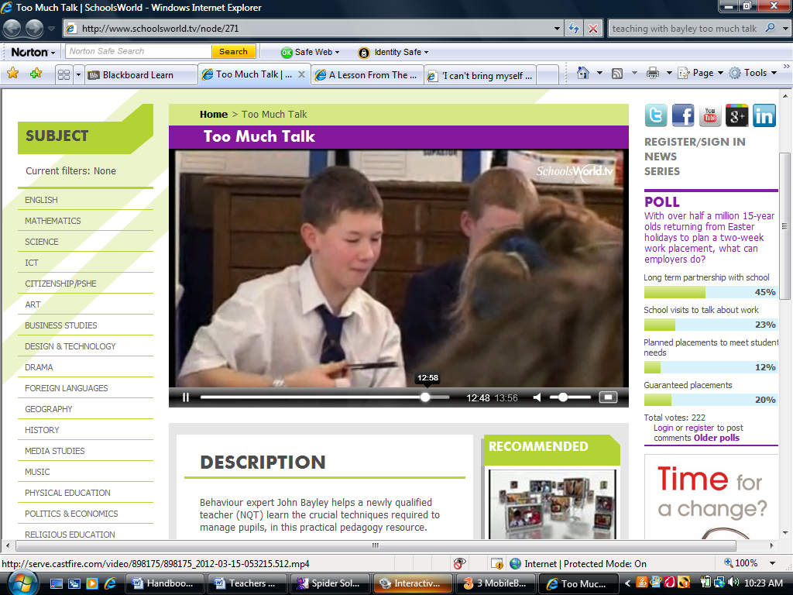

Supportive

Pros

Students have needs and ‘when these needs are not fulfilled, individuals take action to fulfil them’ (Levin & Nolan 2004, p. 201). If a teacher is aware of the type of recognition the student is wanting, they can use positive strategies and play to the student’s strengths to fulfil that desire.

Corrective

Cons

Teachers will not be able to identify context specific behaviours as easily as a constant behaviour. A child may be behaving a certain way due to extraneous factors that are unknown to and out of the teacher’s control. Teachers must then tread lightly as to not impose the incorrect consequence.

4.2 Gordon’s Theory: Problem Ownership

Preventative

Gordon’s theory involves identifying who the problem is effecting and how to solve the issue. To determine this, the teacher must actively listen and reflect back the meanings and feelings of the student in order to show an understanding (Gordon 2011) of any possible underlying issue. If the problem is affecting the teacher, they must use a directive I-message so the student understands that it is not themself that the teacher has an issue with, but their alterable behaviour.

To use a directive I-message, teachers must:

* Give a brief description of the students behaviour
* Explain the negative effect it is having

Supportive

* Clarify how the teacher feels

(McInerney & McInerney 2002, pp. 263-264)

*\*See appendix 6 for direct application of theory\**

Classroom Strategies

* A student, who is normally relatively happy, is irritable and begins to argue with the teacher. The teacher actively listens to find out that the student has had a fight with their friend. The teacher sees the student owns the problem, and decides on the logical consequence that the student may work individually and at their own pace for the day.

Corrective

* A student continually calls out in class because they are eager about the topic. The teacher says to the student, that the behaviour of calling out is unfair on other students who want to have a go and that the teacher feels that everyone should have the chance to answer a question.

Preventative

Case Study Five

Ben Nelson is teaching woodwork and has stopped students to explain the next step. He gave little reasoning why the students should stop, so some continued. He then began to overuse the school’s behaviour policy with many students, who didn’t understand why they were being punished. If Ben used the I-message to explain the importance of the next step, students may see the value, and he would not have to use sanctions.

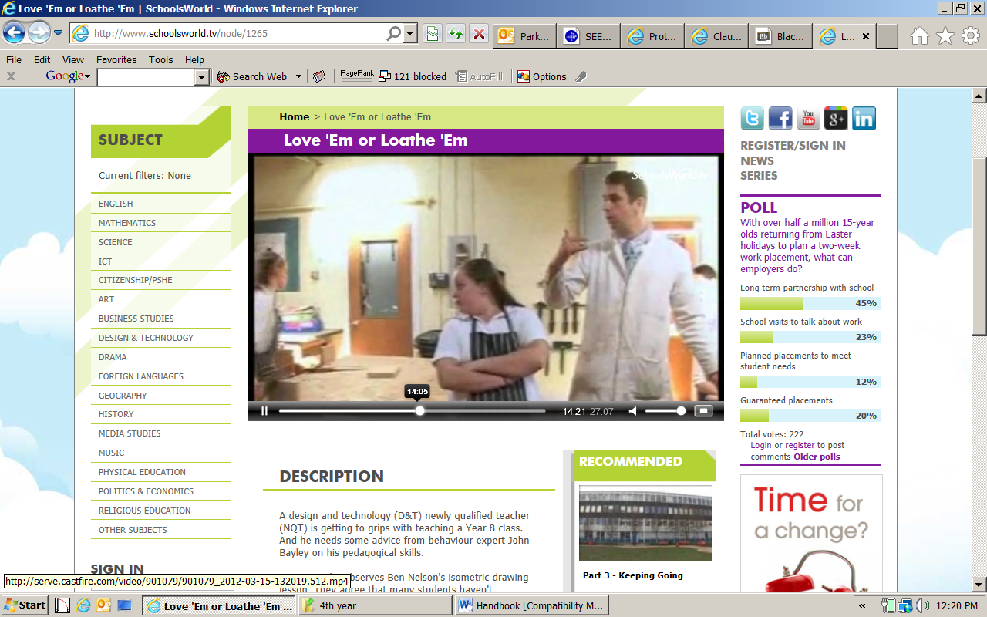

Supportive

Pros

‘Teachers should care about their learners. They should respect all students, be concerned about their welfare, have empathy with the students and make students feel accepted and important’ (Killen 2006, p. 35). Actively listening to a student reiterates this; and the I-message shows that the teacher respects the student enough to discuss their emotional reaction as a peer.

Cons

Corrective

A student may see the I-message as a weakness or that their behaviour has the power to genuinely affect the teacher, and continue the behaviour. When using the I-messages, the teacher needs to be highly aware of their phrasing and their tone as to ensure the student is aware that it is about the behaviour and not themself. Depersonalising the situation may decrease the chance of repetition.

4.3 The Choice Theory

Preventative

*This theory should, on most occasions, only be used ‘when all else fails’* (Levin & Nolan 2005, p. 42). Nonetheless it can be used effectively at the most opportune moments

The choice theory allows students understand that every type of behaviour has a logical consequence; and either positive and negative. It is imperative for students to understand that ‘logical consequences are not punishment; they are not imposed by the teacher as authority but are a conscious ‘choice’ made by the student’ (McInerney & McInerney 2002, p. 257).

*\*See appendix 7 for direct application of theory\**

Supportive

Classroom Strategies

* As a final attempt at behavioural management, the teacher can directly communicate with the student, preferably in private, and say that they can behave and continue to be a part of the class, or continue and know that one of the school’s behavioural policies will ensue.

Pros

The ‘development of social responsibility and moral character is a matter of great concern to parents, teachers and students themselves’ (McInerney & McInerney 2002, p. 244). The choice theory displays the options clearly for the students to understand, while depersonalising the situation (Cowley 2006, p. 41).

Corrective

Cons

As this is a teacher centred approach, the delivery is important, otherwise it can be seen as an attack on the student.

1. Conclusion

It is possible to achieve a positive learning environment by using an array of behavioural management strategies. Each theory has its positives and negatives, and will work in some situations and fail in others. It is possible to use a mixture of strategies that are preventative, supportive and corrective; by knowing the student cohort it is easy to understand what will work. It is best, however, to try to negotiate through the more student centred strategies before going straight to the teacher centred approaches. Remember, it’s not about you.

There are many external factors can affect the behaviour of a class (Cowley 2006, p. 37) from lesson to lesson. Working with the students and developing sound relationships will help to establish the behavioural norms.



**Remember:**

*‘No single teaching strategy is effective all the time for all learners’* (Killen 2006, p. 1). Learn to read the class and make flexible judgements on the appropriate style of teaching for each student each day.

1. References

Andrius, J 2012a, ‘The Dreikurs Model of Discipline’, *Teacher Matters*, viewed 15th April 2012, <<http://www.teachermatters.com/classroom-discipline/models-of-discipline/the-dreikers-model.html>>.

Andrius, J 2012b, ‘The Jones Model of Discipline’, *Teacher Matters,* viewed 15th April 2012, <<http://www.teachermatters.com/classroom-discipline/models-of-discipline/the-jones-model.html>>.

Andrius, J 2012c, ‘The Skinner Model of Discipline’, *Teacher Matters*, viewed 15th April 2012, <<http://www.teachermatters.com/classroom-discipline/models-of-discipline/the-skinner-model.html>>.

Brady, L, & Scully, A 2005, ‘Generating and sustaining interest’, *Engagement: Inclusive Classroom Management*, Pearson, NSW, pp.45-67.

Charles, CM 2002, ‘Finalizing a personal system of discipline’, *Building Classroom Discipline*, Pearson, New Jersey, 7th edn, pp. 235-251.

Cowley, S 2006, ‘Key strategies and techniques’, *Getting the Buggers to Behave*, Continuum International Publishing Group, pp. 35-50.

Eby, JW, Herrell, AL, Jordan, ML 2006, ‘Building a repertoire of teaching strategies’, *Teaching in K-12 Schools: A Reflective Action Approach*, Pearson, 4th Edn, pp. 215-237.

Edwards, CH 2000, ‘Making decisions about discipline’, *Classroom Discipline and Management*, John Wiley & Sons, 4th Edn, pp. 17-42.

Gordon, T 2011, ‘Origins of the Gordon Model’, *Gordon Training International*, viewed 19th April 2012, <<http://www.gordontraining.com/thomas-gordon/origins-of-the-gordon-model/>>

Killen, R 2006, ‘Foundations for quality teaching and learning’, *Effective Teaching Strategies: Lessons from Research and Practice*, Thomson, 4th Edn, pp. 1-44.

Levin, J & Nolan, JF 2004, ‘Classroom intervention for chronic problems’, *Principles of Classroom Management: A Professional Decision-Making Model*, Pearson, 4th Edn, pp. 193-222.

Levin, J & Nolan, JF 2005, ‘Managing common misbehaviours’, *What Every Teacher Should Know About Classroom Management*, Pearson Education, pp. 29-72.

McInenery, DM, & McInerney, V 2002, ‘Classroom management and cooperative group work for effective learning’, *Educational Psychology: Constructing Learning*, Pearson, pp. 243-274.

Pressman, B 2008, *Withitness In the Classroom*, viewed 17th April 2012, <<http://www.education.com/reference/article/using-xray-vision-substitute-teacher/>>.

Smith, MK 2004, ‘Carl Rogers, core conditions and education’, *the Encyclopedia of Informal Education*, viewed 6th May, <<http://www.infed.org/thinkers/et-rogers.htm>>.

Zimring, F 1994, ‘Carl Rogers (1902-1987)’, *Prospects: the quarterly review of comparative education*, vol. 24, no. 3/4, pp. 411-422.

**Case Studies**

SchoolsWorld 2012, ‘A Lesson From the Best’, *Inspirations*, viewed 2nd May 2012, <<http://www.schoolsworld.tv/node/263>>.

SchoolsWorld 2012, ‘Attention Seekers’ *Teaching with Bayley*, viewed 26th April 2012, <<http://www.schoolsworld.tv/node/1044>>.

SchoolsWorld 2012, ‘Girl Talk’, *Teaching with Bayley*, viewed 23rd April 2012, <<http://www.schoolsworld.tv/node/126>>.

SchoolsWorld 2012, ‘Love ‘Em or Loathe ‘Em’, *Teaching with Bayley*, viewed 29th April 2012, <<http://www.schoolsworld.tv/node/1265>>.

SchoolsWorld 2012, ‘Too Much Talk’, *Teaching with Bayley*, viewed 8th April 2012, <<http://www.schoolsworld.tv/node/271>>.

**Images**

Abraham Maslow: Father of Modern Management 2012, ‘Maslow’s Hierarchy of Needs’, viewed 6th May 2012, <<http://www.abraham-maslow.com/m_motivation/Hierarchy_of_Needs.asp>>.

Appendices

**Appendix 1: Skinner’s Theory**

**Application of the Model** - Jack will not work

Jack, in Mr. Jones' class, is quite docile. He never disrupts class and does little socializing with other students. But despite Mr. Jones' best efforts, he can hardly get Jack to participate in class activities. He rarely completes an assignment. He doesn't seem to care. He is simply there, like a bump on a log, putting forth virtually no effort. How would Skinner deal with Jack? Skinner would suggest that Mr. Jones try the following approaches with Jack.

1. Catch Jack being good (doing anything that is appropriate). Reward him whenever he participates or works.
2. Reiterate the class rules regarding work. Praise Jack whenever he follows the rule.
3. Consider stronger reinforcers. If praise is ineffective, use points, tokens, or other tangible objects to reinforce and shape Jack's improvement.
4. Set up a contract with Jack. Identify a reward that is exceptionally attractive to him. Outline what he must do in order to earn the reward. Share the contract with Jack's parents to enlist their support. Reinforce every improvement Jack makes.

**(Andrius 2012d)**

**Appendix 2: Rogers’ Theory**

**Application of the Model** – Amy will not work

Amy, in Mr. Jones' class, is quite docile. She never disrupts class and does little socializing with other students. But despite Mr. Jones' best efforts, she can hardly get Amy to participate in class activities. She rarely completes an assignment. She doesn't seem to care. She is simply there, like a bump on a log, putting forth virtually no effort. How would Skinner deal with Amy? Skinner would suggest that Mr. Jones try the following approaches with Amy.

1. Ask Amy why it is she will not do the work.
2. If it is lack of interest, ask her what her interests are.
3. Make a connection of her interests to the topic/unit.
4. Ask her how she would like to present her work.
5. Give other students the option of variety as well

**(Own Example)**

**Appendix 3: Jones’s Theory**

**Application of the Model** - Sam will not work

Sam, in Mr. Andrews' class, is quite docile. He never disrupts class and does little socializing with other students. But despite Mr. Andrews' best efforts, Sam rarely completes an assignment. He doesn't seem to care. He is simply there, putting forth virtually no effort. How would Jones deal with Sam? Jones would suggest that Mr. Andrew take the following steps to improve Sam's behavior:

1. Make frequent eye contact with him. Even when he looks down, the teacher should make sure to look directly at him . He will be aware of it and it may make him uncomfortable enough that he will begin work.
2. Move close to Sam. Stand beside him while presenting the lesson.
3. Use encouraging facial expressions and hand signals every time eye contact can be made.
4. Give Sam frequent help during seat work. Check on his progress several times during the lesson; give specific suggestions; and move quickly on.
5. Set up a personal incentive system with Sam - a certain amount of work earns something that Sam values. 6. Set up a system in which Sam by working, can earn rewards for the entire class. This brings added peer support to Sam.

**(Andrius 2012b)**

**Appendix 4: Kounin’s Theory**

**Application of the Model -** Donna will not work

Donna, in Mr. Jake's class, is quite docile. She never disrupts class and does little socializing with other students. But despite Mr. Jake's best efforts, Donna rarely completes an assignment. She doesn't seem to care. She is simply there putting forth virtually no effort. How would Kounin deal with Donna? Kounin would suggest to teachers that they use the following sequence of interventions until they find one that is effective with Donna.

1. Use the ripple effect. "I see many people have already completed half their work." Look at Donna, later comment, "I'm afraid a few people will have to stay late to complete their work".
2. Let Donna know you are aware she is not working. Say to her, "I see you have barely started. This work must be done today!"
3. Call on Donna in discussions preceding independent work, as a means of involving her in the lesson.
4. Point out Donna's progress when it occurs: "Good! Now you are on the track! Keep up the good work."
5. Provide variety. Continually challenge Donna to accomplish more.
6. Hold Donna accountable with group focus techniques. Do not disregard her just because she has been non-productive.

**(Andrius 2012c)**

**Appendix 5: Dreikurs’ Theory**

**Application of the Model -** Nathan will not work

Nathan is quite docile in Mr. Smith's class. He never disrupts the class and has little contact with other students. Regardless of Mr. Smith's best efforts Nathan rarely completes an assignment. Nathan doesn't seem to care. He makes little effort. He is simply there - a mere physical presence in the classroom!

How would Dreikers deal with Nathan?

1. Identify Nathan's mistaken goal. (Mr. Smith can do this by checking his own reaction to Nathan's lethargy and by noting the reactions of other students when he attempts to correct him.)
2. If Nathan's mistaken goal is attention seeking, ignore him.
3. If Nathan's mistaken goal is gaining power, admit that Nathan has power: "I can't make you do your work. What do you think I should do?"
4. If Nathan's goal is taking revenge, ask other members of the class to be especially encouraging to him when he displays any pleasing behaviour.
5. If Nathan's goal is to appear inadequate, encourage any favourable behaviour and give him continual support for it.
6. Gently confront Nathan with his mistaken goal and draw him into discussion about it and his related behavior.

**(Andrius 2012a)**

**Appendix 6: Gordon’s Theory**

**Application of the Model -** John will not work

John is quite docile in Mr. Smith's class. He never disrupts the class and has little contact with other students. Regardless of Mr. Smith's best efforts John rarely completes an assignment. John doesn't seem to care. He makes little effort. He is simply there - a mere physical presence in the classroom!

How would Gordon deal with John?

1. Identify John’s behaviour
2. Actively listen to John’s reasons for incompletion of work
3. Determine who owns the problem (both do)
4. Give a simple description of John’s behaviour
5. Describe its tangible effects on the teacher
6. Give a description of the teacher’s feeling of this behaviour
7. Plan on working out how both could mutually benefit from John completing his work.

**(Own example)**

**Appendix 7: Choice Theory**

**Application of the Model –** Clair will not work

When Mr. Ronowski observed Clair disturbing the class by talking excessively and throwing objects, he motioned him up to his desk and, out of earshot of the rest of the class, engaged him in the following conversation:

**Mr. Ronowski** Clair , what were you doing during class discussion today that disturbed others around you?

**Clair** I was just talking to Owen

**Mr. Ronowski** What did you along with the rest of the class decide would happen to anyone who disturbed the class by talking?

**Clair** We decided we would be kicked out of class and not be allowed back until we made a written plan about how we planned to avoid these problems.

**Mr. Ronowski** When will you get your plan to me?

**Clair** I’ll try to get it to you by tomorrow.

**Mr. Ronowski** Where must you go until you have your written plan prepared?

**Clair** The counsellor’s office

**Mr. Ronowski** I will anticipate hearing from you before class then.

**(Edwards 2000, p. 25)**