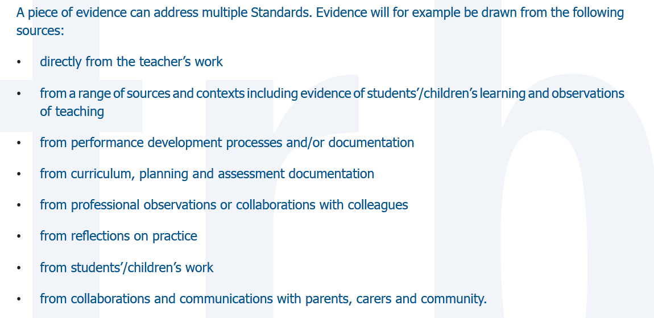

The descriptors listed below are at the proficient stage.

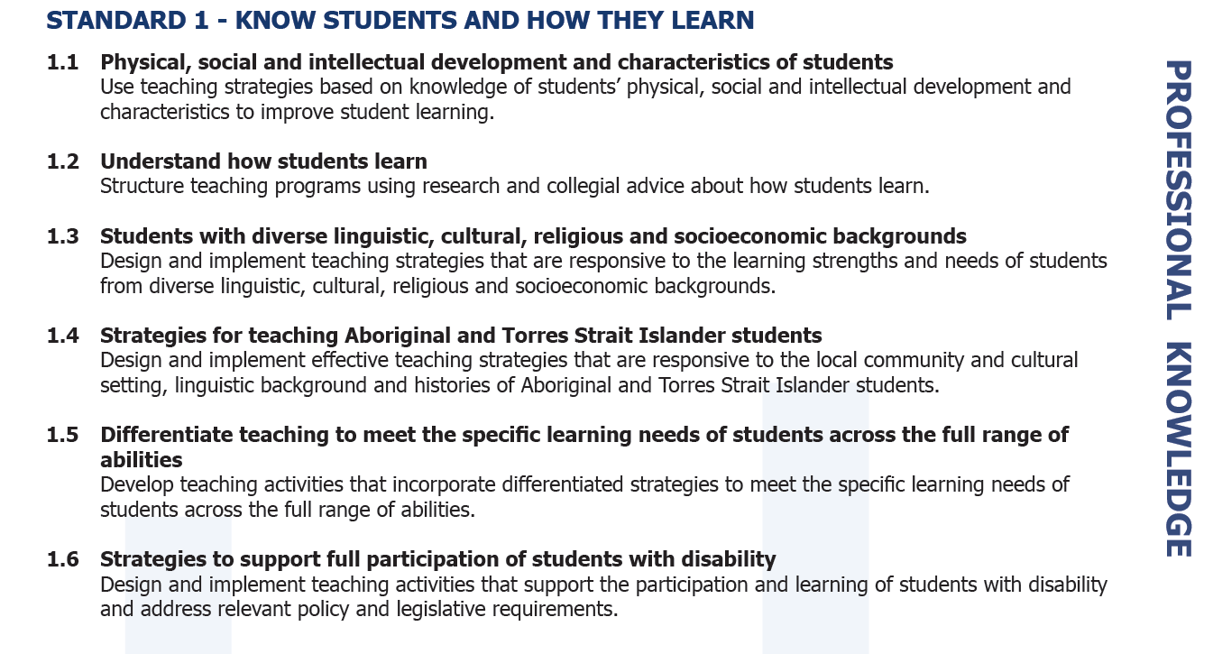

|  |  |
| --- | --- |
| What evidence do you have that would support standard 1? | * Reflective journal * “How I learn” Student feedback from start of term * Lesson, unit, term plans * Observation notes from manager/mentor * Differentiated assessment/work * NEP’s IEP’s * unit plans highlighting indigenous content * Indigenous learning plans * Differentiated assessment in line with ILP/IEP * Professional development focused on Aboriginal and TSI * Emails between indigenous support * Examples of scaffolding * Teaching evidence of catering for different learning preferences * Differentiated worksheets (confidentially) * Differentiated assessment/work * NEP’s IEP’s * Examples of classroom setup to cater for disabilities * Examples of differentiated curriculum for students with a disability * Notes from meetings with parents and staff in regards to catering for students with a disability * Minutes/reflections on parent meetings * Evidence of involvement in co-curricular * Working with specialisation * Acknowledgement of Country * Learning programs used and explanations of their use * Online lesson platform * Social and emotional lesson programmes * Use of resources * Examples of collaborative learning * Classroom setup – seating plans |

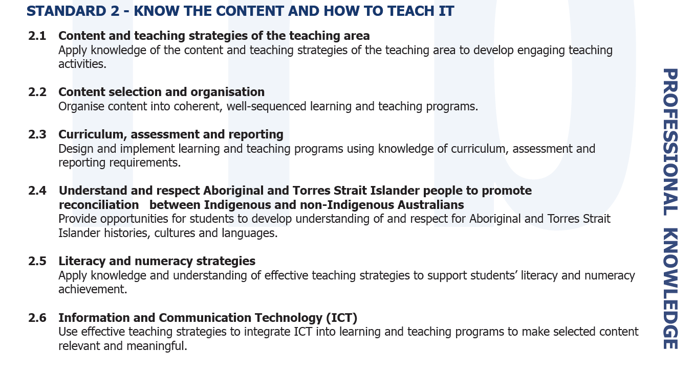

|  |  |
| --- | --- |
| What evidence do you have that would support standard 2? | * Lesson plans (specific) * Appropriateness of content to areas * Unit plans LAP’s * NEP’s * Assessment package (cur link, reports) * Evidence of Indigenous links to content * Drafting Portfolio * Examples of use of Skool Bag app for teacher parent communication * Examples of the use of PHeT simulations * Cosmos lessons * STILE * Examples of flipping the classroom * Examples of Kahoot Quiz and how it has been used & other diagnostic tools i.e. Plickers * Evidence of effective ICT resources in lessons * Differentiated literacy and numeracy work * Activities form literacy and numeracy week * Targeted learning based on NAPLAN, PAT-M and PAT-R assessment * Survey monkey/student feedback * Australian Curriculum cover sheets for assignments * WALT and WILF * Learning goals * Pre assessment * Examples of integration * Plans outlining use of technologies e.g. I pad’s, SharePoint, seesaw, Sector * Examples of how learning styles will be integrated |

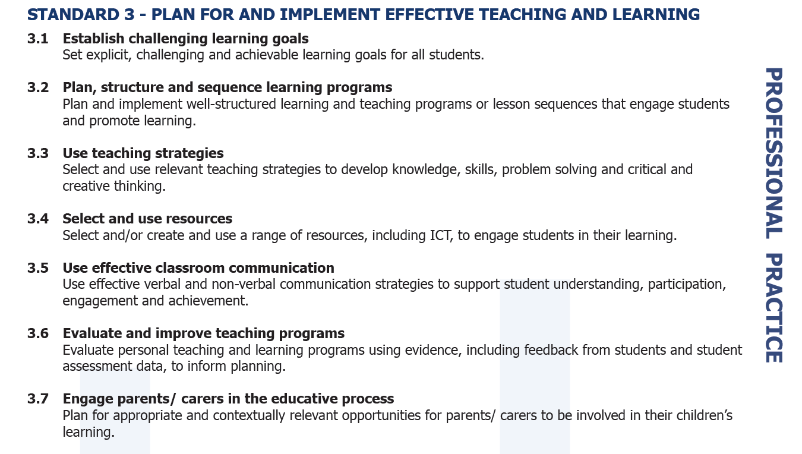

|  |  |
| --- | --- |
| What evidence do you have that would support standard 3? | * Use of open ended question * Lesson plans * Learning objectives * Unit plans * Skill building * Student work samples * Examples of using backwards by design in planning * tFEl reflective examples * student evaluations * parent teacher interview notes * records of subject selection night * self-reflection notes * parent email and phone records * reflective journal * observation feedback * student feedback * copies of weekly information emails * day map * SMART goals * Examples of real world connections * Phots of equipment used during lessons * Articulate pedagogy styles used * Structures used * Non-verbal strategies used e.g. thumbs up etc. * Learning/teaching reflections * Learning intentions |

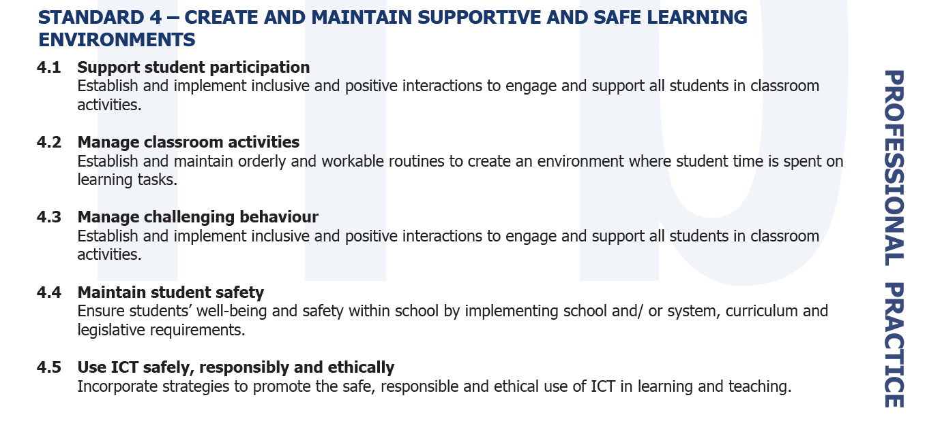

|  |  |
| --- | --- |
| What evidence do you have that would support standard 4? | * Record of classroom expectations and rules * Records of mentor notes and reflections of your classroom practice and observations * Email records of evidence of contact with students, pastoral care teachers and parents regarding challenging behaviour * Seating plans with justification * Evidence of routine setting * Evidence of consideration and monitoring of ICT risks * Student reflections on their own behaviour * Communication with other staff regarding supporting mental health and well being * Evidence of work you’ve scaffolding or differentiated to ensure classroom activities run smoothly * Risk assessment * Safety guidelines and instructions * Contracts   + Behaviour   + Classroom * Awareness of emergency routines and drills * Evidence of implementing cyber safety * Parent/student feedback * R.E. wellbeing programmes * ICT policies and protocols * External/guest speakers * Language used * Explicit teaching |

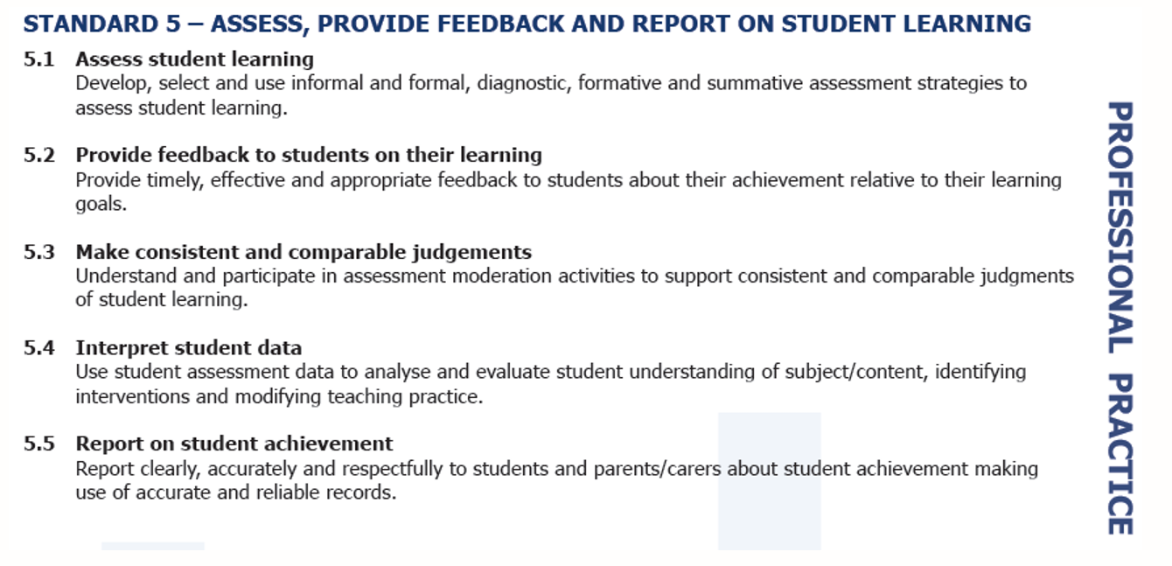

|  |  |
| --- | --- |
| What evidence do you have that would support standard 5? | * Kahoot and Plickers results * Written online feedback on results * Rubrics ( including differentiated versions) * Learning management systems comments and grading * Email responses to student emails * Report comments * Gradebook * Examples of different assessment types formative/summative * Evidence of moderation (internal and external) * Evidence of marking * Parent-teacher interview notes * Evidence of PAT/NAPLAN results and analysis and the impact this has on teaching * Evidence on assessment specific PD * Evidence of scaffolding * Evidence of multimodal modification * Evidence of modification for students with a disability * Moderation opportunities * Examples of feedback/drafting * Score link myed |

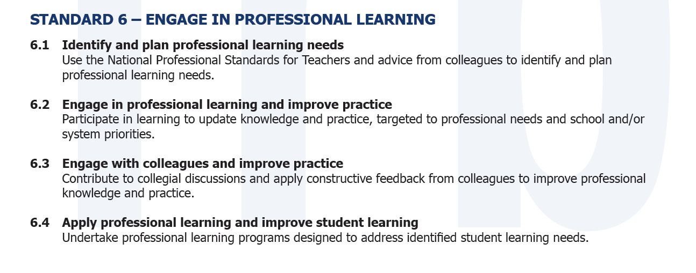

|  |  |
| --- | --- |
| What evidence do you have that would support standard 6? | * Emails with staff at your school and others discussing your practice * Collaboration on resource production and assessment tasks including drafts and communication * PD on learning difficulty needs * Self-reflection notes- implementing new ideas * Feedback form mentors * AITSL self-assessment tool * Notes and minutes from staff/faculty meetings * Conferences attend from relevant associations * Identifying content weakness through reflective practice and complete relevant PD * PD notes and task development * Professional development plan * PD certificates * Evidence of educational reading * Mentors support from other teachers * Notes form online seminars * Action plans |

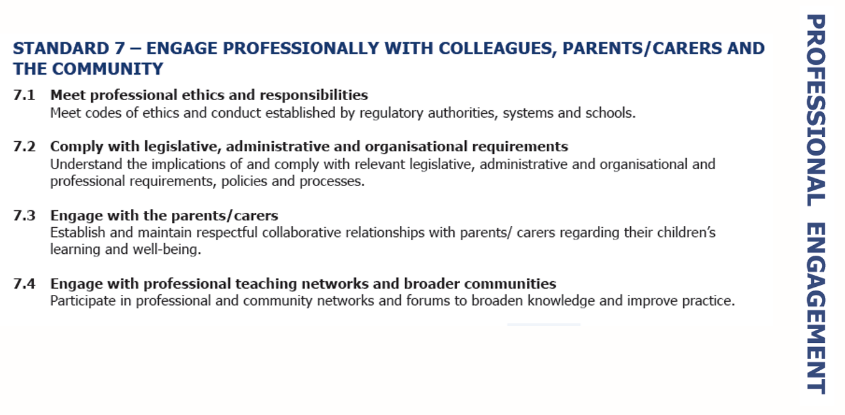

|  |  |
| --- | --- |
| What evidence do you have that would support standard 7? | * Records of relevant emails * Staff/faculty meeting notes * Child protection curriculum (training) * Class newsletter * Report comments * Peer observations * Professional memberships/forums * Co-curricular activities * Parent teacher interviews * Professional development * Participation in school events * Contributions to School newsletters/social media * Membership of school committees * Digital media permissions and risk assessment * Risk assessment * Phone call log * Evidence of community and industry partnerships * Mandatory reporting protocols * Professional teaching network * Meet and greets * Understanding and abiding by teacher code of ethics * Membership of professional associations * Records of parent communication * Professional Facebook groups |